Nikola Tesla 1856-1943
http://en.wikipedia.org/wiki/Nikola_Tesla
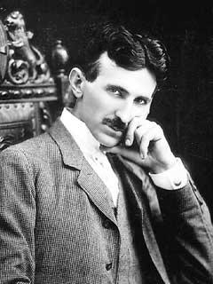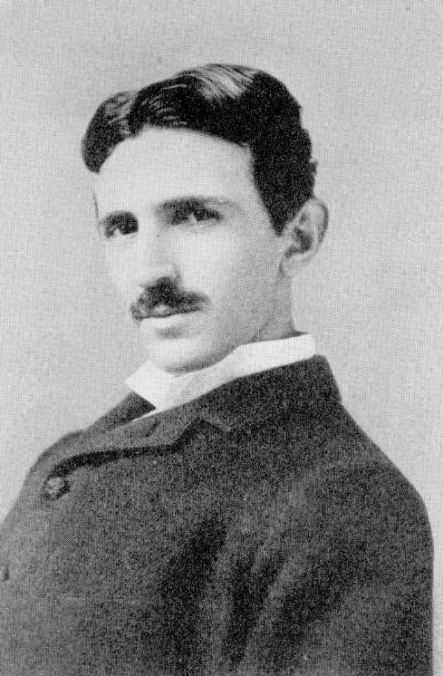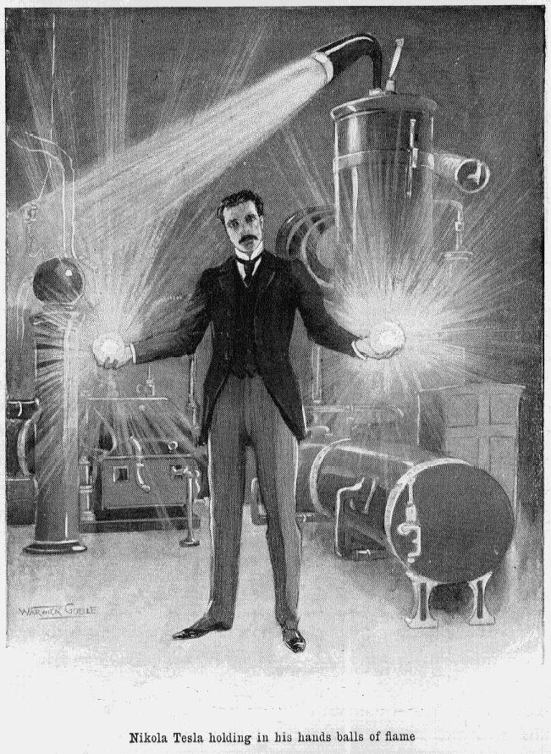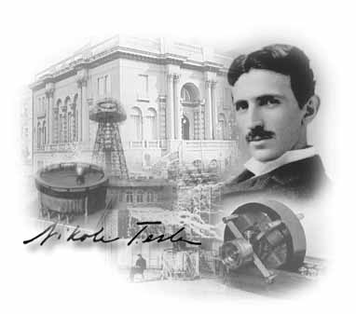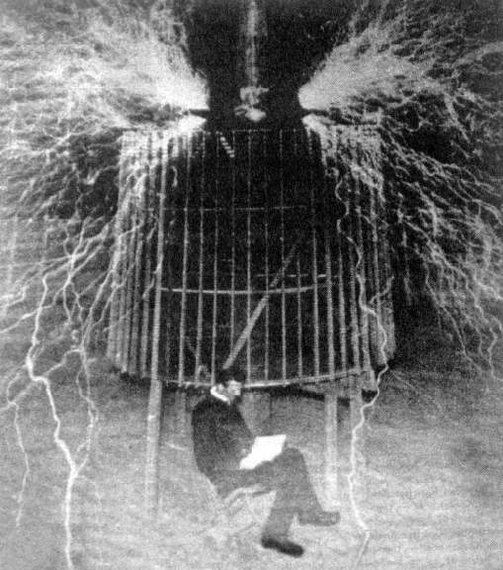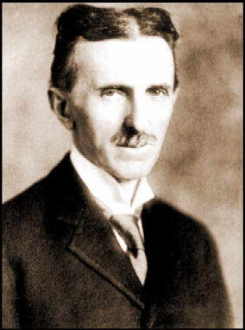
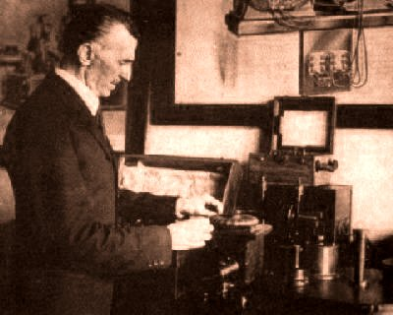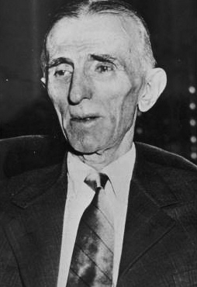
I have harnessed the cosmic rays and caused them to operate a motive device.^{[1]} Born: 10 July 1856
Smiljan, Military Frontier, Austrian Empire Died: January 7, 1943
New York City, New York, USA Occupation: inventor, physicist, mechanical engineer and electrical engineer
-------------------------------------------------------------------------------------------------------------------------------------------------------------------------------------------------------------------------------------------
Nikola Tesla (Serbian Cyrillic: Никола Тесла) (10 July 1856 - 7 January 1943^{[2]}) was a world-renowned Serb-American inventor, physicist, mechanical engineer and electrical engineer. Tesla is regarded as one of the most important inventors in history. He is well known for his contributions to the discipline of electricity and magnetism in the late 19th and early 20th century. Tesla's patents and theoretical work form the basis of modern alternating current electric power (AC) systems, including the polyphase power distribution systems and the AC motor, with which he helped usher in the Second Industrial Revolution.
In the United States, Tesla's fame rivaled that of any other inventor or scientist in history or popular culture. After his demonstration of wireless communication in 1893 and after being the victor in the "War of Currents", he was widely respected as America's greatest electrical engineer. Much of his early work pioneered modern electrical engineering and many of his discoveries were of groundbreaking importance. In 1943, the United States Supreme Court credited him as being the inventor of the radio. Never putting much focus on his finances, Tesla died impoverished and forgotten at the age of 86.
His contribution was recognised and the derived SI unit measuring magnetic flux density or magnetic induction (commonly known as the magnetic field ), the tesla, was named in his honour (at the Conférence Générale des Poids et Mesures, Paris, 1960).
Tesla's legacy can be seen across the modern world wherever electricity is used. Aside from his work on electromagnetism and engineering, Tesla is said to have contributed in varying degrees to the fields of robotics, ballistics, computer science, nuclear physics, and theoretical physics. In his later years, Tesla was regarded as a mad scientist and became noted for making bizarre claims about possible scientific developments.^{[3][4]} Many of his achievements have been used, with some controversy, to support various pseudosciences, UFO theories, and New Age occultism. Contemporary admirers of Tesla have deemed him "the man who invented the twentieth century."^{[5]}

Contents
- 1 Early years
  - 1.1 Hungary and France
  - 1.2 United States
- 2 Middle years
  - 2.1 Colorado Springs
- 3 Later years
  - 3.1 Field theories
  - 3.2 Directed-energy weapon
  - 3.3 Theoretical inventions
- 4 Death and afterwards
- 5 Relations and friendships
- 6 Personal views
- 7 Education
- 8 Recognition and honors
- 9 Notes and references
- 10 See also
- 11 Further material
  - 11.1 Articles (pre-1900)
  - 11.2 Books
  - 11.3 Magazines
  - 11.4 Documentary and biographical films
  - 11.5 Fictional Portrayal
- 12 External links

Early years
According to legend, Tesla was born precisely at midnight during an electrical storm, to a Serb family in the village of Smiljan near Gospić, in the Lika region of the Austrian Empire, in the Croatian part of Military Frontier, located in present-day Croatia.^{[6]} His baptism certificate reports that he was born on June 28 [N.S. July 10], 1856, and christened by the Serbian Orthodox priest Toma Oklobdžija. His father was Rev. Milutin Tesla, a priest in the Serbian Orthodox Church Metropolitanate of Sremski Karlovci. His mother was Đuka Mandić, herself a daughter of a Serbian Orthodox Church priest. She was talented in making home craft tools. She memorized many Serbian epic poems, but never learned to read.^{[7]} His godfather, Jovan Drenovac, was a captain in the army protecting the Military Frontier. Tesla was one of five children, having one brother (Dane, who was killed in a horse-riding accident when Nikola was five) and three sisters (Milka, Angelina and Marica).^{[8]} His family moved to Gospić in 1862. Tesla went to school in Karlovac, Croatia then studied electrical engineering at the Austrian Polytechnic in Graz, Austria (1875). While there, he studied the uses of alternating current. He attended only through the first semester of his junior year and did not graduate.^{[9]} He then attended the Charles-Ferdinand branch of the University of Prague for one summer term where he studied physics and higher mathematics.^{[10]}
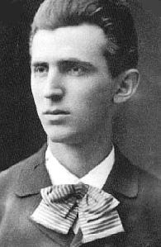
Nikola Tesla as a young man
Tesla engaged in reading many works, memorizing complete books. He had a photographic memory.^{[11]} Tesla related in his autobiography that he experienced detailed moments of inspiration. During his early life, Tesla was stricken with illness time and time again. He suffered a peculiar affliction in which blinding flashes of light would appear before his eyes, often accompanied by hallucinations. Much of the time the visions were linked to a word or idea he might come across; just by hearing the name of an item, he would involuntarily envision it in realistic detail. Modern-day synesthetes report similar symptoms. Tesla would visualise an invention in his brain in precise form before moving to the construction stage; a technique which is sometimes known as picture thinking. Tesla also often had flashbacks to events that had happened previously in his life, this began to happen during childhood.^{[12]}

Hungary and France
In 1881 he moved to Budapest, Hungary, to work for a telegraph company, the American Telephone Company. There, he met Nebojša Petrovič, then a young inventor from Austria. Although their encounter was brief, they did work on a project together using twin turbines to create continual power. On the opening of the telephone exchange in Budapest, 1881, Tesla became the chief electrician to the company, and was later engineer for the country's first telephone system. He also developed a device that, according to some, was a telephone repeater or amplifier, but according to others could have been the first loudspeaker.^{[13]} For a while he stayed in Maribor, Slovenia, where he was first employed as an assistant engineer. He suffered a nervous breakdown during this time. In 1882 he moved to Paris, France to work as an engineer for the Continental Edison Company, designing improvements to electric equipment. In the same year, Tesla conceived of the induction motor and began developing various devices that use rotating magnetic fields (for which he received patents in 1888).
Soon thereafter, Tesla hastened from Paris to his mother's side as she lay dying, arriving hours before her death in 1882. Her last words to him were, "You've arrived, Nidžo, my pride." After her death, Tesla fell ill. He spent two to three weeks recuperating in Gospić and the village of Tomingaj near Gračac, Croatia, the birthplace of his mother.

United States
In 1884, when Tesla first arrived in the US, he had little besides a letter of recommendation from Charles Batchelor, his manager in his previous job. In the letter of recommendation to Thomas Edison, Charles Batchelor wrote, "I know two great men and you are one of them; the other is this young man." Edison hired Tesla to work for his company Edison Machine Works. Tesla's work for Edison began with simple electrical engineering and quickly progressed to solving the company's most difficult problems. Tesla was offered the task of a complete redesign of the Edison company's direct current generators.
In 1919 Tesla wrote that Edison offered him the then-staggering sum of $50,000 (almost $1 million today, adjusted for inflation [1]) if he completed the motor and generator improvements. Tesla said he worked nearly a year to redesign them and gave the Edison company several enormously profitable new patents in the process. When Tesla inquired about the $50,000, Edison reportedly replied to him, "Tesla, you don't understand our American humor," and reneged on his promise.^{[14]} Tesla resigned when he was refused a raise to $25 per week. At Tesla's salary of $18 per week the bonus would have amounted to over 53 years pay, and the amount was equal to the initial capital of the company.^{[15]} He eventually found himself digging ditches for a short period of time-- ironically for the Edison company. Edison had also never wanted to hear about Tesla's AC polyphase designs, believing that DC electricity was the future. Tesla focused intently on his AC polyphase system, even while digging ditches.^{[16]}
Electromechanical devices and principles developed by Nikola Tesla^{[17]} :

- Various devices that use rotating magnetic fields (1882)
- The Induction motor, rotary transformers, and "high" frequency alternators
- The Tesla coil, his magnifying transmitter, and other means for increasing the intensity of electrical oscillations (including condenser discharge transformations and the Tesla oscillator)
- Alternating current long-distance electrical transmission system^{[18]} (1888) and other methods and devices for power transmission
- Systems for wireless communication (prior art for the invention of radio) and radio frequency oscillators
- Robotics and the "AND" logic gate^{[19]}
- Electrotherapy Tesla currents
- Tesla impedance phenonomena
- Tesla effect and the Tesla electro static field
- Tesla principle
- Bifilar coil
- Telegeodynamics
- Tesla insulation
- Forms of commutators and methods of regulating third brushes
- Tesla turbines (eg., bladeless turbines) for water, steam, and gas
- Tesla pumps
- Tesla igniter
- Tesla compressor
- X-rays Tubes using the bremsstrahlung process
- Devices for ionized gases
- Devices for high field emission
- Devices for charged particle beams
- Arc light systems
- Methods for providing extremely low level of resistance to the passage of electrical current (predecessor to superconductivity)
- Voltage multiplication circuitry
- Devices for high voltage discharges
- Devices for lightning protection
- VTOL aircraft
- Dynamic theory of gravity
- Concepts for electric vehicles
- Polyphase systems

Middle years
In 1886, Tesla formed his own company, Tesla Electric Light & Manufacturing. The initial financial investors disagreed with Tesla on his plan for an alternating current motor and eventually relieved him of his duties at the company. Tesla worked in New York as a common laborer from 1886 to 1887 to feed himself and raise capital for his next project. In 1887, he constructed the initial brushless alternating current induction motor, which he demonstrated to the American Institute of Electrical Engineers (now IEEE) in 1888. In the same year, he developed the principles of his Tesla coil and began working with George Westinghouse at Westinghouse Electric & Manufacturing Company's Pittsburgh labs. Westinghouse listened to his ideas for polyphase systems which would allow transmission of alternating current electricity over large distances.
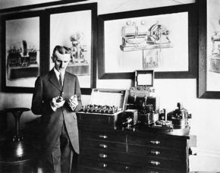
Tesla working in his lab
In April of 1887, Tesla began investigating what would later be called X-rays using his own single node vacuum tubes (similar to his patent #514170). This device differed from other early X-ray tubes in that they had no target electrode. The modern term for the phenomenon produced by this device is bremsstrahlung (or braking radiation). We now know that this device operated by emitting electrons from the single electrode through a combination of field emission and thermionic emission. Once liberated, electrons are strongly repelled by the high electric field near the electrode during negative voltage peaks from the oscillating HV output of the Tesla Coil, generating X-rays as they collide with the glass envelope. He also used Geissler tubes. By 1892, Tesla became aware of what Wilhelm Röntgen later identified as effects of X-rays.
Tesla commented on the hazards of working with single node X-ray producing devices, incorrectly attributing the skin damage to ozone rather than the radiation: "As to the hurtful actions on the skin... I note that they have been misinterpreted... They are not due to the Röntgen rays, but merely to the ozone generated in contact with the skin. Nitrous acid may also be responsible, but to a small extent". (Tesla, in Electrical Review, 30 November 1895). Tesla later observed an assistant severely "burnt" by X-rays in his lab. He performed several experiments prior to Röntgen's discovery (including photographing the bones of his hand; later, he sent these images to Röntgen) but didn't make his findings widely known; much of his research was lost in the 5th Avenue lab fire of March 1895.
On July 30, 1891, he became a naturalized citizen of the United States at the age of 35. Tesla established his 35 South Fifth Avenue laboratory in New York during this same year. Later, Tesla would establish his Houston Street laboratory in New York at 46 E. Houston Street. He lit vacuum tubes wirelessly at both of the New York locations, providing evidence for the potential of wireless power transmission.^{[20]} Some of Tesla's closest friends were artists. He befriended Century Magazine editor Robert Underwood Johnson, who adapted several Serbian poems of Jovan Jovanović Zmaj (which Tesla translated). Also during this time, Tesla was influenced by the Vedic philosophy teachings of the Swami Vivekananda.^{[21]}
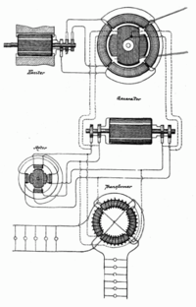
Nikola Tesla's generation system using AC circuits to transport energy across great distances. It is contained in US390721.
When Tesla was 36 years old, the first patents concerning the polyphase power system were granted. He continued research of the system and rotating magnetic field principles. Tesla served as the vice president of the American Institute of Electrical Engineers (now part of the IEEE) from 1892 to 1894. From 1893 to 1895, he investigated high frequency alternating currents. He generated AC of one million volts using a conical Tesla coil and investigated the skin effect in conductors, designed tuned circuits, invented a machine for inducing sleep, cordless gas discharge lamps, and transmitted electromagnetic energy without wires, effectively building the first radio transmitter. In St. Louis, Missouri, Tesla made a demonstration related to radio communication in 1893. Addressing the Franklin Institute in Philadelphia, Pennsylvania and the National Electric Light Association, he described and demonstrated in detail its principles. Tesla's demonstrations were written about widely through various media outlets.
At the 1893 World's Fair, the World's Columbian Exposition in Chicago, an international exposition was held which for the first time devoted a building to electrical exhibits. It was a historic event as Tesla and George Westinghouse introduced visitors to AC power by using it to illuminate the Exposition. On display were Tesla's fluorescent lights and single node bulbs. Tesla also explained the principles of the rotating magnetic field and induction motor by demonstrating how to make an egg made of copper stand on end in his demonstration of the device he constructed known as the "Egg of Columbus".
Also in the late 1880s, Tesla and Edison became adversaries in part due to Edison's promotion of direct current (DC) for electric power distribution over the more efficient alternating current advocated by Tesla and Westinghouse. Until Tesla invented the induction motor, AC 's advantages for long distance high voltage transmission were counterbalanced by the inability to operate motors on AC. As a result of the "War of Currents," Edison and Westinghouse were almost bankrupt, so in 1897, Tesla released Westinghouse from contract, providing Westinghouse a break from Tesla's patent royalties. Also in 1897, Tesla researched radiation which led to setting up the basic formulation of cosmic rays.^{[22]}
When Tesla was 41 years old, he filed the first basic radio patent (U.S. Patent 645576). A year later, he demonstrated a radio controlled boat to the US military, believing that the military would want things such as radio controlled torpedoes. Tesla developed the "Art of Telautomatics", a form of robotics.^{[23]} In 1898, a radio-controlled boat was demonstrated to the public during an electrical exhibition at Madison Square Garden. These devices had an innovative coherer and a series of logic gates. Radio remote control remained a novelty until the 1960s. In the same year, Tesla devised an "electric igniter" or spark plug for Internal combustion gasoline engines. He gained U.S. Patent 609250, "Electrical Igniter for Gas Engines", on this mechanical ignition system. Tesla lived in the former Gerlach Hotel, renamed The Radio Wave building, at 49 W 27th St. (between Broadway and Sixth Avenue), Lower Manhattan, before the end of the century where he conducted the radio wave experiments. A commemorative plaque was placed on the building in 1977 to honor his work.

Colorado Springs
Main article: Magnifying Transmitter
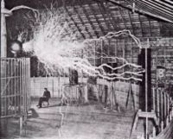
Publicity picture of a participant sitting in his laboratory in Colorado Springs with his "Magnifying Transmitter" generating millions of volts of electricity. The arcs are about 7 meters (22 ft) long. (Tesla's notes identify this as a double exposure.)
In 1899, Tesla decided to move and began research in Colorado Springs, Colorado, where he would have room for his high-voltage, high-frequency experiments. Upon his arrival he told reporters that he was conducting wireless telegraphy experiments transmitting signals from Pikes Peak to Paris. Tesla's diary contains explanations of his experiments concerning the ionosphere and the ground's telluric currents via transverse waves and longitudinal waves.^{[24]} At his lab, Tesla proved that the earth was a conductor, and he produced artificial lightning (with discharges consisting of millions of volts, and up to 135 feet long).^{[25]} Tesla also investigated atmospheric electricity, observing lightning signals via his receivers. Reproductions of Tesla's receivers and coherer circuits show an unpredicted level of complexity (e.g., distributed high-Q helical resonators, radio frequency feedback, crude heterodyne effects, and regeneration techniques).^{[26]} Tesla stated that he observed stationary waves during this time.^{[27]} In the Colorado Springs lab, he "recorded" signals of what he believed were extraterrestrial radio signals, though these announcements and his data were rejected by the scientific community. He noted measurements of repetitive signals from his receiver which are substantially different from the signals he had noted from storms and earth noise. Specifically, he later recalled that the signals appeared in groups of one, two, three, and four clicks together. Tesla spent the latter part of his life trying to signal Mars. In 1996 Corum and Corum published an analysis of Jovian plasma torus signals which indicate that there was a correspondence between the setting of Mars at Colorado Springs, and the cessation of signals from Jupiter in the summer of 1899 when Tesla was there.^{[28][29]}
Tesla left Colorado Springs on January 7, 1900. The lab was torn down and its contents sold to pay debts. The Colorado experiments prepared Tesla for his next project, the establishment of a wireless power transmission facility that would be known as Wardenclyffe. Tesla was granted U.S. Patent 685012 for the means of increasing the intensity of electrical oscillations. The United States Patent Office classification system currently assigns this patent to the primary Class 178/43 ("telegraphy/space induction"), although the other applicable classes include 505/825 ("low temperature superconductivity-related apparatus").

Later years
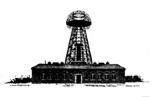
Tesla's Wardenclyffe Tower located in Shoreham, Long Island, New York
In 1900, with $150,000 (51% from J. Pierpont Morgan), Tesla began planning the Wardenclyffe Tower facility. In June 1902, Tesla's lab operations were moved to Wardenclyffe from Houston Street. The tower was finally dismantled for scrap during wartime. Newspapers of the time labeled Wardenclyffe "Tesla's million-dollar folly." In 1904, the US Patent Office reversed its decision and awarded Guglielmo Marconi the patent for radio, and Tesla began his fight to re-acquire the radio patent. On his 50th birthday in 1906, Tesla demonstrated his 200 hp (150 kW) 16,000 rpm Bladeless Turbine. During 1910–1911 at the Waterside Power Station in New York, several of his bladeless turbine engines were tested at 100–5000 hp.
Since the Nobel Prize in Physics was awarded to Marconi for radio in 1909, Thomas Edison and Tesla were mentioned as potential laureates to share the Nobel Prize of 1915 in a press dispatch, leading to one of several Nobel Prize controversies. Some sources have claimed^{[30]} that due to their animosity toward each other neither was given the award, despite their enormous scientific contributions, and that each sought to minimize the other one's achievements and right to win the award, that both refused to ever accept the award if the other received it first, and that both rejected any possibility of sharing it. In the following events after the rumors, neither Tesla nor Edison won the prize (although Edison did receive one of 38 possible bids in 1915, and Tesla did receive one bid out of 38 in 1937).^{[31]} Earlier, Tesla alone was rumored to have been nominated for the Nobel Prize of 1912. The rumored nomination was primarily for his experiments with tuned circuits using high-voltage high-frequency resonant transformers.
In 1915, Tesla filed a lawsuit against Marconi attempting, unsuccessfully, to obtain a court injunction against the claims of Marconi. Around 1916, Tesla filed for bankruptcy because he owed so much in back taxes. He was living in poverty. After Wardenclyffe, Tesla built the Telefunken Wireless Station in Sayville, Long Island. Some of what he wanted to achieve at Wardenclyffe was accomplished with the Telefunken Wireless. In 1917, the facility was seized and torn down by the Marines, because it was suspected that it could be used by German spies.
Prior to World War I, Tesla looked overseas for investors to fund his research. When the war started, Tesla lost the funding he was receiving from his European patents. After the war ended, Tesla made predictions regarding the relevant issues of the post-World War I environment, in a printed article (December 20, 1914). Tesla believed that the League of Nations was not a remedy for the times and issues. Tesla started to exhibit pronounced symptoms of obsessive-compulsive disorder in the years following. He became obsessed with the number three; he often felt compelled to walk around a block three times before entering a building, demanded a stack of three folded, cloth napkins beside his plate at every meal, etc. The nature of OCD was little understood at the time and no treatments were available, so his symptoms were considered by some to be evidence of partial insanity, and this undoubtedly hurt what was left of his reputation.
At this time, he was staying at the Waldorf-Astoria Hotel, renting in an arrangement for deferred payments. Eventually, the Wardenclyffe deed was turned over to George Boldt, proprietor of the Waldorf-Astoria to pay a $20,000 debt. In 1917, around the time that the Wardenclyffe Tower was demolished by Boldt to make the land a more viable real estate asset, Tesla received AIEE's highest honor, the Edison Medal.
Tesla, in August 1917, first established principles regarding frequency and power level for the first primitive RADAR units.^{[32]} In 1934, Emile Girardeau, working with the first French RADAR systems, stated he was building RADAR systems "conceived according to the principles stated by Tesla". By the twenties, Tesla was reportedly negotiating with the United Kingdom government about a ray system. Tesla had also stated that efforts had been made to steal the so called "death ray". It is suggested that the removal of the Chamberlain government ended negotiations.
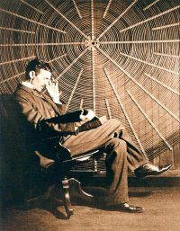
Nikola Tesla, with Rudjer Boscovich's book Theoria Philosophiae Naturalis, sits in front of the spiral coil of his high-frequency transformer at East Houston Street, New York.
On Tesla's seventy-fifth birthday in 1931, Time magazine put him on its cover.^{[33]} The cover caption noted his contribution to electrical power generation. Tesla received his last patent in 1928 for an apparatus for aerial transportation which was the first instance of VTOL aircraft. In 1934, Tesla wrote to consul Janković of his homeland. The letter contained the message of gratitude to Mihajlo Pupin who initiated a donation scheme by which American companies could support Tesla. Tesla refused the assistance, and chose to live by a modest pension received from Yugoslavia and to continue researching.

Field theories
When he was 81, Tesla stated he had completed a dynamic theory of gravity. He stated that it was "worked out in all details" and that he hoped to soon give it to the world.[2] The theory was never published. At the time of his announcement, it was considered by the scientific establishment to exceed the bounds of reason. Most believe that Tesla never fully developed the Unified Field Theory.
The bulk of the theory was developed between 1892 and 1894, during the period that he was conducting experiments with high frequency and high potential electromagnetism and patenting devices for their utilization. It was completed, according to Tesla, by the end of the 1930s. Tesla's theory explained gravity using electrodynamics consisting of transverse waves (to a lesser extent) and longitudinal waves (for the majority). Reminiscent of Mach's principle, Tesla stated in 1925 that,
There is no thing endowed with life - from man, who is enslaving the elements, to the nimblest creature - in all this world that does not sway in its turn. Whenever action is born from force, though it be infinitesimal, the cosmic balance is upset and the universal motion results.
Tesla, concerning Albert Einstein's relativity theory, stated that '...the relativity theory, by the way, is much older than its present proponents. It was advanced over 200 years ago by my illustrious countryman Ruđer Bošković, the great philosopher, who, not withstanding other and multifold obligations, wrote a thousand volumes of excellent literature on a vast variety of subjects. Bošković dealt with relativity, including the so-called time-space continuum...'.^{[34]}
Tesla was critical of Einstein's relativity work,
...[a] magnificent mathematical garb which fascinates, dazzles and makes people blind to the underlying errors. The theory is like a beggar clothed in purple whom ignorant people take for a king...., its exponents are brilliant men but they are metaphysicists rather than scientists....^{[35]}
Tesla also stated that:
I hold that space cannot be curved, for the simple reason that it can have no properties. It might as well be said that God has properties. He has not, but only attributes and these are of our own making. Of properties we can only speak when dealing with matter filling the space. To say that in the presence of large bodies space becomes curved is equivalent to stating that something can act upon nothing. I, for one, refuse to subscribe to such a view.^{[36]}

Directed-energy weapon
Later in life, Tesla made some remarkable claims concerning a "teleforce" weapon^{[37]} The press called it a "peace ray" or death ray.^{[38][39]} In total, the components and methods included:^{[40][41]}
- An apparatus for producing manifestations of energy in free air instead of in a high vacuum as in the past. This, according to Tesla in 1934, was accomplished.
- A mechanism for generating tremendous electrical force. This, according to Tesla, was also accomplished.
- A means of intensifying and amplifying the force developed by the second mechanism.
- A new method for producing a tremendous electrical repelling force. This would be the projector, or gun, of the invention.
Tesla worked on plans for a directed-energy weapon between the early 1900s till the time of his death. In 1937, Tesla composed a treatise entitled "The Art of Projecting Concentrated Non-dispersive Energy through the Natural Media" concerning charged particle beams.^{[42]} Tesla published the document in an attempt to expound on the technical description of a "superweapon that would put an end to all war". This treatise of the particle beam is currently in the Nikola Tesla Museum archive in Belgrade. It described an open ended vacuum tube with a gas jet seal that allowed particles to exit, a method of charging particles to millions of volts, and a method of creating and directing nondispersive particle streams (through electrostatic repulsion).^{[43]}
Records of his indicate that it was based on a narrow stream of atomic clusters of liquid mercury or tungsten accelerated via high voltage (by means akin to his magnifying transformer). Tesla gave the following description concerning the particle gun's operation:
[The nozzle would] "send concentrated beams of particles through the free air, of such tremendous energy that they will bring down a fleet of 10,000 enemy airplanes at a distance of 200 miles from a defending nation's border and will cause armies to drop dead in their tracks".^{[44]} The weapon could be used against ground based infantry or for antiaircraft purposes.^{[45]}
Tesla tried to interest the US War Department in the device.^{[46]} He also offered this invention to European countries.^{[47]} None of the governments purchased a contract to build the device. He was unable to act on his plans.^{[48]}

Theoretical inventions
Tesla began to theorize about electricity and magnetism's power to warp, or rather change, space and time and the procedure by which man could forcibly control this power. Near the end of his life, Tesla was fascinated with the idea of light as both a particle and a wave, the fundamental proposition of what would become quantum physics. This field of inquiry led to the idea of creating a "wall of light" by manipulating electromagnetic waves in a certain pattern. This mysterious wall of light would enable time, space, gravity and matter to be altered at will, and engendered an array of Tesla proposals that seem to leap straight out of science fiction, including anti-gravity airships, teleportation, and time travel. The single strangest invention Tesla ever proposed was probably the "thought photography" machine. He reasoned that a thought formed in the mind created a corresponding image in the retina, and the electrical data of this neural transmission could be read and recorded in a machine. The stored information could then be processed through an artificial optic nerve and played back as visual patterns on a viewscreen.
Another of Tesla's theorized inventions is commonly referred to as Tesla's Flying Machine. Tesla claimed that one of his life goals was to create a flying machine that would run without the use of an airplane engine, wings, ailerons, propellers, or an onboard fuel source. Initially, Tesla pondered about the idea of a flying craft that would fly using an electric motor powered by grounded base stations. As time progressed, Tesla suggested that perhaps such an aircraft could be run entirely mechanically. The theorized appearance would typically take the form of a cigar or saucer. This fact later enticed UFO conspiracy theorists.

Death and afterwards
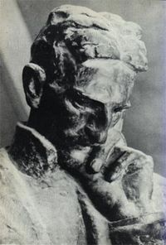
Bust of Tesla by Ivan Meštrović, 1952, in Zagreb, Croatia
Tesla died of heart failure alone in the New Yorker Hotel, some time between the evening of January 5 and the morning of January 8, 1943, at the age of 86. Despite selling his AC electricity patents, Tesla was essentially destitute and died with significant debts. Later that year the US Supreme Court upheld Tesla's patent number 645,576 in effect recognizing him as the inventor of radio.
Immediately after Tesla's death became known, the Federal Bureau of Investigation instructed the Office of Alien Property to take possession of his papers and property, despite his US citizenship. His safe at the hotel was also opened. At the time of his death, Tesla had been continuing work on the teleforce weapon, or death ray, that he had unsuccessfully marketed to the US War Department. It appears that his proposed death ray was related to his research into ball lightning and plasma and was composed of a particle beam weapon. The US government did not find a prototype of the device in the safe. After the FBI was contacted by the War Department, his papers were declared to be top secret. The so-called "peace ray" constitutes a part of some conspiracy theories as a means of destruction. The personal effects were seized on the advice of presidential advisors, and J. Edgar Hoover declared the case "most secret", because of the nature of Tesla's inventions and patents.^{[49]} One document states that "[he] is reported to have some 80 trunks in different places containing transcripts and plans having to do with his experiments [...]". Charlotte Muzar reported that there were several "missing" papers and property.^{[50]}
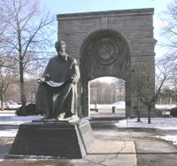
Statue of Nikola Tesla in Niagara Falls State Park
Tesla's family and the Yugoslav embassy struggled with the American authorities to gain these items after his death due to the potential significance of some of his research. Eventually, his nephew, Sava Kosanoviċ, got possession of some of his personal effects which are now housed in the Nikola Tesla Museum in Belgrade, Serbia.^{[51]} Tesla's funeral took place on January 12, 1943, at the Cathedral of Saint John the Divine in Manhattan, New York City. After the funeral, his body was cremated. His ashes were taken to Belgrade, Yugoslavia in 1957. The urn was placed in the Nikola Tesla Museum, where it resides to this day.
Tesla did not like to pose for portraits. He did it only once for princess Vilma Lwoff-Parlaghy, but that portrait is lost. His wish was to have a sculpture made by his close friend, Croat, Ivan Meštrović, who was at that time in United States, but he died before getting a chance to see it. Meštrović made a bronze bust (1952) that is held in the Nikola Tesla Museum in Belgrade and a statue (1955/56) placed at the Ruđer Bošković Institute in Zagreb. This statue was moved to Nikola Tesla Street in Zagreb's city centre on the 150th anniversary of Tesla's birth, with the Ruđer Bošković Institute to receive a duplicate. In 1976, a bronze statue of Tesla was placed at Niagara Falls, New York. A similar statue was also erected in his hometown of Gospić in 1986.
The year of 2006 was proclaimed by UNESCO, as well as the governments of Croatia and Serbia, to be the year of Nikola Tesla. At the 150th anniversary of Tesla's birth, July 10th 2006, the renovated village of Smiljan (which had been demolished during the wars of the 1990s) was opened to the public along with Tesla's house (as a memorial museum) and a new multimedia center dedicated to the life and work of Nikola Tesla. The parochial church of St. Peter and Paul, where Tesla's father had held services, was renovated as well. The museum and multimedia center are filled with replicas of Tesla's work. The museum has collected almost all of the papers ever published by, and about, Nikola Tesla, most of these provided by Ljubo Vujovic from the Tesla Memorial Society in New York. Alongside Tesla's house, a monument created by sculptor Mile Blazevic has been erected. In the nearby city of Gospić, on the same date as the reopening of the renovated village and museums, a higher education school named Nikola Tesla was opened, and a replica of the statue of Tesla made by Frano Krsinic (the original is in Belgrade) was presented.
In the years after, many of his innovations, theories and claims have been used, at times unsuitably and with some controversy, to support various fringe theories that are regarded as unscientific. Most of Tesla's own work conformed with the principles and methods accepted by science, but his extravagant personality and sometimes unrealistic claims, combined with his unquestionable genius, have made him a popular figure among fringe theorists and believers in conspiracies about 'hidden knowledge'. Some conspiracy theorists even in his time believed that he was actually an angelic being from Venus sent to Earth to reveal scientific knowledge to humanity.^{[52]}

Relations and friendships
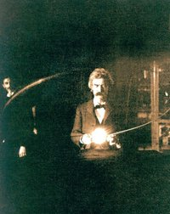
Twain in the lab of Nikola Tesla, spring of 1894
In his middle life, Nikola Tesla became very close friends with Mark Twain. They spent a lot of time together in his lab and elsewhere. Tesla was also friends with Robert Underwood Johnson. He had amicable relations with, among others, Francis Marion Crawford, Stanford White, Fritz Lowenstein, George Scherff, and Kenneth Swezey. He remained bitter in the aftermath of his incident with Edison. The day after Edison died the New York Times contained extensive coverage of Edison's life, with the only negative opinion coming from Tesla who was quoted as saying, "He had no hobby, cared for no sort of amusement of any kind and lived in utter disregard of the most elementary rules of hygiene" and that, "His method was inefficient in the extreme, for an immense ground had to be covered to get anything at all unless blind chance intervened and, at first, I was almost a sorry witness of his doings, knowing that just a little theory and calculation would have saved him 90 per cent of the labor. But he had a veritable contempt for book learning and mathematical knowledge, trusting himself entirely to his inventor's instinct and practical American sense." Tesla never married. He was celibate and asexual and claimed that his chastity was very helpful to his scientific abilities.^{[53][54]}

Personal views
Tesla believed that war could not be avoided until the cause for its recurrence was removed, but was opposed to wars in general.^{[55]} He sought to reduce distance, such as in communication for better understanding, transportation, and transmission of energy, as a means to ensure friendly international relations.^{[56]}
"One day man will connect his apparatus to the very wheelwork of the universe... and the very forces that motivate the planets in their orbits and cause them to rotate will rotate his own machinery," he predicted.
Like many of his era, Tesla, a life-long bachelor, became a proponent of a self-imposed selective breeding version of eugenics. In a 1937 interview, he stated,
[...] man's new sense of pity began to interfere with the ruthless workings of nature. The only method compatible with our notions of civilization and the race is to prevent the breeding of the unfit by sterilization and the deliberate guidance of the mating instinct [...]. The trend of opinion among eugenists is that we must make marriage more difficult. Certainly no one who is not a desirable parent should be permitted to produce progeny. A century from now it will no more occur to a normal person to mate with a person eugenically unfit than to marry a habitual criminal.^{[57]}
In 1926, Tesla in an interview, commenting on the ills of the social subservience of women and the struggle of women toward gender equality, indicated that humanity's future would be run by "Queen Bees". He believed that women would become the dominant sex in the future.^{[58]}

Education
Tesla was fluent in many languages. Along with Serbian and Croatian, he also spoke seven other foreign languages: Czech, English, French, German, Hungarian, Italian, and Latin.
Degrees and graduate studies
Tesla studied mathematics, physics and engineering at the Polytechnic School in Graz, Austria, now the Technische Universität Graz. Two sources say he received Baccalaureate degrees from the university at Graz.^{[59][60]} The University denies that he received a degree and says that he did not continue beyond the first semester of his third year, during which he stopped attending lectures.^{[61]} Others have stated that he was discharged without a degree for nonpayment of his tuition for the first semester of his junior year.^{[62][63]} According to a college roommate of Tesla, he did not graduate.^{[64]} Tesla was later persuaded by his father to attend the Charles-Ferdinand branch of the University of Prague, which he attended for the summer term of 1880. After his father died, Tesla moved to Budapest in January 1881 where he found work as a draftsman at the Central Telegraph office.^{[65]}
Docteur Honoris Causa
For his work Tesla received numerous honorary doctoral degrees from a number of universities to include: Columbia University, Graz Polytechnic Institute, University of Zagreb, Polytechnic Institute of Bucharest, University of Belgrade, University of Brno, University of Grenoble, University of Paris, University de Poitiers, Charles University in Prague, University of Sofia, Vienna Polytechnic Institute, and Yale University
Further reading
For more information on Dr. Tesla's education and certifications, see:
* W.C. Wysock, J.F. Corum, J.M. Hardesty and K.L. Corum, "Who Was The Real Dr. Nikola Tesla? (A Look At His Professional Credentials)". Antenna Measurement Techniques Association, posterpaper, October 22–25, 2001 (PDF)

Recognition and honors
Scientific societies
As the result of his achievements in the development of electricity and radio, Nikola Tesla received many awards and accolades. He was selected as a fellow of the IEEE (at the time the AIEE) and was awarded its most prestigious prize, the Edison Medal. He was also made a fellow of the American Association for the Advancement of Science, and accepted invitations to become a member of the American Philosophical Society, and the Serbian Academy of Sciences and Arts. Because of his research in electrotherapy and his invention of high frequency oscillators, he was also made a fellow of the American Electro-Therapeutic Association.
SI Unit
The scientific compound derived SI unit measuring magnetic flux density or magnetic induction (commonly known as the magnetic field ), the tesla, was named in his honor (at the Conférence Générale des Poids et Mesures, Paris, 1960).
IEEE Nikola Tesla Award
In 1975 the Institute of Electrical and Electronics Engineers (IEEE) created a Nikola Tesla Award via an agreement between the IEEE Power Engineering Society and the IEEE Board of Directors. It is given to individuals or a team that has made outstanding contributions to the generation or utilization of electric power. The Tesla award is considered the most prestigious award in the area of electric power.^{[66]}
Belgrade airport
On July 10, 2006 in honor of his 150th birthday the biggest airport in Serbia (Belgrade) was renamed Belgrade Nikola Tesla Airport.
Yugoslavian/Serbian currency
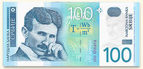
100 Serbian dinar banknote obverse. Photo courtesy of National Bank of Serbia.^{[67]}
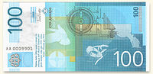
100 Serbian dinars banknote reverse. Note the drawing of the electric motor.
Nikola Tesla was featured on the currency of the former Yugoslavia. The current 100 Serbian dinar banknotes issued by the National Bank of Serbia have a picture of a handsome young Tesla on the obverse (front side). On the reverse side there is portion of drawing of an induction motor from his patent application and a photograph of Tesla holding a gas filled tube emitting light as a result of electric induction.
Cosmological objects
The Tesla crater on the far side of the moon and the minor planet 2244 Tesla are named after Tesla.
Electric power stations
Two of the coal fired power stations run by Electric Power Industry of Serbia, TPP Nikola Tesla A and TPP Nikola Tesla B, are named in honor of Tesla.^{[68]}
Commerce
The Croatian subsidiary of Ericsson is named Ericsson Nikola Tesla d.d. (Nikola Tesla was a phone hardware company in Zagreb before Ericsson bought it in 1990s) in honour of Nikola Tesla's pioneering work in wireless communication.
Train
Silverlink Metro in London has a train named "Nikola Tesla", which, like the rest of the rollingstock, is an electrically powered train that can take power from either trackside and overhead power lines within the same journey on the North London Line.
Sports car
Tesla Motors states, "The namesake of our Tesla Roadster is the genius Nikola Tesla [...] We‘re confident that if he were alive today, Nikola Tesla would look over our car and nod his head with both understanding and approval."^{[69]}

Notes and references
- Cheney, Margaret & Uth, Robert, "Tesla, Master of Lightning", published by Barnes & Noble, 1999 ISBN
- Germano, Frank, "Dr. Nikola Tesla". Frank. Germano.com.
- Lomas, Robert, "The Man who Invented the Twentieth Century". Lecture to South Western Branch of Instititute of Physics.
- Martin, Thomas Commerford, "The Inventions, Researches, and Writings of Nikola Tesla", New York: The Electrical Engineer, 1894 (3rd Ed); reprinted by Barnes & Noble, 1995 ISBN-X
- O'Neill, John J., "Prodigal Genius: The Life of Nikola", 1944. ISBN (Tesla reportedly said of this biographer "You understand me better than any man alive"; also the version at uncletaz.com with other items at uncletaz's site])
- Penner, John R.H. The Strange Life of Nikola Tesla, corrupted version of My Inventions.
- Pratt, H., "Nikola Tesla 1856–1943", Proceedings of the IRE, Vol. 44, September, 1956.
- "Nikola Tesla". IEEE History Center, 2005.
- Seifer, Marc J. "Wizard: The Life and Times of Nikola Tesla; Biography of a Genius", Secaucus, NJ: Carol Publishing Group, 1996. ISBN
- Weisstein, Eric W., "Tesla, Nikola (1856–1943)". Eric Weisstein's World of Science.
- "Gazetteer of Planetary Nomenclature", Moon Nomenclature: Crater. USGS, Astrogeology Research Program.
- Dimitrijevic, Milan S., "Belgrade Astronomical Observatory Historical Review". Publ. Astron. Obs. Belgrade,), 162–170. Also, "Srpski asteroidi, Tesla". Astronomski magazine.
- Hoover, John Edgar, et al., FOIA FBI files, 1943.
- Pratt, H., "Nikola Tesla 1856–1943", Proceedings of the IRE, Vol. 44, September, 1956.
- W.C. Wysock, J.F. Corum, J.M. Hardesty and K.L. Corum, "Who Was The Real Dr. Nikola Tesla? (A Look At His Professional Credentials)". Antenna Measurement Techniques Association, posterpaper, October 22–25, 2001 (PDF)
- Roguin, Ariel, "Historical Note: Nikola Tesla: The man behind the magnetic field unit". J. Magn. Reson. Imaging 2004;19:369–374. © 2004 Wiley-Liss, Inc.
- Sellon, J. L., "The impact of Nikola Tesla on the cement industry". Behrent Eng. Co., Wheat Ridge, CO. Cement Industry Technical Conference. 1997. XXXIX Conference Record., 1997 IEEE/PC. Page(s) 125–133. ISBN
- Valentinuzzi, M.E., "Nikola Tesla: why was he so much resisted and forgotten?" Inst. de Bioingenieria, Univ. Nacional de Tucuman; Engineering in Medicine and Biology Magazine, IEEE. Jul/Aug 1998, 17:4, p 74–75. ISSN
- Waser, André, "Nikola Tesla’s Radiations and the Cosmic Rays". (PDF)
- Secor, H. Winfield, "Tesla's views on Electricity and the War", Electrical Experimenter, Volume 5, Number 4, August, 1917.
- Florey, Glen, "Tesla and the Military". Engineering 24, December 5, 2000.
- Corum, K. L., J. F. Corum, "Nikola Tesla, Lightning Observations, and Stationary Waves". 1994.
- Corum, K. L., J. F. Corum, and A. H. Aidinejad, "Atmospheric Fields, Tesla's Receivers and Regenerative Detectors". 1994.
- Meyl, Konstantin, H. Weidner, E. Zentgraf, T. Senkel, T. Junker, and P. Winkels, "Experiments to proof the evidence of scalar waves Tests with a Tesla reproduction". Institut für Gravitationsforschung (IGF), Am Heerbach 5, D-63857 Waldaschaff.
- Anderson, L. I., "John Stone Stone on Nikola Tesla’s Priority in Radio and Continuous Wave Radiofrequency Apparatus". The Antique Wireless Association Review, Vol. 1, 1986, pp. 18–41.
- Anderson, L. I., "Priority in Invention of Radio, Tesla v. Marconi". Antique Wireless Association monograph, March 1980.
- Marincic, A., and D. Budimir, "Tesla's contribution to radiowave propagation". Dept. of Electron. Eng., Belgrade Univ. (5th International Conference on Telecommunications in Modern Satellite, Cable and Broadcasting Service, 2001. TELSIKS 2001. pg., 327–331 vol.1) ISBN-X
- Page, R.M., "The Early History of Radar", Proceedings of the IRE, Volume 50, Number 5, May, 1962, (special 50th Anniversary Issue).
- C Mackechnie Jarvis "Nikola Tesla and the induction motor". 1970 Phys. Educ. 5 280–287.
- "Giant Eye to See Round the World" (DOC)
- Nichelson, Oliver, "Nikola Tesla's Energy Generation Designs", Eyring, Inc., Provo, Utah.
- Nichelson, Oliver, "The Thermodynamics of Tesla's Fuelless Electrical generator". American Fork, Utah. (American Chemical Society, 1993. 2722-5/93/0028-63)
- Toby Grotz, "The Influence of Vedic Philosophy on Nikola Tesla's Understanding of Free Energy".
- ^ Nikola Tesla; Brooklyn Eagle, July 10, 1931
- ^ http://www.neuronet.pitt.edu/~bogdan/tesla/
- ^ Childress, David Hatcher, (ed.) "The Tesla Papers: Nikola Tesla on Free Energy & Wireless Transmission of Power". Adventures Unlimited Press, 2000. ISBN
- ^ Lomas, Robert, "The essay", Spark of genius. Independent Magazine, 21 August 1999.
- ^ Title of a biography by Robert Lomas (seen)
- ^ Dommermuth-Costa, Carol, Nikola Tesla: A Spark of Genius, pp. 11-12. 1994. ISBN
- ^ Seifer, "Wizard" p 7
- ^ Cheney, Margaret and Uth, Robert, Tesla: Master of Lightning, p. 3. 1999. ISBN
- ^ "Nikola Tesla und die Technik in Graz", Josef W. Wohinz (Hg.), Verlag der Technischen Universität Graz, 2006; ISBN-10:; ISBN-13:
- ^ Seifer, "Wizard" p20
- ^ Cheney, Margaret, "Tesla: Man Out of Time", 1979. ISBN
- ^ Cheney, Margaret, "Tesla: Man Out of Time", 1979. ISBN
- ^ "Did Tesla really invent the loudspeaker?". Twenty First Century Books, Breckenridge, CO.
- ^ "My Inventions" by Nikola Tesla, printed in Electrical Experimenter Feb-June, 1919. Reprinted, edited by Ben Johnson, New York: Barnes & Noble, 1982. ISBN
- ^ Jonnes,"Empire of light" p110
- ^ Cheney, Margaret, "Tesla: Man Out of Time", 1979. ISBN
- ^ Hugo Grensback, "Nikola Tesla and his inventions" Electrical Experimentor.
- ^ Tesla, Nikola, "A New System of Alternating Current Motors and Transformers". American Institute of Electrical Engineers, May 1888.
- ^ "Tesla's invention of the AND logic gate". Twenty First Century Books, Breckenridge, CO. (ed., this pertains to the U.S. Patent 723188 and U.S. Patent 725605)
- ^ Krumme, Katherine, Mark Twain and Nikola Tesla: Thunder and Lightning. December 4, 2000 (PDF)
- ^ Grotz, Toby, "The Influence of Vedic Philosophy on Nikola Tesla's Understanding of Free Energy".
- ^ Waser, André, "Nikola Tesla’s Radiations and the Cosmic Rays".
- ^ Tesla, Nikola, "My Inventions", Electrical Experimenter magazine, Feb, June, and Oct, 1919. ISBN (teslaplay.comversion; also the version at rastko.org)
- ^ Tesla, Nikola, "The True Wireless". Electrical Experimenter, May 1919. (also at pbs.org)
- ^ Gillispie, Charles Coulston, "Dictionary of Scientific Biography"; Tesla, Nikola. Charles Scribner's Sons, New York. ISBN
- ^ Corum, K. L., J. F. Corum, and A. H. Aidinejad, "Atmospheric Fields, Tesla's Receivers and Regenerative Detectors". 1994.
- ^ Corum, K. L., J. F. Corum, "Nikola Tesla, Lightning Observations, and Stationary Waves". 1994.
- ^ Tesla, Nikola, "Talking with Planets". Collier's Weekly, February 19, 1901. (EarlyRadioHistory.us)
- ^ Corum, K. L., J. F. Corum, "The Electrical Signals of Planetary Origins".
- ^ O'Neill, "Prodigal Genius" pp228-229
- ^ Seifer, "Wizard" pp378-380
- ^ Page, R.M., "The Early History of RADAR", Proceedings of the IRE, Volume 50, Number 5, May, 1962, (special 50th Anniversary Issue).
- ^ "Tribute to Nikola Tesla". Tesla Society. [ed., site contains a picture of the magazine]
- ^ 1936 unpublished interview, quoted in Anderson, L, ed. Nikola Tesla: Lecture Before the New York Academy of Sciences: The Streams of Lenard and Roentgen and Novel Apparatus for Their Production, April 6, 1897, reconstructed 1994
- ^ New York Times, July 11, 1935, p23, c.8
- ^ New York Herald Tribune, September 11, 1932
- ^ "Tesla's Ray". Time, July 23, 1934.
- ^ "Tesla, at 78, Bares New 'Death-Beam"', New York Times, July 11, 1934.
- ^ "Tesla Invents Peace Ray". New York Sun, July 10, 1934.
- ^ "Death-Ray Machine Described", New York Sun, July 11, 1934.
- ^ "A Machine to End War". Feb. 1935.
- ^ Seifer, Marc J., "Wizard, the Life and Times of Nikola Tesla". ISBN (HC) pg. 454
- ^ Seifer, "Wizard" pg. 454
- ^ "Beam to Kill Army at 200 Miles, Tesla's Claim on 78th Birthday". July 11, 1934.
- ^ "'Death Ray' for Planes". New York Times, September 22, 1940.
- ^ "Aerial Defense 'Death-Beam' Offered to U. S. By Tesla" July 12, 1940
- ^ O'Neill, John J., "Tesla Tries To Prevent World War II". (unpublished Chapter 34 of Prodigal Genius) (PBS)
- ^ Velox, Particle beam weapon. everything2.com
- ^ Hoover, John Edgar, et al., FOIA FBI files, 1943.
- ^ http://www.teslasociety.com/muzar.htm
- ^ Nikola Tesla Museum
- ^ Cheney, Margaret, "Tesla: Man Out of Time", 1979. ISBN
- ^ Cheney, Margaret, "Tesla: Man Out of Time", 1979. ISBN
- ^ source:http://www.nndb.com/people/334/000022268//
- ^ Secor, H. Winfield, "Tesla's views on Electricity and the War", Electrical Experimenter, Volume 5, Number 4, August, 1917.
- ^ "Giant Eye to See Round the World" Albany Telegram, February 25, 1923. (DOC)
- ^ Viereck, George Sylvester, and Nikola Tesla, "A Machine to End War - A Famous Inventor, Picturing Life 100 Years from Now, Reveals an Astounding Scientific Venture Which He Believes Will Change the Course of History". Liberty, February 1937.
- ^ Kennedy, John B., "When woman is boss, An interview with Nikola Tesla". Colliers, January 30, 1926.
- ^ Wysock, W.C., J.F. Corum, J.M. Hardesty and K.L. Corum (October 22,2001). "Who Was The Real Dr. Nikola Tesla? (A Look At His Professional Credentials)". Antenna Measurement Techniques Association, posterpaper.
- ^ "The Book of New York: Forty Years' Recollections of the American Metropolis" [says he matriculated 4 degrees (physics, mathematics, mechanical engineering and electrical engineering)
- ^ http://www.serbnatlfed.org/Archives/Tesla/TeslaBook.htm
- ^ Wohinz, Josef W. (May 16, 2006). Nikola Tesla und Graz. Technischen Universität Graz. Retrieved on January 29, 2006.
- ^ Wohinz, Josef W. (Ed,) (2006). Nikola Tesla und die Technik in Graz. Graz, Austria: Verlag der Technischen Universität Graz. ISBN -10:3-902465-39-5; ISBN -13:978-3-902465-39-9.. page 16
- ^ Kulishich, Kosta. "Tesla Nearly Missed His Career as Inventor: College Roommate Tells", Newark News, August 27, 1931, cited in Seifer, Marc, The Life and Times of Nikola Tesla, 1996.
- ^ Seifer, Marc (1996). Wizard: The Life and Times of Nikola Tesla; Biography of a Genius. Secaucus, NJ: Carol Publishing Group. ISBN.
- ^ IEEE, "IEEE Nikola Tesla Award. Apr 01, 2005.
- ^ National Bank of Serbia
- ^ Electric Power Industry of Serbia (EPS)
- ^ Why the Name "Tesla"?, Tesla Motors, Inc., 2006

See also
- List of Tesla patents
- Nikola Tesla in popular culture

Further material

Articles (pre-1900)
- Selected Tesla Writings, Written by Tesla and others,.
- Light Without Heat, The Manufacturer and Builder, January 1892, Vol. 24
- Biography - Nikola Tesla, The Century Magazine, November 1893, Vol. 47
- Tesla's Oscillator and Other Inventions, The Century Magazine, November 1894, Vol. 49
- The New Telegraphy. Recent Experiments in Telegraphy wih Sparks, The Century Magazine, November 1897, Vol. 55

Books
- Anderson, Leland I., "Dr. Nikola Tesla (1856–1943)", 2d enl. ed., Minneapolis, Tesla Society. 1956. LCCN /L
- Cheney, Margaret, "Tesla: Man Out of Time", 1979. ISBN
- Childress, David H., "The Fantastic inventions of Nikola Tesla," 1993. ISBN
- Glenn, Jim, "The Complete Patents of Nikola Tesla," 1994. ISBN
- Jonnes, Jill "Empires of Light: Edison, Tesla, Westinghouse, and the Race to Electrify the World". New York: Random House, 2003. ISBN
- Martin, Thomas C., "The Inventions, Researches, and Writings of Nikola Tesla," 1894 . ISBN-X
- O'Neill, John H.,"Prodigal Genius," 1944. ISBN
- Seifer, Marc J., "Wizard, the Life and Times of Nikola Tesla," 1998. ISBN (HC), ISBN (SC)
- Tesla, Nikola, "Colorado Springs Notes, 1899–1900", ISBN-X
- Tesla, Nikola, "My Inventions" Parts I through V published in the Electrical Experimenter monthly magazine from February through June, 1919. Part VI published October, 1919. Reprint edition with introductory notes by Ben Johnson, New York: Barnes and Noble,1982, ISBN; also online at "My Inventions'", 1919. ISBN
- Valone, Thomas, "Harnessing the Wheelwork of Nature," 2002. ISBN

Magazines
- Carlson, W. Bernard, "Inventor of dreams". Scientific American, March 2005 v292 i3 p78(7).
- Jatras, Stella L., "The genius of Nikola Tesla". The New American, July 28, 2003 v19 i15 p9(1)
- Rybak, James P., "Nikola Tesla: Scientific Savant". Popular Electronics, 1042170X, Nov99, Vol. 16, Issue 11.
- Lawren, B., "Rediscovering Tesla". Omni, Mar88, Vol. 10 Issue 6.

Documentary and biographical films
- There are at least two films describing Tesla's life. In the first, filmed in 1977, arranged for TV, Tesla was portrayed by Rade Šerbedžija. In 1980, Orson Welles produced a Yugoslavian film named Tajna Nikole Tesle (The Secret of Nikola Tesla), in which Welles himself played the part of Tesla's patron, J.P. Morgan.
- "Tesla: Master of Lightning". 1999. ISBN (Book) ISBN (PBS Video)

Fictional Portrayal
- Tesla is a minor character in director Christopher Nolan's 2006 film The Prestige, in which the main characters, played by Hugh Jackman and Christian Bale, explore the use of his inventions to make their magic tricks more spectacular. In the film, he is portrayed by David Bowie.
- Tesla also appears as a character in several of science fiction author Spider Robinson's series of novels set in a Cheers-style bar filled with time-travellers and aliens; the inventor has been rescued from his deathbed in 1943, rejuvenated and recruited by the Callahan bar-buddies in their quest to save the universe.
- A recent novel by Australian author Robert G. Barrett uses Nikola Tesla as one of the main characters in his book The Tesla Legacy. Tesla apparrently built a 'doomsday machine' that is hidden in the New South Wales Hunter Valley that could destroy Australia if not the earth itself.

External links
Find more information on Nikola Tesla by searching Wikipedia's sister projects:
Dictionary definitions from Wiktionary
Textbooks from Wikibooks
Quotations from Wikiquote
Source texts from Wikisource
Images and media from Commons
News stories from Wikinews
- Nikola Tesla memorial centre in Smiljan, Croatia
- The Nikola Tesla museum
- The Tesla Memorial Society - The Genius Who Lit the World "[3]".
- World of Scientific Biography: Nikola Tesla, by Wolfsram Research
- Nikola Tesla Page, tesla coils, Plasma Sphere wo-glass, Plasma Sphere HV supplies, Coil plans, instructions, High voltage projects.
- Tesla's grand-nephew William H. Terbo's site: Tesla Memorial Society, The Official Nikola Tesla Web Site. Mr. Terbo lives in New Jersey, USA.
- Tesla's great-grand niece Daniela Tesla lives in Serbia - Glas Javnosti interview with 16-year old Tesla's descendant, Serbian refugee from Croatia (in Serbian)
- Tesla's relative Boško Budisavljević lives in Zagreb Croatia - about Tesla's Croatian homeland and Serbian parents (newspaper Jutarnji list)- text is on Croatian language.
- Wagner, John W., "Nikola Tesla, Forgotten American Scientist".
- Vujovic, Ljubo, "Tesla Memorial Society of New York", New York, USA.
- "The Tesla Wardenclyffe Project". Shoreham, New York. (Aims to reuse Wardenclyffe.)
- "Nikola Tesla's Father - Milutin Tesla (1819–1879)". Serb National Federation.
- Kosanovic, Bogdan R., "Serbian-American inventor, electrical engineer, and scientist". December 29, 2000.
- Mrkich, D., "Tesla - The European Years", Serb National Federation.
Patents
- Pepe, "Pepe's Tesla Pages",.
  - Nikola's Page (Hungarian - original images of text)
- Fred Walters' hand-scanned Tesla patents (PDFs)
- Jim Bieberich's The Complete Nikola Tesla U.S. Patent Collection
- Science Friday, "Strange Scientists", August 7, 1998
- Science Friday, "The Science of Radio", October 13, 1995
- Ockhams Razor, "Nikola Tesla -- The Unknown Inventor"
- Online Archive of Many of Tesla's Writings, Articles and Published Papers (1.1 megs of text)
- Nikola Tesla Research Paper
- Biography of Nikola Tesla, from Experiments with Alternate Currents of High Potential and High Frequency.
- Nikola Tesla Story: Tells more about Tesla and Edison.
- Seifer, Marc J., and Michael Behar, Electric Mind, Wired Magazine, October 1998.
- Palmer, Stephen E., "Wardenclyffe: Nikola Tesla's Dream For Free Energy And The Conspiracy Which Destroyed It".
- Works by Nikola Tesla at Project Gutenberg
- Requiem for Tesla: a play created by Rude Mechanicals in Austin, Texas 2001, 2003
- Nikola Tesla on various Yugoslavian and Serbian banknotes.
- Nikola Tesla's FBI file in pdf
- Various writings and lectures by Nikola Tesla
- Kenneth M. Swezey Papers, 1891–1982, Archives Center, National Museum of American History, archival resources.
- Nikola Tesla Special Event Amateur Radio Station 9A150NT (celebrating Tesla's 150th birthday)
- Nikola Tesla biography (Best collection of texts about Tesla on Serbian language)
- Documentary on the missing secrets of Nikola Tesla
======================================================================================================================
END

