Viktor Schauberger 1885-1958
http://en.wikipedia.org/wiki/Viktor_Schauberger

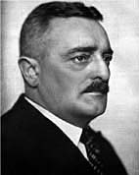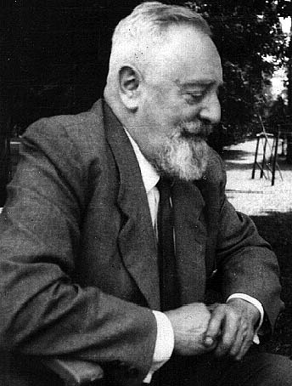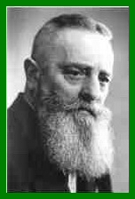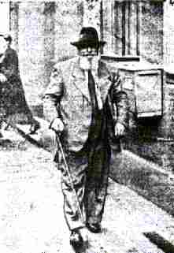

Viktor Schauberger (30 June 1885–25 September 1958) was an Austrian forester, naturalist and inventor.
The inventor of what he called "implosion technology", Schauberger developed his own highly idiosyncratic theories based on fluidic vortices. Very little of Schauberger's work has received mainstream acceptance, and the bulk of his work would likely be classified as pseudo-science.

Contents
[hide]
- 1 Biography
  - 1.1 Early years
  - 1.2 World War II
  - 1.3 Later years
- 2 Patents
- 3 Quotes
- 4 See also
- 5 Further reading
- 6 External links and references
  - 6.1 Mailinglists

[] Biography

[] Early years
Viktor Schauberger was born in Holzschlag, Austria, to a long line of Austrian foresters. Creek and river flow fascinated him during his youth. He went on to develop a basic theory that contains a two fold movement principle for such phenonomena.
In 1926, he undertook research at a timber flotation installation in Neuberg an der Mürz in Styria. In 1929, Schauberger submitted his first applications for patents in the fields of water engineering and turbine construction. He conducted research on how to artificially generate centripetal movement in various types of machines. He proposed a means of utilising hydroelectric power by a jet turbine. The log flumes used for timber flotation allegedly disregarded the Law of Archimedes, i.e. Schauberger was allegedly able to transport heavier-than-water objects, by creating a centripetal movement (making the timber spin around its own axis, by special guiding-vanes which caused the water to spiral)

[] World War II
During World War II, Schauberger developed his concepts of vortex dynamics under, he claimed, duress and, he claimed, at the behest of Germany's SS.^{[citation needed]} In 1941 he was confined to a mental hospital in Mauer-Öhling under, he later claimed, continuous observation by the SS.^{[citation needed]} He ran a laboratory at Mauthausen concentration camp with twenty to thirty scientists under his supervsion. He claimed that in Augsburg he worked with Messerschmidt on engine cooling systems, and corresponded with designer Heinkel about aircraft engines.^{[citation needed]} In 1944, Schauberger developed his Repulsine machines at the little known SS-run Technical College of Engineering at Rosenhügel in Vienna.^{[citation needed]} He produced several prototypes, but the Russian and American military confiscated his work at the end of the war.^{[citation needed]} After the war, Schauberger worked on a concept involving perpetual motion leading to water-based power generation through vortex action, in a closed cycle.

[] Later years
In 1958, Schauberger returned to Austria, after negotiations with an American company.^{[citation needed]} He died in Linz, Austria, on September 25.

[] Patents
All patents noted and listed below are Austrian. Schauberger gained patent protection in other countries as well.
- 113487 — "Construction for Creating Wild Brooks and Flow Regulation"
  - The construction for creating wild brooks and flow-regulation through the speed of water that is dammed; no destruction from course of the waterpath through the damming constructs; and, center watercourse in the middle of the stream.
- 117749 — "Jet Turbine"
  - This construction uses a ribbed funnel, to induce vortical motion in water, and once the water reaches the bottom of the funnel, it is sprayed onto a spiraling turbine, made of copper, which is connected to an electricity generator, in order to generate electricity.
- 122144 — "Artificial Channel for Transporting Logs"
  - Conduits, channels, and other water sluices for the transporting felled trees or logs.
- 134543 — "Conduction of Water in Tubes & Channels"
  - Concentrates water flow within conduits, channels, and tubes; Increase passing the amount of flowing medium through the paths.
- 136214 — "Installation & Correction of Flow in Draining Channels"
  - Installation and operation of the conduction and regulation water channels by means of dams.
- 138296 — "Water Conduction"
  - Improvement of the tubes and channels shown in "Conduction of Water in Tubes & Channels"; and, flowing water within conduit is led into the middle of the pipe to force it to effect a circular motion.
- 142032 — "Construction for Fabricating Tap Water"
  - Fabrication of mineral water through devices; Avoids unhygienic condition in the pipes; and, water treatment.
- 145141 — "Air-Turbine"
- 146141 — "Processes and equipment for the Atomic Transformation of Droppable Liquids or gaseous substances" — Repulsine.
- 166644 — "Plow"
  - Plowing of the soil can be achieved with copper-covered plows instead of using plows made of iron or steel; reduce friction between the ground and the corresponding portion of the plow; and, slow disintegration.
- 196680 — "Tubing for Flowing & Gaseous Media"
  - Tubing for flowing and gaseous media to prevent the formation of incrustations; prevent loss of flow speed; and, helically tubes.

[] Quotes
"They called me crazy. I hope that they are right. It is of no greater import if another fool wanders this earth. But if I am right and science is wrong — then may the Lord God have mercy on mankind." Viktor Schauberger.
"Implosion is no invention in the conventional sense, but rather the renaissance of ancient knowledge, lost over the course of time." Viktor Schauberger, Implosion Magazine, No.36, p.3
"I must furnish those, who would protect or save life, with an energy source, which produces energy so cheaply that nuclear fission will not only be uneconomical, but ridiculous, This is the task I have set myself in what little life I have left" Viktor Schauberger in a letter to Aloys Kokaly in 1953 - Implosion Magazine No. 29, p.22.

[] See also
- Vortex : Vortical, Vorticity
- Centripetal : Centripetal Force, Centripetal Acceleration
- Implosion
- Forester

[] Further reading
- Jane Cobbald, Viktor Schauberger - a Life of Learning from Nature (2006) ISBN 0-86315-569-3
- Olof Alexandersson, Living Water — Viktor Schauberger and the Secrets of Natural Energy
  - (1982) ISBN 0-85500-112-7
  - (1990) ISBN 0-936551-57-X
  - (2002) ISBN 0-7171-3390-7
- Alick Bartholomew, Hidden Nature — The Startling Insights of Viktor Schauberger (2003) ISBN 0-86315-432-8
- Brian Desborough, A Blueprint for A Better World (2002) ISBN 0-9742018-0-4
- Viktor Schauberger and Callum Coats, The Schauberger Companion (1994) ISBN 1-85860-011-1
  - Eco-Technology (1994) ISBN 1-85860-011-1
  - Living Energies (1995) ISBN 0-7171-3307-9 {UK ion has more ill.}
    - Living Energies — Viktor Schauberger's brilliant work with Natural Energies Explained (2002) ISBN 0-7171-3307-9
  - The Water Wizard: The Extraordinary Properties of Natural Water, Eco-Technology no.1, (1997) ISBN 1-85860-048-0
  - Nature As Teacher: New principles in the Working of Nature, Eco-Technology no.2, (1998) ISBN 1-85860-056-1
  - The Fertile Earth: Nature's Energies in Agriculture, Soil Fertilisation and Forestry, Eco-Technology no.3,(2000) ISBN 1-85860-060-X
  - Energy Evolution: Harnessing Free Energy from Nature, Eco-Technology no.4, (2001) ISBN 1-85860-061-8
- Nick Cook, The Hunt for Zero Point - Inside the Classified World of Antigravity Technology (2001) ISBN 0-7679-0628-4 / ISBN 0-7679-0627-6

[] External links and references
- A Schauberger machine in creation The Klimator
- Ovesen, Morten, "Life and work". Malmö group.
- "Who was Viktor Schauberger?". Frank.Germano.com.
- "Viktor Schauberger". (30.6.1885 - 25.9.1958)
- "Viktor Schauberger, The Water-wizard from Austria.".
- "Viktor Schauberger : Austrian Patents (Water Control by Vortex Action)". Rex Research.
- "Viktor Schauberger". Fusion Anomaly.net.
- Naudin, J., "The Schauberger's Flying Saucer".
- "Qualitatives Torkado-Modell (Hypothesen und Studien zu freien 3D-Schwingungen)". (German)
- "Energy Technology".
- "Viktor Schauberger The Water-wizard from Austria". -- "Viktor Schauberger".
- "Modern Energy Research Library".

[] Mailinglists
- viktorschaubergergroup — The Viktor Schauberger Research Group : An Email forum on Viktor Schauberger. (ed: Discussion on all aspects of Viktor Schauberger's amazing inventions and life history. An attempt will be made to duplicate and build some of his inventions, and to implement his environmental technologies into mainstream use.)
====================================================================================================================================
END

