Voltaire - François-Marie Arouet 1694-1778
http://en.wikipedia.org/wiki/Voltaire

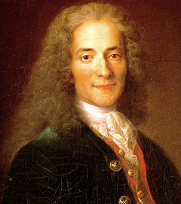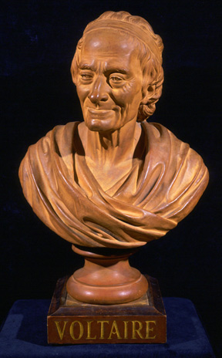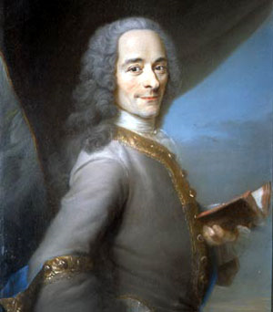
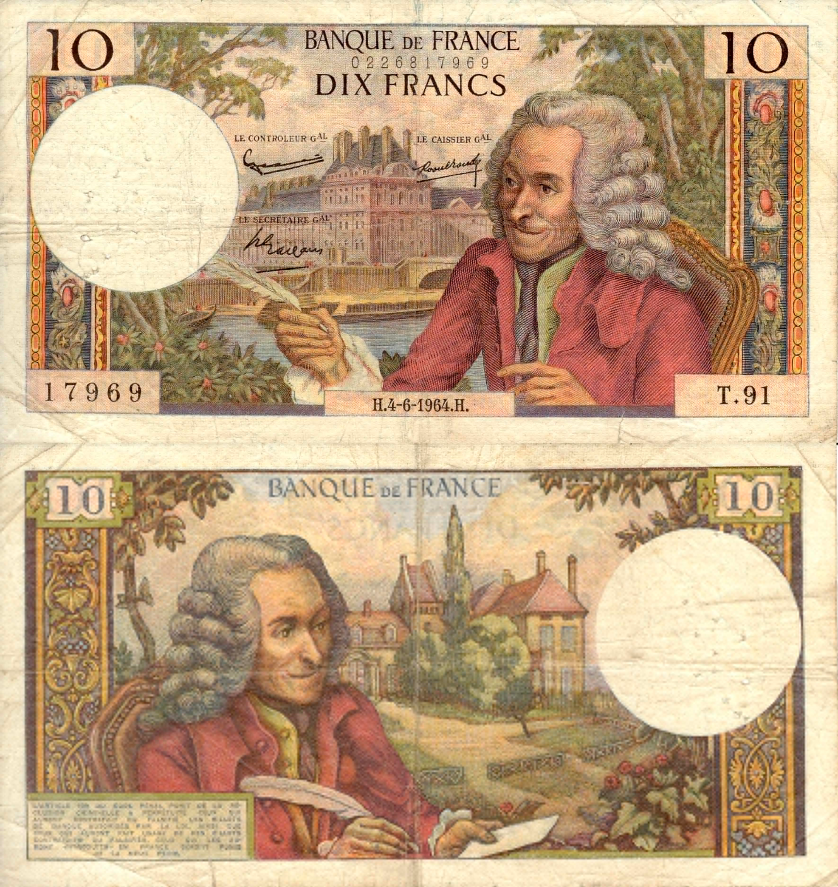
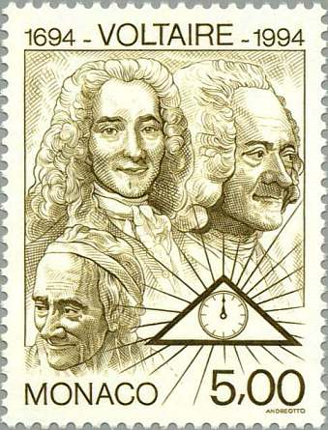
François-Marie Arouet (21 November 1694 – 30 May 1778), better known by the pen name Voltaire, was a French Enlightenment writer and philosopher famous for his wit and for his advocacy of civil liberties, including freedom of religion and free trade. Voltaire was a prolific writer and produced works in almost every literary form including plays, poetry, novels, essays, historical and scientific works, more than 20,000 letters and more than 2,000 books and pamphlets. He was an outspoken supporter of social reform, despite strict censorship laws and harsh penalties for those who broke them. As a satirical polemicist, he frequently made use of his works to criticize intolerance, religious dogma and the French institutions of his day.
Voltaire was one of several Enlightenment figures (along with Montesquieu, John Locke and Jean-Jacques Rousseau) whose works and ideas influenced important thinkers of both the American and French Revolutions.

Contents
[hide]
- 1 Life
  - 1.1 Early career
  - 1.2 The name "Voltaire"
  - 1.3 Great Britain
  - 1.4 Château de Cirey
  - 1.5 Sanssouci
  - 1.6 Geneva and Ferney
  - 1.7 Death and burial
- 2 Writings
  - 2.1 Poetry
  - 2.2 Prose
  - 2.3 Letters
- 3 Philosophy
  - 3.1 Religion
  - 3.2 Freemasonry
- 4 Legacy
- 5 Works
  - 5.1 Major works
  - 5.2 Plays
  - 5.3 Historical
- 6 Chronology
- 7 See also
- 8 Notes
- 9 Further reading
  - 9.1 In French
  - 9.2 Primary sources
- 10 External links

Life

Early career
François Marie Arouet was born in Paris, the youngest of the five children^{[1]} (only three of which survived) of François Arouet (1650 – 1 January 1722), a notary who was a minor treasury official, and his wife, Marie Marguerite d'Aumart (ca. 1660 – 13 July 1701), from a noble family of the province of Poitou. Voltaire was educated by Jesuits at the Collège Louis-le-Grand (1704–1711), where he learned Latin and Greek; later in life he became fluent in Italian, Spanish and English.^{[2]}
By the time he left school, Voltaire had decided he wanted to be a writer, against the wishes of his father who wanted him to become a notary. Voltaire, pretending to work in Paris as an assistant to a notary, spent much of his time writing poetry. When his father found him out, he sent Voltaire to study law, this time in Caen (Normandy). Nevertheless, he continued to write, producing essays and historical studies. Voltaire's wit made him popular among some of the aristocratic families with whom he mixed. His father then obtained a job for him as a secretary to the French ambassador in the Netherlands, where Voltaire fell in love with a French refugee named Catherine Olympe Dunoyer. Their scandalous elopement was foiled by Voltaire's father and he was forced to return to France.^{[citation needed]}
Most of Voltaire's early life revolved around Paris. From early on, Voltaire had trouble with the authorities for his energetic attacks on the government and the Catholic Church. These activities were to result in numerous imprisonments and exiles. He allegedly wrote satirical verses about the aristocracy. A work about the Régent thought to be by him led to his imprisonment in the Bastille for eleven months, until the real author came forward. While there, he wrote his debut play, Œdipe. Its success established his reputation.

[edit] The name "Voltaire"
The name "Voltaire", which the author adopted in 1718, is an anagram of "AROVET LI," the Latinized spelling of his surname, Arouet, and the initial letters of "le jeune" ("the younger").^{[3]} The name also echoes in reverse order the syllables of the name of a family château in the Poitou region: "Airvault". The adoption of the name "Voltaire" following his incarceration at the Bastille is seen by many to mark Voltaire's formal separation from his family and his past.
Richard Holmes^{[4]} supports this derivation of the name, but adds that a writer such as Voltaire would have intended it to also convey its connotations of speed and daring. These come from associations with words such as "voltige" (acrobatics on a trapeze or horse), "volte-face" (a spinning about to face one's enemies), and "volatile" (originally, any winged creature). "Arouet" was not a noble name fit for his growing reputation, especially given that name's resonance with "à rouer" ("for thrashing") and "roué" (a "débauché").
Voltaire is known to have used at least 178 separate pen names during his lifetime.^{[5]}

[edit] Great Britain
The aptitude for quick, perceptive, cutting, witty and often scathingly critical repartee for which Voltaire is known today made him highly unpopular with many of his contemporaries, including much of the French aristocracy. These sharp-tongued retorts were responsible for Voltaire's exile from France, during which he resided in Great Britain.
After Voltaire retorted to an insult given him by the young French nobleman Chevalier de Rohan in late 1725, the aristocratic Rohan family obtained a royal lettre de cachet, an irrevocable and often arbitrary penal decree signed by the French King (Louis XV, in the time of Voltaire) that was often bought by members of the wealthy nobility to dispose of undesirables. They then used this warrant to force Voltaire first into imprisonment in the Bastille and then into exile without holding a trial or giving him an opportunity to defend himself.^{[6]} The incident marked the beginning of Voltaire's attempts to improve the French judicial system.
Voltaire's exile in Great Britain lasted over two years, and his experiences there greatly influenced many of his ideas. The young man was impressed by Britain's constitutional monarchy in contrast to the French absolute monarchy, as well as the country's support of the freedoms of speech and religion. He was also influenced by several of the neoclassical writers of the age, and developed an interest in earlier English literature, especially the works of Shakespeare, still little known in continental Europe at the time. Despite pointing out his deviations from neoclassical standards, Voltaire saw Shakespeare as an example French writers might look up to, since drama in France, despite being more polished, lacked on-stage action. Later, however, as Shakespeare's influence was being increasingly felt in France, Voltaire would endeavour to set a contrary example with his own plays, decrying what he considered Shakespeare's barbarities.
After almost three years in exile, Voltaire returned to Paris and published his views on British attitudes towards government, literature, and religion in a collection of essays in letter form entitled the Lettres philosophiques sur les Anglais (Philosophical Letters on the English). Because he regarded the British constitutional monarchy as more developed and more respectful of human rights (particularly religious tolerance) than its French counterpart, these letters met great controversy in France, to the point where the book was burnt and Voltaire was forced again to flee.

[edit] Château de Cirey
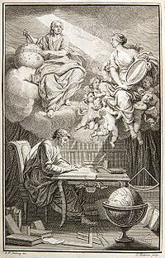
In the frontispiece to their translation of Newton, Émilie du Châtelet appears as Voltaire's muse, reflecting Newton's heavenly insights down to Voltaire.
Voltaire's next destination was the Château de Cirey, located on the borders of Champagne and Lorraine. The building was renovated with his money, and here he began a relationship with the Marquise du Châtelet, Gabrielle Émilie le Tonnelier de Breteuil (famous in her own right as Émilie du Châtelet). Cirey was owned by the Marquise's husband, Marquis Florent-Claude du Chatelet, who sometimes visited his wife and her lover at the chateau. The relationship, which lasted for fifteen years, had a significant intellectual element. Voltaire and the Marquise collected over 21,000 books, an enormous number for the time. Together, they studied these books and performed experiments in the "natural sciences" in his laboratory. Voltaire's experiments included an attempt to determine the elements of fire.
Having learned from his previous brushes with the authorities, Voltaire began his future habit of keeping out of personal harm's way, and denying any awkward responsibility. He continued to write many plays, such as Mérope (or "La Mérope française") and began his long researches into science and history . Again, a main source of inspiration for Voltaire were the years of his British exile, during which he had been strongly influenced by the works of Sir Isaac Newton. Voltaire strongly believed in Newton's theories, especially concerning optics (Newton’s discovery that white light is composed of all the colours in the spectrum led to many experiments at Cirey), and gravity (Voltaire is the source of the famous story of Newton and the apple falling from the tree, which he had learned from Newton's niece in London and first mentioned in his Essai sur la poésie épique, or Essay on Epic Poetry). Although both Voltaire and the Marquise were curious about the philosophies of Gottfried Leibniz, a contemporary and rival of Newton, they remained essentially "Newtonians", despite the Marquise's adoption of certain aspects of Leibniz's arguments against Newton. She translated Newton's Latin Principia in full, adjusting a few errors along the way, and hers remained the definitive French translation well into the 20th century. Voltaire's book Eléments de la philosophie de Newton (Elements of Newton's Philosophy), which was probably co-written with the Marquise, made Newton accessible to a far greater public. It is often considered the work that finally brought about general acceptance of Newton's optical and gravitational theories.
Voltaire and the Marquise also studied history—particularly those persons who had contributed to civilization. Voltaire's second essay in English had been Essay upon the Civil Wars in France. It was followed by La Henriade, an epic poem on the French king Henri IV, glorifying his attempt to end the Catholic-Protestant massacres with the Edict of Nantes, and by a historical novel on King Charles XII of Sweden. These, along with his Letters on England mark the beginning of Voltaire's open criticism of intolerance and established religions. Voltaire and the Marquise also worked with philosophy, particularly with metaphysics, the branch of philosophy that deals with being, and what is beyond the material realm such as whether or not there is a God or souls, etc. Voltaire and the Marquise analyzed the Bible, trying to discover its validity in their time. Voltaire's critical views on religion are reflected in his belief in separation of church and state and religious freedom, ideas that he had formed after his stay in England.
Though deeply committed to the Marquise, Voltaire by 1744 found life at the château confining. On a visit to Paris that year, he found a new love: his niece. At first, his attraction to Marie Louise Mignot was clearly sexual, as evidenced by his letters to her (only discovered in 1937). ^{[7]} Much later, they lived together, perhaps platonically, and remained together until Voltaire's death. Meanwhile, the Marquise also took a lover, the Marquis de Saint-Lambert.^{[8]}

[edit] Sanssouci
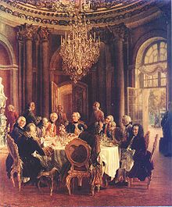
Die Tafelrunde by Adolph von Menzel. Guests of Frederick the Great, in Marble Hall at Sanssouci, include members of the Prussian Academy of Sciences and Voltaire (seated, third from left).
After the death of the Marquise in childbirth in September 1749, Voltaire briefly returned to Paris and in 1750 moved to Potsdam to join Frederick the Great, a close friend and admirer of his.^{[9]} The king had repeatedly invited him to his palace, and now gave him a salary of 20,000 francs a year. Though life went well at first—in 1752 he wrote Micromégas, perhaps the first piece of science fiction involving ambassadors from another planet witnessing the follies of humankind—his relationship with Frederick the Great began to deteriorate and he encountered other difficulties. An argument with Maupertuis, the president of the Berlin Academy of Science, provoked Voltaire's Diatribe du docteur Akakia (Diatribe of Doctor Akakia), which satirized some of Maupertuis' theories and his abuse of power in his persecutions of a mutual acquaintance, Samuel Koënig. This greatly angered Frederick, who had all copies of the document burned and arrested Voltaire at an inn where he was staying along his journey home.

[edit] Geneva and Ferney
Voltaire headed toward Paris, but Louis XV banned him from the city, so instead he turned to Geneva, near which he bought a large estate (Les Délices). Though he was received openly at first, the law in Geneva which banned theatrical performances and the publication of The Maid of Orleans against his will made him move at the end of 1758 out of Geneva across the French border to Ferney, where he had bought an even larger estate, and led to Voltaire's writing of Candide, ou l'Optimisme (Candide, or Optimism) in 1759. This satire on Leibniz's philosophy of optimistic determinism remains the work for which Voltaire is perhaps best known. He would stay in Ferney for most of the remaining 20 years of his life, frequently entertaining distinguished guests, like James Boswell, Giacomo Casanova, and Edward Gibbon.^{[10]} In 1764 he published his most important philosophical work, the Dictionnaire Philosophique, a series of articles mainly on Christian history and dogmas, a few of which were originally written in Berlin.^{[6]}
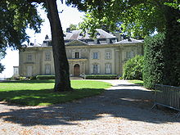
Voltaire's château at Ferney, France.
From 1762 he began to champion unjustly persecuted people, the case of Jean Calas being the most celebrated. This Huguenot merchant had been tortured to death in 1763, supposedly because he had murdered his son for wanting to convert to Catholicism. His possessions were confiscated and his remaining children were taken from his widow and were forced to become members of a monastery. Voltaire, seeing this as a clear case of religious persecution, managed to overturn the conviction in 1765.^{[6]}

[edit] Death and burial
In February 1778, Voltaire returned for the first time in 20 years to Paris, among other reasons to see the opening of his latest tragedy, Irene. The 5-day journey was too much for the 83-year old, and he believed he was about to die on February 28, writing "I die adoring God, loving my friends, not hating my enemies, and detesting superstition." However, he recovered, and in March saw a performance of Irene where he was treated by the audience as a returning hero.^{[6]} However, he soon became ill again and died on 30 May 1778. When asked on his deathbed by a priest to renounce the devil and turn to God, he is alleged to have replied, "For God's sake, let me die in peace."^{[11]}
Because of his well-known criticism of the church, which he had refused to retract before his death, Voltaire was denied a Christian burial, but friends managed to bury his body secretly at the abbey of Scellières in Champagne before this prohibition had been announced. His heart and brain were embalmed separately. On 11 July 1791, the National Assembly, which regarded him as a forerunner of the French revolution, had his remains brought back to Paris to enshrine him in the Panthéon. It is estimated that a million people attended the procession, which stretched throughout Paris. There was an elaborate ceremony, complete with an orchestra, and the music included a piece that André Grétry composed specially for the event, which included a part for the "tuba curva". This was an instrument that originated in Roman times as the cornu but had been recently revived under a new name.^{[12]}
A widely repeated story that the remains of Voltaire were stolen by religious fanatics in 1814 or 1821 during the Pantheon restoration and thrown into a garbage heap is false. Such rumours resulted in the coffin being opened in 1897, which confirmed that his remains were still present.^{[13]}
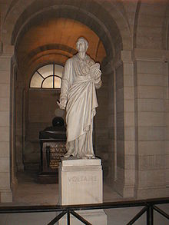
Voltaire's tomb in Paris' Pantheon

[edit] Writings

[edit] Poetry
From an early age, Voltaire displayed a talent for writing verse and his first published work was poetry. He wrote two long poems, the Henriade and The Maid of Orleans, besides many other smaller pieces.
The Henriade was written in imitation of Virgil, using the Alexandrine couplet reformed and rendered monotonous for modern readers but it was a huge success in the 18th and early 19th century, with sixty-five editions and translations into several languages. The epic poem transformed French King Henry IV into a national hero for his attempts at instituting tolerance with his Edict of Nantes. La Pucelle, on the other hand, is a burlesque on the superhuman powers attributed to virginity in the legend of Joan of Arc. Voltaire's minor poems are generally considered superior to either of these two works.

[edit] Prose
Many of Voltaire's prose works and romances, usually composed as pamphlets, were written as polemics. Candide attacks the passivity inspired by Leibniz's philosophy of optimism; L'Homme aux quarante ecus, certain social and political ways of the time; Zadig and others, the received forms of moral and metaphysical orthodoxy; and some were written to deride the Bible. In these works, Voltaire's ironic style, free of exaggeration, is apparent, particularly the restraint and simplicity of the verbal treatment. Candide in particular is the best example of his style. Voltaire also has, in common with Jonathan Swift, the distinction of paving the way for science fiction's philosophical irony, particularly in his Micromégas.
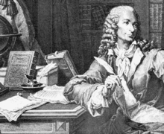
Voltaire at Frederick the Great's Sanssouci. Engraving by Pierre Charles Baquoy.
In general criticism and miscellaneous writing, Voltaire's writing was comparable to his other works. Almost all of his more substantive works, whether in verse or prose, are preceded by prefaces of one sort or another, which are models of his caustic yet conversational tone. In a vast variety of nondescript pamphlets and writings, he displays his skills at journalism. In pure literary criticism his principal work is the Commentaire sur Corneille, although he wrote many more similar works – sometimes (as in his Life and notices of Molière) independently and sometimes as part of his Siècles.
Voltaire's works, especially his private letters, frequently contain the word "l'infâme" and the expression "écrasez l'infâme," or "crush the infamous". The phrase refers to abuses to the people by royalty and the clergy that Voltaire saw around him, and the superstition and intolerance that the clergy bred within the people.^{[14]} He had felt these effects in his own exiles, in the confiscations of his books, and the hideous sufferings of Calas and La Barre. He also stated that (one of his most famous quotes) "Superstition sets the whole world in flames; philosophy quenches them".
The most oft-cited Voltaire quotation is apocryphal. He is incorrectly credited with writing, “I disapprove of what you say, but I will defend to the death your right to say it.” These were not his words, but rather those of Evelyn Beatrice Hall, written under the pseudonym S. G. Tallentyre in her 1906 biographical book The Friends of Voltaire. Hall intended to summarize in her own words Voltaire's attitude towards Claude Adrien Helvétius and his controversial book De l'esprit, but her first-person expression was mistaken for an actual quotation from Voltaire. Her interpretation does capture the spirit of Voltaire’s attitude towards Helvetius; it had been said Hall's summary was inspired by a quotation found in a 1770 Voltaire letter to an Abbot le Roche, in which he was reported to have said, “I detest what you write, but I would give my life to make it possible for you to continue to write.”^{[15]} Nevertheless, scholars believe there must have again been misinterpretation, as the letter does not seem to contain any such quote.^{[16]}
Voltaire's first major philosophical work in his battle against "l'infâme" was the Treatise on Tolerance, exposing the Calas affair, along with the tolerance exercised by other faiths and in other eras (for example, by the Jews, the Romans, the Greeks and the Chinese). Then, in his Dictionnaire philosophique, containing such articles as "Abraham", "Genesis", "Church Council", he wrote about what he perceived as the human origins of dogmas and beliefs, as well as inhuman behavior of religious and political institutions in shedding blood over the quarrels of competing sects.
Amongst other targets, Voltaire criticized France's colonial policy in North America, dismissing the vast territory of New France as "a few acres of snow" ("quelques arpents de neige").

[edit] Letters
Voltaire also engaged in an enormous amount of private correspondence during his life, totaling over 20,000 letters. Theodore Besterman's collected edition of these letters, completed only in 1964, fills 102 volumes.^{[17]} One historian called the letters "a feast not only of wit and eloquence but of warm friendship, humane feeling, and incisive thought."^{[18]}

[edit] Philosophy

[edit] Religion
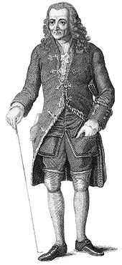
Voltaire at 70. Engraving from 1843 edition of his Philosophical Dictionary.
Voltaire did not believe that any single religious text or tradition of revelation was needed to believe in God. Voltaire's focus was rather on the idea of a universe based on reason and a respect for nature which reflected the contemporary pantheism.
Like other key thinkers during the European Enlightenment, Voltaire considered himself a deist, expressing the idea: "What is faith? Is it to believe that which is evident? No. It is perfectly evident to my mind that there exists a necessary, eternal, supreme, and intelligent being. This is no matter of faith, but of reason."^{[19][20]}
As for religious texts, Voltaire's opinion of the Bible was mixed. This did not hinder his religious practice, though it did win for him a bad reputation among religious fundamentalists. The deeply Catholic Wolfgang Amadeus Mozart wrote to his father the year of Voltaire's death, saying, "The arch-scoundrel Voltaire has finally kicked the bucket...."^{[21]}
Views of Islam and its prophet, Muhammad, can be found in Voltaire's writings. In a letter recommending his play Fanaticism, or Mahomet to Pope Benedict XIV, Voltaire described the founder of Islam as "the founder of a false and barbarous sect" and "a false prophet."^{[22]} Elsewhere, his views were more generous, often praising the relative tolerance of Muslim behavior in the lands they conquered (as opposed the Christian Inquisitions) and the fact that its doctrines were written by its founder himself, not based on hearsay, and had not endured the innumerable changes Christian doctrine had. His Essai sur les Moeurs et l'Esprit des Nations, contains much fuller accounts on Muhammad and the founding and spread of his religion as do a number of his polemical works on religion. ^{[23]}
From translated works on Confucianism and Legalism, Voltaire drew on Chinese concepts of politics and philosophy (which were based on rational principles), to look critically at European organized religion and hereditary aristocracy.^{[citation needed]}
There is an apocryphal story that his home at Ferney was purchased by the Geneva Bible Society and used for printing Bibles,^{[24]} but this appears to be due to a misunderstanding of the 1849 annual report of the American Bible Society.^{[25]} Voltaire's chateau is now owned and administered by the French Ministry of Culture.
Though many books have been written taxing Voltaire with anti-semitism,^{[26]} they do not explain, nor usually even mention, the numerous pamphlets he wrote attacking anti-semitism itself. This apparent contradiction led many to conclude that his remarks were in fact anti-Biblical and not anti-semitic. His "Sermon du rabbin Akib", for example, is a scathing attack on Christian persecution of the Jews, and similar remarks can be found scattered throughout his 200-odd pamphlets and books on religion.^{[27]} It has been pointed out that thirty of the 118 articles in his Dictionnaire Philosophique described the ancient Jews in consistently negative ways, as barbarous, absurd and deeply superstitious; however, this ignores his qualifiers, in which he points out that "all of antiquity was", as a rule.^{[28]} Peter Gay, the best known contemporary authority on the Enlightenment,^{[26]} wrote that "Voltaire struck at the Jews to strike at Christianity," a view shared by certain leading Jewish Voltairians—indeed, the point usually is, if the Jews were cruel and absurd, what can be made of other faiths that declare their histories sacred, yet persecute them? "When I see Christians cursing Jews," he wrote in his English Notebook, "methinks I see children beating their fathers." And posing as a freshly minted Spanish priest in Les Questions de Zapata, he asks his superiors how how he should go about explaining that the Jews, whom they burn by the hundreds, were the chosen people of God for four thousand years, and why we chant their prayers while burning them.^{[29]} Voltaire grew exceedingly vocal against the Church during the campaign for tolerance of his later years, openly writing that it had been the "consistently implacable enemy of progress, decency, humanity and rationality" and that it had been the Church's interest to "keep people as ignorant and submissive as children".^{[30]}
In the Scottish Enlightenment the Scots began developing a uniquely practical branch of humanism to the extent that Voltaire said "We look to Scotland for all our ideas of civilisation".^{[31][32]}

[edit] Freemasonry
Voltaire was initiated into Freemasonry one month before his death. On April 4, 1778 Voltaire accompanied his close friend Benjamin Franklin into Loge des Neuf Soeurs in Paris, France and became an Entered Apprentice Freemason, perhaps only to please Franklin.^{[33]}

[edit] Legacy
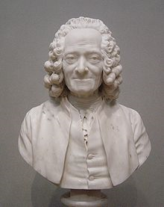
Bust of Voltaire by Houdon.
Voltaire perceived the French bourgeoisie to be too small and ineffective, the aristocracy to be parasitic and corrupt, the commoners as ignorant and superstitious, and the church as a static and oppressive force useful only as a counterbalance since its "religious tax" or the tithe helped to create a strong backing for revolutionaries. Voltaire distrusted democracy, which he saw as propagating the idiocy of the masses.^{[34]} Voltaire long thought only an enlightened monarch could bring about change, given the social structures of the time and the extremely high rates of illiteracy, and that it was in the king's rational interest to improve the education and welfare of his subjects. But his disappointments and disillusions with Frederick the Great changed his philosophy somewhat, and soon gave birth to one of his most enduring works, his novella, Candide, ou l'Optimisme (Candide, or Optimism, 1759), which ends with a new conclusion: "It is up to us to cultivate our garden". His most polemical and ferocious attacks on intolerance and religious persecutions indeed began to appear a few years later. Candide was also subject to censorship and Voltaire jokingly claimed the actual author was a certain "Demad" in a letter, where he reaffirmed the main polemical stances of the text.^{[35]}
Voltaire is also known for many memorable aphorisms, such as: "Si Dieu n'existait pas, il faudrait l'inventer" ("If God did not exist, it would be necessary to invent him"), contained in a verse epistle from 1768, addressed to the anonymous author of a controversial work, The Three Impostors. But far from being the cynical remark it is often taken for, it was meant as a retort to the atheistic clique of d'Holbach, Grimm, and others.
Voltaire is remembered and honored in France as a courageous polemicist who indefatigably fought for civil rights—the right to a fair trial and freedom of religion—and who denounced the hypocrisies and injustices of the ancien régime. The ancien régime involved an unfair balance of power and taxes between the First Estate (the clergy), the Second Estate (the nobles), and the Third Estate (the commoners and middle class, who were burdened with most of the taxes).
Voltaire has had his detractors among his later colleagues. The Scottish Victorian writer Thomas Carlyle argued that, while Voltaire was unsurpassed in literary form, not even the most elaborate of his works were of much value for matter and that he never uttered an original idea of his own. Nietzsche, however, called Carlyle an "insipid muddlehead" who failed to free himself from the very petty-mindedness he professed to condemn.
He often used China, Siam and Japan as examples of brilliant non-European civilizations and harshly criticized slavery,^{[36]}.
The town of Ferney, where Voltaire lived out the last 20 years of his life, is now named Ferney-Voltaire in honor of its most famous resident. His château is a museum.
Voltaire's library is preserved intact in the National Library of Russia at St. Petersburg, Russia.
In Zurich 1916, the theater and performance group who would become the early avant-garde movement Dada named their theater The Cabaret Voltaire. A late-20th-century industrial music group then named themselves after the theater.
A character based on Voltaire plays an important role in The Age of Unreason, a series of four alternate history novels written by American science fiction and fantasy author Gregory Keyes.
Voltaire was also known to have been an advocate for coffee, as he was purported to have drunk the beverage at least 30 times per day. It has been suggested that high amounts of caffeine acted as a mental stimulant to his creativity.^{[37]}
His great grand-niece was the mother of Pierre Teilhard de Chardin, a famous writer and Jesuit priest.^{[citation needed]}

[edit] Works

[edit] Major works
- Lettres philosophiques sur les Anglais (1733), revised as Letters on the English (circa 1778)
- Le Mondain (1736)
- Sept Discours en Vers sur l'Homme (1738)
- Zadig (1747)
- Micromégas (1752)
- Candide (1759)
- Treatise on Tolerance (1763)
- Ce qui plaît aux dames (1764)
- Dictionnaire philosophique (1764)
- L'Ingénu (1767)
- La Princesse de Babylone (1768)

[edit] Plays
Voltaire wrote between fifty and sixty plays, including a few unfinished ones. Among them are these:
- Œdipe (1718)
- Zaïre (1732)
- Eriphile (1732)
- Irène
- Socrates
- Mahomet
- Mérope
- Nanine
- The Orphan of China (1755)^{[38]}

[edit] Historical
- History of Charles XII, King of Sweden (1731)
- The Age of Louis XIV (1751)
- The Age of Louis XV (1746–1752)
- Annals of the Empire - Charlemagne, A.D. 742 - Henry VII 1313, Vol. I (1754)
- Annals of the Empire - Louis of Bavaria, 1315 to Ferdinand II 1631 Vol. II (1754)
- ' Essay on the Manners of Nations (or 'Universal History') (1756)
- History of the Russian Empire Under Peter the Great (Vol. I 1759; Vol. II 1763)

Chronology
Timeline of François Marie Arouet ('Voltaire') (1694-1778)
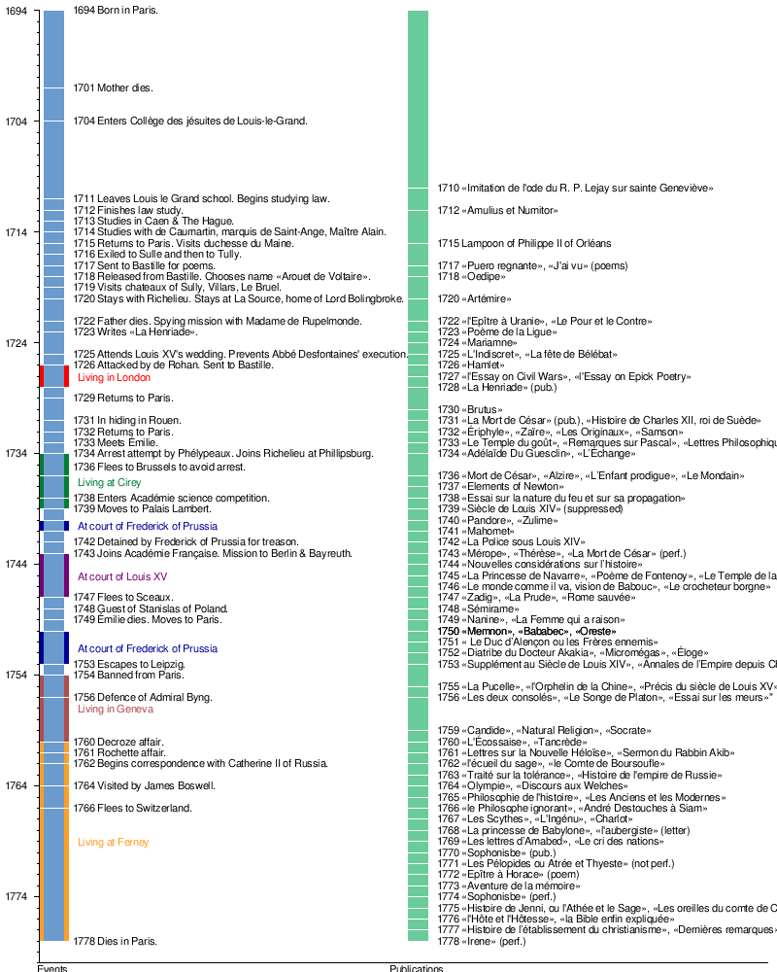

[edit] See also
- Classical liberalism
- Contributions to liberal theory
- List of Freemasons
- List of coupled cousins
- Mononymous persons

[edit] Notes
- ^ Wright, p 505.
- ^ Liukkonen, Petri. "Voltaire (1694-1778) - pseudonym of François-Marie Arouet". http://www.kirjasto.sci.fi/voltaire.htm. Retrieved 24 July 2009.
- ^ Christopher Thacker (1971), "Voltaire", Profiles in literature series (Taylor & Francis): p. 3, ISBN 9780710070203, http://books.google.com.ph/books?id=D5s9AAAAIAAJ.
- ^ Holmes, Richard (2000). Sidetracks: explorations of a romantic biographer. HarperCollins. pp. 345–366. and "Voltaire's Grin" in New York Review of Books, 30 November 1995, pp. 49-55
- ^ - "The appendixes offer even more: a listing of Voltaire's and Daniel Defoe's numerous pseudonyms (178 and 198, respectively)..."
- ^ ª ^{b} ^{c} ^{d} "The Life of Voltaire". Thegreatdebate.org.uk. http://thegreatdebate.org.uk/Voltaire.html. Retrieved 2009-08-03.
- ^ Ian Davidson, Voltaire in Exile, Grove Press 2006. http://books.google.com/books?id=99Rnph1FGxcC&pg=PA6&lpg=PA6&dq=%22mme+denis%22++Voltaire&lr=&as_brr=3&ie=ISO-8859-1&output=html. See also Will and Ariel Durant, The Age of Voltaire, Simon & Schuster (196 ) page 392 [1]
- ^ Davidson, ibid, page 7. Books.google.com. http://books.google.com/books?id=99Rnph1FGxcC&pg=PA7&lpg=PA6&dq=%22mme+denis%22++Voltaire&lr=&as_brr=3&ie=ISO-8859-1&output=html. Retrieved 2009-08-03.
- ^ According to poet Richard Armour, Voltaire's friendship with Frederick William existed because "Frederick considered Voltaire to be immensely clever and so did Voltaire."
- ^ The Scottish diarist Boswell recorded their conversations in 1764, which are published in Boswell and the Grand Tour.
- ^ Norman Davies, Europe: A history p. 687
- ^ Grove's Dictionary of Music and Musicians, 5th ed, 1954; "Cornu" article
- ^ Voltaire and Rousseau, Their Tombs in the Pantheon Opened and Their Bones Exposed, New York Times, January 8, 1898
- ^ Palmer, R.R.; Colton, Joel (1950). A History of the Modern World. McGraw-Hill, Inc.. ISBN 0-07-040826-2.
- ^ Boller, Jr., Paul F.; George, John (1989). They Never Said It: A Book of Fake Quotes, Misquotes, and Misleading Attributions. New York: Oxford University Press. ISBN 0-19-505541-1.
- ^ Charles Wirz, archivist at The Voltaire Institute and Museum in Geneva, recalled in 1994, that Hall, placed wrongly, between speech marks this quotation in two works devoted to Voltaire, recognising expressly the quotation in question was not one, in a letter of 9 May 1939, which was published in 1943 in volume LVIII under the title "Voltaire never said it" (pp.534-5) of the review "Modern language notes", Johns Hopkins Press, 1943, Baltimore. An extract from the letter: 'The phrase "I disapprove of what you say, but I will defend to the death your right to say it" which you have found in my book "Voltaire in His Letters" is my own expression and should not have been put in inverted commas. Please accept my apologies for having, quite unintentionally, misled you into thinking I was quoting a sentence used by Voltaire (or anyone else but myself).' "The words "my own" were underlined personally by Hall in her letter. To believe certain commentators - Norbert Guterman, A Book of French Quotations, 1963 - Hall was referencing back to a Voltaire letter of 6 February 1770 to an abbot le Riche where Voltaire said "Reverend, I hate what you write, but I will give my life so that you can continue to write." The problem is that, if you consult the letter itself, the sentence there does not appear, nor even the idea: A M LE RICHE A AMIENS. 6 February. You left, Sir, des Welches for des Welches. You will find everywhere barbarians obstinate. The number of wise will always be small. It is true...it has increased; but it is nothing in comparison with the stupid ones; and, by misfortune, one says that God is always for the big battalions. It is necessary that the decent people stick together and stay under cover. There are no means that their small troop could tackle the party of the fanatics in open country. I was very sick, I was near death every winter; this is the reason, Sir, why I have answered you so late. I am not less touched by it than your memory. Continue to me your friendship; it comforts me my evils and stupidities of the human genre. Receive my assurances, etc. Voltaire, however, did not hesitate to wish censure against slander and personal libels. Here is what he writes in his “Atheism” article in the Dictionnaire philosophique: Aristophanes (this man that the commentators admire because he was Greek, not thinking that Socrates was Greek also), Aristophanes was the first who accustomed the Athenians to consider Socrates an atheist. ... The tanners, the shoemakers and the dressmakers of Athens applauded a joke in which one represented Socrates raised in the air in a basket, announcing there was God, and praising himself to have stolen a coat by teaching philosophy. A whole people, whose bad government authorized such infamous licences, deserved well what it got, to become the slave of the Romans, and today of the Turks.
- ^ "article in Forum for Modern Language Studies". Fmls.oxfordjournals.org. doi:10.1093/fmls/I.3.230. http://fmls.oxfordjournals.org/cgi/pdf_extract/I/3/230. Retrieved 2009-08-03.
- ^ Will and Ariel Durant, Rousseau and Revolution (1967), page 138
- ^ "Voltaire". Deism.com. 2009-06-25. http://deism.com/voltaire.htm. Retrieved 2009-08-03.
- ^ Voltaire. W. Dugdale, A Philosophical Dictionary ver 2, 1843, Page 473 sec 1. Retrieved October 31, 2007.
- ^ Keffe, Simon P. (2003). The Cambridge Companion to Mozart. Cambridge University Press. ISBN 0521001927.
- ^ Voltaire, Letter to Benedict XIV written in Paris on 17 August 1745: Your holiness will pardon the liberty taken by one of the lowest of the faithful, though a zealous admirer of virtue, of submitting to the head of the true religion this performance, written in opposition to the founder of a false and barbarous sect. To whom could I with more propriety inscribe a satire on the cruelty and errors of a false prophet, than to the vicar and representative of a God of truth and mercy? Your holiness will therefore give me leave to lay at your feet both the piece and the author of it, and humbly to request your protection of the one, and your benediction upon the other; in hopes of which, with the profoundest reverence, I kiss your sacred feet.
- ^ "Essai sur les Moeurs et l'Esprit des Nations". Voltaire Intégral. http://www.voltaire-integral.com/Html/00Table/11.html. Retrieved 2009-06-27., Vol. I: Tome XI: Chap. VII "De l’Alcoran, et de la loi musulmane."
- ^ Geisler, N.L.; Nix, W.E.. A General Introduction to the Bible. Moody Press.
- ^ "Voltaire's House and The Bible Society" (pdf). The Open Society. http://www.nzarh.org.nz/journal/2004v77n1aut.pdf. Retrieved 2008-07-01. 2.18 MiB
- ^ ª ^{b} Prager, D; Telushkin, J. Why the Jews?: The Reason for Antisemitism. New York: Simon & Schuster, 1983. page 128-9.
- ^ Voltaire, François-Marie. Essai sur les Moeurs. See also: Voltaire, François-Marie. Dictionnaire Philosophique.
- ^ Poliakov, L. The History of Anti-Semitism: From Voltaire to Wagner. Routledge & Kegan Paul, Ltd., 1975 (translated). page 88-89.
- ^ Gay, P. The Party of Humanity: Essays in the French Enlightenment. Alfred Knopf, 1964. pages 103-105.
- ^ Gay, Party of Humanity, 44, 53.
- ^ José Manuel Barroso, 11th President of the European Commission (28 November 2006). "The Scottish enlightenment and the challenges for Europe in the 21st century; climate change and energy" (html). Enlightenment Lecture Series, Edinburgh University. http://europa.eu/rapid/pressReleasesAction.do?reference=SPEECH/06/756&format=HTML&aged=1&language=EN&guiLanguage=en. "I will try to show why Voltaire was right when he said: 'Nous nous tournons vers l’Écosse pour trouver toutes nos idées sur la civilisation' [we look to Scotland for all our ideas on civilisation]."
- ^ "Visiting The Royal Society of Edinburgh…" (html). Royal Society of Edinburgh. First published in The Scotsman Saturday 4 June 2005. http://www.royalsoced.org.uk/international/potocnik.htm. "Scotland has a proud heritage of science, research, invention and innovation, and can lay claim to some of the greatest minds and greatest discoveries since Voltaire wrote those words 250 years ago."
- ^ "Benjamin Franklin...urged Voltaire to become a freemason; and Voltaire agreed, perhaps only to please Franklin.Ridley, Jasper (2002). The Freemasons: A History of the World's Most Powerful Secret Society. pp. 112. http://books.google.com/books?id=ISMObxdcmfsC&pg=RA4-PA112&dq=freemason+voltaire&ei=ssVASJfIOKakiwGz44zbCQ&sig=DSRHtjUrh3wTLPDfM9SiyFTyvyg. See also: "I did not know that: Mason Facts". http://www.americanmason.com/didntARC.ihtml. and "Voltaire on British Columbia Grand Lodge Site". http://freemasonry.bcy.ca/biography/voltaire/voltaire.html.
- ^ "Democracy". The Philosophical Dictionary. Knopf. 1924. http://history.hanover.edu/texts/voltaire/voldemoc.html. Retrieved 2008-07-01.
- ^ "Letter on the subject of Candide, to the Journal encyclopédique July 15, 1759". University of Chicago. http://web.archive.org/web/20061013194545/http://humanities.uchicago.edu/homes/VSA/Candide/Candide.letter.html. Retrieved 2008-01-07.
- ^ Voltaire, François-Marie. Candide (chapter 19).
- ^ Washingtonmonthly.com
- ^ This is a translation of a famous Chinese play Orphan of Zhao about the revenge of the orphan of the clan of Zhao on his enemies who killed almost every member of his clan. This play was based on an actual historical event in the Spring-Autumn period of Chinese history. Voltaire's version was translated by Arthur Murphy as The Orphan of China in 1759.

[edit] Further reading
- Besterman, Theodore, Voltaire, (1969).
- Brumfitt, J. H. Voltaire: Historian (1958) online edition
- Davidson, Ian, Voltaire. A Life, London, Profile Books, 2010. ISBN 978184668261
- Durant, Will, The Story of Civilization. Vol. IX: The Age of Voltaire. New York: Simon and Schuster, 1965.
- Gay, Peter, Voltaire's Politics, The Poet as Realist, Yale University, 1988.
- Hadidi, Djavâd, Voltaire et l'Islam, Publications Orientalistes de France, 1974.
- Knapp, Betina L. Voltaire Revisited (2000) 228pp
- Mason, Haydn, Voltaire, A Biography
- Muller, Jerry Z., 2002. The Mind and the Market: Capitalism in Western Thought. Anchor Books.
- Pearson, Roger, 2005. Voltaire Almighty: a life in pursuit of freedom. Bloomsbury. ISBN 9781582346304. 447pp
- Quinones, Ricardo J. Erasmus and Voltaire: Why They Still Matter (University of Toronto Press; 2010) 240 pages; Draws parallels between the two thinkers as voices of moderation with relevance today.
- Schwarzbach, Bertram Eugene, Voltaire's Old Testament Criticism, Librairie Droz, Geneva, 1971.
- Torrey, Norman L., The Spirit of Voltaire, Columbia University Press, 1938.
- Vernon, Thomas S. (1989). "Chapter V: Voltaire". Great Infidels. M & M Pr. ISBN 0943099056. http://www.positiveatheism.org/hist/voltvern.htm.
- Wade, Ira O. (1967). Studies on Voltaire. New York: Russell & Russell.
- Wright, Charles Henry Conrad, A History of French Literature, Oxford University Press, 1912.
- "The Cambridge Companion to Voltaire", ed by Nicholas Cronk, 2009.

[edit] In French
- Pomeau, René La Religion de Voltaire, Librairie Nizet, Paris, 1974.
- Valérie Crugten-André, La vie de Voltaire [2]

[edit] Primary sources
- Morley, J., The Works of Voltaire, A Contemporary Version, (21 vol 1901), online edition

[edit] External links
Find more about Voltaire on Wikipedia's sister projects:
 |  | Definitions from Wiktionary
 |  | Textbooks from Wikibooks
 |  | Quotations from Wikiquote
 |  | Source texts from Wikisource
 |  | Images and media from Commons
 |  | News stories from Wikinews
 |  | Learning resources from Wikiversity
 |  |  | Wikisource has the text of the 1911 Encyclopædia Britannica article Voltaire.
- Encyclopédie, ARTFL Project, University of Chicago
- Liste chronologique des oeuvres de Voltaire, adlitteram.free.fr
- PRÉSENTATION DES OEUVRES COMPLÈTES DE VOLTAIRE EN CD-ROM, Voltaire: Édition Electronique^{[dead link]}
- Château de Cirey - Residence of Voltaire, visitvoltaire.com
- Gabrielle Émilie Le Tonnelier de Breteuil Marquise du Châtelet, School of Mathematics and Statistics, University of St Andrews, Scotland
- Hewett, Caspar J. M. (August 2006). "The Great Debate: Life of Voltaire.". http://thegreatdebate.org.uk/Voltaire.html. Retrieved 2008-11-02.
- The Société Voltaire
- A complete bibliography
- An analysis of Voltaire's texts (in the "textes" topic) (French)
- Complete french ebooks of Voltaire (French)
- Biography and quotes of Voltaire
- Full Ebooks of Voltaire in French on the website "La philosophie"
- Institut et Musée Voltaire, Geneva, Switzerland
- Internet Encyclopaedia of Philosophy on Voltaire
- Monsieur de Voltaire Correspondence in French
- The Life of Voltaire Essay by Caspar J M Hewett
- VisitVoltaire.com site with images
- Voltaire Foundation, Oxford, United Kingdom
- Voltaire on the 10 French Franc banknote.
- Voltaire's Candide and Leibniz
- Voltaire's works: works: text, concordances and frequency list
- Voltaire's writings from Philosophical Dictionary. Selected and Translated by H.I. Woolf, 1924
- Worldly and Personal Influences on Voltaire’s Writing
- Works by Voltaire at Project Gutenberg
- Works by Voltaire in free audio format from LibriVox
- Voltaire's works and chronology
==========================================================================================================================================

