Benedictus de Spinoza 1632-1677
http://en.wikipedia.org/wiki/Baruch_Spinoza
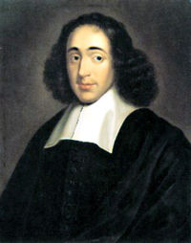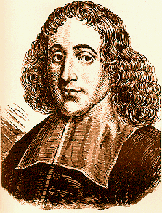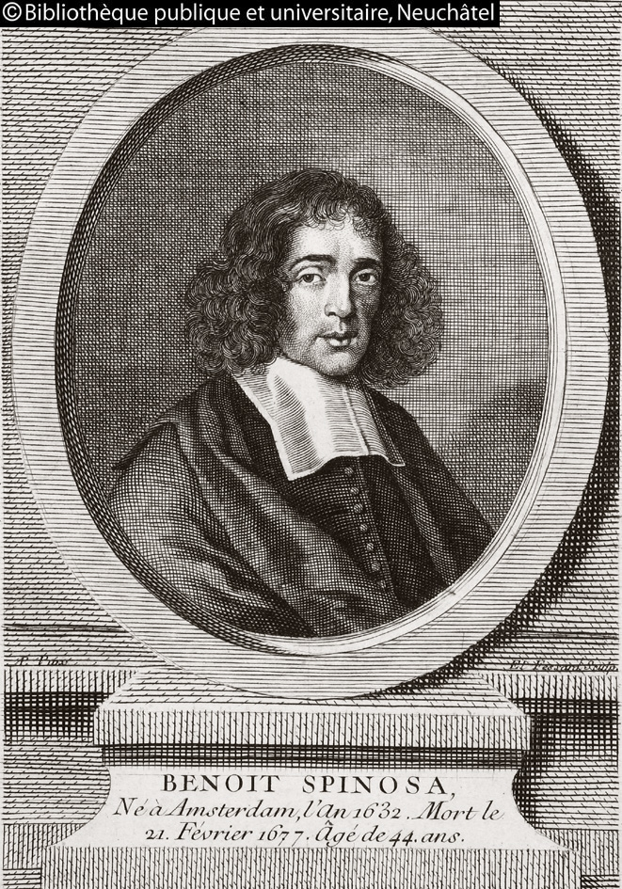

Benedictus de Spinoza or Baruch de Spinoza ((Hebrew: ברוך שפינוזה)) (November 24, 1632 – February 21, 1677). He was a Dutch philosopher, considered one of the great rationalists of 17th-century philosophy and, by virtue of his magnum opus the posthumous Ethics, one of the definitive ethicists. His writings, like those of his fellow rationalists, reveal considerable mathematical training and facility. Spinoza was a lens crafter by trade, an exciting engineering field at the time because of great discoveries being made by telescopes. The full effect of his work was realized only some time after his death, following the publication of his Opera Posthuma. He is now recognized as having laid the groundwork for the 18th century Enlightenment, and as a founder of modern biblical criticism. 20th century philosopher Gilles Deleuze referred to Spinoza as "The absolute philosopher, whose Ethics is the foremost book on concepts" (Deleuze, 1990). Variations to his surname are abundant: Despinosa, d'Espinoza, de Spinoza, Spinoza, etcetera.

Contents
- 1 Life
- 2 Overview of his philosophy
- 3 Ethical philosophy
- 4 The Pantheism Controversy (Pantheismusstreit)
- 5 Modern relevance
- 6 See also
- 7 References
  - 7.1 Notes
  - 7.2 Works cited
- 8 Bibliography
  - 8.1 By Spinoza
  - 8.2 About Spinoza
- 9 External links

Life
Following their expulsion from Spain around 1492, many Jews sought refuge in Portugal, only to be instructed to accept Christianity or be banished. Spinoza's parents were arrested, then fled to the Netherlands. Spinoza was born to this family of Sephardic Jews, among the Portuguese Jews of Amsterdam. He had an orthodox Jewish upbringing; however, his critical, curious nature would soon come into conflict with the Jewish community.
He initially gained infamy for positions that defied the Jewish law, with highly critical positions towards the Talmud and other sacred texts. In general, Judaism is quite tolerant with untypical representations of God; nonetheless, Spinoza believed that God was itself Nature, a thought that definitely outgrows any traditional semblance of what God is. In the summer of 1656, he was issued the writ of cherem, (similar to excommunication)^{[1]} from the Jewish community, for the apostasy of how he conceived God. The terms of his cherem were quite severe (see Kasher and Biderman): it was never revoked. Following his excommunication, he adopted the first name Benedictus, the Latin equivalent of his given name, Baruch; they both mean "blessed". In his native Amsterdam he was also known as Bento de Spinoza, which was the informal form of his name, also used by him when working with his brother Gabriel in the business their father left them.
Spinoza was reluctant to discuss his excommunication with others. After his excommunication, Spinoza lived and worked in the school of Franciscus van den Enden, who taught him Latin and may have introduced him to modern philosophy. During this period Spinoza also became acquainted with several Collegiants, members of a non-dogmatic and interdenominational sect with tendencies towards rationalism and Arianism. Spinoza also corresponded with Peter Serrarius, a radical Protestant merchant. Serrarius is believed to have been a patron of Spinoza at some point. By the beginning of the 1660s, Spinoza's name became more widely known, and eventually Gottfried Leibniz and Henry Oldenburg paid him visits. He corresponded with the latter for the rest of his life. Spinoza's first publication was his Tractatus de intellectus emendatione. From December 1664 to June 1665, Spinoza engaged in correspondence with Blyenbergh, an amateur Calvinist theologian, who questioned Spinoza on the definition of evil. Later in 1665, he notified Oldenburg that he had started to work on a new book, the Theologico-Political Treatise, published in 1670.
It has been suggested that Spinoza was writing prodigiously to offset the pain of separation from his two siblings.^{[citation needed]} His sister, Rebeka, defended him at first, though later abandoned him, unable to accept his "apostasy". His brother, Gabriel, moved to an island and changed his surname.
Since the public reactions to the anonymously published Theologico-Political Treatise were unfavourable to his brand of Cartesianism, Spinoza abstained from publishing more of his works. Wary and independent, he wore a signet ring engraved with his initials, a rose and the word "caute" (Latin for caution). The Ethics and all other works, apart from the Principles of Cartesian Philosophy and the Theologico-Political Treatise, were published after his death in the Opera Postuma ed by his friends.
Spinoza lived in Amsterdam and the surrounding area all his life, earning a comfortable living from lens-grinding. While the lens-grinding aspect of Spinoza's work is uncontested, the type of lenses he made is in question. Many have said he produced excellent magnifying glasses, and some historians cr him with being an optician (in the sense of making lenses for eyeglasses). He was also supported by small, but regular, donations from close friends. He died in 1677 while still working on a political thesis. His premature death was due to a lung illness, possibly the result of breathing in glass dust from the lenses he ground. Only a year earlier, Spinoza had met with Leibniz at The Hague for a discussion of his principal philosophical work, Ethics, which had been completed in 1676 (Lucas, 1960). Spinoza never married, nor did he father any children.

[] Overview of his philosophy
After having first subscribed to Descartes's dualistic belief that body and mind are two separate substances, Spinoza later changed his view and asserted that they were not separate, being merely different aspects of one substance. In this, he was influenced by his reading of Malebranche:
[Malebranche] teaches that we see all things in God himself. This is certainly equivalent to explaining something unknown by something even more unknown. Moreover, according to him, we see not only all things in God, but God is also the sole activity therein, so that physical causes are so only apparently; they are merely occasional causes. (Recherches de la vérité, Livre VI, seconde partie, chap. 3.) And so here we have essentially the pantheism of Spinoza who appears to have learned more from Malebranche than from Descartes.
—Schopenhauer, Parerga and Paralipomena, Vol. I, "Sketch of a History of the Doctrine of the Ideal and the Real"
Spinoza argued that God and Nature were two names for the same reality, namely the single substance (meaning "to stand beneath" rather than "matter") that underlies the universe and of which all lesser "entities" are actually modes or modifications. The argument for this single substance runs as follows:
- Substance exists and cannot be dependent on anything else for its existence.
- No two substances can share an attribute.
Proof: If they share an attribute, they would be identical. Therefore they can only be individuated by their modes. But then they would depend on their modes for their identity. This would have the substance being dependent on its mode, in violation of premise 1. Therefore, two substances cannot share the same attribute.
- A substance can only be caused by something similar to itself (something that shares its attribute).
- Substance cannot be caused.
Proof: Something can only be caused by something which is similar to itself, in other words something that shares its attribute. But according to premise 2, no two substances can share an attribute. Therefore substance cannot be caused.
- Substance is infinite.
Proof: If substance were not infinite, it would be finite and limited by something. But to be limited by something is to be dependent on it. However, substance cannot be dependent on anything else (premise 1), therefore substance is infinite.
Conclusion: There can only be one substance.
Proof: If there were two infinite substances, they would limit each other. But this would act as a restraint, and they would be dependent on each other. But they cannot be dependent on each other (premise 1), therefore there cannot be two substances.
Spinoza contended that "Deus sive Natura" ("God or Nature") was a being of infinitely many attributes, of which extension and thought were two. His account of the nature of reality, then, seems to treat the physical and mental worlds as two different, parallel "subworlds" that neither overlap nor interact. This formulation is a historically significant panpsychist solution to the mind-body problem known as neutral monism. The consequences of Spinoza's system also envisage a God that does not rule over the universe by providence, but a God which itself is part of the deterministic system of which everything in nature is a part. Thus, God is the natural world and has no personality.
Spinoza was a thoroughgoing determinist who held that absolutely everything that happens occurs through the operation of necessity. For him, even human behaviour is fully determined, with freedom being our capacity to know we are determined and to understand why we act as we do. So freedom is not the possibility to say "no" to what happens to us but the possibility to say "yes" and fully understand why things should necessarily happen that way. By forming more "adequate" ideas about what we do and our emotions or affections, we become the adequate cause of our effects (internal or external), which entails an increase in activity (versus passivity). This means that we become both more free and more like God, as Spinoza argues in the Scholium to Prop. 49, Part II. However, Spinoza also held that everything must necessarily happen the way that it does. Therefore, there is no free will.
Spinoza's philosophy has much in common with Stoicism in as much as both philosophies sought to fulfil a therapeutic role by instructing people how to attain happiness (or eudaimonia, for the Stoics). However, Spinoza differed sharply from the Stoics in one important respect: he utterly rejected their contention that reason could defeat emotion. On the contrary, he contended, an emotion can be displaced or overcome only by a stronger emotion. For him, the crucial distinction was between active and passive emotions, the former being those that are rationally understood and the latter those that are not. He also held that knowledge of true causes of passive emotion can transform it to an active emotion, thus anticipating one of the key ideas of Sigmund Freud's psychoanalysis.
Some of Spinoza's philosophical positions are:
- The natural world is infinite.
- There is no real difference between good and evil.
- Everything done by humans and other animals is excellent and divine.
- All rights are derived from the State.
- Animals can be used in any way by people for the benefit of the human race, according to a rational consideration of the benefit as well as the animals' status in nature.^{[2]}

[] Ethical philosophy
Encapsulated at the start in his Treatise on the Improvement of the Understanding (Tractatus de intellectus emendatione) is the core of Spinoza's ethical philosophy, what he held to be the true and final good. Spinoza held a relativist's position, that nothing is good or bad, except to the extent that it is subjectively perceived to be by the individual. Things are only good or evil in respect that humanity sees it desirable to apply these conceptions to matters. Instead, Spinoza believes in his deterministic universe that, "All things in nature proceed from certain necessity and with the utmost perfection". Therefore, no things happen by chance in Spinoza's world, and reason does not work in terms of contingency. In the universe anything that happens comes from the essential nature of objects, or of God and nature. Perfection therefore abounds according to Spinoza. If circumstances are seen as unfortunate it is only because of our inadequate conception of reality. Spinoza's point is, there is nothing inherent in any thing, to make it either good or bad. From this he concluded that the ethical ventures of other philosophers had been mistaken.
Acts such as altruism and piety should be made by the "mere guidance of reason". Spinoza's system also teaches that the knowledge of God induces us "to do those things which love and piety persuade us". For instance, one person may find roasted peanuts tasty and so for her roasted peanuts are good. But another person may be allergic to nuts and so for him peanuts are bad. Spinoza's point is, there is nothing inherent in any thing, like a nut, to make it either good or bad.

[] The Pantheism Controversy (Pantheismusstreit)
In 1785, Friedrich Heinrich Jacobi published a condemnation of Spinoza's pantheism, after Lessing was thought to have confessed on his deathbed to being a "Spinozist", which was the equivalent in his time of being called an atheist. Jacobi claimed that Spinoza's doctrine was pure materialism, because all Nature and God are said to be nothing but extended substance. This, for Jacobi, was the result of Enlightenment rationalism and it would finally end in absolute atheism. Moses Mendelssohn disagreed with Jacobi, saying that there is no actual difference between theism and pantheism. The entire issue became a major intellectual and religious concern for European civilization at the time, which Immanuel Kant rejected, as he thought that attempts to conceive of transcendent reality would lead to antinomies in thought.
The attraction of Spinoza's philosophy to late eighteenth-century Europeans was that it provided an alternative to Materialism, Atheism, and Deism. Three of Spinoza's ideas strongly appealed to them:
- the unity of all that exists;
- the regularity of all that happens; and
- the identity of spirit and nature.
Spinoza's "God or Nature" provided a living, natural God, in contrast to the Newtonian mechanical First Cause or the dead mechanism of the French "Man Machine."

[] Modern relevance
Late twentieth century Europe has demonstrated a greater philosophical interest in Spinoza, often from a left-wing or Marxist perspective. Notable philosophers Gilles Deleuze, Antonio Negri, Étienne Balibar and the Brazilian philosopher Marilena Chauí have each written books on Spinoza. Deleuze's doctoral thesis, published in 1968, refers to him as "the prince of philosophers". (Deleuze, 1968). Other philosophers heavily influenced by Spinoza include Constantin Brunner and John David Garcia. Stuart Hampshire wrote a major English language study of Spinoza, though H. H. Joachim's work is equally valuable. Unlike most philosophers, Spinoza and his work were highly regarded by Nietzsche.
Prominent Cambridge philosopher Ludwig Wittgenstein also recognized Spinoza's importance. At the suggestion of G. E. Moore, Wittgenstein's first definitive philosophical work was entitled,Tractatus Logico-Philosophicus. This was an allusion to Spinoza's Tractatus Theologico-Politicus. Both texts erect complex philosophical arguments starting from basic logical assertions and principles.
Spinoza has had influence beyond the confines of philosophy. Albert Einstein named Spinoza as the philosopher who exerted the most influence on his world view (Weltanschauung). Spinoza equated God (infinite substance) with Nature, consistent with Einstein's belief in an impersonal deity. In 1929, Einstein was asked in a telegram by Rabbi Herbert S. Goldstein whether he believed in God. Einstein responded by telegram "I believe in Spinoza's God who reveals himself in the orderly harmony of what exists, not in a God who concerns himself with the fates and actions of human beings."[1] Spinoza's pantheism has also influenced the environmental theory. Arne Næss, the father of the deep ecology movement, acknowledged Spinoza as an important inspiration.
Spinoza is an important historical figure in the Netherlands, where his portrait was featured prominently on the Dutch 1000-guilder banknote, legal tender until the euro was introduced in 2002. The highest and most prestigious scientific award of the Netherlands is named the Spinozapremie (Spinoza grant).

[] See also
- Affect
- Contributions to liberal theory
- History of philosophy in Poland
- Liberalism
- Medieval philosophy
- Plane of immanence
- Spinozism
- The Treatise of the Three Impostors
- Voorburg

[] References

[] Notes
- ^ A Cherem is not strictly an "excommunication"; it simply states that the teachings of the particular individual (sinner) must not be listened to and the community members should stay away from him.
- ^ Ethics, Pt. IV, Prop. XXXVII, Note I.: "Still I do not deny that beasts feel: what I deny is, that we may not consult our own advantage and use them as we please, treating them in a way which best suits us; for their nature is not like ours...." (Emphasis added to quotation.)

[] Works cited
- Deleuze, G. (1968) Expressionism in Philosophy: Spinoza trans. Martin Joughin (New York: Zone Books)
- Deleuze, G. (1990) Negotiations trans. Martin Joughin (New York: Columbia University Press)
- Lucas, P. G. (1960) "Some Speculative and Critical Philosophers", in I. Levine (ed.), Philosophy (London: Odhams)
- Popkin, R. H. (2004) Spinoza (Oxford: One World Publications)

[] Bibliography

[] By Spinoza
- Short Treatise on God, Man and His Well-Being.
- 1662. On the Improvement of the Understanding. Project Gutenberg
- 1663. Principia philosophiae cartesianae. Gallica. Principles of Cartesian Philosophy, translated by Samuel Shirley, with an Introduction and Notes by Steven Barbone and Lee Rice, Indianapolis, 1998.
- 1670. Tractatus Theologico-Politicus A Theologico-Political Treatise
Project Gutenberg: Part 1 Part 2 Part 3 Part 4
- 1677. Ethica Ordine Geometrico Demonstrata (The Ethics) Project Gutenberg. Another translation, by Jonathan Bennett.
- 1677. Hebrew Grammar.

[] About Spinoza
- Gabriel Albiac, 1987. La sinagoga vacía: un estudio de las fuentes marranas del espinosismo. Madrid: Hiperión D.L. ISBN 84-7517-214-8
- Etienne Balibar, 1985. Spinoza et la politique ("Spinoza and politics") Paris: PUF.
- Boucher, Wayne I., 1999. Spinoza in English: A Bibliography from the Seventeenth Century to the Present. 2nd edn. Thoemmes Press.
- Boucher, Wayne I., ed., 1999. Spinoza: Eighteenth and Nineteenth-Century Discussions. 6 vols. Thommes Press.
- Gilles Deleuze, 1968. Spinoza et le problème de l'expression. Trans. "Expressionism in Philosophy: Spinoza".
- ———, 1970. Spinoza - Philosophie pratique. Transl. "Spinoza: Practical Philosophy".
- Della Rocca, Michael. 1996. Representation and the Mind-Body Problem in Spinoza. Oxford University Press. ISBN 0-19-509562-6
- Garrett, Don, ed., 1995. The Cambridge Companion to Spinoza. Cambridge Uni. Press.
- Gatens, Moira, and Lloyd, Genevieve, 1999. Collective imaginings : Spinoza, past and present. Routledge. ISBN 0-415-16570-9, ISBN 0-415-16571-7
- Gullan-Whur, Margaret, 1998. Within Reason: A Life of Spinoza. Jonathan Cape. ISBN 0-224-05046-X
- Lloyd, Genevieve, 1996. Spinoza and the Ethics. Routledge. ISBN 0-415-10781-4, ISBN 0-415-10782-2
- Kasher, Asa, and Shlomo Biderman. "Why Was Baruch de Spinoza Excommunicated?"
- Arthur O. Lovejoy, 1936. "Plenitude and Sufficient Reason in Leibniz and Spinoza" in his The Great Chain of Being. Harvard University Press: 144-82 (ISBN 0-674-36153-9). Reprinted in Frankfurt, H. G., ed., 1972. Leibniz: A Collection of Critical Essays. Anchor Books.
- Pierre Macherey, 1977. Hegel ou Spinoza, Maspéro (2nd ed. La Découverte, 2004).
- ———, 1994-98. Introduction à l'Ethique de Spinoza. Paris: PUF.
- Matheron, Alexandre, 1969. Individu et communauté chez Spinoza, Paris: Minuit.
- Nadler, Steven, 1999. Spinoza: A Life. Cambridge Uni. Press. ISBN 0-521-55210-9
- Antonio Negri, 1991. The Savage Anomaly: The Power of Spinoza's Metaphysics and Politics.
- ———, 2004. Subversive Spinoza: (Un)Contemporary Variations).
- Michael Hardt, trans., University of Minnesota Press. Preface, in French, by Gilles Deleuze, available here.
- Pierre-Francois Moreau, 2003, Spinoza et le spinozisme, PUF (Presses Universitaires de France)
- Stoltze, Ted and Warren Montag (eds.), The New Spinoza (Minneapolis: University of Minnesota Press, 1997.

[] External links
- The Ethics An easily readable version.
- Vereniging Het Spinozahuis
- The Spinoza Net
- Spinoza and Spinozism - BDSweb
- A Theologico-Political Treatise -English Translation
- HyperSpinoza
- Internet Encyclopedia of Philosophy - Spinoza
- The Rationalists: Life, bibliography, links on Spinoza.
- Biography of Spinoza
- An Interview With Rebecca Goldstein, Author of "Betraying Spinoza: The Renegade Jew Who Gave Us Modernity" California Literary Review
- Stanford Encyclopedia of Philosophy:
  - Spinoza
  - Spinoza's Psychological Theory
- Dutch Spinoza Museum in Rijnsburg
- Works by Baruch Spinoza at Project Gutenberg
==========================================================================================================================
END

