René Descartes 1596-1650
http://en.wikipedia.org/wiki/Ren%C3%A9_Descartes
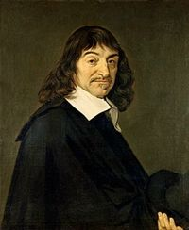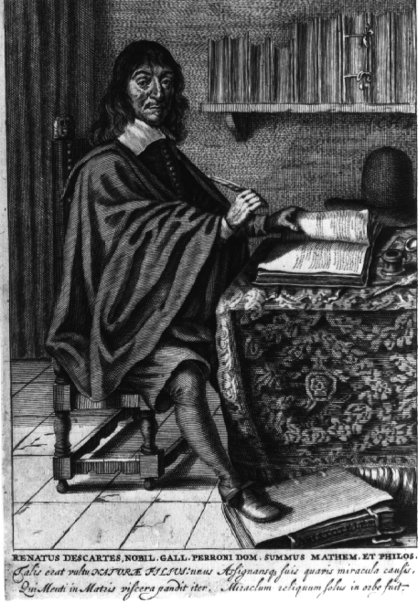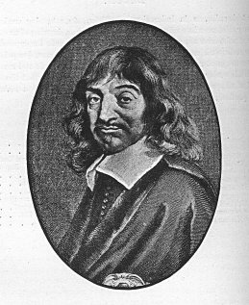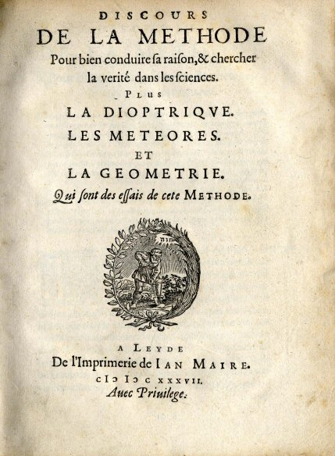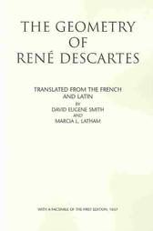
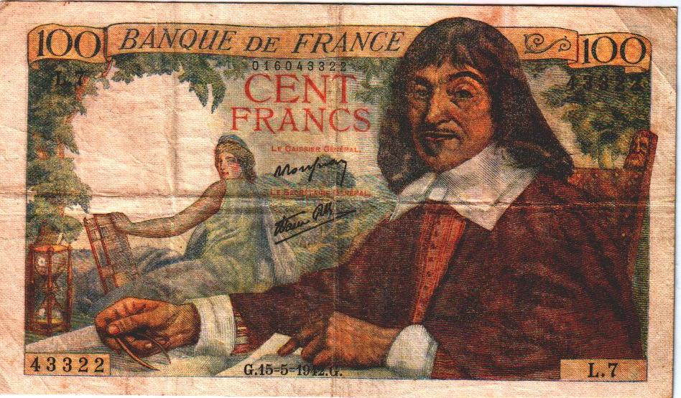

René Descartes (March 31, 1596 – February 11, 1650), also known by the name Cartesius, was a highly influential French philosopher, mathematician, and scientist. Dubbed the "Founder of Modern Philosophy" and the "Father of Modern Mathematics", much of subsequent western philosophy is a reaction to his writings, which have been closely studied from his time down to the present day. His influence in mathematics is also apparent, the Cartesian coordinate system used in plane geometry and algebra being named after him, and he was one of the key figures in the Scientific Revolution.
Descartes frequently contrasted his views with those of his predecessors. In the opening section of the Passions of the Soul, he goes so far as to assert that he will write on his topic "as if no one had written on these matters before". Nevertheless many elements of his philosophy have precedents in late Aristotelianism, the revived Stoicism of the 16th century, or in earlier philosophers like Augustine. In his natural philosophy, he differs from the Schools on two major points: first, he rejects the analysis of corporeal substance into matter and form; second, he rejects any appeal to ends—divine or natural—in explaining natural phenomena. In his theology, he insists on the absolute freedom of God’s act of creation.
Descartes was a major figure in 17th century continental rationalism, later advocated by Baruch Spinoza and Gottfried Leibniz, and opposed by the empiricist school of thought, consisting of Hobbes, Locke, Berkeley, and Hume. Leibniz, Spinoza and Descartes were all versed in mathematics as well as philosophy, and Descartes and Leibniz contributed greatly to science as well. As the inventor of the Cartesian coordinate system, Descartes founded analytic geometry, that bridge between algebra and geometry crucial to the invention of the calculus and analysis. Descartes's reflections on mind and mechanism began the strain of western thought that much later, impelled by the invention of the electronic computer and by the possibility of machine intelligence, blossomed into, e.g., the Turing test. His most famous statement is Cogito ergo sum (French: Je pense, donc je suis or in English: I think, therefore I am), found in §7 of Principles of Philosophy (Latin) and part IV of Discourse on Method (French).

Contents
- 1 Biography
- 2 Philosophical work
- 3 Mathematical legacy
- 4 Writings by Descartes
- 5 See also
- 6 References
- 7 Footnotes
- 8 External links
  - 8.1 Stanford Encyclopedia of Philosophy
  - 8.2 Further references

Biography
On March 31, 1596, Rene Descartes was born in La Haye en Touraine (now Descartes), Indre-et-Loire, France. When he was 1 year old, his mother died of tuberculosis. His father was a judge in the High Court of Justice. At the age of ten, he entered the Jesuit Collège Royal Henry-Le-Grand at La Flèche. After graduation, he studied at the University of Poitiers, earning a Baccalauréat and Licence in law in 1616, in accordance with his father's wishes that he become a lawyer.
Descartes never actually practiced law, however, and in 1618 he entered the service of Maurice of Nassau, leader of the United Provinces of the Netherlands. His intention was to see the world and to discover the truth.
"I entirely abandoned the study of letters. Resolving to seek no knowledge other than that which could be found in myself or else in the great book of the world, I spent the rest of my youth traveling, visiting courts and armies, mixing with people of diverse temperaments and ranks, gathering various experiences, testing myself in the situations which fortune offered me, and at all times reflecting upon whatever came my way so as to derive some profit from it. (Descartes, Discourse on the Method of Rightly Conducting One's Reason and Seeking the Truth in the Sciences)
Here he met Isaac Beeckman, who sparked his interest in mathematics and the new physics, particularly the problem of fall of heavy bodies. On November 10, 1619, while traveling in Germany and thinking about using mathematics to solve problems in physics, Descartes had a vision in a dream through which he "discovered the foundations of a marvelous science" ^{[1]}. This became a pivotal point in young Descartes's life and the foundation on which he develops analytical geometry. He dedicated the rest of his life to researching this connection between mathematics and nature.
In 1622 he returned to France, and during the next few years spent time in Paris and other parts of Europe. He arrived in La Haye in 1623, selling all of his property, investing this remuneration in bonds which provided Descartes with a comfortable income for the rest of his life. Descartes was present at the siege of La Rochelle by Cardinal Richelieu in 1627. He left for Holland in 1628, where he lived and changed his address frequently until 1649.
In 1633, Galileo was condemned by the Roman Catholic Church, and Descartes abandoned plans to publish Treatise on the World, his work of the previous four years.
Although Descartes never married, he fathered a daughter, the issue of an affair with a woman named Helene, Francine, born in 1635 and baptized on August 7 of the same year. Much to Descartes's distress, she died in 1640 at the age of 5.
Descartes continued to publish works concerning both mathematics and philosophy for the rest of his life. In 1643, Cartesian philosophy was condemned at the University of Utrecht, and Descartes began his long correspondence with Princess Elizabeth of Bohemia. In 1647, he was awarded a pension by the King of France. Descartes was interviewed by Frans Burman at Egmond-Binnen in 1648.
René Descartes died on February 11, 1650 in Stockholm, Sweden, where he had been invited as a teacher for Queen Christina of Sweden. The cause of death was said to be pneumonia - accustomed to working in bed until noon, he may have suffered a detrimental effect on his health due to Christina's demands for early morning study. Others believe that Descartes may have contracted pneumonia as result of nursing a French ambassador, ill with aforementioned disease, back to health. [1] However, letters to and from the doctor Eike Pies have recently been discovered which indicate that Descartes may have been poisoned using arsenic.
In 1663, the Pope placed his works on the Index of Prohibited Books.
As a Roman Catholic in a Protestant nation, he was interred in a graveyard mainly used for unbaptized infants in Adolf Fredrikskyrkan in Stockholm. Later, his remains were taken to France and buried in the church of Sainte-Geneviève-du-Mont in Paris. His memorial erected in the 18th century remains in the Swedish church.
During the French Revolution, his remains were disinterred for burial in the Panthéon among the great French thinkers. The village in the Loire Valley where he was born was renamed La Haye - Descartes in 1802, which was shortened to "Descartes" in 1967. Currently his tomb is in Saint-Germain-des-Prés' church in Paris.

[] Philosophical work
Descartes is often regarded as the first modern thinker to provide a philosophical framework for the natural sciences as these began to develop. In his Mations on First Philosophy he attempts to arrive at a fundamental set of principles that one can know as true without any doubt. To achieve this, he employs a method called methodological skepticism: he doubts any idea that can be doubted in order to acquire a firm foundation for genuine knowledge.
Initially, Descartes arrives at only a single principle: thought exists. Thought cannot be separated from me, therefore, I exist (Mations on First Philosophy). Most famously, this is known as cogito ergo sum, ("I think, therefore I am").
Therefore, Descartes concludes that he can be certain that he exists. But in what form? He perceives his body through the use of the senses; however, these have previously been proven unreliable. So Descartes concludes that the only undoubtable knowledge is that he is a thinking thing. Thinking is his essence as it is the only thing about him that cannot be doubted. Descartes defines "thought" (cogitatio) as "what happens in me such that I am immediately conscious of it, insofar as I am conscious of it". Thinking is thus every activity of a person of which he is immediately conscious.
To further demonstrate the limitations of the senses, Descartes proceeds with what is known as the Wax Argument. He considers a piece of wax: his senses inform him that it has certain characteristics, such as shape, texture, size, color, smell, and so forth. When he brings the wax towards a flame, these characteristics change completely. However, it seems that it is still the same thing: it is still a piece of wax, even though the data of the senses inform him that all of its characteristics are different. Therefore, in order to properly grasp the nature of the wax, he cannot use the senses: he must use his mind. Descartes concludes:
"Thus what I thought I had seen with my eyes, I actually grasped solely with the faculty of judgment, which is in my mind."
In this manner, Descartes proceeds to construct a system of knowledge, discarding perception as unreliable and instead admitting only deduction as a method. Halfway through the Mations, he offers an ontological proof of a benevolent God (through both the ontological argument and trademark argument). Because God is benevolent, he can have some faith in the account of reality his senses provide him, for God has provided him with a working mind and sensory system and does not desire to deceive him; however, this is a contentious argument, as his very notion of a benevolent God from which he developed this argument is easily subject to the same kind of doubt as his perceptions. From this supposition, however, he finally establishes the possibility of acquiring knowledge about the world based on deduction and perception. In terms of epistemology therefore, he can be said to have contributed such ideas as a rigorous conception of foundationalism and the possibility that reason is the only reliable method of attaining knowledge, as others said before him, though not as clearly as he did, and the rationalist answer to skepticism which other rationalists have elaborated on.
In Descartes's system, knowledge takes the form of ideas, and philosophical investigation is the contemplation of these ideas. This concept would influence subsequent internalist movements as Descartes's epistemology requires that a connection made by conscious awareness will distinguish knowledge from falsity. As a result of his Cartesian doubt, he sought for knowledge to be "incapable of being destroyed", in order to construct an unshakable ground from which all other knowledge can be based on. The first item of unshakable knowledge that Descartes argues for is the aforementioned cogito, or thinking thing.
Descartes also wrote a response to skepticism about the existence of the external world. He argues that sensory perceptions come to him involuntarily, and are not willed by him. They are external to his senses, and according to Descartes, this is evidence of the existence of something outside of his mind, and thus, an external world. Descartes goes on to show that the things in the external world are material by arguing that since God would not deceive him as to the ideas that are being transmitted, and that God has given him the "propensity" to believe that such ideas are caused by material things. Skeptics have responded to Descartes's proof for the external world by positing a brain in a vat thought experiment, in that Descartes's brain may be connected up to a machine which simulates all of these perceptions (though the vat itself would still be part of an external world, so this argument doesn't completely eliminate that outside the mind.)

[] Mathematical legacy
Descartes's theory provided the basis for the calculus of Newton and Leibniz, by applying infinitesimal calculus to the tangent problem, thus permitting the evolution of that branch of modern mathematics ^{[2]}. This appears even more astounding considering that the work was just intended as an example to his Discours de la méthode pour bien conduire sa raison, et chercher la verité dans les sciences (Discourse on the Method to Rightly Conduct the Reason and Search for the Truth in Sciences, known better under the shortened title Discours de la méthode).
Descartes's rule of signs is also a commonly used method in modern mathematics to determine possible quantities of positive and negative zeros of a function.
Descartes invented analytic geometry, and discovered the law of conservation of momentum. He outlined his views on the universe in his Principles of Philosophy.
Descartes also made contributions in the field of optics; for instance, he showed by geometrical construction using the Law of Refraction that the angular radius of a rainbow is 42° (i.e. the angle subtended at the eye by the edge of the rainbow and the ray passing from the sun through the rainbow's centre is 42°). ^{[3]}

[] Writings by Descartes
- 1618. Compendium Musicae. A treatise on music theory and the aesthetics of music written for Descartes's early collaborator Isaac Beeckman.
- 1626–1628. Regulae ad directionem ingenii (Rules for the Direction of the Mind). Incomplete. First published posthumously in 1684. The best critical ion, which includes an early Dutch translation, is ed by Giovanni Crapulli (The Hague: Martinus Nijhoff, 1966).
- 1630–1633. Le Monde (The World) and L'Homme (Man). Descartes's first systematic presentation of his natural philosophy. Man was first published in Latin translation in 1662; The World in 1664.
- 1637. Discours de la méthode (Discourse on Method). An introduction to the Essais, which include the Dioptrique, the Météores and the Géométrie.
- 1637. La Géométrie (Geometry). Descartes's major work in mathematics. There is an English translation by Michael Mahoney (New York: Dover, 1979).
- 1641. Mationes de prima philosophia (Mations on First Philosophy), also known as Metaphysical Mations. In Latin; a French translation, probably done without Descartes's supervision, was published in 1647. Includes six Objections and Replies. A second ion, published the following year, included an additional objection and reply, and a Letter to Dinet.
- 1644. Principia philosophiae (Principles of Philosophy). A Latin textbook at first intended by Descartes to replace the Aristotelian textbooks then used in universities. A French translation, Principes de philosophie by Claude Picot, under the supervision of Descartes, appeared in 1647 with a letter-preface to Queen Christina of Sweden.
- 1647. Notae in programma (Comments on a Certain Broadsheet). A reply to Descartes's one-time disciple Henricus Regius.
- 1647. The Description of the Human Body. Published posthumously.
- 1648. Responsiones Renati Des Cartes… (Conversation with Burman). Notes on a Q&A session between Descartes and Frans Burman on 16 April 1648. Rediscovered in 1895 and published for the first time in 1896. An annotated bilingual ion (Latin with French translation), ed by Jean-Marie Beyssade, was published in 1981 (Paris: PUF).
- 1649. Les passions de l'âme (Passions of the Soul). Dedicated to Princess Elizabeth of Bohemia.
- 1657. Correspondence. Published by Descartes's literary executor Claude Clerselier. The third ion, in 1667, was the most complete; Clerselier omitted, however, much of the material pertaining to mathematics.

[] See also
- Dualistic interactionism
- Baruch Spinoza
- Asteroid 3587 Descartes, named after the philosopher
- Defect (geometry)
- Analytic geometry
- Cartesian coordinate system
- Folium of Descartes
- Cartesian Circle

[] References
Collected works:
- 1983. Oeuvres de Descartes in 11 vols. Adam, Charles, and Tannery, Paul, eds. Paris: Librairie Philosophique J. Vrin.
Collected English translations:
- 1988. The Philosophical Writings Of Descartes in 3 vols. Cottingham, J., Stoothoff, R., Kenny, A., and Murdoch, D., trans. Cambridge University Press.
Single works:
- 1618. Compendium Musicae.
- 1628. Rules for the Direction of the Mind.
- 1637. Discourse on Method (‘’Discours de la Methode’’). An introduction to Dioptrique, Des Météores and La Géométrie. Original in French, because intended for a wider public.
- 1637. La Géométrie. Smith, David E., and Lantham, M. L., trans., 1954. The Geometry of René Descartes. Dover.
- 1641. Mations on First Philosophy. Cottingham, J., trans., 1996. Cambridge University Press. Latin original. Alternative English title: Metaphysical Mations. Includes six Objections and Replies. A second ion published the following year, includes an additional ‘’Objection and Reply’’ and a Letter to Dinet. HTML Online Latin-French-English ion
- 1644. Les Principes de la philosophie. Miller, V. R. and R. P., trans., 1983. Principles of Philosophy. Reidel.
- 1647. Comments on a Certain Broadsheet.
- 1647. The Description of the Human Body.
- 1648. Conversation with Burman.
- 1649. Passions of the Soul. Voss, S. H., trans., 1989. Indianapolis: Hackett. Dedicated to Princess Elizabeth of Bohemia.
Secondary literature:
- Keeling, S. V. (1968). Descartes. Oxford: Oxford University Press. ISBN.
- Boyer, Carl (1985). A History of Mathematics. Princeton, NJ: Princeton University Press. ISBN 0-691-02391-3.
- Clarke, Desmond (2006). Descartes: A Biography. Cambridge: Cambridge University Press. ISBN 0-521-82301-3.
- Farrell, John. “Demons of Descartes and Hobbes.” Paranoia and Modernity: Cervantes to Rousseau (Cornell UP, 2006), chapter seven.
- Sorrell, Tom (1987). Descartes. Oxford: Oxford University Press.. ISBN 0-19-287636-8.
- Costabel, Pierre (1987). Rene Descartes - Exercises pour les elements des solides. Paris: Presses Universitaires de France. ISBN 2-13-040099-X.
- Cottingham, John (1992). The Cambridge Companion to Descartes. Cambridge: Cambridge University Press. ISBN 0-521-36696-8.
- Garber, Daniel (1992). Descartes's Metaphysical Physics. Chicago: University of Chicago Press. ISBN 0-226-28219-8.
- Gaukroger, Stephen (1995). Descartes: An Intellectual Biography. Oxford: Oxford University Press. ISBN 0-19-823994-7.
- Garber, Daniel, Michael Ayers (1998). The Cambridge History of Seventeenth-Century Philosophy. Cambridge: Cambridge University Press. ISBN 0-521-53721-5.
- Melchert, Norman (2002). The Great Conversation: A Historical Introduction to Philosophy. New York: McGraw Hill. ISBN 0-19-517510-7.

[] Footnotes
- Keeling (1968).
- Cottingham et al. (1988).
- ^ (1911) Encyclopedia Britannica.
- ^ Gullberg, Jan (1997). Mathematics From The Birth Of Numbers. W. W. Norton. ISBN 0-393-04002-X.
- ^ Tipler, P. A. and G. Mosca (2004). Physics For Scientists And Engineers. W. H. Freeman. ISBN 0-7167-4389-2.
Citations: [2]

[] External links
- The Rationalists Web Web Guide, Full texts, extended bibliography, web resources;
- French Audio Book (mp3): excerpt about animals/machines from Discourse On the Method
- Discourse On the Method – at Project Gutenberg
- Selections from the Principles of Philosophy – at Project Gutenberg
- Detailed biography of Descartes
- CATHOLIC ENCYCLOPEDIA: Rene Descartes
- More easily readable versions of Mations, Discourse on the Method, and the Objections to the Mations and Descartes's Replies.
- Conscientia in Descartes
- Descartes and Ryle (lecture notes)
- The science of Rene Descartes

[] Stanford Encyclopedia of Philosophy
- Descartes's Epistemology
- Descartes's Ethics
- Descartes's Life and Works
- Descartes's Modal Metaphysics
- Descartes's Ontological Argument
- Descartes and the Pineal Gland

[] Further references
- Centro di Studi su Descartes e il Seicento, containing the Bulletin Cartésian online
- Centre d'études cartésiennes, Paris IV Sorbonne
- Research Centre for the Foundations of Modern Thought, University of Bucharest
=============================================================================================================================
END

