Susan Brownell Anthony 1820-1906

http://en.wikipedia.org/wiki/Susan_B._Anthony

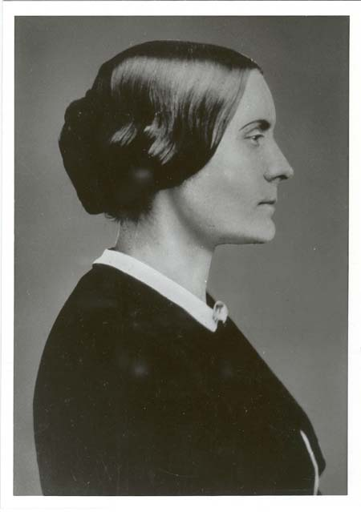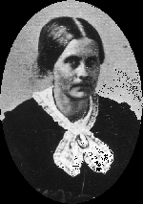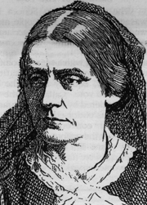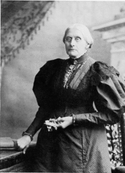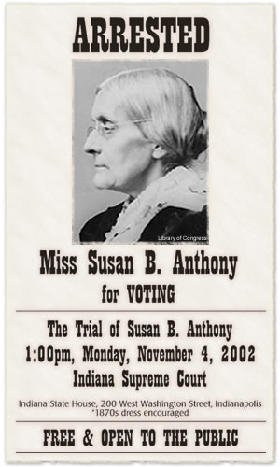

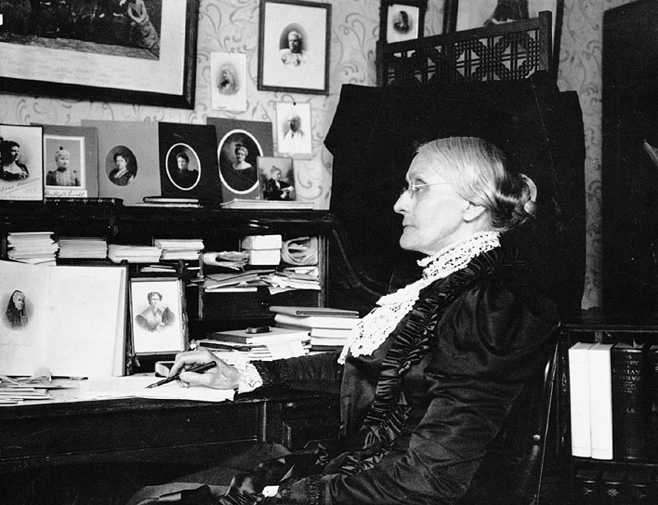

Susan Brownell Anthony (February 15, 1820 – March 13, 1906) was a prominent, independent and well-educated American civil rights leader who played a pivotal role in the 19th century women's rights movement to secure women's suffrage in the United States. She traveled thousands of miles throughout the United States and Europe, and gave 75 to 100 speeches per year on women's rights for some 45 years. Susan B. Anthony died in Rochester, New York, on March 13, 1906, and is buried at Mount Hope Cemetery.

Contents
[hide]
- 1 Early life
- 2 Early social activism
- 3 National suffrage organizations
- 4 United States vs. Susan B. Anthony
- 5 The court speech on women's right to vote
- 6 Legacy
- 7 References
- 8 External links

[] Early life
Anthony was born and raised in Adams, Massachusetts, the second of eight children. She was a precocious child, having learned to read and write at the age of three. Her father, cotton manufacturer and abolitionist Daniel Anthony, was a stern but open-minded man born into the Quaker religion. Her mother Lucy Read Anthony and Daniel fell in love during the years when Lucy was a student in Daniel's school. Although Lucy readily agreed to marry Daniel in 1817, she was less sure about marrying into the Society of Friends. She was not a convinced Quaker and claimed that she was “not good enough” to be a Quaker. In 1826, when the Quakers split into liberal and conservative camps, the Anthonys followed the liberals, known as the "Hicksite Friends", a group named after Elias Hicks.
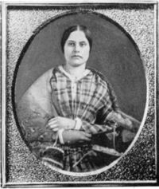
Susan Brownell Anthony, age 28

Daniel wished to raise his children in a moderately strict household, and did not allow Susan to experience what he perceived as the childish amusements of toys and games, which were seen as distractions from the “Inner Light”. However, Daniel was shunned by other Quakers for permitting dancing and citing a firm belief in "complete personal, mental and spiritual freedom" in his home.
Lucy was a progressive-minded woman. She attended the Rochester women’s rights convention held in August of 1848, two weeks after the historic Seneca Falls Convention, and signed the Rochester convention’s Declaration of Sentiments. Together the Anthony's enforced self-discipline, principled convictions, and belief in one's own self-worth.
In 1826, when Susan was six years old, the Anthony family moved from Massachusetts to Battenville, New York. Anthony was sent to attend a local district school where a teacher refused to teach her long division due to her gender. Upon learning of the weak education she was receiving, her father had her placed in a group home school that he had set up. A teacher there, named Mary Perkins, conveyed a progressive image of womanhood to Anthony, further fostering her growing belief in women's equality. In 1837, she was sent to Deborah Moulson's Female Seminary, a Quaker boarding school in Philadelphia.
Anthony was not happy at Moulson's, but she did not have to stay there long. She was forced to end her formal studies because her family, like many others, was financially ruined during the Panic of 1837. Their losses were so great that they were forced to attempt to sell everything in an auction, even their most personal belongings, which were saved at the last minute when Anthony's uncle, Joshua Read, stepped up and bid for them in order to restore them to the family.
In 1839, the family moved to Hardscrabble (later called Center Falls) New York, in the wake of the Panic and economic depression that followed. That same year, Anthony left home to teach and to help pay off her father's debts. She taught first at Eunice Kenyon's Friends' Seminary in New Rochelle, and then at the Canajoharie Academy in 1846, where she rose to become headmistress of the Female Department. Her occupation inspired her to fight for wages equivalent to those of male teachers, as, at the time, men earned roughly four times more than women for the same duties. She continued to teach until she was 29.
In 1849, Anthony quit teaching and moved to the family farm in Rochester, New York. It was in New York State that she began to first take part in conventions and gatherings related to the temperance movement. In Rochester, she attended the local Unitarian Church and began to distance herself from the Quakers, in part because she had frequently witnessed instances of hypocritical behavior such as alcohol abuse amongst Quaker preachers. As she got older, Anthony would continue to move further away from organized religion in general, and would later be chastised by various Christian religious groups for displaying atheistic tendencies.
In her youth, Susan was very self-conscious of her looks and speaking abilities. She long resisted public speaking for fear she would not be sufficiently eloquent. Despite these insecurities, she would become a renowned public presence, eventually helping to lead the women's movement.

[] Early social activism
In the decade before the American Civil War, Anthony took a prominent role in the New York anti-slavery and temperance movements. In 1849, at age 29, Anthony became secretary for the Daughters of Temperance, allowing her a forum to speak out against alcohol abuse, and beginning a movement towards the public limelight.
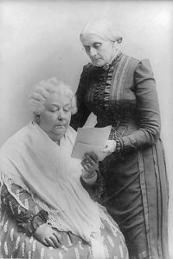
Anthony (standing) with Elizabeth Cady Stanton

In 1851, on a street in Seneca Falls, Anthony was introduced to Elizabeth Cady Stanton by mutual acquaintance and fellow feminist Amelia Bloomer. Anthony joined with Stanton in organizing the first women's state temperance society in America in 1852. Stanton would remain a close friend and colleague of Anthony's for the remainder of their lives, but unlike Anthony, Stanton longed for a broader, more radical women's rights platform. Together, the two women traversed the United States giving speeches and attempting to persuade the government that society should treat men and women equally.
After the first American women's rights convention took place on July 19 and 20, 1848, in Seneca Falls, New York, Anthony took the opportunity to attend and support the women's rights convention held in Syracuse, New York in 1852. It was around this time that Anthony began to gain widespread notoriety as a powerful public advocate of women's rights, and as a new and stirring voice for change.
In 1856, Anthony further attempted to unify the African-American and women's rights movements when she became agent for William Lloyd Garrison's American Anti-Slavery Society of New York State. Speaking at the Ninth National Women’s Rights Convention on May 12, 1859, Anthony asked "Where, under our Declaration of Independence, does the Saxon man get his power to deprive all women and Negroes of their inalienable rights?"
In 1869, long time friends Frederick Douglass and Susan B. Anthony found themselves, for the first time, on opposing sides of a debate. The Equal Rights Association, which had originally fought for both blacks’ and women’s right to suffrage, voted to support the 15th Amendment to the Constitution granting suffrage to black men, but not women. Anthony questioned why women should support this amendment when black men were not continuing to show support for women’s voting rights. Partially as a result of the decision by the Equal Rights Association, Anthony soon thereafter devoted herself almost exclusively to the agitation for women's rights.
On January 1, 1868, Susan B. Anthony first published a weekly journal entitled, The Revolution published in New York City, and having as its motto: "The true republic — men, their rights and nothing more; women, their rights and nothing less." Anthony worked as the publisher and business manager, while Elizabeth Cady Stanton acted as or. The main thrust of The Revolution was to promote women’s and African Americans’ right to suffrage, but it also discussed issues of equal pay for equal work, more liberal divorce laws, and the church’s position on women’s issues. The journal was funded by an independently wealthy man, named George Francis Train, who provided $600 in starting funds.
In the 19th century there were none of the standard contraceptive options available to women today, such as birth control, and abortion was a life-threatening and unsanitary procedure. Anthony occasionally wrote about abortion, which she opposed, and for which she blamed men, laws, and the "double standard", as women had no other options:^{[1]} "No matter what the motive, love of ease, or a desire to save from suffering the unborn innocent, the woman is awfully guilty who commits the deed. It will burden her conscience in life, it will burden her soul in death; But oh, thrice guilty is he who drove her to the desperation which impelled her to the crime! … All the articles on this subject that I have read have been from men. They denounce women as alone guilty, and never include man in any plans for the remedy." ^{[2]}
Pulitzer prize winner Stacy Schiff has discussed Anthony's opposition to abortion, saying that "...[although] Anthony deplored abortion, in 19th century abortion was life-threatening [and] it is impossible to know what Anthony would make of today's debate." Schiff cautions that "...thrusting historical figures into contemporary debate is treacherous because argument can be made for anything when words are taken out of context..." ^{[3]}
Anthony used The Revolution as a vehicle in her crusade for equality, writing passionately about a variety of subjects relating to women's rights.

[] National suffrage organizations
In 1869, Anthony and Stanton founded the National Woman's Suffrage Association (NWSA), an organization dedicated to gaining women's suffrage. Anthony was vice-president-at-large of the NWSA from the date of its organization until 1892, when she became president.
In the early years of the NWSA, Anthony made attempts to unite women in the labor movement with the suffragist cause, but with little success. She and Stanton were delegates at the 1868 convention of the National Labor Union. However, Anthony inadvertently alienated the labor movement not only because suffrage was seen as a concern for middle-class rather than working-class women, but because she openly encouraged women to achieve economic independence by entering the printing trades, where male workers were on strike at the time. Anthony was later expelled from the National Labor Union over this controversy.
In 1890, Anthony orchestrated the merger of the NWSA with the more conservative American Woman Suffrage Association (AWSA), creating the National American Woman Suffrage Association. Prior to the controversial merge, Anthony had created a special NWSA executive committee to vote on whether they should merge with the AWSA, despite the fact that using a committee instead of an all-member vote went against the NWSA constitution. Motions to make it possible for members to vote by mail were strenuously opposed by Anthony and her adherents, and the committee was stacked with members who favored the merger. (Two members who voted against the merger were asked to resign).
Anthony's pursuit of alliances with moderate and conservative suffragists created long lasting tension between herself and more radical suffragists like Stanton. Anthony felt strongly that a moderate rather than radical approach to women's rights was more realistic, and would consequently serve to gain more for women in the long-run. Anthony's strategy was to unite the suffrage movement wherever possible and to then concentrate strictly on gaining the vote, temporarily postponing other efforts related to women's rights in order to focus attention on a singular cause. Stanton openly criticized Anthony's stance, writing that Anthony and AWSA leader Lucy Stone, "see suffrage only. They do not see woman's religious and social bondage." Anthony responded to Stanton: "We number over 10,000 women and each one has opinions...we can only hold them together to work for the ballot by letting alone their whims and prejudices on other subjects."
The creation of the NAWSA effectively marginalized the more radical elements within the women's movement, including Stanton. Anthony pushed for Stanton to be voted in as the first NAWSA president, and stood by her as Stanton was belittled by the large conservative factions within the new organization.
In collaboration with Stanton, Matilda Joslyn Gage, and Ida Husted Harper, Anthony published The History of Woman Suffrage (4 vols., New York, 1884–1887). Anthony also befriended Josephine Brawley Hughes, an advocate of women's rights and of alcohol abolition in Arizona, and Carrie Chapman Catt, whom Anthony endorsed for the presidency of the NAWSA when Anthony formally retired in 1900.

[] United States vs. Susan B. Anthony
For casting a vote in the presidential election held on November 5, 1872, in Rochester, New York, Anthony was arrested on November 18 and pled not guilty, asserting that the 14th amendment entitled her to vote because, unlike the original Constitution, it provides that all "persons" (which includes females) born in the US are "citizens" who shall not be denied the "privileges" of citizenship (which includes voting).
She was defended at trial by Matilda Joslyn Gage, who asserted that it was the United States that was truly on trial, not Anthony. At the trial, Anthony made her famous On Women's Right to Vote speech (see in the next section below), which asserted that casting her vote in the previous presidential election was not a crime but the legal right of a United States citizen. Citing the Constitution, her speech was a strong attempt to persuade the federal government that she was not unlawful in her action, and if she were male, her behavior would have never been questioned.
However, her defense was all for naught. The judge, Supreme Court Associate Justice Ward Hunt, explicitly instructed the jury to deliver a guilty verdict, refused to poll the jury, delivered an opinion he had written before trial had even begun, and on June 18, 1873, sentenced her to pay a $100 fine. Anthony responded, "May it please your honor, I will never pay a dollar of your unjust penalty." She never did pay the fine, and the government never pursued her for nonpayment.

[] The court speech on women's right to vote
In 1873, Susan B. Anthony recited a now famous speech before court, in defense of women's suffrage. The following is a summary of her remarks:
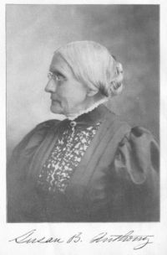
"Friends and fellow citizens: I stand before you tonight under indictment for the alleged crime of having voted at the last presidential election, without having a lawful right to vote. It shall be my work this evening to prove to you that in thus voting, I not only committed no crime, but, instead, simply exercised my citizen's rights, guaranteed to me and all United States citizens by the National Constitution, beyond the power of any state to deny.
The preamble of the Federal Constitution says: "We, the people of the United States, in order to form a more perfect union, establish justice, insure domestic tranquility, provide for the common defense, promote the general welfare, and secure the blessings of liberty to ourselves and our posterity, do ordain and establish this Constitution for the United States of America."
It was we, the people; not we, the white male citizens; nor yet we, the male citizens; but we, the whole people, who formed the Union. And we formed it, not to give the blessings of liberty, but to secure them; not to the half of ourselves and the half of our posterity, but to the whole people - women as well as men. And it is a downright mockery to talk to women of their enjoyment of the blessings of liberty while they are denied the use of the only means of securing them provided by this democratic-republican government - the ballot.
For any state to make sex a qualification that must ever result in the disfranchisement of one entire half of the people, is to pass a bill of attainder, or, an ex post facto law, and is therefore a violation of the supreme law of the land. By it the blessings of liberty are forever withheld from women and their female posterity. To them this government has no just powers derived from the consent of the governed. To them this government is not a democracy. It is not a republic. It is an odious aristocracy; a hateful oligarchy of sex; the most hateful aristocracy ever established on the face of the globe; an oligarchy of wealth, where the rich govern the poor. An oligarchy of learning, where the educated govern the ignorant, or even an oligarchy of race, where the Saxon rules the African, might be endured; but this oligarchy of sex, which makes father, brothers, husband, sons, the oligarchs over the mother and sisters, the wife and daughters, of every household - which ordains all men sovereigns, all women subjects, carries dissension, discord, and rebellion into every home of the nation.
Webster, Worcester, and Bouvier all define a citizen to be a person in the United States, entitled to vote and hold office. The only question left to be settled now is: Are women persons? And I hardly believe any of our opponents will have the hardihood to say they are not. Being persons, then, women are citizens; and no state has a right to make any law, or to enforce any old law, that shall abridge their privileges or immunities. Hence, every discrimination against women in the constitutions and laws of the several states is today null and void, precisely as is every one against Negroes."

[] Legacy
Susan B. Anthony was honored as the first real (non-allegorical) American woman on circulating U.S. coinage with her appearance on the Susan B. Anthony dollar. The coin, approximately the size of a U.S. quarter, was minted for only four years, 1979, 1980, 1981, and 1999. Anthony dollars were produced at the Philadelphia and Denver mints for all four of these years, and at the San Francisco mint for all production years except 1999.
Anthony's birthplace in Adams was purchased in 2006 by Carol Crossed, affiliated with both Democrats for Life of America and Feminists for Life. She has stated that efforts will be made to open the home to the public in the near future.^{[4]}
The American composer Virgil Thomson and poet Gertrude Stein wrote an opera, The Mother of Us All, that abstractly explores Anthony's life and mission.

[] References
- ^ Susan B. Anthony at womenshistory.com
- ^ The Revolution, IV, No. 1 (July 8, 1869)
- ^ New York Times October 13, 2006
- ^ Suffragist leader's home sold for $164K
- Baker, Jean H. Sisters: The Lives of America's Suffragists. Hill and Wang, New York, 2005. ISBN 0-8090-9528-9.
- Barry, Kathleen , Susan B. Anthony: A Biography of a Singular Feminist, Authorhouse 2000, ISBN 1-58721-009-6
- Bass, Jack. "CIVIL RIGHTS: Judges followed Parks' bold lead." 27 November 2005. Atlanta Journal Constitution. LexisNexis. 5 March 2006. <http:/web.lexisnexis.com/universe/document?_m=00a2bc74653371...>.
- Boller, Paul F., Jr. "Presidential Campaigns." Oxford University Press, 1984.
- "From Kansas." Proquest Historical Newspapers Chicago Tribune. 7 September 1876. O1
- Harper, Mrs Ida Husted. Life and Work of Susan B. Anthony (3 vols., Indianapolis, 1898-1908)
- Linder, Douglas. "Susan B. Anthony: A Biography." Law.umkc.edu. 2001. 05 March 2006 22 October 2005 http://www.law.umkc.edu/faculty/projects/ftrials/anthony/sbabiog.html
- Linder, Douglas. "Famous American Trials: The Anthony Trial: An Account." Argument for the Defense Concerning Legal Issues in the Case of: United States vs. Susan B. Anthony. 2001. 5 March 2006. <http://www.law.umkc.edu/faculty/projects/ftrials/anthony/defargument.html>
- McCulloch, John. "The Struggle for Women's Suffrage in Queensland." Hecate: 1874.
- Patriot Ledger Staff. "Role model: Susan B. Anthony to come to life." The Patriot Ledger: City ion. LexisNexis., Quincy, MA. 1 MArch 2006 <http://lexis-nexis.com/universe/document?_m=969f13ed043290...>.
- "Suffragist." Susan B. Anthony House. 03 2006. 18 Mar. 2006 <http://susanbanthonyhouse.org/index.shtml>.
- "Susan B. Anthony." The National Women's History Project. 1994 18 Mar. 2006 <http://www.mith2.umd.edu/WomensStudies/PictureGallery/anthony.html>.
- "Susan Brownwell Anthony." Women in History. Women in History: Living Vignettes of Women From the Past. 21 Mar. 2006
- "The Women in the Field." Proquest Historical Newspaper Chicago Tribune. 9 July 1868. O3.
- Stories in Stone - "Famous People in Mount Hope Cemetery, Lucy Read Anthony"<http://www.fomh.org/stories.php?subaction=showfull&id=1120617483&archive=&start_from=&ucat=1&>
- Western New York Suffragists - "Susan Brownell Anthony"<http://www.winningthevote.org/SBAnthony.html>

[] External links
- The Elizabeth Cady Stanton and Susan B. Anthony Papers Project, Rutgers University
- The Life and Work of Susan B. Anthony (Volume 1 of 2), by Ida Husted Harper, available freely at Project Gutenberg
- The Trial of Susan B. Anthony, available freely at Project Gutenberg
- First Unitarian Church
- Susan B. Anthony House Website
- Anthony trial
- New York Times obituary
Retrieved from "http://en.wikipedia.org/wiki/Susan_B._Anthony"
Categories: American skeptics | American women's rights activists | American feminists | American suffragists | Social entrepreneurs | American Unitarians | American vegetarians | People from Rochester, New York | People from Berkshire County, Massachusetts | 1820 births | 1906 deaths | American abolitionists
====================================================================================================================================
END

