The Piri Re'is Map
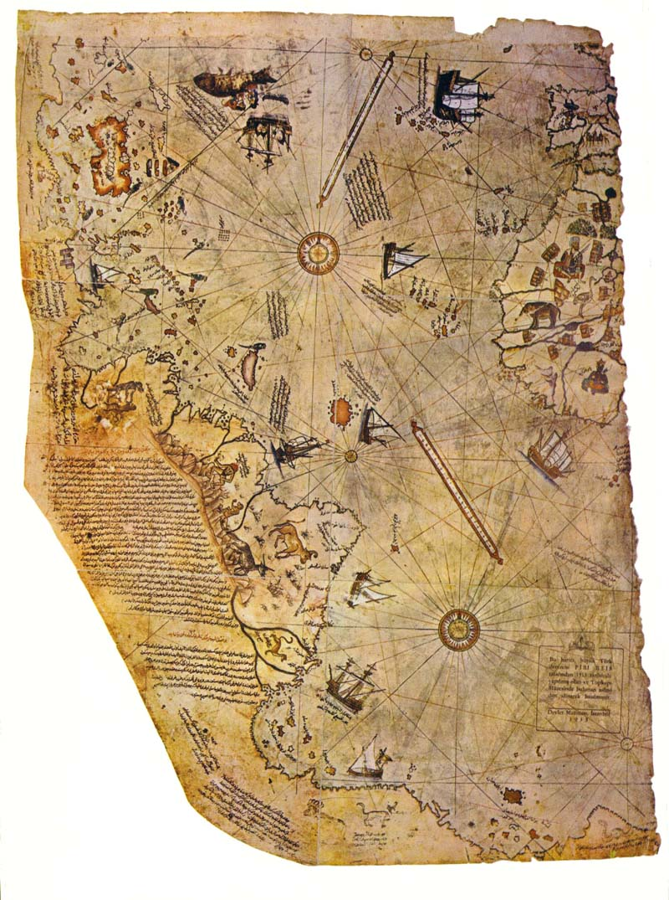

http://www.sacred-texts.com/piri/index.htm
Most theories about ancient unknown civilizations are based on absolutely no physical evidence, usually just hearsay and speculation. What really would shake the basis of our knowledge of history would be an actual artifact. This probably wouldn't be something spectacular like finding a sunken city in the Atlantic, or armor-piercing bullets embedded in a dinosaur skeleton. It would probably be something that only an expert in the field would recognize as anomalous.
More likely, this artifact would be a document or tradition from the past which reveals a deep understanding of some scientific fact recently discovered. This could be a description of the structure and function of DNA, knowledge of astronomy or physics which is only known to modern science . . . or accurate maps of the earth drawn long before the "Age of Exploration". The Piri Re'is map appears to be just that artifact.
The Piri Re'is Map is only one of several anomalous maps drawn in the 15th Century and earlier which appear to represent better information about the shape of the continents than should have been known at the time. Furthermore, this information appears to have been obtained at some distant time in the past.
Piri Re'is, Ptolomy (2nd Century A.D.), as well as Mercator and Oronteus Finaeus, well-known 15th Century map-makers, included the traditional southern continent in their world maps, as did others. Antarctica was not discovered until the 19th Century, and it was largely unexplored until the middle of the 20th. This is just the start. Anomalous maps also show the Behring Strait as linking Asia and America, river deltas which appear much shorter than they do today, islands in the Aegean which haven't been above water since the sea-level rise at the end of the ice-age and huge glaciers covering Britian and Scandinavia. Long dismissed as attempts by cartographers to fill in empty spaces, some of the details of the old maps look very startling when correlated with modern (very mainstream) knowledge of the changes in the Earths' geography in the geologic past, particularly during the Ice Ages.
The Piri Re'is map is most interesting because of the attribution of the source of its information, and the extraordinary detail of the coastal outlines.
The Piri Re'is map was found in 1929 in the Imperial Palace in Constantinople. It is painted on parchment and dated 919 A.H. (in the Islamic calendar), which corresponds to 1513 AD. It is signed by an admiral of the Turkish Navy named Piri Ibn Haji Memmed, also known as Piri Re'is. According to Piri Re'is, the map had been assembled from a set of 20 maps drawn in the time of Alexander the Great.
This map and others were analyzed by Charles H. Hapgood and his graduate stutents. Hapgood was a historian and geographer at the University of New Hampshire, in his book Maps of the Ancient Sea Kings (1966). Only the conclusions of this book are sensational; for the most part it is a technical monograph on the history and geography of the anomalous maps, employing spherical trigonometry to associate map features with actual geographic locations. This book has recently been republished, and we highly recommend it.
The conclusion that Hapgood reached was that a civilization with high seafaring and mapping skills surveyed the entire earth in the ancient past. They left maps which have been copied by hand through many generations. The Piri Re'is map is a patchwork which has gaps (most notably the Drake Passage between South America and Antarctica) which can be explained as non-overlapping areas between the source maps. Maps of the Ancient Sea Kings and Hapgood's other book The Earth's Shifting Crust, in which he advanced a theory of polar shifts, are controversial, and earned him the scorn of offical academia.
More evidence has appeared in recent years. Hapgood may yet be vindicated (at least his guess as to the signficance of the anomalous maps). The Piri Re'is map is one of the cornerstones of the growing body of evidence for an unknown Ice Age civilization. Along with this we can include the book Hamlet's Mill, by De Santillana and von Dechend (1969), and the works of Graham Hancock.
One striking thing about this map is the level of detail of the coasts and interiors in South America. Although the scale is somewhat off, a long, high mountain range is shown as the source of the rivers flowing to the coast of South America.
However, the best-known feature in the Piri Re'is map (and other pre-modern maps) is the Antarctic coastline. In Hapgood and others' opinions, this represents the outline of the coast of Antarctica without glaciers.
Our modern knowledge of the coastline under the ice was obtained using seismic sounding data from Antarctic expeditions in the 1940s and 50s. Sonar is one way to map the coast under the Antarctic glaciers. The other way would be to have surveyed them when they were ice-free. According to Hapgood, who based the claim on 1949 core samples from the Ross Sea, the last time the particular area shown in the Piri Re'is map was free of ice was more than 6000 years ago. More recent studies show that this may be off by a couple of orders of magnitude. In any case, this geography should have been unknown to the ancients. If this is correct, there are some big mysteries to explain.
A number of writers have rushed in and attempted to do just this. One school of thought about the Piri Re'is map is the 'Atlantis in Antarctica' thesis. The chief proponents of this are Rand and Rose Flem-Ath in their book When the Sky Fell, though there are others. The Flem-Aths buy into both Hapgoods' Sea Kings and Polar shift thesis. In the latter, Hapgood claimed that the inclination of the Earth's axis of rotation shifted suddenly in the year 9,500 B.C. causing Antarctica to move hundreds of miles to the south. This transformed its climate from semi-temperate to freezing. In contrast to the Sea Kings hypothesis, there is no evidence that a rapid polar shift actually occured at this time and much negative evidence that it didn't.
There is no scientific explanation for a mechanism which could cause such a global transformation in a matter of hours without completely destroying the crust of the planet. A planetary collision would be required, of the sort that has not occurred since the early period of planetary formation. If such a collision occured in 9,500 B.C., it is fairly certain that all life on Earth would have been wiped out, which is obviously not the case. While it is not impossible that some instability in the planet could cause the Earth's axis to change its inclination, this would not occur overnight. Additionally, a polar shift would probably leave an obvious mark in the geomagnetic strata found in sea floor cores, which is not the case.
Much has been made of Einstein's endorsement of Hapgood's polar shift theory. This proves nothing, since Einstein was not a geologist. Furthermore, although Einstein's theories have stood up to rigorous experimental and observational evidence, it's important to note that he was a human being and wasn't always right. Part of Einstein's greatness was his ability to admit his errors.
In any case, the Flem-Aths propose that this shift destroyed a hypothetical Antarctic civilization, located somewhere in the present-day Ross penninsula. They attempt (with mixed success) to relate this to Plato's Atlantis. Unfortunately, proving this would involve doing archaeology under an ice sheet thousands of meters thick. This is an excellent example of 'extraordinary claims require extraordinary proof'.
One subconscious influence on this may be fantasy writer H.P. Lovecraft's Cthulhu mythos, which places the abode of the Ancient Gods, R'lyeh, in Antarctica. Lovecraft's mythos is completly fictional, even if it has resemblances to actual mythologies.
While features suggestive of advanced geographical knowledge are shown in the map itself, the annotations and illustrations paint a different picture. Skeptics will note that the Piri Re'is map of the Antarctic coast, of which so much has been made, is notated as follows:
This country is a waste. Everything is in ruin and it is said that large snakes are found here. For this reason the Portuguese infidels did not land on these shores and these are also said to be very hot.
There are also pictures of some mythical animals in the same vicinity, of which the text reads:
And in this country it seems that there are white-haired monsters in this shape, and also six-horned oxen. The Portuguese infidels have written it in their maps. . . .
This doesn't invalidate the startling landforms, but does indicate that whoever wrote these notes (presumably Piri Re'is) never actually visited Antarctica. Non-skeptics might argue that when the source map was surveyed there could have been 1) large snakes, 2) unknown varieties of land mammals, as well as a 3) "very hot" climate in Antarctica, but there is no physical evidence that this has ever been the case. This also does not explain the other fanciful illustrations and notations on the map, including a sketch of a red-haired headless man (with his face on his chest) in the Andes area. This takes us out of the realm of the possible into the fantastic, a line which Hapgood was careful not to cross, at least in Maps of the Ancient Sea Kings.
-- J.B. Hare
Text on this page is © Copyright 2001, J.B. Hare.

The Piri Re'is map
The image here was scanned from the frontpiece of a first edition of Hapgood's Maps of the Ancient Sea Kings. It is included here for non-profit archival and research purposes only.
Click here for translation of the map text

Key to the Piri Re'is Map
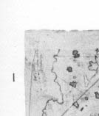 | 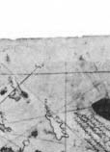 | 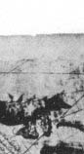 | 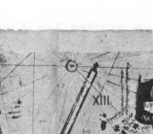 | 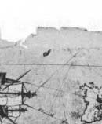 | 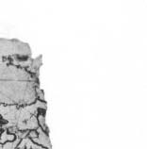
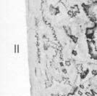 | 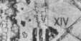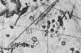 | 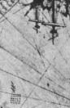 | 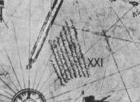 | 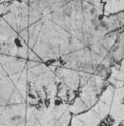 | 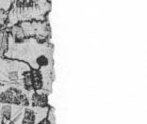
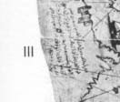 | 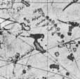 | 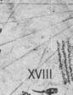 | 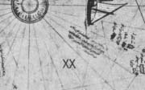 | 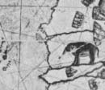 | 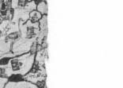
 | 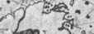 | 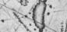 | 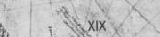 | 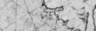 | 
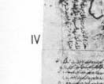 | 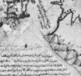 | 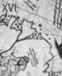 | 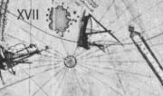 | 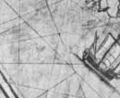 | 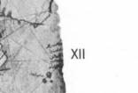
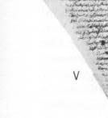 | 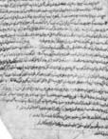 | 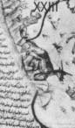 | 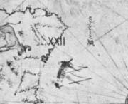 | 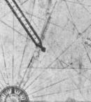 | 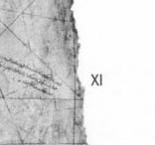
 | 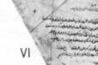 | 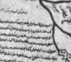 | 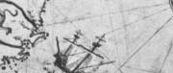 | 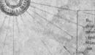 | 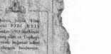
 | 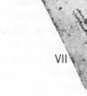 | 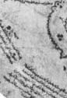 | 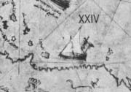 | 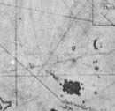 | 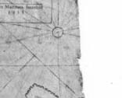
 |  | 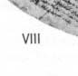 | 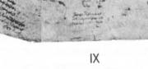 | 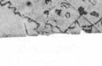 | 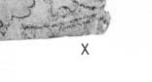

[From "The Oldest Map of America," by Professor Dr. Afet Inan. Ankara, 1954, pp. 28-34.]
I. There is a kind of red dye called vakami, that you do not observe at first, because it is at a distance . . . the mountains contain rich ores. . . . There some of the sheep have silken wool.
II. This country is inhabited. The entire population goes naked.
III. This region is known as the vilayet of Antilia. It is on the side where the sun sets. They say that there are four kinds of parrots, white, red, green and black. The people eat the flesh of parrots and their headdress is made entirely of parrots' feathers. There is a stone here. It resembles black touchstone. The people use it instead of the ax. That it is very hard . . . [illegible]. JPe saw that stone.
[NOTE: Piri Reis writes in the "Babriye": "In the enemy ships which we captured in the Mediterranean, we found a headdress made of these parrot feathers, and also a stone resembling touchstone."]
IV. This map was drawn by Piri Ibn Haji Mehmed, known as the nephew of Kemal Reis, in Gallipoli, in the month of muharrem of the year 919 (that is, between the 9th of March and the 7th of April of the year 1513).
V. This section tells how these shores and also these islands were found.
These coasts are named the shores of Antilia. They were discovered in the year 896 of the Arab calendar. But it is reported thus, that a Genoese infidel, his name was Colombo, be it was who discovered these places. For instance, a book fell into the hands of the said Colombo, and be found it said in this book that at the end of the Western Sea [Atlantic] that is, on its western side, there were coasts and islands and all kinds of metals and also precious stones. The above-mentioned, having studied this book thoroughly, explained these matters one by one to the great of Genoa and said: "Come, give me two ships, let me go and find these places." They said: "O unprofitable man, can an end or a limit be found to the Western Sea? Its vapour is full of darkness." The above-mentioned Colombo saw that no help was forthcoming from the Genoese, he sped forth, went to the Bey of Spain [king], and told his tale in detail. They too answered like the Genoese. In brief Colombo petitioned these people for a long time, finally the Bey of Spain gave him two ships, saw that they were well equipped, and said:
"O Colombo, if it happens as you say, let us make you kapudan [admiral] to that country." Having said which he sent the said Colombo to the Western Sea. The late Gazi Kemal had a Spanish slave. The above-mentioned slave said to Kemal Reis, he had been three times to that land with Colombo. He said: "First we reached the Strait of Gibraltar, then from there straight south and west between the two . . . [illegible]. Having advanced straight four thousand miles, we saw an island facing us, but gradually the waves of the sea became foamless, that is, the sea was becalmed and the North Star--the seamen on their compasses still say star--little by little was veiled and became invisible, and be also said that the stars in that region are not arranged as here. They are seen in a different arrangement. They anchored at the island which they had seen earlier across the way, the population of the island came, shot arrows at them and did not allow them to land and ask for information. The males and the females shot hand arrows. The tips of these arrows were made of fishbones, and the whole population went naked and also very . . . [illegible]. Seeing that they could not land on that island; they crossed to the other side of the island, they saw a boat. On seeing them; the boat fled and they [the people in the boat] dashed out on land. They [the Spaniards] took the boat. They saw that inside of it there was human flesh. It happened that these people were of that nation which went from island to island hunting men and eating them. They said Colombo saw yet another island, they neared it, they saw that on that island there were great snakes. They avoided landing on this island and remained there seventeen days. The people of this island saw that no harm came to them from this boat, they caught fish and brought it to them in their small ship's boat [filika]. These [Spaniards] were pleased and gave them glass beads. It appears that he [Columbus] had read-in the book that in that region glass beads were valued. Seeing the beads they brought still more fish. These [Spaniards] always gave them glass beads. One day they saw gold around the arm of a woman, they took the gold and gave her beads. They said to them, to bring more gold, we will give you more beads, [they said]. They went and brought them much gold. It appears that in their mountains there were gold mines. One day, also, they saw pearls in the hands of one person. They saw that when; they gave beads, many more pearls were brought to them. Pearls were found on the shore of this island, in a spot one or two fathoms deep. And also loading their ship with many logwood trees and taking two natives along, they carried them within that year to the Bey of Spain. But the said Colombo, not knowing the language of these people, they traded by signs, and after this trip the Bey of Spain sent priests and barley, taught the natives how to sow and reap and converted them to his own religion. They had no religion of any sort. They walked naked and lay there like animals. Now these regions have been opened to all and have become famous. The names which mark the places on the said islands and coasts were given by Colombo, that these places may be known by them. And also Colombo was a great astronomer. The coasts and island on this map are taken from Colombo's map.
VI. This section shows in what way this map was drawn. In this century there is no map like this map in anyone's possession. The--hand of this poor man has drawn it and now it is constructed. From about twenty charts and Mappae Mundi--these are charts drawn in the days of Alexander, Lord of the Two Horns, which show the inhabited quarter of the world; the Arabs name these charts Jaferiye--from eight Jaferiyes of that kind and one Arabic map of Hind, and from the maps just drawn by four Portuguese which show the countries of Hind, Sind and China geometrically drawn, and also from a map drawn by Colombo in the western region I have extracted it. By reducing all these maps to one scale this final form was arrived at. So that the present map is as correct and reliable for the Seven Seas as the map of these our countries is considered correct and reliable by seamen.
VII. It is related by the Portuguese infidel that in this spot night and day are at their shortest of two hours, at their longest of twenty two hours. But the day is very warm and in the night there is much dew.
VIII. On the way to the vilayet of Hind a Portuguese ship encountered a contrary wind [blowing] from the shore. The wind from the shore . . . [illegible] it [the ship]. After being driven by a storm in a southern direction they saw a shore opposite them they advanced towards it [illegible]. They saw that these places are good anchorages. They threw anchor and went to the shore in boats. They saw people walking, all of them naked. But they shot arrows, their tips made of fishbone. They stayed there eight days. They traded with these people by signs. That barge saw these lands and wrote about them which. . . . The said barge without going to Hind, returned to Portugal, where, upon arrival it gave information. . . . They described these shores in detail. . . . They have discovered them.
IX. And in this country it seems that there are white-haired monsters in this shape, and also six-horned oxen. The Portuguese infidels have written it in their maps. . . .
X. This country is a waste. Everything is in ruin and it is said that large snakes are found here. For this reason the Portuguese infidels did not land on these shores and these are also said to be very hot.
XI. And these four ships are Portuguese ships. Their shape is written down. They travelled from the western land to the point of Abyssinia [Habesh] in order to reach India. They said towards Shuluk. The distance across this gulf is 4200 miles.
XII. .... On this shore a tower
.... is however
.... in this climate gold
.... taking a rope
.... is said they measured
[NOTE: The fact that half of each of these lines is missing is the clearest proof of the map's having been torn in two.]
XIII. And a Genoese kuke [a type of ship] coming from Flanders was caught in a storm. Impelled by the storm it came upon these islands, and in this manner these islands became known.
XIV. It is said that in ancient times a priest by the name of Sanvolrandan (Santo Brandan) travelled on the Seven Seas, so they say. The above-mentioned landed on this fish. They thought it dry land and lit a fire upon this fish, when the fish's back began to burn it plunged into the sea, they reembarked in their boats and fled to the ship. This event is not mentioned by the Portuguese infidels. It is taken from the ancient Mappae Mundi.
XV. To these small islands they have given the name of Undizi Vergine. That is to say the Eleven Virgins.
XVI. And this island they call the Island of Antilia. There are many monsters and parrots and much logwood. It is not inhabited.
XVII. This barge was driven upon these shores by a storm and remained where it fell. . . . Its name was Nicola di Giuvan. On his map it is written that these rivers which can be seen have for the most part gold [in their beds]. When the water had gone they collected much gold [dust] from the sand. On their map. . . .
XVIII. This is the barge from Portugal which encountered a storm and cam( to this land. The details are written on the edge of this map. [NOTE: see VIII.]
XIX. The Portuguese infidels do not go west of here. All that side belongs entirely to Spain. They have made an agreement that [a line] two thousand miles to the western side of the Strait of Gibraltar should be taken as a boundary. The Portuguese do not cross to that side but the Hind side and the southern side belong to the Portuguese.
XX. And this caravel having encountered a storm was driven upon this island. Its name was Nicola Giuvan. And on this island there are many oxen with one horn. For this reason they call this island Isle de Vacca, which means, Ox Island.
XXI. The admiral of this caravel is named Messir Anton the Genoese, but be grew up in Portugal. One day the above-mentioned caravel encountered a storm, it was driven upon this island. He found much ginger here and has written about these islands.
XXII. This sea is called the Western Sea, but the Frank sailors call it the Mare d'Espagna. Which means the Sea of Spain. Up to now it was known by these names, but Colombo, who opened up this sea and made these islands known, and also the Portuguese, infidels who have opened up the region of Hind have agreed together to give this sea a new name. They have given it the name of Ovo Sano [Oceano] that is to say, sound egg. Before this it was thought that the sea had no end or limit, that at its other end was darkness. Now they have seen that this sea is girded by a coast, because it is like a lake, they have called it Ovo Sano.
XXIII. In this spot there are oxen with one horn, and also monsters in this shape.
XXIV. These monsters are seven spans long. Between their eyes there is a distance of one span. But they are harmless souls.

==================================================================================================================================================
http://www.mindspring.com/~hellfire/bishop/
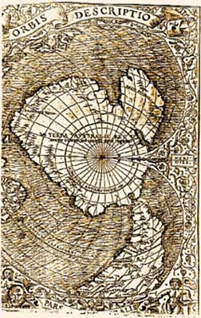
THE ORONTEUS FINAEUS MAP OF ANTARCTICA OF 1532
One of a number of Medieval and Renaissance maps compiled at a time when much earlier source maps from remote antiquity were apparently still available. Antique maps and now lost manuscripts survived until the 1400s and beyond, for example, in Spain, and in Constantinople, which only fell to the Turks in 1453. Some of these materials turned up as recently as World War I. Hapgood's team at Keene State College, who analyzed the Finaeus map, submitted it to Captain (later Lt. Col.) Lorenzo W. Burroughs and his team at the Cartographic Section at Westover AFB. Burroughs wrote Hapgood: "It is our opinion that the accuracy of the cartographic features shown...suggest, beyond doubt, that it also was compiled from accurate source maps of Antartica ...the original source maps must have been compiled at a time when the land mass and inland waterways of the continent were relatively free of ice..." Col. Burroughs later was a leading analyst for the National Photographic Interpretation Center, a joint CIA/DOD high level intelligence asset.

V

