**Origins of The Shaka, As Told in the World’s Oldest Language, Symbolism**

**By Joseph O. Gill July 4th 2013**

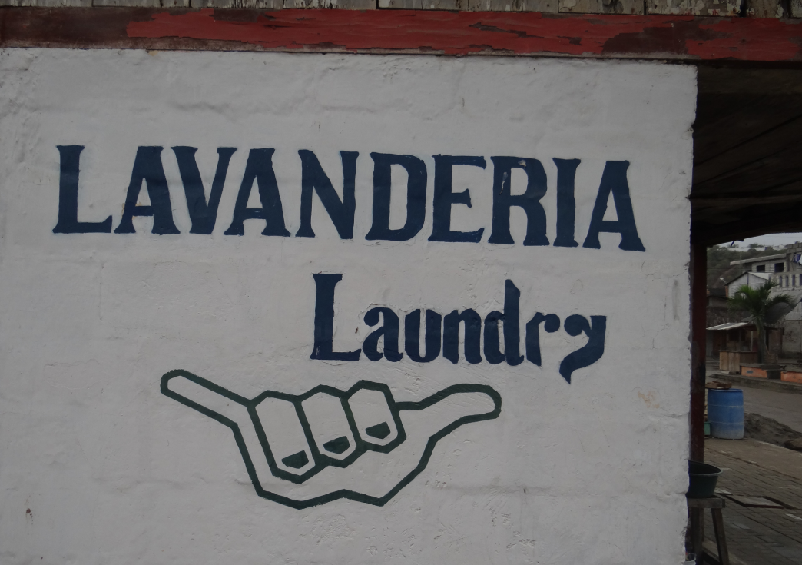 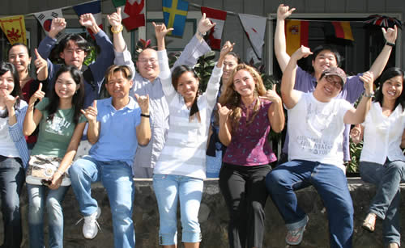  
 Montanita, Ecuador 2013 University of Hawaii at Manoa, Outreach College

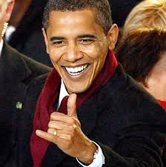

President Obama, of Hawaii

Joseph Gill has talked for over 8 hours on national syndicated talk radio shows, with 6 to 7 million listeners, about symbolism and the simple origins of our different religions.  After many personal requests Joseph has put together this simple picture documentary article for easy understanding.

This paper is given after 40 years of research in thousands of books and 50 years of travel 1961-2013; personally viewing symbolism in over 150 countries.

Please see his three other articles on Symbolism on the top of our homepage of www.worldglobetrotters.com .

--------------------------------------------------------------------------------------------------------------------------------------------------------------------------------------------------------

I first went to Hawaii with my parents in 1961, and visited many times thereafter. On September 6th 1989 I moved to the Big Island of Hawaii, a year after my retirement from business. I lived in South Kona for 13 wonderful years before selling our home and leaving on our 10 years of continuous World travel.

As a symbologist I noticed many people giving each other the "Shaka" symbol illustrated above. The people had many interesting stories of it's origins. I had in the early 1980's been a director of Sotheby's, the largest fine arts and antiques auction house in the world. While there, I had seen among many thousands of antiques, some heavy earthenware bottles from 1480-1750. They weighed near 100 pounds when filled. They were used by the early Portuguese sailing ships to transport rum. These bottles, being so very heavy, had a special 3-fingered handle, with 2 small ribs to separate the fingers so they could be more easily held up for drinking of the rum. The thumb and little finger were also used to balance this heavy bottle. Your other hand was used to hold up and steady the bottom of this bottle. A well known Historian of Hawaiiana and friend, had told me that the Portuguese had come to Hawaii near 100 years before Captain Cook. In my World travels in the 1960s, with my Mother, I had seen the same shaka symbol in many other countries, all where the Portuguese had traded in the early days.

The explanation is very easy: when the ships appeared on the horizon the local peoples ran to the shore and put the "Shaka" symbol up, meaning "BRING THE RUM".  
  
Over the years I spent living in Hawaii I have never had a single argument from the local Hawaiian people, but I always got a laugh of amazement and agreement. This short article is my gift to help the wonderful Hawaiian people to reclaim the original meaning of this important symbol in their culture.

Another interesting fact about Hawaii: When I was in New Zealand a few years ago, I spent some time with a Maori elder & Kahuna. This highly respected leader told me that the name "Hawaii" means in Maori, "The Lonely One", and that made perfect sense to me, because Hawaii is the most isolated, populated spot geographically, on Earth.

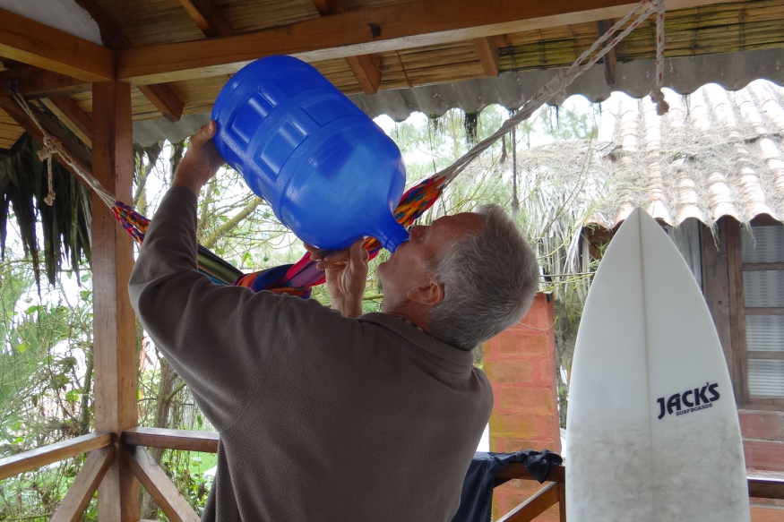 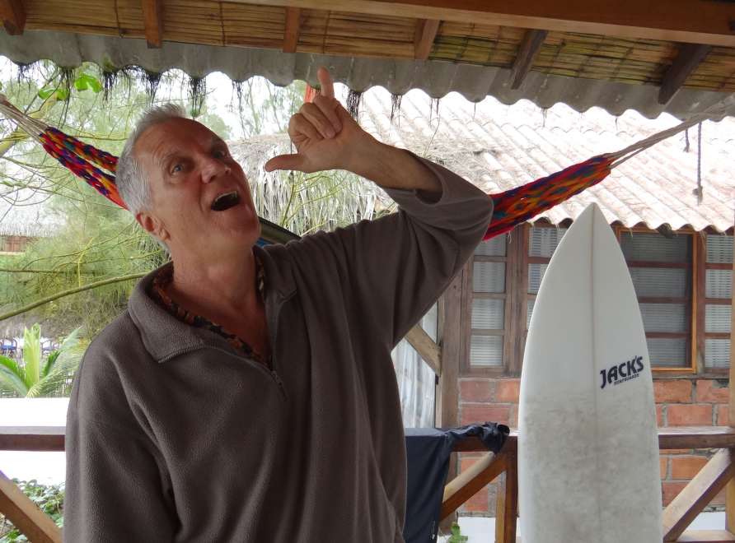

**Before (A similar sized water bottle) After**

**Love & Understanding. Joseph O. Gill gilljoseph1949@yahoo.com**

===================================================================================================================================

**FROM THE WEB:**

**http://en.wikipedia.org/wiki/Shaka_sign**

The **shaka sign**, commonly known as "hang loose", is a gesture often associated with [Hawaii](http://en.wikipedia.org/wiki/Hawaii) and surfer culture. It consists of extending the thumb and smallest finger while holding the three middle fingers curled, and raising the hand in salutation while presenting the back; the hand may be rotated back and forth for emphasis.

The shaka sign was popularized among locals in Hawaii through its use by surfers and in surf culture throughout the state in the 1960s. It has remained a salutation of friendship used by the local culture at large from then on.

**Meaning and use**

Hawaiian locals use the shaka to convey what they call the "[Aloha](http://en.wikipedia.org/wiki/Aloha) Spirit", a gesture of friendship and understanding between the various ethnic cultures that reside within Hawaii, and thus it does not have a direct semantic to literal translation. Depending on context it can also be used to communicate notions such as "thank you", "hi", "howzit", and the like. The shaka is used on the road among drivers and in photographs to communicate a distant greeting.

Outside of Hawaii, the shaka may be used to mean "hang loose", "hello", "goodbye", "till next time", "take care", or "all right!". In sign language, the shaka is one of the two signs used to refer to [surfing](http://en.wikipedia.org/wiki/Surfing).[[*citation needed*](http://en.wikipedia.org/wiki/Wikipedia:Citation_needed)] In California, the Shaka sign may be referred to as the "chill" or "hang ten" sign- both associated with surfer culture.

The gesture enjoys common use in American [hang gliding](http://en.wikipedia.org/wiki/Hang_gliding) culture, for both sentiment and word play, in part due to the simultaneous rise of surfing and hang gliding in California in the 1960s and 70s.

On the coast of [Brazil](http://en.wikipedia.org/wiki/Brazil), the shaka sign is known as the "hang loose" sign and is a common gesture; the shaka is also associated with the [brazilian jiu jitsu](http://en.wikipedia.org/wiki/Brazilian_jiu_jitsu) community through the world.

There are two [textese](http://en.wikipedia.org/wiki/Textese) glyphs for the shaka sign - \.../ and \, ,/ - the first known use of both is in c. 2006.

**Similar gestures**

The sign can also be used to gesticulate the imbibing of a bottled drink, as attested to below, by placing the thumb to the mouth and motioning the little finger upward as if tipping up a bottle's bottom end.

With the thumb held near the ear and the little finger pointed at the mouth, the gesture is commonly understood to mean "call me", as it resembles a handheld telephone.

With the fingers facing forward, the same gesture is the letter [Y](http://en.wikipedia.org/wiki/Y) in the [American manual alphabet](http://en.wikipedia.org/wiki/American_manual_alphabet). *Also see* [ILY sign](http://en.wikipedia.org/wiki/ILY_sign).

In the Caribbean, mostly in the Lesser Antilles Aruba, Bonaire & Curaçao, it may be used to suggest a sexual exchange; for such, the thumb points to the gesturer and the little finger toward the subject of the proposition as the hand is moved forward and back.

In China, this gesture also means "6".

In Russia, this gesture with vertically oriented thumb and horizontally oriented little finger as if holding a beer mug is understood as an invitation to have a drink.

In Australia and New Zealand, raising the thumb to the mouth while pointing the pinky to the air is seen as invitation for one to smoke cannabis, the posture resembling the use of a pipe.

**Origin**

The "shaka sign" may have its roots in the Hawaiian custom of holding a [lei](http://en.wikipedia.org/wiki/Lei_%28garland%29) (a necklace made of flowers) for the purpose of placement over the head on the shoulders of another in an Aloha greeting. The three middle fingers grasp the lei from over the top while the thumb and small finger rest under the lei thus spreading the 'necklace' open.

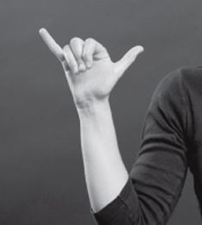

The shaka sign resembles the [American Sign Language](http://en.wikipedia.org/wiki/American_Sign_Language) letter for [Y](http://en.wikipedia.org/wiki/Y).

Another theory maintains that when Spanish explorers initially came upon the islands and their people, unable to speak the native tongue, they motioned the gesture as if drinking from it, like a bottle of sorts, in an attempt to convey peaceful intentions; namely, sharing a drink. Perhaps misunderstanding the gesture, the natives took it to be a friendly greeting, and the behavior persisted.[[4]](http://en.wikipedia.org/wiki/Shaka_sign#cite_note-Possible_Origin-4)

Yet another theory, according to the Honolulu Star-Bulletin,[[5]](http://en.wikipedia.org/wiki/Shaka_sign#cite_note-Watanabe-5) prevailing local lore credited the gesture to [Hamana Kalili](http://en.wikipedia.org/wiki/Hamana_Kalili) of [Laie](http://en.wikipedia.org/wiki/Laie), who lost the three middle fingers of his right hand while working at the [Kahuku](http://en.wikipedia.org/wiki/Kahuku) Sugar Mill. Kalili was then shifted to guarding the sugar train, and his all-clear wave of thumb and pinkie is said to have evolved over the years into the shaka as children would imitate his unique hand "waaaave.

=============================================================================================================================

**http://www.urbandictionary.com/define.php?term=shaka**

|  |  |  |  |  |  |  |
| --- | --- | --- | --- | --- | --- | --- |
| [1.](http://shaka.urbanup.com/407788) | | shaka | | | |  |
|  | | August 10, 2006 Urban Word of the Day  Hawaiian hand gesture. It has many meanings. Originally it means to "hang loose", or to chill and be laid back. It can be used as a positive reinforcement. If somebody did something good, cool, or righteous; You can give them a shaka as a sign of approval or praise. It can also be used as a welcome/goodbye sign. Most people would give the shaka as a sign of wassup or hello, use it as a way of saying goodbye, and even use it as a thank you.   To make a shaka:  1. make a fist (not a tight fist)  2. extend both your pinky and your thumb.  3. lightly shake your hand (too fast makes you like retarded or like a tourist, and too slow make you look stupid.)  4. If you don't want to do the shake, you are also able to do the "I'm tuff" motion. In a downward motion, move your hand. Giving a kind of downward wrist flick at the end. It gives you a more "i'm bad look". It's mainly used by old school Local boyz.  "Eh, shaka brah." | | | | | |
| [2.](http://shaka.urbanup.com/4113671) | | Shaka | |  |
|  | | Originated in Hawaii. Old story goes:  Old man dynamites reef for fish, heʻs good at it and does it all the time.One day blows up hand and is left with 2 fingers thumb and pinky. Locals would see him around and wave at him, he would wave back but only with thumb and pinky. Pretty soon locals would wave back in same way. Its called shaka because he always claimed he didnʻt feel anything when it first happened, he claimed he was "shocked" at the fact that he actually blew his hand up after all these years.Thus this hawaii tradition has always meant "no worry", everything here is and will always be good no matter what happens. Dynamite is no longer allowed. this happened before hawaii was a state of USA. Around turn of century or "plantation days". Always used as a greeting or gesture, usually conveying tones of love, family, friend, aloha, togetherness, rightousness, thankful, greatful, blessed, supreme karma. Given freely without anything expected in return, and always from the heart.  CHOKE KINE SHAKAS  1 shake (quick and easy) REQURES A "TANKS AH" use this when someone lets you "in" when get choke traffic.  MOKE SHAKA (Loud and furious) donʻt curl your 3 fingers closed. Instead, keep them togther and stick thumb and pinky way out to the side. Stick arm straight out and up kinda like nazi hail hitler but instead yeal "HO CUZ" Use this when your driving your lifted truck and you see your friend driving the other way. Country boy style cuz.  Bro shaka  after you shake hands Bro style, end with shaka  Boom Shaka  after pound fist to greet you end with shaka instead of "blowing it up"  Shaka Brah  make a shaka and "punch" towards person and leave it extended out aiming towards them. the longer you extend and leave out, the more excited you are to see them. Use this with "eh brah" or "U FAKA"  Double shaka  make shaka with one hand, make shaka with da other hand now you get 2 shakas. Use this when extremely happy like when someone does you huge favor or hooks you up. the more you spread out your arms, the bigger the favor that was done for you.  Shaka pause  no need shake, jus hold um out. Use this to prolong a favorable experience like getting barreled.  Secret Shaka  small almost no can see shaka, hold it way down low, pointed to ground. All the coolest braddahs do this. Country boy style cuz. | | | |

========================================================================================