Howard Zinn 1922 - 2010
http://en.wikipedia.org/wiki/Howard_Zinn
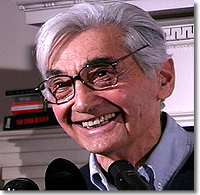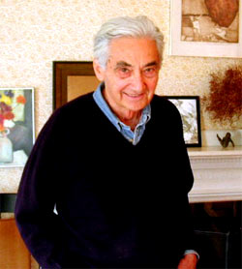
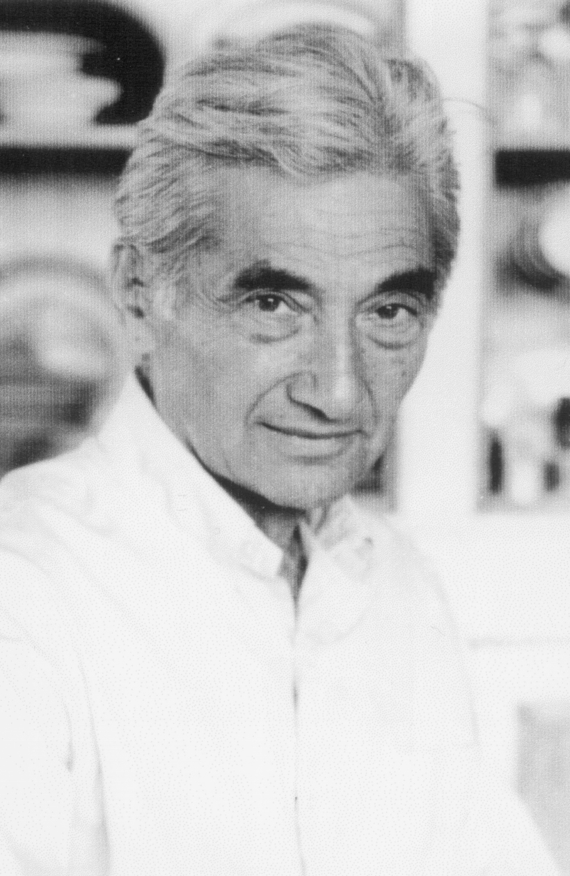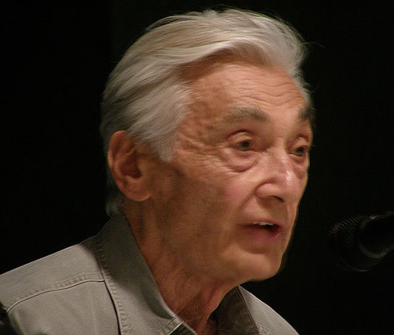

Howard Zinn (August 24, 1922 – January 27, 2010)^{[1]} was an American historian, author, anarchist, socialist, activist, playwright, intellectual and Professor of Political Science at Boston University from 1964 to 1988.^{[2]} ^{[3]} He wrote more than 20 books, which included his best-selling and influential A People's History of the United States.^{[4]} Zinn also wrote extensively about the civil rights, civil liberties and anti-war movements. His memoir, You Can't Be Neutral on a Moving Train, became the title of a 2004 documentary about Zinn's life and work.^{[5]}
Zinn's philosophy incorporates ideas from Marxism, anarchism, socialism, and social democracy. Since the 1960s, he has been a visible figure in the Civil Rights and anti-war movements in the United States.
Author of 20 books, including the best seller A People's History of the United States, Zinn is Professor Emeritus in the Political Science Department at Boston University. He lives in the Auburndale neighborhood of Newton, Massachusetts with his wife Roslyn. The couple have two children, Myla and Jeff, and five grandchildren. Roslyn is an artist and editor who has had a role in editing all of Zinn's books.

Contents
- 1 Early life
- 2 Civil rights
- 3 Anti-war efforts
  - 3.1 Vietnam
  - 3.2 Iraq
- 4 A People's History
- 5 Criticism
- 6 Awards and other accomplishments
- 7 Theatrical works
- 8 Books Written or Edited by Howard Zinn
  - 8.1 Books
  - 8.2 Forewords and introductions by Howard Zinn
  - 8.3 Compact discs
- 9 Online interviews and video
  - 9.1 Criticism of Howard Zinn
- 10 See also
- 11 External links
  - 11.1 Ways of telling history compared

Early life
Howard Zinn was born to a Jewish immigrant family in Brooklyn. His father, Eddie Zinn, born in Austria-Hungary, emigrated to the United States with his brother Phil before the outbreak of World War I. Howard's mother Jenny Zinn emigrated from the Eastern Siberian city of Irkutsk.
Both parents were factory workers with limited education when they met and married, and there were no books or magazines in the series of apartments where their children were raised. Zinn's parents introduced him to literature by sending 25 cents plus a coupon to the New York Post for each of the 20 volumes of Charles Dickens' collected works. [1]
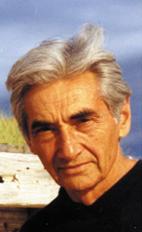
Howard Zinn in Wellfleet on Cape Cod.
As a young adult, Zinn worked as a shipyard worker and labor organizer in the Brooklyn shipyards. Later, Zinn was a bombadier aboard a B-17 with the 490th Bomb Group, and conducted bombing missions in Europe during World War II. Zinn's participation in these missions would subsequently shape his opposition to war.
After World War II, Zinn attended New York University on the GI Bill, graduating with a B.A. in 1951 and Columbia University, where he earned an M.A. (1952) and Ph.D. in history with a minor in political science (1958). His doctoral dissertation LaGuardia in Congress was a study of Fiorello LaGuardia's congressional career, and depicted LaGuardia representing "the conscience of the twenties" as he fought for public power, the right to strike, and the redistribution of wealth by taxation. "His specific legislative program," Zinn wrote, "was an astonishingly accurate preview of the New Deal." It was published by the Cornell University Press for the American Historical Association.

Civil rights
In 1956, Zinn was appointed chairman of the department of history and social sciences at Spelman College, where he participated in the Civil Rights movement. Zinn served as an adviser to the Student Nonviolent Coordinating Committee (SNCC).
While at Spelman, Zinn collaborated with historian Staughton Lynd and mentored young student activists, among them writer Alice Walker and Marian Wright Edelman. Although Zinn was a tenured professor, he was dismissed, in June 1963, after siding with students in their desire to challenge Spelman's traditional emphasis of turning out "young ladies" when, as Zinn described in an article in The Nation, Spelman students were likely to be found on the picket line, or in jail for participating in the greater effort to break down segregation in public places in Atlanta. An account of Zinn's years at Spelman is in You Can't Be Neutral on a Moving Train: A Personal History of Our Times. His seven years at Spelman College, Zinn said, "are probably the most interesting, exciting, most educational years for me. I learned more from my students than my students learned from me." [2]
Zinn said that while at Spelman, he observed 30 violations of the First and Fourteenth amendment rights to the United States Constitution in Albany, Georgia, including freedom of speech, freedom of assembly and equal protection of the laws. In an article on the Civil Rights movement in Albany, Zinn describes the people who participated in the Freedom Rides to end segregation, and of the reluctance of President John F. Kennedy to enforce the law.[3]
Zinn wrote frequently about the struggle for Civil Rights, both as a participant and historian. [4] and in 1960-61, he took a year off from teaching to write SNCC: The New Abolitionists and The Southern Mystique. [5] In his book on SNCC, Zinn describes how the sit-ins against segregation were initiated by students and, in that sense, independent of the older, more established civil rights organizations.

Anti-war efforts
In 1964, he joined the faculty at Boston University where he taught history and civil liberties until 1988. It was at this time that Zinn became known as a high-profile critic of war, the Vietnam War in particular.
His anti-war stance was, in part, informed by his own experiences in the military. In April, 1945, he participated in the bombing of Royan, France, the first time napalm was used in warfare. The bombings were aimed at German soldiers who were, in Zinn's words, hiding and waiting out the closing days of the war. The attacks killed not only the German soldiers, but French civilians as well. Nine years later, Zinn visited Royan to examine documents and interview residents. In his books, The Politics of History and The Zinn Reader, he concluded that the bombing was ordered by decision-makers for career advancement rather than for any legitimate military objective.
Zinn later said his experience as a bombardier, combined with his research into the reasons for and effects of the bombing of Royan, sensitized him to the ethical dilemmas faced by G.I.'s during wartime. [6] Zinn questioned the justifications for military operations inflicting civilian casualties in the Allied bombing of cities such as Dresden, Royan, Tokyo, and Hiroshima and Nagasaki in World War II, Hanoi during the U.S. war in Vietnam, and Baghdad during the U.S. war in Iraq. In his pamphlet "Hiroshima: Breaking the Silence", Zinn laid out his case against targeting civilians. [7]. Instead of bombing civilians, he contended that the Axis powers could have been opposed during World War II through popularly organized acts of nonviolent resistance.

Vietnam
Zinn's diplomatic visit to Hanoi with Rev. Daniel Berrigan, during the Tet Offensive in January 1968, resulted in the return of three American airmen, the first American POWs released by the North Vietnamese since the U.S. bombing of that nation had begun. The event was widely reported in the news media and discussed in a variety of books including Who Spoke Up? American Protest Against the War in Vietnam 1963-1975 by Nancy Zaroulis and Gerald Sullivan [(Horizon Book Promotions: 1989) ISBN 0-385-17547-7]. Zinn remained friends and allies with the brothers Dan and Philip over the years.
Daniel Ellsberg, a former RAND consultant who had secretly copied The Pentagon Papers, which described internal planning and policy decisions of the United States in the Vietnam War, gave a copy of them to Howard and Roslyn Zinn. [Ellsberg autobiography, Zinn autobiography] Along with Noam Chomsky, Zinn edited and annotated the copy of The Pentagon Papers that Ellsberg entrusted to him. Zinn's longtime publisher, Beacon Press, published what has come to be known as the Senator Gravel edition of The Pentagon Papers, four volumes plus a fifth volume with analysis by Chomsky and Zinn.
At Ellsberg's criminal trial for theft, conspiracy, and espionage in connection with the publication of the Pentagon Papers by The New York Times, defense attorneys called Zinn as an expert witness to explain to the jury the history of U.S. involvement in Vietnam from World War II to 1963. Zinn discussed that history for several hours and later reflected on his time before the jury. "I explained there was nothing in the papers of military significance that could be used to harm the defense of the United States, that the information in them was simply embarrassing to our government because what was revealed, in the government's own interoffice memos, was how it had lied to the American public. The secrets disclosed in the Pentagon Papers might embarrass politicians, might hurt the profits of corporations wanting tin, rubber, oil, in far-off places. But this was not the same as hurting the nation, the people," Zinn wrote in his autobiography. Most of the jurors later said they voted for acquittal. [p. 161] However, the federal judge dismissed the case on grounds it had been tainted by the Nixon administration's 'plumber' operation, a burglary at the office of Ellsberg's psychiatrist.
Zinn's testimony as to the motivation for government secrecy was confirmed in 1989 by Erwin Griswold, who as U.S. solicitor general during the administration of Richard M. Nixon prosecuted The New York Times in the Pentagon Papers case in 1971.["The lie behind the secrets" by Tom Blanton, May 21, 2006, Los Angeles Times] Griswold persuaded three Supreme Court justices to vote to stop The New York Times from continuing to publish the Pentagon Papers, an order known as "prior restraint." (The papers were subsequently published in The Washington Post.) In 1989, Griswold admitted there was no actual national security damage from publication of the papers.[8] In a column in the Washington Post, Griswold wrote: "It quickly becomes apparent to any person who has considerable experience with classified material that there is massive overclassification and that the principal concern of the classifiers is not with national security, but with governmental embarrassment of one sort or another."
In the decades that followed, Zinn supported the G.I. antiwar movement during the U.S. war in Vietnam, and, in the 2001 film Unfinished Symphony, Zinn provides a historical context for the 1971 antiwar march by Vietnam Veterans against the War. The marchers traveled from Lexington, Massachusetts, to Bunker Hill, "which retraced Paul Revere's ride of 1775 and ended in a massive arrest of 410 veterans and civilians by the Lexington police." The film depicts "scenes from the 1971 'Winter Soldier' investigations, during which former G.I.s testified about atrocities" they either participated in or witnessed in Vietnam. [9]

Iraq
Zinn has also been a critic of the Iraq conflict. He asserts that the U.S. will end its war with, and occupation of, Iraq when resistance within the military increases, in the same way resistance within the military contributed to ending the U.S. war in Vietnam. He compares the demand by a growing number of contemporary U.S. military families to end the war in Iraq to the parallel "in the Confederacy in the Civil War, when the wives of soldiers rioted because their husbands were dying and the plantation owners were profiting from the sale of cotton, refusing to grow grains for civilians to eat." [10]

Roslyn Zinn, artist, and co-editor with Cynthia Merman of People's History of the United States.
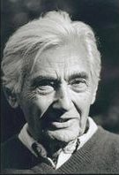
Howard Zinn, teacher, editor of People's History Series; photo by Robert Birnbaum

A People's History
As a historian, Zinn found that the point of view expressed in traditional history books was often limited. He created a historical text, A People's History of the United States with the goal to provide other perspectives of American history. The text depicts the struggles of Native Americans against European and U.S. conquest and expansion, slaves against slavery, unionists and other workers against capitalists, women against patriarchy, African-Americans against racism and for civil rights, and others whose stories are not often told in mainstream histories.
In the years since the first edition of A People's History was published in 1980, it has been assigned reading both as a high school and college textbook, and is one of the most widely known examples of critical pedagogy.
In the spring of 2003, to commemorate the sale of the millionth copy of A People's History, a dramatic reading from the book was held at the 92nd Street Y in New York City. The reading featured Danny Glover, Andre Gregory, James Earl Jones, actress Myla Pitt, Marisa Tomei, Kurt Vonnegut, Alice Walker, Alfre Woodard, Harris Yulin, Jeff Zinn, producing artistic director of the Wellfleet Harbor Actors Theater [11], and Howard Zinn as narrator. The event was aired on Democracy Now!, hosted by Amy Goodman, and is online at Democracy Now The program was also released as a book and CD under the title, The People Speak: American Voices, Some Famous, Some Little Known.
Interwoven with commentary by Zinn, both the book and the dramatic reading upon which the newer book is based, includes passages from Zinn's research in A People's History of the United States on Christopher Columbus on the Arawaks; Plough Jogger, a farmer and participant in Shays' Rebellion; Harriet Hanson, a Lowell mill worker; Frederick Douglass; Mark Twain; Mother Jones; Emma Goldman; Helen Keller; Eugene V. Debs; Langston Hughes; Genova Johnson Dollinger on a sit-down strike at General Motors in Flint, Michigan; an interrogation from a 1953 HUAC hearing; Fannie Lou Hamer, a sharecropper and member of the Freedom Democratic Party; Malcolm X; and James Lawrence Harrington, a Gulf War resister, among others.
In 2004, Zinn published Voices of A People's History of the United States with Anthony Arnove. Voices expands on the concept and provides a large collection of dissident voices in long form. The book is intended as a companion to A People's History and parallels its structure.
Zinn was a consultant to the six-part documentary A People's History of the United States [12], a television series produced by Alvin H. Perlmutter. According to the documentary's website, the series is expected to be broadcast in early 2007.

Criticism
Anti-communist liberal writer Michael Kazin describes Howard Zinn as "an evangelist of little imagination for whom history is one long chain of stark moral dualities." [13]. Aaron Sarver replies to Kazin with praise for Zinn (and Arnove's) Voices of a People's History of the United States, noting that both the book and CD of dramatic readings serve as a useful response to Kazin’s harsh critique. "Voices is a vast anthology that tells heartbreaking and uplifting stories of American history. Kazin will be hard-pressed to charge Zinn with politicizing the intelligence here; the volume offers only Zinn’s sparse introductions to each piece, letting the actors and their words speak for themselves."^{[1]} Daniel J. Flynn, who has written two books pressing rightwing views, says of Zinn, "his is a captive mind long closed by ideology." [14]

Awards and other accomplishments
Zinn has received the Thomas Merton Award and the Eugene V. Debs Award. In 1998, he won the Lannan Literary Award[15] for nonfiction and the following year won the Upton Sinclair Award, which honors social activism. In 2003, Zinn was awarded the Prix des Amis du Monde Diplomatique[16] for the French version of his seminal work, Une histoire populaire des Etats-Unis.
Zinn's autobiography is You Can't Be Neutral on a Moving Train. A biographical documentary film of the same name was produced in 2004 and shown in select theaters. It is available[17]on DVD. The film, by Deb Ellis and Denis Mueller[18] with music was composed by Richard Martinez[19] featuring music by Billy Bragg, Woodie Guthrie, and Pearl Jam. The film includes footage of Howard and Roslyn Zinn, Noam Chomsky, Marian Wright Edelman, Daniel Ellsberg, Tom Hayden and Alice Walker. The 78-minute film on DVD includes these special features: On Human Nature and Aggression; his speech at Veterans for Peace Conference, 2004; and audio of his 1971 speech at the Boston Common on Civil Disobedience. In the film, Noam Chomsky says Zinn "changed the consciousness of a generation."
The film was narrated by actor Matt Damon; when Damon was a child, his family moved next door to the Zinns in West Newton, Massachusetts, and became friends (the Zinns occasionally babysat the Damon boys)^{[citation needed]}. Damon included a reference to A People's History in his film Good Will Hunting, and read the latter half of People's History for an audiobook released February 1, 2003 (ISBN 0-06-053006-5). People's History was also referenced in a Columbus Day episode of the TV show The Sopranos.
In October 2005, Chicago's indie punk label Thick Records released a CD by Springfield-based indie rock band, Resident Genius, which featured excerpts from several Zinn talks, tying them into the band's songs. The CD is titled You Can't Blow Up A Social Relationship." The six Zinn excerpts are "a greatest hits of his speeches recorded over the last 15 years by Roger Leisner of Radio Free Maine. They touch on his 'usual' topics of engaged activism, history from below, war, the media and much more."[20]
On October 5, 2006, Howard Zinn received the Haven's Center Award for Lifetime Contribution to Critical Scholarship in Madison, Wisconsin.[21]

Theatrical works
Zinn has been the playwright for three plays, including Daughter of Venus (1985), his first play.
Zinn's second play, Emma, is based on the life of the early 20th century anarchist Emma Goldman. Goldman, an anarchist, feminist, and free-spirited thinker was exiled from the United States because of what was perceived as radical and dangerous viewpoints, including her staunch opposition to World War I. As Zinn writes in his Introduction, Emma Goldman 'seemed to be tireless as she traveled the country, lecturing to large audiences everywhere, on birth control (‘A woman should decide for herself’), on the falsity of marriage as an institution (‘Marriage has nothing to do with love’), on patriotism (‘the last refuge of a scoundrel’) on free love (‘What is love if not free?’), and also on drama, including Shaw, Ibsen, and Strindberg'.
His most recent is Marx in Soho, a play on history that has been continuously performed [22]to encouraging reviews[23] [24]in small theaters throughout the United States, with Brian Jones in the title role starting in 1999 through 2005. In February 2005, Bob Weick took on the title role in a traveling tour. Details of the traveling tour are at Iron Age Theatre.

Books Written or Edited by Howard Zinn

Books
- Artists in Times of War (2003) ISBN 1-58322-602-8
- The Cold War & the University: Toward an Intellectual History of the Postwar Years (Noam Chomsky (Editor) Authors: Ira Katznelson[25], R. C. Lewontin, David Montgomery, Laura Nader, Richard Ohmann[26], Ray Siever, Immanuel Wallerstein, Howard Zinn (1997) ISBN 1-56584-005-4
- Declarations of Independence: Cross-Examining American Ideology (1991) ISBN 0-06-092108-0 [27]
- Disobedience and Democracy: Nine Fallacies on Law and Order (1968, re-issued 2002) ISBN 0-89608-675-5
- Emma: A Play in Two Acts About Emma Goldman, American Anarchist (2002) ISBN 0-89608-664-X
- Failure to Quit: Reflections of an Optimistic Historian (1993) ISBN 0-89608-676-3
- The Future of History: Interviews With David Barsamian (1999) ISBN 1-56751-157-0
- Hiroshima: Breaking the Silence (1995) ISBN 1-884519-14-8
- Howard Zinn On Democratic Education Donaldo Macedo, Editor (2004) ISBN 1-59451-054-7
- Howard Zinn on History (2000) ISBN 1-58322-048-8
- Howard Zinn on War (2000) ISBN 1-58322-049-6
- Justice in Everyday Life: The Way It Really Works (Editor) (1974) ISBN 0-89608-677-1
- Justice? Eyewitness Accounts (1977) ISBN 0-8070-4479-2
- La Otra Historia De Los Estados Unidos (2000) ISBN 1-58322-054-2
- LaGuardia in Congress (1959) ISBN 0-8371-6434-6, ISBN 0-393-00488-0
- Marx in Soho: A Play on History (1999) ISBN 0-89608-593-7
- New Deal Thought (editor) (1965) ISBN 0-87220-685-8
- Passionate Declarations: Essays on War and Justice (2003) ISBN 0-06-055767-2
- The Pentagon Papers Senator Gravel Edition. Vol. Five. Critical Essays. Boston. Beacon Press, 1972. 341p. plus 72p. of Index to Vol. I-IV of the Papers, Noam Chomsky, Howard Zinn, editors
- Playbook by Maxine Klein, Lydia Sargent and Howard Zinn (1986) ISBN 0-89608-309-8
- A People's History of the Civil War: Struggles for the Meaning of Freedom by David Williams, Howard Zinn (Series Editor) (2005) ISBN 1-59558-018-2
- A People's History of the United States: 1492–Present (1980), revised (1995) ISBN 0-06-052837-0
- A People's History of the United States: Teaching Edition Abridged (2003 updated) ISBN 1-56584-826-8
- A People's History of the United States: The Civil War to the Present Kathy Emery Ellen Reeves Howard Zinn (2003 teaching edition) ISBN 1-56584-725-3
- A People's History of the United States: The Wall Charts by Howard Zinn and George Kirschner (1995) ISBN 1-56584-171-9
- The People Speak: American Voices, Some Famous, Some Little Known (2004) ISBN 0-06-057826-2
- The Politics of History (1970) (2nd edition 1990) ISBN 0-252-06122-5
- Postwar America: 1945–1971 (1973) ISBN 0-89608-678-X
- The Power of Nonviolence: Writings by Advocates of Peace Editor (2002) ISBN 0-8070-1407-9
- SNCC: The New Abolitionists (1964) ISBN 0-89608-679-8
- The Southern Mystique (1962) ISBN 0-89608-680-1
- Terrorism and War (2002) ISBN 1-58322-493-9 (interviews, Anthony Arnove (Ed.))
- The Twentieth Century: A People's History (2003) ISBN 0-06-053034-0
- Three Strikes: Miners, Musicians, Salesgirls, and the Fighting Spirit of Labor's Last Century (Dana Frank, Robin Kelley, and Howard Zinn) (2002) ISBN 0-8070-5013-X
- Vietnam: The Logic of Withdrawal (1967) ISBN 0-89608-681-X
- Voices of a People’s History of the United States (with Anthony Arnove, 2004) ISBN 1-58322-647-8
- You Can't Be Neutral on a Moving Train: A Personal History of Our Times (1994) ISBN 0-8070-7127-7
- The Zinn Reader: Writings on Disobedience and Democracy (1997) ISBN 1-888363-54-1

Forewords and introductions by Howard Zinn
- A Gigantic Mistake by Mickey Z, (2004) ISBN 1-930997-97-3
- A People's History of the Supreme Court by Peter H. Irons (2000) ISBN 0-14-029201-2
- A Political Dynasty In North Idaho, 1933-1967 by Randall Doyle (2004) ISBN 0-7618-2843-5
- American Political Prisoners: Prosecutions Under the Espionage and Sedition Acts by Stephen M. Kohn (1994) ISBN 0-275-94415-8
- American Power and the New Mandarins by Noam Chomsky (2002) ISBN 1-56584-775-X
- Broken Promises Of America: At Home And Abroad, Past And Present: An Encyclopedia For Our Times by (Douglas F. Dowd (2004) ISBN 1-56751-313-1
- Deserter From Death: Dispatches From Western Europe 1950-2000 by Daniel Singer (2005) ISBN 1-56025-642-7
- Ecocide of Native America: Environmental Destruction of Indian Lands and Peoples by Donald Grinde, Bruce Johansen (1994) ISBN 0-940666-52-9
- Eugene V. Debs Reader: Socialism and the Class Struggle by William A. Pelz (2000) ISBN 0-9704669-0-0
- From a Native Son: Selected Essays in Indigenism, 1985–1995 by Ward Churchill (1996) ISBN 0-89608-553-8
- Green Parrots: A War Surgeon's Diary by Gino Strada, (2005) ISBN 88-8158-420-4
- Hijacking Catastrophe: 9/11, Fear And The Selling Of American Empire by Sut Jhally editor, Jeremy Earp editor, (2004) ISBN 1-56656-581-2
- If You're Not a Terrorist…Then Stop Asking Questions! by Micah Ian Wright, (2004) ISBN 1-58322-626-5
- Iraq: The Logic of Withdrawal by Anthony Arnove, (2006) ISBN 9781595580795
- Life of an Anarchist: The Alexander Berkman Reader by Alexander Berkman Gene Fellner, editor, (2004) ISBN 1-58322-662-1
- Masters of War: Latin America and United States Aggression from the Cuban Revolution Through the Clinton Years by Clara Nieto, Chris Brandt (trans) (2003) ISBN 1-58322-545-5
- Peace Signs: The Anti-War Movement Illustrated by James Mann, editor (2004) ISBN 3-283-00487-0
- Silencing Political Dissent: How Post-9-11 Anti-terrorism Measures Threaten Our Civil Liberties by Nancy Chang, Center for Constitutional Rights (2002) ISBN 1-58322-494-7
- Soldiers In Revolt: GI Resistance During The Vietnam War by David Cortright, (2005) ISBN 1-931859-27-2
- Sold to the Highest Bidder: The Presidency from Dwight D. Eisenhower to George W. Bush by Daniel M. Friedenberg (2002) ISBN 1-57392-923-9
- The Autobiography of Abbie Hoffman Intro by Norman Mailer, Afterword by HZ (2000) ISBN 1-56858-197-1
- The Case for Socialism by Alan Maass, (2004) ISBN 1-931859-09-4
- The Forging of the American Empire: From the Revolution to Vietnam, a History of U.S. Imperialism by Sidney Lens (2003) ISBN 0-7453-2101-1
- The Higher Law: Thoreau on Civil Disobedience and Reform by Henry David Thoreau Wendell Glick, editor, (2004) ISBN 0-691-11876-0
- The Iron Heel by Jack London, (1971) ISBN 55305969095
- The Sixties Experience: Hard Lessons about Modern America by Edward P. Morgan, (1992) ISBN 1-56639-014-1
- You Back the Attack, We'll Bomb Who We Want by Micah Ian Wright, (2003) ISBN 1-58322-584-6

Compact discs
- A People's History of the United States (1999)
- Artists in the Time of War (2002)
- Heroes & Martyrs: Emma Goldman, Sacco & Vanzetti, and the Revolutionary Struggle (2000)
- Stories Hollywood Never Tells (2000)
- You Can't Blow Up A Social Relationship - split CD featuring Zinn talks and noted indie rock band Resident Genius (Thick Records) (2005)

Online interviews and video
- Interview with Zinn for Guernica Magazine (guernicamag.com)
- What the left thinks: Howard Zinn, Part I, interview with Dennis Prager (September 12, 2006)
- Transcript ofPBS interview by Bill Moyers (January 10, 2003)
- C-SPAN Book TV In Depth (3-hour interview)
- Interview with Howard Zinn on Air America Radio's The Majority Report (April 16th, 2004)
- "The Myth of American Exceptionalism" (April 13, 2005) Videolecture published by MIT World and sponsored by MIT SPURS/Humphrey Program.
- Public Reading of A People's History of the United Stateswith Howard Zinn, Jeff Zinn,[28] James Earl Jones, Harris Yulin, Andre Gregory, Marisa Tomei, Danny Glover, Myla Pitt, Kurt Vonnegut, Alfre Woodard, Alice Walker
- Interviewed by David Barsamian (November 11, 1992)
- Gray Matters Interviews Howard Zinn (December 3, 1998)
- Interview by Harry Kreisler (April 20, 2001)
- Interview by Robert Birnbaum at identitytheory.com (April 3, 2003)
- A-Infos Radio Project: Talks by Howard Zinn
- 1996 Interview on the death penalty
- Rawstory.com interview (September 9, 2005) — Compares U.S. wars in Iraq and Vietnam.
- Amy Goodman: Conversations with Howard Zinn on Democracy Now! (1997–2005), based on a compilation at HowardZinn.org
  - "A special hour-long conversation: To Be Neutral, To Be Passive In A Situation Is To Collaborate With Whatever Is Going On" (April 27, 2005)Interview with Amy Goodman
  - "Bush Represents Everything That Martin Luther King Opposed" (January 20, 2005)[29]
  - "Reaction to John Kerry's Concession and the Reelection of George W Bush" (November 3, 2004)[30]
  - "Nader vs. Anybody But Bush: A Debate on Ralph Nader's Candidacy" (October 26, 2004)[31]
  - "Candidates Not Addressing Fundamental Issues of American Policy" in the World"(October 14, 2004)[32]
  - "Revolutionary Non-Violence: Remembering Dave Dellinger, 1915-2004" (May 27, 2004)[33]
  - "Labor Day Special: Howard Zinn on Occupied Iraq, the Role of Resistance Movements, Government Lies and the Media" (September 1, 2003)[34]
  - "Independence Day Special: A Dramatic Reading of 'A People's History of the United States' with James Earl Jones, Alfre Woodard, Kurt Vonnegut, Danny Glover, Harris Yulin and others"(July 4, 2003) [35]
  - "Howard Zinn and Arundhati Roy: A Conversation Between Two Leading Social Critics" (May 28, 2003)[36]
  - "Howard Zinn Talks About Bombs, Terrorism, the Anti-War Movement and the Bush Administration's Impending War On Iraq" (February 25, 2003) [37]
  - "People's History of the United States, 1,000,000 Copies and Counting: Alice Walker, Danny Glover, Kurt Vonnegut, Marisa Tomei and Others Celebrate Howard Zinn's Classic" (February 25, 2003)[38]
  - "Renowned Historian Howard Zinn On the History of Government and Media Lies in Time of War" (February 13, 2003)[39]
  - "President Bush Takes the Nation to the Brink of War and Defends American Empire in His State of the Union Address; Simultaneously, He Tries to Prove He Cares About the Economy" (January 29, 2003)[40]
  - "Over 600 Gather for the Funeral of Legendary Anti-War Activist Philip Berrigan in Baltimore: We Hear From Historian Howard Zinn and Brendan Walsh, Who Co-Founded Viva House, a Catholic Worker House in Baltimore"(December 10, 2003)[41]
  - "Howard Zinn On the History of the US Government and CIA 'Changing Regimes' Around the World" (November 28, 2003)[42]
  - "Saying No to War: From Boston to Washington, D.C. to Madison, Wisconsin, We Hear From Howard Zinn, Medea Benjamin and Others" (October 29, 2003)[43]
  - "Congress Holds Joint Session in New York for First Time in 200 Years" (September 6, 2003)[44]
  - "The People's Historian" (June 21, 2002)[45]
  - "Reflections On 9/11 and Beyond" (March 11, 2002)[46]
  - "Where Are We Heading: Terrorism, Global Security, and the Peace Movement": During a Time Ofseemingly Endless War, We'll Hear From Radical Historian Howard Zinn" (February 22, 2002)[47]
  - "As Bush Delivers His First State of the Union Address, Democracy Now! Convenes a Shadowcongress to Respond" (January 30, 2002)[48]
  - "As Pacifica Stations WBAI, KPFK and WPFW Continue to Censor Democracy Now!, a Medley of The Voices That Pacifica Has Refused to Air Since September 11" (January 8, 2002)[49]
  - "Howard Zinn Speaks On the US War Against Afghanistan, US Wars Gone By, and the Prospects for a Humane US Foreign Policy" (Part II) (October 22, 2001)[50]
  - "Howard Zinn Speaks On the US War Against Afghanistan, US Wars Gone By, and the Prospects for a Humane US Foreign Policy" (Part I) (October 22, 2001)[51]
  - "Manning Marable, Howard Zinn and Grace Paley Speak Out Against the Bush Administration'smarch to War" (September 13, 2001)[52]
  - "Pearl Harbor: The Corporatization of History" (Part II) (Wednesday, May 30, 2001)[53]
  - "The Electoral College and Election 2000: A Historical Perspective From Howard Zinn" ( December 8, 2000) [54]
  - "American History Review of the 20th Century: Manning Marable and Howard Zinn" (December 27, 1999)[55]
  - "A People's History of the United States" (May 18, 1999)[56]
  - "Historian Howard Zinn Discusses Mergers" of two oil giants Exxon and Mobil (December 7, 1998)[57]
  - "Historian Zinn Addresses Nation's Censored Reports" (May 13, 1998)[58][59]
  - "Columbus Day Broadcast: A Talk by Howard Zinn" (October 13, 1997) [60]

Criticism of Howard Zinn
- "Howard Zinn's History Lessons" by Michael Kazin
- Master of Deceit by Daniel J. Flynn. Retrieved 2006-09-13.

See also
- Noam Chomsky
- Daniel Ellsberg
External links

Wikiquote has a collection of quotations related to:
Howard Zinn
- Howard Zinn's homepage
- Critical Resources: Howard Zinn
- G7 Welcoming Committee - A record label that has put out several Howard Zinn spoken word albums.
- Howard Zinn's articles for ZNet and Z Mag
- Howard Zinn's articles for The Progressive
- A People's History of the United States (The entire book)
- War is the Health of the State Interview with Zinn
- Howard Zinn: A Radical American Vision by Davis D. Joyce, Noam Chomsky (Foreword) (2003) ISBN 1-59102-131-6
- [61]War is not a solution for terrorism
- What the left thinks: Howard Zinn, Part I by Dennis Prager
- What the left thinks: Howard Zinn, Part II by Dennis Prager
============================================================================================================
END

