**US Under Military Law, Congress Arrested, War With CCP Won and No One Knows It**

**<https://beforeitsnews.com/politics/2021/01/us-under-military-law-congress-arrested-war-with-ccp-won-and-no-one-knows-it-3224688.html>**

Friday, January 29, 2021 14:31

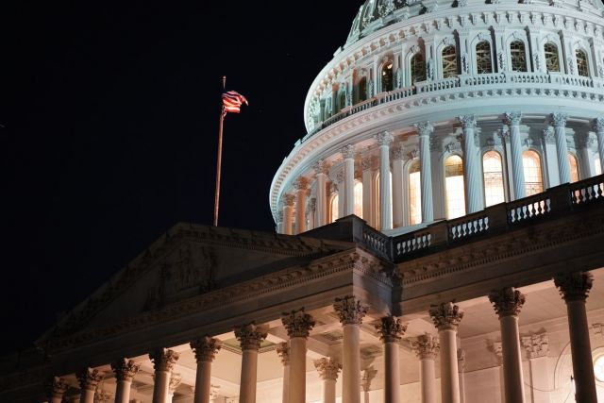

Joe Biden was sworn in as president of a bankrupt and defunct US Inc. Corporation. Just prior to his pre-recorded-in-Hollywood-by-Castle Rock Entertainment Inauguration, Washington DC, Capitol Hill and the White House were secured within miles of barbed wire fences and 60,000 National Guard troops.

Now over a week later, over 30,000 troops and the barbed wire fencing remained. Why?

An answer came early Mon. morning 25 Jan. when from 3am to 6am arrests of 80 to 140 Congress people appeared to be underway at Capitol Hill – after which Congress seemed to have disappeared. Why? [https://www.bitchute.com/video/oYzu0wcwa3GE/](https://beforeitsnews.com/v3/r2/?url=https://www.bitchute.com/video/oYzu0wcwa3GE/)  [House cancels business during first full Biden week – Washington Times](https://beforeitsnews.com/v3/r2/?url=https://www.washingtontimes.com/news/2021/jan/21/house-cancels-business-during-first-full-biden-wee/) [US Military at the White House Arresting Congress | Politics | Before It’s News](https://beforeitsnews.com/politics/2021/01/us-military-at-the-white-house-arresting-congress-3224466.html)

[Discover How To Survive in North America in Case of an Emergency](https://225e505pjo7-s6cf1g5jdswy81.hop.clickbank.net/?tid=BINRTL2121220)

[The Secret To Manifesting Anything You Desire In Life](https://6be7dtxjplv-n5bgmpv8ozxxlu.hop.clickbank.net/?tid=BINRTL1&s=suggesteda)

In reality an Interim Military US Government had taken over Washington DC and was running our country. The two US governments: (1) a legitimate Interim Military US Government empowered by the Constitution and the Department of Defense under Military Code 11.3, and (2) an illegal, fraudulent foreign paid-for, foreign controlled (on the foreign ground of the District of Columbia) Biden Administration.

The US Military appeared to be in charge of Biden and making him sign blank Executive Orders on a stage set of the Oval Office. The White House was said to be empty. Why? [https://www.rumormillnews.com/cgi-bin/forum.cgi?read=164754](https://beforeitsnews.com/v3/r2/?url=https://www.rumormillnews.com/cgi-bin/forum.cgi?read=164754)

The whole operation began way last Jan. 2020 during a government shutdown. President Trump was said to have reorganized several agencies including the US Treasury, IRS and Federal Reserve. Now the US Military had control of all assets including taxpayer dollars at the new US Treasury near Reno. Why?

The Military had been tasked with conducting a return to a gold/asset-backed dollar and to insure that the US Republic was restored to original laws of the Constitution as written prior to **1871**. [http://www.rumormillnews.com/cgi-bin/forum.cgi?read=115613](https://beforeitsnews.com/v3/r2/?url=http://www.rumormillnews.com/cgi-bin/forum.cgi?read=115613)

This was all made possible after a Sat. 9 Jan 2021 raid by US Military Special Op Teams on CIA Headquarters in Langley Virginia. The raid produced firm evidence that the CIA, Democrats and other traitors had conspired with foreign entities led by the Chinese Communist Party (CCP), to interfere in the 2020 Election.

[Try THIS Smart Meter Shield and Cut Radiation by 98%! It's Why the Illuminati Are Freaking Out! (VIDEO)](https://mitocopper.com/product/emf-blocking-smart-meter-cover/)

[Discover How To Survive in North America in Case of an Emergency](https://225e505pjo7-s6cf1g5jdswy81.hop.clickbank.net/?tid=BINRTL2121220)

Earlier that Saturday morning 9 Jan. there had been two attempts on Trump and his wife Melania’s lives (there were said to have been twelve plus such attempts since he gained office).

Trump had had enough. He immediately instigated the Insurrection Act (put into law by George Bush Jr. after 9/11), and then turned his authority over to the US Military.

With the nation now under Martial Law, Trump would remain as US President until all those who committed treason were arrested, including those who certified the illegal 2020 Election.

Some in the Pentagon had been preparing for this for over twenty years. US Attorney General for Utah John Huber and his 740 investigators had been very busy since 2016. The US government was corrupt throughout including Congress and the three letter agencies. There were a lot of traitors whose cases had already been processed through State Grand Juries. There was an estimated 80 to 140 Congress people thought named in over 223,000 sealed indictments filed in federal courts since Trump took office.

Of those, 85% to 95% indicted were Democrats, intermixed with a few Rino Republicans. The majority of charges were said to be pedophilia, child exploitation, misappropriation of US Taxpayer funds and conspiring with foreign powers to influence the 2020 Presidential Election – an act of Treason. Some serious charges couldn’t be brought because Obama pardoned so many in his last days in office.

By Jan. 2 2020 Military Tribunals were said to have already began at GITMO for high profile elites such as the Clintons, Obamas and Bushes. Charges against them were believed to include Capital High Treason, Election Fraud, Child Sex Trafficking, Money Laundering, Misappropriation of US Taxpayer Funds, plus Uranium One, 9/11 and Benghazi crimes.

Deep State Special prosecutor Robert Mueller was believed to have been charged for his involvement in the 9/11 cover-up (he was appointed FBI Director 7 days before 9/11 and oversaw 9/11 so-called “investigations”), plus he conducted an ongoing fake Russian witch-hunt against Trump. [https://archive.4plebs.org/pol/thread/168059921/](https://beforeitsnews.com/v3/r2/?url=https://archive.4plebs.org/pol/thread/168059921/)

It was no wonder the Democrats wanted to impeach Trump, again. On Thurs. 28 Jan. certain traitors in both the House and Senate did in fact recognize Trump as the acting US President when they voted, again, to try to impeach him. Under rules of the Constitution you could not impeach a US President if he didn’t presently hold the office.

Donald Trump wasn’t worried about being impeached from the presidency of the bankrupt and defunct US Corporation. He had other plans. On 11 Jan. 2021 Donald Trump was inaugurated as head of the Patriot or Constitutional Party, which made him a candidate for US President, again.

The US Military was about to restore the US Republic to laws underlying the original Constitution as written prior to **1871.** That election was planned to be held on 4 March 2021 through use of a transparent, secure and instantaneous Quantum Voting Computer where citizens could vote using their own computers, or phones.

For many years the Chinese Communist Party (not the Chinese government, which was working to become a democracy) had been involved in a takeover of America. That war culminated when just prior to the 2020 US Presidential Election, the CCP bought Dominion Voting machines that through use of an Italian satellite loaned with money at the Vatican, threw what was believed to be millions of Trump votes to Biden. And, the CIA raid proved it all.

The war between the CCP and the US actually ended on Thurs. 28 Jan. Former Navy Intelligence officer Simeon Parkes reported a showdown in the South China Sea. The CCP had been trying to take over Taiwan. Taiwan was where gold was stored that would back countries including the US, for a Global Currency Reset. Parks said that there were air battles between America and Taiwan fighter jets against CCP jets and “the CCP lost big time.”

The New World Order fans had lost their war. A banker source out of Zurich said they had promised to settle everything by Fri. 29 Jan. [https://www.simonparkes.org/blog](https://beforeitsnews.com/v3/r2/?url=https://www.simonparkes.org/blog)

Rinus Verhagen reported that “the CCP has abandoned their Big Restart Operation and the liberal elite-scheduled reboot of Globalism has failed. Operation COVID-19, expressed in the book “Great Restoration” by Klaus Schwab, President of the Davos Global Economic Forum, has also failed. The CCP would not impose a Global Order. Their power, like any commercial empire, was limited to an economic expansion.