**ILLEGITIMATE PRESIDENT - Nov. 15 2020**

<https://www.theburningplatform.com/2020/11/15/illegitimate-president/>

“Every normal man must be tempted, at times, to spit on his hands, hoist the black flag, and begin slitting throats.” – **H.L. Mencken**

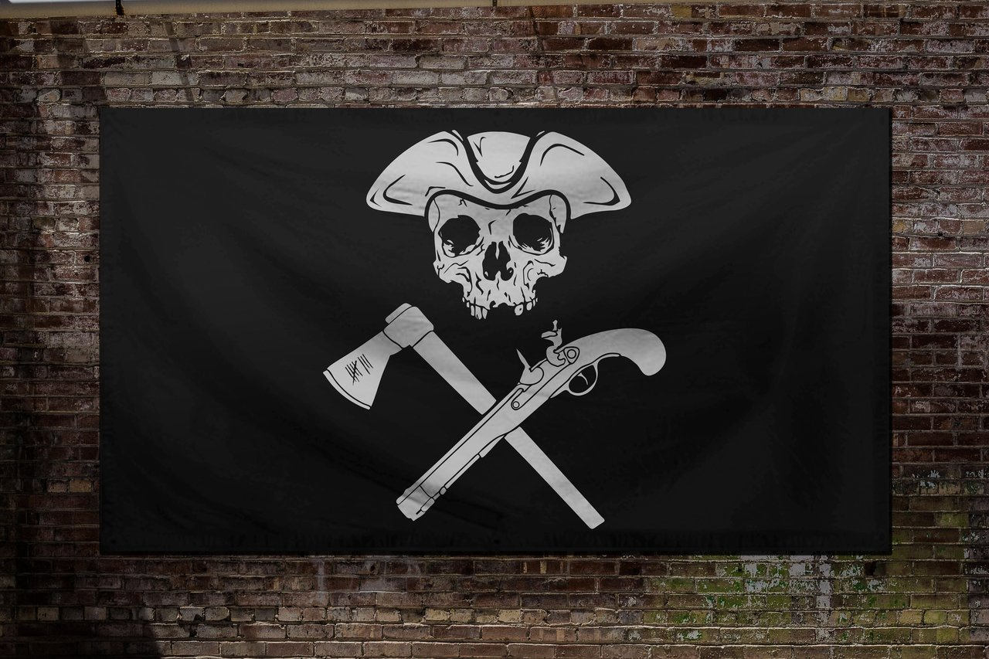

It’s now almost two weeks since the most crooked, rigged, fraudulent election in U.S. history. The engineered elevation of a handsy, sniffy, senile, empty portal, trojan horse by billionaire oligarchs, their Silicon Valley techno-geek social media censorship police, and the corporate media propaganda mouthpieces looks like it might succeed. Republican cucks like Romney and even the pliable Fox News talking heads have acquiesced to this third attempt during this ongoing coup like obedient lapdogs positioning themselves to profit from doing the bidding of their global oligarch masters.

Make no mistake. There was a master plan implemented by dark forces to steal this election, overriding the will of the American people. The anger of 70 million Americans is perfectly captured in the above quote from Mencken. If Trump and his allies are unable to prove fraud and overturn this sham of an election, myself and millions more will treat the Kamala Harris administration as illegitimate and do everything in our power to resist and insure its failure.

The level of fake news media propaganda about the “most secure fairest election in history”, and the vociferous blatant systematic censorship by Twitter, Facebook, and Google of anyone who dares to question the approved narrative of “a mostly fraud free election” on their social media platforms is all the proof a critical thinking person needs to realize this election was stolen by left wing oligarchs. Trump was too erratic, uncontrollable and resistant to their new world order agenda of climate extremism, population control through fear, communist economics, cash elimination, and ruling through a technocratic Big Brother surveillance state.

Trump, through naivety, foolishness or carelessness, allowed enemies of his administration to wield power and influence for the last four years. He chose swamp creature after swamp creature for key cabinet positions and seemed surprised when they stabbed him in the back. He failed to purge Obama loyalists holding middle level positions in the FBI, CIA, Dept of Defense, and numerous other agencies. They actively worked to subvert everything he tried to accomplish.

The military industrial complex apparatchiks are cackling like hyenas about how they misled him about troop levels in Syria and continue to ignore his orders to bring the troops home from Afghanistan. Obama and his gang of traitorous thieves conspired to bring Trump down before he assumed office and continued for the entire four years, assisted by a feckless mainstream media of faux journalists peddling fake news and disinformation fed to them by the Deep State coup collaborators.

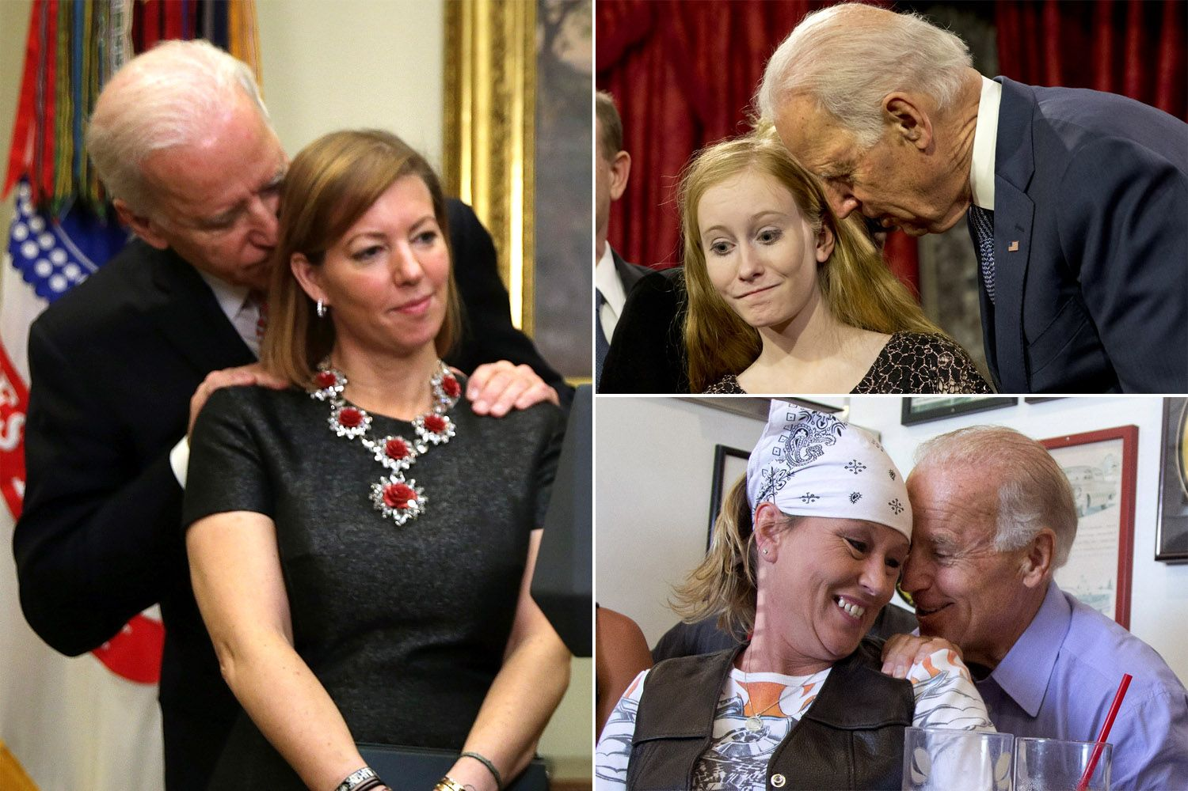

It was creepy Joe Biden who suggested using the Logan Act to entrap General Flynn and derail the Trump presidency before it began. He was part of the plot, along with Obama, Clinton, Comey, Brennan, Clapper, and a myriad of other slimy toadies doing the bidding of their treacherous back-stabbing superiors. Joe Biden, in addition to being a senile old pervert and the father of coke addict son who slept with his dead brother’s wife, is a racist and a traitor to this country.

Along with his dishonorably discharged deviant son and his gold-digging brother, he shook down foreign leaders and sold his influence for millions of dollars. This was all revealed on Hunter’s laptop, and completely memory-holed by Jake Tapper and the contingent of Deep State media hacks pretending to be journalists. Biden was selected by the shadowy billionaires constituting the invisible government, who really run the show, as a pretend viable candidate for president – whose job was to shut up, stay in the basement, and let them do the vote rigging to hand him the presidency. So now Mencken has been proven right once again.

“As democracy is perfected, the office of president represents, more and more closely, the inner soul of the people. On some great and glorious day the plain folks of the land will reach their heart’s desire at last and the White House will be adorned by a downright moron.” – **H.L. Mencken**

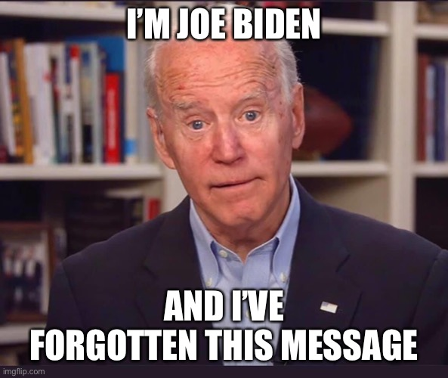

The “resistance”, also known as left-wing Deep State corporate fascists, have been conducting an ongoing coup since before Trump took the oath of office and it has continued through this rigged election. It has been a planned, coordinated and well-funded coup d’état against a duly elected president and the wishes of the American people. The Steele Dossier was a ploy by Hillary Clinton and her minions to undermine Trump. The accusations of Russian collusion were false and promulgated by CNN, MSNBC, NYT and Washington Post because they were active participants in attempting to undermine the Trump presidency, in collusion with Obama, the FBI, CIA and State Dept.

The Mueller investigation was a complete fraud and nothing more than a diversionary tactic from the true criminality of Obama, Clinton, Comey, Clapper and Brennan. The impeachment scheme engineered by pandemic Pelosi and bug-eyed Schiff head was based upon the fact that Joe Biden illegally interfered in the investigation of a foreign country to protect his crackhead son’s multi-million-dollar Burisma scam. It failed so miserably, not a word was spoken about the sham during the election.

Then, like manna from heaven for down in the dumps left wing billionaires, the Wu-flu was released upon the world by Biden’s communist pals in China. With the unemployment rate at 3.5%, the economy growing strongly, the stock market at all-time highs, the failed impeachment farce over, and a Democrat slate of losers, nutjobs, and communists competing for their nomination, Trump was a shoe-in to win re-election.

Hanoi Jane Fonda told the truth shortly before the election, “I just think Covid is God’s gift to the left.” As Obama’s best buddy Rahm Emmanuel once said, the left never lets a good crisis go to waste. The billionaire oligarchs Soros, Bloomberg, Gates, Bezos, Zuckerberg, and Dorsey, along with the Deep State democrats and Never-Trumpers, and their propaganda media mouthpieces hatched a plan to weaponize a flu that has a 99.7% survival rate.

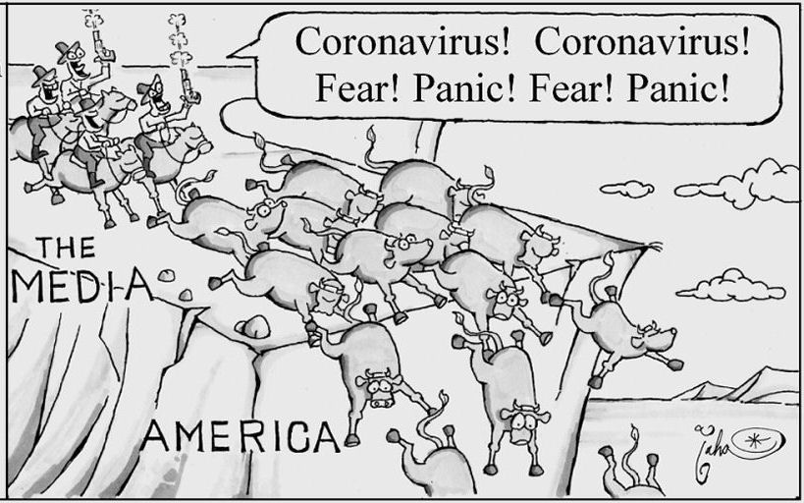

“The whole aim of practical politics is to keep the populace alarmed (and hence clamorous to be led to safety) by an endless series of hobgoblins, most of them imaginary.” – **H.L. Mencken**

The anti-Trump coalition was reinvigorated by the opportunity to use the pandemic to wrestle power away from Trump by any means necessary. Under the cover of Covid, the Constitution was shredded and Democrat governors, mayors and bureaucrat drones in swing states changed the rules of the game to encourage and sanction voter fraud. The fix was in. Even though Americans could “safely” stand in long lines at Wal-Mart, Target, and Home Depot, our left-wing Governors across the land declared it unsafe to vote in person.

They had to save lives by instituting mass mail-in voting with absolutely no safeguards against fraud. Matching signatures was racist. Requiring ID verification was racist. Their voter rolls were filled with dead people and people who had moved years ago. They all received ballots. Biden received 100% of the dead vote. Over the summer, BLM and ANTIFA terrorists were encouraged to “peacefully protest” in large groups while looting and burning left wing run cities in swing states. Looting and rioting was safe, but going to church, school or voting in person was too dangerous.

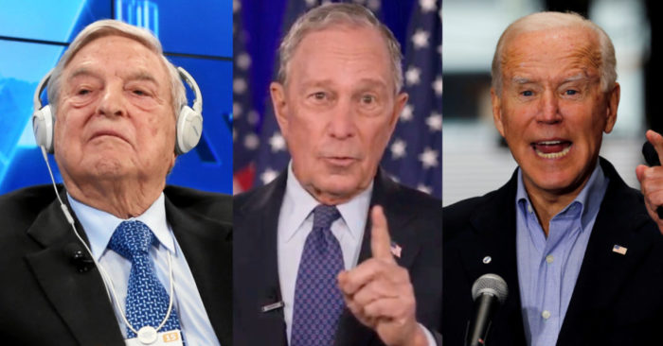

You could see the plan to dispose of Trump developing as we approached Fall. Soros, Bloomberg, and their ilk poured hundreds of millions into key states to influence the vote, but the real work was being done behind the curtain. Left wing Secretaries of State in the key battleground states were issuing edicts without legislature approval to insure a Biden victory. While Hiden Biden took long naps in his basement bunker, his handlers took care of laying the groundwork for a successful election embezzlement.



When Pelosi wasn’t breaking her own lockdown rules by getting her hair did, she was blocking any bill that would help the economy recover before the election. Fauci, the CDC, and the medical industrial complex Trump haters then pushed the Covid fear into overdrive. They rolled-out mass testing with a faulty PCR test to drive up cases to all-time highs just before the election.

The MSM talking heads then did their part to hyperventilate about the coming mass death event unless sleepy Joe was put in charge. His brilliant plan of more masking and more lockdowns would surely work this time, just like they worked so well in Europe. The billionaire oligarchs propping up their corpse of a candidate understood Mencken’s truths about the ignorance of the masses.

“Democracy is a pathetic belief in the collective wisdom of individual ignorance. No one in this world, so far as I know—and I have researched the records for years, and employed agents to help me—has ever lost money by underestimating the intelligence of the great masses of the plain people. Nor has anyone ever lost public office thereby.” – **H.L. Mencken**

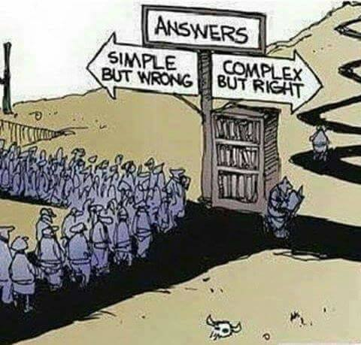

The entire Deep State apparatus was working in coordination to steal this election and override the wishes of the majority of Americans, because they know what is best for our country – government control of every aspect of our lives and a Great Reset to a new world order run by global elite oligarchs.

The hobgoblin of Covid cases has been the cudgel used to beat the masses into submission and invoke fear into those incapable of independent thought, who have been so dumbed down by the government education system they can’t understand the data right in front of their faces. If you conduct a record number of highly faulty tests, you will get a record number of false cases – not sicknesses. Elon Musk took the exact same test four times in one day and tested positive twice and negative twice.

The chart below is so scary if you can’t add, subtract, multiply or divide. The only thing that should matter to people are deaths “FROM” Covid. The fact is only 6% of the 245,000 deaths were from Covid. The other 94% died from something else, while they had Covid. We know the average age of death is 80, higher than the overall average age of death. They should have a death classification of “FROM Cuomo”. We know for a fact 50% of the deaths were in nursing homes where Cuomo, Murphy, Wolf, and Whitmer sentenced senior citizens to death by sending infected patients into the nursing homes.

We know virtually no one under the age of 50 dies from this over-hyped flu, but government school teacher unions refuse to teach children in person. Only 450 deaths between 5 and 24 years old is far less than the annual flu deaths in this age group. Anything to help derail Trump’s re-election chances has been implemented.

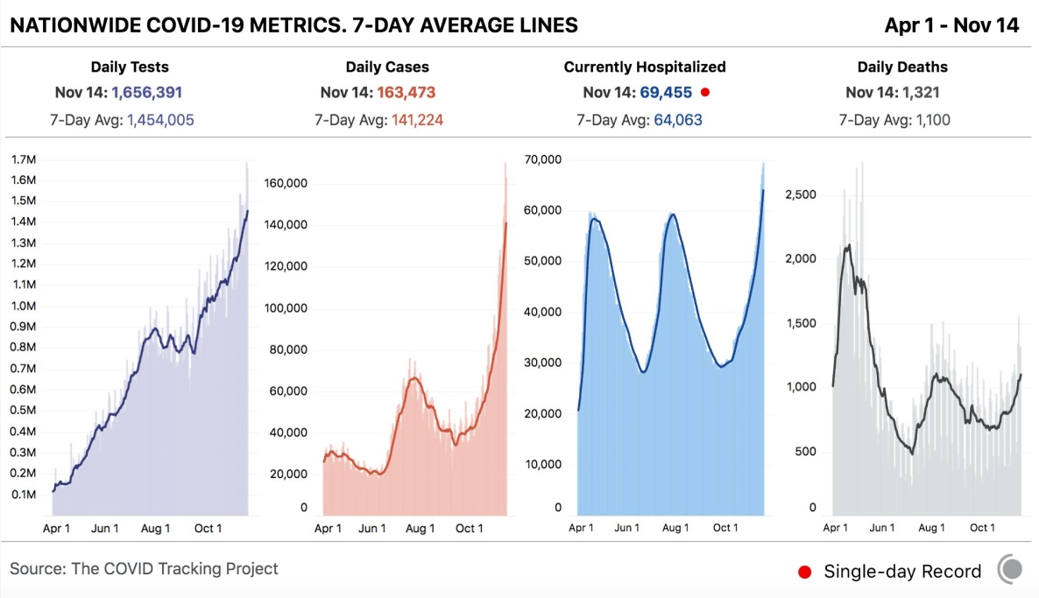

Back to the chart. In April the deaths per case was 7%. Two months-ago the deaths per case was 2.1%. Today the deaths per case is 0.8%. For the math challenged, the death rate has plunged by 88% since April. Have you heard that great news from Fredo on CNN or Madcow on MSNBC?  It’s pretty clear approximately 8% of the U.S. population has been infected by this flu. That’s 26 million people. The 245,000 deaths are less than 1%. Shockingly, that is the exact same death rate of the annual flu, as documented by our beloved [**CDC**](https://www.cdc.gov/flu/about/burden/2018-2019.html):

CDC estimates that influenza was associated with more than 35.5 million illnesses, more than 16.5 million medical visits, 490,600 hospitalizations, and 34,200 deaths during the 2018–2019 influenza season.

It’s the flu bro!!!! – And you have a 99.7% chance of not dying from this scary virus.

Does anyone really think it was a coincidence Fauci and Pfizer withheld the results of their vaccination trial until a few days after the election? Do you think that news would have swayed some votes? What I have realized is there are no coincidences. This is all part of the plan. Is it a coincidence that Nancy Pelosi’s former chief of staff is a lobbyist for Dominion or that Feinstein’s husband was a major investor? Is it a coincidence Dominion voting machines were rolled out in every swing state, even though Democrat Senators in December 2019 questioned the security of these machines?

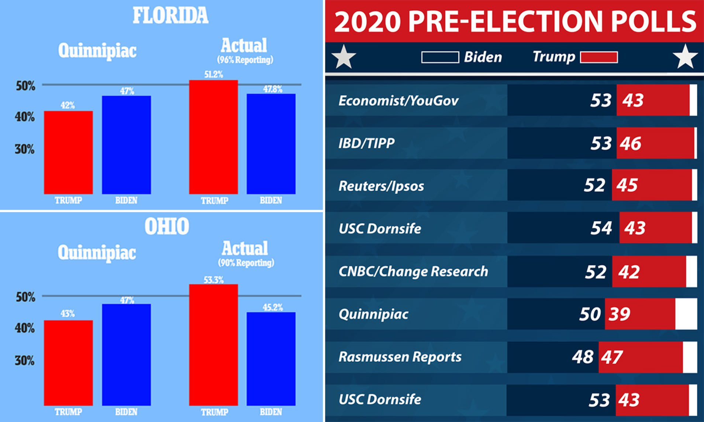

Despite the rigged polls purporting to show a Biden landslide and a blue wave, utilized to depress the Trump vote, and the hundreds of millions spent by the billionaire elitists, it was clear Trump was going to win on election night at 2:00 am. Dorsey and Zuckerberg had been working like madmen during the last week before the election suppressing and censoring the truth about Hunter Biden and the Biden crime family adventures around the globe. But it looked like all that money and effort was going to fail.



Then another non-coincidence occurred in Pennsylvania, Michigan, Georgia and Wisconsin, as they all simultaneously stopped counting votes for a few hours, when Trump had commanding leads in all four states. Mysteriously, as soon as counting resumed, an avalanche of Biden votes began pouring in. Republican poll watchers were given the boot or not allowed access to witness the vote counting. Machines “accidentally” switched thousands of Trump votes to Biden in Michigan. Bins of votes arrived in the wee hours of the morning under cover of darkness.

Data experts analyzing the vote counts show the chances of such a one-sided distribution in Biden’s favor was mathematically impossible. The results in Philadelphia, Detroit, Milwaukee and Atlanta are skewed so far out of line with the rest of their states and the country, the only explanation is massive fraud. The frantic level of pushback from the corporate media and social media censorship police is proof the claims are true. Trump was right when he said “Bad things happen in Philadelphia”. Was the CIA Hammer program used against Trump? We know the CIA brass hates him. Were the Dominion machines programmed to switch votes from Trump to Biden? We may never find out.

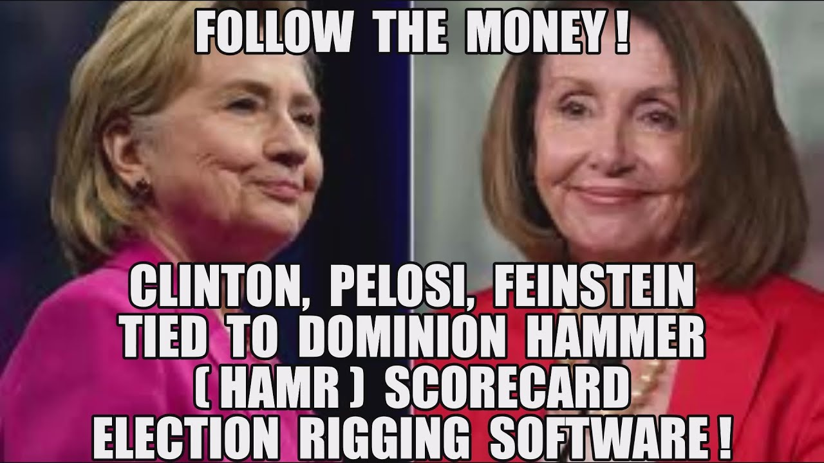

Trump’s only hope at this point is for his lawyers and data analysts to prove this level of fraud occurred. As Mencken profoundly stated:

“The most dangerous man to any government is the man who is able to think things out for himself, without regard to the prevailing superstitions and taboos. Almost inevitably he comes to the conclusion that the government he lives under is dishonest, insane, and intolerable.” – **H.L. Mencken**

I’ve come to the conclusion those who run our government from the shadows are dishonest, insane, intolerable and evil. If the American people allow this coup to succeed and continue to believe the lies they are being told about Covid and the communist agenda of the left, they will deserve to get it good and hard, as Mencken predicted when pondering democracy. Honoring thieves and liars, while detesting those who tell them the truth, is where we find ourselves today.

Those on the verge of gaining power want to rule over you. Freedom, liberty, free speech, and the 2nd Amendment are considered dangerous by these tyrants. These elitists want a global reset where you are nothing but a serf who will be given what they decide and told to shut up and obey. Otherwise they will destroy your ability to earn a living and will publicly shame you. If they can steal the two Georgia senate seats, and they will use any means necessary to do so, they will fundamentally attempt to destroy this country. For those who don’t believe these left-wing communist radicals would ever go as far as they bloviate on social media, heed the words of someone who experienced it first-hand in a gulag.

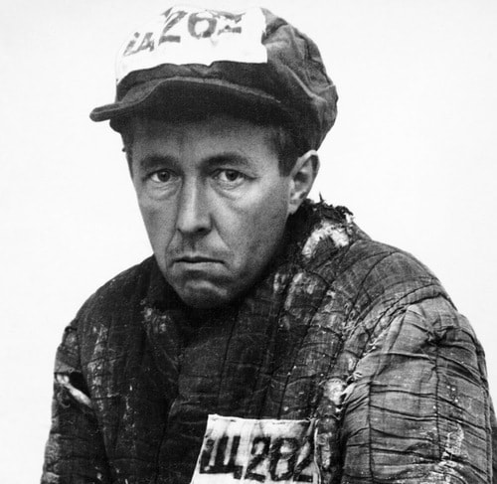

“All of the Communist Parties, upon attaining power, have become completely merciless. But at the stage before they achieve power, it is necessary to use disguises.” – ***Aleksandr Solzhenitsyn***

We have arrived at a key juncture in this Fourth Turning. In my October article [**Fourth Turning Election Year Crisis**](https://www.theburningplatform.com/2020/10/22/fourth-turning-election-year-crisis-3/) I anticipated the current state of affairs.

“I do not believe either side will accept the outcome of the election and will treat the victor as illegitimate. Once that mindset gains control, only violent conflict can result.”

Based on my observations of fraud, I will not consider Biden a legitimate president if he is appointed by the oligarchs in January. If Trump is able to overturn this blatant fraudulent outcome, the left and their BLM and ANTIFA mercenaries will lose their minds – burning, looting, rioting and attacking defenseless white people. The violence kicked off at the Washington DC March for Trump, with the low-life left wing terrorists sucker punching old people, women and families with kids.

When they picked the wrong victim, they got the shit kicked out of them. This was only a prelude to what is coming. As the intensity of hatred between the 70 million Trump supporters and the 70 million AOC, Sanders, Pelosi, Harris, Soros contingent ratchets up to war level, this will become a shooting conflict. Assassination of politicians, bankers, and oligarchs is a likely next step. The intensity of conflict will only ramp up from here.

I’ve been wondering how Trump could be the Grey Champion if he was to lose the election. As he refuses to concede and continues to fight against this election fraud chapter of this four-year long coup, it becomes clear that even if he is forcibly removed from office, he will become the real resistance. This Fourth Turning is resembling our first Civil War. Both sides were led by men from the Prophet generation (Lincoln & Davis), so both could be classified as Grey Champions. Biden is Silent Generation and Harris is Gen X, so Trump remains the Grey Champion.

With his bully pulpit, Twitter account, mass rallies, a potential for TNN (Trump News Network), and 70 million dedicated followers who believe he was robbed, Trump can essentially create an alternative presidency. Every decision or policy from Harris/Biden will be contested by Trump. Imagine the fireworks if he chooses to hold a counter rally in DC on inauguration day. The pussy hat wearing lefties did so in 2017. Paybacks are a bitch.

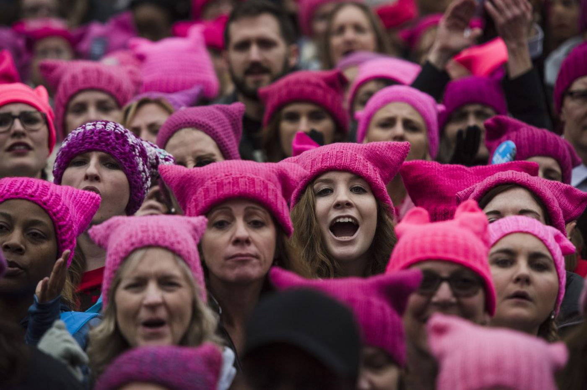

I see two potential triggers for the coming violent upheaval. If the Supreme Court rules in favor of Trump regarding the coordinated election fraud, the left will go berserk, but this time the Trump supporters will fight back. If Trump is unsuccessful and the wizards of fraud are able to steal the two Georgia Senate seats, the left will try to implement their radical takeover of the country by packing the Supreme Court and adding Puerto Rico and Washington D.C. as states.

If they successfully seize power, they have no intention of ever relinquishing it. They will work with their global elite brotherhood to institute their desired global reset. The right will either surrender and accept their fate as slaves or violently fight back. Trump will be provoking conflict and leading the resistance to the illegitimate Harris/Biden regime. Since Harris/Biden is controlled by warmongering statists, one cannot rule out a foreign conflict added to the mix. This civic chaos and global disorder will be exacerbated by the financial collapse caused by the toppling of the global debt Ponzi scheme.

This four-year coup attempt has radicalized millions of liberty-loving, critical thinking people who love their country, but now hate those hijacking their government. We are tired of seeing our country debauched. Good people who are driven to despair and feel they are backed into a corner are dangerous, and heavily armed.

If you are not armed, it is time to do so. Starve the beast. Do business with locals using cash. Reduce your footprint. Get out of debt. Become anti-fragile. Resist every mandate issued by dictatorial politicians and low IQ government drones. Figure out who you can depend upon and know your enemy. Do not associate with anyone who voted for Harris/Biden. Only tough choices await. Mencken’s time for slitting throats seems to be rapidly approaching. This is how Fourth Turnings roll.

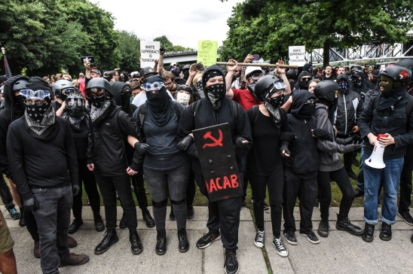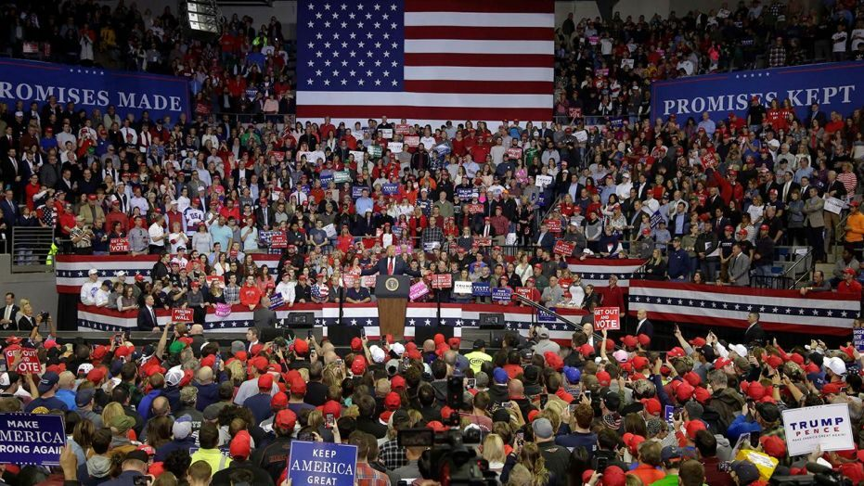

“The notion that a radical is one who hates his country is naïve and usually idiotic. He is, more likely, one who likes his country more than the rest of us, and is thus more disturbed than the rest of us when he sees it debauched. He is not a bad citizen turning to crime; he is a good citizen driven to despair.” – **H.L. Mencken**