**BOMBSHELL: The 2020 election took place under a Trump-declared “National Emergency” that set an Election Day trap for the “unauthorized accessing of election and campaign infrastructure”**

<https://www.naturalnews.com/2020-11-13-2020-election-took-place-under-a-trump-declared-national-emergency.html>

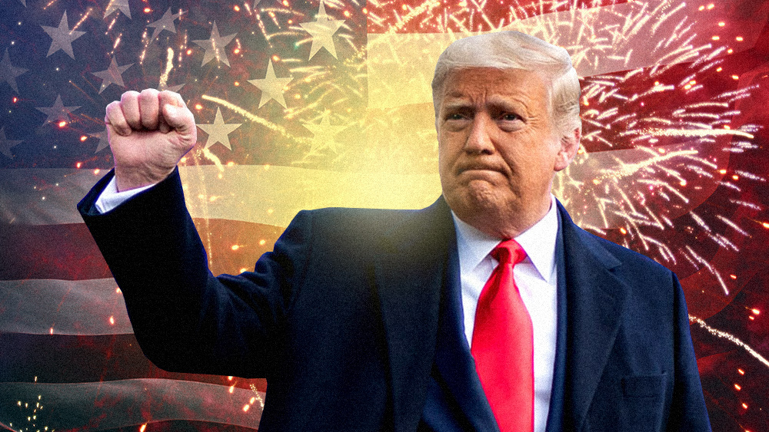

([Natural News](https://www.naturalnews.com)) We have another major bombshell for you here, regarding the 2020 election. Despite the intense, malicious censorship of Big Tech, we’re really becoming known for in-depth analysis and research of current events, so thank you for your support as we continue to fight for the very survival of America, our constitutional republic.

This story begins with the little-known executive order signed into existence on September 12, 2018, by President Donald J. Trump. That order, [available at Whitehouse.gov](https://www.whitehouse.gov/presidential-actions/executive-order-imposing-certain-sanctions-event-foreign-interference-united-states-election/), is entitled, “Executive Order on Imposing Certain Sanctions in the Event of Foreign Interference in a United States Election.”

In that executive order, which almost no one has covered since the day it was signed, President Trump **declares a national emergency**. That emergency is still in play to this day, and the 2020 election was conducted under this state of emergency, which is a crucial point to understand what’s coming next.

## “Unauthorized accessing of election infrastructure”

In the EO, the President also states that people and organizations located, in part, outside the United States are known to be able to, “interfere in or undermine public confidence in United States elections, including through the unauthorized accessing of election and campaign infrastructure or the covert distribution of propaganda and disinformation.”

If you’re starting to see how this ties in to CNN, the NY Times, the Washington Post and MSNBC, you’re not alone. All those organizations, as you’ll soon see, have been caught under this emergency declaration of “foreign interference” in U.S. elections, aided by complicit corporations on U.S. soil.

The EO further states that this foreign interference in U.S. elections, “constitutes an unusual and extraordinary threat to the national security and foreign policy of the United States.”

Why is this relevant to anything we’re seeing right now with the massive election fraud carried out by the Democrats and the deep state? Because **Dominion Voting Systems is a Canadian company**. And Scytl is run out of Spain.

That’s right. Dominion is a foreign-owned company, which makes Dominion-based election theft a “foreign interference issue.”

Scytl, by the way, is [connected to George Soros and the Democrats](https://thenewamerican.com/soros-connected-vote-counting-firm-expands-in-u-s/), and according to TGP (see below), “Bill Gates also own stock in Scytl.”

## Dominion is Canadian, Scytl is from Spain; both represent “foreign interference” in US elections… with data routed through servers in Germany

Another voting machine company called Scytl — also widely used in US elections — is located in Spain. As [Great Game India reports](https://greatgameindia.com/us-election-bankrupted-spanish-scytl/):

Days after it was revealed how 2020 US Elections were rigged by Canadian Crown Agent Dominion Voting Systems through a so-called “glitch”, now GreatGameIndia has found involvement of another dubious foreign company in US Election meddling. The votes cast by Americans were counted by a bankrupted Spanish company Scytl in Spain. Like Dominion Voting Systems, Scytl has a long history of election fraud in various nations including injecting backdoors in its election software. The issue has prompted experts to question why the sensitive job of counting votes was outsourced to a foreign company? How could a bankrupted Spanish company count American votes in Spain? Due to such widespread fraud, the Chairman of the US Federal Election Commission Trey Trainor believes that the 2020 US Presidential Elections is illegitimate.

What people are missing in all this is that Trump’s 2018 executive order gives the DOJ the power **to seize all assets of individuals and companies that were complicit in aiding or covering up this foreign interference in U.S. elections**.

The National Emergency order specifically calls for seizure of all assets of entities that have, “directly or indirectly engaged in, sponsored, concealed, or otherwise been complicit in foreign interference in a United States election.”

That would, of course, have to include practically every CNN fake news anchor, every Big Tech CEO, every fake news journo-terrorist from NBC News, the NY Times and the Washington Post. They are all complicit in gaslighting America and covering up the massive foreign election interference that just took place.

Trump’s EO further explains that asset seizures shall target people and entities which have:

…materially assisted, sponsored, or provided financial, material, or technological support for, or goods or services to or in support of, any activity described in subsection (a)(i) of this section or any person whose property and interests in property are blocked pursuant to this order; or (iii) to be owned or controlled by, or to have acted or purported to act for or on behalf of, directly or indirectly, any person whose property or interests in property are blocked pursuant to this order.

In other words, **the EO covers every person who has been corrupted or compromised by communist China**. And that includes at least 80% of Democrat lawmakers, by our estimates, including Senators Feinstein and Schiff.

## Every organization involved in the election theft and cover-up can now be seized by the US government

But that’s not even the full extent of what’s demanded by this Executive Order. In Section 8, the order explains that the term “person” also means, “a partnership, association, trust, joint venture, corporation, group, subgroup, or other organization.”

In other words, any media organization that assisted in covering up or assisting foreign interference in a U.S. election is specifically targeted by this Executive Order.

Further in the definitions section, the EO explains:

…the term “election infrastructure” means information and communications technology and systems used by or on behalf of the Federal Government or a State or local government in managing the election process, including voter registration databases, voting machines, voting tabulation equipment, and equipment for the secure transmission of election results.

That would include the Dominion voting systems as well as all other voting systems used in the recent election.

Finally, the EO describes what it means by the term “foreign interference.” It means: (emphasis added)

…any covert, fraudulent, deceptive, or unlawful actions or attempted actions of a foreign government, or of any person acting as an agent of or on behalf of a foreign government, undertaken with the purpose or effect of influencing, undermining confidence in, or ***altering the result or reported result of***, the election, or undermining public confidence in election processes or institutions.

Note the important words of “altering the result or reported result of the election.” This is exactly what Big Tech and the lying fake news media have done to America. More that merely a crime, it’s treason… and it fell right into the national emergency trap that Trump publicly announced in 2018 which now means all these corporations and organizations can have their assets seized literally overnight.

In this video, Trump attorney Sidney Powell describes “staggering statistical evidence” and “staggering witness testimony” about the criminal election fraud that was carried out across America. She adds, “If you want to talk about foreign election interference, we certainly have it now.” Listen:

<https://twitter.com/i/status/1327379704014393344>

## Rep. Louie Gohmert (R-TX) says the US military just raided the server farm of Scytl in Spain

Lest you think this is all speculation and rumor, we now get to the part where the rubber meets the road. According to a video interview with Rep. Louis Gohmert (R-TX) which aired earlier today, the US military has just conducted a raid on the server farm of the now-bankrupt Scytl company in Barcelona, Spain.

The Gateway Pundit, which has been at the forefront of much of the bombshell reporting of the election rigging conspiracy that took place on November 3rd, reached out to its sources to confirm the military operations in Europe, as related to gathering evidence of election theft. [Here’s what TGP just reported](https://www.thegatewaypundit.com/2020/11/us-raid-software-company-scytl-seize-servers-germany-intel-source-says-yes-happened/):

The US government, once they determined that this Dominion server was involved in switching votes, then the intelligence community began a search for the server and discovered that the server was in Germany. In order to get access to that server and have it available for use in a legal manner they had to have the State Department work in tandem with the Department of Justice. They had to request that the government of Germany cooperate in allowing this seizure of this server.

The appropriate documents required to affect that kind of seizure were put in place, signed off on, and it appears there was also US military support in this operation. The US military was not in the lead. But this helps explain why Esper was fired and Miller and Kash Patel were put in place — so that the military would not interfere with the operation in any way.

By getting ahold of the server they now are going to have the direct evidence of when they were instructed to stop counting. They will also discover who gave the direction to stop counting and who initiated the algorithm that started switching votes. The CIA was completely excluded from this operation.

Here’s the interview with Rep. Gohmert, now on [Brighteon.com](http://Brighteon.com), just in case YouTube tries to memory hole this video:

## The raid appears to have targeted the CIA’s Frankfurt server farm operation

We also now have confirmation from WikiLeaks documents that **the CIA used a data center in Frankfurt as a remote hacking base** to rig US elections. [DW.com reported](https://www.dw.com/en/frankfurt-used-as-remote-hacking-base-for-the-cia-wikileaks/a-37841830):

WikiLeaks released a trove of CIA documents on Tuesday that it claimed revealed details of its secret hacking arsenal.

The release included 8,761 documents that it claimed revealed details of “malware, viruses, trojans, weaponized ‘zero day’ exploits, malware remote control systems and associated documentation.”

The leaks purportedly revealed that a top secret CIA unit used the German city of Frankfurt am Main as the starting point for numerous hacking attacks on Europe, China and the Middle East.

German daily “Süddeutsche Zeitung” reported the building was known to be home to a vast network of intelligence personnel including CIA agents, NSA spies, military secret service personnel, Department of Homeland Security employees and Secret Service employees. It reported the Americans had also established a dense network of outposts and shell companies in Frankfurt.

It appears the CIA was using the same foreign data center to hack the US elections… and got caught. This is precisely why, as the Gateway Pundit reports, the CIA was kept completely out of the server raid operation that just took place in Germany. The raid was likely leveled against the CIA’s own server farm that ran the remote Dominion hacking operation the night of the election!

======================================================================================================