**TRUMP BOMBSHELL: Dominion software deleted over 2.7 million votes nationwide, switched over 500,000 from Trump to Biden**

Thursday, November 12, 2020 by: [Mike Adams](https://www.naturalnews.com/author/healthranger)   
*Tags:* [*dominion*](https://www.naturalnews.com/tag/dominion)*,* [*election fraud*](https://www.naturalnews.com/tag/election-fraud)*,* [*Glitch*](https://www.naturalnews.com/tag/glitch)*,* [*Joe Biden*](https://www.naturalnews.com/tag/joe-biden)*,* [*left cult*](https://www.naturalnews.com/tag/left-cult)*,* [*President Trump*](https://www.naturalnews.com/tag/president-trump)*,* [*rigged*](https://www.naturalnews.com/tag/rigged)*,* [*Software*](https://www.naturalnews.com/tag/software)*,* [*stolen!*](https://www.naturalnews.com/tag/stolen)*,* [*Trump*](https://www.naturalnews.com/tag/trump)*,* [*vote fraud*](https://www.naturalnews.com/tag/vote-fraud)*,* [*voting machines*](https://www.naturalnews.com/tag/voting-machines)

<https://www.naturalnews.com/2020-11-12-trump-bombshell-dominion-software-deleted-votes-switched-biden.html>

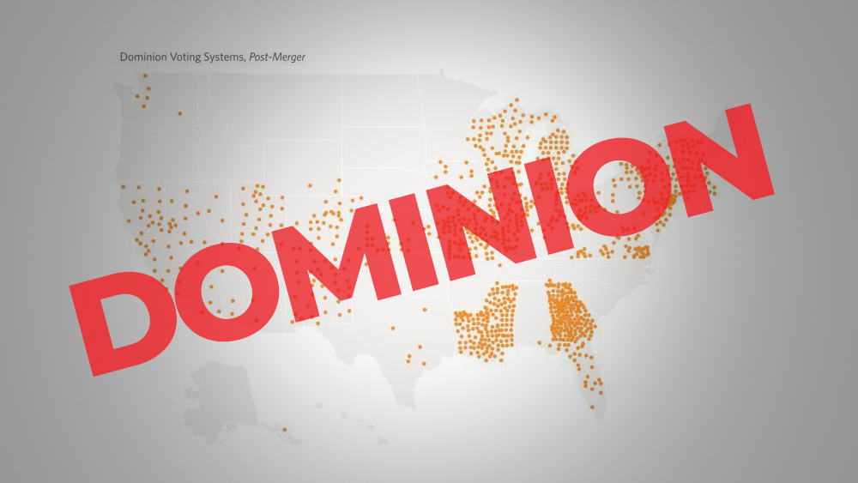

([Natural News](https://www.naturalnews.com)) As more evidence of Dominion software vote theft continues to emerge, President Trump has tweeted a bombshell news item, stemming from a data analysis of the raw vote log transaction data:

“REPORT: DOMINION DELETED 2.7 MILLION TRUMP VOTES NATIONWIDE. DATA ANALYSIS FINDS 221,000 PENNSYLVANIA VOTES SWITCHED FROM PRESIDENT TRUMP TO BIDEN. 941,000 TRUMP VOTES DELETED. STATES USING DOMINION VOTING SYSTEMS SWITCHED 435,000 VOTES FROM TRUMP TO BIDEN.”

In fact, data analysis reveals that over 2.8 million votes were deleted from President Trump, while 512,000 votes were switched from Trump to Biden. The data are now public, with Python language data analysis tools and full transaction data released by numerous analysts, including the “Centipede” user at TheDonald.win. ([See this page](https://thedonald.win/p/11Q8O2wesk/happening-calling-every-pede-to-/).)

Here’s the spreadsheet showing the deleted and switched votes. Not that votes were only deleted from Trump, never from Biden:

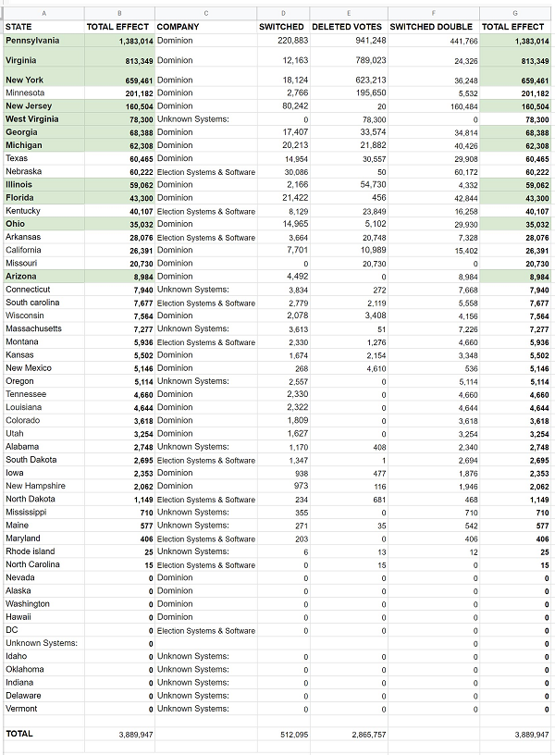

Here’s a map showing where Dominion voting systems are used. Note the heavy emphasis on swing states? This is where Democrats focus their vote theft and fraud against the People of the United States:

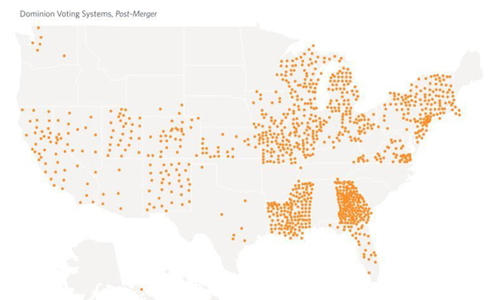

## Ballots dumped in Michigan to “catch up with Trump”

At the same time this is happening, Rudy Giuliani is now revealing that 100,000 ballots were brought into a ballot center in Michigan in order to “catch up with Trump.” This is coming from a **sworn affidavit** from an eyewitness, one of hundreds who will soon be presented to the courts:

https://twitter.com/RealAmVoice/status/1326704136323272709

[NewsTarget.com is reporting](https://www.newstarget.com/2020-11-12-dominion-voting-systems-behind-much-of-2020-vote-fraud.html) that Dominion Voting Systems is increasingly emerging as the single point for massive vote theft in the 2020 election, and [this article reveals the software machines are riddled with backdoor methods](https://www.naturalnews.com/2020-11-12-what-we-learned-from-dominion-voting-system.html) for remote access users who can alter votes and change the outcome of entire elections.

=========================================================================