And now, look at this picture of the Dal-Tex building. The Dal-Tex building is across the street from the Book Depository, and many leading researchers into the assassination, including Jim Garrison, say there was certainly a team of shooters in this building:

[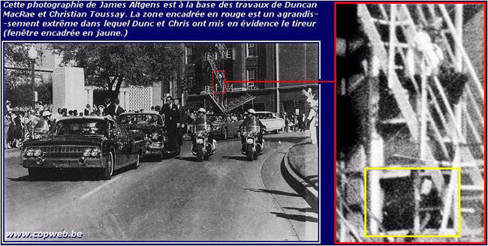](http://worldtruth.tv/wp-content/uploads/2015/06/bush-kennedy-connection-4.jpg)

And as you can see, some imaginative individual has added some colour to indicate three men in this window. Very creative, very imaginative; and at least plausible. Still, it takes way too much imagination and effort, to see Bush’s face. [**But now observe this link**](http://www.ratical.com/ratville/JFK/WTKaP.html).

Actually, You don’t have to stop and read it, because I’ll quote the relevant part. It’s a statement from Roger Craig, winner of the deputy of the year award for Dallas in 1960, and one of the most honest men working that day in Dallas. He’s an amazing and heroic fellow, worthy of all the time you could take looking into his background and character. And here, in the following passage, he is describing a conversation he had with Jim Garrison, and he says,

**“Jim also asked me about the arrests made in Dealey Plaza that day. I told him I knew of twelve arrests, one in particular made by R. E. Vaughn of the Dallas Police Department. The man Vaughn arrested was coming from the Dal-Tex Building across from the Texas School Book Depository.**

**The only thing which Vaughn knew about him was that he was an independent oil operator from Houston, Texas. The prisoner was taken from Vaughn by Dallas Police detectives and that was the last that he saw or heard of the suspect.”**

Holy Moe Lee! Please notice that, in speaking to Jim Garrison, Craig says “in particular”. Apparently he and Vaughn thought this was the most significant arrest made that day; pretty amazing given that E.Howard Hunt was arrested in the rail yard behind the grassy knoll. And the only thing Craig knew about this “particular” arrestee was that he had exactly the same singular CIA-cover, **“an independent oil operator from Houston, Texas”**, that George Bush had used that same day in his contact with the FBI.

Now. There are a very limited number of possible explanations for who this “independent oil operator” was. Let’s look at them.

**It is conceivable that the CIA had two men in Dallas area that day, supervising the shooters, who both had the designated cover of being an “independent oil operator from Houston.”** Bush was one, as the evidence above clearly shows; and perhaps there was another who was with the shooters in the Dal-Tex building, supervising them directly.

But unless the CIA overlords were trying to set Bush up, they would not have told anyone else to use Bush’s CIA cover to identify themselves to the police. If another man was involved in the crime, and was arrested for it, and he told the cops he was an “independent oil operator from Houston,” this would tend to throw suspicion in Bush’s direction.

**“The Khazarian Mafia’s intense hatred of anyone who professed faith in any God but their god Baal has motivated them to murder kings and royalty, and make sure they can never rule. They have done the same with American presidents – running sophisticated covert operations to disempower them.**

If that doesn’t work the KM assassinates them, like they did to McKinley, Lincoln and JFK. The KM wants to eliminate any strong rulers or elected officials who dare to resist their Babylonian money-magick power or their covert power gained from their deployment of their human compromise network.”

Bush’s association with the CIA’s Cubans was already widely known. Fletcher Prouty knew and wrote of it. Fabian Escalante, the head of Cuban counter intelligence, knew and has written about it. James Files, who claims very credibly, to have been a driver for the Mafia shooters in Dallas, has spoken on-camera about it.

And FBI director J. Edgar Hoover, knew about it and wrote about it in his memo. So Bush was already a suspect in Hoover’s eyes. The CIA planners, then, would not have told anyone else, “in case you get arrested, tell the cops you’re an independent oil man from Houston”. Right? They would not have done this, since it would tend to incriminate Bush, who was already in a highly visible, highly suspicious position.

Another unlikely possibility is that this “independent oil operator from Houston” was just some innocent oil operator, who somehow managed to attract suspicion, and was arrested. Do you think it’s possible that another oil man from Houston just happened to be in that corner of Dealey Plaza?

[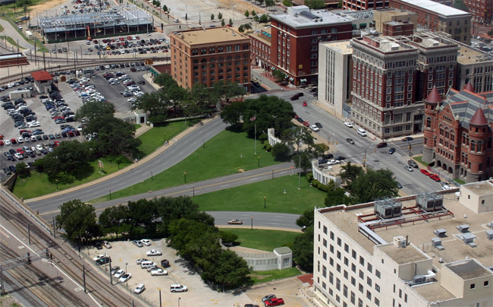](http://worldtruth.tv/wp-content/uploads/2015/06/dealey-plaza-1.jpg)

Now remember, Roger Craig tells this story in the context of his discussions with New Orleans District Attorney Jim Garrison**about the suspects who were arrested that day and who then evaporated without leaving a mugshot, interview, fingerprint, or name.** Garrison spoke not only to Roger Craig, but he no-doubt spoke to Vaughn, who made the arrest. And Garrison adds the following:

**“At least one man arrested immediately after the shooting had come running out of the Dal-Tex Building and offered no explanation for his presence there. Local authorities hardly could avoid arresting him because of the clamor of the onlookers.**

He was taken to the Sheriff’s office, where he was held for questioning. However, the Sheriff’s office made no record of the questions asked this suspect, if any were asked; nor did it have a record of his name. Later two uniformed police officers escorted him out of the building to the jeers of the waiting crowd.

They put him in a police car, and he was driven away. Apparently this was his farewell to Dallas, for he simply disappeared forever.”

The third problem is this question of why Bush would feel that it was necessary to concoct such a story at all? Why does he have to tell us this lie? Why does he have to get others, like Irby, to lie for him? The irony is that the harder he tries to make himself appear innocent, by lying, the more evidence he gives us of his guilt.

[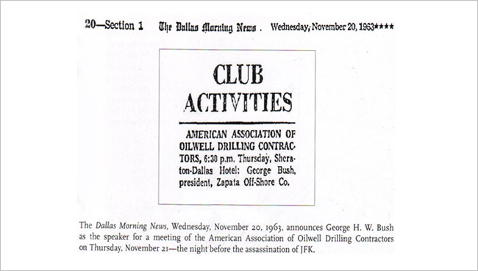](http://worldtruth.tv/wp-content/uploads/2015/06/bush-kennedy-connection-6.jpg)

There are some people who manage to point to this and say “ahah! That’s why Bush was in Dallas! Not to kill the President, but to speak to the other oilmen!” But as the Hoover memo shows, being an oilman was just a cover for Bush’s real occupation as a CIA supervisor of trained killers. **He needed an excuse for being in Dallas. This speaking engagement provided him with one.**