BARBARA BUSH DEAD

**'I'm a lucky man that Barbara Bush was my mother': George W Bush leads tributes as former First Lady dies aged 92, two days after falling ill and saying she no longer wanted medical treatment**

* **Former first lady and wife of 41st president George H.W. Bush died at home on Tuesday, family said**
* **Bush was loved by the American people for her plainspoken manner and campaigns to boost literacy**
* **George W Bush remembered his mother as a woman who 'brought levity, love, and literacy to millions'**
* **President Trump paid tribute along with former presidents Barack Obama, Bill Clinton and Jimmy Carter**
* **Funeral service will be 11am Saturday at St. Martin's Episcopal Church in Houston**

By [Rory Tingle For Dailymail.com](http://www.dailymail.co.uk/home/search.html?s=&authornamef=Rory+Tingle+For+Dailymail.com)

**PUBLISHED:** 00:44 BST, 18 April 2018 | **UPDATED:** 07:17 BST, 18 April 2018

* [e-mail](mailto:?subject=Read%20this:%20%27I%27m%20a%20lucky%20man%20that%20Barbara%20Bush%20was%20my%20mother%27:%20George%20W%20Bush%20leads%20tributes%20as%20former%20First%20Lady%20dies%20aged%2092,%20two%20days%20after%20falling%20ill%20and%20saying%20she%20no%20longer%20wanted%20medical%20treatment&body=%27I%27m%20a%20lucky%20man%20that%20Barbara%20Bush%20was%20my%20mother%27%3A%20George%20W%20Bush%20leads%20tributes%20as%20former%20First%20Lady%20dies%20aged%2092%2C%20two%20days%20after%20falling%20ill%20and%20saying%20she%20no%20longer%20wanted%20medical%20treatment%0A%0ABarbara%20Bush%20has%20died%20aged%2092%20two%20days%20after%20falling%20seriously%20ill%20and%20saying%20she%20no%20longer%20wanted%20medical%20treatment.%20She%20was%20being%20cared%20for%20at%20her%20home%20in%20Houston%2C%20Texas.%0A%0Ahttp%3A%2F%2Fwww.dailymail.co.uk%2Fnews%2Farticle-5627825%2FBarbara-Bush-dies-aged-92-two-days-falling-seriously-ill.html%3Fito%3Demail_share_article-top%0A%0A%0AMost%20Read%20Articles%3A%0A%0AMother-of-two%20Wells%20Fargo%20executive%20from%20Albuquerque%2C%2043%2C%20is%20named%20as%20woman%20who%20was%20killed%20after%20being%20sucked%20out%20of%20Southwest%20737%20jet%20window%20when%20engine%20exploded%20at%2032%2C000ft%0Ahttp%3A%2F%2Fwww.dailymail.co.uk%2Fnews%2Farticle-5626379%2FSouthwest-Airlines-flight-makes-emergency-landing-Philadelphia-engine-blows-out.html%3Fito%3Demail_share_article-top_most-read-articles%0A%0AEXCLUSIVE%3A%20%27I%20thought%20my%20limbs%20might%20have%20to%20be%20amputated%27%3A%20Battered%20boyfriend%20stabbed%20and%20starved%20by%20his%20controlling%20girlfriend%20tells%20of%20his%20mental%20and%20physical%20torture%20as%20she%20is%20jailed%0Ahttp%3A%2F%2Fwww.dailymail.co.uk%2Fnews%2Farticle-5625663%2FBattered-boyfriend-stabbed-starved-controlling-girlfriend-tells-ordeal.html%3Fito%3Demail_share_article-top_most-read-articles%0A%0A%27Strap%20in%2C%20it%27s%20going%20to%20get%20bumpy%21%27%20Restaurant%20boss%20issues%20blistering%20response%20to%20TripAdvisor%20reviewer%20who%20complained%20her%20salad%20was%20COLD%250)

**5k**shares

**[1.6k](http://www.dailymail.co.uk/news/article-5627825/Barbara-Bush-dies-aged-92-two-days-falling-seriously-ill.html" \l "comments)**

[View comments](http://www.dailymail.co.uk/news/article-5627825/Barbara-Bush-dies-aged-92-two-days-falling-seriously-ill.html" \l "comments)

George W Bush has led tributes to his mother, former First Lady Barbara Bush, who has died aged 92 two days after falling ill and saying she no longer wanted medical treatment.

'My dear mother has passed on at age 92. Laura, Barbara, Jenna, and I are sad, but our souls are settled because we know hers was,' the 43rd US president said in a joint family statement on Tuesday.

'Barbara Bush was a fabulous First Lady and a woman unlike any other who brought levity, love, and literacy to millions.'

Bush held the hand of her husband, 41st president George H.W. Bush, all day on Tuesday and had him by her side when she passed away.

Scroll down for video

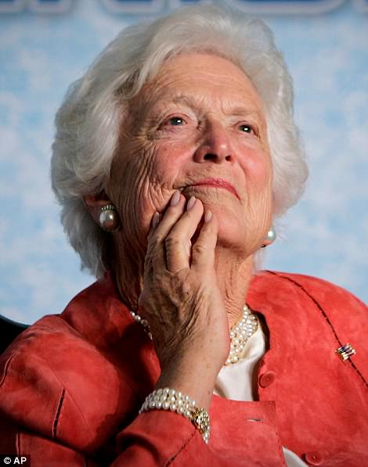

+50

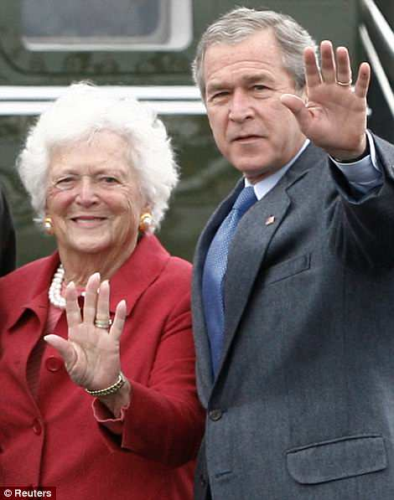

+50

Barbara Bush (pictured left on March 18, 2005 and right with George W Bush at Fort Hood, Texas, on April 8, 2007), died on Tuesday, according to a statement from the office of former President George H.W. Bush

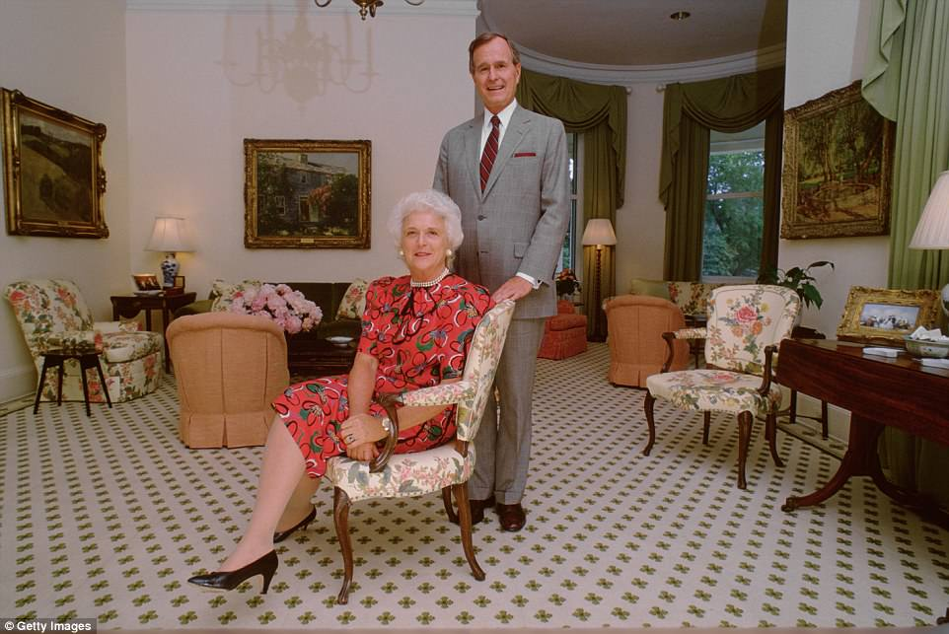

+50

Bush was the wife of the 41st president, George H.W. Bush. They are pictured together in the residence they shared when he was Vice President in 1983

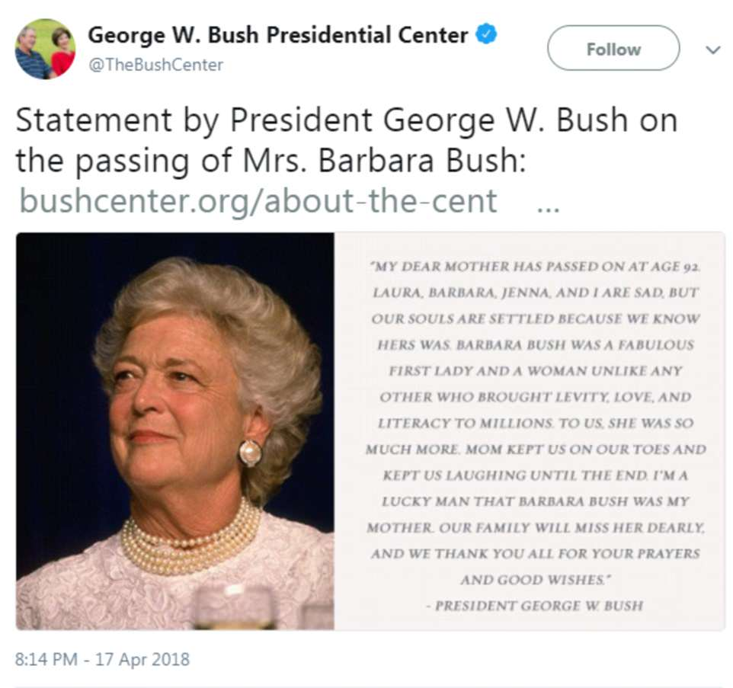

+50

George W Bush, the 43rd president, remembered his mother as a woman who 'brought levity, love, and literacy to millions'

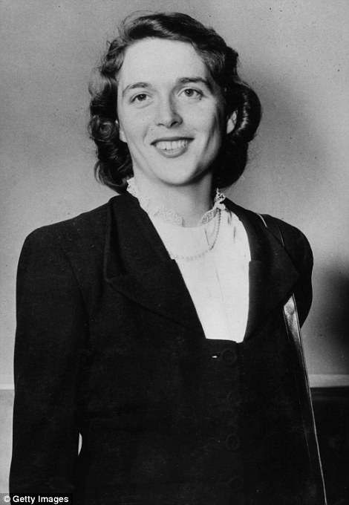

+50

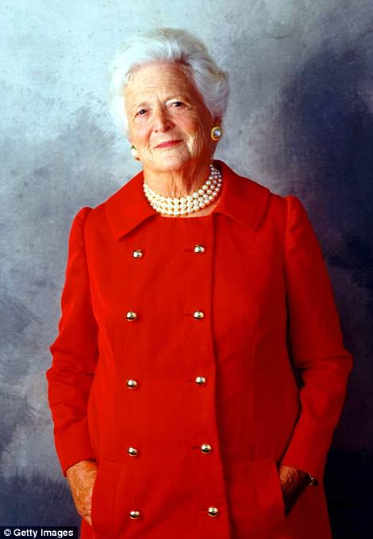

+50

Bush is pictured as the chair of the Barbara Bush Foundation for Family Literacy in an undated photo, left, and in Houston, Texas, on August 23, 2001

The snowy-haired first lady brought a grandmotherly style to buttoned-down Washington, often appearing in her trademark fake pearl chokers and displaying no vanity about her white hair and wrinkles.

'What you see with me is what you get. I'm not running for president — George Bush is,' she said at the 1988 Republican National Convention, where her husband was nominated to succeed Ronald Reagan.

Her death on Tuesday was announced in a statement from the office of George H.W. Bush.

'A former first lady of the United States of America and relentless proponent of family literacy, Barbara Pierce Bush passed away Tuesday, April 17, 2018, at the age of 92,' it read.

Funeral services are planned for 11am Saturday at St Martin's Episcopal Church in Houston. She will lie in repose from noon to midnight Friday at the church, and the funeral service is by invitation only. Burial will be on the grounds of the Bush library at Texas A&M university in College Station, about 100 miles northwest of Houston.

One of her 14 grandchildren, Texas land commissioner George P. Bush, tweeted: 'My grandmother's entire life was focused on others. For my grandfather, she was his top adviser and confidante. For her family, she was a steady, loving and guiding hand. And for her country, she was an inspiration and an example for all.

'My grandmother didn't just live life; she lived it well. And the sorrow of her loss is softened by the knowledge of her impact on our family and our country. I will miss you, Ganny—but know we will see you again.'

President Donald Trump released a joint statement with First Lady Melania Trump praising Bush's 'unfailing' service to her country and family. he has ordered US flags to be flown at half-staff in her honor.

**RELATED ARTICLES**

* [Previous](http://www.dailymail.co.uk/news/article-5627825/Barbara-Bush-dies-aged-92-two-days-falling-seriously-ill.html?ito=email_share_article-top_most-read-articles)
* [1](http://www.dailymail.co.uk/news/article-5627825/Barbara-Bush-dies-aged-92-two-days-falling-seriously-ill.html?ito=email_share_article-top_most-read-articles)
* [Next](http://www.dailymail.co.uk/news/article-5627825/Barbara-Bush-dies-aged-92-two-days-falling-seriously-ill.html?ito=email_share_article-top_most-read-articles)
* [**[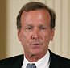](http://www.dailymail.co.uk/news/article-5623705/Tearful-Neil-Bush-reveals-mother-Barbara-92-walk-anymore-reading-her.html)Tearful Neil Bush reveals his mother Barbara, 92, is unable...**](http://www.dailymail.co.uk/news/article-5623705/Tearful-Neil-Bush-reveals-mother-Barbara-92-walk-anymore-reading-her.html)[**[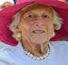](http://www.dailymail.co.uk/news/article-5618549/Former-lady-Barbara-Bush-seriously-ill-refusing-medical-treatment.html)Former first lady Barbara Bush, 92, is seriously ill with...**](http://www.dailymail.co.uk/news/article-5618549/Former-lady-Barbara-Bush-seriously-ill-refusing-medical-treatment.html)[**[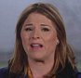](http://www.dailymail.co.uk/news/article-5621115/Jenna-Bush-Hager-gives-update-grandmother-Barbaras-condition.html)'She's a fighter. She's an enforcer': Jenna Bush Hager says...**](http://www.dailymail.co.uk/news/article-5621115/Jenna-Bush-Hager-gives-update-grandmother-Barbaras-condition.html)

**SHARE THIS ARTICLE**

Share

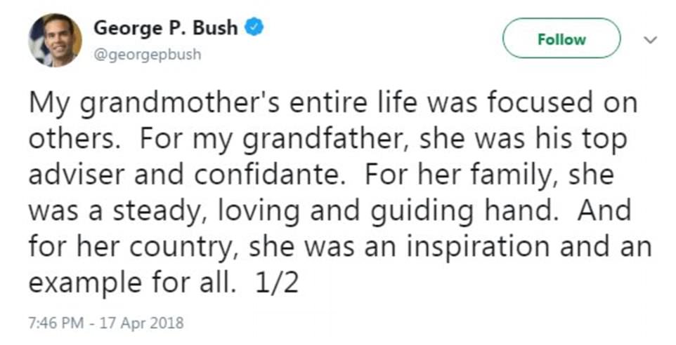

+50

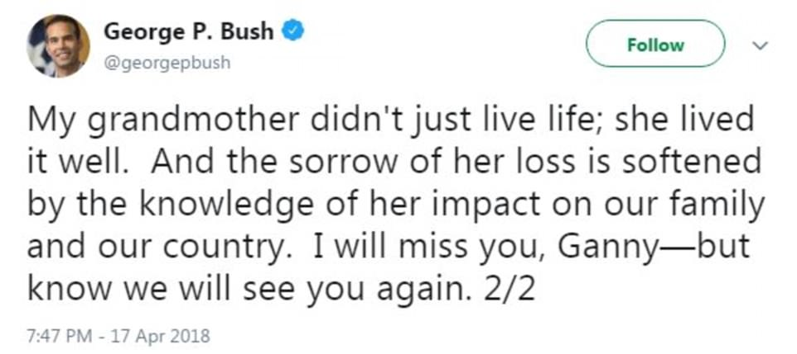

+50

One of his 14 grandchildren, Texas land commissioner George P. Bush, posted his own heartfelt tribute on Twitter

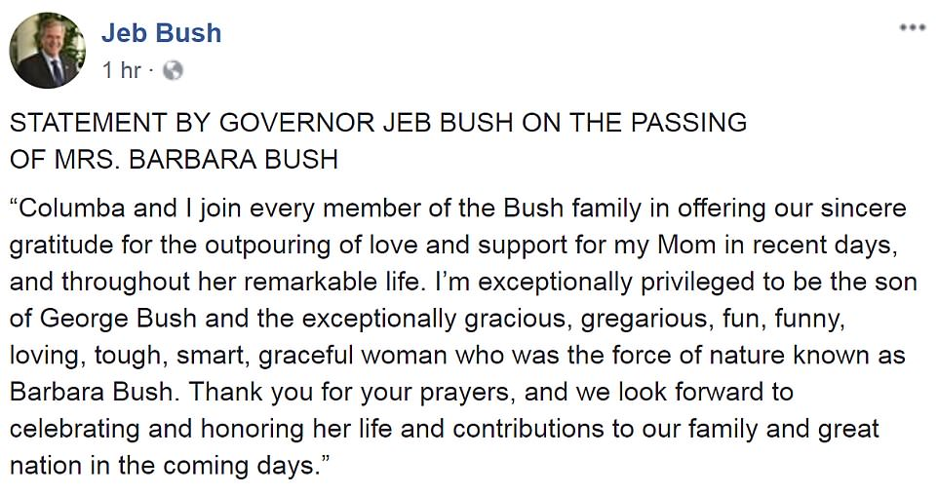

+50

Jeb Bush said in a statement the family looks forward to 'celebrating and honoring' Barbara Bush's life

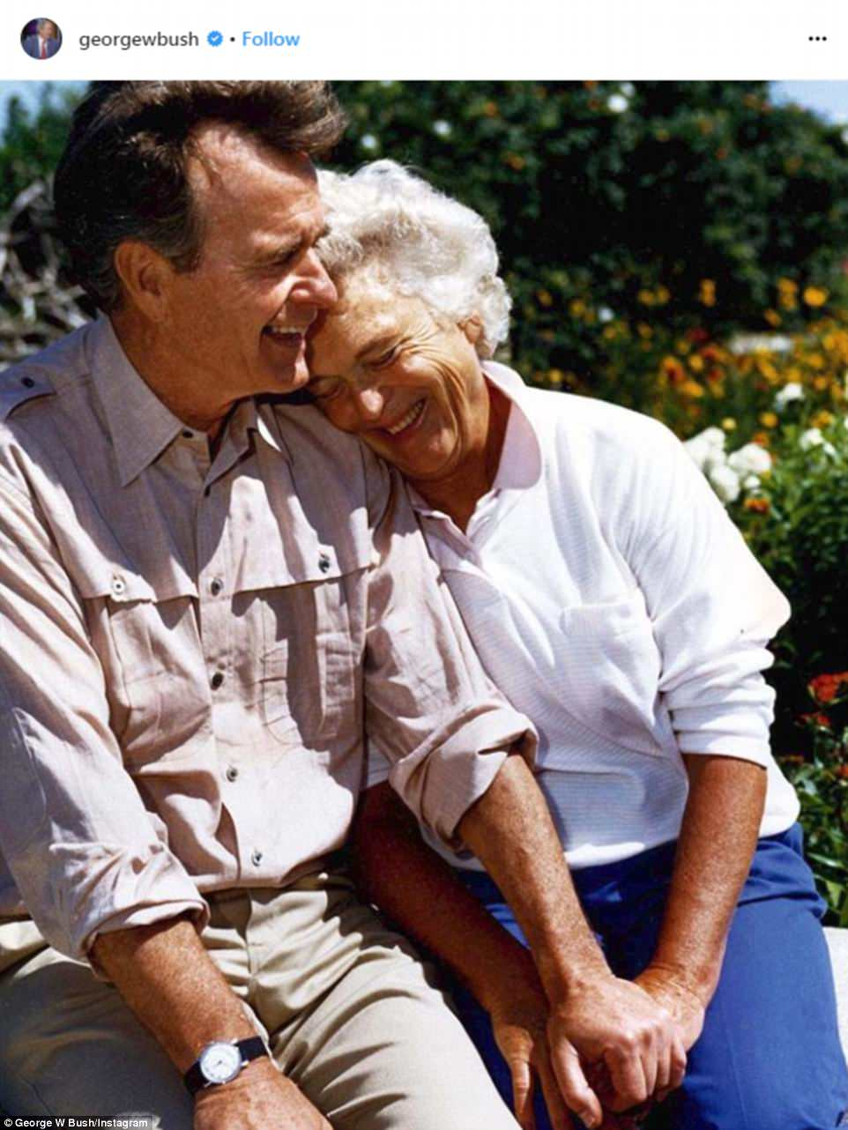

+50

George W Bush posted this charming image of his parents holding hands on Instagram next to his tribute to the former first lady

'As a wife, mother, grandmother, military spouse, and former first lady, Mrs Bush was an advocate of the American family. Amongst her greatest achievements was recognizing the importance of literacy as a fundamental family value that requires nurturing and protection.

'She will be long remembered to her strong devotion to country and family, both of which she served unfailingly well.'

Jeb Bush, who was governor of Florida from 1999 to 2007 and sought the 2016 Republican presidential nomination, said: 'I'm exceptionally privileged to be the son of George Bush and the exceptionally gracious, gregarious, fun, funny, loving, tough, smart, graceful woman.

'Thank you for your prayers, and we look forward to celebrating and honoring her life and contributions to our family and great nation in the coming days.'

A raft of former presidential couples also paid tributes to Bush as the news of her death emerged on Tuesday evening.

Bill Clinton praised her as a 'remarkable woman' who had 'grit and grace, brains and beauty', adding: 'She showed us what an honest, vibrant, full life looks like. Hillary and I mourn her passing and bless her memory.'

Barack and Michelle Obama said: 'Barbara Bush was the rock of a family dedicated to public service. We'll always be grateful to Mrs Bush for the generosity she showed to us throughout our time in the White House, but we're even more grateful for the way she lived her life - as a testament to the fact that public service is an important and noble calling; as an example of the humility and decency that reflects the very best of the American spirit.'

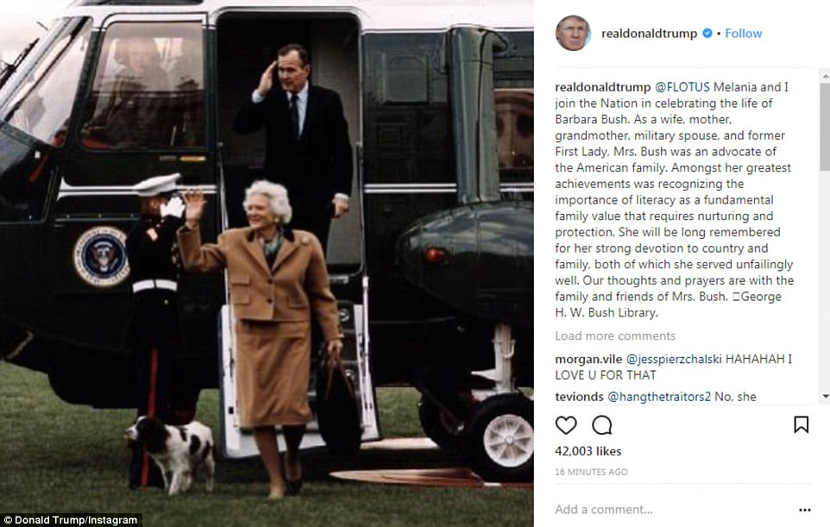

+50

President Trump released a statement praising Bush's 'unfailing' service to her country and family alongside an old photo of her with President George H.W. Bush

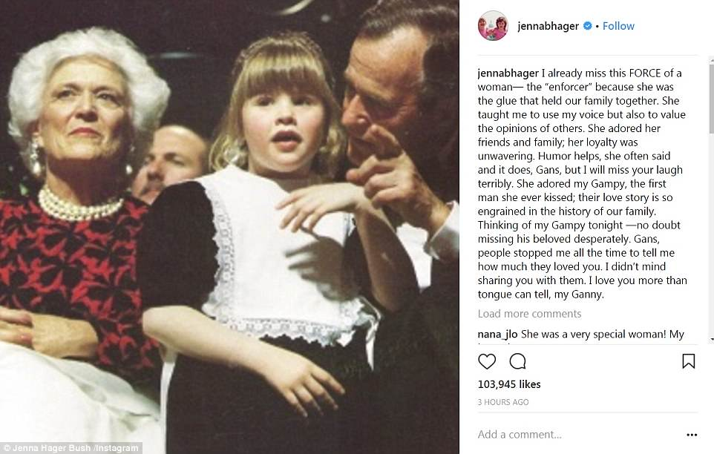

+50

George W Bush's daughter Jenna Bush Hager said she could miss a woman who 'adored her friends and family' and whose loyalty was 'unwavering'

39th president Jimmy Carter and his wife, Rosalynn, said: 'She touched the hearts of millions with her warmth, generosity, and keen wit. The matriarch of a family dedicated to servicing, she urged volunteerism as a way for all citizens to participate in our nation's progress.'

Former President Lyndon Johnson's daughter, Lynda Johnson Robb, said she smiles when she thinks of Barbara Bush, because her candor was always refreshing and her grace was endless.

Robb said Bush's love of family 'never wavered and she was always a true patriot.' She says her family was fortunate to know her and 'will always be grateful for her service to our country.'

Robb's sister, Lucy Baines Johnson, described Bush as a 'no nonsense' devoted mother to her family and the nation and was 'wit, wisdom, honesty, and character on two feet.'

Johnson said Bush inspired 'a 'thousand points of light' of service to our country and was a beacon to us all. We loved her for who she was and for what we became because of her example. Our hearts go out to her remarkable family and to all who loved her as we did. The world is a poorer placer without Barbara Bush.'

The Bush family had announced in a statement on April 15 that she was in failing health, had decided not to seek further medical treatment and instead would focus on 'comfort care.'

Bush reportedly had been battling chronic obstructive pulmonary disease and congestive heart problems in recent years.

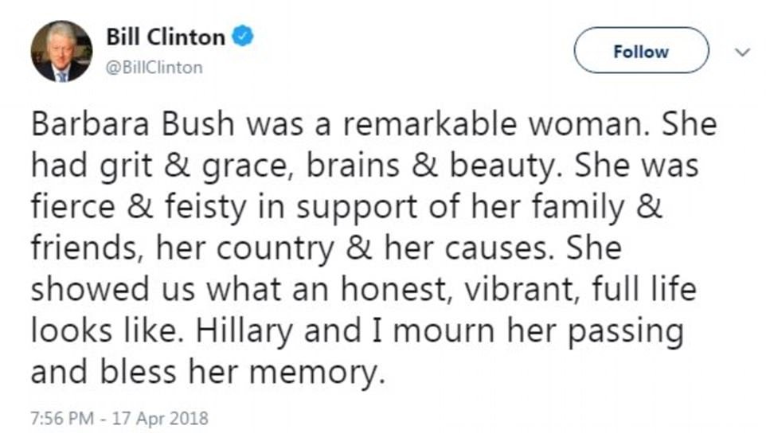

+50

Bill Clinton praised Barbara Bush on Twitter as a 'remarkable woman' who had 'grit and grace, brains and beauty'

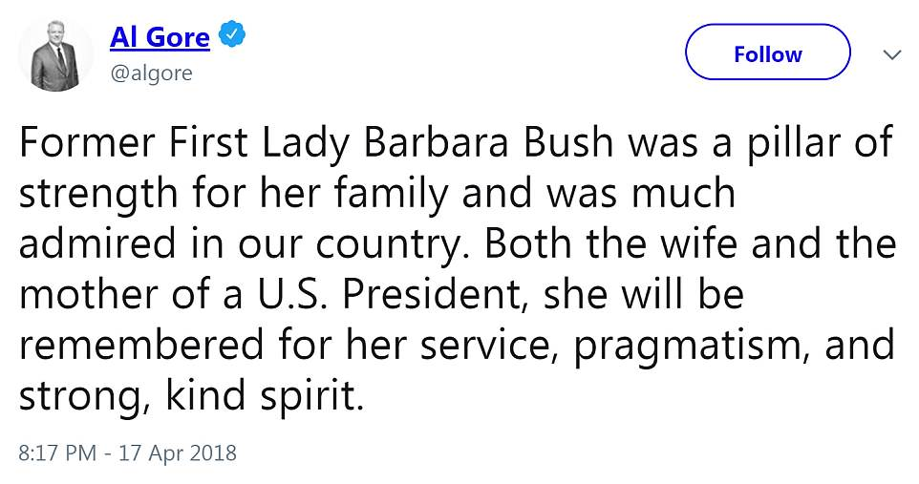

+50

Al Gore also shared his sentiments and condolences to the Bush family following the death of Barbara Bush

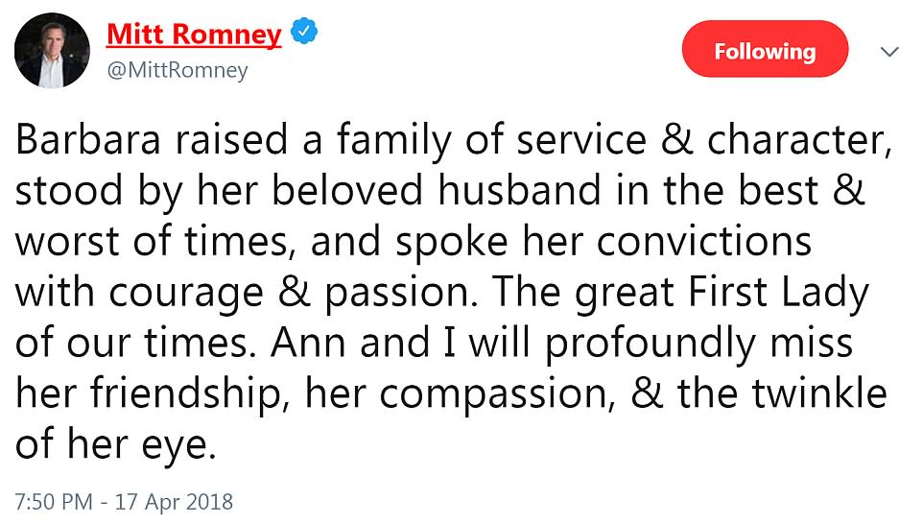

+50

Mitt Romney: 'Barbara raised a family of service & character, stood by her beloved husband in the best & worst of times, and spoke her convictions with courage & passion'

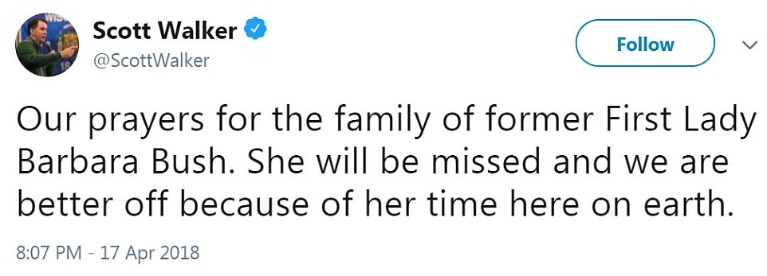

+50

Scott Walker, the governor of Wisconsin, also tweeted his condolences to the Bush family Tuesday night

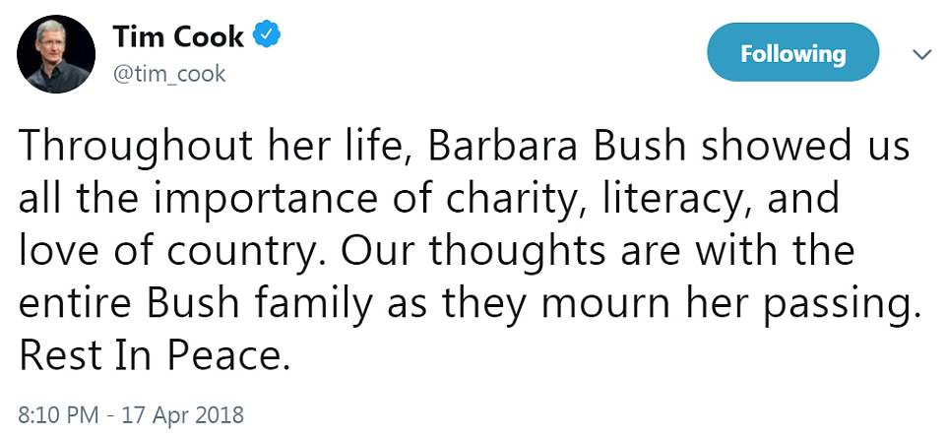

+50

Apple CEO Tim Cook thanked Barbara Bush for her 'charity, literacy and love of country'

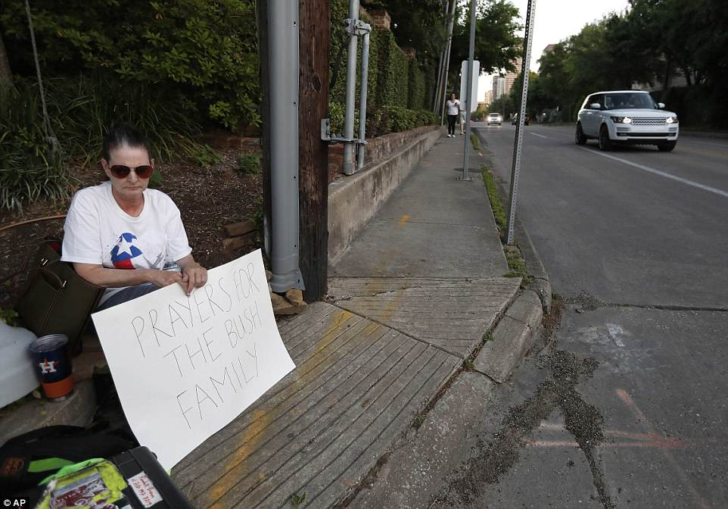

+50

Clarissa Lockett holds a sign reading 'Prayers for the Bush Family' across the street from the gated community where former first lady Barbara Bush died earlier on Tuesday

Barbara Bush was dubbed 'The Silver Fox' by her husband and children due to her snow-white hair, and was known for being highly protective of her family.

Her uncoiffed, matronly appearance often provoked jokes that she looked more like the boyish president's mother than his wife. Late-night comedians quipped that her bright white hair and pale features also imparted a resemblance to George Washington.

The Bushes married on Jan. 6, 1945, and recently celebrated their 73rd wedding anniversary, making them the longest presidential couple in history.

She was first lady when her husband was in the White House from 1989 to 1993. Her son, meanwhile, triumphed in the disputed 2000 U.S. election and was president from 2001 to 2009.

The only other woman to be both wife and mother of US presidents was Abigail Adams, the first lady from 1797 to 1801.

Bush discouraged speculation that she wielded political influence with the president like her predecessors - Ronald Reagan's wife, Nancy Reagan, and Jimmy Carter's wife, Rosalynn Carter.

As first lady, she promoted literacy and reading but said she was more interested in running a household than in helping her husband run the country.

'I don't fool around with his office and he doesn't fool around with my household,' she once said.

'She'll speak her mind but only to him,' said Jack Steel, a longtime Bush aide.

The publisher's daughter and oilman's wife had an independent streak and could be sharp-tongued. But her public image was that of a self-sacrificing, supportive spouse who referred to her husband as her 'hero.'

In the White House, 'you need a friend, someone who loves you, who's going to say, 'You are great,' Mrs. Bush said in a 1992 television interview.

'I had the best job in America,' she wrote in a 1994 memoir describing her time in the White House. 'Every single day was interesting, rewarding, and sometimes just plain fun.'

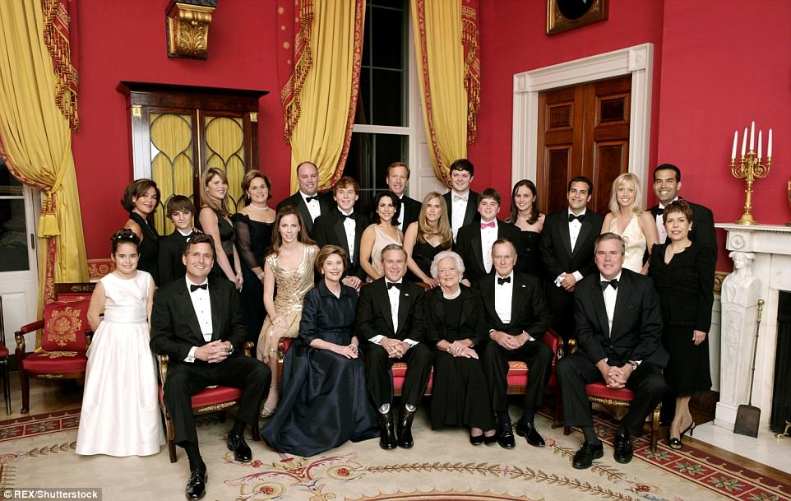

+50

The Bushes mark their 60th wedding anniversary on January 6, 2005, with a family photo in the White House. Pictured on the front row (left to right): Marvin Bush, Laura Bush, George W. Bush, Barbara Bush, George H. W. Bush, Jeb Bush. Also pictured, from left: Georgia Grace Koch, Margaret Bush, Brian Berzins Walker Bush, Jenna Bush Hager, Doro Bush, Barbara Pierce Bush, Robert P. Koch, Pierce Bush, Maria Bush, Neil Bush, Ashley Bush, Sam LeBlond, Robert Koch, Nancy Ellis LeBlond, John 'Jebby' Bush, Amanda Bush, George P. Bush, and Columba Bush

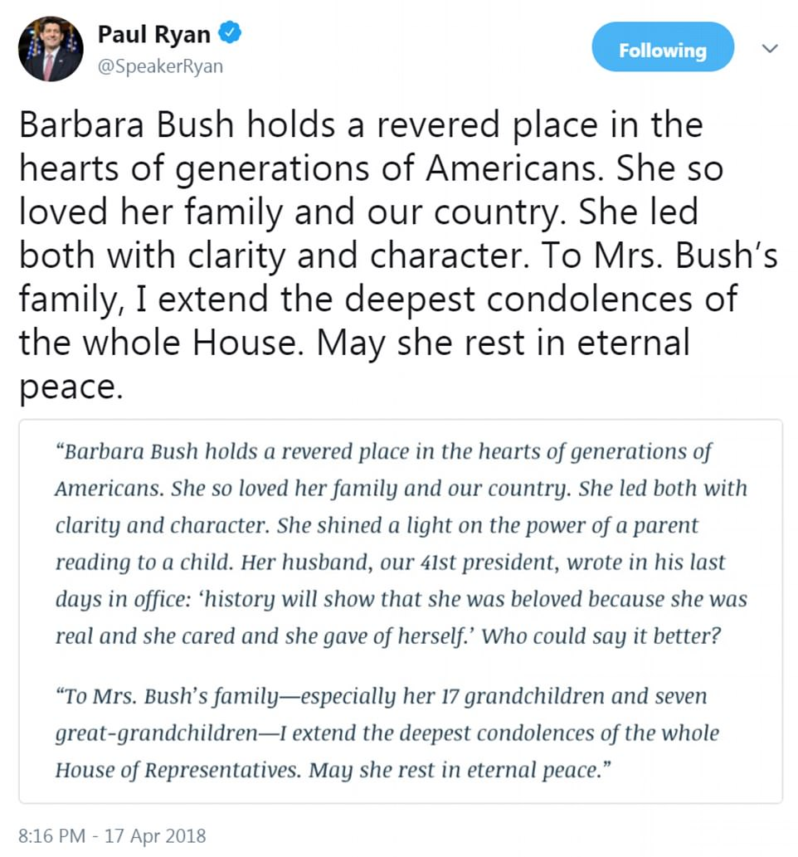

+50

Paul Ryan shared a lengthy statement on Twitter saying Bush held a 'revered place in the hearts of generations of Americans'

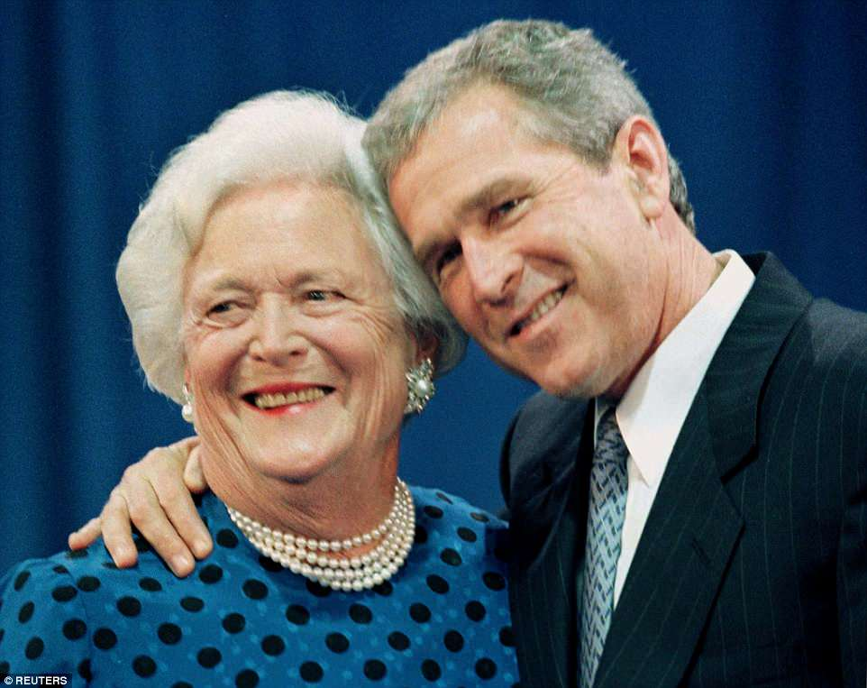

+50

Then governor George W. Bush gives his mother a hug after a family portrait session in Texas on June 10, 1999

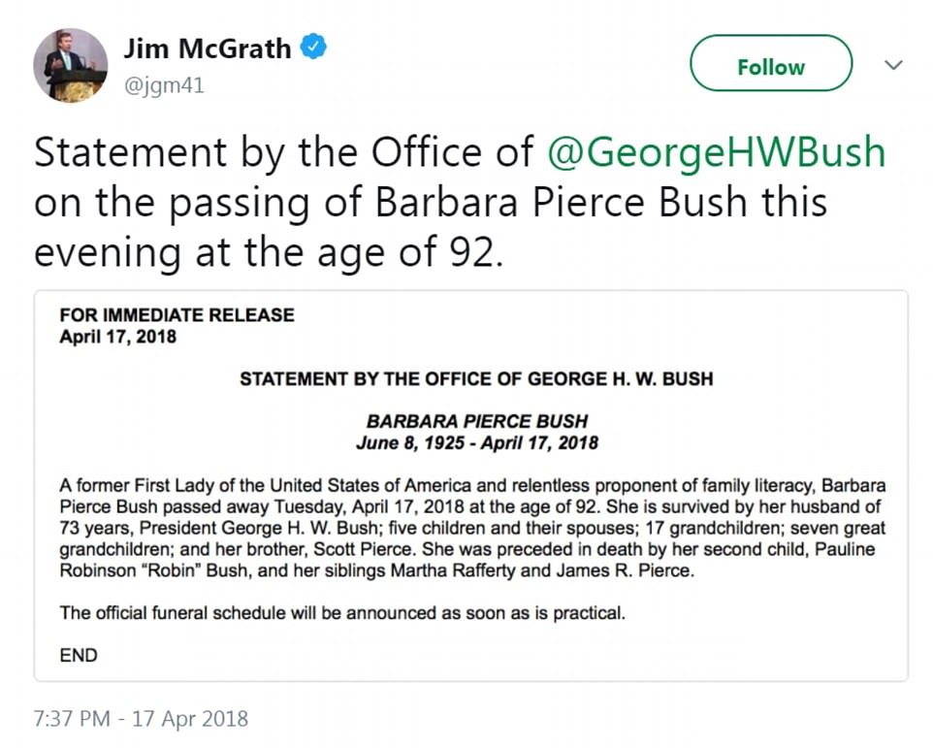

+50

The news was announced on Tuesday evening in a statement from the office of former President George H.W. Bush

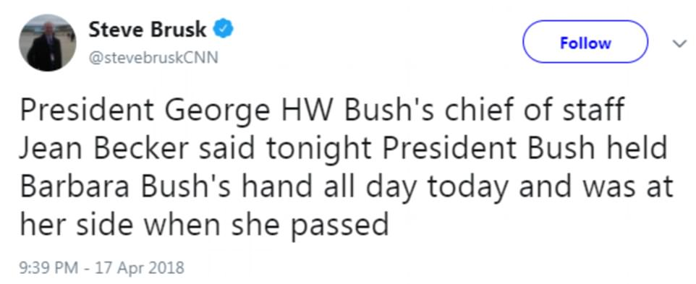

+50

Bush held the hand of her husband, George H.W. Bush, all day on Tuesday and had him by her side when she passed away, according to the former president's chief of staff

**Video playing bottom right...**

Loaded: 0%

Progress: 0%

0:53

Pause

Unmute

Current Time0:53

/

Duration Time2:32

Fullscreen

ExpandClose

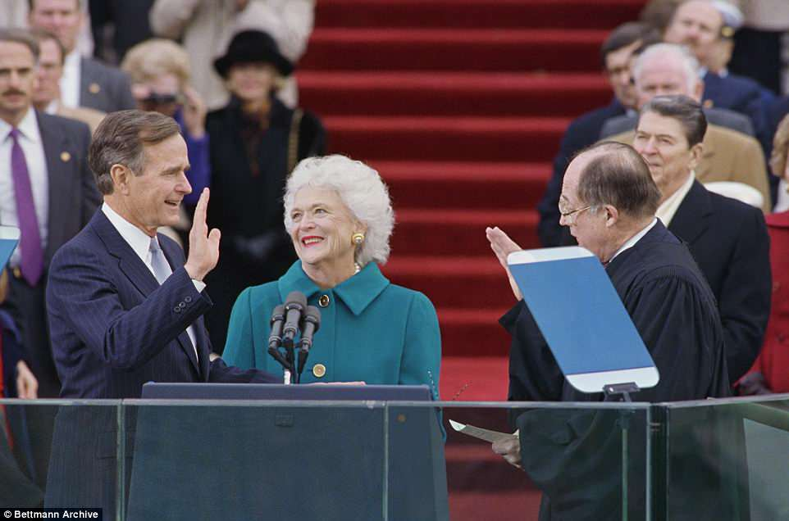

+50

Bush seen being sworn during his inauguration on January 20, 1989, while Barbara looks on lovingly and Ronald Reagan stands in the background

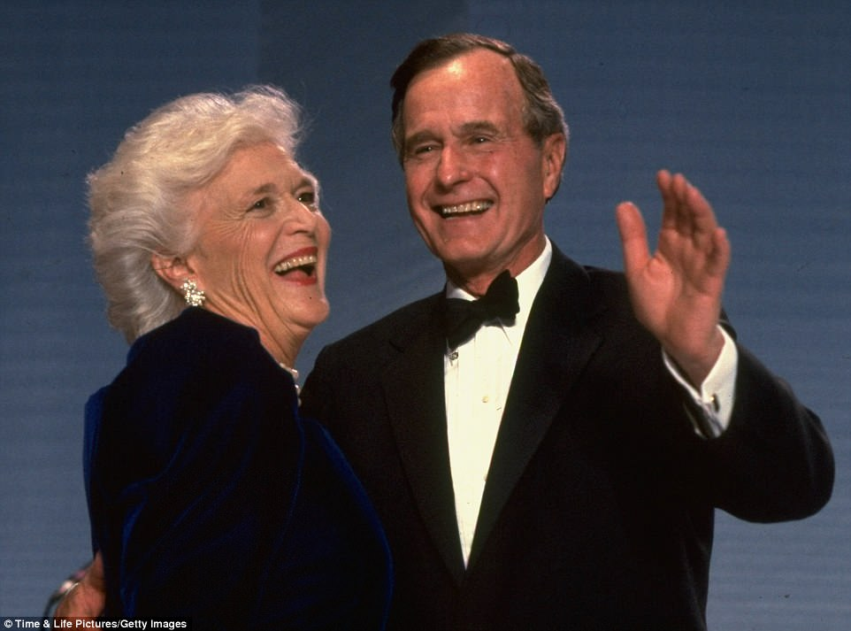

+50

The Bushes dance together at George H.W.'s Inaugural Ball, which was held in Washington DC on January 20, 1989

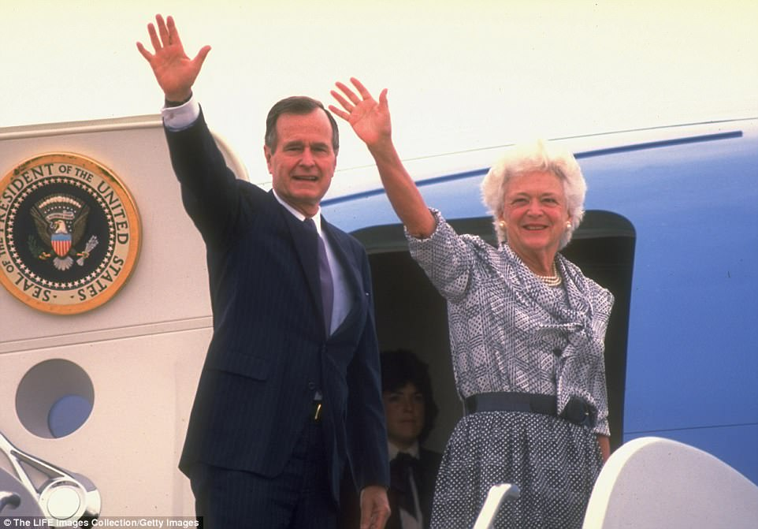

+50

Barbara Bush waves alongside her husband before boarding Air Force One in an undated photo

**Barbara Bush & George H.W. Bush visit UK Royals in 1989**

Loaded: 0%

Progress: 0%

0:00

Previous

Play

Skip

Mute

Current Time0:00

/

Duration Time1:23

Fullscreen

Need Text

**'I can't say it, but it rhymes with 'rich'': The wit, wisdom (and wicked insults) of Barbara Bush**

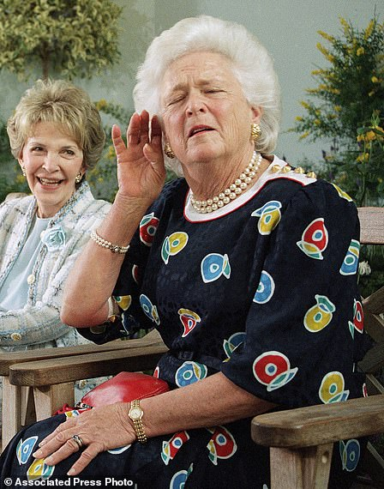

+50

**Bush, right, playfully strains to hear a reporter's question while posing with other former first ladies, at the U.S. Botanic Garden in Washington on May 11, 1994**

'She's a million dollar... I can't say it but it rhymes with 'rich''.

Speaking to reporters about Geraldine Ferraro, her husband's Democratic rival for the vice presidency, and the first woman running for U.S. vice president on a major-party ticket.

'Poppy (Bush's nickname) told me later that he had begged his mother to let him use the Oldsmobile that night because it had a radio and their other car did not. He was so afraid we would sit in stony silence and have nothing to say to each other. For years he has teased me that there was no silence that night and I haven't stopped talking since. All I know is that I liked him a lot.'

On her first date with George H.W. Bush, in 1941.

'Eventually the medicine that was controlling the leukemia caused other terrible problems. We called George, and by the time he got there after flying all night, our baby was in a coma. Her death was very peaceful. One minute she was there, and the next she was gone. I truly felt her soul go out of that beautiful little body. For one last time I combed her hair, and we held our precious little girl. I never felt the presence of God more strongly than at that moment.'

On the death of their 3-year-old daughter, Robin, in 1953.

'For the most part, I liked the reporters and found the lunches stimulating and fun. But I never got off scot-free. I always made news even though I swore I wouldn't. I must say, however, I found it was interesting that the fact George and I agreed on 99 percent of the issues never made the news!'

On meetings with reporters.

'The butlers loved trying to make me guess whose china I was using. Imaging being served a meal on dishes that Abraham Lincoln ate from!'

On the White House butlers.

'Millie was a perfect mom. She knew exactly how long she should sleep with them, and after about a month she moved back in with us. I have wondered so when I read about parents abusing their children: If a dog's natural instincts are to protect her young, why, oh, why wouldn't we humans do the same?'

On her dog Millie.

'Why did we lose? George Bush says it was because he didn't communicate as well as his predecessor or successor. I just don't believe that. I think we lost because people really wanted a change.'

On her husband's loss to Bill Clinton in 1992.

 'Avoid this crowd like the plague. And if they quote you, make damn sure they heard you.' Advice to Hillary Clinton about speaking to reporters as first lady on August 24, 1992.

Source: Barbara Bush: A Memoir.

Barbara set up households in numerous cities as her husband moved from being a Texas oilman to being a member of Congress, Republican Party leader, U.S. envoy to China and the United Nations and head of the CIA.

The Bushes had six children. A daughter, Robin, died of leukemia in 1953 at age 3. Barbara Bush's hair began to turn prematurely white after the shock of the girl's death.

In a speech in 1985, she recalled the stress of raising a family while married to a man whose ambitions carried him from the Texas oil fields to Congress and into influential political positions that included ambassador to the United Nations, GOP chairman and CIA director.

'This was a period, for me, of long days and short years,' she said, 'of diapers, runny noses, earaches, more Little League games than you could believe possible, tonsils and those unscheduled races to the hospital emergency room, Sunday school and church, of hours of urging homework or short chubby arms around your neck and sticky kisses.'

Along the way, she said, there were also 'bumpy moments — not many, but a few — of feeling that I'd never, ever be able to have fun again and coping with the feeling that George Bush, in his excitement of starting a small company and traveling around the world, was having a lot of fun.'

In 2003, she wrote a follow-up memoir, 'Reflections: Life After the White House.'

'I made no apologies for the fact that I still live a life of ease,' she wrote. 'There is a difference between ease and leisure. I live the former and not the latter.'

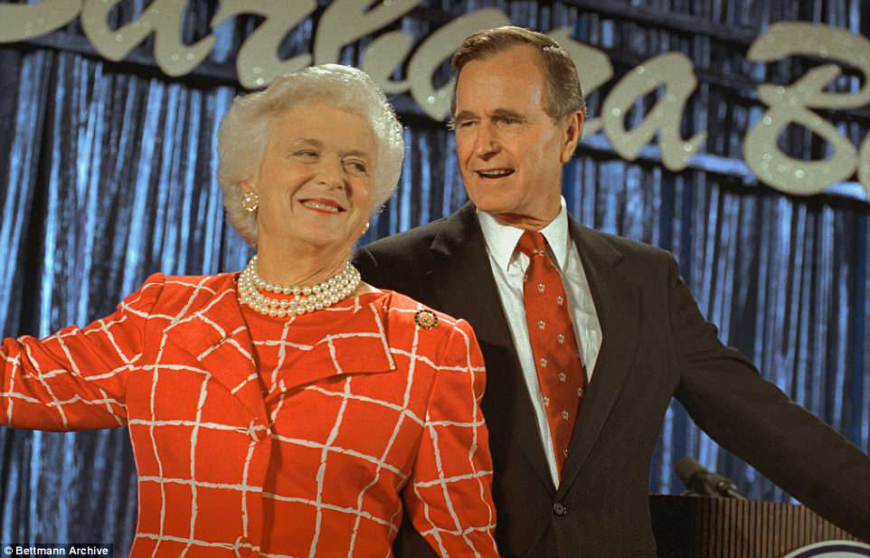

+50

Barbara, above in 1988 with her husband, had been battling chronic obstructive pulmonary disease and congestive heart failure

Along with her memoirs, she wrote 'C. Fred's Story' and 'Millie's Book,' based on the lives of her dogs. Proceeds from the books benefited adult and family literacy programs. Laura Bush, a former teacher with a master's degree in library science, continued her mother-in-law's literacy campaign in the White House.

George W. Bush made no secret that when he was growing up, it was his mother he had to answer to when he got into trouble.

Barbara Bush sometimes made biting remarks, particularly when she felt the need to defend her husband. One notable example came in 1984 when George H.W. was seeking re-election as vice president under Reagan, a post he held from 1981 until becoming president in 1989.

She told reporters that Geraldine Ferraro, her husband's Democratic rival for the vice presidency, was a '4 million dollar ... I can't say it but it rhymes with 'rich.' She apologized to Ferraro, the first woman running for U.S. vice president on a major-party ticket.

Texas Governor Ann Richards mocked her husband at the 1988 Democratic convention - saying 'poor George ... was born with a silver foot in his mouth' - and Barbara henceforth referred to Richards as 'that woman.'

In 2012, Bush dismissed the political ambitions of U.S. conservative darling Sarah Palin, saying, 'I think she's very happy in Alaska - and I hope she'll stay there.'

Daughter-in-law Laura Bush, wife of the 43rd president, said Mrs. Bush was 'ferociously tart-tongued.'

'She's never shied away from saying what she thinks. ... She's managed to insult nearly all of my friends with one or another perfectly timed acerbic comment,' Laura Bush wrote in her 2010 book, 'Spoken from the Heart.'

In her 1994 autobiography, 'Barbara Bush: A Memoir,' Mrs. Bush said she did her best to keep her opinions from the public while her husband was in office. But she revealed that she disagreed with him on two issues: She supported legal abortion and opposed the sale of assault weapons.

'I honestly felt, and still feel, the elected person's opinion is the one the public has the right to know,' Mrs. Bush wrote.

She also disclosed a bout with depression in the mid-1970s, saying she sometimes feared she would deliberately crash her car. She blamed hormonal changes and stress.

'Night after night, George held me weeping in his arms while I tried to explain my feelings,' she wrote. 'I almost wonder why he didn't leave me.'

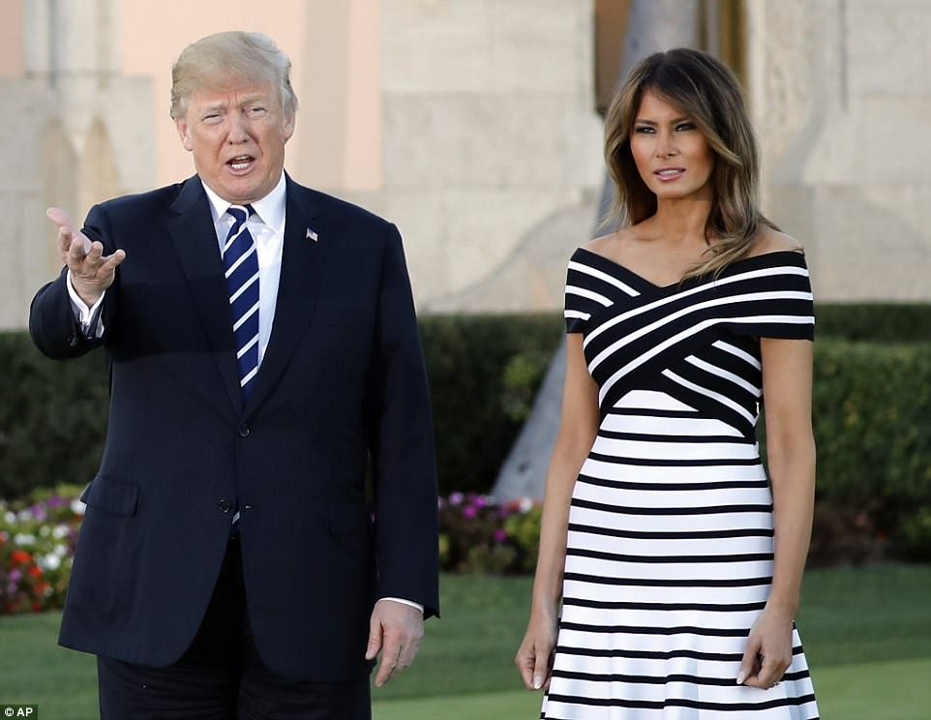

+50

President Donald Trump released a statement praising Bush's 'unfailing' service to her country and family. The pair are pictured together at Mar-a-Lago during Japanese prime minister Shinzo Abe's visit on Tuesday

**Former First Lady Barbara Bush through the years**

Loaded: 0%

Progress: 0%

0:00

Previous

Play

Skip

Mute

Current Time0:00

/

Duration Time2:20

Fullscreen

Need Text

Bush generally refused to discuss publicly her personal views on controversial topics such as abortion, an issue on which she was believed to differ from her husband's more conservative stance.

But during her husband's 1992 re-election race, which he lost to Democrat Bill Clinton, she told reporters that abortion and homosexuality were 'personal things' that should be left out of political conventions and party platforms. 'I don't think that's healthy for the country when anyone thinks their morals are better than anyone else's,' she said.

Opinion polls often showed her popularity as first lady exceeding her husband's as president. 'I don't threaten anyone,' she said. 'That's because I'm everyone's grandma.'

A year younger than her husband, she was born Barbara Pierce on June 8, 1925, and grew up in Rye, New York. Her father was Marvin Pierce, publisher of McCall's magazine.

She was home from boarding school in 1941 when she met her future husband at a Christmas party in Connecticut. She dropped out of prestigious Smith College to marry Bush, then a young naval aviator home on leave from World War Two.

George Bush said marrying Barbara, whom he called 'Bar,' was 'the thing I did right.' But the marriage nearly did not take place. While they were engaged, his bomber was shot down by the Japanese in the Pacific in 1944. He bailed out and was rescued in the ocean by a submarine crew but his crew mates died.

'When you're 18, you think everybody is invincible. ... I mean, that was stupid - but I knew he was going to come home. He was Superman,' she told CNN in 2003.

After leaving the White House, she found time to write her memoirs. In 1990, she authored 'Millie's Book,' a humorous look at the adventures of the family's English springer spaniel in the White House.

In one of their last public appearances, the Bushes attended the 2017 Super Bowl in Houston with George performing the ceremonial pre-game coin flip. Only a few days before the couple had been released from a hospital where George had been treated for pneumonia and Barbara for bronchitis.

Sons Marvin and Neil both became businessmen. Neil achieved some notoriety in the 1980s as a director of a savings and loan that crashed. Daughter Dorothy, or Doro, has preferred to stay out of the spotlight. She married lobbyist Robert Koch, a Democrat, in 1992.

In a collection of letters published in 1999, George H.W. Bush included a note he gave to his wife in early 1994.

'You have given me joy that few men know,' he wrote. 'You have made our boys into men by bawling them out and then, right away, by loving them. You have helped Doro to be the sweetest, greatest daughter in the whole wide world. I have climbed perhaps the highest mountain in the world, but even that cannot hold a candle to being Barbara's husband.'

Mrs. Bush was born Barbara Pierce in Rye, New York. Her father was the publisher of McCall's and Redbook magazines. After attending Smith College for two years, she married young naval aviator George Herbert Walker Bush. She was 19.

After World War II, the Bushes moved to the Texas oil patch to seek their fortune and raise a family. It was there that Bush began his political career, representing Houston for two terms in Congress in the late 1960s and early 1970s.

In all, the Bushes made more than two dozen moves that circled half the globe before landing at the White House in 1989. Opinion polls taken over the next four years often showed her approval ratings higher than her husband's.

The couple's final move, after Bush lost the 1992 election to Bill Clinton, was to Houston, where they built what she termed their 'dream house' in an affluent neighborhood. The Bush family also had an oceanfront summer home in Kennebunkport, Maine.

After retiring to Houston, the Bushes helped raise funds for charities and appeared frequently at events such as Houston Astros baseball games. Public schools in the Houston area are named for both of them.

In 1990, Barbara Bush gave the commencement address at all-women Wellesley College. Some had protested her selection because she was prominent only through the achievements of her husband. Her speech that day was rated by a survey of scholars in 1999 as one of the top 100 speeches of the century.

'Cherish your human connections,' Mrs. Bush told graduates. 'At the end of your life, you will never regret not having passed one more test, winning one more verdict or not closing one more deal. You will regret time not spent with a husband, a child, a friend or a parent.'

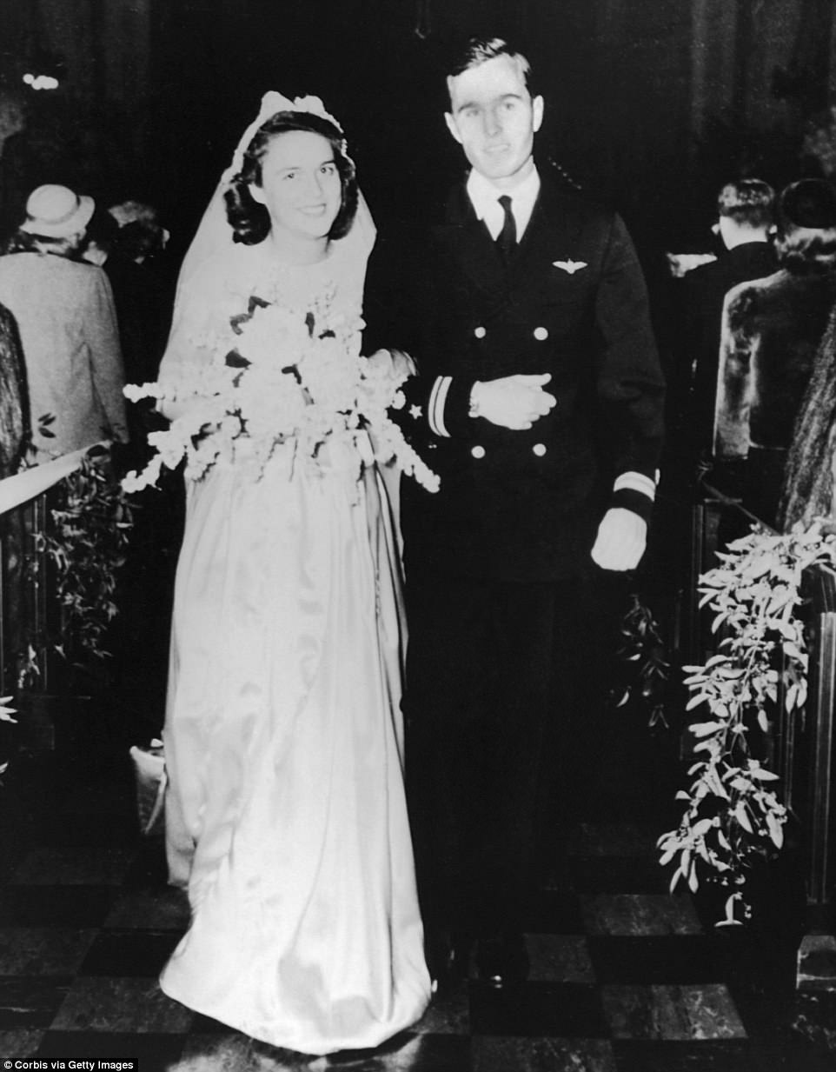

+50

Barbara and George H.W. Bush married in January 1945 at the First Prsbyterian Church in Rye, New York

A champion of children's literacy and AIDS activist: How Barbara Bush used her role as the second woman in US history to be both a wife and mother of a president to bring about change

Valerie Edwards for Dailymail.com

Barbara Bush used her role as the first lady of the United States to become a champion of children's literacy and to fight against AIDS.

Bush, who died Tuesday at 92 years old while surrounded by her family, started her lifelong mission to improve the quality of life for children when her own son, Neil Bush, struggled with reading in elementary school.

Neil said it began when she attended reading day at his school.

'So there's a reading circle and all the kids have a book and they're passing the book kid to kid and they passed it to me and I couldn't read,' he told [**KHOU**](http://www.khou.com/article/news/community/emotional-neil-bush-on-his-mothers-life-and-legacy/285-540211907).

According to Neil, his mother was shocked and determined to bring his reading level up.

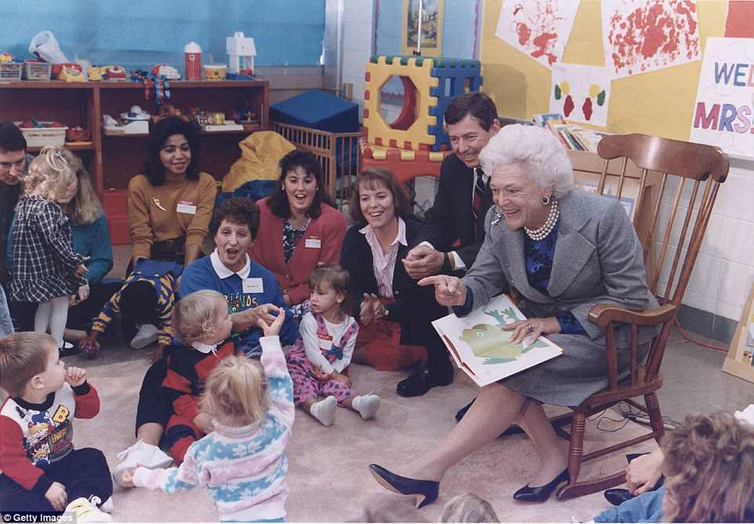

+50

Barbara Bush used her role as the first lady of the United States to become a champion of children's literacy and to fight against AIDS. The former first lady is pictured in 1991 reading to children in Missouri

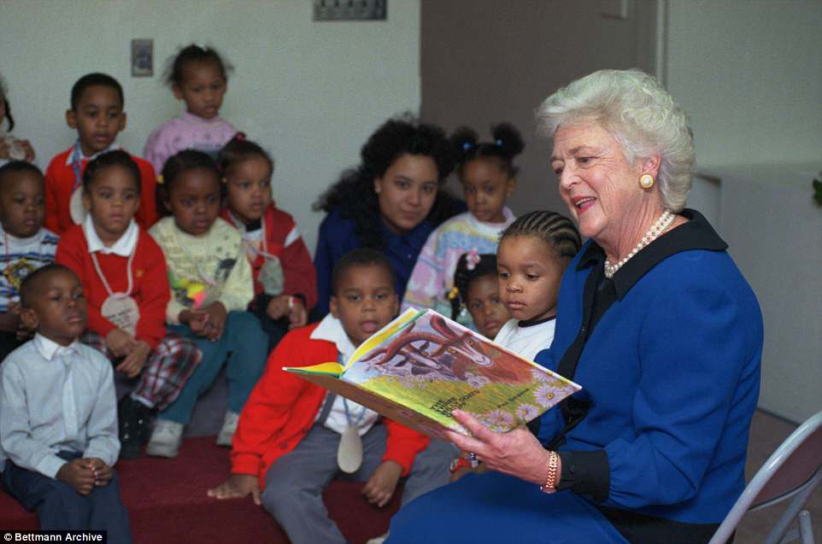

+50

Bush, who died Tuesday at 92 years old, started her lifelong mission to improve the quality of life for children when her own son, Neil Bush, struggled with reading in elementary school. She's pictured reading to children during a visit to the Capitol Children's Museum

Neil spent Saturdays attending various programs to help him learn to manage his dyslexia.

As first lady - between 1989 to 1993 - Barbara made her main focus literacy and became involved in a number of reading organizations.

She eventually founded the non-profit Barbara Bush Foundation for Family Literacy, which is based in Florida, to help increase literacy levels nationwide.

It was through Neil's struggle that she realized the alarming statistics of illiteracy in schools.

The Barbara Bush Literacy Foundation will hold its 24th annual Celebration of Reading on Thursday, April 19, at the Hobby Center.

'She will be long remembered for her strong devotion to country and family, both of which she served unfailingly well,' President Donald Trump and his wife and First Lady, Melania Trump, said in a statement that noted Bush's championing of literacy 'as a fundamental family value'.

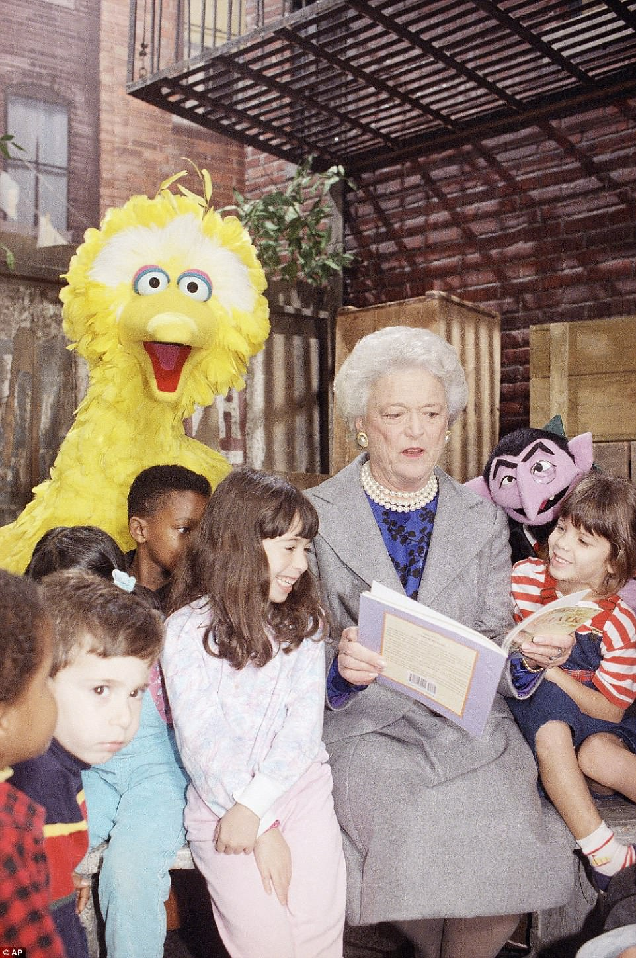

+50

As first lady - between 1989 to 1993 - Barbara made her main focus literacy and became involved in a number of reading organizations. She's pictured chatting with Big Bird and children while taping a segment of PBS' Sesame Street for its 21st season in October 1989

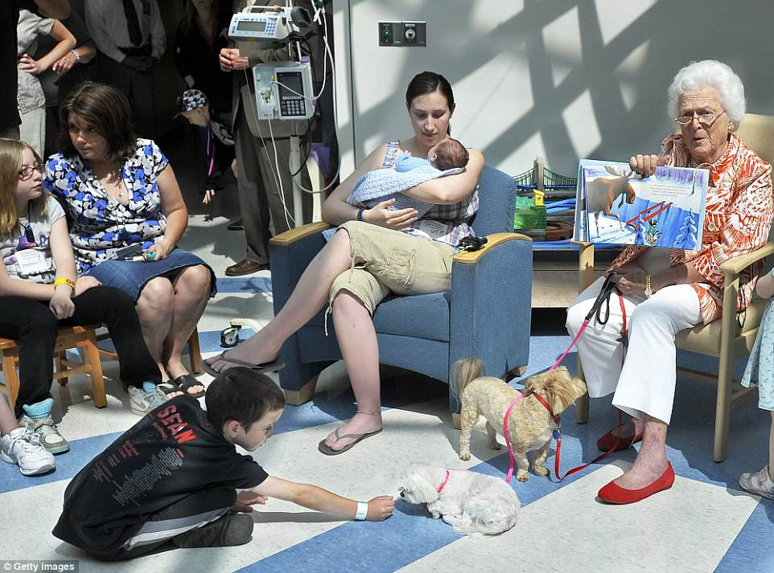

+50

She eventually founded the non-profit Barbara Bush Foundation for Family Literacy, which is based in Florida, to help increase literacy levels nationwide. She's pictured in 2011 reading to children at the Maine Medical Center

Not only was literacy a huge focus for Bush, she also took on issues such as homelessness, teenage pregnancy, and AIDS.

Paul Brandus with West Wing Reports reminded Bush's admirers of her commitment to these issues when he tweeted a photo of Bush in 1989 on Tuesday.

'A First Lady has the power to make people think. In 1989 Barbara Bush visited a Washington hospice where abandoned infants with the AIDS virus were being cared for,' the tweet read.

'Some folks were ignorant and thought you could get AIDS from touching someone. Mrs. Bush hugged and kissed the kids,' Brandus added in the tweet.

Bush tried to make sure the public understood that AIDS wasn't contracted through hugs and handshakes at a time when many were worried that if they touched someone with the disease they would contract it.

In her 1994 autobiography, 'Barbara Bush: A Memoir' Bush spoke about another visit with a young man who had the AIDS virus.

'It was a wrenching visit. Besides having trouble finding housing and medical care, they all had personal problems. I especially remember a young man who told us that he had been asked to leave his church studies when it was discovered he had AIDS,' she wrote.

'His parents also had disowned him, and he said he longed to be hugged again by his mother. A poor substitute, I hugged that darling young man and did it again in front of the cameras. But what he really needed was family,' Bush added.

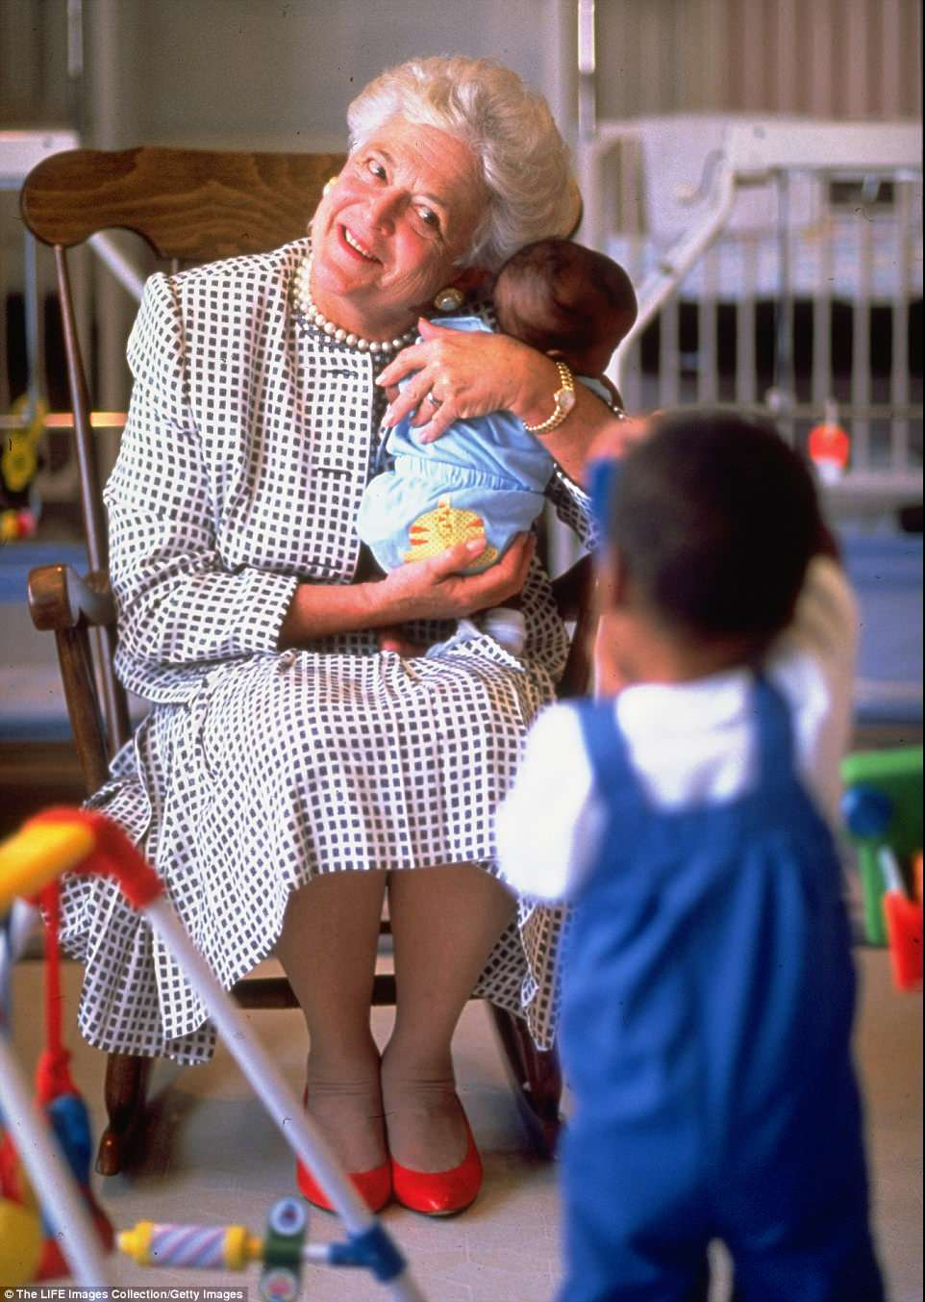

+50

Bush also took on issues such as homelessness, teenage pregnancy, and AIDS. Paul Brandus with West Wing Reports reminded Bush's admirers of her commitment to these issues when he tweeted a photo of Bush in 1989 holding a child who was born with AIDS

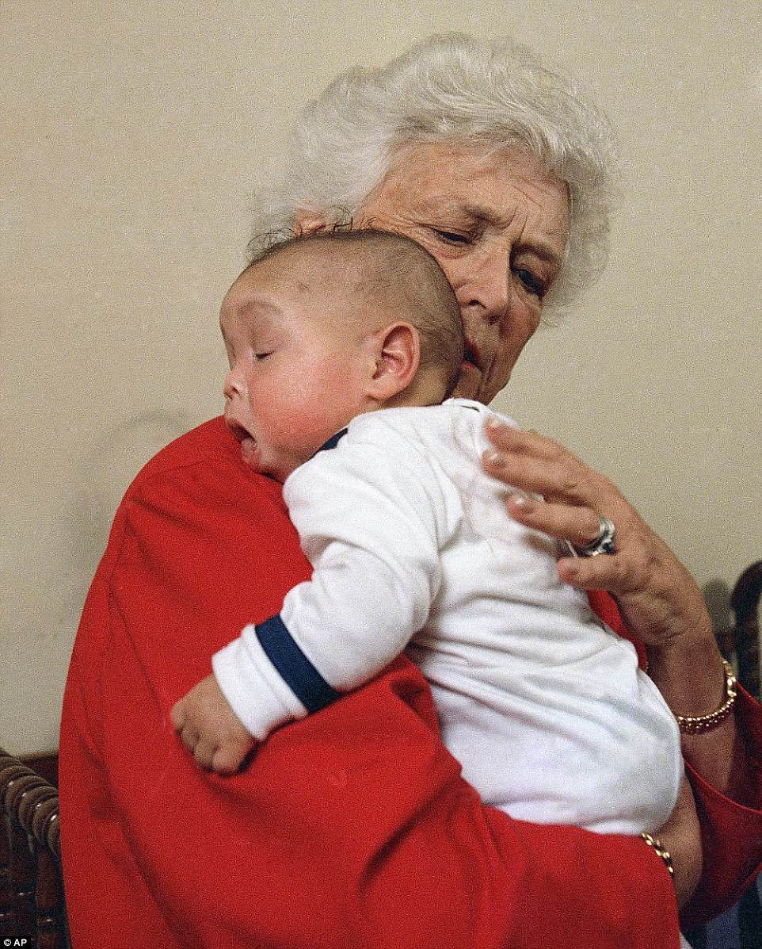

+50

Bush tried to make sure the public understood that AIDS wasn't contracted through hugs and handshakes at a time when many were worried that if they touched someone with the disease they would contract it

**Former First Lady Barbara Bush through the years**

Loaded: 0%

Progress: 0%

0:00

Previous

Play

Skip

Mute

Current Time0:00

/

Duration Time2:20

Fullscreen

Need Text

**more videos**

* [**1**](http://www.dailymail.co.uk/news/article-5627825/Barbara-Bush-dies-aged-92-two-days-falling-seriously-ill.html?ito=email_share_article-top_most-read-articles)
* [**2**](http://www.dailymail.co.uk/news/article-5627825/Barbara-Bush-dies-aged-92-two-days-falling-seriously-ill.html?ito=email_share_article-top_most-read-articles)
* [**3**](http://www.dailymail.co.uk/news/article-5627825/Barbara-Bush-dies-aged-92-two-days-falling-seriously-ill.html?ito=email_share_article-top_most-read-articles)

**[Watch video](http://www.dailymail.co.uk/video/news/video-1669590/Video-Damascus-researcher-lab-destroyed-airstrikes.html)**

**[Damascus researcher lab destroyed after being hit by airstrikes](http://www.dailymail.co.uk/video/news/video-1669590/Video-Damascus-researcher-lab-destroyed-airstrikes.html)**

[[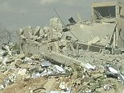](http://www.dailymail.co.uk/video/news/video-1669590/Video-Damascus-researcher-lab-destroyed-airstrikes.html)](http://www.dailymail.co.uk/video/news/video-1669590/Video-Damascus-researcher-lab-destroyed-airstrikes.html)

**[Watch video](http://www.dailymail.co.uk/video/news/video-1670882/Video-8-year-old-girl-raped-murdered-wedding-India.html)**

**[8-year-old girl raped and murdered a wedding in India](http://www.dailymail.co.uk/video/news/video-1670882/Video-8-year-old-girl-raped-murdered-wedding-India.html)**

[[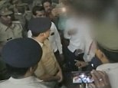](http://www.dailymail.co.uk/video/news/video-1670882/Video-8-year-old-girl-raped-murdered-wedding-India.html)](http://www.dailymail.co.uk/video/news/video-1670882/Video-8-year-old-girl-raped-murdered-wedding-India.html)

**[Watch video](http://www.dailymail.co.uk/video/news/video-1670436/Video-British-Laura-Plummer-filmed-church-Egyptian-prison.html)**

**[British Laura Plummer filmed in Egyptian prison for first time](http://www.dailymail.co.uk/video/news/video-1670436/Video-British-Laura-Plummer-filmed-church-Egyptian-prison.html)**

[[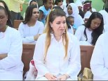](http://www.dailymail.co.uk/video/news/video-1670436/Video-British-Laura-Plummer-filmed-church-Egyptian-prison.html)](http://www.dailymail.co.uk/video/news/video-1670436/Video-British-Laura-Plummer-filmed-church-Egyptian-prison.html)

**[Watch video](http://www.dailymail.co.uk/video/news/video-1670876/Video-Karen-Brady-despairs-entrepreneurs-business-decision.html)**

**[Karen Brady despairs over entrepreneur's £1000 luxury mug](http://www.dailymail.co.uk/video/news/video-1670876/Video-Karen-Brady-despairs-entrepreneurs-business-decision.html)**

[[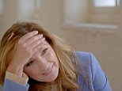](http://www.dailymail.co.uk/video/news/video-1670876/Video-Karen-Brady-despairs-entrepreneurs-business-decision.html)](http://www.dailymail.co.uk/video/news/video-1670876/Video-Karen-Brady-despairs-entrepreneurs-business-decision.html)

**[Watch video](http://www.dailymail.co.uk/video/news/video-1670444/Video-Moment-Theresa-appears-roll-eyes-Jeremy-Corbyn.html)**

**[Moment Theresa May appears to roll her eyes at Jeremy Corbyn](http://www.dailymail.co.uk/video/news/video-1670444/Video-Moment-Theresa-appears-roll-eyes-Jeremy-Corbyn.html)**

[[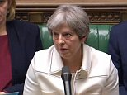](http://www.dailymail.co.uk/video/news/video-1670444/Video-Moment-Theresa-appears-roll-eyes-Jeremy-Corbyn.html)](http://www.dailymail.co.uk/video/news/video-1670444/Video-Moment-Theresa-appears-roll-eyes-Jeremy-Corbyn.html)

**[Watch video](http://www.dailymail.co.uk/video/news/video-1671248/Why-help-Cate-Campbell-admits-selfish.html)**

**['Why would I help her?' Cate Campbell admits to being selfish](http://www.dailymail.co.uk/video/news/video-1671248/Why-help-Cate-Campbell-admits-selfish.html)**

[[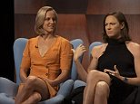](http://www.dailymail.co.uk/video/news/video-1671248/Why-help-Cate-Campbell-admits-selfish.html)](http://www.dailymail.co.uk/video/news/video-1671248/Why-help-Cate-Campbell-admits-selfish.html)

**[Watch video](http://www.dailymail.co.uk/video/news/video-1670820/Dramatic-moment-knife-wielding-cyclist-tackled-pedestrians.html)**

**[Dramatic moment knife wielding cyclist is tackled by pedestrians](http://www.dailymail.co.uk/video/news/video-1670820/Dramatic-moment-knife-wielding-cyclist-tackled-pedestrians.html)**

[[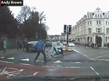](http://www.dailymail.co.uk/video/news/video-1670820/Dramatic-moment-knife-wielding-cyclist-tackled-pedestrians.html)](http://www.dailymail.co.uk/video/news/video-1670820/Dramatic-moment-knife-wielding-cyclist-tackled-pedestrians.html)

**[Watch video](http://www.dailymail.co.uk/video/news/video-1671026/Video-Theresa-holds-talks-Jamaican-counterpart.html)**

**[Theresa May holds talks with her Jamaican counterpart](http://www.dailymail.co.uk/video/news/video-1671026/Video-Theresa-holds-talks-Jamaican-counterpart.html)**

[[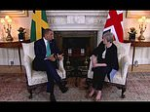](http://www.dailymail.co.uk/video/news/video-1671026/Video-Theresa-holds-talks-Jamaican-counterpart.html)](http://www.dailymail.co.uk/video/news/video-1671026/Video-Theresa-holds-talks-Jamaican-counterpart.html)

**[Watch video](http://www.dailymail.co.uk/video/news/video-1671180/Battered-boyfriend-Alix-Skeel-tells-mental-torture.html)**

**[Battered boyfriend Alex Skeel tells of his mental torture](http://www.dailymail.co.uk/video/news/video-1671180/Battered-boyfriend-Alix-Skeel-tells-mental-torture.html)**

[[](http://www.dailymail.co.uk/video/news/video-1671180/Battered-boyfriend-Alix-Skeel-tells-mental-torture.html)](http://www.dailymail.co.uk/video/news/video-1671180/Battered-boyfriend-Alix-Skeel-tells-mental-torture.html)

**[Watch video](http://www.dailymail.co.uk/video/news/video-1671494/Video-mouth-eating-Ugandas-president-warns-against-oral-sex.html)**

**['The mouth is for eating': Uganda's president warns against oral sex](http://www.dailymail.co.uk/video/news/video-1671494/Video-mouth-eating-Ugandas-president-warns-against-oral-sex.html)**

[[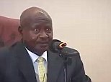](http://www.dailymail.co.uk/video/news/video-1671494/Video-mouth-eating-Ugandas-president-warns-against-oral-sex.html)](http://www.dailymail.co.uk/video/news/video-1671494/Video-mouth-eating-Ugandas-president-warns-against-oral-sex.html)

**[Watch video](http://www.dailymail.co.uk/video/news/video-1671474/Video-Terrifying-moment-surfer-mauled-four-metre-great-white-shark.html)**

**[Terrifying moment surfer is mauled by four-metre great white shark](http://www.dailymail.co.uk/video/news/video-1671474/Video-Terrifying-moment-surfer-mauled-four-metre-great-white-shark.html)**

[[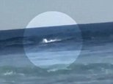](http://www.dailymail.co.uk/video/news/video-1671474/Video-Terrifying-moment-surfer-mauled-four-metre-great-white-shark.html)](http://www.dailymail.co.uk/video/news/video-1671474/Video-Terrifying-moment-surfer-mauled-four-metre-great-white-shark.html)

**[Watch video](http://www.dailymail.co.uk/video/news/video-1670694/Video-Two-surfers-mauled-great-white-shark-just-hours-apart.html)**

**[Two surfers have been mauled by great white shark just hours apart](http://www.dailymail.co.uk/video/news/video-1670694/Video-Two-surfers-mauled-great-white-shark-just-hours-apart.html)**

[[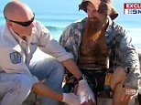](http://www.dailymail.co.uk/video/news/video-1670694/Video-Two-surfers-mauled-great-white-shark-just-hours-apart.html)](http://www.dailymail.co.uk/video/news/video-1670694/Video-Two-surfers-mauled-great-white-shark-just-hours-apart.html)

Bush was the only woman to see her husband and son both sworn in as president.

She was the wife of the 41st president, George H.W. Bush, and mother of the 43rd, George W. Bush.

The Bush family had said in a statement on Sunday that she was in failing health, had decided not to seek further medical treatment and instead would focus on 'comfort care'.

According to some media reports, Bush had been battling chronic obstructive pulmonary disease and congestive heart problems in recent years.

Bush was dubbed The Silver Fox by her husband and children. She was known for her snow-white hair and for being fiercely protective of her family.

She was first lady when her husband was in the White House from 1989 to 1993. Her son, Republican George Walker Bush, triumphed in the disputed 2000 US election and was president from 2001 to 2009.

The Bushes celebrated their 73rd wedding anniversary in January.

Bush had an independent streak and could be sharp-tongued. As first lady, she promoted literacy and reading but said she was more interested in running a household than helping her husband run the country.

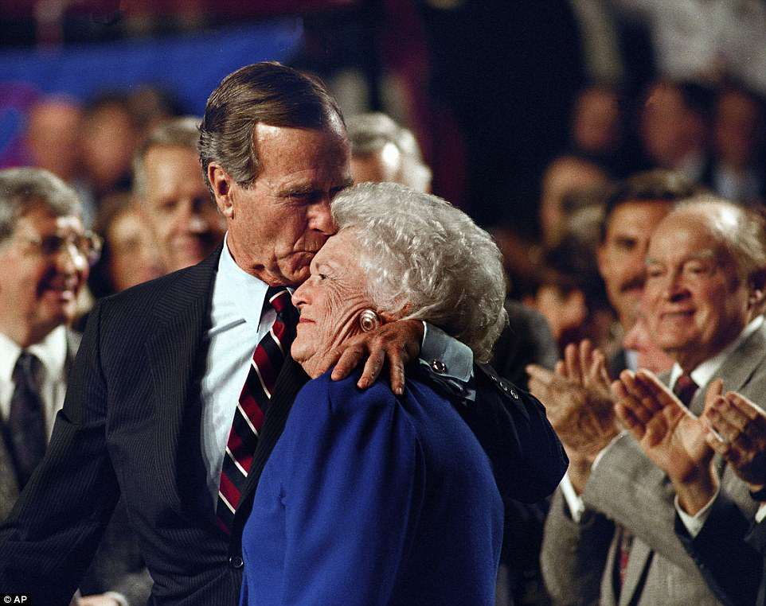

+50

She was the wife of the 41st president, George H.W. Bush, and mother of the 43rd, George W. Bush

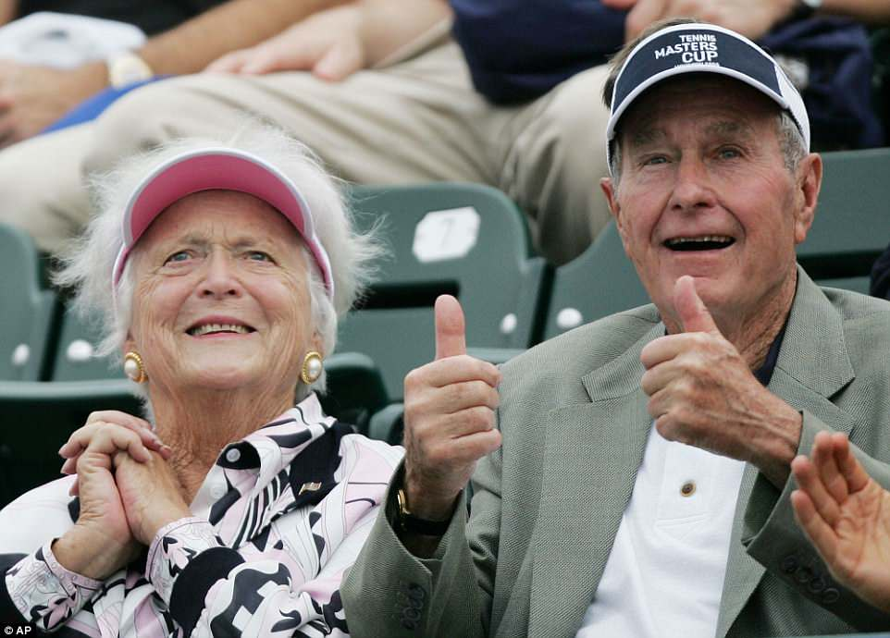

+50

The Bushes had six children. A daughter, Robin, died of leukemia in 1953 at age 3. Barbara Bush's hair began to turn prematurely white after the shock of the girl's death. In addition to George W. and Jeb, the other Bush children are sons Neil and Marvin and daughter Dorothy

She discouraged speculation that she wielded political influence with the president like her predecessors - Ronald Reagan's wife, Nancy Reagan, and Jimmy Carter's wife, Rosalynn Carter.

'I don't fool around with his office and he doesn't fool around with my household,' she once said.

'She'll speak her mind but only to him,' said Jack Steel, a longtime Bush aide.

The only other woman to be both wife and mother of US presidents was Abigail Adams, the first lady from 1797 to 1801.

She was a major influence on husband John Adams, the nation's second president, but died before son John Quincy Adams was elected president in 1824.

Another of Bush's sons, Jeb, who served as governor of Florida from 1999 to 2007, sought the 2016 Republican presidential nomination and she campaigned for him before he dropped out of the race.

The Bushes had six children. A daughter, Robin, died of leukemia in 1953 at age 3. Barbara Bush's hair began to turn prematurely white after the shock of the girl's death. In addition to George W. and Jeb, the other Bush children are sons Neil and Marvin and daughter Dorothy.

The Bushes married on January 6, 1945, and Barbara set up households in numerous cities as her husband moved from being a Texas oilman to being a member of Congress, Republican Party leader, US envoy to China and the United Nations and head of the Central Intelligence Agency.

Barbara Bush generally refused to discuss publicly her personal views on controversial topics such as abortion, an issue on which she was believed to differ from her husband's more conservative stance.

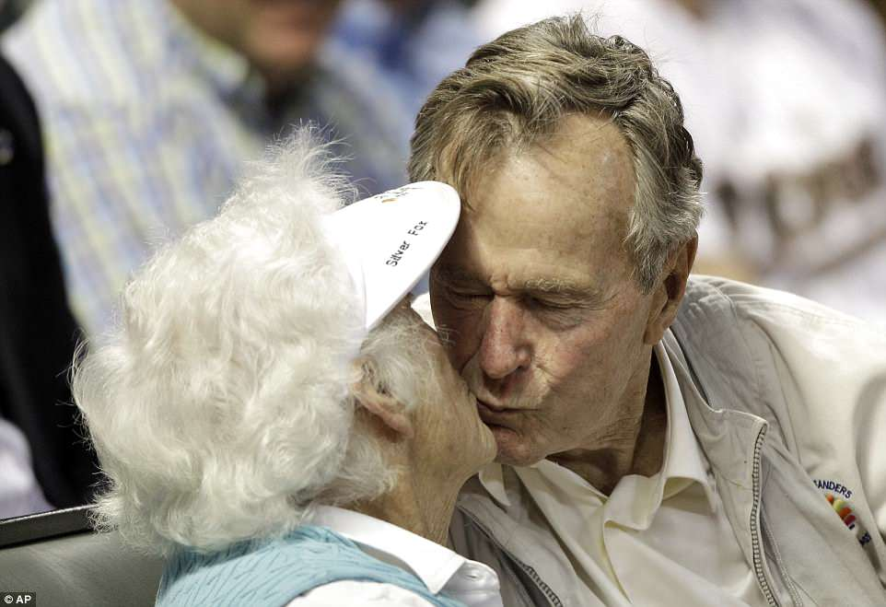

+50

A year younger than her husband, she was born Barbara Pierce on June 8, 1925, and grew up in Rye, New York. Her father was Marvin Pierce, publisher of McCall's magazine

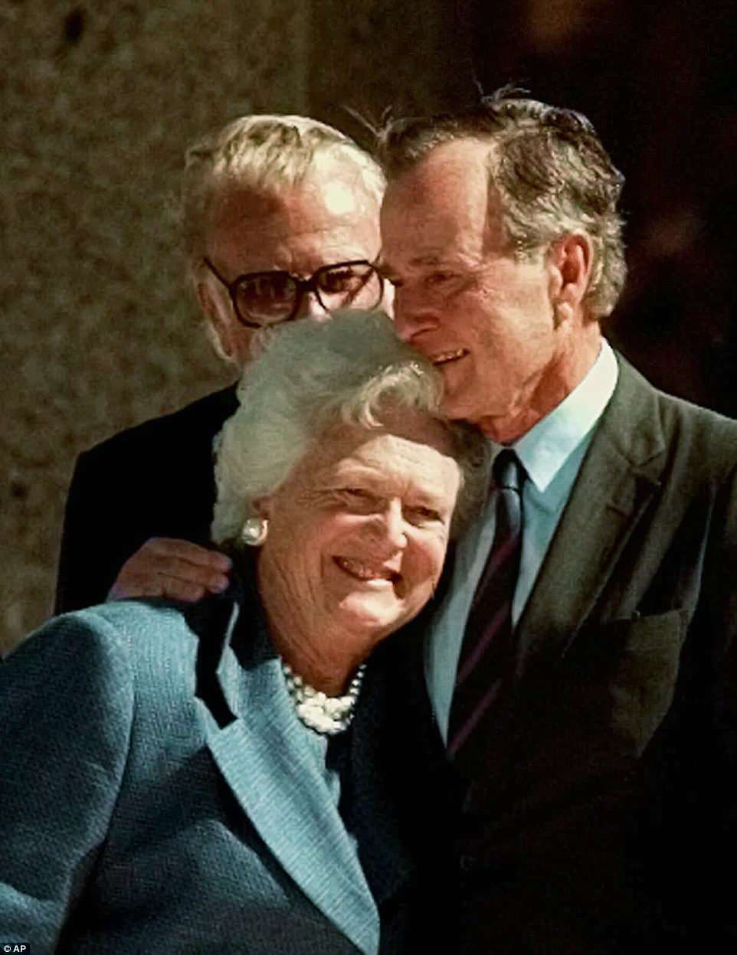

+50

She was home from boarding school in 1941 when she met her future husband at a Christmas party in Connecticut. She dropped out of prestigious Smith College to marry Bush, then a young naval aviator home on leave from World War Two

But during her husband's 1992 re-election race, which he lost to Democrat Bill Clinton, she told reporters that abortion and homosexuality were 'personal things' that should be left out of political conventions and party platforms. 'I don't think that's healthy for the country when anyone thinks their morals are better than anyone else's,' she said.

Opinion polls often showed her popularity as first lady exceeding her husband's as president. 'I don't threaten anyone,' she said. 'That's because I'm everyone's grandma.'

A year younger than her husband, she was born Barbara Pierce on June 8, 1925, and grew up in Rye, New York. Her father was Marvin Pierce, publisher of McCall's magazine.

She was home from boarding school in 1941 when she met her future husband at a Christmas party in Connecticut. She dropped out of prestigious Smith College to marry Bush, then a young naval aviator home on leave from World War Two.

George Bush said marrying Barbara, whom he called Bar, was 'the thing I did right'.

But the marriage nearly did not take place. While they were engaged, his bomber was shot down by the Japanese in the Pacific in 1944. He bailed out and was rescued in the ocean by a submarine crew, but his crewmates died.

'When you're 18, you think everybody is invincible. ... I mean, that was stupid - but I knew he was going to come home. He was Superman,' she told CNN in 2003.

After leaving the White House, she found time to write her memoirs. In 1990, she authored 'Millie's Book,' a humorous look at the adventures of the family's English springer spaniel in the White House.

In one of their last public appearances, the Bushes attended the 2017 Super Bowl in Houston with George performing the ceremonial pregame coin flip.

Only a few days before, the couple had been released from a hospital where George had been treated for pneumonia and Barbara for bronchitis.

A love that stood the test of time: From a holiday dance and WWII love letters to six children and 14 grandkids, how George and Barbara Bush's incredible romance lasted nearly 80 years

Charlie Lankston for Dailymail.com

'Still in the love with the man I married 72 years ago,' Barbara Bush said of her incredible relationship with George HW Bush shortly before she passed away at her home in Houston on Tuesday.

The simple, yet poignant, statement is a testament to the couple's incredible love story, which began at a Christmas dance in Connecticut when they were both teenagers, and went on to span nearly 80 years.

During that time, the couple faced triumphs and heartache together, both personal and professional, had six children, including President George W Bush, and 14 grandkids, eventually becoming the longest-married couple in presidential history.

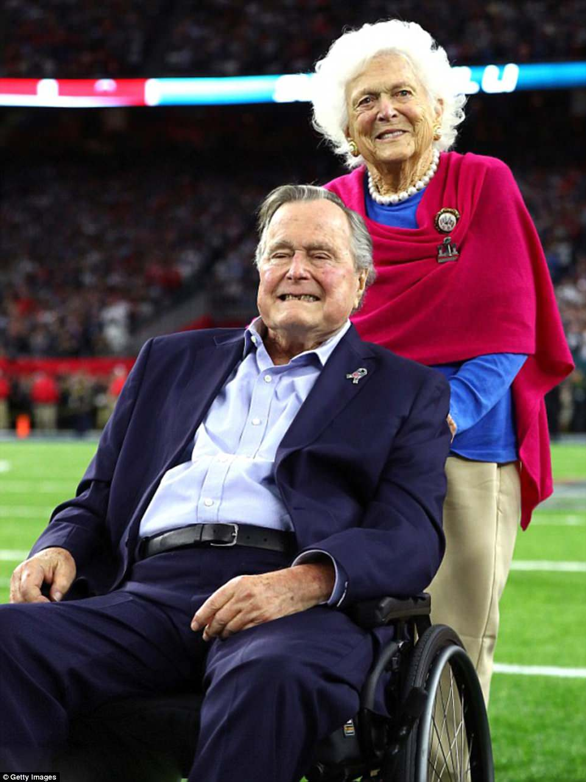

+50

A love that stood the test of time: George and Barbara Bush, pictured in February 2017, were married for an incredible 73 years, having tied the knot on January 6, 1945

On Tuesday evening, the former president issued a short statement about his wife's death, paying tribute to the 'relentless proponent of family literacy'.

The announcement came just days after it was announced that Barbara had been admitted to hospital for congestive heart failure and chronic obstructive pulmonary disease. Soon after, she made the decision to refuse further treatment, and return home to be with her husband and family.

As family, friends, and political leaders both past and present paid public tribute to Barbara, her enduring love for her husband and her phenomenal devotion to her family were given due respect and praise by many.

Her grandson George P. Bush described her as a 'top adviser and confidante' to his grandfather, while President Donald Trump and his wife Melania spoke of Barbara's 'unfailing' service to her country and family.

But it was Barbara herself who perhaps described it best, offering an intimate insight into her relationship with George in a romantic essay penned for her alma mater's magazine, which was published just last month.

'I am still old and still in love with the man I married 72 years ago,' she wrote at the time, before later going on to say: 'George Bush has given me the world. He is the best — thoughtful and loving.'

The couple's relationship is a true love story, which granddaughter Jenna Bush Hager described Monday as 'remarkable.'

Honoring her grandparents' rock-solid relationship on the Today show, the 36-year-old NBC correspondent revealed that Barbara was spending her final days by George's side, 'the man she's loved for over 73 years'.

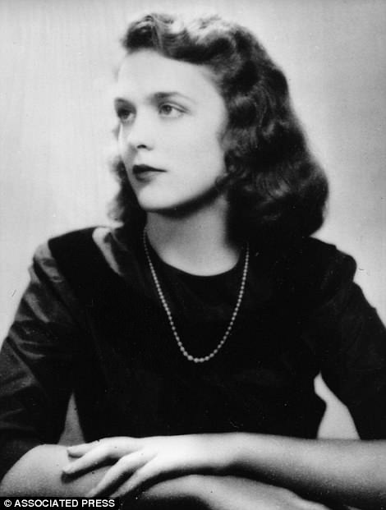

+50

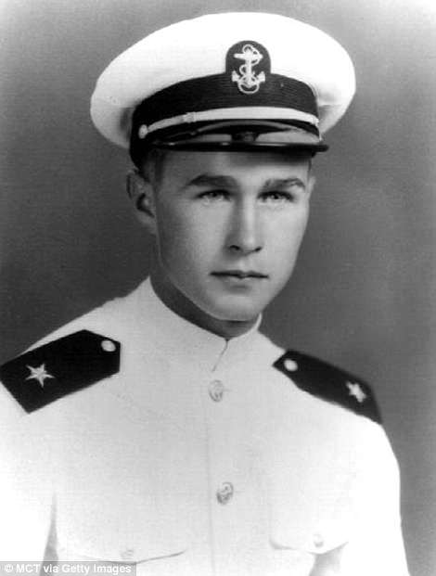

+50

First meeting: Barbara met George when she was 16 at a dance in Connecticut, when she was studying at Ashley Hall School (left) and he was at Phillips Academy in Andover (right)

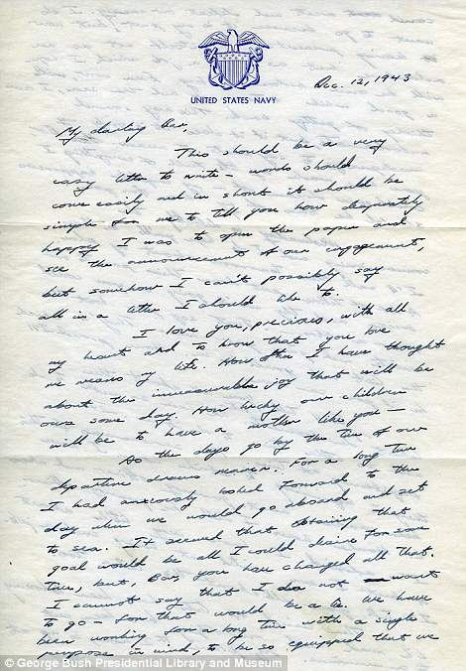

+50

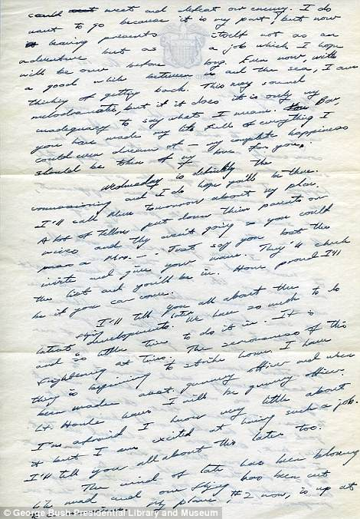

+50

'My darling Bar': In one letter, pictured, George spoke of his 'immeasurable joy' at knowing he would one day marry Barbara and have children with her

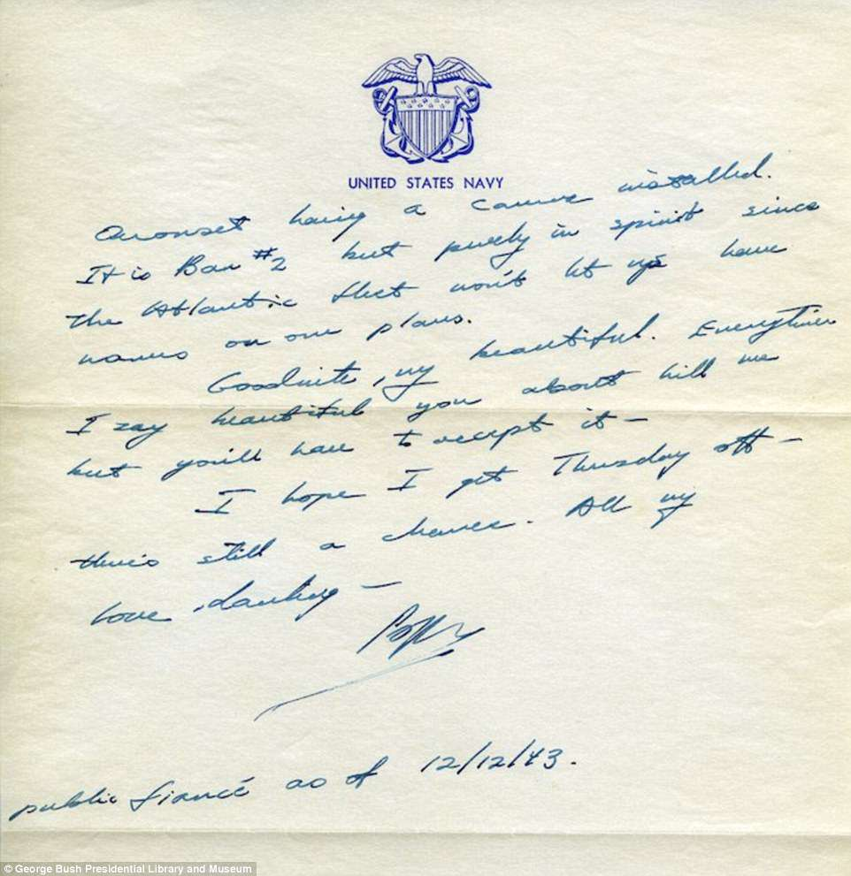

+50

 Sentimental: He signed off his letters 'Poppy', and joked that he was her 'public fiance as of 12/12/43' after their engagement was officially announced in the newspaper

'They are surrounded by family, but I think the fact that they're together and that he still says, 'I love you Barbie' every night is pretty remarkable,' she added.

The former president was a naval aviator in training when they met.

'I'm not much at recalling what people wear, but that particular occasion stands out in my memory,' he recalled of the moment in his autobiography.

The band was playing Glenn Miller tunes and he asked a friend from Rye, New York, if he knew the girl across the room in the green and red holiday dress.

The friend introduced him to Barbara Pierce, a publisher's daughter from Rye who was studying at Ashley Hall finishing school in Charleston, South Carolina, and was in the area on a Christmas vacation.

Clearly captivated by Barbara, George immediately struck up conversation with her, revealing in his autobiography that they actually sat out their first potential dance together because 'he didn't waltz'.

'[We sat out] several more after that, talking and getting to know each other,' he went on, before saying of their first night together: 'It was a storybook meeting.'

When he returned to finish his education at Phillips Academy in Andover, she went back to school in Charleston, however it was just a matter of months before they had met each others' parents.

While they were apart, George and Barbara kept up their long-distance romance by writing letters to one another - a tradition that grew when George went away to fight with the Navy in World War II in mid-1942, forcing them apart once again.

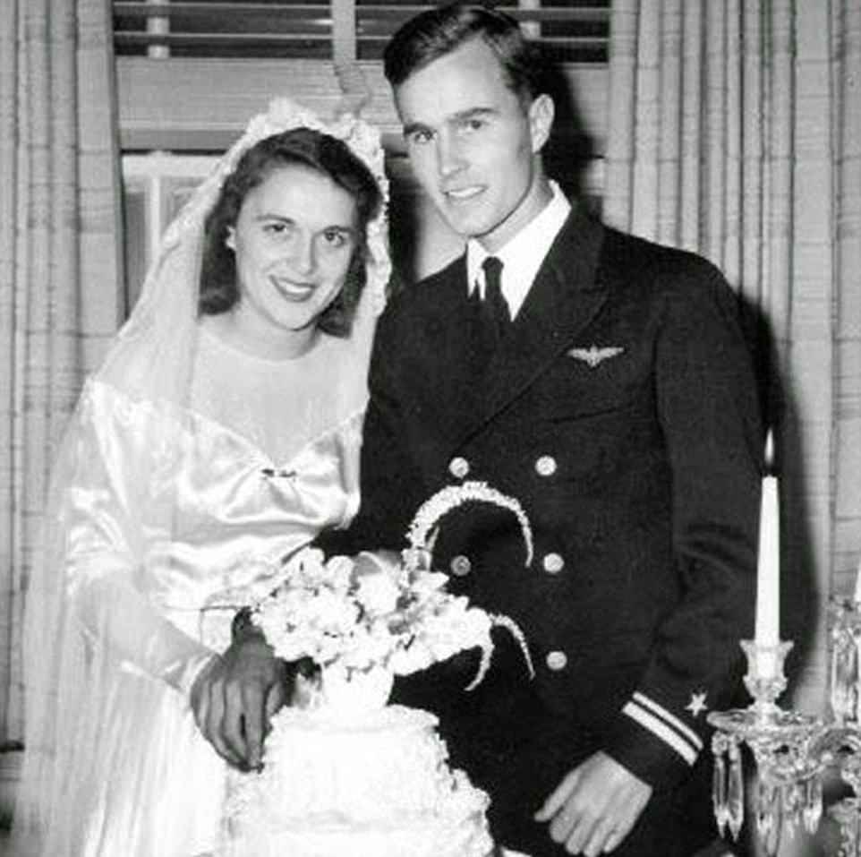

+50

Making it official: The couple tied the knot in Barbara's hometown in Jnauary 1945, just a few weeks after George returned from the South Pacific, where he had been fighting in WWII

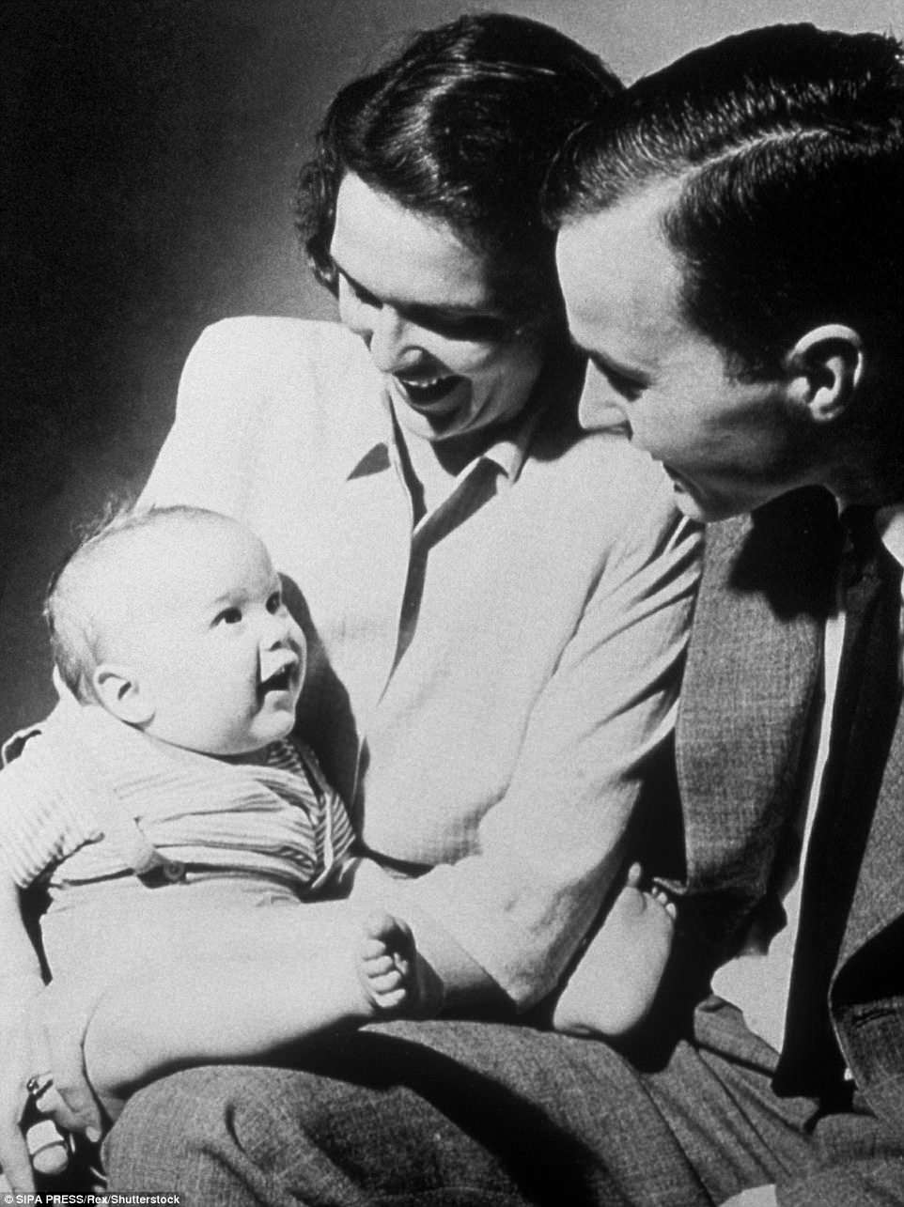

+50

Raising a family: George HW and Barbara had six children during their marriage, including future president George W Bush (pictured)

During his time in the Navy however, George proposed, and he and Barbara became officially engaged in August 1943, a fact that was celebrated in a letter to 'My darling Bar' from 'Poppy' just a few months later.

My Darling Bar, This should be a fairly easy letter to write,' George began, going on to say that 'it should be simple for me to tell you how desperately happy I was to open the paper and see the announcement of our engagement'.

'But somehow I can?t possibly say all in a letter I should like to,' he continued. 'I love you, precious; with all my heart and to know that you love me means my life.

'How often I have thought about the immeasurable joy that will be ours some day. How lucky our children will be to have a mother like you. So the days go by, the time of our departure draws nearer. For a long time I have anxiously looked forward to the day when we would go abroad and set to sea.

'It seemed that obtaining that goal would be all I could desire for some time, but, Bar, you have changed all that.'

Barbara, meanwhile, responded with her own heartfelt messages, admitting that she was 'really excited' about the prospect of their marriage, but also 'scared to death too'.

She joked in one note: 'If you hear a big noise up there, don't worry, it's just my knees knocking.'

Her fears were not entirely unwarranted; in 1944, her husband-to-be, who famously named three of his planes after his future bride, was shot down near the Japanese island of Chichi Jima. He was the only one out of nine airmen who escaped from their planes to evade capture by the Japanese.

Later reports revealed that those taken prisoner were tortured and beaten, before being beheaded or stabbed to death.

George, who was the Navy's youngest aviator when he got his wings, was eventually rescued by a lifeguard submarine, and returned home at the end of that year, and married Barbara just a few weeks later, before he began his studies at Yale.

The couple tied the knot at the First Presbyterian Church in Rye, New York - Barbara's hometown, before moving to Texas.

George then set out to make his mark in the oil business as the couple grew their family and then turned to politics, a journey that would take them around the world and into the White House.

'You have given me joy that few men know,' George wrote to his wife around this time in a letter that was published as part of a collection in 1999.

'I have climbed perhaps the highest mountain in the world, but even that cannot hold a candle to being Barbara's husband,' added.

Photos taken of the couple by The Associated Press over the decades have captured moments of care, such as when Barbara Bush applied sunscreen to the 41st president's nose at a 2015 baseball game between the Houston Astros and Seattle Mariners; and candor, notably after Bush stepped on his wife's toe in 1989 while boarding Air Force One.

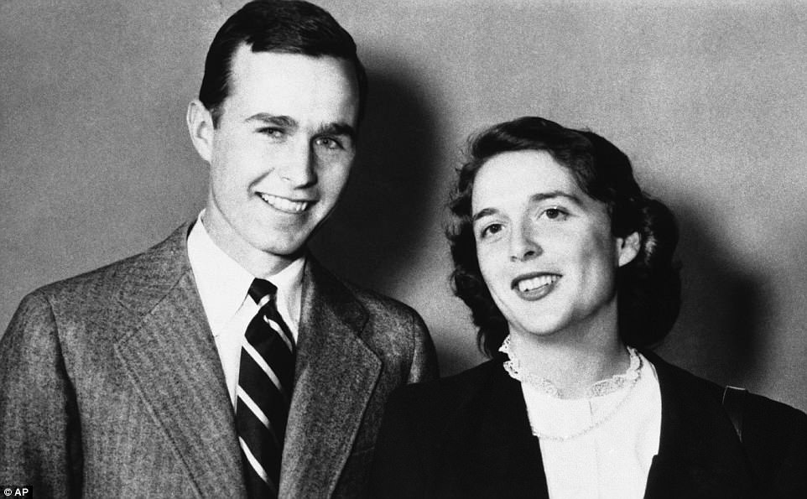

+50

The next step: George and Barbara, pictured in 1945, soon moved to Texas, where he began making his mark on the oil industry, and the couple grew their family together

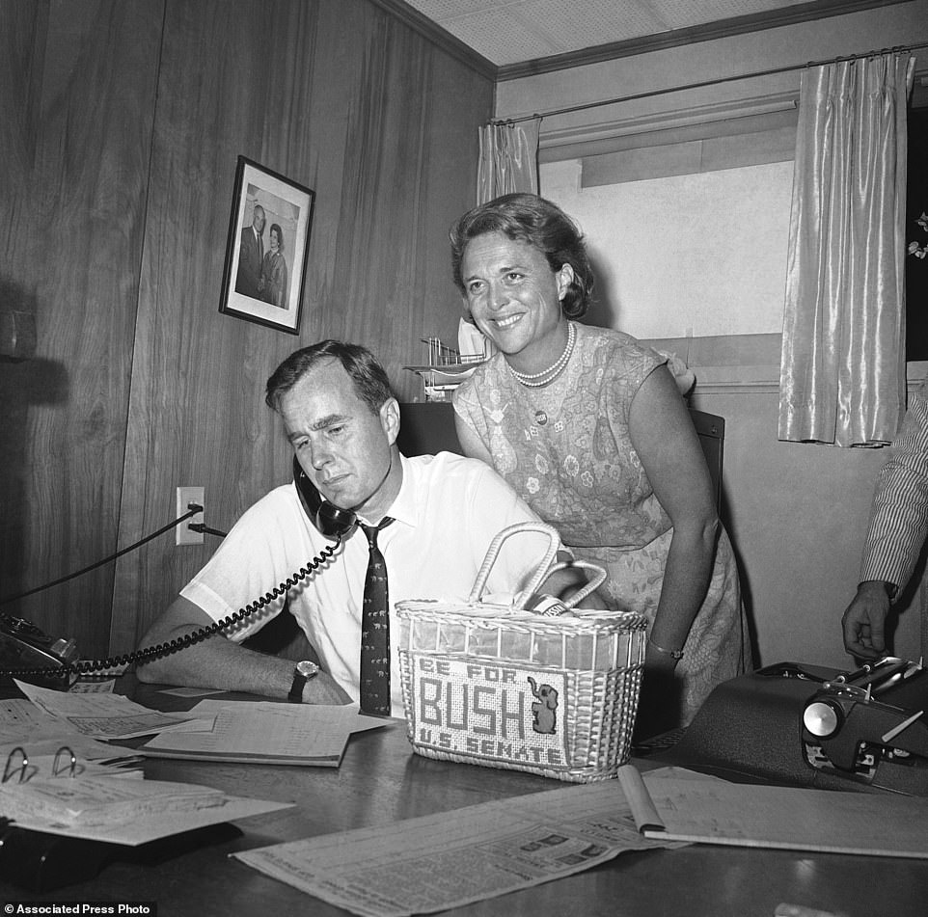

+50

Support system: Barbara was by her husband's side throughout his career. They are pictured on June 6, 1964 when George was running as the Republican nominee for the U.S. Senate

Their marriage also has endured more serious trials.

A daughter, Robin, died in 1953 of leukemia a few weeks before her 4th birthday.

Barbara Bush has recalled a bout of depression in the mid-1970s.

'Night after night, George held me weeping in his arms while I tried to explain my feelings,' she said. 'I almost wonder why he didn't leave me.'

Just last year, allegations surfaced that Bush, who for more than five years has used a wheelchair for mobility, inappropriately touched more than a half dozen women on their buttocks as they stood next to him to take photos.

Through McGrath, Bush issued repeated apologies 'to anyone he has offended.'

'George Bush simply does not have it in his heart to knowingly cause anyone distress,' McGrath said.

Also last year, they both wound up in the same Houston hospital - the former president with pneumonia; his wife with bronchitis.

In 2013, she told C-SPAN in an interview that they pray aloud each night 'and sometimes we fight over whose turn it is.'

In the same conversation, she said she didn't fear death for herself or 'my precious George.'

'I know there is a great God, and I'm not worried,' she said.

Read more: <http://www.dailymail.co.uk/news/article-5627825/Barbara-Bush-dies-aged-92-two-days-falling-seriously-ill.html#ixzz5D0mYOn9A>   
Follow us: [@MailOnline on Twitter](http://ec.tynt.com/b/rw?id=bBOTTqvd0r3Pooab7jrHcU&u=MailOnline) | [DailyMail on Facebook](http://ec.tynt.com/b/rf?id=bBOTTqvd0r3Pooab7jrHcU&u=DailyMail)