The Bush family
http://en.wikipedia.org/wiki/Bush_family
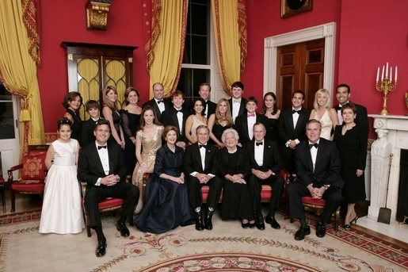
The Bush family:President George W. Bush, First Lady Laura Bush, former First Lady Barbara Bush, and former President George H.W. Bush sit surrounded by family in the Red Room (White House) on January 6, 2005, together to celebrate the senior couple's 60th wedding anniversary. Also pictured are, from left, Georgia Grace Koch, Margaret Bush, Walker Bush, Marvin Bush, Jenna Bush, Doro Bush, Barbara Pierce Bush, Robert P. Koch, Pierce Bush, Maria Bush, Neil Bush, Ashley Bush, Sam LeBlond, Bobby Koch, Nancy Ellis LeBlond, Jeb Bush, Jr., Florida Governor Jeb Bush, Mandi Bush, George P. Bush, and Columba Bush)
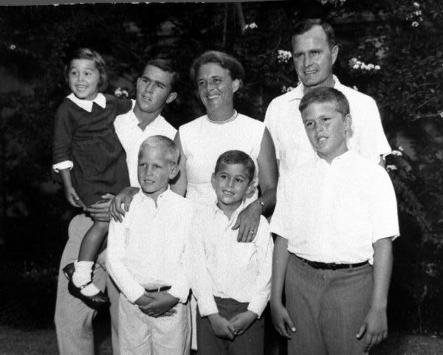
The George H. W. Bush family in the early 1960s. In the front row, from left to right, stand Neil Bush, Marvin Bush, and Jeb Bush. In the back row are Doro Bush, George W. Bush, Barbara Bush, and George H. W. Bush)

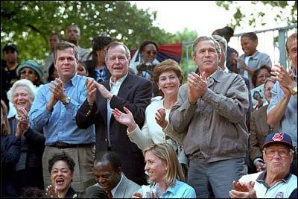
Barbara Bush, Jeb Bush, George H.W. Bush, Laura Bush, and George W. Bush watch tee ball on the White House lawn.

Originating in Columbus, Ohio, the Bush family in the 20th century became an accomplished political family in the United States, including across three generations a U.S. Senator, two Governors, and two Presidents. Many other members have been successful bankers and businessmen. Peter Schweitzer, author of a biography of the family, has described the Bushes as "the most successful political dynasty in American history."^{[1]}

Contents
[hide]
- 1 Family tree
- 2 Ancestors
  - 2.1 Patrilineal line
  - 2.2 Other notable relatives
  - 2.3 Claims of Native American ancestry
- 3 Connections to other prominent families
  - 3.1 Fish family
  - 3.2 Pierce family
  - 3.3 Kerry family
- 4 Further reading
- 5 References
- 6 See also
- 7 External links

[] Family tree
The following is an approximate family tree of notable members of the modern Bush family:
- Samuel P. Bush (1863-1948), a close advisor to President Hoover, was president of the Ohio Association of Manufacturers and a major Columbus industrialist.
  - Prescott Bush (1895-1972), Samuel P. Bush's son, served as a US Senator from Connecticut.
  - Dorothy Walker Bush (1901-1992), the wife of Prescott, was the daughter of George Herbert Walker of the well-connected Walker family of bankers and businessmen
    - Prescott Bush, Jr. (b. 1922), Prescott Bush's eldest son, served as chairman of the U.S.-China Chamber of Commerce.
    - George H.W. Bush (b. 1924), Prescott Bush Sr.'s second son, was the 41st US President, the 43rd Vice President, a Congressman from Houston, and CIA director, as well as other political and diplomatic posts. Before his political career he was in the oil business in Texas.
    - Barbara Pierce Bush (b. 1925), the daughter of publisher Marvin Pierce, was First Lady of the US and Second Lady of the US during her husband's terms.

      - George W. Bush (b. 1946), George H.W. Bush's eldest son, is the 43rd President of the United States and was the 46th Governor of Texas.
      - Laura Welch Bush (b. 1946), the wife of George W., is a former teacher and the First Lady of the United States.
        - Barbara Pierce Bush and Jenna Welch Bush (b. 1981), George W. Bush's twin daughters.
      - Pauline Robinson Bush (b. 1949, d. 1953), George H.W. Bush's second child and first daughter, died of leukemia.
      - Jeb Bush (b. 1953), George H.W. Bush's second son, is the 43rd Governor of Florida. Married to Columba Bush.
        - George P. Bush, son of Jeb Bush, is an associate with Dallas law firm Akin Gump Strauss Hauer & Feld.
        - Jeb Bush, Jr. is attending University of Texas
        - Noelle Bush
      - Neil Bush (b. 1955), third son of George H. W. Bush and brother of President George W. Bush, is a businessman.
        - Lauren Bush (b. 1984), model for Tommy Hilfiger, daughter of Neil
        - Pierce Bush, son of Neil
      - Marvin Bush (b. 1956), a venture capitalist, fourth son of George H. W. Bush, and brother of President George W. Bush.
      - Dorothy Bush Koch (b. 1959), second daughter of George H. W. Bush and sister of President George W. Bush. Married to Bobby Koch, wine lobbyist.
    - Nancy Bush Ellis (b. 1926), Prescott Bush Sr.'s third child, and the only daughter.
      - John Prescott Ellis, son of Nancy Bush Ellis, media consultant
    - Jonathan Bush, Prescott Bush Sr.'s fourth child, banker
      - Jonathan S. Bush, son of Jonathan Bush, insurance executive
      - Billy Bush, son of Jonathan Bush, Access Hollywood host
    - William H.T. Bush, Prescott Bush Sr.'s fifth child, banker and executive

[] Ancestors

[] Patrilineal line
- Richard Bush (ca. 1696/7–September 27, 1732) in Bristol, Plymouth Colony) is believed to be the earliest known patrilineal member of the Bush family in North America.
- Timothy Bush (1728–1815 in Springport, New York) may have been the son of Richard Bush.
- Timothy Bush, Jr. (1761–1850 in Penfield, New York) was the son of Timothy Bush.
- Obadiah Newcomb Bush (January 28, 1797–1851) was the son of Timothy Bush, Jr.
- James Smith Bush (1825-1869), an Episcopal priest in New Jersey, California, and New York, was the son of Obadiah Bush and the father of Samuel Prescott Bush.

[] Other notable relatives
- Måns Andersson (d. 1677 ?), a Swedish immigrant believed to be among the earliest ancestors of the Bush family in North America.
- Anne Hutchinson (1591-1643), a Massachusetts religious dissident, was an 11th–generation ancestor of Samuel P. Bush through his mother Harriet Fay.^{[2]} The same family line makes the Bushes distant cousins of Presidents George Washington, Franklin Delano Roosevelt and Calvin Coolidge.
- George Bush (1796-1859), a biblical scholar who wrote a book Life of Mohammed, was a cousin of Obadiah Bush.
- Jonathon Fairbanks (b. 1595) who first built the Fairbanks House, the oldest house in North America.^{[3]} He is also an ancestor of William Howard Taft^{[4]} and Vice President Charles W. Fairbanks^{[5]}.

[] Claims of Native American ancestry
The Bush family is sometimes said to have Native American connections.
- A Bush ancestor, Austin Bearse, has been claimed to have married Mary Hyanno, a descendant of Wampanoag Indians. This assertion has been debunked by genealogists.^{[6]}

[] Connections to other prominent families

[] Fish family
Samuel Prescott Bush married Flora Sheldon, who had a common ancestor with Hamilton Fish and Thomas Kean.^{[7]}
See also: Fish family; Kean family

[] Pierce family
First Lady Barbara Bush (née Pierce), the wife of George H.W. Bush (the 41st President of the United States) and the mother of George W. Bush (the 43rd), is related to Franklin Pierce (1804-1869), the 14th.^{[7]}

[] Kerry family
George W. Bush and his opponent in the 2004 U.S. Presidential election John Kerry share a common ancestor in Edmund Reade (1563-1623) and his wife Elizabeth Cooke. Bush and Kerry are 9th cousins, twice removed.^{[8]}

[] Further reading
- The Bushes: Portrait of a Dynasty, Peter Schweitzer

[] References
- ^ Joseph Curl. "Rise of 'dynasty' quick, far-reaching", The Washington Times, January 20, 2005. Retrieved on 2006-11-10.
- ^ Richard W. Field. Notable Families Having Multiple Connections. Retrieved on 2006-10-26.
- ^ Lineage as follows: Jonathon (b. 1595) to his son Jonathon (b. 1628) to his son Jeremiah (b. 1674) to his daughter Mary who married Richard Bush and together had Timothy Bush (b. 1728). The lineage continues with Timothy's son Timothy Bush, Jr. (b. 1761) to his son Obadiah Newcomb Bush(b. 1791) to his son James Smith Bush (b. 1825) to his son Samuel P. Bush (b. 1863) to his son Senator Prescott Bush to his son President George H. W. Bush who is George W. Bush's father.
- ^ Lineage as follows: Jonathon (b. 1595) to his son George (b. 1619) to his daughter Mary who married Joseph Daniels and together they had a son Eleazer (b. 1681). It continues through his son David to his daughter Cloe who married Seth Davenport and together had a child Anna. Anna married William Torrey whose son Samuel had a daughter Louisa. Louisa married Alphonso Taft and together they had President William Howard Taft.
- ^ Lineage as follows: Jonathon to his son Jonas to his son Jabez to his son Joshua to his son Luther to his son Luther to his son Loriston Monroe who was the father of Vice President Charles Warren Fairbanks.
- ^ "Some of the less careful, or more credulous, or more romantically inclined, genealogists have accepted at face value the claims presented by Franklin Ele-watum Bearse in his 1933 monograph Who Our Forefathers Really Were, and given wider circulation by an article in the July 1935 issue of the Utah Genealogical Magazine (vol. 26, pp. 99-100) as to the origin of the wife of Austin Bearse, namely that she was Mary Hyanno, daughter of John Hyanno, a Mattachee Sagamore (or Wampanoag) Indian. The inherent implausibility of the story is demonstrated by Donald Lines Jacobus in "Austin Bearse and his alleged Indian connections", published in the October 1938 issue of The American Genealogist (vol. XV, no. 2, pp. 111-118). Mr. Bearse presented no documentary evidence to support his claims, and none has surfaced since."^{[3]}
- ^ ª ^{b} William Addams Reitwiesner. Ancestry of George W. Bush. Retrieved on 2006-08-16.
- ^ David Paul Kuhn (March 4, 2004). Bush, Kerry & Hefner: Odd Cousins. CBSNews.com. Retrieved on 2006-10-26.

[] See also
- List of U.S. political families
- Political families of the world

[] External links
- George W. Bush Family Tree
- New York Times: A Bush Dynasty Begins To Look Real
- CNN: Victory restores Bush dynasty to Washington
- Guardian The Bush dynasty and the Cuban criminals
- Village Voice: The Kennedy Dynasty vs. the Bush Dynasty
- Cincinnati Enquirer: Cheney's health beside the point in Bush dynasty
- St. Petersburg Times(FL): The Bush dynasty parties on
- Bush41 and Bush43 info on possible Native American ancestry
- Four Generations of Bush Family Arms Industry Involvement
========================================================================================================================
END

