Martin Luther King, Jr. 1929-1968 Wikipedia July 8 2014
http://en.wikipedia.org/wiki/Martin_Luther_King,_Jr.
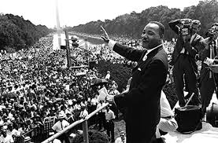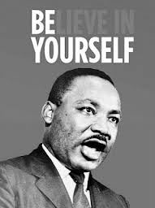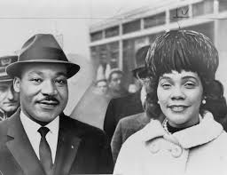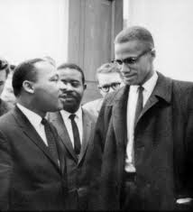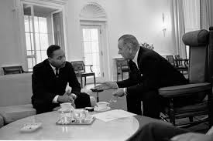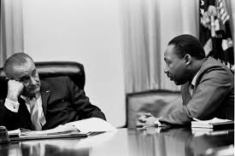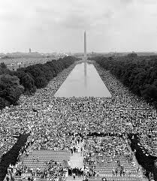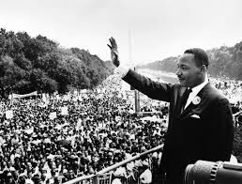

Martin Luther King, Jr.
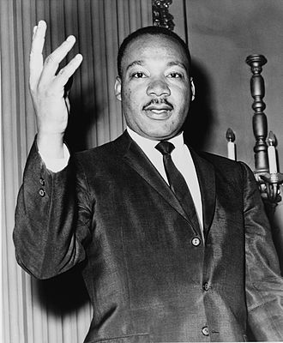
King in 1964
Born | Michael King, Jr.  January 15, 1929  Atlanta, Georgia, U.S.
Died | April 4, 1968 (aged 39)  Memphis, Tennessee, U.S.
Monuments | Martin Luther King, Jr. Memorial
Alma mater | - Morehouse College (B.A.)  - Crozer Theological Seminary (B.D.)  - Boston University (Ph.D.)
Occupation | Clergyman, activist
Organization | Southern Christian Leadership Conference (SCLC)
Movement | African-American Civil Rights Movement, Peace movement
Religion | Christianity
Denomination | Baptist (Progressive National Baptist Convention)
Spouse(s) | Coretta Scott King (m. 1953–1968)
Children | - Yolanda Denise King (1955–2007)  - Martin Luther King III (b. 1957)  - Dexter Scott King (b. 1961)  - Bernice Albertine King (b. 1963)
Parents | Martin Luther King, Sr.  Alberta Williams King
Awards | Nobel Peace Prize (1964), Presidential Medal of Freedom (1977, posthumous), Congressional Gold Medal (2004, posthumous)
Signature | 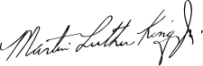
Martin Luther King, Jr. (January 15, 1929 – April 4, 1968) was an American pastor, activist, humanitarian, and leader in the African-American Civil Rights Movement. He is best known for his role in the advancement of civil rights using nonviolent civil disobedience based on his Christian beliefs.
He was born Michael King, but his father changed his name in honor of the German reformer Martin Luther. A Baptist minister, King became a civil rights activist early in his career. He led the 1955 Montgomery Bus Boycott and helped found the Southern Christian Leadership Conference (SCLC) in 1957, serving as its first president. With the SCLC, King led an unsuccessful struggle against segregation in Albany, Georgia, in 1962, and organized nonviolent protests in Birmingham, Alabama, that attracted national attention following television news coverage of the brutal police response. King also helped to organize the 1963 March on Washington, where he delivered his famous "I Have a Dream" speech. There, he established his reputation as one of the greatest orators in American history. J. Edgar Hoover considered him a radical and made him an object of the Federal Bureau of Investigation's COINTELPRO for the rest of his life.
On October 14, 1964, King received the Nobel Peace Prize for combating racial inequality through nonviolence. In 1965, he and the SCLC helped to organize the Selma to Montgomery marches and the following year, he took the movement north to Chicago to work on segregated housing. In the final years of his life, King expanded his focus to include poverty and the Vietnam War, alienating many of his liberal allies with a 1967 speech titled "Beyond Vietnam". In 1968 King was planning a national occupation of Washington, D.C., to be called the Poor People's Campaign, when he was assassinated on April 4 in Memphis, Tennessee. His death was followed by riots in many U.S. cities. Allegations that James Earl Ray, the man convicted of killing King, had been framed or acted in concert with government agents persisted for decades after the shooting. The jury of a 1999 civil trial found Loyd Jowers to be complicit in a conspiracy against King.
King was posthumously awarded the Presidential Medal of Freedom and the Congressional Gold Medal. Martin Luther King, Jr. Day was established as a holiday in numerous cities and states beginning in 1971, and as a U.S. federal holiday in 1986. Hundreds of streets in the U.S. have been renamed in his honor. In addition, a county was rededicated in his honor. A memorial statue on the National Mall was opened to the public in 2011.

Contents
- 1 Early life and education
  - 1.1 Doctoral studies
- 2 Ideas, influences, and political stances
  - 2.1 Religion
  - 2.2 Non-violence
  - 2.3 Politics
  - 2.4 Compensation
- 3 Montgomery Bus Boycott, 1955
- 4 Southern Christian Leadership Conference
  - 4.1 Albany movement
  - 4.2 Birmingham campaign
  - 4.3 St. Augustine, Florida
  - 4.4 Selma, Alabama
  - 4.5 New York City
- 5 March on Washington, 1963
- 6 Selma Voting Rights Movement and "Bloody Sunday", 1965
- 7 Chicago Open Housing Movement, 1966
- 8 Opposition to the Vietnam War
- 9 Poor People's Campaign, 1968
  - 9.1 After King's death
- 10 Assassination and its aftermath
  - 10.1 Aftermath
  - 10.2 Allegations of conspiracy
- 11 FBI and King's personal life
  - 11.1 FBI surveillance and wiretapping
  - 11.2 NSA monitoring of King's communications
  - 11.3 Allegations of communism
  - 11.4 Allegations of adultery
  - 11.5 Presence during the assassination
- 12 Legacy
  - 12.1 Martin Luther King, Jr. Day
  - 12.2 Liturgical commemorations
- 13 Awards and recognition
- 14 Bibliography
- 15 See also
- 16 References
  - 16.1 Notes
  - 16.2 Citations
  - 16.3 Sources
  - 16.4 Further reading
- 17 External links

Early life and education
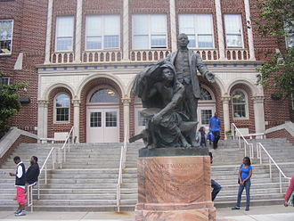
King's high school alma mater was named after African-American scholar Booker T. Washington
Martin Luther King, Jr. was born on January 15, 1929, in Atlanta, Georgia, to Reverend Martin Luther King, Sr. and Alberta Williams King.^{[1]} His legal name at birth was "Michael King".^{[2]} King's father was also born Michael King. The father "changed" both names on his own during a 1934 trip to Nazi Germany to attend the Fifth Baptist World Alliance Congress in Berlin. It was during this time he chose to be called Martin Luther King in honor of the German reformer Martin Luther.^{[3]} King had Irish ancestry through his paternal great grandfather.^{[4][5]}
Martin, Jr., was a middle child, between an older sister, Willie Christine King, and a younger brother, Alfred Daniel Williams King.^{[6]} King sang with his church choir at the 1939 Atlanta premiere of the movie Gone with the Wind.^{[7]}
King suffered from depression throughout most of his life. In his adolescent years, he initially felt some resentment against whites due to the "racial humiliation" that he, his family, and his neighbors often had to endure in the segregated South.^{[8]} At age 12, shortly after his maternal grandmother died, King blamed himself and attempted to commit suicide by jumping out of a second story window, but survived.^{[9]}
King was originally skeptical of many of Christianity's claims.^{[10]} At the age of thirteen, he denied the bodily resurrection of Jesus during Sunday school. From this point, he stated, "doubts began to spring forth unrelentingly".^{[11]} However, he later concluded that the Bible has "many profound truths which one cannot escape" and decided to enter the seminary.^{[10]}
Growing up in Atlanta, King attended Booker T. Washington High School. A precocious student, he skipped both the ninth and the twelfth grades and entered Morehouse College at age fifteen without formally graduating from high school.^{[12]} In 1948, he graduated from Morehouse with a B.A. degree in sociology, and enrolled in Crozer Theological Seminary in Chester, Pennsylvania, from which he graduated with a B.Div. degree in 1951.^{[13][14]} King married Coretta Scott, on June 18, 1953, on the lawn of her parents' house in her hometown of Heiberger, Alabama.^{[15]} They became the parents of four children: Yolanda King, Martin Luther King III, Dexter Scott King, and Bernice King.^{[16]} During their marriage, King limited Coretta's role in the civil rights movement, and expected her to be a housewife.^{[17]}

Doctoral studies
See also: Martin Luther King, Jr. authorship issues
King then began doctoral studies in systematic theology at Boston University and received his Ph.D. degree on June 5, 1955, with a dissertation on "A Comparison of the Conceptions of God in the Thinking of Paul Tillich and Henry Nelson Wieman". An academic inquiry concluded in October 1991 that portions of his dissertation had been plagiarized and he had acted improperly. However, "[d]espite its finding, the committee said that 'no thought should be given to the revocation of Dr. King's doctoral degree,' an action that the panel said would serve no purpose."^{[18][19][20]} The committee also found that the dissertation still "makes an intelligent contribution to scholarship."

Ideas, influences, and political stances

Religion
King became pastor of the Dexter Avenue Baptist Church in Montgomery, Alabama, when he was twenty-five years old, in 1954.^{[21]} As a Christian minister, his main influence was Jesus Christ and the Christian gospels, which he would almost always quote in his religious meetings, speeches at church, and in public discourses. King's faith was strongly based in Jesus' commandment of loving your neighbor as yourself, loving God above all, and loving your enemies, praying for them and blessing them. His non-violent thought was also based in the injuction to turn the other cheek in the Sermon on the Mount, and Jesus' teaching of putting the sword back into its place (Matthew 26:52).^{[22]} In his famous Letter from Birmingham Jail, King urged action consistent with what he describes as Jesus' "extremist" love, and also quoted numerous other Christian pacifist authors, which was very usual for him. In his speech "I've Been to the Mountaintop", he stated that he just wanted to do God's will.

Non-violence
King at a Civil Rights March on Washington, D.C.
Veteran African-American civil rights activist Bayard Rustin served as King's main advisor and mentor in the late 1950s.^{[23]} Rustin came from the Christian pacifist tradition; he had also studied Gandhi's teachings and applied them with the Journey of Reconciliation campaign in the 1940s.^{[24]} King had initially known little about Gandhi and rarely used the term "nonviolence" during his early years of activism in the early 1950s. King also believed in and practiced self-defense, even obtaining guns in his household as a means of defense against possible attackers. Rustin guided King by showing him the alternative of nonviolent resistance, arguing that this would be a better means to accomplish his goals of civil rights than self-defense. ^{[25]} Rustin counseled King to dedicate himself to the principles of non-violence.^{[26]}
Inspired by Mahatma Gandhi's success with non-violent activism, King had "for a long time...wanted to take a trip to India".^{[27]} With assistance from the Quaker group the American Friends Service Committee, he was able to make the journey in April 1959.^{[28]} The trip to India affected King, deepening his understanding of non-violent resistance and his commitment to America's struggle for civil rights. In a radio address made during his final evening in India, King reflected, "Since being in India, I am more convinced than ever before that the method of nonviolent resistance is the most potent weapon available to oppressed people in their struggle for justice and human dignity".
Bayard Rustin's open homosexuality, support of democratic socialism, and his former ties to the Communist Party USA caused many white and African-American leaders to demand King distance himself from Rustin,^{[29]} which King agreed to do.^{[30]} However, King agreed that Rustin should be one of the main organizers of the 1963 March on Washington.^{[31]}
King's admiration of Gandhi's non-violence did not diminish in later years. He went so far as to hold up his example when receiving the Nobel Peace Prize in 1964, hailing the "successful precedent" of using non-violence "in a magnificent way by Mohandas K. Gandhi to challenge the might of the British Empire... He struggled only with the weapons of truth, soul force, non-injury and courage."^{[32]}
Gandhi seemed to have influenced him with certain moral principles,^{[33]} though Gandhi himself had been influenced by The Kingdom of God Is Within You, a nonviolent classic written by Christian anarchist Leo Tolstoy. In turn, both Gandhi and Martin Luther King had read Tolstoy. King quoted Tolstoy's War and Peace in 1959.^{[34]}
Another influence for King's non-violent method was Thoreau's essay On Civil Disobedience, which King read in his student days. He was influenced by the idea of refusing to cooperate with an evil system.^{[35]} He also was greatly influenced by the works of Protestant theologians Reinhold Niebuhr and Paul Tillich,^{[36]} as well as Walter Rauschenbusch's Christianity and the Social Crisis. In his later career, King used the concept of "agape" (the deepest form of Christian love), which may have represented an influence of Paul Ramsey.^{[37]}

Politics
As the leader of the SCLC, King maintained a policy of not publicly endorsing a U.S. political party or candidate: "I feel someone must remain in the position of non-alignment, so that he can look objectively at both parties and be the conscience of both—not the servant or master of either."^{[38]} In a 1958 interview, he expressed his view that neither party was perfect, saying, "I don't think the Republican party is a party full of the almighty God nor is the Democratic party. They both have weaknesses ... And I'm not inextricably bound to either party."^{[39]}
King critiqued both parties' performance on promoting racial equality:
Actually, the Negro has been betrayed by both the Republican and the Democratic party. The Democrats have betrayed him by capitulating to the whims and caprices of the Southern Dixiecrats. The Republicans have betrayed him by capitulating to the blatant hypocrisy of reactionary right wing northern Republicans. And this coalition of southern Dixiecrats and right wing reactionary northern Republicans defeats every bill and every move towards liberal legislation in the area of civil rights.^{[40]}
Although King never publicly supported a political party or candidate for president, in a letter to a civil rights supporter in October 1956 he said that he was undecided as to whether he would vote for Adlai Stevenson or Dwight Eisenhower, but that "In the past I always voted the Democratic ticket."^{[41]} In his autobiography, King says that in 1960 he privately voted for Democratic candidate John F. Kennedy: "I felt that Kennedy would make the best president. I never came out with an endorsement. My father did, but I never made one." King adds that he likely would have made an exception to his non-endorsement policy for a second Kennedy term, saying "Had President Kennedy lived, I would probably have endorsed him in 1964."^{[42]} King supported the ideals of democratic socialism, although he was reluctant to speak directly of this support due to the anti-communist sentiment being projected throughout America at the time, and the association of socialism with communism. King believed that capitalism could not adequately provide the basic necessities of many American people, particularly the African American community.^{[43]}

Compensation
King stated that black Americans, as well as other disadvantaged Americans, should be compensated for historical wrongs. In an interview conducted for Playboy in 1965, he said that granting black Americans only equality could not realistically close the economic gap between them and whites. King said that he did not seek a full restitution of wages lost to slavery, which he believed impossible, but proposed a government compensatory program of $50 billion over ten years to all disadvantaged groups.^{[44]}
He posited that "the money spent would be more than amply justified by the benefits that would accrue to the nation through a spectacular decline in school dropouts, family breakups, crime rates, illegitimacy, swollen relief rolls, rioting and other social evils".^{[45]} He presented this idea as an application of the common law regarding settlement of unpaid labor, but clarified that he felt that the money should not be spent exclusively on blacks. He stated, "It should benefit the disadvantaged of all races".^{[46]}

Montgomery Bus Boycott, 1955
Main articles: Montgomery Bus Boycott and Jim Crow laws § Public arena
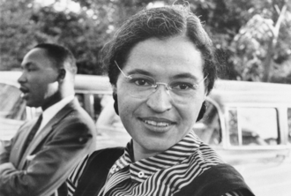
Rosa Parks with King, 1955
In March 1955, a fifteen-year-old school girl in Montgomery, Claudette Colvin, refused to give up her bus seat to a white man in compliance with Jim Crow laws, laws in the US South that enforced racial segregation. King was on the committee from the Birmingham African-American community that looked into the case; because Colvin was pregnant and unmarried, E.D. Nixon and Clifford Durr decided to wait for a better case to pursue.^{[47]}
On December 1, 1955, Rosa Parks was arrested for refusing to give up her seat.^{[48]} The Montgomery Bus Boycott, urged and planned by Nixon and led by King, soon followed.^{[49]} The boycott lasted for 385 days,^{[50]} and the situation became so tense that King's house was bombed.^{[51]} King was arrested during this campaign, which concluded with a United States District Court ruling in Browder v. Gayle that ended racial segregation on all Montgomery public buses.^{[52][53]} King's role in the bus boycott transformed him into a national figure and the best-known spokesman of the civil rights movement.^{[54]}

Southern Christian Leadership Conference
In 1957, King, Ralph Abernathy, Fred Shuttlesworth, Joseph Lowery, and other civil rights activists founded the Southern Christian Leadership Conference (SCLC). The group was created to harness the moral authority and organizing power of black churches to conduct non-violent protests in the service of civil rights reform. King led the SCLC until his death.^{[55]}
On September 20, 1958, while signing copies of his book Stride Toward Freedom in Blumstein's department store in Harlem,^{[56]} King narrowly escaped death when Izola Curry, a mentally ill black woman who believed he was conspiring against her with communists, stabbed him in the chest with a letter opener. After emergency surgery, King was hospitalized for several weeks, while Curry was found mentally incompetent to stand trial.^{[57][58]} In 1959, he published a short book called The Measure of A Man, which contained his sermons "What is Man?" and "The Dimensions of a Complete Life". The sermons argued for man's need for God's love and criticized the racial injustices of Western civilization.^{[59]}
Harry Wachtel—who joined King's legal advisor Clarence B. Jones in defending four ministers of the SCLC in a libel suit over a newspaper advertisement (New York Times Co. v. Sullivan)—founded a tax-exempt fund to cover the expenses of the suit and to assist the nonviolent civil rights movement through a more effective means of fundraising. This organization was named the "Gandhi Society for Human Rights". King served as honorary president for the group. Displeased with the pace of President Kennedy's addressing the issue of segregation, King and the Gandhi Society produced a document in 1962 calling on the President to follow in the footsteps of Abraham Lincoln and use an Executive Order to deliver a blow for Civil Rights as a kind of Second Emancipation Proclamation - Kennedy did not execute the order.^{[60]}
Lyndon Johnson and Robert Kennedy with Civil Rights leaders, June 22, 1963
The FBI, under written directive from Attorney General Robert F. Kennedy, began tapping King's telephone in the fall of 1963.^{[61]} Concerned that allegations of communists in the SCLC, if made public, would derail the administration's civil rights initiatives, Kennedy warned King to discontinue the suspect associations, and later felt compelled to issue the written directive authorizing the FBI to wiretap King and other SCLC leaders.^{[62]} J. Edgar Hoover feared Communists were trying to infiltrate the Civil Rights movement, but when no such evidence emerged, the bureau used the incidental details caught on tape over the next five years in attempts to force King out of the preeminent leadership position.^{[63]}
King believed that organized, nonviolent protest against the system of southern segregation known as Jim Crow laws would lead to extensive media coverage of the struggle for black equality and voting rights. Journalistic accounts and televised footage of the daily deprivation and indignities suffered by southern blacks, and of segregationist violence and harassment of civil rights workers and marchers, produced a wave of sympathetic public opinion that convinced the majority of Americans that the Civil Rights Movement was the most important issue in American politics in the early 1960s.^{[64][65]}
King organized and led marches for blacks' right to vote, desegregation, labor rights and other basic civil rights.^{[53]} The SCLC's 1957 Prayer Pilgrimage for Freedom was the first time King addressed a national audience.^{[66]} Most of these rights were successfully enacted into the law of the United States with the passage of the Civil Rights Act of 1964 and the 1965 Voting Rights Act.^{[67][68]}
King and the SCLC put into practice many of the principles of the Christian Left and applied the tactics of nonviolent protest with great success by strategically choosing the method of protest and the places in which protests were carried out. There were often dramatic stand-offs with segregationist authorities. Sometimes these confrontations turned violent.^{[69]}
Throughout his participation in the civil rights movement, King was criticized by many groups. This included opposition by more militant blacks such as Nation of Islam member Malcolm X.^{[70]} Stokely Carmichael was a separatist and disagreed with King's plea for racial integration because he considered it an insult to a uniquely African-American culture.^{[71]} Omali Yeshitela urged Africans to remember the history of violent European colonization and how power was not secured by Europeans through integration, but by violence and force.^{[72]}

Albany movement
Main article: Albany movement
The Albany Movement was a desegregation coalition formed in Albany, Georgia in November 1961. In December, King and the SCLC became involved. The movement mobilized thousands of citizens for a broad-front nonviolent attack on every aspect of segregation within the city and attracted nationwide attention. When King first visited on December 15, 1961, he "had planned to stay a day or so and return home after giving counsel."^{[73]} The following day he was swept up in a mass arrest of peaceful demonstrators, and he declined bail until the city made concessions. According to King, "that agreement was dishonored and violated by the city" after he left town.^{[73]}
King returned in July 1962, and was sentenced to forty-five days in jail or a $178 fine. He chose jail. Three days into his sentence, Police Chief Laurie Pritchett discreetly arranged for King's fine to be paid and ordered his release. "We had witnessed persons being kicked off lunch counter stools ... ejected from churches ... and thrown into jail ... But for the first time, we witnessed being kicked out of jail."^{[74]}
After nearly a year of intense activism with few tangible results, the movement began to deteriorate. King requested a halt to all demonstrations and a "Day of Penance" to promote non-violence and maintain the moral high ground. Divisions within the black community and the canny, low-key response by local government defeated efforts.^{[75]} Though the Albany effort proved a key lesson in tactics for Dr. King and the national civil rights movement,^{[76]} the national media was highly critical of King's role in the defeat, and the SCLC's lack of results contributed to a growing gulf between the organization and the more radical SNCC. After Albany, King sought to choose engagements for the SCLC in which he could control the circumstances, rather than entering into pre-existing situations.^{[77]}

Birmingham campaign
Main article: Birmingham campaign
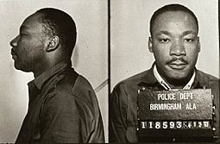
King following his arrest in Birmingham
In April 1963, the SCLC began a campaign against racial segregation and economic injustice in Birmingham, Alabama. The campaign used nonviolent but intentionally confrontational tactics, developed in part by Rev. Wyatt Tee Walker. Black people in Birmingham, organizing with the SCLC, occupied public spaces with marches and sit-ins, openly violating laws that they considered unjust.
King's intent was to provoke mass arrests and "create a situation so crisis-packed that it will inevitably open the door to negotiation".^{[78]} However, the campaign's early volunteers did not succeed in shutting down the city, or in drawing media attention to the police's actions. Over the concerns of an uncertain King, SCLC strategist James Bevel changed the course of the campaign by recruiting children and young adults to join in the demonstrations.^{[79]} Newsweek called this strategy a Children's Crusade.^{[80][81]}
During the protests, the Birmingham Police Department, led by Eugene "Bull" Connor, used high-pressure water jets and police dogs against protesters, including children. Footage of the police response was broadcast on national television news and dominated the nation's attention, shocking many white Americans and consolidating black Americans behind the movement.^{[82]} Not all of the demonstrators were peaceful, despite the avowed intentions of the SCLC. In some cases, bystanders attacked the police, who responded with force. King and the SCLC were criticized for putting children in harm's way. But the campaign was a success: Connor lost his job, the "Jim Crow" signs came down, and public places became more open to blacks. King's reputation improved immensely.^{[80]}
King was arrested and jailed early in the campaign—his 13th arrest^{[83]} out of 29.^{[84]} From his cell, he composed the now-famous "Letter from Birmingham Jail" which responds to calls on the movement to pursue legal channels for social change. King argues that the crisis of racism is too urgent, and the current system too entrenched: "We know through painful experience that freedom is never voluntarily given by the oppressor; it must be demanded by the oppressed."^{[85]} He points out that the Boston Tea Party, a celebrated act of rebellion in the American colonies, was illegal civil disobedience, and that, conversely, "everything Adolf Hitler did in Germany was 'legal'".^{[85]} King also expresses his frustration with white moderates and clergymen too timid to oppose an unjust system:
I have almost reached the regrettable conclusion that the Negro's great stumbling block in his stride toward freedom is not the White Citizen's Councilor or the Ku Klux Klanner, but the white moderate, who is more devoted to "order" than to justice; who prefers a negative peace which is the absence of tension to a positive peace which is the presence of justice; who constantly says: "I agree with you in the goal you seek, but I cannot agree with your methods of direct action"; who paternalistic-ally believes he can set the timetable for another man's freedom; who lives by a mythical concept of time and who constantly advises the Negro to wait for a "more convenient season".^{[85]}

St. Augustine, Florida
Main article: St. Augustine Movement
In March 1964, King and the SCLC joined forces with Robert Hayling's then-controversial movement in St. Augustine, Florida. Hayling's group had been affiliated with the NAACP but was forced out of the organization for advocating armed self-defense alongside nonviolent tactics. Ironically, the pacifist SCLC accepted them.^{[86]} King and the SCLC worked to bring white Northern activists to St. Augustine, including a delegation of rabbis and the 72-year-old mother of the governor of Massachusetts, all of whom were arrested.^{[87][88]} During June, the movement marched nightly through the city, "often facing counter demonstrations by the Klan, and provoking violence that garnered national media attention." Hundreds of the marchers were arrested and jailed. During the course of this movement, the Civil Rights Act of 1964 was passed.^{[89]}

Selma, Alabama
In December 1964, King and the SCLC joined forces with the Student Nonviolent Coordinating Committee (SNCC) in Selma, Alabama, where the SNCC had been working on voter registration for several months.^{[90]} A local judge issued an injunction that barred any gathering of 3 or more people affiliated with the SNCC, SCLC, DCVL, or any of 41 named civil rights leaders. This injunction temporarily halted civil rights activity until King defied it by speaking at Brown Chapel on January 2, 1965.^{[91]}

New York City
On February 6, 1964, King delivered the inaugural speech of a lecture series initiated at the New School called "The American Race Crisis". No audio record of his speech has been found, but in August 2013, almost 50 years later, the school discovered an audiotape with 15 minutes of a question-and-answer session that followed King's address. In these remarks, King referred to a conversation he had recently had with Jawaharlal Nehru in which he compared the sad condition of many African Americans to that of India's untouchables.^{[92]}

March on Washington, 1963
Main article: March on Washington for Jobs and Freedom
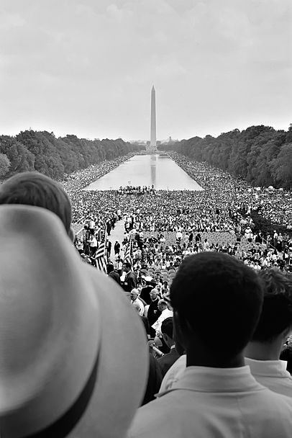
March on Washington for Jobs and Freedom
King, representing the SCLC, was among the leaders of the so-called "Big Six" civil rights organizations who were instrumental in the organization of the March on Washington for Jobs and Freedom, which took place on August 28, 1963. The other leaders and organizations comprising the Big Six were Roy Wilkins from the National Association for the Advancement of Colored People; Whitney Young, National Urban League; A. Philip Randolph, Brotherhood of Sleeping Car Porters; John Lewis, SNCC; and James L. Farmer, Jr. of the Congress of Racial Equality.^{[93]}
The primary logistical and strategic organizer was King's colleague Bayard Rustin.^{[94]} For King, this role was another which courted controversy, since he was one of the key figures who acceded to the wishes of President John F. Kennedy in changing the focus of the march.^{[95][96]} Kennedy initially opposed the march outright, because he was concerned it would negatively impact the drive for passage of civil rights legislation. However, the organizers were firm that the march would proceed.^{[97]} With the march going forward, the Kennedys decided it was important to work to ensure its success. President Kennedy was concerned the turnout would be less than 100,000. Therefore, he enlisted the aid of additional church leaders and the UAW union to help mobilize demonstrators for the cause.^{[98]}
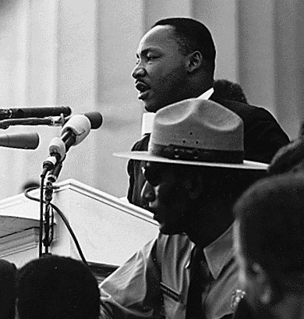
King is most famous for his "I Have a Dream" speech, given in front of the Lincoln Memorial during the 1963 March on Washington for Jobs and Freedom.
The march originally was conceived as an event to dramatize the desperate condition of blacks in the southern U.S. and an opportunity to place organizers' concerns and grievances squarely before the seat of power in the nation's capital. Organizers intended to denounce the federal government for its failure to safeguard the civil rights and physical safety of civil rights workers and blacks. However, the group acquiesced to presidential pressure and influence, and the event ultimately took on a far less strident tone.^{[99]} As a result, some civil rights activists felt it presented an inaccurate, sanitized pageant of racial harmony; Malcolm X called it the "Farce on Washington", and the Nation of Islam forbade its members from attending the march.^{[99][100]}
I Have a Dream

Menu
0:00
30-second sample from "I Have a Dream" speech by Martin Luther King, Jr. at the March on Washington for Jobs and Freedom on August 28, 1963

Problems playing this file? See media help.
The march did, however, make specific demands: an end to racial segregation in public schools; meaningful civil rights legislation, including a law prohibiting racial discrimination in employment; protection of civil rights workers from police brutality; a $2 minimum wage for all workers; and self-government for Washington, D.C., then governed by congressional committee.^{[101][102][103]} Despite tensions, the march was a resounding success.^{[104]} More than a quarter of a million people of diverse ethnicities attended the event, sprawling from the steps of the Lincoln Memorial onto the National Mall and around the reflecting pool. At the time, it was the largest gathering of protesters in Washington, D.C.'s history.^{[104]}
King delivered a 17-minute speech, later known as "I Have a Dream". In the speech's most famous passage—in which he departed from his prepared text, possibly at the prompting of Mahalia Jackson, who shouted behind him, "Tell them about the dream!"^{[105][106]}—King said:
I say to you today, my friends, so even though we face the difficulties of today and tomorrow, I still have a dream. It is a dream deeply rooted in the American dream.
I have a dream that one day this nation will rise up and live out the true meaning of its creed: 'We hold these truths to be self-evident: that all men are created equal.'
I have a dream that one day on the red hills of Georgia the sons of former slaves and the sons of former slave owners will be able to sit down together at the table of brotherhood.
I have a dream that one day even the state of Mississippi, a state sweltering with the heat of injustice, sweltering with the heat of oppression, will be transformed into an oasis of freedom and justice.
I have a dream that my four little children will one day live in a nation where they will not be judged by the color of their skin but by the content of their character.
I have a dream today.
I have a dream that one day, down in Alabama, with its vicious racists, with its governor having his lips dripping with the words of interposition and nullification; one day right there in Alabama, little black boys and black girls will be able to join hands with little white boys and white girls as sisters and brothers.
I have a dream today.^{[107]}
"I Have a Dream" came to be regarded as one of the finest speeches in the history of American oratory.^{[108]} The March, and especially King's speech, helped put civil rights at the top of the agenda of reformers in the United States and facilitated passage of the Civil Rights Act of 1964.^{[109][110]}
The original, typewritten copy of the speech, including Dr. King's handwritten notes on it, was discovered in 1984 to be in the hands of George Raveling, the first African-American basketball coach of the University of Iowa. In 1963, Raveling, then 26, was standing near the podium, and immediately after the oration, impulsively asked King if he could have his copy of the speech. He got it.^{[111]}

Selma Voting Rights Movement and "Bloody Sunday", 1965
Main article: Selma to Montgomery marches
Acting on James Bevel's call for a march from Selma to Montgomery, King, Bevel, and the SCLC, in partial collaboration with SNCC, attempted to organize the march to the state's capital. The first attempt to march on March 7, 1965, was aborted because of mob and police violence against the demonstrators. This day has become known as Bloody Sunday, and was a major turning point in the effort to gain public support for the Civil Rights Movement. It was the clearest demonstration up to that time of the dramatic potential of King's nonviolence strategy. King, however, was not present.^{[112]}
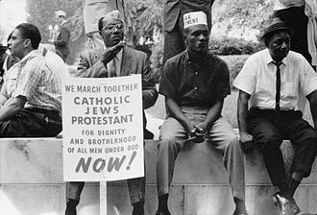
The civil rights march from Selma to Montgomery, Alabama in 1965
King met with officials in the Lyndon B. Johnson Administration on March 5 in order to request an injunction against any prosecution of the demonstrators. He did not attend the march due to church duties, but he later wrote, "If I had any idea that the state troopers would use the kind of brutality they did, I would have felt compelled to give up my church duties altogether to lead the line."^{[113]} Footage of police brutality against the protesters was broadcast extensively and aroused national public outrage.^{[114]}
King next attempted to organize a march for March 9. The SCLC petitioned for an injunction in federal court against the State of Alabama; this was denied and the judge issued an order blocking the march until after a hearing. Nonetheless, King led marchers on March 9 to the Edmund Pettus Bridge in Selma, then held a short prayer session before turning the marchers around and asking them to disperse so as not to violate the court order. The unexpected ending of this second march aroused the surprise and anger of many within the local movement.^{[115]} The march finally went ahead fully on March 25, 1965.^{[116][117]} At the conclusion of the march on the steps of the state capitol, King delivered a speech that became known as "How Long, Not Long". In it, King stated that equal rights for African Americans could not be far away, "because the arc of the moral universe is long, but it bends toward justice".^{[a][118][119]}

Chicago Open Housing Movement, 1966
Main article: Chicago Freedom Movement
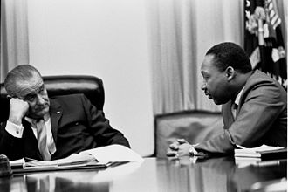
King with President Lyndon Johnson in 1966
In 1966, after several successes in the South, King, Bevel, and others in the civil rights organizations tried to spread the movement to the North, with Chicago as their first destination. King and Ralph Abernathy, both from the middle class, moved into a building at 1550 S. Hamlin Ave., in the slums of North Lawndale^{[120]} on Chicago's West Side, as an educational experience and to demonstrate their support and empathy for the poor.^{[121]}
The SCLC formed a coalition with CCCO, Coordinating Council of Community Organizations, an organization founded by Albert Raby, and the combined organizations' efforts were fostered under the aegis of the Chicago Freedom Movement.^{[122]} During that spring, several white couple / black couple tests of real estate offices uncovered racial steering: discriminatory processing of housing requests by couples who were exact matches in income, background, number of children, and other attributes.^{[123]} Several larger marches were planned and executed: in Bogan, Belmont Cragin, Jefferson Park, Evergreen Park (a suburb southwest of Chicago), Gage Park, Marquette Park, and others.^{[122][124][125]}
Abernathy later wrote that the movement received a worse reception in Chicago than in the South. Marches, especially the one through Marquette Park on August 5, 1966, were met by thrown bottles and screaming throngs. Rioting seemed very possible.^{[126][127]} King's beliefs militated against his staging a violent event, and he negotiated an agreement with Mayor Richard J. Daley to cancel a march in order to avoid the violence that he feared would result.^{[128]} King was hit by a brick during one march but continued to lead marches in the face of personal danger.^{[129]}
When King and his allies returned to the South, they left Jesse Jackson, a seminary student who had previously joined the movement in the South, in charge of their organization.^{[130]} Jackson continued their struggle for civil rights by organizing the Operation Breadbasket movement that targeted chain stores that did not deal fairly with blacks.^{[131]}

Opposition to the Vietnam War
See also: Opposition to the U.S. involvement in the Vietnam War
External audio
You may watch the speech, "Why I Am Opposed to the War in Vietnam", by Martin Luther King here.
In 1965 King began to publicly express doubts about the Vietnam War. In an April 4, 1967 appearance at the New York City Riverside Church—exactly one year before his death—King delivered a speech titled "Beyond Vietnam: A Time to Break Silence".^{[132]} He spoke strongly against the U.S.'s role in the war, arguing that the U.S. was in Vietnam "to occupy it as an American colony"^{[133]} and calling the U.S. government "the greatest purveyor of violence in the world today".^{[134]} He also connected the war with economic injustice, arguing that the country needed serious moral change:
A true revolution of values will soon look uneasily on the glaring contrast of poverty and wealth. With righteous indignation, it will look across the seas and see individual capitalists of the West investing huge sums of money in Asia, Africa and South America, only to take the profits out with no concern for the social betterment of the countries, and say: "This is not just."^{[135]}
King also opposed the Vietnam War because it took money and resources that could have been spent on social welfare at home. The United States Congress was spending more and more on the military and less and less on anti-poverty programs at the same time. He summed up this aspect by saying, "A nation that continues year after year to spend more money on military defense than on programs of social uplift is approaching spiritual death".^{[135]} He stated that North Vietnam "did not begin to send in any large number of supplies or men until American forces had arrived in the tens of thousands",^{[136]} and accused the U.S. of having killed a million Vietnamese, "mostly children".^{[137]} King also criticized American opposition to North Vietnam's land reforms.^{[138]}
King's opposition cost him significant support among white allies, including President Johnson, union leaders and powerful publishers.^{[139]} "The press is being stacked against me", King said,^{[140]} complaining of a double standard that applauded his non-violence at home, but deplored it when applied "toward little brown Vietnamese children".^{[141]} Life magazine called the speech "demagogic slander that sounded like a script for Radio Hanoi",^{[135]} and The Washington Post declared that King had "diminished his usefulness to his cause, his country, his people".^{[141][142]}
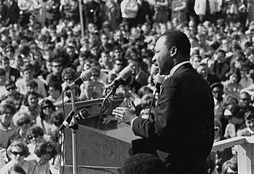
King speaking to an anti-Vietnam war rally at the University of Minnesota, St. Paul on April 27, 1967
The "Beyond Vietnam" speech reflected King's evolving political advocacy in his later years, which paralleled the teachings of the progressive Highlander Research and Education Center, with which he was affiliated.^{[143][144]} King began to speak of the need for fundamental changes in the political and economic life of the nation, and more frequently expressed his opposition to the war and his desire to see a redistribution of resources to correct racial and economic injustice.^{[145]} He guarded his language in public to avoid being linked to communism by his enemies, but in private he sometimes spoke of his support for democratic socialism.^{[146]} In a 1952 letter to Coretta Scott, he said "I imagine you already know that I am much more socialistic in my economic theory than capitalistic..."^{[147]} In one speech, he stated that "something is wrong with capitalism" and claimed, "There must be a better distribution of wealth, and maybe America must move toward a democratic socialism."^{[148]} King had read Marx while at Morehouse, but while he rejected "traditional capitalism", he also rejected communism because of its "materialistic interpretation of history" that denied religion, its "ethical relativism", and its "political totalitarianism".^{[149]}
King also stated in "Beyond Vietnam" that "true compassion is more than flinging a coin to a beggar ... it comes to see that an edifice which produces beggars needs restructuring".^{[150]} King quoted a United States official who said that, from Vietnam to Latin America, the country was "on the wrong side of a world revolution".^{[150]} King condemned America's "alliance with the landed gentry of Latin America", and said that the U.S. should support "the shirtless and barefoot people" in the Third World rather than suppressing their attempts at revolution.^{[150]}
On April 15, 1967, King participated in and spoke at an anti-war march from New York's Central Park to the United Nations organized by the Spring Mobilization Committee to End the War in Vietnam and initiated by its chairman, James Bevel. At the U.N. King also brought up issues of civil rights and the draft.
I have not urged a mechanical fusion of the civil rights and peace movements. There are people who have come to see the moral imperative of equality, but who cannot yet see the moral imperative of world brotherhood. I would like to see the fervor of the civil-rights movement imbued into the peace movement to instill it with greater strength. And I believe everyone has a duty to be in both the civil-rights and peace movements. But for those who presently choose but one, I would hope they will finally come to see the moral roots common to both.^{[151]}
On January 13, 1968, the day after President Johnson's State of the Union Address, King called for a large march on Washington against "one of history's most cruel and senseless wars".^{[152][153]}
We need to make clear in this political year, to congressmen on both sides of the aisle and to the president of the United States, that we will no longer tolerate, we will no longer vote for men who continue to see the killings of Vietnamese and Americans as the best way of advancing the goals of freedom and self-determination in Southeast Asia.^{[152][153]}

Poor People's Campaign, 1968
Main article: Poor People's Campaign
In 1968, King and the SCLC organized the "Poor People's Campaign" to address issues of economic justice. King traveled the country to assemble "a multiracial army of the poor" that would march on Washington to engage in nonviolent civil disobedience at the Capitol until Congress created an "economic bill of rights" for poor Americans.^{[154][155]} The campaign culminated in a march on Washington, D.C., demanding economic aid to the poorest communities of the United States.
King and the SCLC called on the government to invest in rebuilding America's cities. He felt that Congress had shown "hostility to the poor" by spending "military funds with alacrity and generosity". He contrasted this with the situation faced by poor Americans, claiming that Congress had merely provided "poverty funds with miserliness".^{[155]} His vision was for change that was more revolutionary than mere reform: he cited systematic flaws of "racism, poverty, militarism and materialism", and argued that "reconstruction of society itself is the real issue to be faced".^{[156]}
The Poor People's Campaign was controversial even within the civil rights movement. Rustin resigned from the march, stating that the goals of the campaign were too broad, that its demands were unrealizable, and that he thought that these campaigns would accelerate the backlash and repression on the poor and the black.^{[157]}

After King's death
The plan to set up a shantytown in Washington, D.C. was carried out soon after the April 4 assassination. Criticism of King's plan was subdued in the wake of his death, and the SCLC received an unprecedented wave of donations for the purpose of carrying it out. The campaign officially began in Memphis, on May 2, at the hotel where King was murdered.^{[158]}
Thousands of demonstrators arrived on the National Mall and established a camp they called "Resurrection City". They stayed for six weeks.^{[159]}

Assassination and its aftermath
Main article: Assassination of Martin Luther King, Jr.
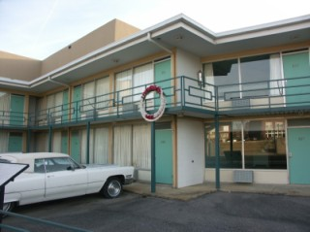
The Lorraine Motel, where King was assassinated, is now the site of the National Civil Rights Museum.
I've Been to the Mountaintop
Menu
0:00
Final 30 seconds of "I've Been to the Mountaintop" speech by Martin Luther King, Jr.

Problems playing this file? See media help.
On March 29, 1968, King went to Memphis, Tennessee, in support of the black sanitary public works employees, represented by AFSCME Local 1733, who had been on strike since March 12 for higher wages and better treatment. In one incident, black street repairmen received pay for two hours when they were sent home because of bad weather, but white employees were paid for the full day.^{[160][161][162]}
On April 3, King addressed a rally and delivered his "I've Been to the Mountaintop" address at Mason Temple, the world headquarters of the Church of God in Christ. King's flight to Memphis had been delayed by a bomb threat against his plane.^{[163]} In the close of the last speech of his career, in reference to the bomb threat, King said the following:
And then I got to Memphis. And some began to say the threats, or talk about the threats that were out. What would happen to me from some of our sick white brothers?
Well, I don't know what will happen now. We've got some difficult days ahead. But it doesn't matter with me now. Because I've been to the mountaintop. And I don't mind. Like anybody, I would like to live a long life. Longevity has its place. But I'm not concerned about that now. I just want to do God's will. And He's allowed me to go up to the mountain. And I've looked over. And I've seen the promised land. I may not get there with you. But I want you to know tonight, that we, as a people, will get to the promised land. So I'm happy, tonight. I'm not worried about anything. I'm not fearing any man. Mine eyes have seen the glory of the coming of the Lord.^{[164]}
King was booked in room 306 at the Lorraine Motel, owned by Walter Bailey, in Memphis. Abernathy, who was present at the assassination, testified to the United States House Select Committee on Assassinations that King and his entourage stayed at room 306 at the Lorraine Motel so often it was known as the "King-Abernathy suite".^{[165]} According to Jesse Jackson, who was present, King's last words on the balcony before his assassination were spoken to musician Ben Branch, who was scheduled to perform that night at an event King was attending: "Ben, make sure you play 'Take My Hand, Precious Lord' in the meeting tonight. Play it real pretty."^{[166]}
Then, at 6:01 p.m., April 4, 1968, a shot rang out as King stood on the motel's second-floor balcony. The bullet entered through his right cheek, smashing his jaw, then traveled down his spinal cord before lodging in his shoulder.^{[167][168]} Abernathy heard the shot from inside the motel room and ran to the balcony to find King on the floor.^{[169]} Jackson stated after the shooting that he cradled King's head as King lay on the balcony, but this account was disputed by other colleagues of King's; Jackson later changed his statement to say that he had "reached out" for King.^{[170]}
After emergency chest surgery, King was pronounced dead at St. Joseph's Hospital at 7:05 p.m.^{[171]} According to biographer Taylor Branch, King's autopsy revealed that though only 39 years old, he "had the heart of a 60 year old", which Branch attributed to the stress of 13 years in the civil rights movement.^{[172]}

Aftermath
Further information: King assassination riots
The assassination led to a nationwide wave of race riots in Washington D.C., Chicago, Baltimore, Louisville, Kansas City, and dozens of other cities.^{[173][174]} Presidential candidate Robert F. Kennedy was on his way to Indianapolis for a campaign rally when he was informed of King's death. He gave a short speech to the gathering of supporters informing them of the tragedy and urging them to continue King's ideal of non-violence.^{[175]} James Farmer, Jr. and other civil rights leaders also called for non-violent action, while the more militant Stokely Carmichael called for a more forceful response.^{[176]} The city of Memphis quickly settled the strike on terms favorable to the sanitation workers.^{[177]}
President Lyndon B. Johnson declared April 7 a national day of mourning for the civil rights leader.^{[178]} Vice President Hubert Humphrey attended King's funeral on behalf of the President, as there were fears that Johnson's presence might incite protests and perhaps violence.^{[179]} At his widow's request, King's last sermon at Ebenezer Baptist Church was played at the funeral,^{[180]} a recording of his "Drum Major" sermon, given on February 4, 1968. In that sermon, King made a request that at his funeral no mention of his awards and honors be made, but that it be said that he tried to "feed the hungry", "clothe the naked", "be right on the [Vietnam] war question", and "love and serve humanity".^{[181]} His good friend Mahalia Jackson sang his favorite hymn, "Take My Hand, Precious Lord", at the funeral.^{[182]}
Two months after King's death, escaped convict James Earl Ray was captured at London Heathrow Airport while trying to leave the United Kingdom on a false Canadian passport in the name of Ramon George Sneyd on his way to white-ruled Rhodesia.^{[183]} Ray was quickly extradited to Tennessee and charged with King's murder. He confessed to the assassination on March 10, 1969, though he recanted this confession three days later.^{[184]} On the advice of his attorney Percy Foreman, Ray pled guilty to avoid a trial conviction and thus the possibility of receiving the death penalty. He was sentenced to a 99-year prison term.^{[184][185]} Ray later claimed a man he met in Montreal, Quebec, with the alias "Raoul" was involved and that the assassination was the result of a conspiracy.^{[186][187]} He spent the remainder of his life attempting, unsuccessfully, to withdraw his guilty plea and secure the trial he never had.^{[185]}

Allegations of conspiracy
Ray's lawyers maintained he was a scapegoat similar to the way that John F. Kennedy assassin Lee Harvey Oswald is seen by conspiracy theorists.^{[188]} One of the claims used to support this assertion is that Ray's confession was given under pressure, and he had been threatened with the death penalty.^{[185][189]} Ray was a thief and burglar, but he had no record of committing violent crimes with a weapon.^{[187]}
Those suspecting a conspiracy in the assassination point to the two successive ballistics tests which proved that a rifle similar to Ray's Remington Gamemaster had been the murder weapon, but did not prove that his specific rifle had been the one used.^{[185][190]} Moreover, witnesses surrounding King at the moment of his death say the shot came from another location, from behind thick shrubbery near the rooming house—which had been cut away in the days following the assassination—and not from the rooming house window.^{[191]}
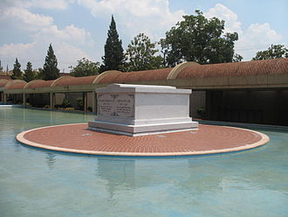
Martin Luther King and Coretta Scott King's tomb, located on the grounds of the Martin Luther King, Jr. National Historic Site in Atlanta, Georgia
In 1997, King's son Dexter Scott King met with Ray, and publicly supported Ray's efforts to obtain a new trial.^{[192]} Two years later, Coretta Scott King, King's widow, along with the rest of King's family, won a wrongful death claim against Loyd Jowers and "other unknown co-conspirators". Jowers claimed to have received $100,000 to arrange King's assassination. The jury of six whites and six blacks found in favor of the King family and that government agencies were party to the assassination.^{[193][194]} William F. Pepper represented the King family in the trial.^{[195]}
In 2000, the U.S. Department of Justice completed the investigation about Jowers' claims but did not find evidence to support allegations about conspiracy. The investigation report recommended no further investigation unless some new reliable facts are presented.^{[196]} In 2002, The New York Times reported that a church minister, Rev. Ronald Denton Wilson, claimed his father, Henry Clay Wilson—not James Earl Ray—assassinated Martin Luther King, Jr. He stated, "It wasn't a racist thing; he thought Martin Luther King was connected with communism, and he wanted to get him out of the way." Wilson provided no evidence to back up his claims.^{[197]}
King researchers David Garrow and Gerald Posner disagreed with William F. Pepper's claims that the government killed King.^{[198]} In 2003, William Pepper published a book about the long investigation and trial, as well as his representation of James Earl Ray in his bid for a trial, laying out the evidence and criticizing other accounts.^{[199]} King's friend and colleague, James Bevel, also disputed the argument that Ray acted alone, stating, "There is no way a ten-cent white boy could develop a plan to kill a million-dollar black man."^{[200]} In 2004, Jesse Jackson stated:
The fact is there were saboteurs to disrupt the march. And within our own organization, we found a very key person who was on the government payroll. So infiltration within, saboteurs from without and the press attacks. ... I will never believe that James Earl Ray had the motive, the money and the mobility to have done it himself. Our government was very involved in setting the stage for and I think the escape route for James Earl Ray.^{[201]}

FBI and King's personal life

FBI surveillance and wiretapping
FBI director J. Edgar Hoover personally ordered surveillance of King, with the intent to undermine his power as a civil rights leader.^{[139][202]} According to the Church Committee, a 1975 investigation by the U.S. Congress, "From December 1963 until his death in 1968, Martin Luther King, Jr. was the target of an intensive campaign by the Federal Bureau of Investigation to 'neutralize' him as an effective civil rights leader."^{[203]}
The Bureau received authorization to proceed with wiretapping from Attorney General Robert F. Kennedy in the fall of 1963^{[204]} and informed President John F. Kennedy, both of whom unsuccessfully tried to persuade King to dissociate himself from Stanley Levison, a New York lawyer who had been involved with Communist Party USA.^{[205][206]} Although Robert Kennedy only gave written approval for limited wiretapping of King's phones "on a trial basis, for a month or so",^{[207]} Hoover extended the clearance so his men were "unshackled" to look for evidence in any areas of King's life they deemed worthy.^{[208]} The Bureau placed wiretaps on Levison's and King's home and office phones, and bugged King's rooms in hotels as he traveled across the country.^{[205][209]} In 1967, Hoover listed the SCLC as a black nationalist hate group, with the instructions: "No opportunity should be missed to exploit through counterintelligence techniques the organizational and personal conflicts of the leaderships of the groups ... to insure the targeted group is disrupted, ridiculed, or discredited."^{[202][210]}

NSA monitoring of King's communications
In a secret operation code-named "Minaret", the National Security Agency (NSA) monitored the communications of leading Americans, including King, who criticized the U.S. war in Vietnam.^{[211]} A review by the NSA itself concluded that Minaret was "disreputable if not outright illegal."^{[211]}

Allegations of communism
For years, Hoover had been suspicious about potential influence of communists in social movements such as labor unions and civil rights.^{[212]} Hoover directed the FBI to track King in 1957, and the SCLC as it was established (it did not have a full-time executive director until 1960).^{[63]} The investigations were largely superficial until 1962, when the FBI learned that one of King's most trusted advisers was New York City lawyer Stanley Levison.^{[213]}
The FBI feared Levison was working as an "agent of influence" over King, in spite of its own reports in 1963 that Levison had left the Party and was no longer associated in business dealings with them.^{[214]} Another King lieutenant, Hunter Pitts O'Dell, was also linked to the Communist Party by sworn testimony before the House Un-American Activities Committee (HUAC).^{[215]} However, by 1976 the FBI had acknowledged that it had not obtained any evidence that King himself or the SCLC were actually involved with any communist organizations.^{[203]}
For his part, King adamantly denied having any connections to communism, stating in a 1965 Playboy interview that "there are as many Communists in this freedom movement as there are Eskimos in Florida".^{[216]} He argued that Hoover was "following the path of appeasement of political powers in the South" and that his concern for communist infiltration of the civil rights movement was meant to "aid and abet the salacious claims of southern racists and the extreme right-wing elements".^{[203]} Hoover did not believe King's pledge of innocence and replied by saying that King was "the most notorious liar in the country".^{[217]} After King gave his "I Have A Dream" speech during the March on Washington on August 28, 1963, the FBI described King as "the most dangerous and effective Negro leader in the country".^{[209]} It alleged that he was "knowingly, willingly and regularly cooperating with and taking guidance from communists".^{[218]}
The attempt to prove that King was a communist was related to the feeling of many segregationists that blacks in the South were happy with their lot but had been stirred up by "communists" and "outside agitators".^{[219]} However, the civil rights movement arose from activism within the black community dating back to before World War I. King said that "the Negro revolution is a genuine revolution, born from the same womb that produces all massive social upheavals—the womb of intolerable conditions and unendurable situations."^{[220]}

Allegations of adultery
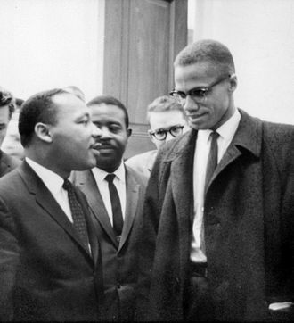
Martin Luther King, Jr. and Malcolm X, March 26, 1964
Having concluded that King was dangerous due to communist infiltration, the FBI shifted to attempting to discredit King through revelations regarding his private life. FBI surveillance of King, some of it since made public, attempted to demonstrate that he also engaged in numerous extramarital affairs.^{[209]} Lyndon Johnson once said that King was a "hypocritical preacher".^{[221]}
Ralph Abernathy stated in his 1989 autobiography And the Walls Came Tumbling Down that King had a "weakness for women", although they "all understood and believed in the biblical prohibition against sex outside of marriage. It was just that he had a particularly difficult time with that temptation".^{[222]} In a later interview, Abernathy said that he only wrote the term "womanizing", that he did not specifically say King had extramarital sex and that the infidelities King had were emotional rather than sexual.^{[223]} Abernathy criticized the media for sensationalizing the statements he wrote about King's affairs,^{[223]} such as the allegation that he admitted in his book that King had a sexual affair the night before he was assassinated.^{[223]} In his original wording, Abertnathy had claimed he saw King coming out of his room with a lady when he awoke the next morning and later claimed that "he may have been in there discussing and debating and trying to get her to go along with the movement, I don't know."^{[223]}
In his 1986 book Bearing the Cross, David Garrow wrote about a number of extramarital affairs, including one woman King saw almost daily. According to Garrow, "that relationship ... increasingly became the emotional centerpiece of King's life, but it did not eliminate the incidental couplings ... of King's travels." He alleged that King explained his extramarital affairs as "a form of anxiety reduction". Garrow asserted that King's supposed promiscuity caused him "painful and at times overwhelming guilt".^{[224]} King's wife Coretta appeared to have accepted his affairs with equanimity, saying once that "all that other business just doesn't have a place in the very high level relationship we enjoyed."^{[225]} Shortly after Bearing the Cross was released, civil rights author Howell Raines gave the book a positive review but opined that Garrow's allegations about King's sex life were "sensational" and stated that Garrow was "amassing facts rather than analyzing them".^{[226]}
The FBI distributed reports regarding such affairs to the executive branch, friendly reporters, potential coalition partners and funding sources of the SCLC, and King's family.^{[227]} The Bureau also sent anonymous letters to King threatening to reveal information if he did not cease his civil rights work.^{[228]} One anonymous letter sent to King just before he received the Nobel Peace Prize read, in part:
The American public, the church organizations that have been helping—Protestants, Catholics and Jews will know you for what you are—an evil beast. So will others who have backed you. You are done. King, there is only one thing left for you to do. You know what it is. You have just 34 days in which to do (this exact number has been selected for a specific reason, it has definite practical significant [sic]). You are done. There is but one way out for you. You better take it before your filthy fraudulent self is bared to the nation.^{[229]}
A tape recording of several of King's extramarital liaisons, excerpted from FBI wiretaps, accompanied the letter.^{[230]} King interpreted this package as an attempt to drive him to suicide,^{[231]} although William Sullivan, head of the Domestic Intelligence Division at the time, argued that it may have only been intended to "convince Dr. King to resign from the SCLC".^{[203]} King refused to give in to the FBI's threats.^{[209]}
Judge John Lewis Smith, Jr. in 1977 ordered that all known copies of the recorded audiotapes and written transcripts resulting from the FBI's electronic surveillance of King between 1963 and 1968 to be held in the National Archives and sealed from public access until 2027.^{[232]}

Presence during the assassination
Across from the Lorraine Motel, next to the boarding house in which Ray was staying, was a fire station. Police officers were stationed in the fire station to keep King under surveillance.^{[233]} Agents were watching King at the time he was shot.^{[234]} Immediately following the shooting, officers rushed out of the station to the motel. Marrell McCollough, an undercover police officer, was the first person to administer first aid to King.^{[235]} The antagonism between King and the FBI, the lack of an all points bulletin to find the killer, and the police presence nearby led to speculation that the FBI was involved in the assassination.^{[236]}

Legacy
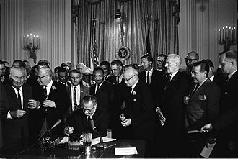
President Johnson signs the Civil Rights Act of 1964. Among the guests behind him is Martin Luther King.
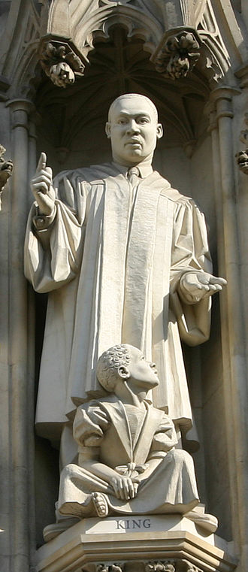
Martin Luther King, Jr. statue over the west entrance of Westminster Abbey, installed in 1998.
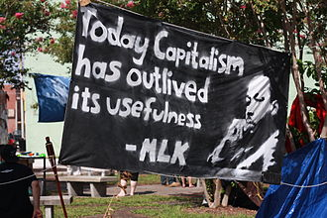
Protestors at the 2012 Republican National Convention display Dr. King's words and image on a banner.
King's main legacy was to secure progress on civil rights in the U.S. Just days after King's assassination, Congress passed the Civil Rights Act of 1968.^{[237]} Title VIII of the Act, commonly known as the Fair Housing Act, prohibited discrimination in housing and housing-related transactions on the basis of race, religion, or national origin (later expanded to include sex, familial status, and disability). This legislation was seen as a tribute to King's struggle in his final years to combat residential discrimination in the U.S.^{[237]}
Internationally, King's legacy includes influences on the Black Consciousness Movement and Civil Rights Movement in South Africa.^{[238][239]} King's work was cited by and served as an inspiration for South African leader Albert Lutuli, who fought for racial justice in his country and was later awarded the Nobel Prize.^{[240]} The day following King's assassination, school teacher Jane Elliott conducted her first "Blue Eyes/Brown Eyes" exercise with her class of elementary school students in Riceville, Iowa. Her purpose was to help them understand King's death as it related to racism, something they little understood as they lived in a predominately white community.^{[241]} King has become a national icon in the history of American progressivism.^{[242]}
King's wife, Coretta Scott King, followed in her husband's footsteps and was active in matters of social justice and civil rights until her death in 2006. The same year that Martin Luther King was assassinated, she established the King Center in Atlanta, Georgia, dedicated to preserving his legacy and the work of championing nonviolent conflict resolution and tolerance worldwide.^{[243]} Their son, Dexter King, serves as the center's chairman.^{[244][245]} Daughter Yolanda King, who died in 2007, was a motivational speaker, author and founder of Higher Ground Productions, an organization specializing in diversity training.^{[246]}
Even within the King family, members disagree about his religious and political views about gay, lesbian, bisexual and transgender people. King's widow Coretta said publicly that she believed her husband would have supported gay rights.^{[247]} However, his youngest child, Bernice King, has said publicly that he would have been opposed to gay marriage.^{[248]}
On February 4, 1968, at the Ebenezer Baptist Church, in speaking about how he wished to be remembered after his death, King stated:
I'd like somebody to mention that day that Martin Luther King Jr. tried to give his life serving others. I'd like for somebody to say that day that Martin Luther King Jr. tried to love somebody.
I want you to say that day that I tried to be right on the war question. I want you to be able to say that day that I did try to feed the hungry. I want you to be able to say that day that I did try in my life to clothe those who were naked. I want you to say on that day that I did try in my life to visit those who were in prison. And I want you to say that I tried to love and serve humanity.
Yes, if you want to say that I was a drum major. Say that I was a drum major for justice. Say that I was a drum major for peace. I was a drum major for righteousness. And all of the other shallow things will not matter. I won't have any money to leave behind. I won't have the fine and luxurious things of life to leave behind. But I just want to leave a committed life behind.^{[176][249]}

Martin Luther King, Jr. Day
Main article: Martin Luther King, Jr. Day
Beginning in 1971, cities such as St. Louis, Missouri, and states established annual holidays to honor King.^{[250]} At the White House Rose Garden on November 2, 1983, President Ronald Reagan signed a bill creating a federal holiday to honor King. Observed for the first time on January 20, 1986, it is called Martin Luther King, Jr. Day. Following President George H. W. Bush's 1992 proclamation, the holiday is observed on the third Monday of January each year, near the time of King's birthday.^{[251][252]} On January 17, 2000, for the first time, Martin Luther King Jr. Day was officially observed in all fifty U.S. states.^{[253]} Arizona (1992), New Hampshire (1999) and Utah (2000) were the last three states to recognized the holiday. Utah previously celebrated the holiday at the same time but under the name Human Rights Day.^{[254]}

Liturgical commemorations
King is remembered as a martyr by the Episcopal Church in the United States of America with an annual feast day on the anniversary of his death, April 4.^{[255]} The Evangelical Lutheran Church in America commemorates King liturgically on the anniversary of his birth, January 15.^{[256]}

Awards and recognition
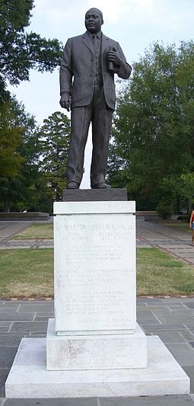
Statue of King in Birmingham's Kelly Ingram Park
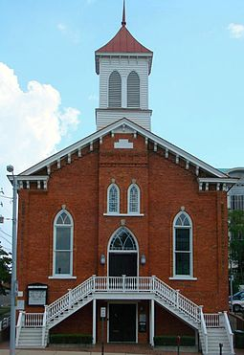
Dexter Avenue Baptist Church where King ministered was renamed Dexter Avenue King Memorial Baptist Church in 1978
King was awarded at least fifty honorary degrees from colleges and universities.^{[257]} On October 14, 1964, King became the youngest recipient of the Nobel Peace Prize, which was awarded to him for leading non-violent resistance to racial prejudice in the U.S.^{[258]} In 1965, he was awarded the American Liberties Medallion by the American Jewish Committee for his "exceptional advancement of the principles of human liberty".^{[257][259]} In his acceptance remarks, King said, "Freedom is one thing. You have it all or you are not free."^{[260]}
In 1957, he was awarded the Spingarn Medal from the NAACP.^{[261]} Two years later, he won the Anisfield-Wolf Book Award for his book Stride Toward Freedom: The Montgomery Story.^{[262]} In 1966, the Planned Parenthood Federation of America awarded King the Margaret Sanger Award for "his courageous resistance to bigotry and his lifelong dedication to the advancement of social justice and human dignity".^{[263]} Also in 1966, King was elected as a fellow of the American Academy of Arts and Sciences.^{[264]} In 1971 he was posthumously awarded a Grammy Award for Best Spoken Word Album for his Why I Oppose the War in Vietnam.^{[265]}
In 1977, the Presidential Medal of Freedom was posthumously awarded to King by President Jimmy Carter. The citation read:
Martin Luther King, Jr., was the conscience of his generation. He gazed upon the great wall of segregation and saw that the power of love could bring it down. From the pain and exhaustion of his fight to fulfill the promises of our founding fathers for our humblest citizens, he wrung his eloquent statement of his dream for America. He made our nation stronger because he made it better. His dream sustains us yet.^{[266]}
King and his wife were also awarded the Congressional Gold Medal in 2004.^{[267]}
King was second in Gallup's List of Most Widely Admired People of the 20th Century.^{[268]} In 1963, he was named Time Person of the Year, and in 2000, he was voted sixth in an online "Person of the Century" poll by the same magazine.^{[269]} King placed third in the Greatest American contest conducted by the Discovery Channel and AOL.^{[270]}
More than 730 cities in the United States have streets named after King.^{[271]} King County, Washington rededicated its name in his honor in 1986, and changed its logo to an image of his face in 2007.^{[272]} The city government center in Harrisburg, Pennsylvania, is named in honor of King.^{[273]}
In 1980, the U.S. Department of the Interior designated King's boyhood home in Atlanta and several nearby buildings the Martin Luther King, Jr. National Historic Site. In 1996, Congress authorized the Alpha Phi Alpha fraternity, of which King had been a member, to establish a foundation to manage fund raising and design of a national Martin Luther King, Jr. Memorial on the Mall in Washington, D.C.^{[274]} King was the first African American and the fourth non-president honored with his own memorial in the National Mall area.^{[275]} The memorial opened in August 2011^{[276]} and is administered by the National Park Service.^{[277]} The address of the monument, 1964 Independence Avenue, S.W., commemorates the year that the Civil Rights Act of 1964 became law.^{[278]}

Bibliography
- Stride Toward Freedom: The Montgomery Story (1958) ISBN 978-0-06-250490-6
- The Measure of a Man (1959) ISBN 978-0-8006-0877-4
- Strength to Love (1963) ISBN 978-0-8006-9740-2
- Why We Can't Wait (1964) ISBN 978-0-8070-0112-7
- Where Do We Go from Here: Chaos or Community? (1967) ISBN 978-0-8070-0571-2
- The Trumpet of Conscience (1968) ISBN 978-0-8070-0170-7
- A Testament of Hope: The Essential Writings and Speeches of Martin Luther King, Jr. (1986) ISBN 978-0-06-250931-4
- The Autobiography of Martin Luther King, Jr. (1998), ed. Clayborne Carson ISBN 978-0-446-67650-2
- "All Labor Has Dignity" (2011) ed. Michael Honey ISBN 978-0-8070-8600-1
- "Thou, Dear God": Prayers That Open Hearts and Spirits Collection of Dr. King's prayers. (2011), ed. Dr. Lewis Baldwin ISBN 978-0-8070-8603-2
- MLK: A Celebration in Word and Image Photographed by Bob Adelman, introduced by Charles Johnson ISBN 978-0-8070-0316-9

See also
 | African American portal
 | Atlanta portal
 | Biography portal
 | Saints portal
 | Social movements portal
- Martin Luther King, Jr. authorship issues
- Sermons and speeches of Martin Luther King, Jr.
- The Meeting
Concepts:
- Christian radicalism
- Equality before the law
General:
- List of American philosophers
- List of civil rights leaders
- List of peace activists
After Martin Luther King:
- Post–Civil Rights era in African-American history

