**The Trudeau Tradition**

The Canadian Cabal, Pedophilia, Murder and Treason

**By**[**Victor S. Whyte**](https://planetaryliberation.community/author/victorswhyte/)

[**https://mail.yahoo.com/d/folders/1/messages/AE7euRdoLzfeYgwf-ghoWDavBe8?reason=invalid_crumb**](https://mail.yahoo.com/d/folders/1/messages/AE7euRdoLzfeYgwf-ghoWDavBe8?reason=invalid_crumb)

[**https://planetaryliberation.community/2021/08/15/the-canadian-cabal-pedophilia-murder-and-treason/**](https://planetaryliberation.community/2021/08/15/the-canadian-cabal-pedophilia-murder-and-treason/)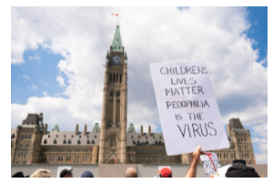**Protest in Ottawa**Dating back to 3000BC the Cabal has been involved in strange sexual practices. There is evidence that Pierre Trudeau was a communist and a pedophile.

**Right Edition**

<https://historylessonsdeleted.blogspot.com/2018/12/pierre-trudeau-was-communist.html>

History Lesson Deleted

***Pierre Trudeau was a Communist***

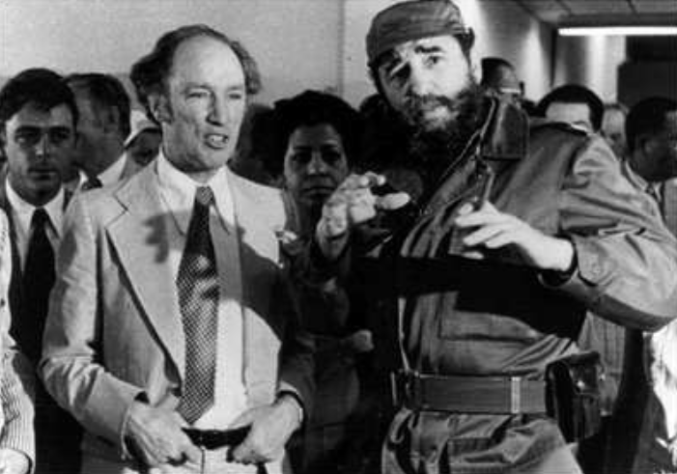

**Excerpt**

***Trudeau had an unhappy childhood, as a man of the people should. True, he did like being driven to school in a Rolls Royce. He was glad his father was a millionaire. Money came in so handy. But he became unhappy because so many other fathers were not millionaires. He decided to become “socially conscious.”***

***Pierre Trudeau is now about fifty-one years old. As with so much else about him, his exact age is a mystery. In 1939, Hitler and his ally Stalin signed their Non-Aggression Pact, started World War II and divided Poland between them. And Lucky Pierre apparently became two years younger – less vulnerable to the Canadian draft.***

***He opposed the war, he explained, because,***

***“Like most Quebecers, I was taught to keep away from imperialistic wars…”***

***In 1947, Trudeau was a student at the London School of Economics, founded by the Fabian Socialists to train Marxists and spread Marxism. Professor Harold Laski, then head of the Fabian Society, was publicly advocating violent revolution at the time.***

***Almost twenty years later, Trudeau, about to become Prime Minister, reflected on his training and told reporter Norman DePoe that Laski is,***

***“the most stimulating and powerful influence he has encountered.”***

***He met his idol, Mao Tse-tung. He collaborated on a book called Two Innocents In Red China. (Toronto, Oxford University Press, 1968.)***

***Trudeau describes his meeting with the Communist leaders like this:***

***“…It is a stirring moment: these greybeards, in their ripe old age, embody today the triumph of an idea, an idea that has turned the whole world upside down and profoundly changed the course of human history.”***

***Of the greybeard who has murdered more than 30 million Chinese, Trudeau says:***

***“…Mao Tse-tung, one of the great men of the century, has a powerful head, an unlined face, and a look of wisdom tinged with melancholy. The eyes in that tranquil face are heavy with having seen too much of the misery of men.”***

***You don’t believe he said it. I know. Neither did I. Get the book. Notice that the typical Trudeau sarcasm and condescension are gone. Now the Lord Protector of the Realm fawns and scrapes.***

***Indeed, says Trudeau:***

***“Everyone knows that the Communists summarily rushed to the gallows or to jail many of the great landed proprietors. It was the genius of Mao Tse-tung to realize the extent to which his revolution must depend on the peasants, and he mercilessly suppressed the class that inspired in these peasants awe, respect, and submissiveness towards outworn traditions.”***

***This you still may not believe, even if you read the book yourself. Here, Trudeau not only justifies Mao Tse-tung’s mass murders – he applauds them. They are good, he says. They are necessary. They prove Mao’s genius.***

***Lucky Pierre loves to travel. He was in Ghana when Communist Kwame Nkrumah took control. We don’t know why. Pierre won’t say. He was in Algeria when Communist Ahmed Ben Bella took over. We don’t know why. Pierre won’t say. Early in 1961, at about the time of the Bay of Pigs, the U.S. Coast Guard picked him up.***

***Pierre was paddling a canoe to Cuba from Key West. We don’t know why. Pierre won’t say. The Coast Guard deported Pierre to Canada, but he did get to Cuba in 1964, after all. He doesn’t say what happened there. Neither does Fidel.***

***“When a question is tough or Mr. Trudeau wishes to avoid it, he goes into an elaborate performance,” writes Peter Worthington.***

***“His hands start gesturing, the shoulders wriggle, the eyebrows squirm, the mouth puckers and after some groping for appropriate words Mr. Trudeau invariably says something that is often irrelevant, usually amusing and always evasive. His listeners laugh or giggle as is their individual wont, and the moment is past. Next question.”***

***By 1962, traditionalist Quebec Premier Maurice Duplessis was dead, and Trudeau finally became a professor at the University of Montreal, overcoming the usual protests. He went right to work turning out Fidelistas. Indeed, the school is now teeming with them. Apparently he admires Castro as much as Mao.***

***And in 1963, he campaigned vigorously with the Marxist New Democratic Party against the Liberals, who roughly correspond to the Democrats in the States. Trudeau called the Liberals “idiots” because they had decided to use nuclear weapons for defense. The Liberals, he said, were “a spineless herd.”***

***So much for Trudeau’s biography. What about his ideas? What’s behind his policies?***

***Thoughts Of Chairman Trudeau***

***“…The drive towards power must begin with the establishment of bridgeheads,” says Trudeau (Federalism And The French Canadians, New York, St. Martin’s Press, 1968),” since at the outset it is obviously easier to convert specific groups or localities than to win over an absolute majority of the whole nation.”***

***So Trudeau isn’t simply trying to govern Canada. He isn’t just trying to protect the realm, as he should. What he is really doing is using his powerful position as a weapon.***

***What he really wants, like his idol, Mao Tse-tung, is power.***

***Indeed, says Trudeau,***

***“the experience of that superb strategist Mao Tse-tung might lead us to conclude that in a vast and heterogeneous country, the possibility of establishing socialist strongholds in certain regions is the very best thing…”***

***It’s unnecessary and infeasible to establish Socialism all at once he says.***

***In a big country like China, or like Canada, the best way to impose Socialism is to manipulate group after group and seize region after region. He says,***

***“Federalism must be welcomed as a valuable tool which permits dynamic parties to plant socialist governments in certain provinces, from which the seed of radicalism can slowly spread.”***

***Notice the crucially important fact that Trudeau’s famous opposition to separatism isn’t based, like Lincoln’s, on a desire to keep his country together. Federalism for Trudeau is like everything else a tool – with which to impose Communism on Canada.***

***Socialism in one province will seep into another, he says. But if the separatists are successful – if a Socialist province becomes a foreign country – then that seepage is made more difficult.***

***On the other hand, without the degree of provincial autonomy federalism allows, Trudeau says, he would be faced with the difficult task of imposing Socialism at once. Federalism allows it to be done province by province. That is why he wants just enough autonomy – but not too much. What about specific tactics?***

***Trudeau explains that,***

***“in terms of political tactics, the only real question democratic socialists must answer is, ‘Just how much reform can the majority of the people be brought to desire at the present time?’ ”People are “brought” to desire what Pierre wants. They are manipulated.***

***The Socialism is slyly slipped over on them.***

**You won’t find any of these facts on wikipedia. So wikipedia is obviously just another Cabal controlled source of misinformation**.**And don’t think that Google Chrome browser will give you all the facts about a topic. It censors info the controllers don’t want you to see. I used DuckDuckGo to get this information.**

Pierre Elliot Trudeu was a Pedophile

In her book, [***TRANCE-FORMATION OF AMERICA***](https://books.google.ca/books?id=exFyBQAAQBAJ&pg=PT91&lpg=PT91&dq=pierre+trudeau+pedop%C4%A5ile&source=bl&ots=CUazQLiot-&sig=Y5aABLDh7NxM3ZddppqeYY0044U&hl=en&sa=X&ei=liMxVYatG9ewyASzrYDACw&ved=0CDMQ6AEwBA#v=onepage&q&f=false) (1995) MK-ULTRA survivor Cathy O’Brien stated that many world leaders, including Pierre Trudeau and Brian Mulroney, are pedophiles. She met them in the course of her life as a sex slave trained (with her young daughter) to service high-profile politicians. Other sources support Cathy O’Brien’s allegations.

**Here’s O’Brien’s statements about Pierre Elliot Trudeau.**

The mind controlled part of me that was prostituted there perceived Mackinac as another dimension, the timelessness of which was enhanced by the island’s antiquated styling. Automobiles were forbidden on the tiny island, which relied on horse drawn buggies or bicycles for transportation. Once when Lee Iaccoca was attending a cocktail party at then Governor Romney’s Mansion, I overheard him comment, “What better place for auto execs to get away from it all than on an island with no cars?”

Mackinac Island, due to its geographic location, provided an air of friendliness between the U.S. and Canada that formed my childish perception that our countries knew no boundaries. This political view was further enhanced by my father always taking the family to Niagra Falls where my mind was to be symbolically “washed of all memory” of what had occurred in Mackinac. Niagra Falls’ numerous, powerful waterfalls were in reasonably close proximity to Mackinac Island, and shared the border between the U.S. and Canada.  
When Pierre Trudeau was elected Prime Minister of Canada in 1968, I often heard it said, “Pierre Trudeau is one of Ours, you know.” I first heard this phrase cryptically referring to Trudeau’s loyalty to the Vatican when Father Don was discussing him with my father one Sunday after mass. This fact circulated quickly among those I knew who were involved in the Catholic/Jesuit aspect of Project Monarch.  
The summer after Trudeau was elected, my father took the family to Mackinac Island as usual. Climbing on a large statue on the grounds of the Governor’s Mansion, I could see across the field to the Grand Hotel. I noticed Canadian flags flying amongst the American flags that lined the front of the old hotel. As I slid down off the statue, Guy VanderJagt approached with a drink and a cigarette in his hand. Patting my hair into place he said, “Straighten your shirt, I’ve got someone important for you to meet.”  
“I knew someone important was here because of those flags,” I said, tucking my shirt in my pink shorts.  
“When I was at the Vatican,” VanderJagt began, “I was told that Prime Minister Trudeau is a friend of the Pope. He thinks like one of us. A true Catholic. He likes Cathy-licks.”  
VanderJagt led me upstairs in the mansion, where Pierre Trudeau was lowering the window shades in a dimly lit bedroom crowded with antiques. VanderJagt closed the door behind me. Trudeau’s tuxedo coat was neatly draped over a chair, which left him in his formal pants, white shirt, and a bright red cummerbund which caught my eye. “I like your sash,” I said.  
“Hasn’t anyone taught you Silence yet?” His somber, gruff attitude was softened by his smooth, silky voice.  
Triggered into the part of me that endured the Rite to Remain Silent, I assumed Trudeau knew all about interdimensions according to my deliberately formed perceptions. I could not/did not understand that interdimensions actually equated to the inner-dimensions of my own compartmentalized mind. Likewise, I did not understand that “Keys to the Kingdom” referred to knowing the codes, keys, and triggers to my controlled mind. “Guy said you like Cathy- licks,” I said, repeating what VanderJagt had told me. “Are you the Keeper of the Keys?”  
Trudeau seemingly bore his cold, dark eyes right through me. “You can learn more from the school of thought than you can by asking precocious questions. Haven’t you learned that children are to be seen and not heard?”  
“Is that a precocious question?” I asked. “What is a precocious question?”  
Trudeau sighed with impatience. “That is irrelevant. What matters is that you shut your mouth, still your mind, and enter the school of thought. Silence is a virtue. Listen to the silence in the stillness of your mind. Go deep inside your mind,” he slowly led. “Deeper and deeper where it’s quiet and still…”  
Trudeau expertly manipulated my mind with sophisticated hypnotic language. Not only did he enlist my Silence for the pedophile perversions he indulged in, but he instructed my “school of thought” in a manner that equated to programming. He laid a foundation for Air-Water programs that is a mirror dimensional theme often used by NASA and others involved in Project Monarch. Playing off his own name “Pee-Air,” he added a perverse twist to the theme that he accessed each time I was prostituted to him.  
Had I been capable of fear, I would have been afraid of Pierre Trudeau. Trudeau’s slow, deliberate movements masked the brutal power of his body much the way his smooth, soft voice pierced my mind and intruded on my thoughts. The icey cold touch of his effeminate, manicured long fingers contrasted with the heat of his perversion… a perversion for which he blamed me and my “temptuous, contemptuous ways”.  
In my childish ignorance, I believed Trudeau’s demeanor and forward combed hair were characteristic of his French descent. “I know all about the French,” I had bragged to my new “Grandpa” Van while visiting his home in Milwaukee, Wisconsin.

O’Brien, Cathy. TRANCE Formation of America: True life story of a mind control slave (pp. 133-135). Reality Marketing. Kindle Edition.

**Cathy O’Brien was born on December 4, 1957. So she was only eight years old when she was abused by Pierre Trudeau.**

**I have more unpleasant truths for you. If you don’t want to see them you should change lines now and leave this post.**

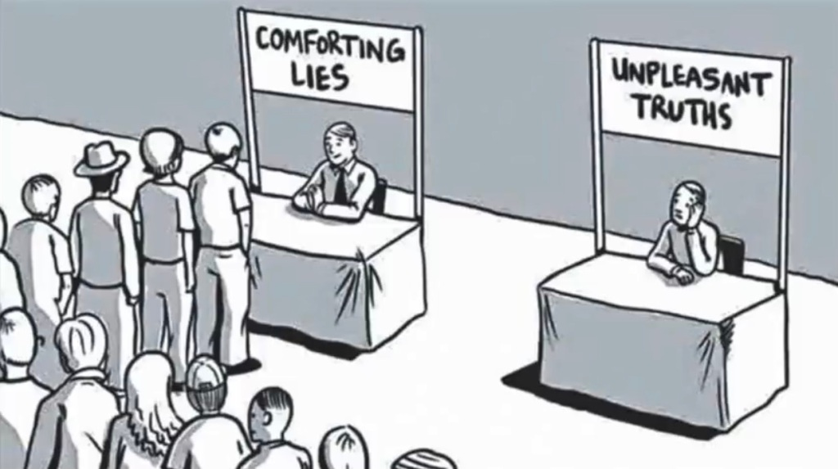

[**Henrymakow.com**](http://henrymakow.com/)

Justin Trudeau: Mind-Controlled Illuminati Poster Child?

September 22, 2019

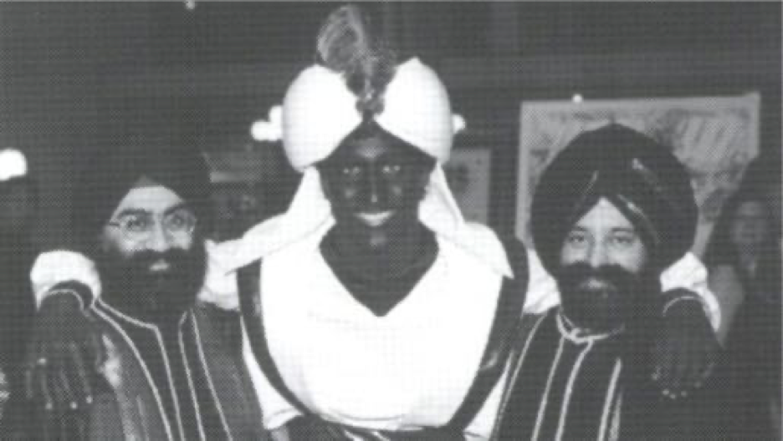

Justin Trudeau’s visceral hatred of males ( re. he says it’s *peoplekind*, not mankind) and Canada’s European heritage has made him an international laughing stock. His blackfaced history seals the deal. Many now question his mental stability.

Are these the symptoms of having been a victim of MK-Ultra mind control and pedophilia?

Our political leaders all belong to the Illuminati satanic cult that sexually exploit and trauma to brainwash their children.

Are the effects of this traumatic childhood now playing out?

In his father’s eulogy, Justin Trudeau seems to allude to MK-Ultra pedophilia and mind control.

Over the years, insiders have told me that Pierre’s 1968 marriage to Margaret was “arranged” by the military. The couple was programmed with LSD at a remote farm in British Columbia.

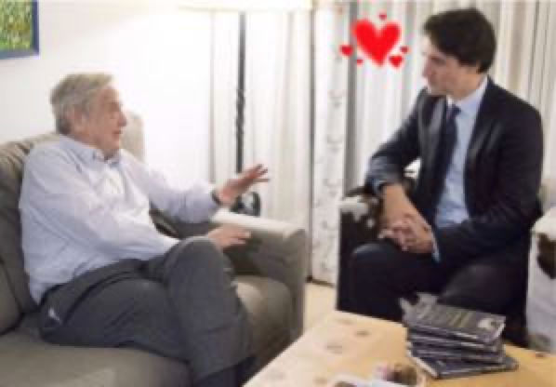

*(With George Soros. Justin is an errand boy for the Communist wing of the Illuminati conspiracy. Opposition leader Andrew Scheer is an errand boy for the Zionist wing.)*

According to Trudeau’s Jesuit mentor, Trudeau ordered the kidnap and murder of his enemy[**Pierre Laporte**](https://en.wikipedia.org/wiki/Pierre_Laporte) in October 1970, because Laporte was threatening him with blackmail and exposure as a pedophile.

After Margaret ran off with the Rolling Stones in 1977, the marriage was over. Soon after, as a single father, Pierre turned to a York University sociologist, [**John Seeley, for parental advice**](https://tspace.library.utoronto.ca/handle/1807/43489).

[**John Seeley,**](http://m.independent.com/news/2008/jan/31/john-r-seeley-1913-2007/?templates=mobile) a self-proclaimed ‘sadist and pedophile’ would fly up to Ottawa on weekends to “advise” Pierre on how he should be raising his three sons. Justin was six. [**(See also this article.)**](http://canadianbritishhomechildren.weebly.com/dr-john-r-seeley.html)

Quite a childhood. First the trauma of being separated from the mother he adored, then frequent exposure to his father’s unsavory friends.

Children often idealize their abusive parents..

During [**his eulogy at Pierre’s funeral**](https://www.youtube.com/watch?v=5p4NUJMPAjQ), a smiling 28-year-old Justin seemed dissociated, almost giddy. He began the eulogy with a weird story about a trip he took at age six, with his father and grandfather “to the North Pole,” to a “military installation” at [**Alert NWT.**](https://en.wikipedia.org/wiki/Alert,_Nunavut)

**(My comments**. **Actually he began the eulogy with the first line of the play Julius Caesar by William Shakespear. Let’s look at the lines Justin didn’t say but was alluding to.)**

**“Friends, Romans, Countrymen” is how he began the eulogy. These are the lines that follow in the play.**

“I come to bury Caesar, not to praise him;  
The evil that men do lives after them,  
The good is oft interred with their bones,  
So let it be with Caesar … The noble Brutus  
Hath told you Caesar was ambitious:  
If it were so, it was a grievous fault,  
And grievously hath Caesar answered it …”

**So Justin is saying in a cryptic way that his father’s greatest fault was ambition and he has come to bury him, not to praise him. “The evil that men do that lives after them” refers to Justin himself and how he was made evil by Pierre’s raping him as a child.**

**Back to Mackow’s article.**

There the awe-struck boy discovered Santa Claus and “that’s when I understood just how powerful and wonderful my father was.”

Carolyn Hamlett, a victim of Illuminati mind control and pedophilia, said these abuses took place at[**military installations.**](https://www.henrymakow.com/the_making_of_an_illuminati_sl.html)

Is Justin referring to MK-Ultra brainwashing? In general, the eulogy rings insincere and hollow.  There is no trace of love or grief. His father had little time for his children.

A few years ago, I was shown a 1984 letter signed by Pierre Elliot Trudeau expressing enthusiastic interest in meeting a ten-year-old boy. The letter may have been used in a blackmail attempt by the boy’s father.

If Pierre Trudeau was abusing their children, Margaret’s history of bipolar illness takes on a whole different cast.

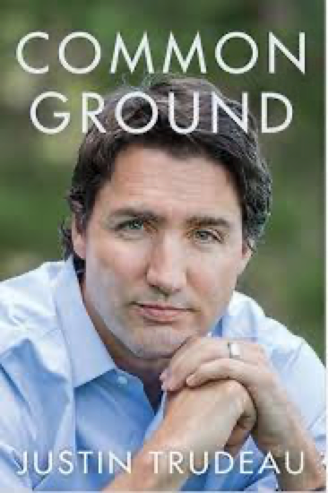

**Common Ground by Justin Trudeau**

**Reviewed by Ann Diamond**

*Common Ground* is all about the heir to the Trudeau throne.

The book is persuasive and well put together, probably with help from a seasoned journalist. It flows like slick PR, but has much-unhealed trauma in the margins. Posing as saviours, Trudeaus and Sinclairs may be well-paid agents of national decline, but their story is emblematic and unavoidable.

Here and there, a reader encounters tragedy almost worthy of a Russian novel. Certain passages actually moved me to tears: his parents’ divorce and the loss of his brother. His love for his mother, who skidded into depression while partying with rock stars and royals.

As for the politics – you’re not really interested in Liberal rhetoric, are you? Young Trudeau manfully appeals to Liberal platitudes: tolerance, openness to cultural differences, gender equality, all of which sound good after the Harper Decade.

There are odd references suggesting the author has rubbed shoulders with elite perverts. Prince Andrew and the Starlight Foundation. Jacques Hebert and Katimavik. West Point Grey Academy and his roommate Christopher Ingvaldson, convicted of [**possessing child porn.**](https://www.google.ca/url?sa=t&rct=j&q=&esrc=s&source=web&cd=2&cad=rja&uact=8&ved=0CCkQFjAB&url=http%3A%2F%2Fmetronews.ca%2Fnews%2Fvancouver%2F501287%2Fvancouver-ex-private-school-teacher-sentenced-to-three-months-for-child-porn%2F&ei=P0wyVdj-J--HsQTkiIGoAw&usg=AFQjCNGrpkElJpt9eSPFuUQlKmLdXPK7xQ&sig2=dagrAz8pB3ubghhVxbco2Q&bvm=bv.91071109,d.cWc)

All in all, Justin’s very likable, although Post Traumatic Stress glimmers from his eyes. In*Common Ground*, he reminds us that everyone has a story to tell.  Justin could have flown away like Le Petit Prince, but instead is doing his utmost to move back to the scene of his childhood trauma: the cold, drafty mausoleum called “24 Sussex Drive.”

**Related- Pedophilia-The Fish Rots from the Head. This satanic cult controls society.**

|  |  |
| --- | --- |
| [**The Trudeau Foundation Revealed**](https://www.youtube.com/watch?v=zgxwqG8qxB8)[**Margaret Trudeau says she dreads ‘bullying’ attack ads against son Justin**](http://www.cbc.ca/news/politics/margaret-trudeau-says-she-dreads-bullying-attack-ads-against-son-justin-1.3033482) (Is Justin a Manchurian Candidate?) |  |

**New First Comment from D (an insider):**

While in university, friends from West Vancouver knew Margaret Sinclair and her family. I was told by Margaret’s friends, some years after the event, that very early in her marriage to Pierre Trudeau, while living in the Prime Ministerial home in Ottawa, she had arranged to be away for a weekend, but something unexpectedly came up, and she returned home to walk in on a full-blown orgy, replete with little boys and at least one goat. Let your imagination run wild, for apparently everything imaginable was well underway. In shock, she was promptly ushered away by Trudeau, and was soon at the Allen Memorial Hospital, in the care of Ewan Cameron, who made certain she had a well managed “breakdown”.  This is what is behind the nervous breakdown she supposedly had, which was dutifully “handled” by the press for public miscomprehension. Yes, Trudeau was a satanic pedophile who was recruited early on in his life to serve Luciferian intent. By the way, he met and became a good friend of Fidel Castro before his election as Canadian P.M. They met at a communist training camp in Algeria in 1948. Castro, when meeting Justin at the age of just a few months, is on record as saying, “It’s a pleasure to be in the presence of the future Prime Minister of Canada.” Yes, absolutely, Justin was subjected to whatever conditioning was needed to create this Manchurian Candidate who is currently performing his long ago programmed role to advance the satanic agenda.

**Anon wrote:**

Your information about Pierre Trudeau

*“According to Trudeau’s Jesuit mentor, Trudeau ordered the kidnap and murder of his enemy Pierre Laporte in October 1970, because Laporte was threatening him with blackmail and exposure as a pedophile.”*

This exceedingly important and makes huge sense according to Jack English see [http://cuabcimc.blogspot.com](http://cuabcimc.blogspot.com/) who has advised me, today, as follows:

*Trudeau was a pedophile and Paul Hellyer was informed of this by Patrick Walsh who was Trudeau’s RCMP bodyguard as I recall…Hellyer and Walsh were so shocked by the discovery that Trudeau was a Satanic Pedophile that they convened a meeting at Hellyer’s Resort to discuss removing Trudeau from office, but for reasons unknown, it did not proceed. It would be good to be able to discuss this with Paul and set the historical record straight.*

My friends in the Canadian military have previously corroborated the reports from Mr. English and the information you have posted on your web site.

We have published important information about Mr. Trudeau at the Water War Crimes web site including

1.  That he sent his wife Margaret to the MK Ultra Brainwashing Hospital – The Allen Memorial Hospital in Montreal when she had her nervous breakdown.

*(India trip. An embarrassment to all Canadians and well as hosts.)*

2.  That Margaret was treated by Dr. Pivnicki the father of Brian Mulroney’s wife Mila.  This was no coincidence.

3.  That his son Michel was in a near-fatal accident, probably a targeted hit, in Brandon Manitoba six months before he was killed on Friday the 13th in a suspicious avalanche in November 1998 a month when avalanches are very rare.

4. That Trudeau was part of the plan to loot Canada’s water export revenues.

[http://www.waterwarcrimes.com/prime-minister-pierre-trudeau—the-northern-magus—develops-the-art-of-resource-takeover-and-personal-enrichment.html](http://www.waterwarcrimes.com/prime-minister-pierre-trudeau---the-northern-magus---develops-the-art-of-resource-takeover-and-personal-enrichment.html)

Thank you for your tireless efforts in bringing these matters to light.

**Trudeau’s Pedophile Connections**[**https://youtu.be/YI2AMv9cV-A?t=87**](https://youtu.be/YI2AMv9cV-A?t=87)

If you do this you will get your ass kicked.What about this pedo symbol that the Pierrie Eliott Trudeau Foundation used?

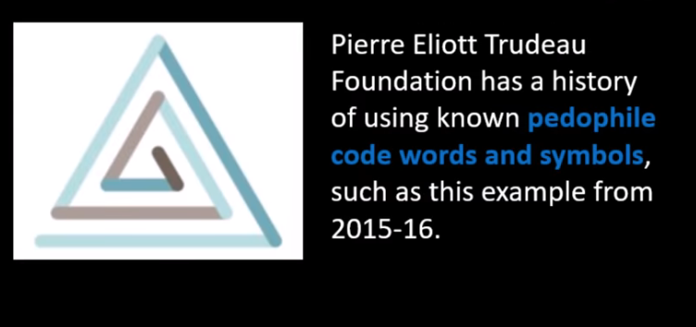

**The FBI has revealed the meaning of these pedo symbols.**

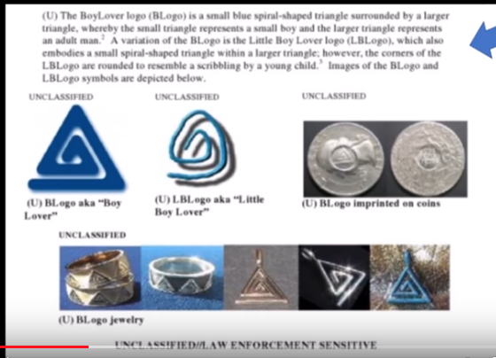

**Where have we seen this symbol before?**

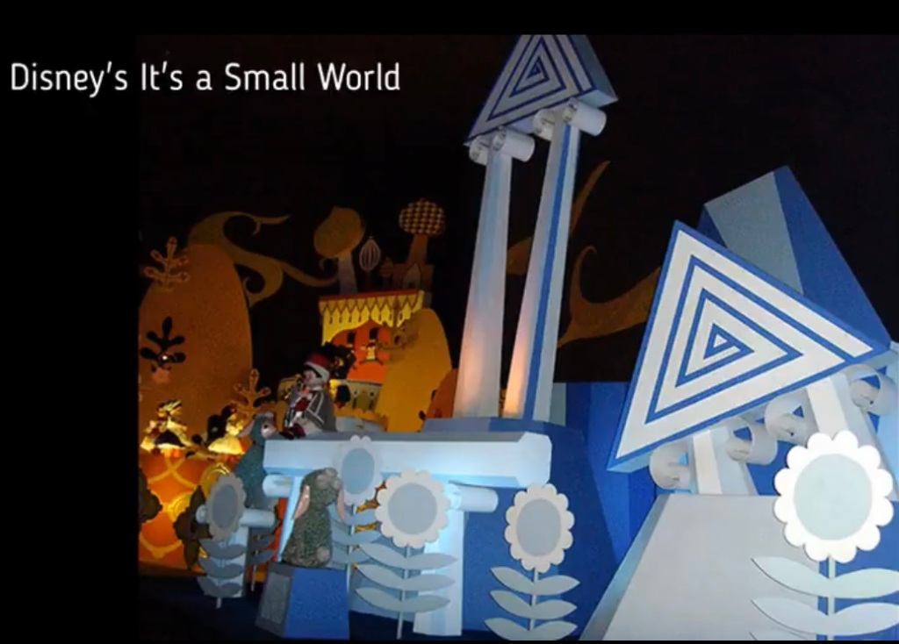



**These pedo references are even more obvious.**

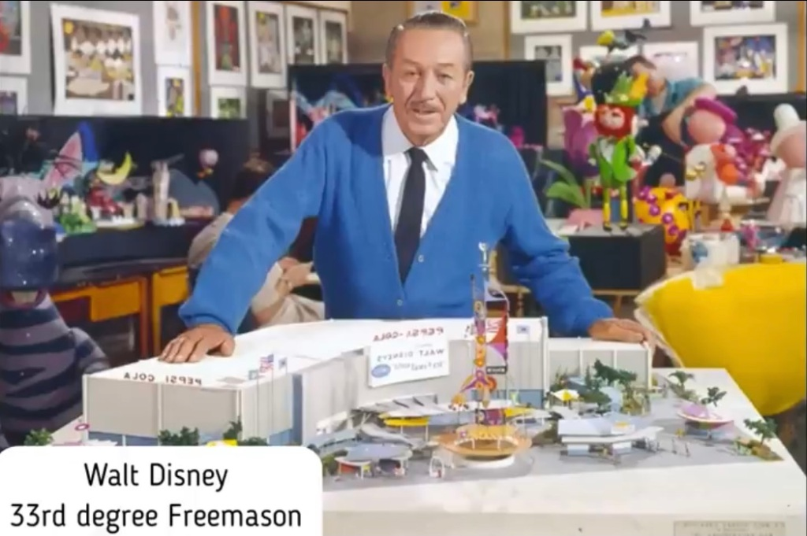This should come as no suprise.

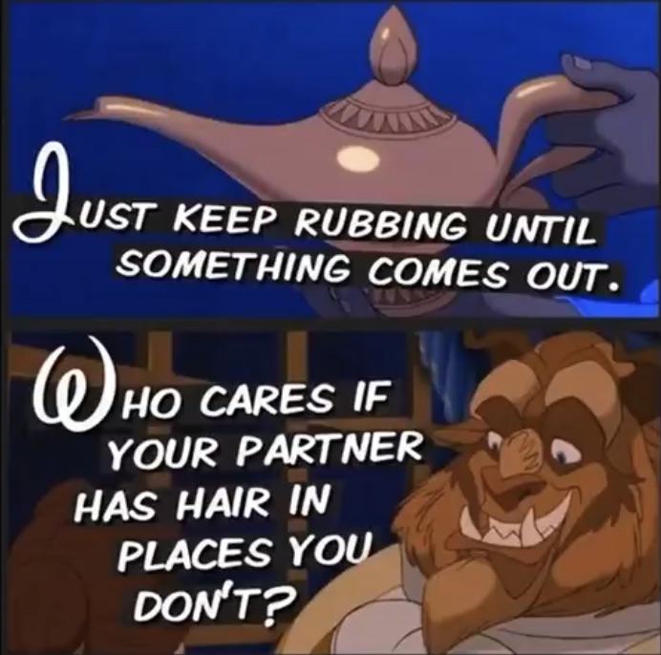

**On this subject, what are the other pedo symbols?**

The so called girlover logo is a heart within a heart.

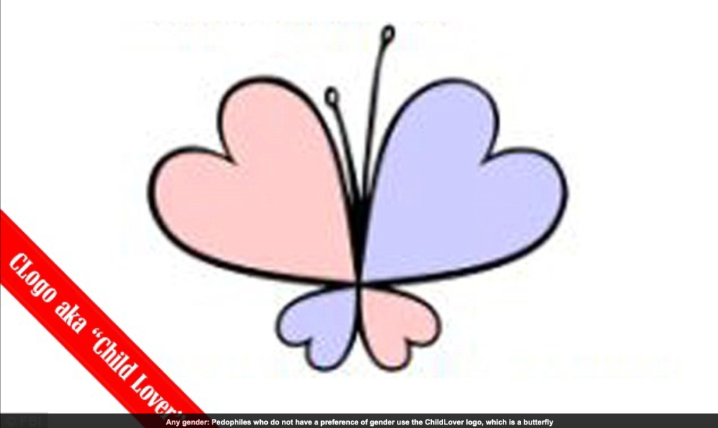Pedos who don’ have a gender preference use this symbol.

This is the Childlove Online Media Activism logo which pedos use to promote the decriminalization of relationships between adults and minors.