**James George Frazer 1854 – 1941**

[**http://en.wikipedia.org/wiki/James_George_Frazer**](http://en.wikipedia.org/wiki/James_George_Frazer)

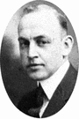 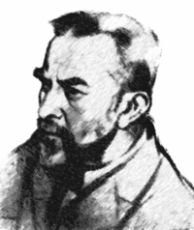 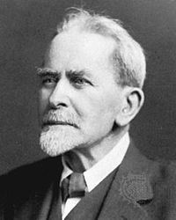 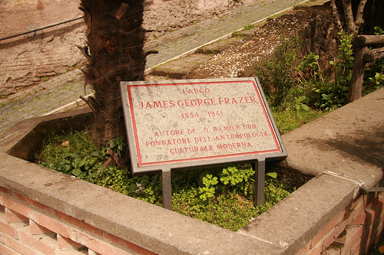

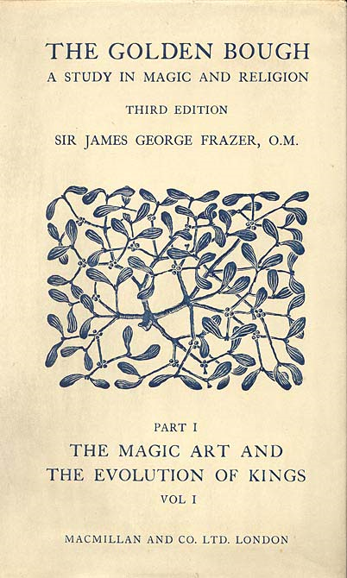

Sir **James George Frazer** ([January 1](http://en.wikipedia.org/wiki/January_1), [1854](http://en.wikipedia.org/wiki/1854), [Glasgow](http://en.wikipedia.org/wiki/Glasgow), [Scotland](http://en.wikipedia.org/wiki/Scotland) – [May 7](http://en.wikipedia.org/wiki/May_7), [1941](http://en.wikipedia.org/wiki/1941), Cambridge), was a [Scottish](http://en.wikipedia.org/wiki/Scotland) [social anthropologist](http://en.wikipedia.org/wiki/Social_anthropologist) influential in the early stages of the modern studies of [mythology](http://en.wikipedia.org/wiki/Mythology) and [comparative religion](http://en.wikipedia.org/wiki/Comparative_religion).[[1]](http://en.wikipedia.org/wiki/James_George_Frazer#cite_note-0)

His most famous work, [*The Golden Bough*](http://en.wikipedia.org/wiki/The_Golden_Bough) (1890), documents and details similar magical and religious beliefs across the globe. Frazer posited that human belief progressed through three stages: primitive magic, replaced by religion, in turn replaced by science.

## Biography

He studied at the [University of Glasgow](http://en.wikipedia.org/wiki/University_of_Glasgow) and [Trinity College, Cambridge](http://en.wikipedia.org/wiki/Trinity_College,_Cambridge), where he graduated with honors in [Classics](http://en.wikipedia.org/wiki/Classics) (his dissertation would be published years later as *The Growth of* [*Plato*](http://en.wikipedia.org/wiki/Plato)*'s Ideal Theory*) and remained a Classics Fellow all his life. He went on from Trinity to study law at the [Middle Temple](http://en.wikipedia.org/wiki/Middle_Temple) and yet never practised. He was four times elected to Trinity's Title Alpha Fellowship, and was associated with the college for most of his life, except for a year, 1907-1908, spent at the [University of Liverpool](http://en.wikipedia.org/wiki/University_of_Liverpool). He was knighted in 1914 . He was, if not blind, then severely visually impaired from 1930 on. He and his wife, Lily, died within a few hours of each other. They are buried at the [Ascension Parish Burial Ground](http://en.wikipedia.org/wiki/Ascension_Parish_Burial_Ground,_Cambridge) in [Cambridge](http://en.wikipedia.org/wiki/Cambridge), [England](http://en.wikipedia.org/wiki/England).

The study of [myth](http://en.wikipedia.org/wiki/Mythology) and [religion](http://en.wikipedia.org/wiki/Religion) became his areas of expertise. Except for [Italy](http://en.wikipedia.org/wiki/Italy) and [Greece](http://en.wikipedia.org/wiki/Greece), Frazer was not widely traveled. His prime sources of data were ancient histories and questionnaires mailed to missionaries and Imperial officials all over the globe. Frazer's interest in social anthropology was aroused by reading [E. B. Tylor](http://en.wikipedia.org/wiki/E._B._Tylor)'s *Primitive Culture* (1871) and encouraged by his friend, the biblical scholar [William Robertson Smith](http://en.wikipedia.org/wiki/William_Robertson_Smith), who was linking the Old Testament with early Hebrew folklore.

Frazer was far from being the first to study religions dispassionately, as a cultural phenomenon rather than from within theology. He was, though, the first to detail the relations between [myths and rituals](http://en.wikipedia.org/wiki/Myths_and_rituals). His theories of [totemism](http://en.wikipedia.org/wiki/Totemism) were superseded by [Claude Lévi-Strauss](http://en.wikipedia.org/wiki/Claude_L%C3%A9vi-Strauss) and his vision of the annual sacrifice of the [Year King](http://en.wikipedia.org/w/index.php?title=Year_King&action=edit&redlink=1) has not been borne out by field studies. His generation's choice of [Darwinian evolution](http://en.wikipedia.org/wiki/Darwinian_evolution) as a social [paradigm](http://en.wikipedia.org/wiki/Paradigm), interpreted by Frazer as three rising stages of human progress -- magic giving rise to religion, then culminating in science -- has not proved valid.[[2]](http://en.wikipedia.org/wiki/James_George_Frazer#cite_note-1) Yet [*The Golden Bough*](http://en.wikipedia.org/wiki/The_Golden_Bough), his study of ancient cults, rites, and myths, including their parallels with early [Christianity](http://en.wikipedia.org/wiki/Christianity), arguably his greatest work, is still rifled by modern mythographers for its detailed information. Notably, *The Golden Bough* influenced [René Girard](http://en.wikipedia.org/wiki/Ren%C3%A9_Girard); and led him to study anthropology to develop his [mimesis](http://en.wikipedia.org/wiki/Mimesis) theory of the [scapegoat](http://en.wikipedia.org/wiki/Scapegoat). The work's influence spilled well over the conventional bounds of academia, however; the symbolic cycle of life, death and rebirth which Frazer divined behind myths of all pedigrees captivated a whole generation of artists and poets. Perhaps the most notable product of this fascination is [T. S. Eliot](http://en.wikipedia.org/wiki/T._S._Eliot)'s [*The Waste Land*](http://en.wikipedia.org/wiki/The_Waste_Land). More recently it was an influence on the ending of [Francis Ford Coppola](http://en.wikipedia.org/wiki/Francis_Ford_Coppola)'s [*Apocalypse Now*](http://en.wikipedia.org/wiki/Apocalypse_Now) (a copy of *The Golden Bough* figures in one of the final shots of the film).

The first edition, in two volumes, was published in 1890. The third edition was finished in 1915 and ran to twelve volumes, with a supplemental thirteenth volume added in 1936. He also published a single volume abridgement, largely compiled by his wife Lady Frazer, in 1922, with some controversial material removed from the text.[[3]](http://en.wikipedia.org/wiki/James_George_Frazer#cite_note-2)

[Jane Ellen Harrison](http://en.wikipedia.org/wiki/Jane_Ellen_Harrison), a respected historian of Greek religion and a Fellow of [Newnham College](http://en.wikipedia.org/wiki/Newnham_College), Cambridge, gave Frazer's immensely popular work academic credibility, and it has retained the reputation of a [middle-brow](http://en.wikipedia.org/wiki/Middle-brow) classic.[[4]](http://en.wikipedia.org/wiki/James_George_Frazer#cite_note-3)

Frazer's pioneering work[[5]](http://en.wikipedia.org/wiki/James_George_Frazer#cite_note-4) has come under criticism by more recent scholars, following a series of critical, even vituperative articles by [Edmund Leach](http://en.wikipedia.org/wiki/Edmund_Leach), one of which was selected as the lead article in [*Anthropology Today*](http://en.wikipedia.org/w/index.php?title=Anthropology_Today&action=edit&redlink=1), vol. 1 (1985);[[6]](http://en.wikipedia.org/wiki/James_George_Frazer#cite_note-5) in part Frazer's *Golden Bough* was criticised for the breadth of comparisons drawn from widely separated cultures, but the criticism is often based on the abridged edition, which omits the supportive archaeological details. In a positive review of a work narrowly focusing on the [*cultus*](http://en.wikipedia.org/wiki/Cult_%28religion%29) in the Hittite city of Nerik, J. D. Hawkins remarked approvingly in 1973, "The whole work is very methodical and sticks closely to the fully quoted documentary evidence in a way that would have been unfamiliar to the late Sir James Frazer."[[7]](http://en.wikipedia.org/wiki/James_George_Frazer#cite_note-6)

## Selected works

* *Creation and Evolution in Primitive Cosmogenies, and Other Pieces* (1935)
* *The Fear of the Dead in Primitive Religion* (1933-36)
* *Condorcet on the Progress of the Human Mind* (1933)
* *Garnered Sheaves* (1931)
* *The Growth of Plato's Ideal Theory* (1930)
* *Myths of the Origin of Fire* (1930)
* [*Fasti*](http://en.wikipedia.org/wiki/Fasti_%28poem%29), by [Ovid](http://en.wikipedia.org/wiki/Ovid) (text, translation and commentary), 5 volumes (1929)
  + one-volume abridgement (1931)
    - revised by [G. P. Goold](http://en.wikipedia.org/w/index.php?title=G._P._Goold&action=edit&redlink=1) (1989, corr. 1996): [ISBN 0-674-99279-2](http://en.wikipedia.org/wiki/Special:BookSources/0674992792)
* *Devil's Advocate* (1928)
* *Man, God, and Immortality* (1927)
* *The Gorgon's Head and other Literary Pieces* (1927)
* *The Worship of Nature* (1926) (from 1923–25 [Gifford Lectures](http://en.wikipedia.org/wiki/Gifford_Lectures),[[8]](http://en.wikipedia.org/wiki/James_George_Frazer#cite_note-7))
* [*The Library*](http://en.wikipedia.org/wiki/Bibliotheca_%28Pseudo-Apollodorus%29), by [Apollodorus](http://en.wikipedia.org/wiki/Apollodorus) (text, translation and notes), 2 volumes (1921): [ISBN 0-674-99135-4](http://en.wikipedia.org/wiki/Special:BookSources/0674991354) (vol. 1); [ISBN 0-674-99136-2](http://en.wikipedia.org/wiki/Special:BookSources/0674991362) (vol. 2)
* [*Folk-lore in the Old Testament*](http://en.wikipedia.org/wiki/Folklore_in_the_Old_Testament_Studies_in_Comparative_Religion_Legend_and_Law) (1918)
* *The Belief in Immortality and the Worship of the Dead*, 3 volumes (1913-24)
* [*The Golden Bough*](http://en.wikipedia.org/wiki/The_Golden_Bough), 3rd edition: 12 volumes (1906-15; 1936)
  + 1922 one-volume abridgement: [ISBN 0-486-42492-8](http://en.wikipedia.org/wiki/Special:BookSources/0486424928)
* *Totemism and Exogamy* (1910)
* *Psyche's Task* (1909)
* *The Golden Bough*, 2nd edition: expanded to 6 volumes (1900)
* *Descriptions of Greece*, by [Pausanias](http://en.wikipedia.org/wiki/Pausanias_%28geographer%29) (translation and commentary) (1897)
* [*The Golden Bough*](http://en.wikipedia.org/wiki/The_Golden_Bough)*: a Study in Magic and Religion*, 1st edition (1890)
* [*Totemism*](http://en.wikipedia.org/wiki/Totemism) (1887)

## See also

* [Joseph Campbell](http://en.wikipedia.org/wiki/Joseph_Campbell)
* [Archetypal literary criticism](http://en.wikipedia.org/wiki/Archetypal_literary_criticism)
* [E. B. Tylor](http://en.wikipedia.org/wiki/E._B._Tylor)