**The Hidden History of the Incredibly Evil Khazarian Mafia**

Posted by [Preston James, Ph.D](http://www.veteranstoday.com/author/jim/) on March 8, 2015

http://www.veteranstoday.com/2015/03/08/the-hidden-history-of-the-incredibly-evil-khazarian-mafia/

The curtain is now being pulled back to fully expose the Khazarian Mafia and it's evil plan to infiltrate, tyrannize the whole World and eradicate all Abrahamic Religions and allow only their Babylonian Talmudism also known as Luciferianism, Satanism or ancient Baal worship.

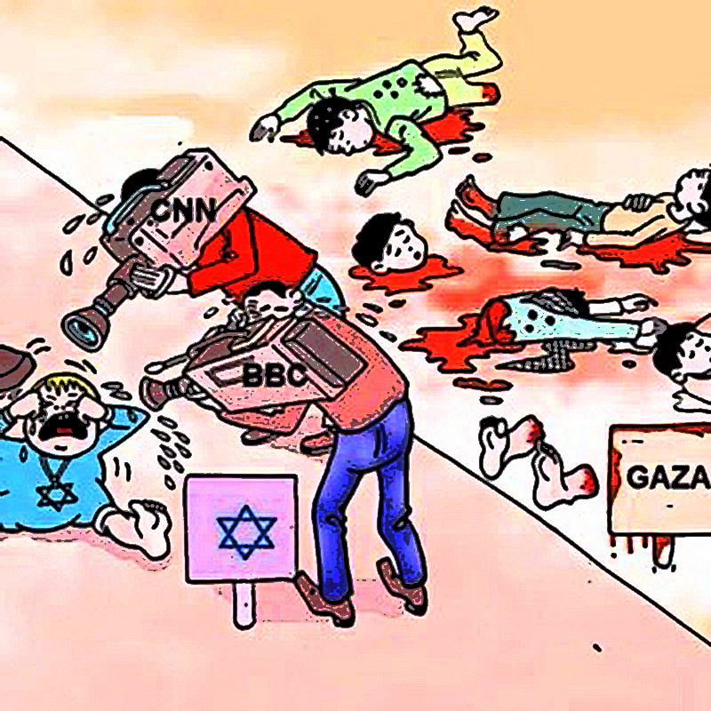

**by** [**Preston James**](http://www.veteranstoday.com/author/jim/) **and Mike Harris**

**Note:** The history of the Khazarians, specifically the Khazarian Mafia (KM), the World’s largest Organized Crime Syndicate that the Khazarian oligarchy morphed into by their deployment of Babylonian Money-Magick, has been nearly completely excised from the history books.

The present day KM knows that it cannot operate or exist without abject secrecy, and therefore has spent a lot of money having its history excised from the history books in order to prevent citizens of the World from learning about its “Evil beyond imagination”, that empowers this World’s largest Organized Crime Cabal. The authors of this article have done their best to resurrect this lost, secret history of the Khazarians and their large International Organized Crime Syndicate, best referred to as the Khazarian Mafia (KM) and make this history available to the World via the Internet, which is the new Gutenberg Press.

It has been exceedingly difficult to reconstruct this hidden secret history of the KM, so please excuse any minor inaccuracies or errors which are unintentional and are due to the difficulty in digging out the true history of Khazaria and its mafia. We have done the best we can to reconstruct it.

It was Mike Harris that connected the dots and made the actual discovery of the presence of the Khazarian Mafia’s secret history and blood oath to take revenge on Russia for helping Americans win the Revolutionary War and the Civil War, and their blood oath of revenge against America and Americans for winning these wars and sustaining the Union.

At the Syrian Conference on Combating Terrorism and Religious Extremism December 1, 2014 — in his [Keynote address, Veterans Today Senior Editor and Director Gordon Duff disclosed publicly](http://www.veteranstoday.com/2014/12/13/historic-speech-in-damascus-sends-shockwaves-around-the-world/) for the first time ever that World Terrorism is actually due to a large International Organized Crime Syndicate associated with Israel. This [disclosure sent shock-waves](http://www.veteranstoday.com/2014/12/31/shock-waves-part-ii/) at the Conference and almost instantly around the world, as almost every world leader received reports of Gordon Duff’s historical disclosure that same day, some within minutes. And the shock-waves from his historic speech in Damascus continue to reverberate around the world even to this very day. [And now Gordon Duff has asked President Putin to release Russian Intel](http://www.veteranstoday.com/2015/03/10/we-demand-president-putin-release-documents-vital-to-world-peace/) which will expose about 300 traitors in Congress for their serious serial felonies and statutory espionage on behalf of the Khazarian Mafia (KM) against America and many Middle East nations.

We now know that the Khazarian Mafia (KM) is waging a secret war against America and Americans by the use of False-flag Gladio-style terrorism, and via the illegal and Unconstitutional Federal Reserve System, the IRS, the FBI, FEMA, Homeland Security and the TSA. We know for certain that the KM was responsible for deploying an inside-job, Gladio-style False-flag attack on America on 9-11-01, as well as the Murrah Building Bombing on April 19, 1995.

***The Hidden History of the Incredibly Evil Khazarian Mafia***

**100-800 AD – an incredibly Evil Society Emerges in Khazaria:**

Khazarians develop into a nation ruled by an evil king, who had ancient Babylonian black arts, occult oligarchs serving as his court. During this time, Khazarians become known to surrounding countries as thieves, murderers, road bandits, and for assuming the identities of those travelers they murdered as a normal occupational practice and way of life.

**800 AD – The Ultimatum is delivered by Russia and other surrounding nations:**

The leaders of the surrounding nations, especially Russia, have had so many years of complaints by their citizens that, as a group, they deliver an ultimatum to the Khazarian king. They send a communique to the Khazarian king that he must choose one of the three Abrahamic religions for his people, and make it his official state religion and require all Khazarian citizens to practice it, and socialize all Khazarian children to practice that faith.

The Khazarian king was given a choice between Islam, Christianity and Judaism. The Khazarian king chose Judaism, and promised to stay within the requirements laid out by the surrounding confederacy of nations led by the Russian czar. Despite his agreement and promise, the Khazarian king and his inner circle of oligarchs kept practicing ancient Babylonian black-magic, also known as Secret Satanism. This Secret Satanism involved occult ceremonies featuring child sacrifice, after “bleeding them out”, drinking their blood and eating their hearts.

The deep dark secret of the occult ceremonies was that they were all based on ancient Baal Worship, also known as worship of the Owl. In order to fool the confederacy of nations led by Russia that were watching Khazaria, the Khazarian king melded these Luciferian black-magick practices with Judaism and created a secret Satanic-hybrid religion, known as Babylonian Talmudism. This was made the national religion of Khazaria, and nurtured the same evil that Khazaria was known for before.

Sadly, the Khazarians continued their evil ways, robbing and murdering those from surrounding countries who traveled through Khazaria. Khazarian robbers often attempted to assume their identities after they murdered these visitors, and became masters of disguises and false identities — a practice they have continued even to this very day, along with their child-sacrifice occult ceremonies, which are actually ancient Baal Worship.

**1,200 AD – Russia and the surrounding nations have had enough and take action:**

About 1,200 AD, the Russians led a group of nations surrounding Khazaria and invaded it, in order to stop the Khazarian crimes against their people, which included kidnapping of their young children and infants for their blood sacrifice ceremonies to Baal. The Khazarian king and his inner court of criminals and murderers came to be known as the Khazarian Mafia (KM) by neighboring countries.

The Khazarian leaders had a well-developed spy network through which they obtained prior warning and escaped from Khazaria to European nations to the west, taking their vast fortune with them in gold and silver. They laid low and regrouped, while assuming new identities. In secret, they continued their Satanic child blood and sacrifice rituals, and trusted Baal to give them the whole world and all its riches, as they claimed he had promised them, as long as they kept bleeding out and sacrificing children and infants for him.

The Khazarian king and his court Mafia plotted eternal revenge against the Russians and the surrounding nations that invaded Khazaria and drove them from power.

**The Khazarian Mafia invades England after being expelled for hundreds of years:**

To accomplish their invasion, they hired Oliver Cromwell to murder King Charles 1, and make England safe for banking again. This began the English Civil Wars which raged for nearly a decade, resulting in regicide of the royal family and hundreds of the genuine English nobility. This is how the City of London was set up as the banking capital of Europe and launched the beginning of the British Empire.

[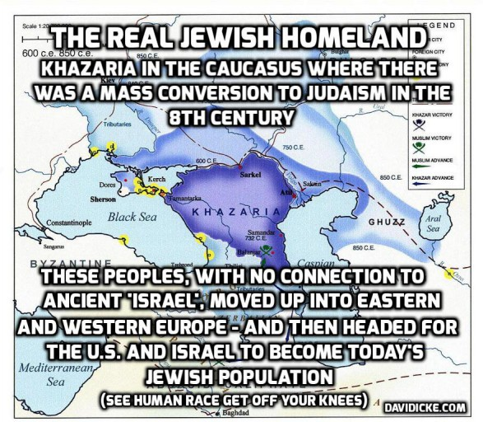](http://www.veteranstoday.com/wp-content/uploads/2015/03/Untitled-76-587x512.jpg)

From David Icke’s website www.davidicke.com. David Icke was the first ever to courageously expose the Rothschilds publicly in front of hundreds. This of course makes him an international hero and we need more with his kind of courage to break open the coverup hiding the Khazarian Mafia and bring an end to their worldwide illegitimate power.

**The Khazarian Mafia (KM) decides to infiltrate and hijack all World Banking using Babylonian Black-Magick, also known as Babylonian Money-Magick or the secret art of making money from nothing also using the power of pernicious usury to accumulate interest:**

The KM used their vast fortune to enter into a new system of banking, based on secret Babylonian black-magic money-magic that they claimed to have learned from the evil spirits of Baal, in return for their many child sacrifices to him.

This Babylonian money-magick involved the substation of paper credit certificates for gold and silver deposits, which allowed travelers to travel with their money in a form that offered easy replacement should they lose the certificates or have them stolen.

Interesting how the very problem that was started by the Khazarians also had a solution provided by them. Eventually the Khazarian king and his small surrounding court infiltrated Germany with a group that chose the name “the Bauers” of Germany to represent them and carry on their Baal-powered system of evil. The Bauers of the Red Shield, which represented their secret blood-based child sacrifices, changed their name to Rothschild (aka “child of the rock, Satan”).

**The Rothschilds as the front Men for the Khazarian Mafia (KM) infiltrate and Hijack British Banking and then hijack the whole nation of England:**

Bauer/Rothschild had five sons who infiltrated and took over European banking and the City of London Central Banking System through various crafty covert operations, including a false report of Napoleon winning against the British, when actually he lost. This allowed the Rothschilds to use fraud and deception to steal the wealth of the English nobility and the landed gentry, who had made business investments with the City of London Banking institutions.

[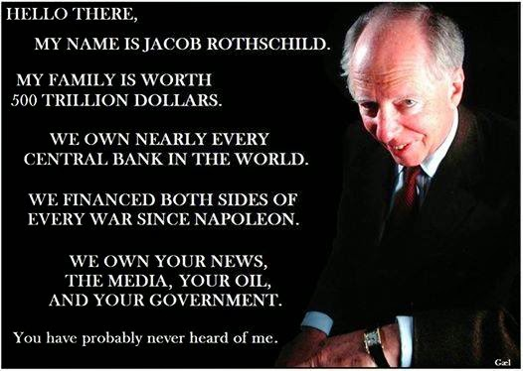](http://www.veteranstoday.com/wp-content/uploads/2015/03/01-Jacob-Rothschild.jpg)

The Rothschilds set up a private Fiat banking system that specialized in making counterfeit money from nothing — charging pernicious usury for the British people, using what should have been their own money.

This was the black art of Babylonian money-magick; they claimed to insiders that such technology and secret money power was provided to them by Baal, because of their frequent child bleeding-out and sacrifices rituals to Baal.

Once they had infiltrated and hijacked the British banking system, they interbred with the British Royals and infiltrated and completely hijacked all of England and all its major institutions. Some experts believe that the Rothschilds genocided the Royal Family members by staging secretly-managed illicit and adulterous breedings with their own Khazarian men in order to replace the Royals with their own pretenders to the throne.

**The Khazarian Mafia (KM) wages an international effort to eradicate Kings who rule by the Divine Right of God Almighty:**

Because the KM claims to have a personal partnership with Baal (aka the Devil, Lucifer, Satan) because of their sacrifices to him. They detest any kings who rule under the authority of God Almighty because most feel a responsibility to make sure their own people are protected from infiltrators and treasonous “Enemies within the Gates.”

In the 1600’s, the KM murder the British Royals and substitute their own fakes. In the 1700’s, they murder the French Royals. Right before WWI they murder, Austrian Archduke Ferdinand to start WW1. In 1917 they assembled their KM army, the Bolsheviks, and infiltrate and hijack Russia, murder the Czar and his family in cold blood, bayonet his favorite daughter through the chest and steal all the Russian gold, silver and art treasures. Right before WW2, they murder the Austrian and German Royals. Then they get rid of the Chinese Royals and disempower the Japanese ruler.

The Khazarian Mafia’s intense hatred of anyone who professed faith in any God but their god Baal has motivated them to murder kings and royalty, and make sure they can never rule. They have done the same with American presidents — running sophisticated covert operations to disempower them.

If that doesn’t work the KM assassinates them, like they did to McKinley, Lincoln and JFK. The KM wants to eliminate any strong rulers or elected officials who dare to resist their Babylonian money-magick power or their covert power gained from their deployment of their human compromise network.

**The Rothschilds create international narcotics trafficking on behalf of the KM:**

The Rothschilds then covertly ran the British Empire and crafted an evil plan to recover the vast amounts of gold and silver the British had been paying to China for its high-quality silk and spices that were unavailable anywhere else.

The Rothschilds, through their international spy network, had heard of Turkish opium and its habit-forming characteristics. They deployed a covert operation to buy Turkish opium and sell it in China, infecting millions with a bad opium habit that brought back gold and silver into the Rothschild coffers, but not to the British People.

The opium addictions created by Rothschild opium sales to China harmed China so much that China went to war on two occasions to stop it. These wars were known as the Boxer Rebellions or the Opium Wars.

The money the Rothschilds gained from the sale of opium was so vast that they became even more addicted to the easy money than the opiate addicts were to the opium.

The Rothschilds were the funding source behind the establishment of the American Colonies, by incorporating the Hudson Bay Company and other trading companies to exploit the New World of the Americas. It was the Rothschild’s who ordered the mass extermination and genocide of the indigenous people of North America to allow for exploitation of the vast natural resources of the continent.

The Rothschild’s also followed the same business template in the Caribbean and in the Asian sub-continent of India, resulting in the murder of millions of innocent people.

**The Rothschilds start the international slave trade, an enterprise that viewed these kidnapped humans as mere animals — a view that the Khazarians would impose on all the people of the world who were not part of their evil circle, which some called the “Old Black Nobility”:**

The Rothschild’s next big project was to start the worldwide slave trade, buying slaves from crooked tribal chiefs in Africa who worked with them to kidnap members of competing tribes for sale as slaves.

The Rothschild slave traders then took these kidnapped slaves on their ships in cramped cells to America and the Caribbean where they were sold. Many died at sea due to bad conditions.

The Rothschild bankers learned early on that war was a great way to double their money in a short time by lending money to both warring sides. But in order to be guaranteed collections, they had to get taxation laws passed, which could be used to force payment.

**The KM Rothschild private Fiat Counterfeit Banksters plot eternal revenge against the American Colonists and Russia who assisted them for losing the Revolutionary War:**

When the Rothschilds lost the American Revolution, they blamed the Russian czar and the Russians for assisting the colonists by blockading British Ships.

They swore eternal revenge on the American colonists, just as they had when the Russians and their allies crushed Khazaria in 1,000 AD.

The Rothschilds and their English oligarchy that surrounded them plotted ways to retake America, and this became their main obsession.

Their favored plan is to set up an American central bank, featuring Babylonian money magic and secret counterfeiting.

**The Rothschild KM attempts to retake America in 1812 on behalf of the Khazarian Mafia but fails, once again because of Russian interference:**

This failure enraged the Rothschild KM, and they once again plot eternal revenge against both the Russians and the American colonists and plan to infiltrate and hijack both nations and asset strip, tyrannize and then mass-murder both nations and their populace.

The KM’s attempts to set up a private American central bank are blocked by President Andrew Jackson, who called them Satanic and vowed to route them out by the grace and power of Almighty God.

The Rothschild banksters regroup and continue their covert attempts to install their own Babylonian money-magick bank inside America.

**Finally in 1913, the Rothschild KM succeeds in establishing a major beachhead inside America — and an evil enemy of all American enter the gates of America:**

In 1913, the Rothschild KM was able to establish a beachhead by bribing crooked, treasonous members of Congress to pass the illegal, Unconstitutional Federal Reserve Act on Christmas Eve without a required quorum. The Act was then signed by a crooked, bought off President, who was a traitor to America, like the members of Congress who voted for it.

[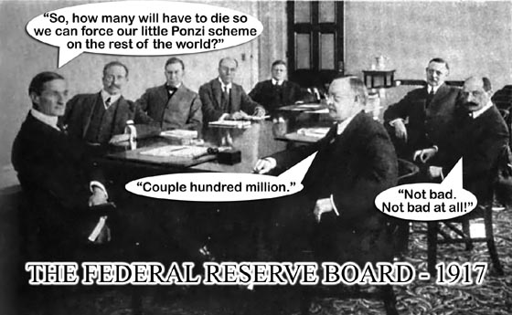](http://www.veteranstoday.com/wp-content/uploads/2015/03/SMALL_ourlittleponzischeme1-2.jpg)

**The Rothschild KM then create an illegal taxation System in America:**

The KM put an illegal, Unconstitutional tax system in place, in order to make sure that Americans would have to pay for high-level USG spending, approved by a bought-off, crooked Congress and Presidential puppets, put in place by corrupt KM campaign finance.

It is easy for the KM to garner enough money to elect anyone they want, because when you control a bank that is a secret major counterfeiter, you have all the money made for you that you desire. At about the same time that they created their illegal tax system in America, they also bribed members of Congress to approve the Internal Revenue Service, which is their private collection agency incorporated in Puerto Rico.

Soon afterwards, they set up the Federal Bureau of Investigation to protect their banksters, to serve their cover-up needs and prevent them from ever being prosecuted for their child sacrifice rituals, pedophile networks; and to also serve as a covert Intel operation on their behalf.

Note that the FBI has no official charter, according to the Library of Congress, and has no right to exist or issue paychecks.

**The Rothschild KM deployed the Bolshevik Revolution in Russia to extract incredibly savage, bloody revenge on innocent Russians, which they had plotted for many years, ever since Khazaria was destroyed:**

The Rothschild KM pre-staged and engineered the Russian Revolution by using its central banks to pay for the Bolshevik infiltration of Russia and their Revolution on behalf of the Khazarian Mafia (KM).

[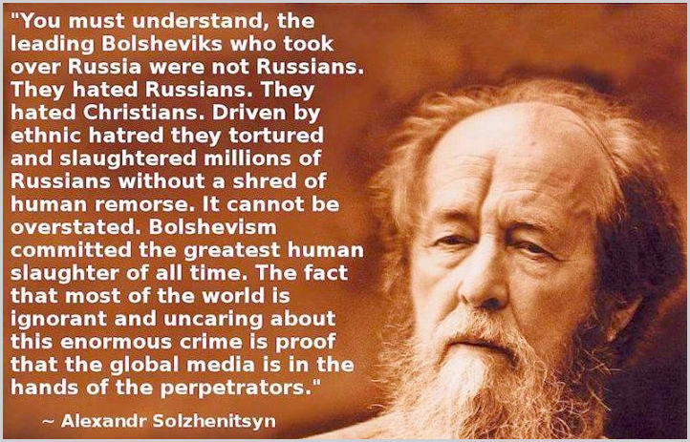](http://www.veteranstoday.com/wp-content/uploads/2015/03/cid_part1_06030604_00040805mounet5.png)

The Bolsheviks were actually created and deployed by the Khazarian Mafia (KM) as the essential part of their long planned revenge on the Russian Czar and the innocent Russian people for breaking up Khazaria in about 1,000 AD for its repeated robbery, murder and identity theft of travelers from countries surrounding Khazaria. This little known fact explains the extreme violence taken out on Russia as long standing revenge by the Rothschild controlled Khazarian Mafia (KM).

In an well-planned savage and inhuman bloodletting that stunned the world, the Bolsheviks were unleashed in full fury on behalf of the KM to gain revenge on the Russians. This had been planned since the destruction of Khazaria.

The Bolsheviks, at the direction of the Rothschild KM, raped, tortured and mass-murdered approximately 100 million Russians, including women, children and infants. Some of the torture and bloodletting was so extreme, we are not going to mention it here in this article.

But readers who want to know can do some in depth internet research on the “Red Terror” or the “Bolshevik Cheka” or watch the classic movie “The Checkist” which is available on www.youtube.com.

**The Rothschild Khazarian Mafia (KM) once again decided to sheep-dip themselves and infiltrated and hijacked all Judaism:**

The Rothschild KM created a master plan to control all of Judaism and mind-kontrol Judaics. The Rothschild KM has hijacked Judaism, patterned it off of Babylonian Talmudism (Luciferianism or Satanism), and gained control over the banking and Wall Street professions in general, Congress, the major mass media; along with most wealth and economic means of success.

Thus, the Rothschild KM could pass out wealth and success to those Judaics who drank their Kool-aide and use them as cutouts, assets and Sayanims. In this manner, the Rothschilds hijacked Judaism.

Their financing of the Israeli Knesset and construction of it using Freemason occult architecture displayed their commitment to the occult and Babylonian Talmudism and all the evil accompanying it, including child sacrifice to their secret god Baal. They set up a NWO system called World Zionism which taught and inculcated susceptible Judaics with a paranoid group delusion of racial superiority, which assumed that all Gentiles were intent on mass-murdering all Judaics.

[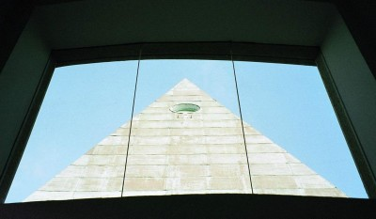](http://www.veteranstoday.com/wp-content/uploads/2015/03/116987567IuRPMv_fs2.jpg)

Freemasonry architecture was used in the building of the Knesset and the Israeli Supreme Court, viewed through windows.

They called this racially-paranoid mass Judaic delusion of world conquest, “World Zionism”, which is really a form of covert Babylonian Talmudism or Luciferianism that had been unknown to mainstream Judaics. The system was designed to use Judaics as cover, but also to anoint them with Babylonian money-power, in order to use them as cutouts, and to later be sacrificed to Lucifer in two stages.

The first stage would be a their planned WWII in Nazi work camps, cut off from supplies, resulting in the deaths of about 200,000 Judaics from starvation and disease, along with about 90,000 non-Judaic inmates from the same causes, according to respected Red Cross official figures. This number is 5% of what the Khazarian Mafia (aka the World Zionists) claim.

The second great sacrifice would be a final one, when their New World Order Luciferian King would be placed into power, and when all three Abrahamic religions would be eradicated — especially Judaism, which would be blamed for all the wars and destruction of the world.

By then, the Rothschilds would once again morph themselves into a complete new identity not associated with Judaism in any form, not even World Zionism.

It is important to realize that the Rothschild KM took Germany down to nothing after WWI, created a vacuum for Fascism, and then rebuilt it, creating Naziism and installing Hitler as a counter-force to their Russian Bolshevism.

Hitler became a problem for the KM when he broke free and begin acting in the interests of the German people and the free people of the world, and developed his own banking system free of the Rothschilds.

Hitler introduced a financial system that was free of usury and beneficial to the working class. This mandated the utter destruction of Germany and the German people, because the Rothschilds and the Khazarians could never allow an economic system that did not depend upon usury to exist.

We see the same thing today with the Khazarian war against Islam, because Islam forbids usury. That is why Israel is so vocal and aggressive about destroying the Islamic people of the world.

The KM expected this to be a large WWII and when they supported both sides, this could be used to industrialize the whole world and maximize their bankster money-power.

[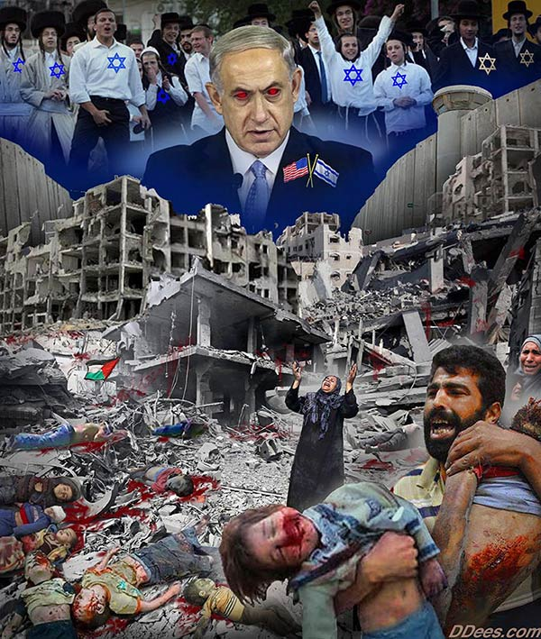](http://www.veteranstoday.com/wp-content/uploads/2015/03/Netenyahoom-R1.jpg)

**The Rothschild KM then bribed and induced Members of Congress to send American Soldiers to their pre-stage and engineered WWI:**

As a continuance of their well-proven pattern of financing both sides in any war to maximize profits, the acquisition of more federal tax monies and increased international power, the Rothschild Khazarians once again bribed, blackmailed and induced members of Congress to declare war against Germany in 1917.

This was facilitated by a KM false-flag attack with the sinking of the Lusitania.

The Rothschild KM has since developed the usual pattern of covertly staging false-flag attacks as a standard operating procedure for inducing Americans to fighting wars for the Khazarian Mafia.

After WWII was finished, the Rothschild KM deployed the Cold War, and used this as an excuse to bring Nazi scientists and mind-kontrol experts to America under Operation Paperclip.

This allowed them to set up a worldwide spying and espionage system that far exceeded any of their prior efforts.

Under this new system, they continue to infiltrate and hijack all American institutions, including the various American church systems, Freemasonry (especially the Scottish Rite and York Rite), the US military, US Intel, and most private defense contractors, the Judiciary and most agencies of the USG, including most State governments, and both major political parties as well.

[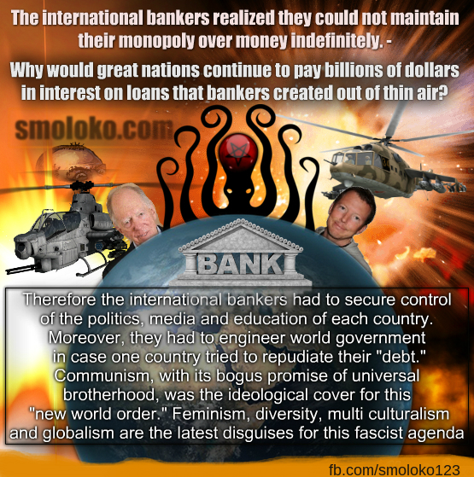](http://www.veteranstoday.com/wp-content/uploads/2015/03/RothschildBankingMeme1.jpg)

**The Rothschild KM sets up Nazi Work Camps as a pretext to later manipulate the Allies into granting them their own private colony in Palestine, using land stolen from the Palestinians:**

The Rothschild KM was able to use their self mis-labelled, so-called “holocaust” to serve as a mind-kontrol trigger to thwart and resist any criticism of their Zionist ways.

The truth of the matter was that the Rothschild KM set up the Nazi work camps to make huge profits for their corporations that ran their work camps and supplied their Nazi war machine.

Once the Rothschild KM gained their own private homeland in Israel in 1947 through their covert political manipulations, they began to secretly view all of Palestine as their New Khazaria, and began plotting how to genocide all the Palestinians and steal all of Palestine for themselves. Their plans include their fantasy of constructing a “greater Israel” by taking over the whole Middle East and manipulating dumb American Goyim to fight and die on their behalf, taking all the Arab lands for Israel and the Khazarian Mafia (KM), so they can asset strip their wealth and natural resources, especially their crude oil.

Recent peer-reviewed Johns Hopkins genetic research by a respected Judaic MD shows that 97.5% of Judaics living in Israel have absolutely no ancient Hebrew DNA, are therefore not Semites, and have no ancient blood ties to the land of Palestine at all. By contrast, 80% of Palestinians carry ancient Hebrew DNA and thus are real Semites, and have ancient blood ties to Palestinian Land. This means that the real anti-Semites are the Israelis who are stealing Palestinian lands in order to build Israeli settlements, and it is the Israelis who are the ones tyrannizing and mass-murdering innocent Palestinians.

[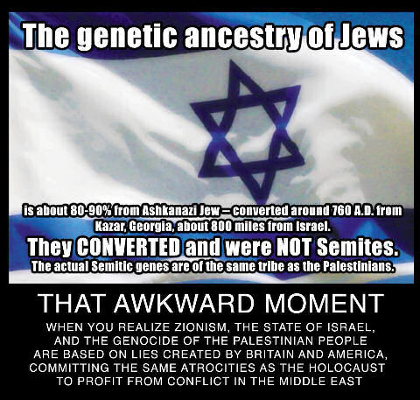](http://www.veteranstoday.com/wp-content/uploads/2015/03/Khazaria1.jpg)

**The Rothschild KM decides to morph again and expand their ranks:**

In the meantime the Rothschild KM realized that they could not stay hidden much longer from the public unless they morphed again and expanded their secret leadership.

So they worked hard to further infiltrate and hijack Freemasonry and its secret offshoots, and inducted top members into their pedophile network and child sacrifice rituals.

Also, key members of Congress were inducted into their secret satanic network by giving them special power, high USG, military and Intel positions, accompanied by great monetary rewards and high status. Massive KM espionage fronts using Israeli-Americam “Israeli-first” dual citizens as cutouts were set up inside America to funnel the Khazarian banksters’ counterfeit money to politicians for their election campaigns, in order to own and control them when elected.

[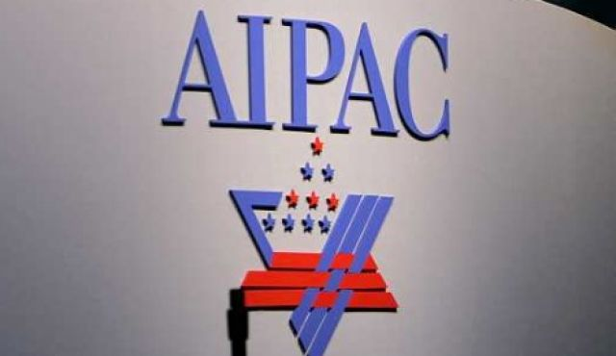](http://www.veteranstoday.com/wp-content/uploads/2015/03/AIPAC.jpg)

**The Rothschild KM decides to Mind-kontrol the American masses to make it much easier to manipulate them into approving their illegal, Unconstitutional unprovoked, undeclared, unwinnable, perpetual wars needed to make huge profits and gain more world power:**

[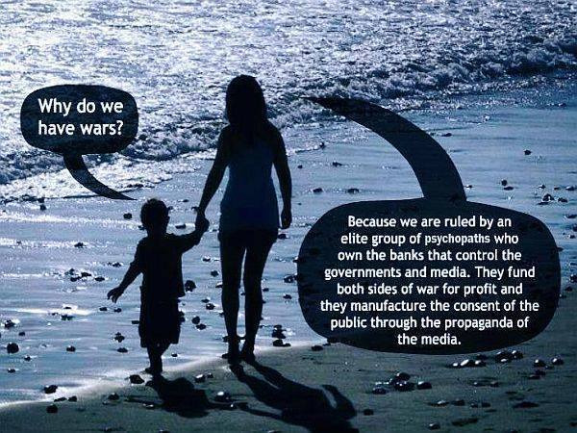](http://www.veteranstoday.com/wp-content/uploads/2015/03/Whydowehavewars1.jpg)

The Rothschild KM decided to gain complete control over all public education by setting up the Department of Education and creating globalist and socialist curriculums based on political correctness, diversity and “perversion is normal” teachings. Fluoride is added to the public water and toothpaste, and dentists are mind-kontrolled to believe that fluoride prevents cavities, and is not harmful to brain function or thyroid function, which it is.

The addition of fluoride to the public water supply and to toothpaste is to dumb-down Americans by on average lowering the operational IQ and making folks much more docile than they would normally be. Programs to develop and deploy vaccinations to dumb-down children and create huge numbers of future chronic health problems were initiated.

Doctors have been mind-kontrolled and misled by biased research that was cherry-picked, ignoring any studies that were negative — and that included most of them. All vaccine cell lines are contaminated with SV-40, a known carcinogenic slow-acting virus.

The KM used its monetary power to gain control over all of the allopathic medical schools, and set up and controlled the American Medical Association and other medical societies, in order to make sure their agenda based on lies and deceit was continued.

Part of this massive plan to dumb-down and mind-kontrol the American masses was the KM’s buying up and consolidating all the American mass media into six controlled major mass media (CMMM), owned and controlled by their cutouts on their behalf. The CMMM functions as an illegal news cartel, and it should be broken up under antitrust laws and for inflicting espionage and illegal propaganda as a weapon of war against the American people.

**The Rothschild KM Chieftains decide that it is time to use America to complete their final take-down and occupation of the Whole World by instituting a major False-Flag attack inside America to blame on the Islamics whom they want America to wrongly attack on their behalf:**

[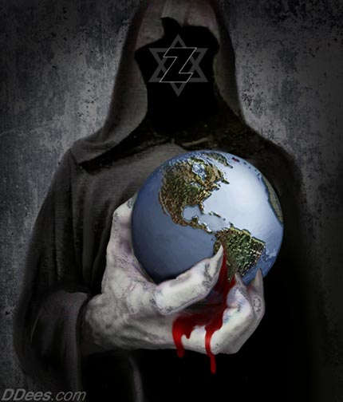](http://www.veteranstoday.com/wp-content/uploads/2015/03/dd395-Z-site.jpg)

So the KM Chieftains use their top Israeli-American “Israeli-first” dual citizens living in America (aka, the PNACers and top NeoCon Cutouts) to plan a major nuclear attack on America on 9-11-01.

Bibi Netanyahu, the operational head of the KM, [deployed the Mossad and these Dual Citizens to set up and institute this attack on America](http://www.veteranstoday.com/2015/01/12/mapping-911-fort-lee/) which was to be blamed by the CMMM on Muslims.

They informed their top Rabbis and “Friends of World Zionism” not to fly on that day and to stay out of NYC, as did “Larry Silverfish”, one of the primary men involved in the operation.

They used their main cutout in the DOD to lure the Able Danger investigators to the Pentagon Naval Intel meeting room, where they would be assassinated by a Tomahawk cruise missile that was fired from an Israeli Dolphin class Diesel submarine bought from Germany.

Thirty-five of the Able Danger investigators who were investigating and tracking the Israeli theft of 350 decommissioned W-54 Davy Crockett nuclear pits out of the backdoor at Pantex in Texas were murdered by this Tomahawk hit, which was timed with the detonation of bombs pre-planted in the Naval Intel wing, which was newly hardened to no avail.

The Israeli Mossad front company, Urban Moving Systems, was used to transport the mini-nukes made from the stolen W-54 nuclear pits from Pantex (and originally made at the Hanford processing plant), where they were stored in the Israeli Embassy in NYC and transported to the Twin Towers for detonation on 9-11-01.

[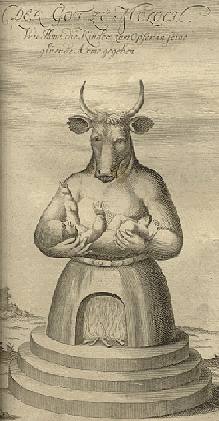](http://www.veteranstoday.com/wp-content/uploads/2015/03/1722_moloch2.gif)

Baal aka Moloch, Lucifer, Satan. Take your pick it’s the same evil spirit that wants to mass-murder all humans. In exchange for doing his “dirty work” he rewards those allow him to snatch their souls by giving them incredible riches, fame and power. This is the secret blood contract called “selling one’s soul.”

**The incredibly Evil Secret Agenda of the Khazarian Mafia (KM) is now revealed publicly for the very first time by Veterans Today’s own Gordon Duff. We now know that Bibi Netanyahoo ran the nuclear attack on America on 9-11-01 and did it as an overall Khazarian Mafia (KM) Agenda.**

Hold on to your chair, this is very big secret and explains a lot of what has been going on inside America, all caused by Israel and the Khazarian Mafia (KM) which has infiltrated almost all of Americas institutions of Government and society.

Now for the first time ever the very specific secret incredibly Evil Agenda of the Khazarian Mafia (KM) is going to be revealed, thanks to an interview that Mike Harris had with Veterans Today Senior Editor and Director Gordon Duff on his talk-show “The Short End of the Stick” on 3-10-15.

I have heard a lot of shocking insider’s secrets over the years but this one really takes the cake and explains exactly what Israel and its minions in America have been to us on behalf of the Rothschild Khazarian Mafia (KM) that has screwed up almost every aspect of our lives creating a poor economy, lots of unemployment and underemployment, massive crime, alcoholism and drug, screwed up schools that dumb down the kids, various eugenics programs like fluoride in the public water and toothpaste, and mercury in vaccines which are a big fraud, and rampant political corruption.

This interview is now sending shock-waves around the world and when you consider the content that Gordon Duff disclosed for the first time anywhere publicly, you will be shocked. And you will understand that Bibi Netanyahoo is the Operational Head of the Khazarian Mafia (KM) and was the one that ordered and supervised the Israeli Nuclear Attack on America on 9-11-01.

In this interview Gordon Duff disclosed from a written transcript of what was said at a meeting between Bibi Netanyahu and American traitor and some other spies in 1990. Gordon Duff disclosed that Netanyahu was a KGB spy like Jonathan Pollard. And we know now that Israel was started as a satellite of Bolshevik Russia and was quite unhappy when the Soviet Union fell.

Benjamin Netanyahu was meeting in at Finks bar in Jerusalem, a well-known Mossad watering-hole. Here is what he said as taken directly from the transcript of the recording which was witnessed and has been 100% fully authenticated:

“*If we get caught they will just replace us with persons of the same cloth. So it doesn’t matter what you do, America is a Golden Calf and we will suck it dry, chop it up, and sell it off piece by piece until there is nothing left but the World’s biggest welfare state that we will create and control. Why? Because it’s god’s will and America is big enough to take the hit so we can do it again, again and again. This is what we do to countries that we hate. We destroy them very slowly and make them suffer for refusing to be our slaves*.”

This is exactly what the Rothschild Khazarian Mafia (KM) has been doing to America since it successfully infiltrated and hijacked America in 1913. Knowledge of what Bibi said on behalf of the Rothschild Khazarian Mafia (KM) should make us all furious and get motivated to drive these evil creatures out of America and take our great Republic back.

When Bibi Netanyahu mentions god’s will, the god he was referring to is Baal (also known as the Great Owl or Moloch), the god these Khazarians believe requires them to worship him by constant bloodletting and painful human sacrifice and mass-murder and that if they “sell their souls” to Baal (aka Lucifer or Satan) do this they will be rewarded with incredible riches, fame and great power. When they “sell their souls” what actually happens is that their souls are snatched away and they become inhuman or soulless and take on the characteristics of Baal, that is they become increasingly psychopathic and evil.

What Bibi Netanyahu was discussing was the upcoming nuclear attack on America on 9-11-01, and when he mentioned “they will just replace us” he was referring to the top Circle of Twelve, the group he answers to that Veterans Today’s own Columnist and talk show host Stew Webb disclosed to the World by identifying 11 of the 12 who call themselves the “Illuminati” or “Disciples of Satan.” These men do semi-annual child sacrifice in Denver and eat the hearts of children, drink their blood after they pedophile them.

Folks, we must get this information out to everyone we can, then unite and drive these soulless Baal worshiping scum out of every nook and cranny of America and bring them all to justice and final judgement for all their incredible evil.

Anyone who understands what Bibi Netanyahu thinks of Americans as a golden calf to asset strip and slaughter should be enraged and driven to community organizing, and political action against Israeli espionage inside America through the Federal Reserve System, AIPAC, JINSA, the Defense Policy Board, the CFR and the like.

**The Rothschild KM planted has 25 nukes in major American cities and other major cities in Europe in order to blackmail the associated government. This is referred to as their Samson Option, and was first discovered and disclosed by Seymour Hersh:**

[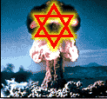](http://www.veteranstoday.com/wp-content/uploads/2015/03/starnukeLG.gif)The Rothschild KM also gained some S-19 and S-20 Warheads from a corrupt Member of Congress assigned the task to buy up Ukrainian Mirvs on behalf of the USG in order to decommission them. Instead, he sold them to the Israelis and split the money with other key Congressmen involved.

This is high treason and a capital offense punishable by execution. Right after their attack on America, the Rothschild KM told the US Administration that they would detonate city-buster sized nukes in some American cities, including DC, if the Administration refused to allow Israel to create their own large police state occupation force inside America, based on the consolidation of all American Law Enforcement and alphabets under one central Israeli control.

This new Israeli occupation force called Homeland Security (DHS) was initially run by dual citizens and perverts. Former DHS Director Janet Napolitano is being sued for sexual harassment of men working at DHS whom she ordered to move their offices into the men’s lavatory.

Dual Citizen traitor Michael Chertoff, (a name translated from Russian as “son of the devil”), was the criminal mastermind that set up DHS, along with former head of the East German Stasi, Marcus Wolfe, who was hired as a special consultant and died mysteriously as soon as his mission was completed.

The Rothschild KM never thought they would get exposed for their nuclear attack on America on 9-11-11, but they made one of the biggest tactical mistakes in history and overplayed their hand from excess hubris, based on too much easy success due to their extreme money power in the past.

**Soon mainstream America will know that Bibi Netanyahu and his Likudist Party deployed the attack on America on 9-11-01 on behalf of the Rothschild KM:**

They thought that they had complete control over the CMMM and could prevent any of the secret IAEA and Sandia Labs investigation from ever being released to the American public.

They made a serious tactical error, because now [the truth about their role in the 9-11-01 attack on America is being published on the worldwide Internet](http://www.veteranstoday.com/2015/01/12/mapping-911-fort-lee/), the world’s new Gutenberg Press. What the Rothschild KM did not understand was the power of the Internet and how truth-nuggets published and broadcast on it resonate with the people of the world and spread like wildfire, at the speed of light. Truth is being diffused to the masses everywhere.

This incredible tactical error by the KM is so great that it will actually doom them to the complete exposure and eventual complete destruction they deserve. Bibi Netanyahu’s order to proceed and deliver the nuclear attack on America on 9-11-01 will go down in history as one of the KM’s biggest mistakes, and the one that will be blamed for their exposure and destruction by the world that is now ganging up against them.

The Russians have now leaked the IAEA and Sandia Labs and Able Danger files given to them by Edward Snowden. Soon all of these files will be provided to all Americans and the world via the Internet, and this cannot be stopped.

A number of Russians in the High Military Command in Russia, and in the highest positions of leadership in the Russian government realize that it was the same Organized Crime Cabal that organized the Khazarians into Bolsheviks to mass-murder 100 million innocent Russians — and these men want payback.

That is why they are making sure that the Rothschild banksters will be put out of business, which will decapitate the Khazarian Mafia from its endless, elastic counterfeit money supply. This is why the BRICS Development Bank was created — to replace the US Petro Dollar as the world’s reserve currency, but this one, unlike the US Petro Dollar is backed by gold, silver and real commodities, with NO counterfeiting allowed.

The CMMM is failing, and most Americans no longer believe any of their prime-time national stories, especially the under-thirty crowd, who cherry pick facts from the Internet and construct their own beliefs.

So many Internet users now reject the CMMM that the truth about the Israelis attacking America on 9-11-01 is becoming easier each day to believe. Soon all of mainstream America will know that Bibi Netanyahu and his Mossad and dual citizens did the 9-11-01 attack on America.

**The American Military High Command knows that Bibi Netanyahu ordered his Mossad and stateside Dual Citizens to attack America using nukes on 9-11-01 on behalf of the Rothschild Khazarian Mafia (KM):**

Various deep cover covert operations are now being deployed globally to expose and decapitate the Rothschild KM from their endless, elastic money supply.

Their days of anti-human power are now limited. The secret, incredibly well-trained US team called the “Nuclear Snake-Eaters” is now hard at work searching all incoming Israeli diplomatic pouches and shipments; driving by and flying over synagogues and Israeli embassies and Mossad safe-houses with high tech gamma ray and helium-3 neutron detectors; and using ultra high-tech custom-tuned and -focused satellites to search for any stored nuclear pits, as well as working hard to recover all stolen nuclear pits by the Israelis anywhere in the world outside of Israel.

This super-elite team was alerted by Michael Shrimpton’s phone call to MI-6 notifying them that an Israeli “City Buster” was planted near the Olympic stadium. This call wrongly has landed him in jail. The City Buster was recovered by the “Nuclear Snake-eaters”, who entered England and recovered and disarmed a large city buster. Sadly MI-6, wanted this nuke detonated in order to gain more power for the Khazarian Mafia in England — their home base inside the City of London Financial District — since it has been losing power fast.

[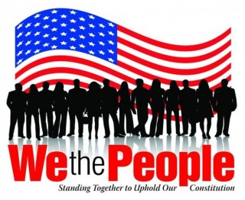](http://www.veteranstoday.com/wp-content/uploads/2015/03/image0102-2.jpg)A secret name for these KM Chieftains which run much of the world out of the City of London is Gog and Magog, despite what so many historians believe is the secret name of Russia which it is not. It is the secret name of the top KM, and apparently represents where they originally came from.

The secret team of super-elite “Nuclear Snake-eaters” is ready to be deployed to Israel anytime, should the nation collapse after most European corporations divest from Israel, and the US cuts off all aid, in order to comply with American law. It is illegal to give aid to a nation that has nukes, and which has not signed the Nuclear Non-proliferation Agreement. Israel has nukes detectable from satellite-based Helium-3 sensors and has never admitted it, nor has it signed the Nuclear Non-proliferation Agreement. We must all demand that our Congress and Administration obey the law and immediately cut off all aid monetary and military aid to Israel, and arrest all Israeli espionage front directors of AIPAC, JINSA, the Defense Policy Board, the “Joint” in NYC, and the ADL, etc.

It is unknown but suspected that a significant number of these stolen nukes have been already recovered. It has been reported by insiders that a very solemn message was communicated to Bibi Netanyahu and his Likudists, as well as all top members of Israeli espionage fronts in America, like AIPAC, JINSA, the Defense Policy Board, the ADL and the like.

What was this serious warning? If insider reports are accurate, these folks were told that if there is one more Israeli based false-flag attack, those who ordered it or were involved will be hunted down under American National Security and eliminated, and the Israeli defense structures associated with such will be turned to dust.

**The rest of Rothschild KM history will likely be determined by YOU:**

[](http://www.veteranstoday.com/wp-content/uploads/2015/03/gordonduff-for-us-president.jpg)The future of the Rothschild KM will likely be determined by Veterans Today readers and We The People who learn the secret, forbidden history of the Khazarian Mafia that was excised from the history books and libraries by the KM to protect their evil history that no one would accept if it was known.

So share this story with your family, friends and associates and take it viral. Be clear about this — unless the KM is able to operate in abject secrecy, it will be attacked from all sides and destroyed forever. So take away their secrecy by exposing their hidden history for all Americans to know and understand.

That is why they have worked so hard to buy up and control the CMMM and public mass education including colleges and universities, to make sure the people of the world would never find out about their secret evil, which is so inhuman, so homicidal that the whole world would gang up on them and attack them from all sides at every level they exist at.

The big question remains: Was the true cause of leaders of the Khazarian Mafia’s incredible evil and savagery toward the human race a byproduct or nature or nurture? Some believe that this gross parasitism and inclination to mass-murder, engage in pedophilia and child bloodletting and child sacrifice is due to a toxic culture, best described as malignant Tribalism, characterized by a paranoid group racial superiority delusion. Others think the leaders of the KM are the bloodline of Cain, that is, “children of Cain”, that are the Devil’s own and have absolutely no soul or human conscience, but are pure predators like a wild beast — while at the same time being [incredibly two-faced](http://www.veteranstoday.com/2014/11/22/evil-with-a-nice-face-the-janus-principal/), that is able to put on [a good con and a nice face](http://www.veteranstoday.com/2015/02/27/evil-with-a-nice-face-part-ii/) on the outside. Perhaps it could be both factors. In any case, it is time to expose this evil, the greatest evil the world has ever experienced. It is time for the world to work together to eradicate this problem now and forever, by whatever means necessary.

___

***Mike Harris*** *is the Financial Editor of Veterans Today, a radio host, a former GOP Finance Chairman, Gubernatorial Candidate for Arizona, and a Senior Vice President of Adamus Defense Group, Switzerland. Mike is an expert in full-contact mixed martial arts. His long term expertise in such has gained him a lot of respect and the nickname “Iron Mike”. Mike was a part of the Veterans Today group that attended the* [*Damascus Conference to Combat Terrorism*](http://www.veteranstoday.com/2014/12/13/historic-speech-in-damascus-sends-shockwaves-around-the-world/) *and Religious Extremism. Mike gave about twenty five televised interviews that were broadcast to millions of viewers in Syria, Iraq, Lebanon and Iran. In these interviews Mike emphasized and supported the historical declaration by Keynote Speaker, Veterans Today Senior Editor and Chairman Gordon Duff that the real problem behind World Terrorism is a large Organized Crime Syndicate.*

Bonus Video for those who have time and interest on the Head of the Khazarian Mafia (KM) Snake.

[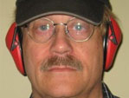](http://www.veteranstoday.com/author/jim/)

[**Preston James, Ph.D**](http://www.veteranstoday.com/author/jim/)

Social Psychologist with Doctorate from Major Midwest Big Ten University. Retired after serving the community for over 36 years during which time there were numerous contacts with those associated with Intel and Law Enforcement.

=======================================================================================================================================================================================

END