**Police speak to Prince Philip for not wearing seat belt**

* 5 hours ago
* [Share this with Facebook](https://www.bbc.com/news/uk-46935721)

* [Share this with Messenger](https://www.bbc.com/news/uk-46935721)

* [Share this with Twitter](https://www.bbc.com/news/uk-46935721)

* [Share this with Email](mailto:?subject=Shared%20from%20BBC%20News&body=https%3A%2F%2Fwww.bbc.com%2Fnews%2Fuk-46935721)

* [Share](https://www.bbc.com/news/uk-46935721#share-tools)

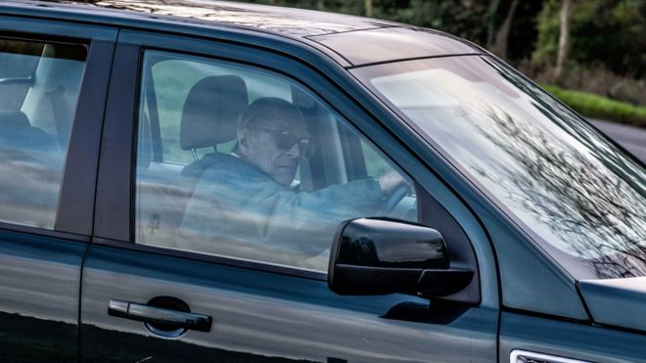Image copyrightALBANPIXImage captionPrince Philip driving the replacement Land Rover Freelander on Saturday

**Norfolk Police say they have spoken to the Duke of Edinburgh after he was pictured driving without a seat belt, 48 hours after being involved in a crash near Sandringham in Norfolk.**

A spokeswoman said "suitable words of advice have been given to the driver".

Meanwhile, Emma Fairweather, who broke her wrist in the crash, [**has told the Mirror**](https://www.mirror.co.uk/news/uk-news/prince-philips-crash-victim-reveals-13882041)the duke has not apologised.

A Palace spokesman has said contact was made with the occupants of the car to exchange "well-wishes".

The crash on the A149, in which Prince Philip's Land Rover Freelander landed on its side after a collision with a Kia, happened on Thursday.

* [**Speed limit cut on duke crash A-road**](https://www.bbc.com/news/uk-england-norfolk-46912556)
* [**Is age a factor behind the wheel?**](https://www.bbc.com/news/uk-46916429)

Two days later, pictures in the [**Daily Mail**](https://www.dailymail.co.uk/news/article-6610325/Philip-rides-Duke-Edinburgh-97-wheel.html) and [**the Sun**](https://www.thesun.co.uk/news/8232915/prince-philip-crash-driving-land-rover-no-seat-belt/) appeared to show the duke, 97, driving alone on a road near the entrance to the Sandringham estate in a replacement Freelander, without a seat belt.

A spokeswoman for the Norfolk Constabulary said the force was aware of the photographs and had spoken to the driver.

"This is in line with our standard response when being made aware of such images showing this type of offence," she said.

The force said earlier it was standard policy to breath test drivers involved in collisions and both had provided negative readings.

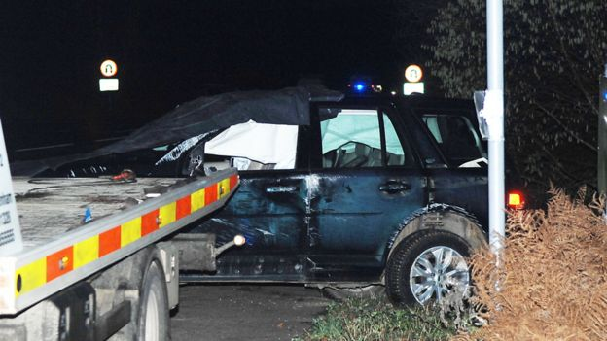Image copyrightARCHANTImage captionDamage to the Land Rover's left side could be seen after Thursday's crash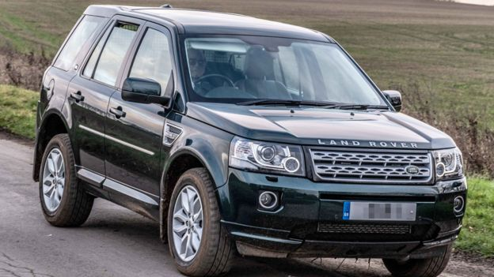Image copyrightALBANPIXImage captionPrince Philip was photographed driving a replacement Land Rover on Saturday

Ms Fairweather, who was a passenger in the car being driven by her friend, told the Sunday Mirror: "I'm lucky to be alive and he hasn't even said sorry.

"It has been such a traumatic and painful time and I would have expected more of the Royal Family," she added.

She said she had not heard from the royal household but had got a call from a police family liaison officer.

"The message he passed on didn't even make sense. He said, 'The Queen and the Duke of Edinburgh would like to be remembered to you,'" she said.

"That's not an apology or even a well-wish."

Buckingham Palace said on Saturday that a "full message of support was sent to both the driver and the passenger".

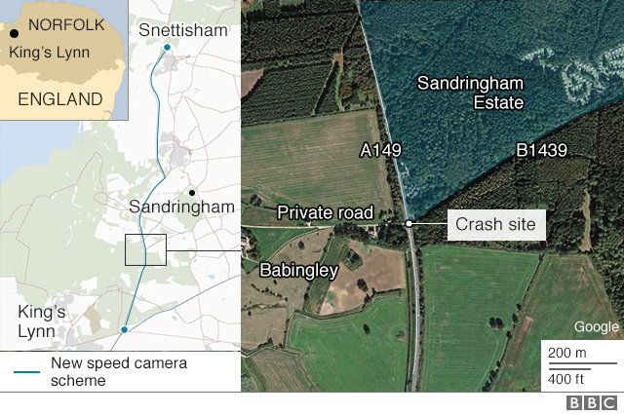Presentational grey line

**What is the law on seat belts?**

* Passengers and drivers must wear a belt when on a public road if there is one fitted in their vehicle. There are a few exceptions, such as when a driver is reversing, or for medical reasons
* A person caught not wearing a seatbelt could receive an on-the-spot £100 fine. If a case goes to court, the fine could increase to £500
* Drivers do not receive penalty points for not wearing a seatbelt

**Sources:**[**RAC**](https://www.rac.co.uk/drive/advice/legal/seat-belt-law/#punishments)**and**[**gov.uk**](https://www.gov.uk/seat-belts-law/when-you-dont-need-to-wear-a-seat-belt)

# Prince Philip: Sandringham crash led to car 'tumbling' across road

* 18 January 2019
* [Share this with Facebook](https://www.bbc.com/news/uk-46918039?fbclid=IwAR1cek5izFeahk1cJYUtIqtFO8q0y9Ka1u1OzdvgljNhA8W5yvAm05rMjkw)

* [Share this with Messenger](https://www.bbc.com/news/uk-46918039?fbclid=IwAR1cek5izFeahk1cJYUtIqtFO8q0y9Ka1u1OzdvgljNhA8W5yvAm05rMjkw)

* [Share this with Twitter](https://www.bbc.com/news/uk-46918039?fbclid=IwAR1cek5izFeahk1cJYUtIqtFO8q0y9Ka1u1OzdvgljNhA8W5yvAm05rMjkw)

* [Share this with Email](mailto:?subject=Shared%20from%20BBC%20News&body=https%3A%2F%2Fwww.bbc.com%2Fnews%2Fuk-46918039)

* [Share](https://www.bbc.com/news/uk-46918039?fbclid=IwAR1cek5izFeahk1cJYUtIqtFO8q0y9Ka1u1OzdvgljNhA8W5yvAm05rMjkw#share-tools)

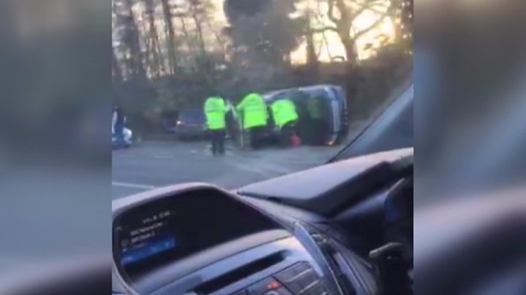

Media captionWitness Roy Warne: "There was a huge collision"

**The man who helped free the Duke of Edinburgh from his Land Rover after his crash has described how he saw the vehicle "careering" across the road.**

Prince Philip, 97, was unhurt but visited hospital on Friday for a check-up following Thursday's crash.

A nine-month-old boy in the other car was uninjured. The driver, a 28-year-old woman, had cuts while a 45-year-old female passenger broke her wrist.

Witness Roy Warne said the duke asked about their welfare after the crash.

A Palace spokesperson said the duke's hospital visit confirmed he had "no injuries of concern".

Mr Warne was driving home when he saw the car roll and end up on the other side of the road.

He said the duke was "obviously shaken" but managed to stand up and ask how the others involved in the crash were, he said.

Mr Warne told BBC Radio 4's Today programme: "I saw it careering, tumbling across the road and ending up on the other side.

"It would take a massive force [to have done that]."

* [**Duke crash 'puts spotlight on road safety'**](https://www.bbc.com/news/uk-england-norfolk-46912556)
* [**Is age a factor behind the wheel?**](https://www.bbc.com/news/uk-46916429)

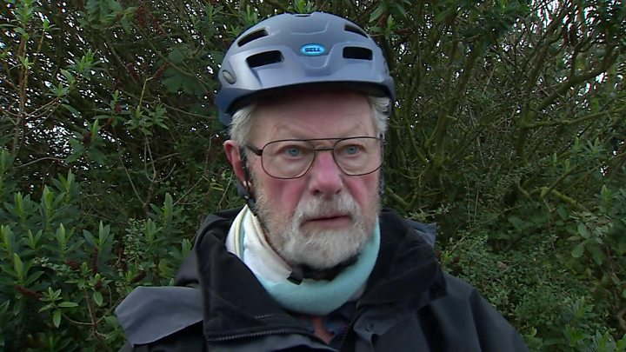

Media captionPrince Philip crash: Roy Warne describes aftermath

He said that after seeing the crash, on the A149 near Sandringham: "I went to the other car. There was a baby in the back and, with another man, we got the baby out.

"Then I went to the black car to help and realised it was the Duke of Edinburgh."

Mr Warne said he overheard the duke telling police he had been "dazzled by the sun".

The two people who were first to the scene of the crash say the duke appears to have been travelling alone in the vehicle at the moment of collision.

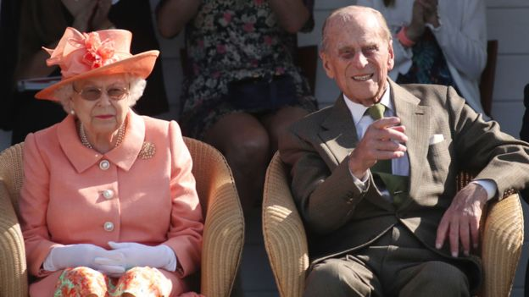Image copyrightPAImage captionThe Queen and Duke of Edinburgh have been staying at the Norfolk estate since ChristmasImage copyrightARCHANTImage captionDamage to the Land Rover's left side could be seen after the crash

The two women in the Kia were taken to the Queen Elizabeth Hospital in King's Lynn to be treated for the broken wrist and cuts to the knee, and were later discharged.

A Palace spokesman said contact had been made with the occupants of the Kia - the other car involved in the crash - to exchange "well-wishes".

Norfolk Police said it was standard policy to breath test drivers involved in collisions and both had provided negative readings.

The incident will be investigated "and any appropriate action taken", the force added.

Chris Spinks, who led Norfolk's roads policing team for five years, said officers would likely follow-up on first hand accounts and interview those involved.

The retired chief inspector added that there would be "no favouritism" shown towards the duke during the investigation.

## Car accidents: Younger v older drivers

**By BBC Reality Check**

In November 2018, there were 5.3 million over-70s with full driving licences in Britain, according to the Driver and Vehicle Licensing Agency.

There were 11,245 people involved in road traffic accidents where the driver was in that age group - a rate of two per 1,000 licence holders.

For Britain's 2.8 million drivers aged 17 to 24, the rate was more than four times as high, at nine per 1,000.

The DVLA did not provide figures on whether this simply reflected that the older age group were on the road less than the younger age group. However, a separate study from the National Travel Survey suggests that over-70 drive an average of 1,000 miles a year more than under-20s.

Asked if Prince Philip was trapped, Mr Warne replied: "Yes, he was. I asked him to move his left leg and that freed his right leg and then I helped him get out."

He said he couldn't remember what the duke had then said, but added that "it was nothing rude".

"He was obviously shaken, and then he went and asked if everyone else was all right," said Mr Warne.

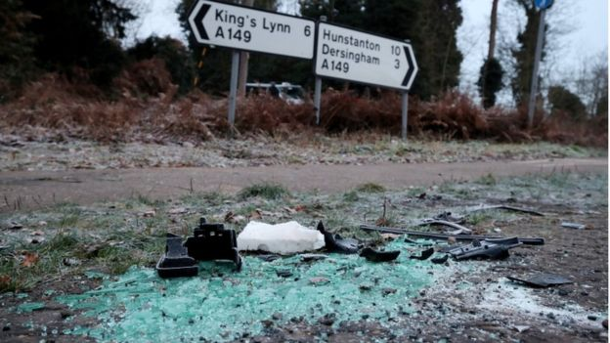Image copyrightREUTERSImage captionDebris at the scene where Prince Philip was involved in a traffic accident

Asked if the duke had then thanked him for getting him out of the car, Mr Warne said: "No, but he wasn't being discourteous. He had other things on his mind, I'm sure."

Mr Warne said there was "a little bit of blood" and that a member of what he described as the royal entourage gave him a wipe for his hands, adding "a lot of people arrived very quickly".

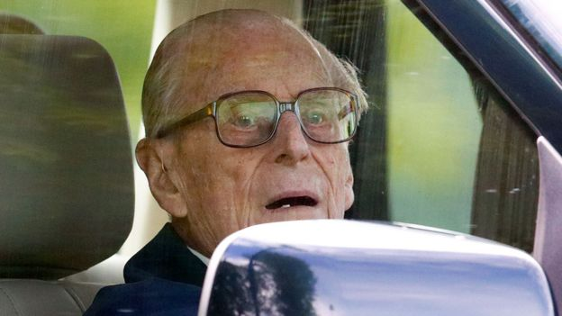Image copyrightGETTY IMAGESImage captionPrince Philip, seen driving here in May 2018, was not taken to hospital

He said the two women involved were "very shaken", adding: "One of them was the mother of the child and she was quite upset."

Norfolk County Council was already due to discuss safety issues on the road - described as a "rat run" by one local - before the crash took place.

On Friday, it approved plans for new safety measures on that section of the A149. The speed limit will be lowered from 60mph to 50mph and an average speed monitoring system will be implemented.

Prime Minister Theresa May sent the duke a message wishing him well following the crash.