Earth Mysteries, Ley Lines, Stonehenge, Other Monuments

Chris Witcombe

http://witcombe.sbc.edu/earthmysteries/EMIntro.html

Ley Lines
Ley lines, or Leys, are alignments of ancient sites stretching across the landscape. Ancient sites or holy places may be situated in a straight line ranging from one or two to several miles in length. A ley may be identified simply by an aligned placing of marker sites, or it might be visible on the ground for all or part of its length by the remnants of an old straight track.

Ley Lines were 're-discovered' on 30 June 1921 by Alfred Watkins (1855-1935), a locally well-known and respected Herefordshire businessman, who while looking at a map for features of interest noticed a straight line that passed over hill tops through various points of interest, all of which were ancient. At the time of his discovery, Watkins had no theory about alignments but on that June afternoon saw "in a flash" a whole pattern of lines stretching across the landscape. Four years later, in 1925, he described his vision in a book he titled The Old Straight Track:
"Imagine a fairy chain stretched from mountain peak to mountain peak, as far as the eye could reach, and paid out until it reached the 'high places' of the earth at a number of ridges, banks, and knowls. Then visualise a mound, circular earthwork, or clump of trees, planted on these high points, and in low points in the valley other mounds ringed around with water to be seen from a distance. Then great standing stones brought to mark the way at intervals, and on a bank leading up to a mountain ridge or down to a ford the track cut deep so as to form a guiding notch on the skyline as you come up.... Here and there, at two ends of the way, a beacon fire used to lay out the track. With ponds dug on the line, or streams banked up into 'flashes' to form reflecting points on the beacon track so that it might be checked when at least once a year the beacon was fired on the traditional day. All these works exactly on the sighting line."
Watkins surmised that these straight tracks, or ley lines as he called them at first, were the remnants of prehistoric trading routes. He went on to associate ley lines with the Greek god Hermes (the Roman Mercury, the Norse Woden) who was the god of communication and of boundaries, the winged messenger, and the guide to travellers on unknown paths. Watkins identified Hermes-Mercury with the chief god of the Druids and argued that:
"A Celtic god, Tout, or in its Romanised form Toutates, is supposed to be what Caesar referred to, and this name has been found on a Romano-British altar. It is a fact that sighting mounds called Tot, Toot, Tout, Tute and Twt abound all over the Kingdom, and the root is probably Celtic... The fact that such mounds are mark-points on trackways strengthen the link..."
The identification of leys as ancient traders' routes was as far as Watkins was prepared to go, despite the fact that numerous ley lines travelled up prohibitively steep hillsides. Speculation as to their meaning and purpose continued after Watkins' death in 1935.
According to Paul Devereux, it was the occultist Dion Fortune in her 1936 novel The Goat-Foot God (republished in 1971 by S. Weiser, New York, and in 1989 by Aquarian Press, Northamptonshire) who invented the idea that ley lines were "lines of power" linking prehistoric sites. A few years later, it was suggested that ley lines followed lines cosmic energy in the Earth and could be detected using dowsing rods. In the 1960s, ley lines, or "leys" as they were now called, became linked with UFO sightings.
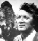
In 1969, ley lines were taken up by John Michell, in his seminal book The View Over Atlantis, who discussed them within the context of geomancy. By 1974, ley lines and geomancy, plus other esoteric subjects having to do with the Earth, were collected under the umbrella term of "Earth Mysteries."

ALFRED WATKINS 1855-1935

Pioneer Photographer and Antiquarian
Alfred Watkins was born on 27th January 1855 at the Imperial Hotel in Widemarsh Street. He was the third of the ten children of Charles and Ann Watkins. Watkins senior was a prosperous farmer whose ancestors had farmed land for generations in Mitcheldean, Gloucestershire, and the adjoining area; he promoted five businesses in Hereford, including the Imperial Flour Mills, Watkins Imperial Brewery and the Imperial Hotel. Alfred Watkins was self-educated, having learnt very little at the small private school where he was sent. He became a "highly cultured man who knew everything about something,and something about everything."
Watkins' first career was as an "out-rider" for Watkins Brewery and later the Imperial Mills and as a result he became well known in the local countryside. He sat and passed his City and Guilds in 1883, winning the premier silver medal.
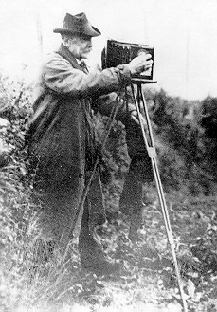
In 1886, Alfred Watkins married Marion Mendam Cross. They had two children; a son Allen and daughter Marion. As a family man, Watkins used to amuse his children with his conjuring tricks and slide shows. The family lived at Sunnyside, Broomy Hill, until 1890 and then moved to the Vineyard Croft, Hampton Park. In 1920, when the children had grown up, Alfred and Marion settled near to the Cathedral at No. 5 Harley Court, where he died in 1935 (photo lower right).
In politics, Watkins was a staunch Liberal. He had a strong sense of public duty and he expected others to have the same. In 1905 and 1906, he organised and spoke at slide-shows throughout the country against Joseph Chamberlain's proposals for protective tariffs. These meetings were well attended and had considerable political effect.
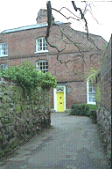
Watkins' involvement in the world of photography started with a primitive pinhole camera which he made from a cigar box. He felt that the entire process of getting a good picture was simpler than what was thought at the time, and involved only one factor, that of the property of light. With that in mind, Watkins devised his Exposure Meter after working out the mathematical properties of light, the size of the camera lens, and the amount of exposure. In April of 1890, he published his findings in the British Journal of Photography, and he also took out a patent for his exposure meter. Like so many good ideas, it received a poor reception amongst the business community! Not to be deterred, Watkins invested his own capital and set aside a room in the Imperial Flour Mills for the manufacture of the meters. The original price was one guinea. This was the beginning of the Watkins Meter Company.
The Watkins Meter Company manufactured the various meters, including the Bee, named after Watkins' own devotion to amateur beekeeping (a collection of his books on beekeeping is now kept at Hereford Library). The company also developed the Watkins Time Tank and the Watkins Time Thermometer, and published the "Watkins Manual of Photography" and issued periodical Plate Speed Cards. The Manual ran into eleven editions. Watkins himself answered many personal letters from photographers with problems.
In 1908. Watkins became President of the annual convention of the Royal Photographic Society, held in Hereford that year, and he gave a public address. Two years later, he was made a fellow of the Society. In the same year, he was awarded the 11th Progress Medal in the Society's history for his scientific research in exposure and development.
The then President, Lord Crawford, said at the time, "The mere fact of the Society giving the highest honour at its command to Mr Watkins this year stamps his methods and inventions with a significance which no other Society in the world could give them".
In 1911. Watkins published a book for photographers called "Photography: Its Principles and Applications" which became a valuable reference work. It was universally praised and was reprinted three times. Watkins carried out the practical research for his book in his cellar at Vineyard Croft. He was not a believer in expensive equipment and built his dark-room with suitable everyday materials to hand.
Alfred Watkins' contribution to photography is not his only claim to fame. He also invented a flour to make a perfect brown bread, the Vagos or "Wandering Maiden" from the Roman name for the River Wye. Though a brown loaf, Vagos did not qualify as a wholemeal because the roughage had been excluded from its ingredients. The loaf soon became popular, it had a pleasant slightly malted flavour and sold well in the local shops. Watkins promoted his new loaf at the Baker's Exhibition which was then held at the Agricultural Hall in Islington, London.
Watkins was also a keen archaeologist and antiquarian. His association with archaeology led to him joining the Woolhope Naturalists' Field Club (founded 1851) which was based in Hereford. He became a leading member of the club and gave frequent lectures, illustrated with his own slides.
Watkins also undertook a survey of pigeon-houses in the county. His report, illustrated with many photographs, was reprinted in 1889 from the Royal Archaeological Journal for private distribution. However, his longest and most comprehensive survey for the Club was of church and market crosses. He photographed and measured some 120 crosses, all of which were included in his report, "The Standing Crosses of Herefordshire", which was published by the Woolhope Club in 1929.
Today, Alfred Watkins is best remembered for his controversial studies of "Ley Lines". He spent the last fourteen years of his lfie accumulating a mass of evidence to support his controversial views. Watkins made his momentous discovery on June 30th, 1921, when, during a visit to Blackwardine, near Leominster, he decided to look at the map for interesting features. He suddenly realised that a series of straight lines could link all the various landmarks into a network of ancient tracks.
Watkins believed that this alignment could not be due to mere chance. He believed that prehistoric man had deliberately made the tracks as a sort of road network, using the various landmarks as sighting points. Many of them are situated on hilltops where they could be seen against the horizon, and thus made excellent reference points for the Neolithic or Bronze Age traveller. He first voiced his discoveries in public at a slide-show and lecture to fellow members of the Woolhope Club where, although treated with some scepticism, they were well received and aroused keen interest.
A few months later, in 1922, Watkins published his first book about Leys, called the "Early British Trackways". During the next three years he continued to amass evidence to back up his proposals concerning Ley Lines. His best known book on the subject, "The Old Straight Track", first published in 1925, is still in print.
In 1927, Alfred Watkins published the "Ley Hunter's Manual" which became a popular guide for field-workers. During the 1920s, the Old Straight Track Club was formed, with Watkins as president. It catered for well informed people in sympathy with his findings and who wished to find out more about them.
Hereford lamented his death in 1935. His funeral took place in the Lady Chapel of the Cathedral, which was crowded to capacity. The Dean, Dr R. Waterfield, conducted the ceremony, and Mr R. H. West was the organist. The Daily Express of the 9th April of that year provides a fitting epitaph for the prominent Herfordian:
"A good citizen died yesterday, the kind which keeps the public life of the countryside on the highest plane of any in the world."
"His name was Alfred Watkins. You can conjure with it in Herefordshire and in the counties of the Welsh border. He was scholar, miller, farmer, archaeologist, naturalist, inventor, magistrate, county councillor, politician and leader of public opinion. He was full of years and honours."
"You could say of him what Earl of Morton said at the graveside of John Knox: "Here lies one who never feared nor flattered any flesh". Alfred Watkins' grave can be found at Hereford Cemetery in Westfaling Street. His last residence, at No. 5 Harley Court, is marked with a plaque.
Most of Alfred Watkins' books are available in the Hereford Library, Broad Street. "The Old Straight Track" can also be purchased at any of Hereford's bookshops.
Alfred Watkins' personal library is also in the Hereford Library, which also houses the transactions of the Woolhope Club, to which Watkins contributed many articles and photographs. Most of his photographs are in the Library in the form of glass-plate negatives, and copies of the photographs may be purchased.
Hereford City Museum has a display featuring a collection of various Watkins Exposure Meters and the cameras with which Watkins took many of his photographs. The building housing the Museum and Library is also the home of the Woolhope Club, which still holds regular meetings and publishes its transactions annually.
ALFRED WATKINS 1855-1935

Megalithic Sites and Mounds
"Mega" (big) "lithos" (stone). The megalithic sites discussed and illustrated here are, with a few exceptions (such as Standing Stones and Stone Circles), prehistoric tombs which incorporate megaliths into their design and structure. Many megalithic structures survive; it is estimated that there are over 40,000 in Northern Europe alone. The focus here will be on megalithic tombs in the British Isles, initially those in the so-called Cotswold-Severn Group (i.e. in the area of the western part of the Cotswolds and the Severn Valley). The form of the tomb is usually that of a Long Barrow with megaliths forming the tomb chamber(s) and/or placed upright about the entrance.

STONEHENGE, ENGLAND
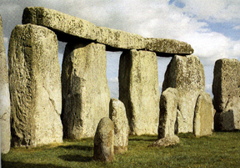
[for the following see also Stonehenge]
Stonehenge stands on the open downland of Salisbury Plain two miles (3 kilometres) west of the town of Amesbury, Wiltshire, in Southern England. It is not a single structure but consists of a series of earth, timber, and stone structures which were revised and re-modelled over a period of more than 2000 years.
The earliest portion of the complex, which dates to approximately 3100-2300 BCE., comprised a circular bank-and-ditch of about 330 feet (100 metres) in diameter. Just inside the earth bank is a circle of the 56 Aubrey holes (discovered by John Aubrey in the 17th century, and now invisible on the surface). Probably also dating to this time are the four Station Stones (only two of which survive) and, on the north-east side, an earthwork which runs from the break in the bank-and-ditch. The now-fallen Slaughter Stone, located at the break in the bank-and-ditch, may date from this period, as may also the Heel Stone, located further out along the Avenue.
Around 2100-2000 BCE, a circle about 108 feet (33 metres) in diameter comprised of originally of 30 neatly trimmed upright sandstone blocks (known today as sarsens), standing on average 13 feet (4 metres) above the ground, about 6.5 feet (2 metres) wide, and 3 feet (1 metre) thick, supporting a continuous ring of sarsen lintels (held in place by tongue-and-groove joints) was constructed in the centre of the original circular bank-and-ditch. A little later was added inside the circle of sarsens, in the shape of a horseshoe, ten upright sarsens arranged as five pairs with a single lintel.
Around 2000-1550 BCE, a horseshoe of smaller upright igneous stones without lintels (the bluestones) were brought from a site in Wales and placed inside the horseshoe of sarsens.
Finally, around 1550-1100 BCE, a circle of smaller upright bluestones was added between the outer sarsen circle and the outer horseshoe. Also added around this time are two concentric circle of holes - the so-called 'Y' and 'Z' holes.
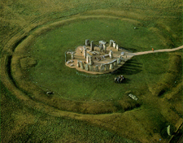

Stonehenge and the Druids

After centuries of neglect in the wake of first Roman and then Christian suppression, the Druids were rediscovered during the Renaissance when the revival of interest in ancient Greek and Latin writers brought attention to the works of Pliny, Tacitus, and Julius Caesar and their descriptions of the Celtic world. First in France in the sixteenth century, and then in England, the ancient Celts (or Gauls as they were known in France) and Druids were claimed as historical ancestors. By the seventeenth century, a new romantic image of Druids began to emerge in French and English literature.
In England as early as 1624 the Celtic warrior queen Boudicca is credited by Edmond Bolton with building Stonehenge as her monument. Although other English writers at this time refused to acknowledge anything worthwhile in Celtic culture, and the architect Inigo Jones (1573-1652), in his The Most Remarkable Antiquity of Great Britain, vulgarly called Stone-Henge, Restored, compiled from his notes by his son-in-law John Webb and published in 1655, would conclude that "Stonehenge was no work of the Druids" (he claimed instead that it had been built by the Romans, see "Stonehenge Restorations"), the link between the Druids and Stonehenge had nonetheless been forged in the popular imagination.
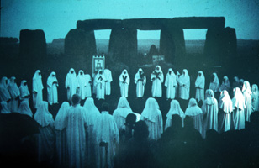
Druids celebrating the summer solstice at Stonehenge
Already by 1649, John Aubrey had suggested that the Druids were probably responsible for building Stonehenge, a theme he developed into a book originally to be titled 'Templa Druidum' but which ultimately formed a chapter in his Monumenta Britannica. In the early 18th century, Aubrey's views became known to William Stukeley who not only declared Stonehenge (and Avebury) to be a temple of the Druids, but, according to some, was instrumental in initiating in 1717 the first Order of Druids on Primrose Hill, London. Some scholars, however, have found no evidence for this, and recognize instead the earliest revived Druidic order as being the Ancient Order of Druids founded in 1781 by Henry Hurle who organized it on the lines of Freemasonry. By 1839, however, conflicts between members led to the formation of a breakaway movement named the United Order of Druids, lodges for which were also established in the United States and Australia. The United Order of Druids still flourishes today as an international charitable organization.
The more mystical Ancient Order of Druids also continued through the 19th century and into the 20th, claiming among its many members Winston Churchill (1874-1965), who was initiated into the Albion Lodge at Oxford.
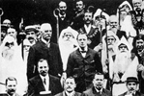
Winston Churchill (center) hosts the Ancient Order of Druids
at Blenheim Palace on 15 August, 1908
Exactly when the Ancient Order of Druids began their annual summer soltice celebrations at Stonehenge is unclear. Meanwhile, though, the monument drew a variety of other visitors and was popular among royalty and public alike. In the photograph on the left, Prince Leopold (4th from the right), the youngest son of Queen Victoria, enjoys a picnic with friends, while the photograph on the right records a village outing in the late 19th century.
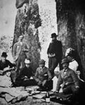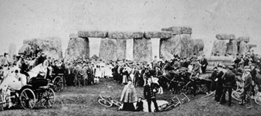
By 1900 visitors were causing a lot of damage to the monument (two stones fell in this year) so its owner, Sir Edward Antrobus fenced in the site and began charging an entry fee. Not surprisingly, this greatly annoyed the Druids who refused to pay and were forcibly ejected by the police. A High Court case in 1905 upheld Antrobus's right to charge admission. A photograph from 1905 shows that despite the entry fee the ceremonies that year were nonetheless well attended.
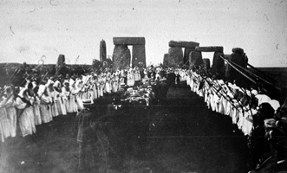
Initiation of novices into the Ancient Order of Druids at Stonehenge, August, 1905
In 1915, Stonehenge was sold and in 1918 the new owner presented it to the nation. By this time the number of Druidic sects had multiplied to five with each one vying to perform 'sacred rites' at the monument. A photograph from 1923 shows one of these sects performing the summer solstice celebration of that year.
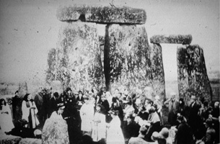
Druidic Ceremony at Stonehenge, 1923
(Photograph from the library of Roger Viollet, Paris)
By 1949 only two of these sects survived, and by 1955 only one, the British Circle of the Universal Bond, which claimed to be not only the true descendants of Henry Hurle's original Ancient Order of Druids but also of William Stukeley's Order of Druids purportedly founded in 1717. In 1963, an internal dispute produced the breakaway Order of Bards, Ovates and Druids. The Bards celebrated their rites at Tower Hill. The Bond, however, continued to welcome the midsummer dawn at Stonehenge.
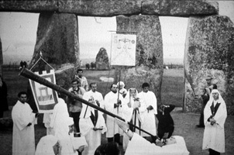
A herald trumpets a welcoming fanfare to the four winds at summer solstice ceremonies in 1966
(Photograph by Austin Underwood)
From the beginning, it would appear, the Druidic ceremonies at Stonehenge drew crowds of spectators and the occasion early acquired a celebratory, festival-like character. A mass induction of novices into the Ancient Order in August, 1905 (the novices can be seen marching in procession between ranks of Druids in the photograph of that occasion), included a grand lunch at which, according to local newspaper reports, a large quantity of drink was consumed.
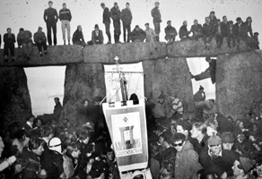
A photograph from 1966 shows the Druids almost lost among the crowds of people a number of whom watch the ceremonies perched on top of the stones. In 1975, the new 'New Age'-oriented, alternative, neo-pagan Secular Order of Druids was initiated and the annual Stonehenge festival began to attract huge crowds. After 65 years or so of being managed by departments of the government, in 1984 Stonehenge was placed under the control of English Heritage, a quasi-independent agency established by Parliament with responsibility for looking after ancient sites in England.

Druids
Although since Christian times Druids have been identified as wizards and soothsayers, in pre-Christian Celtic society they formed an intellectual class comprising philosophers, judges, educators, historians, doctors, seers, astronomers, and astrologers. The earliest surviving Classical references to Druids date to the 2nd century B.C.E.
The word Druidae is of Celtic origin. The Roman writer Pliny the Elder (Gaius Plinius Secundus, 23/24-79 C.E.) believed it to be a cognate with the Greek work drus, meaning "an oak." Dru-wid combines the word roots "oak" and "knowledge" (wid means "to know" or "to see" - as in the Sanskrit vid). The oak (together with the rowan and hazel) was an important sacred tree to the Druids. In the Celtic social system, Druid was a title given to learned men and women possessing "oak knowledge" (or "oak wisdom").
Some scholars have argued that Druids originally belonged to a pre-Celtic ('non-Aryan') population in Britain and Ireland (from where they spread to Gaul), noting that there is no trace of Druidism among Celts elsewhere - in Cisalpine Italy, Spain, or Galatia (modern Turkey). Others, however, believe that Druids were an indigenous Celtic intelligentsia to be found among all Celtic peoples, but were known by other names.
With the revival of interest in the Druids in later times, the question of what they looked like has been largely a matter of imagination. Early representations tended to show them dressed in vaguely classical garb. Aylett Sammes, in his Britannia Antiqua Illustrata (1676), shows a Druid barefoot dressed in a knee-length tunic and a hooded cloak. He holds a staff in one hand and in the other a book and a sprig of mistletoe. A bag or scrip hangs from his belt.
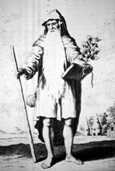
A fanciful image of a Druid
(Plate from Aylett Sammes, Britannia Antiqua Illustrata, 1676)
Sammes's drawing was subsequently copied and modified by William Stukeley who shortened his beard, removed the mistletoe, turned the bag at his side into a sort of bottle or gourd, and placed an axe-head in his belt.
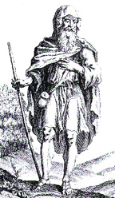
Another fanciful image of a Druid
(Plate from William Stukeley, Stonehenge, a Temple Restored to the British Druids, 1740)
Besides observing that the name 'Druid' is derived from "oak", it was Pliny the Elder, in his Naturalis Historia (XVI, 95), who associates the Druids with mistletoe and oak groves: "The Druids...hold nothing more sacred than the mistletoe and the tree on which it grows provided it is an oak. They choose the oak to form groves, and they do not perform any religious rites without its foliage..." Pliny also describes how the Druids used a "gold pruning hook" or "sickle" to gather the mistletoe.
"Anything growing on those trees [oaks] they regard as sent from heaven and a sign that this tree has been chosen by the gods themselves. Mistletoe is, however, very rarely found, and when found, it is gathered with great ceremony and especially on the sixth day of the moon... They prepare a ritual sacrifice and feast under the tree, and lead up two white bulls whose horns are bound for the first time on this occasion. A priest attired in a white vestment ascends the tree and with a golden pruning hook cuts the mistletoe which is caught in a white cloth. Then next they sacrifice the victims praying that the gods will make their gifts propitious to those to whom they have given it. They believe that if given in drink the mistletoe will give fecundity to any barren animal, and that it is predominant against all poisons."
A nineteenth-century painting shows a Druidess holding both the sickle and a sprig of mistletoe. She is also standing next to a megalithic structure.
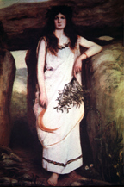
A Druidess, holding mistletoe and a sickle, standing next to a dolmen
(painting by La Roche, late nineteenth century)

Druids and Stone Circles
It was John Aubrey, writing in the 17th century, who first thought it a "probability" that stone circles, such as Stonehenge, "were Temples of the Druids" and called his text on stone circles the Templa Druidum. This idea was picked up by William Stukeley, in the early 18th century, who subtitled his first book, Stonehenge, published in 1740, "a Temple Restored to the British Druids, and his second, on Avebury, published in 1743, "a Temple of the British Druids." Although later, in the 19th century, Sir John Lubbock (1834-1913) dated Stonehenge to a period much earlier than the time of the Druids (that is, to about 2000 B.C.E., whereas the Druids don't appear in the historical record until 1800 years later), nonetheless the view was maintained by a minority that Druids were pre-Celtic inhabitants of Britain and that the religious beliefs and practices for which Stonehenge was first built are ancestral to those of the later Celtic Druids.
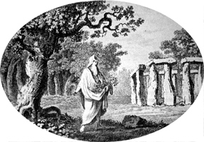
A Druid, holding a sickle and mistletoe, stands in a grove of sacred oak trees with a Stonehenge-like 'temple' (18th century)

Celtic Festivals
The Celtic year was divided into four parts by two major feasts (Samhain and Beltane) and two lesser feasts (Imbolc and Lughasadh):
Samhain, the most important of the four feasts, was celebrated on November 1. It marked the beginning of the dark half of the year. It is now associated with 'All Souls' Day' (All Hallows' Day), which today is mostly celebrated the night before, on Halloween (All Hallows' Eve). This would not be inappropriate because the Celts, and later relgious groups, including the Christians, reckoned a daily unit as running from sunset to sunset, so that the night before was counted with the date of the following day.
Beltane, celebrated on May 1, marked the beginning of the light half of the year. Beltane (also spelled Beltine, Beltain, Beal-tine, Beltan, Bel-tien, and Beltein) means "bright fire" and in the past two fires were lit by Druids in honour of Bel. Later it came to be associated with May Day (Calan Mai).
Imbolc was celebrated on February 1. It was associated with the goddess Brigit, a Mother-goddess and protectress of women in childbirth.
Lughnasadh (also known as Lammas), 'the feast of the god Lugh' (or Lug), was celebrated on August 1 in connection, it would appear, with the harvest.

Morris Dancing
Although the link between Druids and megalithic sites is tenuous at best, there seems to be no reason to doubt that both the celebration of ancient Celtic festivals and the rituals performed at stone circles and other megalithic sites included dancing in one form or another. Evidence for the latter is virtually non-existent, but folklore and other clues suggest, for example, that dance may have been performed at Stonehenge if only through the suggestive description by Geoffrey of Monmouth, writing in the 12th century, who calls Stonehenge the Dance of the Giants (chorea gigantum). Much later, Morris dancing used to take place around the ancient barrow at St. Weonards in Herefordshire. Morris dancing, in fact, has been claimed to be a remnant of a pre-Christian Celtic, or Druidic, fertility dance.
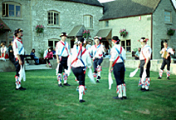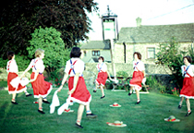
Morris Dancers outside The Old Neighbourhood Inn, Chalford Hill, Gloucestershire, England
Morris dancing also figures among the evidence in support of the claim that dancing formed part of the celebration of Celtic festivals. Among the earliest references to Morris dancing are those made by Shakespeare, who, in All's Well that Ends Well (II.ii.21), makes it clear that the Morris dance was commonly performed on May Day (May 1). That Morris dancing was associated with May Day celebrations in the early 17th century is also suggested through King James I's Book of Sports which permitted among the amusements to be enjoyed on a Sunday the continuation of "May games, Whitsun ales and morris dances, and the setting up of May-poles..." The Whitsun ales referred are a beer produced for Whitsun (or Whitsunday, celebrated in the Christian calendar as Pentacost) which Shakespeare, in Henry V (II.iv.18), says was also a time when Morris dances were performed.
The origins of Morris dancing are lost in the mists of time. It survives today as a form of folkdance performed in the open air in villages in rural England by groups of specially chosen and trained men and women. It is a ritual rather than a social dance which the dancers take seriously. It is felt that the dances have a magic power and serve both to bring luck and to ward of evil. Attempts to uncover the origins of Morris dancing have focused mostly on the name. Some believe Morris to be a corruption of the word "Moorish" and therefore to have originated in Africa. In order to explain how African dancing could crop up in England, it has been suggested that back Moorish captives were brought back from the Holy Land by crusaders. Or, alternatively, it has been suggested that John of Gaunt (1340-1399), Duke of Lancaster, following the failure of his campaign in Spain to claim the kingship of Castile and Leon, returned to England with Spanish Moors as captives.
In this sense, the word "morris" would seem to be related to "morisco", which is a form of court dance performed in Italy. However, Joseph Strutt (1749-1802), in his Sports and Pastimes of the People of England, doubts this was the origin of Morris dancing, stating that "the Morisco or Moor dance is exceedingly different from the morris-dance...being performed with the castanets, or rattles, at the end of the fingers, and not with bells attached to various parts of the dress." Otherwise, Strutt suggests that the morris-dance originated from the "Fool's Dance" (traceable to the 14th century), in which the dancers dressed in the manner of the court fool, and from which can be traced the bells used by morris dancers.
If Morris is a corruption of a similar-sounding word, it could equally well be "moorish" in reference to, at the time of Shakespeare, boggy land, and later used in connection with moorland or heathland. It has also been suggested that the word Morris is derived from the Latin word "moris" meaning tradition or custom. Then again, it might be derived from the game "merelles", forms of which were called ninepenny morris" or "nine men's morris" (referred to, for example, by Shakespeare in A Midsummer Night's Dream, II, i, 98). On the continent, the name was applied to the stepping, dance-like game of 'hop-scotch.'
Attempts to discover the origins of the dances performed have revealed a general connection with other ritual folkdances elsewhere in the world such as santiagos, moriscas, and matachinas of the Mediterranean and Latin America, and the calusari of Romania. The ultimate source of this type of dancing, however, remains hidden. It is suspected, however, to be of pagan origin performed most likely as part of ancient fertility rites. The music and dances were perhaps intended to attract beneficial influences, while the bells, fluttering handkerchiefs, and clashing sticks served as the means to scare away malevolent spirits.
Traditional Morris dancing is today associated with the Cotswolds, a region of England located between Oxford and the Welsh border. Cotswold Morris is danced in sets of six dancers arranged in two rows of three. For some dances, handkerchiefs are held in each hand, while for other dances short sticks are carried, and struck against each other or against those of a partner. Part of the costume includes bells, usually worn tied below the knees.
Costume varies from one Morris team, or 'set', to another, with each village also producing its own steps and dances. Morris men usually wear a white shirt, white trousers or dark breeches, and black shoes. Coloured sashes or baldrics worn over one or both shoulders, or a waistcoat, serve to distinguish different teams. The Stroud Morris Dancers in Stroud, Gloucestershire, for example, wear white trousers and shirts with red and green sashes (the colours of Stroud).
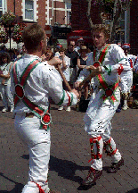
Stroud Morris Dancers performing the Stick Dance, Sidmouth, England
Other teams, such as that dancing in front of the Old Neighbourhood Inn at Chalford Hill in Gloucestershire, are dressed in dark breeches and bowler hats. A variant of Cotswold Morris is Border Morris, associated with the Welsh border counties, which have sides of four, or six, or eight men who darken their faces and wear 'rags' and dark trousers. Border Morris is danced more vigorously than Cotswold Morris and involves much clashing of sticks. Cotswold Morris is usually performed from May 1 to September, while Border Morris is traditionally performed in the winter months. Another form is North West Morris, in the North West of England, which is more of a processional dance with sides of at least nine men wearing clogs.
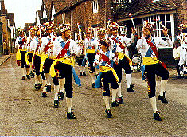
The Manley Morris Men dance in the North West tradition

Archaeoastronomy at Stonehenge
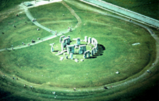
Already in the 18th century the British antiquarian William Stukeley had noticed that the horseshoe of great trilithons and the horseshoe of 19 bluestones at Stonehenge opened up in the direction of the midsummer sunrise. It was quickly surmised that the monument must have been deliberately oriented and planned so that on midsummer's morning the sun rose directly over the Heel Stone and the first rays shone into the centre of the monument between the open arms of the horseshoe arrangement.
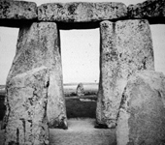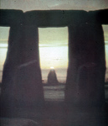
View from the center of Stonehenge towards the Heel Stone, and a photograph of the sun rising over the Heel Stone
This discovery has had tremendous impact on how Stonehenge has been interpreted. For Stukeley in the 18th century and Sir Norman Lockyer in the first years of the 20th century, this alignment implied a ritualistic connection with sun worship and it was generally concluded that Stonehenge was constructed as a temple to the sun. More recently, though, the astronomer Gerald Hawkins has argued that Stonehenge is not merely aligned with solar and lunar astronomical events, but can be used to predict other events such as eclipses. In other words, Stonehenge was more than a temple, it was an astronomical calculator.
It was argued that the summer solstice alignment cannot be accidental. The sun rises in different directions in different geographical latitudes. For the alignment to be correct, it must have been calculated precisely for Stonehenge's latitude of 51° 11'. The alignment, therefore, must have been fundamental to the design and placement of Stonehenge. As if corroborating the claims made by Hawkins for Stonehenge, Alexander Thom, a professor of engineering and a mathematician, has shown that many other megalithic sites throughout Britain are also oriented towards the sun and the moon.
The alignment also made it clear that whoever built Stonehenge had precise astronomical knowledge of the path of the sun and, moreover, must have known before construction began precisely where the sun rose at dawn on midsummer's morning while standing on the future site of the monument. This point needs to be made because, as I suspect, with Stonehenge and many other such monuments, it was the site, a particular place within the landscape, that was important; only later were these sites marked in some more permanent manner by the digging of ditches and banks and (or instead) the erection of wood or stone structures.
For reasons we shall never know, this particular spot in the landscape was so important that not only were ditches and banks dug and, later, stone circles and horseshoe arrangements constructed to mark it, but that some of the stones were deliberately transported there with considerable effort from a great distance away.
Contrary to expectations, the great stone circles and horseshoe arrangements for which Stonehenge is famous are later additions to the monument (mostly Stonehenge III) and are not essential to the lunar and solar calculations.
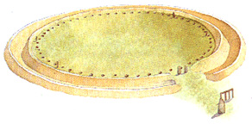
Stonehenge: Phase I
( image from Mohen, p. 30)
Today Stonehenge I is barely noticed by visitors. Standing far outside the massed standing stones of Stonehenge III, the remains are comprised of a circular ditch inside of which was erected a bank. The bank is now eroded down to about a foot or so but can still plainly be seen. There is little agreement on how high it was originally. The diameter of the bank is 320 feet and it has at least one major break in it in the northeast, presumably to allow an uninterrupted view in the direction of the Heel Stone and the midsummer sun. At least one other break is a noticeable, and perhaps also a third. It should be noted that the break in the northeast is not quite aligned with the later horseshoe structures; nor is it quite aligned with the causeway beyond, or with the Heel Stone.
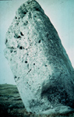
The Heel Stone
Inside the bank were dug 56 holes -- discovered by John Aubrey, and known as the Aubrey Holes -- placed at precisely regular intervals around a concentric circle of about 285 feet in diameter. Archaeological investigations have shown that these holes were not dug to hold upright stones or wooden posts. Besides the Aubrey Holes, of crucial importance are the four Station Stones marked at positions 91, 92, 93, and 94, to form a rectangle that stands in a precise relationship with the centre of the monument and with the Heel Stone. Only two of the Station Stones survive, and one of those may not be original.
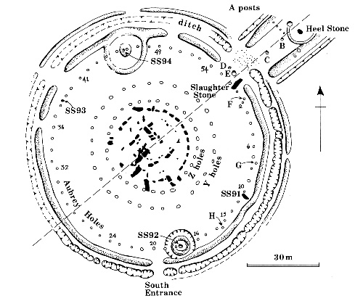
Plan of Stonehenge with the Aubrey holes, the Heel Stone, and the Station Stones 91, 92, 93, 94 marked
(image from Castleden, p. 30)
For the archaeoastronomists, the Aubrey Holes served as fixed reference points along a circle, and their number was essential to astronomical calculations. The cycle of the moon, for example, which takes 27.3 days, can be tracked by moving a marker by two holes each day to complete a circuit in 28 days.
A much longer calculation is to move the marker by three holes per year to complete a full circuit in 18.67 years. In this way, it is argued, it would be possible to keep track of the nodes, points where the paths of the sun and the moon apparently intersect to produce an eclipse. Because the moon slews around in its path, the two nodes move along the path of the sun, a complete circuit of which takes 18.61 years. By means of the markers in the Aubrey Holes and keeping track of the directions of the sun and the moon, the astronomer at Stonehenge could calculate nodal points ahead of time and thus predict both lunar and solar eclipses.
Whether this was in fact the intended use of the Aubrey Holes is highly debatable. In recent years astronomical interpretations have been taken up in support of more fanciful notions about the cosmic "New Age" significance of Stonehenge and contemporary "secular Druidism"

William Stukeley
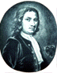
Like John Aubrey, Dr. William Stukeley (1687-1765) was an antiquarian and a scholar of sacred history and cabalistic science. He visited many ancient sites which, since John Aubrey's discoveries in the previous century, had provoked increasing interest in England. Stukeley was particularly curious about the arrangment of stone circles and earthworks in the landscape and his own scholarly predilections led him to claim such sites as Stonehenge and Avebury as monuments to an ancient faith manifest in Britain in the cult of the Druids. These claims he laid out in two books, Stonehenge, a Temple Restored to the British Druids, published in 1740, Abury, a Temple of the British Druids, published three years later in 1743.
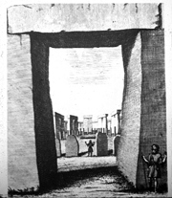
Plate from William Stuekeley's, Stonehenge, a Temple Restored to the British Druids, 1740
Stukeley perceived the entire prehistoric landscape as laid out in a sacred pattern with centres at Stonehenge and Avebury. The stone circles and earthworks at Avebury he recognised as part of a larger figure inscribed in the landscape in the form of a serpent. An illustration drawn by Stukeley for his book on Avebury shows a great stone serpent whose head rested at the now-destroyed Sanctuary on Overton Hill and whose body was formed by West Kennet Avenue and Beckhampton Avenue. The "bulge" of Avebury in the body of the serpent Stukeley explained as a circle through which the serpent is passing (as in the symbol of alchemical fusion). Little of the great stone serpent survives today. Stukeley pondered deeply this "hieroglyphic figure" of the snake proceeding from the circle, and came to the belief that it, and all the other stone circles with avenues known to him (such as Callernish in the Outer Hebrides) belonged to a class of temples for which he invented the name Dracontia: serpent or dragon temples.
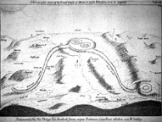
William Stukeley's 'great stone serpent'
Stukeley saw serpents, and dragons (a variant form of the same creature, as are also "worms"), all over countryside and linked the image with the many local legends of dragons and dragon-killers found throughout Britain. The places associated with the dragon legend appear always to coincide with sites of ancient sanctity. Flat-topped hills, such as Dragon Hill near Uffington, are pointed out as the place where a dragon was slain. The dragon-slayers may be local heroes, but may also identified as the Christianised knights St. George and St. Michael.
In geomantic terms, these serpent-dragons in the landscape have come to be identified with the Chinese lung-mei or dragon currents

Sir J. Norman Lockyer

Sir J. Norman Lockyer (1836-1920) was a British astronomer and a respected scientist in his day. In 1869 he founded and served as editor of the prestigious scientific journal Nature and in 1885 he was appointed the world's first professor of astronomical physics at the Royal College of Science, South Kensington, London (now part of Imperial College). During his tenure there he served as director of research until 1913 of the newly built Solar Physics Observatory. In 1912 he founded The Norman Lockyer Observatory at Salcombe Hill, Sidmouth, Devon, in England. As a scientist he is remembered chiefly for his work on the sun and in particular for his discovery of helium in its atmosphere. Because of his application of physics to astronomical studies he is regarded as one of the founders of astro-physics.
Today Lockyer is perhaps better known for his astronomical interpretations of ancient and prehistoric sites. While traveling in Greece in 1890 he had noticed that numerous ancient temples were aligned along an east-west axis and wondered if their precise alignment corresponded to the sunrise on the day of their foundation. He tested this hypothesis on temples in Egypt where he found, for example, an alignment corresponding to the midsummer sunset along the main axis of the Great Temple of Amon-Re at Karnak. These solar alignments, plus other alignments connected with the star Sirius, Lockyer published in The Dawn of Astronomy in 1894.
With this notion that temples may have been aligned to foundation day sunrises, Lockyer turned his attention to Stonehenge. Working on the presumption that the midsummer sun rose originally over the Heel Stone, Lockyer attempted to calculate back from the point where the sun now rose on midsummer's dawn in 1901 to determine when it would have risen precisely over the Heel Stone and thereby establish the date when Stonehenge was built. Together with F. C. Penrose, he published the results of these calculations in 1901 ("An attempt to ascertain the date of the original construction of Stonehenge," Proceedings of the Royal Society of London, 69, 1901, pp. 137-147).
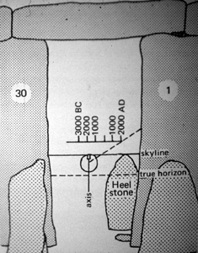
Lockyer's technique for dating Stonehenge
Lockyer calculated that Stonehenge was built around 1680 BCE. His method of calculation, however, was flawed and the result is usually dismissed as meaningless. One of the problems in this sort of calculation is the difficulty in establishing the precise line of the axis. Another problem with Lockyer's calculations was that he used inaccurate tables for correction.
Lockyer developed these ideas further. He measured other alignments at Stonehenge, both along the axis and between certain stones, and tried to relate them to other calendrical events in the ancient Celtic calendar. Besides the summer solstice, he found evidence of alignments that marked midpoints separating the solstices and equinoxes. It needs to be stressed that for Lockyer these alignments were primarily symbolic and had been established by the builders of Stonehenge primarily to serve calendar-based rituals and celebrations. For Lockyer Stonehenge was neither a megalithic calendar nor an astronomical calculator in the way it was later to be interpreted by Gerald Hawkins. He believed that Stonehenge was a temple and that the ruined stone structure we see today is the remains of a much older temple built to celebrate the ancient Celtic festival of Beltane (May Day).
These ideas, which he extended to include other ancient sites, were published in Stonehenge and Other British Monuments Astronomically Considered in 1906. Lockyer's belief in the astronomical purposes of Stonehenge and other stone circles has been the primary impetus behind this kind of research in the twentieth century. For this reason he has been called the "father of archaeoastronomy." His belief that ancient sites such as Stonehenge were axially oriented towards a place on the skyline where a celestial body -- the sun, the moon, or a star -- crossed the horizon on a particular day has been taken up and elaborated upon by later writers, notably Gerald Hawkins and Alexander Thom.

Alexander Thom
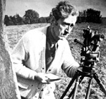
Born in Scotland in 1894, Alexander Thom was a student at Glasgow University. Later he returned there as a lecturer (1922-1939) before becoming a professor of engineering at Oxford University, a post he held from 1945 until his retirement in 1961. He died in 1985.
As early as 1934 Thom had become interested in prehistoric stone circles and their astronomical associations. The nature of his interests is expressed in an article he published in 1951 in the Journal of the British Astronomical Association entitled "The solar observations of megalithic man."
Thom also undertook the project of accurately surveying and carefully measuring megalithic sites throughout Britain, the initial results of which he published in 1955 in the Journal of the Royal Statistical Society. After his retirement, he published two more articles in the same journal, in 1962 and 1964, which addressed megalithic units of length.
His discovery of what he called the megalithic yard (2.72 feet, or 0.83 metres), a unit of measurement he found employed consistently at many prehistoric megalithic sites, is a key feature of his book Megalithic Sites in Britain, published in 1967, for which he had surveyed some 300 megalithic circles, alignments, and isolated standing stones. This was followed in 1971 by another book, Megalithic Lunar Observatories.
Besides the megalithic yard, Thom also contributed a heightened awareness of the geometry of stone circles, showing there were six types: true circles, ellipses, two sorts of egg-shaped circles, and two sorts of flattened circles.
In important ways, Thom's work converged with that of Gerald Hawkins which emphasized the preoccupation of Stonehenge's builders with astronomy and mathematics. Whereas Hawkins focused on Stonehenge, Thom was able to demonstrate that a large number of other megalithic sites were also oriented to the sun and the moon.
Although admired for his impeccable science and respected for the thoroughness and intellectual rigour of his research, Thom's findings remain controversial among scholars.

Gerald Hawkins
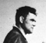
One of the heirs of Sir Norman Lockyer was the astronomer Dr. Gerald S. Hawkins who employed a computer to show that there existed at Stonehenge a pattern of alignments with twelve major lunar and solar events. He first published his findings in an article, "Stonehenge Decoded," in the journal Nature in 1963, and then in a book with the same title, Stonehenge Decoded, in 1965 (New York: Doubleday; published in London: Souvenir Press, in 1966).
Hawkins identified 165 key points in the Stonehenge complex and found that many of them very strongly correlated with the rising and setting positions of the sun and moon. As remarked in the discussion of Stonehenge and Archaeoastronomy, the most important features of the site are those associated with Stonehenge I: the 56 Aubrey Holes, the Heel Stone, and the four Station Stones (91, 92, 93, 94). Hawkins argued that the Aubrey Holes could be used to predict eclipses of the moon. In the following diagram are indicated the summer and winter solstice alignments (including the summer solstice sunrise over the Heel Stone), and the maximum and minimum "standstills" of the moon.
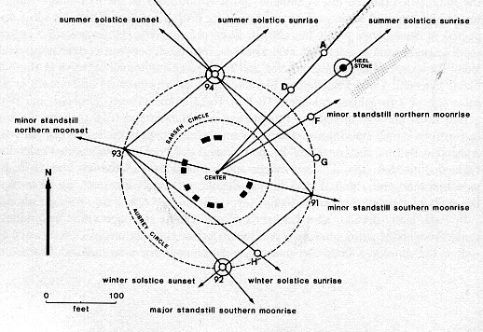
Alignments of sun lines and moon lines through the Station Stones and the Heel Stone
(diagram from Krupp)
Hawkins' ideas dovetail nicely with those of Alexander Thom. His book generated a lot of controversy, fomenting in particular a clash between astronomers on the one hand and archaeologists on the other.
In 1968 Hawkins shifted his attention from Stonehenge and turned to a similar problem in Peru, the possible astronomical alignments and associations found in the mysterious lines and gigantic geometric figures at Nazca. Hawkins published the results of his Nazca surveys in Ancient Lines in the Peruvian Desert in 1969.

The Sanctuary

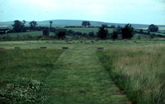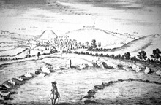
The Sanctuary, situated on Overton Hill next to the Ridgeway near Avebury, was begun around 3,000 B.C.E. It originally comprised six concentric rings of timber uprights. Later, the timbers were replaced by double stone circles. The site, of which only the post and stone holes remain today (now marked by concrete blocks) was destroyed in the 18th century, but not before William Stukeley made a drawing of it (above, right). Excavations have suggested that the site was used for feasting and for some form of mortuary ritual.
For Stukeley, the Sanctuary represented the head of a great stone serpent the body of which was formed by the West Kennet Avenue and the Beckhampton Avenue.
William Stukeley's 'great stone serpent', with the Sanctuary located on Overton Hill at the right
The photograph on the left below is a view of the Sanctuary taken from the West Kennet Long Barrow. The Sanctuary is located about mid-way along the ridge, which is also the line of the Ridgeway. Along the Ridgeway to the left of the Sanctuary can be seen two burial mounds. The photograph on the right is a view of Silbury Hill seen from the Sanctuary. The flat-topped summit of the hill, visible above the trees, is in line with the distant horizon.
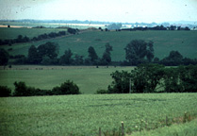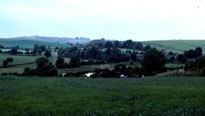

Avebury
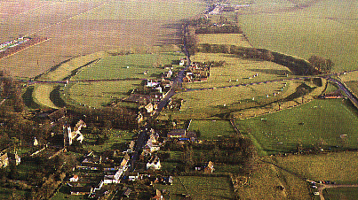
The village of Avebury in Wiltshire has given its name to one of the greatest stone circles in the British Isles. Located in the midst of a rich prehistoric landscape, the village lies a few miles away from the Ridgeway and in close proximity to Silbury Hill, the Sanctuary, the West Kennet Long Barrow, and the long barrows of East Kennet and Beckhampton.
The story goes that while returning from a day's hunting one winter's evening in 1648, John Aubrey, on passing through the village of Avebury, recognized in the earthworks and standing stones around him an ancient temple, which he attributed to the Druids.
In the early 18th century, William Stukeley visited the site on several occasions and witnessed, to his great distress, the destruction of numerous stones by farmers intent on clearing the land for fields. Stukeley agreed with Aubrey's identification of the site and in 1743 published his book Abury, a Temple of the British Druids.
Mostly dating to around 2,600-2,500 B.C.E., the Avebury complex, which covers about 28 acres and is partially overlapped by the village, comprises a huge circular earthwork ditch, originally about 30 feet deep, and bank about a quarter of a mile in diameter which encloses an outer circle of standing stones. Within this outer circle are two inner circles, both about 340 feet in diameter. The northern inner circle, of which only a few stones remain, apparently consisted of two concentric circles; an inner one of 12 stones and an outer one of 27 stones. At the centre of the northern circle stood a trio of very large stones, two of which survive, called "the Cove." At the centre of the southern circle stood a tall stone over 20 feet in length called "the obelisk." It had already fallen when William Stukeley saw, and drew it, in the 18th century, and is now gone altogether (its site, as with the other missing stones at Avebury, is now marked by a concrete pillar).
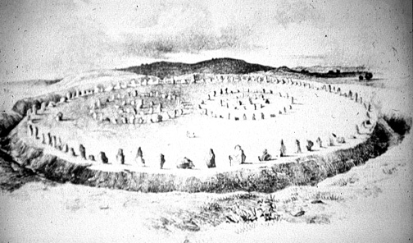
Avebury 'restored'
The northern and southern inner stone circles are believed to have been built first, around 2,600 B.C.E., and the outer circle and the earthworks added about a hundred years later, around 2,500 B.C.E.
The outer circle is breached at four points - roughly at points north, south, east, and west - to form entrances. From two of these originally ran two great avenues of which only the one, leading from the south entrance, the so-called West Kennet Avenue, survives for a short way in reconstructed form with stones lining its course on both sides.
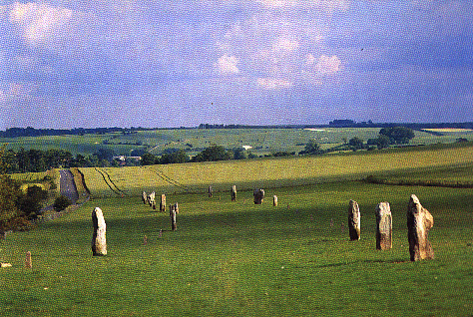
West Kennet Avenue
Originally, according to Stukeley, the West Kennet Avenue stretched all the way to the Sanctuary on Overton Hill, while the other, the Beckhampton Avenue, of which very little survives, terminated near the Beckhampton Long Barrow. Stukeley interpreted the avenues as representing a great stone serpent passing through a ring formed by the Avebury circle.
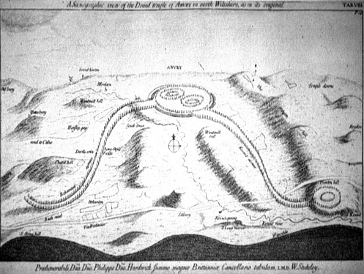
William Stukeley's "great stone serpent"
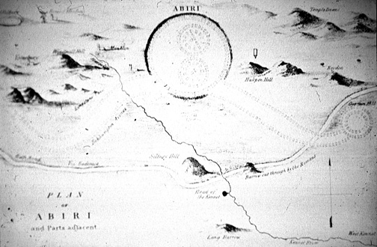
A plan of 'Abiri' (19th century)

Healing Stones
Over the centuries, much folklore has attached itself to megalithic sites in Britain. There is considerable evidence indicating that a stone cult existed in the prehistoric past which Christianity was only partially successful in suppressing. The very necessity of the numerous edicts issued by the church Councils in 5th, 6th, and 8th centuries C.E. against all pagan cults connected with springs and wells, trees, and stones (which no doubt included megalithic standing stones) is indicative of their persistence. According to Leslie Grinsell in his book Folklore of Prehistoric Britain (1976), in the late 9th century C.E., the Council of Nantes in France condemned the veneration of stones. Various decrees not only prohibited the worship of stones but also declared guilty of sacrilege anyone who neglected to destroy them.
It is clear, however, that standing stones continued to be venerated throughout the medieval period and even later. In 1410, according to the Hereford Cathedral Registers, the Bishop of Hereford issued a proclamation forbidding the worship of the stone and well at Turnastone in Herefordshire. It would appear that one of the most popular reasons for venerating standing stones was the belief in their ability to cure illnesses and other ailments. Anglo-Saxon laws were sometimes directed specifically against people who sought cures at stones. In his account of Stonehenge, written in the 12th century, Geoffrey of Monmouth notes that "in these stones is a mystery, and a healing virtue against many ailments." At Stonehenge, the stones were washed and the water poured into baths in which the sick then bathed. Healing properties continued to be attributed to the stones at Stonehenge in the 17th and 18th centuries.
It has been suggested that the association of these stones with healing may have come about through the confusion of "heal" and "heel", with both words possibly a corruption of the name Helios, the Greek name for "sun" and the sun god. That numerous megalithic sites, standing stones, and stone circles have astronomical associations has been convincingly demonstrated by Alexander Thom and, in the case of Stonehenge in particular, by Sir Norman Lockyer, Gerald Hawkins, and Fred Hoyle. The so-called "Heel Stone" at Stonehenge should properly be called the Helios Stone, or sun-stone, over which the sun rose at the summer solstice.
Healing properties were especially associated with stones with holes in them. The most famous example is Men-an-Tol, also known as the Crick Stone, near Madron in Cornwall. According to an 18th-century source, sufferers from pains in the back and limbs were cured after crawling through the hole. Also, children suffering from rickets (a disease of infancy and childhood characterized by defective bone growth caused by a lack of vitamin D in the body) or a 'crick in the neck' would be cured after being passed three or nine times through the hole, usually against the sun (widdershins). For the cure to work, it was important that boys were passed from a woman to a man, and girls from a man to a woman.
A similar practice was performed at the Tolvan Stone, also in Cornwall. Here the ceremony involved passing the child nine times through the hole alternately from one side to the other. In the 19th-century engraving illustrated here can be seen a woman about to pass a baby through the hole to a person on the other side. It was essential to the cure that the child should emerge on the ninth passing through the hole on the side of the stone where there was a little grassy mound on which the child should be set to sleep with a sixpence under his or her head.
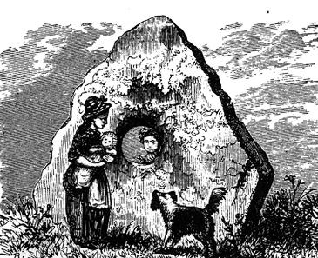
The Tolvan Stone, Constantine, Cornwall (engraving, 1870)
Folklore has attributed similar healing properties to the Long Stone in the Parish of Minchinhampton in Gloucestershire. Known locally as the "holey stone", this slab of oolitic limestone stands nearly 8 feet high with a thickness of about 18 inches. Believed to be the last surviving fragment of a long barrow chamber, the stone has two holes in it through the larger of which mothers would pass their children to cure them of whooping cough or rickets. Folklore also tells that the Long Stone runs around the field it is in when it hears the town clock in nearby Minchinhampton strike midnight.
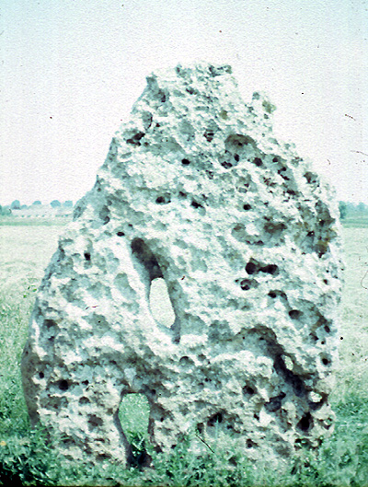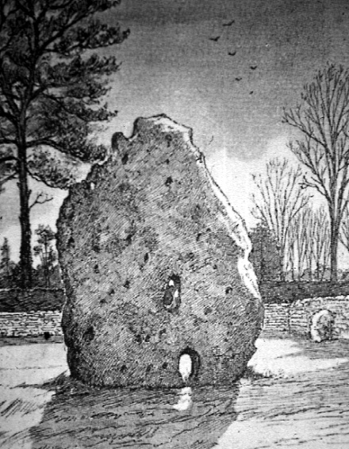
The Long Stone, Parish of Minchinhampton, Gloucestershire (and at right a drawing from 1913)

Mên-an-Tol Monument

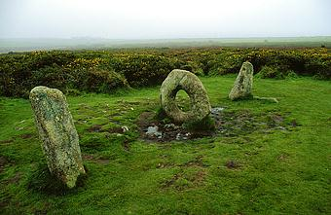
There were many traditional rituals at the Mên-an-Tol, distinguished by its strangely pierced central stone

The Mên-an-Tol monument consists of four stones: one fallen, two uprights, and between these a circular one, 1.3m (4ft 6in) in diameter, pierced by a hole that occupies about half its size. An old plan of Mên-an-Tol (the name means stone with a hole in Cornish) shows that originally the three main stones stood in a triangle, which makes certain astro-archaeological claims for it difficult to support. They could be the remains of a Neolithic tomb, because holed stones have served as entrances to burial chambers. Its age in uncertain but it is usually assigned to the Bronze Age, between 3000-4000 years ago.
Holed stones are found in many parts of British Isles as well as in other countries of the world; together with holy wells they have retained the ideas and customs associated with them more tenaciously than any other type of ancient sites. Beliefs connected with them are remarkably similar from the Orkneys to the far west of Cornwall.
Traditional rituals at Mên-an-Tol (centuries ago known also as Devil's Eye) involved passing naked children three times through the holed stone and then drawing them along the grass three times in an easterly direction. This was thought to cure scrofula (a form of tuberculosis) and rickets. Adults seeking relief from rheumatism, spine troubles or ague were advised to crawl through the hole nine times against the sun. The holed stone also had prophetic qualities and, according to nineteenth-century folklorist Robert Hunt: If two brass pins are carefully laid across each other on the top edge of the stone, any question put to the rock will be answered by the pins acquiring, through some unknown agency, a peculiar motion.
From Mên-an-Tol, about five minutes walk further up the main lane, is Mên Scryfa, a stone clearly visible standing in the centre of a field over to the left

.

Mên Scryfa

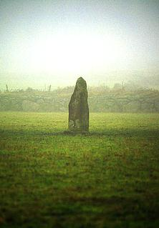
There's an early Christian inscription on the northern face of this standing stone

Mên Scryfa or Screfys (written stone) stands on high ground not far from Mên-an-Tol. Although the stone itself may have been a much earlier menhir, there's an early Christian inscription on it which of course is of too late a date (about AD 500) to qualify it as a prehistoric site. However, Mên Scryfa is a successor to the Bronze Age standing stones in that it marks a grave, but differs from them in that it bears the name of the people buried there. On the granite pillar is inscribed RIALOBRANI CUNOVALI FILI. This signifies that the stone is of the Royal Raven, son of the Glorious Prince.
The raven, a bird of carrion linked with death and the battlefield, was believed to have magical power for those who worshipped it; the bird was venerated over much of northern Europe, being an important symbol in an aggressive warrior society.
The story of Rialobran is very ancient: it seems that an invader attacked the Glorious Prince, seized his lands and occupied his hillfort. The defeated royalty was forced to flee, possibly to the area around Carn Euny. The Royal Raven tried to regain his father's territory and a great battle was fought on the moors where Mên Scryfa now stands. Rialobran was killed and his body buried by the stone which was said to correspond to the height of the dead warrior. That such a monument could be erected suggests that the battle was won and that his tribal lands were retaken.
The inscription on the stone is contemporary with the re-occupation and new defensive works carried out at the nearby fortification of Chûn Castle. This was the period between the departure of Romans and the coming of the English, when Cornwall was again ruled by its native princes. Rialobran is one of the first Cornish names we know: here is the transition between prehistory and history.

Hetty Pegler's Tump
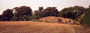
Also known as the Uley Barrow, Hetty Pegler's Tump is a chambered neolithic long barrow 120 feet long, 85 feet at its widest, and 10 feet high at the entrance end. The photograph at left is a view of the tump across the field. The background of trees is recent. Without the trees, the view would extend across the Vale of Gloucester and the Severn Valley, such as ones sees at The Toots Barrow further along the same escarpment.
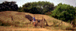
Beyond the fence with the gate in it can be seen the entrance to the tump. A narrow pathway within the remains of a forecourt space leads to the low opening over which is visible the massive lintel slab supported by two uprights.
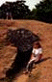
Clearly visible in the photograph here is the great lintel slab which measures over 8 feet by 4.5 feet. The entrance is about 3 feet high. The gallery beyond the entrance is 22 feet long, 3 to 5 feet in width, and 5 feet high. Originally there were two pairs of of facing side chambers on the north and south sides, but those on the north have been blocked off since 1821 when the first excavations occurred. The barrow was dug into again in 1854.
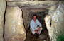
The gallery continues past the side chambers to form an end chamber at the west end. Its size can be judged by the presence of the author. During the 1821 excavation the remains of 15 skeletons were found, and a later, intrusive Roman burial above the northeast chamber.
The name Hetty Pegler derives from one of the 17th-century owners of the field in the tump is located: Hester and Henry Pegler. Hester died in 1694, and Henry in 1695.

Silbury Hill
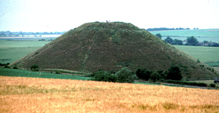
Silbury Hill, located just south of the village of Avebury in Wiltshire, is a massive artificial mound with a flat top. It is approximately 130 feet (40 m.) high, with a base circumference of 1640 feet. It is composed of over 12 million cubic feet (339,600 cubic m.) of chalk and earth and covers over 5 acres (2 ha). Silbury Hill occupies a low-lying site and except at certain points in the landscape (notably from the West Kennet Long Barrow from which this photograph was taken), it does not protrude significantly above the horizon.
It was built in three stages, the first begun around 2,660 B.C.E. The last phase comprised the building of six concentric steps or terraces of chalk which were then covered with chalk rubble, flints, gravel, and finally soil to form a cone-shaped mound. Each of the six steps was concealed within the overall profile of the mound, except the last one at the top which was left as a terrace or ledge about 17 feet (5 m.) below the summit. This terrace is clearly visible on the eastern side of the mound, but less distinct from the west.
Various legends have been attached to Silbury Hill. Folklore has claimed it to be the burial place of an otherwise forgotten King Sil (or Zel); of a knight in golden armour; and even of a solid gold horse and rider. It is also told that the Devil was going to empty a huge sack of earth on the town of Marlborough, but was forced to drop it here by the magic of the priests from nearby Avebury. According to William Stukeley, the top of the hill was dug into in 1723 and some bones were discovered together with an ancient bridle. The mound was again dug into in 1776 and in 1849. In 1967, excavations were undertaken by Richard Atkinson but again neither burials nor any clue to the mound's meaning were discovered. Atkinson did learn, however, through radiocarbon analysis that the mound dates to around 2660 B.C.E. Further evidence from the remains of plants and insects indicated that the structure was begun during the first week in August, probably at the time of the Celtic festival of Lugnasadh (or Lammas) at the start of the harvest season.
When seen from the West Kennet Long Barrow (as in the view at the top of this page), the summit of Silbury breaks the horizon at the line of the terrace.
When seen from the Sanctuary, the summit is in line with the distant horizon, and even appears to slope gently with it.
Silbury can clearly be seen in the background, its summit in line with the horizon, in a drawing made by William Stukeley of part of the Sanctuary in 1723.
Silbury also appears prominently in Stukeley's drawing of the 'great stone serpent of the Avebury complex. The very top of the mound can also be discerned from the village of Avebury in what has been described as a precise geomantic relation with the so-called 'Obelisk' in the Avebury complex. It can be seen, however, only after the crops in the intervening field on the horizon have been harvested; the standing grain is sufficient to obscure the view. For some, this is further evidence for interpreting the mound in connection with harvest festivals.
The original purpose of Silbury is unknown, although various explanations have been put forward over the years. Recently, Michael Dames has suggested that the hill is a symbolic effigy of the ancient Mother Goddess and is to be associated with fertility rituals which marked the course of the year. The festival of Lugnasadh (or Lammas) in August, when it is thought Silbury was founded, celebrates the first fruits of the harvest. It has been pointed out that the spring which rises five hundred yards south of the hill and is the source of the River Kennet, was formerly called the Cunnit, a name which may be connected to the Mother Goddess and fertility.
Another explanation argues that Silbury Hill could have been used as an accurate solar observatory by means of the shadows cast by the mound itself on the carefully levelled plain to the north, towards Avebury. The meridian line from Silbury runs through Avebury church which stands on a ley line running between Stonehenge and the stone circle at Winterbourne Abbas. The same ley line also passes through two churches and the eastern slope of Silbury. Silbury, in fact, is a centre for alignments of straight prehistoric tracks, resurfaced by the Romans, and of standing stones. The Roman road between Marlborough and Bath runs directly towards Silbury Hill before swerving to avoid it. This would indicate that the Roman road followed a pre-existing track or ley line. John Michell (see Ley Lines) makes the following observations:
"In view of the fact that in China mounds like that at Silbury were erected upon lung-mei, the paths of the dragon (see Geomany), there is good reason to suspect that Silbury itself was sited by Pre-Celtic Druids on a dragon line with the assistance of a geomancer's compass. It may also be inferred that the Chinese lung-mei stretch over the entire globe. Many centres of English dragon legend (see Dragons and Dragon-killers) stand at the junction of well-marked leys, one notable long-distance example being the St Michael's line that runs from the Avebury circle to the extreme west of Cornwall." (The View over Atlantis, 1983, p. 70)

The Uffington White Horse
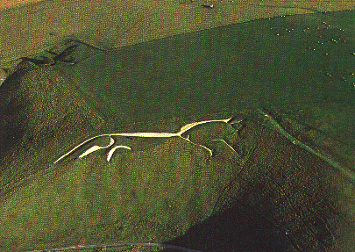

The White Horse is cut out of the turf on the upper slopes of Uffington Castle near the Ridgeway. It is 374 feet long and thought to represent a Celtic god or tribal symbol. For centuries, however, local people have maintained that it is a portrait of the dragon slain by St. George on the nearby Dragon Hill.

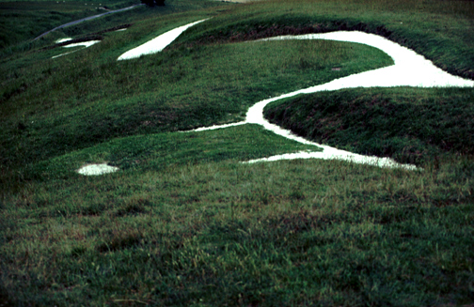
The photograph above shows a view over the head of the White Horse (in foreground: eye to the left, ears to the right) along the length of the body. As can be seen, it is almost impossible to make sense of the figure while standing on the hill into which it has been cut.
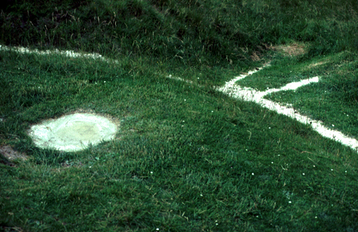

The photograph above shows a detail of the eye and the "beak", both of which, close-up, are surprisingly small. I'm always amazed at how well they show up when seen from far away, such as from the vale, or in an aerial photograph (above).

John Aubrey
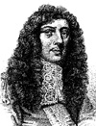
John Aubrey (1626-1697) was an English antiquary and miscellaneous writer. He was born in the hamlet of Easton Piercy in the parish of Kington St Michael near Chippenham in Wiltshire, and educated at Trinity College, Oxford. His most famous work is Lives of Eminent Men, which was not published, however, until 1823. He also wrote Miscellanies (1696), a collection of stories and folklore, the Natural History of Wiltshire (edited by John Britton, 1847), and a Perambulation of Surrey. His most important contribution to the study of British antiquities, the lengthy and discursive Monumenta Britannica, remains in manuscript. A scheme was afoot in 1692 to publish the manuscript and a prospectus and a specimen page were issued in 1693, but nothing more came of the project. It contains the results of Aubrey's field-work at Avebury and Stonehenge and notes on many other ancient sites, including Wayland's Smithy. Apparently the original title of the manuscript was to be Templa Druidum.
It was Aubrey who, in 1648, at the age of 22, while out hunting with some friends near Avebury in Wiltshire, recognized in the earthworks and great stones placed about the landscape in and about the village a great prehistoric temple. In the following century, William Stukeley was to develop the claim that Avebury was as an ancient cult centre of the Druids.
In addition to his 'discovery' of the Avebury complex, Aubrey is also remembered for his inclusion in a plan of Stonehenge in his Monumenta Britannica of a series of slight depressions immediately inside the enclosing earthwork. Curiously, Stukeley does not record them in his painstaking examination of the site, and it was not until excavations undertaken in 1921-25 by the Society of Antiquaries that they were found to be holes cut in the chalk to hold timber uprights. A total of 56 holes were discovered and named the Aubrey Holes in honour of John Aubrey's observation. These holes are now recognized as belonging to the first phase of the monument's construction.

Wayland's Smithy
Wayland's Smithy is a neolithic long barrow located just off the the Ridgeway on the Berkshire Downs about a half mile from Uffington Castle (an Iron Age hill fort) and the Uffington White Horse. It was built between 3,700 and 3, 400 B.C.E. The barrow is first mentioned by name in a charter in 955 C.E. It was sketched by John Aubry around 1670. The present appearance is the result of restoration following excavations undertaken by Richard Atkinson. It was constructed in two periods. The first construction was that of a ridged wooden mortuary hut with a stone floor, where 14 bodies were found, surrounded by sarsen boulders and heaped over with chalk. The mortuary hut disappeared with the construction of the present arrangement of chambers. The mound is 185 feet long and 43 feet wide at the south end.
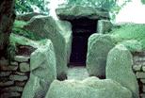
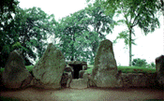
A series of gigantic sarsen stones, the tallest standing 10 feet high, are arranged in a line at the entrance at the south end. From the entrance extends a passage 20 feet long with an opposing pair of chambers and with a terminal chamber at the end. Except for the rearmost chamber, the capstones of the lateral chambers and gallery are missing.
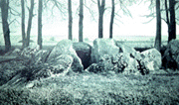
An early photograph of the barrow shows the state of the stones before the restoration was undertaken. It also provides a view through the trees, which have since grown much larger, to the opposite side of the Vale of the White Horse. As in other instances, Wayland's Smithy occupies a site within the larger context of the surrounding landscape and probably in line-of-sight of other important sites.
Wayland's Smithy is one of many prehistoric sites associated with Wayland, the Norse god of blacksmithing. According to legend, a traveller whose horse had lost a shoe could leave his horse and some money of the capstone of the tomb and return the next morning to find the horse shod and the money gone. It is thought that the invisible smithy may have been linked to this site for many centuries before the Saxons recognized him as Wayland. The Ancient Britons may have been accustomed to offer money here, perhaps as a votive offering to the local god.
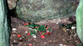
In recent years, at this and other ancient sites, such as the West Kennet Long Barrow, offerings have been left in the form of flowers, cornmeal, nuts, grain, fruit, and feathers, presumably by visiting Neo-Pagans.

The West Kennet Long Barrow
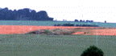
The West Kennet Long Barrow is situated on a ridge one-and-a-half miles south of Avebury in Wiltshire. The photograph at left, taken from a point on the Ridge Way near the Sanctuary, shows the placement of the barrow within the surrounding landscape and the low ridge upon which it sits. The site was recorded by John Aubrey in the 17th century and by William Stukeley in the 18th century. Aubrey describes it as "On the Brow of the hill, south from the west Kynnet" (i.e. the River Kennet, see Silbury Hill for some comments on this stream), and adds that it is "without any name." Stukeley observes that "It stands east and west, pointing to the dragon's head on Overton-hill." The barrow is marked on Stukeley's drawing of the 'great stone serpent' of Avebury in which one can also see Overton Hill (also called The Sanctuary by Stukeley). The barrow was dug into in in 1859, and properly excavated in 1955-56.
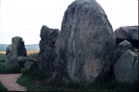
It originally consisted of a trapezoid mound 330 feet long formed of a core of sarsen boulders and a capping of chalk rubble from two flanking quarry ditches. At the eastern end of the mound is an elaborate megalithic structure of five chambers opening off an axial passage. The entrance passage is fronted by a semi-circular forecourt with a flanking facade of massive sarsen uprights aligned along a north-south axis.
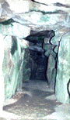
The photograph at left shows the interior with the chambers located off the axial gallery. A minimum of 46 individuals of all ages and both sexes, together with many pottery sherds, flint implements, beads and other objects, were discovered in the course of excavation. The burials evidently took place over a considerable period of time. It appears that a number of the bones, mainly skulls and thigh bones, were abstracted from the tomb at different times, possibly for ritual purposes.
At some point the chambers and passage were filled with chalk rubble and the semi-circular forecourt blocked with a filling of sarsen boulders. At this time, it seems, a 'false entrance' of twin uprights was erected, and three massive blocking stones placed in line across the entrance to the forecourt. This final blocking and closure of the tomb appears to have occurred around 1600 B.C.E.

The Toots
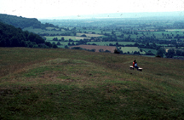
The south end of the Toots Long Barrow
with a view beyond of the Cotswold Escarpment and the Vale of Gloucester
The Toots is one of the largest long barrows in Gloucestershire measuring 210 feet long, 90 feet wide, and 11 feet high. It has been dug into three places; that across the middle is so large that it causes the barrow to appear to be two mounds (the photograph above is taken from on top of the mound at the south end).
About 2 miles from Stroud, the Toots is located high up on Selsley Hill on the edge of the escarpment overlooking the Vale of Gloucester and the Severn Estuary. It should be observed, though, that despite expectations, the Toots, and other barrows simiarly located, is not set upon the highest part of Selsley Hill. In fact, when approaching from the east, the barrow cannot be seen until one crests the top of the hill. On this point, William Stukeley noticed with regard to the barrows upon Hakpen Hill near Avebury that it "and others are set with great art not upon the very highest part of the hills but upon so much of the declivity or edge as they make app[earance] as above to those in the valley" (from Stukeley's miscellaneous Avebury notes). This siting of barrows upon 'false crests' is common in many parts of Britain, but has only been noticed again in recent years. The archaelogist Cyril Fox writing in the 1940s argued that "barrows sited on false crest lines were intended to be seen from some point below them" and adds that "the position of a barrow thus gives an indication of the direction in which the homes of its builders should be sought."
The Toots is clearly visible from the valley as a "bump" on the skyline. Other barrows, such as the Nympsfield Barrow and Hetty Pegler's Tump, are placed similarly within the landscape. Although the view from both the latter barrows, and the view of them from the valley, is today obscured by trees, the original effect must have been the same as The Toots. Besides indicating, as Fox suggests, where the homes of their builders might be located, I would like to add the observation that these barrows were most likely also in line-of-sight with other sites in and across the valley, and with each other. Very probably (trees now prevent a demonstration of this), the Nympsfield Barrow and Hetty Pegler's Tump were visible from the Toots. The Toots is in line-of-sight with Whitefield's Tump on Minchinhampton Common Their visibility would have been enhanced by the fact of their also being white. A point I would like to make is that these barrows, though today are grown over with grass, were originally covered with exposed chalk. Their brilliant whiteness would have been very eye-catching from a distance. A typical barrow would be that described by Stukeley in his book on Stonehenge:
The manner of composition of the barrow was good good earth, quite thro', except a coat of chalk of about two foot thickness, covering it quite over, under the turf. Hence is appears, that the method of making these barrows was to dig up the turf for a great space round, till the barrow was brought to intended bulk. Then with the chalk, dug of the environing ditch, they powder'd it all over."
The name "Toots" would appear to be derived from the name Teutates, a name used by the Druids for a deity identified with the Roman god Mercury (see Ley Lines), and may ultimately be related to the Egyptian god Thoth. The name Toot subsequently also became the name of a hill that was used as a look-out point.

Belas Knap Long Barrow
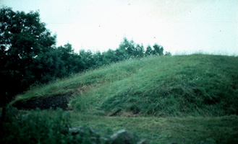
View of the northern end of the Belas Knap long barrow
Belas Knap is one of the finest neolithic long barrows in Gloucestershire. Like all the other seventy or so known long barrows in the county, it is located on the limestone uplands of the Cotswolds. It is situated, like the Toots long barrow and Hetty Peglar's Tump, not at the very top of the hill but just below the crest of the slope so that when it was first built it would have been visible as a bump outlined against the sky from the valley below. Intervening trees now partially cut off a panoramic view east over the valley in which lies Sudeley Castle.
Besides the castle, the valley and its slopes evidently held attractions for other people as well. Further down the slope below Belas Knap are the remains of a Roman villa, with another located due west across the valley on Cole's Hill. The Romans themselves evidently visited Belas Knap; the remains of Romano-British pottery have been found at the north end of the barrow.
The ancient path of the Cotswold Way, having passed through Winchcombe in the valley to the north, winds up the west slope to the Roman villa, up higher to Belas Knap, and then, following the high ground, swings round west and north to descend near Cleve Hill into the Severn Valley. Today, visitors leave their cars on the nearest road and take the long walk up through Humblebee Woods and through open fields to the site.
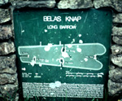
Built about 3000 B.C.E., the barrow originally must have measured about 200 feet in length (today it is approximately 178 feet long), about 80 feet in width (now it is about 60 feet wide), and nearly 14 feet in height. It is a chambered barrow with a false entrance at the larger northern end.
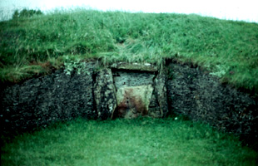
The "false entrance" at the northern end of Belas Knap
The false entrance is located at the rear of a U-shaped forecourt set back into the mass of the mound with two horn-like projections either side. In a more fully developed megalithic monument, such as the West Kennet Long Barrow, or Wayland's Smithy, orthostats and capstones would have been built into this "forecourt" area. In his book Prehistoric Gloucestershire, the archaeologist Timothy Darvill has suggested that the H-shaped portal setting of the false entrance is the remains of an earlier portal dolmen which became incorporated within the larger tomb. The lower courses of the dry-stone walling seen in the false entrance are original. The lintel stone, however, is a modern replacement.
When the original lintel stone was removed during excavations in 1863-5, among the rubble forming the blocking of the false entrance were found the skeletal remains of five children aged between 6 months and 8 years, the skull of a young adult male, horse and pig bones, plus fragments of pottery and serrated flint blade.
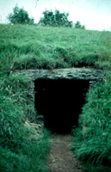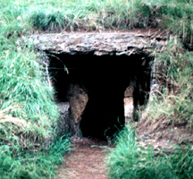
The actual burial chambers, four in all, are located on the long sides of the mound and in the tail. The two photographs above show the two chambers on the north side (on the left, that in the north-west; on the right, that in the north-east). The two photographs below show the chamber on the south-east side side, on the left, and the chamber in the tail. The megalithic roofs of these chambers are reconstructions, undertaken when the mound was restored in 1930-31.
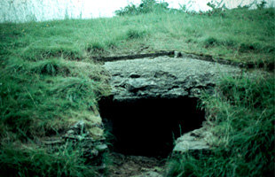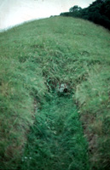
Excavations undertaken in 1963 found the remains of about forty burials in the side chambers. These burials, however, occurred over a long period of time and none may in fact date to the time when the mound was built.
It has been suggested that Belas is derived from the name Baal", an ancient storm god ("Belus", in Latin). Knap on the other hand is thought by some to be a variant form of "Cneph", the Egyptian sacred winged disk. Knap, however, is simply Old English for the top, crest, or summit of a hill. Belas may perhaps be a corruption of the Latin word for "beautiful" -- bellus -- and may describe either the hill itself or the view from it.

The Sanctuary
The Sanctuary, situated on Overton Hill next to the Ridgeway near Avebury, was begun around 3,000 B.C.E. It originally comprised six concentric rings of timber uprights. Later, the timbers were replaced by double stone circles. The site, of which only the post and stone holes remain today (now marked by concrete blocks) was destroyed in the 18th century, but not before William Stukeley made a drawing of it (above, right). Excavations have suggested that the site was used for feasting and for some form of mortuary ritual.
For Stukeley, the Sanctuary represented the head of a great stone serpent the body of which was formed by the West Kennet Avenue and the Beckhampton Avenue.
William Stukeley's 'great stone serpent', with the Sanctuary located on Overton Hill at the right
The photograph on the left below is a view of the Sanctuary taken from the West Kennet Long Barrow. The Sanctuary is located about mid-way along the ridge, which is also the line of the Ridgeway. Along the Ridgeway to the left of the Sanctuary can be seen two burial mounds. The photograph on the right is a view of Silbury Hill seen from the Sanctuary. The flat-topped summit of the hill, visible above the trees, is in line with the distant horizon.

Dragon Hill
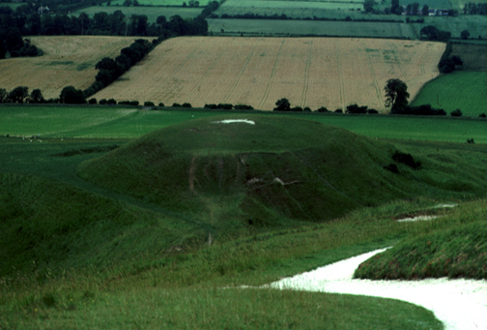
Dragon Hill (view from the White Horse, in the foreground)
Located very near the White Horse at Uffington, Dragon Hill is, apparently, an artifical mound with a flat-top, not unlike Silbury Hill), to which clings the legend that it was on its summit that St. George slew the dragon. A bare patch of chalk upon which no grass will grow, is purported to be where the dragon's blood spilled.

Geomancy
Strictly speaking, the term geomancy refers to an ancient form of divination in which, simply put, handfuls of soil or other materials were scattered on the ground, or markings made in the earth or sand, to generate a range of dot configurations which could then be "read" by a seer.
In the 19th century, however, geomancy came to be applied to the Chinese practice of feng shui by which the location and orientation of houses and tombs was determined with close regard to the topography of the local landscape. The feng shui master or geomant employed a circular magnetic compass, called a luopan, which was marked off in rings containing data relating to astrology, directions, the elements, landscape forms, times of day, and so on. The aim was to locate a site where the energies or ch'i of the land and sky were brought into perfect balance. The harmony of these energies ensured good fortune.
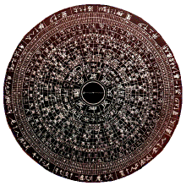
The layout of a typical feng shui compass, also called a luopan
The science of feng shui, literally "wind and water", recognized that certain powerful currents and lines of magnetism run invisible through the landscape over the whole surface of the earth. The task of the geomancer was to detect these currents and interpret their influences on the land through which they passed.
These lines of magnetic force, known in China as the "dragon current", or lung-mei, existed in two forms: the yin, or negative, current represented by the white tiger, and the yang, or positive, current, represented by the blue dragon. The landscape will display both yin and yang features; gently undulating country is yin, or female, while sharp rocks and steep mountains are yang, or male.
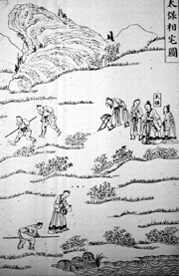
A feng shui geomant at work in the Ch'ing dynasty
It was the aim of the geomancer to place every structure precisely within the landscape in accordance with a magic system by which the laws of music and mathematics were expressed in the geometry of the earth's surface. The landscape itself may be manipulated in order to achieve the harmony sought through the placement or adjustment, or removal, of trees or rocks, or bodies of water. Every feature of the landscape may be contrived to produce an effect which ultimately is perceived as beautiful; indeed, perceived beauty in a landscape may in fact be simply when the lines of the dragon current are in balance.
At the outset, a geomancer must locate the course of the major lines of the dragon current in his or her area. These days, it is claimed that such energy lines can be detected, and traced, through dowsing.
In the 1960s, the ley lines discovered by Alfred Watkins forty years earlier, came to be identified with the dragon lines of Chinese feng shui. This gave a whole new meaning to ley lines which now ceased to be simply straight tracks but in fact mapped on the surface of the landscape lines of energy coursing through the earth. The presence of prehistoric sites - megalithic tombs, stone circles, standing stones - along ley lines indicated that these energy currents were known in prehistoric times and that the sites did not merely mark the route but somehow also tapped into this energy source. Frequently, important prehistoric monuments occupy sites where two or more ley lines intersect. Also located along these ley lines are sites associated with Dragons and Dragon-killers

Notes on Pi ()
Pi, which is denoted by the Greek letter , is the most famous ratio in mathematics, and is one of the most ancient numbers known to humanity. Pi is approximately 3.14 - the number of times that a circle's diameter will fit around the circle. Pi goes on forever, and can't be calculated to perfect precision: 3.1415926535897932384626433832795028841971693993751.... This is known as the decimal expansion of pi. No apparent pattern emerges in the succession of digits - a predestined yet unfathomable code. They do not repeat periodically, seemingly to pop up by blind chance, lacking any perceivable order, rule, reason, or design - "random" integers, ad infinitum.
In 1991, the Chudnovsky brothers in New York, using their computer, m zero, calculated pi to two billion two hundred sixty million three hundred twenty one thousand three hundred sixty three digits (2,260,321,363). They halted the program that summer.
Pi has had various names through the ages, and all of them are either words or abstract symbols, since pi is a number that can't be shown completely and exactly in any finite form of representation. Pi is a transcendental number. A transcendental number is a number but can't be expressed in any finite series of either arithmetical or algebraic operations. Pi slips away from all rational methods to locate it. It is indescribable and can't be found. Ferdinand Lindemann, a German mathematician, proved the transcendence of pi in 1882.
Pi possibly first entered human consciousness in Egypt. The earliest known reference to pi occurs in a Middle Kingdom papyrus scroll, written around 1650 BCE by a scribe named Ahmes. He began scroll with the words: "The Entrance Into the Knowledge of All Existing Things" and remarks in passing that he composed the scroll "in likeness to writings made of old." Towards the end of the scroll, which is composed of various mathematical problems and their solutions, the area of a circle is found using a rough sort of pi.
Around 200 BCE, Archimedes of Syracuse found that pi is somewhere about 3.14 (in fractions, Greeks did not have decimals). Knowledge of pi then bogged down until the 17th century. Pi was then called the Ludolphian number, after Ludolph van Ceulen, a German mathematician. The first person to use the Greek letter for the number was William Jones, an English mathematician, who coined it in 1706.
Physicists have noted the ubiquity of pi in nature. Pi is obvious in the disks of the moon and the sun. The double helix of DNA revolves around pi. Pi hides in the rainbow, and sits in the pupil of the eye, and when a raindrop falls into water pi emerges in the spreading rings. Pi can be found in waves and ripples and spectra of all kinds, and therefore pi occurs in colours and music. Pi has lately turned up in superstrings.
Pi occurs naturally in tables of death, in what is known as a Gaussian distribution of deaths in a population; that is, when a person dies, the event "feels" pi. It is one of the great mysteries why nature seems to know mathematics.
(NOTE: The above information was gleaned from an article in The New Yorkermagazine, March 2, 1992, called "Profiles: The Mountains of Pi")

Dragons and Dragon-killers
The power or energy of the lung-mei, or dragon current (See under Geomancy), has been represented visually by the image of the dragon. The dragon is a familiar image in China, and also figures prominently in one form or another in the legends of many cultures around the world. Frequently, these legends tell of the killing of the dragon, which is a vital part of a cycle of birth and death and the re-animation and fertilization of the earth.
Several local festivals of ancient origin in Britain continue to re-enact the killing of the dragon. Dragon-killers, often well-known members of local families, were celebrated. Some these dragon-killers, at an early date, were 'Christianised' and made into saints, the best known being St. Michael, St. George, St. Catherine, and St. Margaret. All over England there are hills and spots remembered locally where the dragon was killed. Dragon Hill, near Uffington, is one example where St. George, the patron saint of England, is believed to have killed the dragon, its spilled blood falling where grass has never since grown.
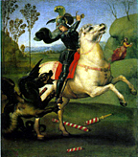
Raphael, St. George killing the Dragon, 1505
Places associated with the dragon legend are often also sites of ancient sanctity. And, because of this sanctity, many of them were 'Christianised', which sometimes included building a church on that spot. The site is often on top of a mound or flat-topped hill, and the church is usually dedicated either to St. Michael or to St. George.
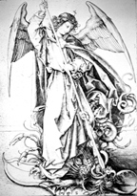
Martin Schongauer (c. 1450-91), St. Michael killing the Dragon
Churches and chapels dedicated to St. Michael are often found on the summits of high points in the landscape. A line of such hill-top shrines dedicated to St. Michael, or to other dragon-killing saints, such as St. George and St. Margaret, runs across southern England from the north-east to St. Michael's Mount near Land's End in Cornwall.

BIBLIOGRAPHY
Richard Atkinson
- Stonehenge. London: H. Hamilton, 1956.
- Stonehenge and Avebury and neighbouring monuments; an illustrated guide. London: H. M. Stationery Office, 1959
Rodney Castleden
- The Making of Stonehenge. London and New York: Routledge, 1993.
Aubrey Burl
- The Stone Circles of the British Isles. New Haven: Yale University Press, 1976.
Rosamund M. J. Cleal, and others
- Stonehenge in Its Landscape: Twentieth-Century Excavations (Archaeological Report 10), English Heritage, London, 1995
Michael Dames
- The Silbury Treasure. London: Thames and Hudson, 1976.
- The Avebury Cycle. London: Thames and Hudson, 1977.
Paul Devereux
- Places of Power. London: Blandford, 1990.
- Earth Memory: Sacred Sites - Doorways into Earth's Mysteries. St. Paul, Minnesota: Llewellyn, 1992.
- Secrets of Ancient and Sacred Places: The World's Mysterious Heritage. London: Blandford, 1992.
Nigel Pennick and Paul Devereux
- Lines on the Landscape: Leys and Other Linear Enigmas. London: Robert Hale, 1989.
Peter Berresford Ellis
- The Celtic Empire: The First Millenium of Celtic History 1000 BB - 51 AD. Durham, NC: Carolina Academic Press, 1990.
- The Druids. Grand Rapids, Michigan: William B. Eerdmans Publiching Company, 1994.
Miranda J. Green
- Dictionary of Celtic Myth and Legend. New York: Thames and Hudson, 1992.
Gerald Hawkins
- Stonehenge Decoded. London: Souvenir Press, 1966.
Fred Hoyle
- On Stonehenge. San Francisco: W. H. Freeman and Company, 1977
Roger Joussaume
- Dolmens for the Dead: Megalithic Building throughout the World. Ithaca: Cornell University Press, [1985] 1988.
Evan Hadingham
- Circles and Standing Stones: An Illustrated Exploration of Megalith Mysteries of Early Britain. Garden City, NJ: Anchor Press/Doubleday, 1976.
Gerhard Herm
- The Celts. New York: St. Martin's Press, 1977.
Ronald Hutton
- The Pagan Religions of the Ancient British Isles. Oxford: Blackwell, 1991.
E. C. Krupp
- Echoes of the Ancient Skies: The Astronomy of Lost Civilizations. New York: Harper & Row, 1983
Sir Norman Lockyer
- Stonehenge and Other British Monuments Astronomically Considered. London: Macmillan, 1906.
John Michell
- Megalithomania: Artist, Antiquarians, and Archaeologists at the Old Stone Monuments. Ithaca: Cornell University Press, 1982.
- The Earth Spirit: Its Ways, Shrines, and Mysteries, London: Thames & Hudson, 1989.
- A Little History of Astro-Archaeology. London: Thames & Hudson, 1989.
- The New View Over Atlantis. San Francisco: HarperCollins, 1983 (first published as The View Over Atlantis by Sago Press in Great Britain in 1969; a new edition was published in Great Britain by Garnstone Press in 1972 and Abacus in 1973 and in the United States by Ballantine Books in 1972).
Hamish Miller and Paul Broadhurst
- The Sun and the Serpent. Pendragon, 1989.
Jean-Pierre Mohen
- The World of Megaliths. New York: Facts on File, 1990 (originally published in French. Tournai: Casterman, 1989).
A. L. Owen
- The Famous Druids. Oxford: Clarendon Press, 1962.
Nigel Pennick
- The Ancient Science of Geomancy. London: Thames & Hudson, 1979.
- Sacred Geometry. Turnstone Press, 1980.
- Magical Alphabets. York Beach, Maine: Samuel Weiser, 1992.
Stuart Piggott
- William Stukeley, An Eighteenth-Century Antiquary. Oxford: Clarendon Press, 1950.
- The West Kennet Long Barrow Excavations. London: H.M. Stationery Office, 1962.
- The Druids. New York: Frederick A. Praeger, 1968
Michael Poynder
- Pi in the Sky: A Revelation of the Ancient Wisdom Tradition. London: Rider, 1992.
H. D. Rankin
- Celts and the Classical World. London & Sydney: Croom Helm, 1987.
Ward Rutherford
- The Druids and their Heritage. London: Gordon & Cremonesi, 1978.
Alexander Thom
- Megalithic Sites in Britain. Oxford: Clarendon Press, 1967.
- Megalithic Lunar Observatories. Oxford: Clarendon Press, 1971.
Alfred Watkins
- The Old Straight Track. London: Methuen & Co., 1925 (reprinted London: Garnstone, 1970).

