US Government Shuts Down Flat-Earther's Rocket Launch

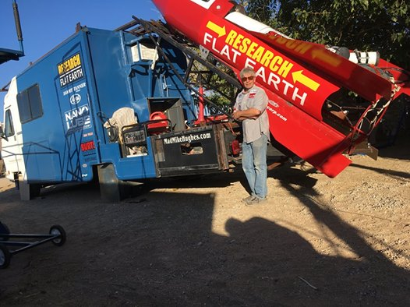

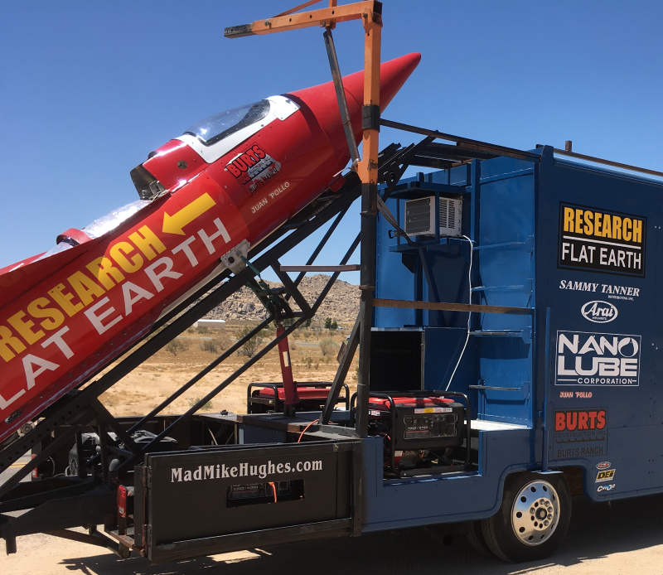

"Mad" Mike Hughes, a flat-Earth conspiracy theorist, will have to wait a little longer to test his science-busting rocket.

Hughes had previously announced plans [to launch himself in a homemade rocket](https://www.livescience.com/61006-flat-earther-homemade-steam-rocket-launch.html) to a height of 1,800 feet (550 meters) above California's Mojave Desert. But the launch, which Hughes had said would take place Nov. 25, did not happen. NPR [reports](https://www.npr.org/sections/thetwo-way/2017/11/26/566583007/flat-earther-postpones-launch-in-his-homemade-rocket-saying-it-s-not-easy) that the Bureau of Land Management (BLM) "got wind" of the plan after [the Associated Press](https://apnews.com/9d8e5e8e9245412ab80f5a1f58d885b7/Self-taught-rocket-scientist-plans-to-launch-over-ghost-town)reported Hughes' announcement. The agency shut down Hughes' launch, which would have taken place on public land.

Advertisement

The AP's original report stated that Hughes had built his steam-powered rocket out of salvaged parts in his garage, for a total personal cost of $20,000. Hughes also bought a motor home and converted it into a ramp. Once the rocket was aloft, Hughes planned to ditch it and parachute back to Earth.

The 61-year-old had ridden a homemade rocket once before, on a quarter-mile flight across the Arizona desert. [[Wishful Thinking: 6 'Magic Bullet' Cures That Don't Exist](https://www.livescience.com/14968-6-magic-bullet-cures.html)]

This launch was supposed to be the first stage in a long-term effort to fly high enough to photograph the "disc Earth" and disprove that Earth is a sphere — a scientific reality that's been [established for about 2,500 years](https://starchild.gsfc.nasa.gov/docs/StarChild/questions/question54.html)and that [anyone can prove for themselves](https://www.livescience.com/60544-ways-to-prove-earth-is-round.html). The curvature is subtly visible at about 35,000 feet (10,700 m) altitude if you have at least a 60-degree field of view.

Hughes claimed [on YouTube](https://www.youtube.com/watch?v=wU0eFpY8RXk) that he had previously received tacit approval for the project from the BLM and the Federal Aviation Administration, and that the agencies reneged on their approval after news reports emerged.

He also said that his mobile launcher broke down in his driveway but that he had repaired it.