Location and Size of the Polar Openings
http://www.ourhollowearth.com/PolarOpn.htm

It is assumed that the polar openings were formed when the earth was created because centrifugal force would throw matter away from the axis of rotation leaving a hollow in the earth and polar openings at the polar axis. Additionally, the earth's foundational premise is a spiritual hollow globe upon which space dust and rocks accumulated.
If these assumptions are correct, then the original locations of the polar openings of the earth were at its polar axis, centered on the north and south poles. There exists, however, evidence that the earth has been bypassed by planet sized comets in the past geologic history of the earth, one or more of which tilted the earth's axis to one side. The Pyramid of Giza, which this author believes was built before the Flood of Noah, has a construction orientation aligned with the original axis of rotation of the earth. When the passageway into the pyramid was first discovered it was soon realized that it had originally pointed towards what was then the North Polar Star. That star is not Polaris, the North Star of today. It has shifted several degrees, indicating that the earth's axis may have been tilted since the construction of that pyramid.
Hollow Earth enthusiasts originally thought that the polar openings were centered over the poles. However, it has been evident since with the advent of intense polar exploration that the openings are NOT located centered over the poles. The United States has a permanent station located at the South Pole on the Antarctic continent. And the North Pole has been crossed several times by polar explorers beginning with the Amundsen dirigible expedition in 1926 which flew from Spitzbergen to Alaska over the Pole. Wally Herbert took his dog sleds over the pole from Alaska to Spitzbergen going the opposite direction. Also the Soviet Ice Breaker, The Yamal, takes tourists to the pole each year north of Franz Josef Land. This service is contracted by Connecticut-based Quark Expeditions (800-356-5699) for a 15-night, $14,900 trip to the North Pole with an additional $1,200 Aeroflot flight from New York to Murmansk, Russia. Bradley Air Service out of Resolute Bay in northern Canada (819-252-3981) regularly flies tourists, scientists and adventurers to the North Pole from the Canadian side of the top of the world for $24,000 per each two-day trip in which a ski landing at the pole is made weather permitting. Two other, more expensive, seven-night trips are offered by High Arctic International (819-252-3616) for $8,650 per person is based also in Resolute Bay, and Arctic Odysseys (206-455-1960) $11,000 out of Medina, Washington. These trips depart each April and include visits to both the geographic and magnetic North Poles, dog sledding along the northwestern coast of Greenland, and overnight stops on Ellesmere Island at the Eureka Weather Station and Grise Fjord. (December 1993, Outside Magazine, p. 50)
Still, there are anomalous occurrences that indicate the polar openings exist. The warm north wind in winter, the warm winter foehn storms that come from the north, the drift wood with green leaves, the migration of birds and animals, the solar wind emanating from the polar region to light up the auroras and then trapped in the Van Allen Radiation Belts.
North Polar Opening
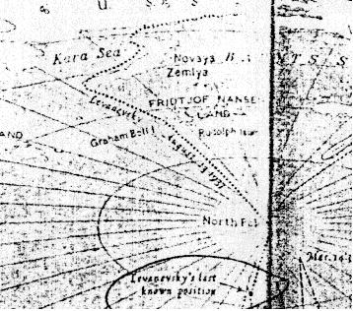
My latest estimate of the location of the North Polar Opening is based on several considerations. There is the case of the Lost Soviet flyers who flew north from Russia and were lost somewhere between the Kara Sea on the Russian side of the pole and Alaska, as reported by Vilhajalmur Stefansson in his book, UNSOLVED MYSTERIES OF THE ARCTIC. Then there is the Olaf Jansen's story in which he described their 1829 trip through the North Polar Opening in their small boat sailing between leads in the ice on a course heading North East of Franz Josef Land. Recently, in Jan Lamprecht's book, Hollow Planets, he describes the sighting by Peary and Cook and other arctic explorers such as Col. Green of the U.S. Navy of a mirage of land North West of Ellesmere Island in Northern Canada. Jan also writes of the Russian sighting of Sannikov land north of Russia. The Amundsen dirigible transpolar flight of 1926 from Spitzbergen to the Pole and from the Pole to about 100 miles west of Point Barrow, Alaska would indicate the north polar opening would need to be located to one side of their line of flight. The British arctic explorer, Wally Herbert, also took this same path only from the other direction from Alaska to Spitzbergen.
If we draw a line northeast of Franz Josef Land, and another northwest of Ellesmere Island in the direction the Crocker land mirage was sighted as described in Jan Lamprecht's book on Hollow Planets, the two lines meet at about 141 E Longitude and 84.4 North Latitude. Let's assume that this is the center of the North Polar Opening. From there to the line of the Amundsen transarctic flight from the pole to 100 miles west of Point Barrow is a little over 300 miles. It is also about 386 miles from the North Geographic pole. So let's assume the polar opening has a diameter of about 600 miles on the surface of the planet. Let's also assume that the polar opening is symmetrical with a curving surface instead of being a straight hole through the planet.
Since most of the earth's atmosphere is located in the first 45 miles from the surface, then perhaps the polar opening is twice that at it's smallest diameter. So we'll estimate a 90 mile wide polar opening at it's smallest diameter at it's "neck." That would place the span from the center of each semi circumference of the sides at 900 miles. The North Geographic pole would be on the top of the rim of the 600 mile perimeter, perhaps even a little inside where the opening begins to dip into the polar hole.
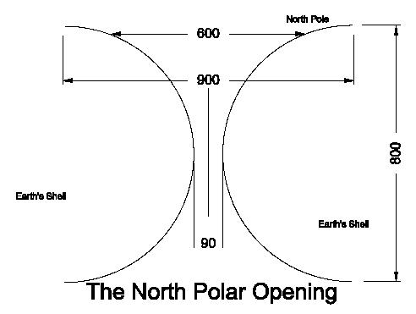
In this drawing of the North Polar Opening, the thickness of the earth's shell is assumed to be 800 miles. If the earth's shell were any larger, say a thousand or 2,000 miles thick, the polar opening would be too big to be hidden in the Arctic Ocean. So the 800 mile estimate of the earth's shell thickness is a reasonable estimate. The beginning of the curvature into the opening begins at 900 miles diameter. At the 600 mile perimeter is where the rim of the opening starts to visibly curve into the earth. At the center of the polar opening, I am estimating the diameter to be 90 miles.
On a map, the 600 mile perimeter would begin about 86 miles from the North Geographic Pole and the center of the polar opening would be located at 141 E Longitude and 84.4 degrees N Latitude (5.6 degrees from the pole, one polar degree = 68.939 miles). This location for the polar opening would be consistent with the lost Soviet Flyers who flew north of the Kara Sea towards Alaska and were lost. This position is also consistent with the Soviet Ice Breakers who take tourists to the pole each year north of Franz Josef Land. This estimated location would place the opening on the Russian side of Amundsen's line of flight from the Pole to Alaska, and yet also be in the line of sight of the direction that Admiral Peary sighted the mirage of Crocker land from the west coast of Ellesmere Island in Northern Canada.
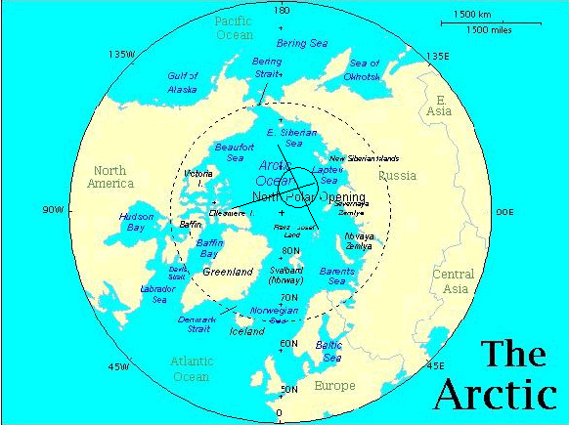
Indicative that the curve into the opening has already begun near the pole is Amundsen's navigator error upon reaching Alaska. They had assumed a straight line of flight from Spitzbergen to the Pole and from the Pole to Point Barrow, Alaska, but upon arriving in Alaska were surprised that they were around a 100 miles too far west of Point Barrow, closer towards the Bering Sea that they didn't even see Point Barrow. This may indicate that near the pole they had actually dipped somewhat down into the polar opening causing their straight line of flight to be skewed.
Wally Herbert on his dog sled crossing of the north pole from Alaska to Spitzbergen also had a hard time pin pointing the north pole. He had to retrace his path towards Spitzbergen back to the pole after having supposedly crossed the Pole in order to find it, and even then he had difficulty pin pointing the location of the pole because the sun height would vary above the horizon throughout the day, which indicates he was actually some distance inside the polar opening as he was attempting to pin point the north pole with his sextant.
On page 66 of The Smoky God, Olaf Jansen mentioned that as he and his father left Franz Josef Land on their expedition to the Hollow Earth, "we seemed to be in a strong current running north by northeast." The island they found on their third day's sailing northeast of Franz Josef Land is not on our maps today. They found a large accumulation of drift-wood on the northern shore of that island, trunks of coniferous trees two feet in diameter and forty feet long. This encouraged them to continue north. Again, several days further on, on page 84, Olaf reported, "...we discovered...that we were sailing slightly north by northeast." If this can be taken as any indication of the direction they were sailing, the north polar opening would seem to be located northeast of Franz Josef Land, in the same area that the Soviet flyers were lost, as described in Vilhajalmur Stefansson's book, UNSOLVED MYSTERIES OF THE ARCTIC, and in the same direction that Admiral Peary and Cook saw the mirage of Crocker land from the west coast of Ellesmere Island.
The Norwegian arctic explorer, Dr. Fridtjof Nansen, in his Farthest North, relates several anomalous occurrences on his Arctic expedition in his ship the Fram. Of all Arctic explorers we have record of, Nansen was the one that got closest to the North Polar Opening without entering and discovering it. Some of the observations of Nansen that support a polar opening location north of the New Siberian Islands are as follows.
First, Nansen discovered a substantial stretch of open ocean north of the New Siberian Islands. In contrast, in his passage north of Norway and Russia to the New Siberian Islands, he had to stay close to the coast to get past the ice. And yet, north of the New Siberian Islands, in September of 1893 on their way north, they didn't find ice until 79 degrees N. Latitude. Only after 7 days sailing north over rolling open ocean did they reach the pack ice north of the New Siberian Islands.
Then to their surprise, out on the ice pack, they found a remarkable number of birds of various kinds including snipe and seagulls, also foxes, walrus and polar bears that indicated they were in the proximity of land towards the north. They passed the winter with their ship frozen in the ice pack and while waiting out the winter, they took scientific measurements and observations. They found rock and large quantities of mud and driftwood on some of the icebergs that indicated to Nansen that much of the Arctic ice originates in some river, perhaps further to the north than they were then located -- in some uncharted land.
In mid winter, on January 17th, 1894, at 79 deg N Latitude, 135 deg 29' E Longitude, observations by Nansen found that a north wind raised the temperature while a south wind lowered it, indicating that warm air was coming out of the north in winter -- perhaps from a land further north warmed by an inner sun. Curiously, Nansen discovered than ocean water temperatures were also warmer the further down he measured it beneath the ice, as also the air temperature above the ice when measured from the ship's crows nest was discovered to be warmer than next to the ice.
Then at 80 deg 1' N Latitude, when Nansen was located 303 miles from the center of my estimated location of the North Polar Opening, on February 16-19 Nansen caught sight of a mirage of the sun. Most likely they were then located on the lip of the polar opening. They thought it must be a mirage of our outer sun. But there is a possibility that it could have been a mirage of the inner sun. On page 162, Nansen recorded, "Monday, February 19th... Both today and yesterday we have seen the mirage of the Sun again; today it was high above the horizon, and almost seemed to assume a round, disk-like form." He remarked that it had a hazy, smoky-red color, similar to the description of the inner sun given by Olaf Jansen, whose father also at first thought it was a mirage, when they first caught sight of it in their 1829 journey to the inner world through the North Polar Opening northeast of Franz Josef Land.
Come summer, Nansen went out on the ice pack and investigated a pollen-like substance that seemed to cover the ice everywhere with a brownish color. Inner Earth explorer Olaf Jansen explains that the northern shores of the inner world are covered with large fields that grow flowers, whose pollen is blown out over the Arctic ice fields through the North Polar Opening. Then volcanic dust fell on the Fram and settled everywhere causing discomfort and irritation. Nansen wrote in his ship's journal, "Let us go home. What have we to stay for? Nothing but dust, dust, dust." There must have been volcanic eruption on the inner continent near the Polar Opening at that time because there was none on the outer world. The dust must have blown out of the Polar Opening onto the ice and upon Nansen's ship, the Fram.
Prior to his Arctic expedition, Nansen had visited Russia and consulted with their experts about their sighting of a mirage of land they termed Sannikov land north of the New Siberian Islands. The New Siberian islands even today are covered with bones and remains of mammoths and other inner earth animals that Olaf Jansen claims fell into ice crevasses of inner earth rivers that empty into the Arctic Polar Opening where they froze and later were carried out to sea and eventually ended up deposited on northern Arctic shores. Remains of woolly rhino, steppe lions, giant deer, mammoth, foxes and a hardy breed horse that scientists claim are prehistoric are preserved in the Arctic ice. Recently these scientists have been attempting to find some of these exotic animal remains that are frozen and preserved in Arctic ice. They want to take samples of the frozen flesh and use it to clone these exotic animals to start a sort of Jurassic Park. Little do they know that a Jurassic Park already exists located inside Our Hollow Earth, and can be reached through the North Polar Opening, north of New Siberian Islands, from whence all the frozen exotic carcasses come from.
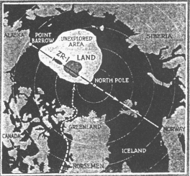
On the opposite side of the Arctic from the New Siberian Islands, Lt. Green of the U.S. Navy had accompanied MacMillan on his expedition northwest of Ellesmere Island following the mirage of Crocker land that Peary had sighted from Cape Thomas Hubbard on his way north to discover the pole. MacMillan had turned back after journeying 120 miles out over the ice pack because the mirage of Crocker land continued to appear ever farther northward no matter how far they traveled towards it. Later, Lt. Green published an article in Popular Science, in 1929, that he was still convinced that Crocker land still existed and had even convinced the Navy to build a dirigible named the ZR-1 that was going to attempt an over flight of that land. Here is Lt. Green's Arctic map showing his estimated location of that unknown land that MacMillan and his eskimos thought was just a mirage.
In warmer climates of the world, a mirage mostly looks like water on the horizon because it is reflecting the blue sky. But in the Arctic, a mirage is is caused by warm moist air that comes up out of the Polar Opening from the Inner World. This layer of warmer air above the colder air next to the ice causes mirages or reflections of the ground or ice on the ocean, and not the sky, as in the warmer climates of the world. In the warmer climates of the world the temperature of the air becomes colder with height above the ground. Just the opposite is the case in the Arctic and Antarctic. Warm, moist air emanating from the earth's hollow interior through the polar openings rises above the ice and serves as a boundary of air that reflects objects on the ground. Jan Lamprecht, in his book, Hollow Planets, gives solid evidence that the mirage of Peary's Crocker land and Cook's Bradley land could easily have been a double inverted image of land within the North Polar Opening located somewhere northwest of Ellesmere Island within the area Lt. Green termed on his map the "Unexplored Area." Notice that my estimated location for the North Polar Opening is located within Green's unexplored area. The land that Green thought must be there, is, however, actually located within the Polar Opening.
Another curious story that relates to Lt. Green's estimated location of Crocker land is the disappearance of the Viking Greenland colony. In 985 A.D., Eric the Red discovered Greenland and subsequently settled it with Viking residents of Iceland. The Greenland colony thrived for several centuries, but then as Europe became embroiled in war and the disease of the plague, the Norwegians lost contact with their Arctic colonies in Iceland and Greenland. The last ship known to have returned from their Arctic colonies to Norway was in 1410. When the Dark Ages had past and Greenland was once again rediscovered with Hans Egede establishing the first modern settlement there in 1721, all that could be found of the original Viking settlers was their ruins and some of their animals. Even the Arctic author Vilhajalmur Stefansson in his book, UNSOLVED MYSTERIES OF THE ARCTIC, concluded that the disappearance of the lost Viking colony in Greenland was a mystery. The Viking colonists had apparently migrated further and further north where they found wild life and fish more plentiful, until they disappeared.
In an attempt at determining where the lost Viking Greenland colony went, Lt. Green says he reviewed the Eskimo traditions. The Eskimos say the Vikings had migrated further and further north, then one day their men found a paradise in the north -- a place the Eskimo had always known about but stayed away from because they believed it to be inhabited by evil spirits. The Viking explorer parties had came back and had told the rest of their Greenland colony of their wonderful discovery. All promptly packed their bags, and singing songs, departed suddenly northward and never returned. The eskimo tradition is that over the ice towards the northwest, in the direction Admiral Peary sighted Crocker land and Cook sighted Bradley land, is a ..."land that is warm; is clothed in summer verdure the year around; is populated by fat caribou and musk-ox. It lies," they say even to this day, "in the direction of the coastal trail-route north." Lt. Green shows that trail on his map. It is located on west side of Greenland, and goes up around Ellesmere Island, and out over the pack ice in a northwest direction towards the land he claimed exists in the "Unexplored Area." That is the same area I have estimate the North Polar Opening is located.
Jan Lamprecht has a map on page 193 of his book, HOLLOW PLANETS, showing the location and directions of sightings of mirages of anomalous lands in the arctic, which are not found on any current day maps. Taking these sightings and triangulating them towards the points towards which they were observed and from the locations in which they were sighted, gives us another indication where the center of the North Polar Opening most likely is located. North from the New Siberian Islands the Russians sighted the mirage of Sannikov land. Northwest of Ellesmere Island was the sighting of Crocker land by Admiral Peary, Lt. Green and MacMillan. Bradley land was also sighted in that same general direction by Polar explorer Dr. Cook on his way to discover the pole. From Alaska, from Harrison Bay, was sighted land also towards the north west by Captain Keenan. If we draw a line from each of these locations towards their respective directions in which anomalous land was sighted, we arrive once again at the location I have determined must be the location of the North Polar Opening centered on 141 E Longitude, 84.4 deg N Latitude.
South Polar Opening
The recently published RadarSat image of Antarctic by NASA contains a circular area of low radar reflectivity which I consider could be a likely candidate for the South Polar Opening.
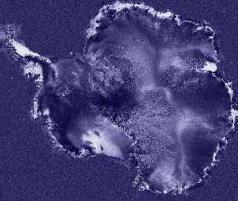
In the following RadarSat images, I have placed a red circle over the place where I estimate the South Polar Opening may be located. The first image is untouched. The second image has the red circle I have placed to indicate the possible location of the South Polar Opening.
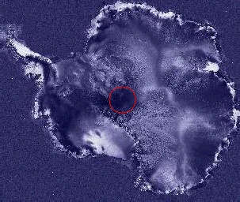
This circular area of low radar reflectivity near the center of the image on this RadarSat image of Antarctica appears to be about 400 miles in diameter. This location of the South Polar opening is located in the same area that looks like an elliptical area in the Apollo 17 image.
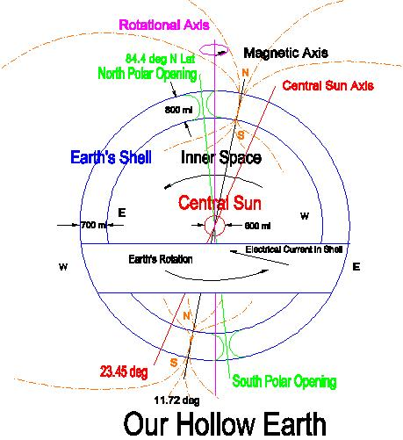
The location for the South Polar Opening is located on the earth opposite the North Polar Opening. The North Polar Opening I have estimated to be located centered on the coordinates of 141 deg E Longitude, 84.4 deg N Latitude. The location of the South Polar Opening then is located 180 degrees opposite the location of the North Polar Opening, or at 39 deg W Longtitude and at 84.4 deg S Latitude.

END

