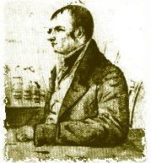  The Newton of the West: John Cleves Symmes, Jr. and his hollow earth, "Drawn by John J. Audobon, Aug. 1820, for the Western Museum."    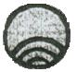  Wood engravings of the planet Mars that Symmes cut with his penknife: note the openings at the poles From the Cincinnati Advertiser, May 4, 1819 Photograph Copyright © 1998 by Alex Boese  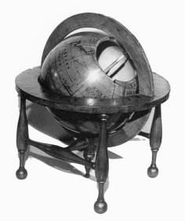 | John Cleves Symmes, Jr Declaires a Hollow Earth in 1818  http://www.museumofhoaxes.com/symzonia.html  Symzonia  In 1818 John Cleves Symmes, Jr., a former American soldier in the War of 1812, sent a pamphlet to all the major institutions of learning in the United States. In this pamphlet he wrote, "I declare the earth is hollow, habitable within; containing a number of solid concentric spheres; one within the other, and that it is open at the pole twelve or sixteen degrees. I pledge my life in support of this truth, and am ready to explore the hollow if the world will support and aid me in the undertaking."  Symmes then traveled around the country, lecturing on his theory. Over the next decade, with the help of an Ohio millionaire named James McBride, Symmes lobbied for both government and private-funding for an expedition that would enter the earth's interior through the openings at the poles. It was suggested that a profitable trade might be opened with the inhabitants found within.  In 1820 a book appeared titled Symzonia: A Voyage of Discovery, written by a "Captain Adam Seaborn". This book purports to describe an actual journey into the hollow earth. It has long been thought that the author of this book was really Symmes himself. If so, the book is a hoax. If the book was not written by Symmes, then it might be a satire of his ideas. However, the book's tone of absolute seriousness blunts any satirical purpose it might have had.  In 1823 McBride, through influential friends, managed to submit a proposal to congress requesting that the U.S. government fund an expedition led by Symmes to the earth's interior. The proposal was voted down 56 to 46. However, one of Symmes's followers, Jeremiah Reynolds, continued to lobby congress and was instrumental in obtaining funding for the 1838 Wilkes Expedition to the Antarctic. Reynolds is also known as the author of a short piece titled "Mocha Dick" which described the legend of a white whale. Herman Melville later expanded this idea into his masterpiece Moby Dick.  Symmes died in 1829, but his ideas provided the inspiration for Edgar Allan Poe's novella, The Narrative of Arthur Gordon Pym (1838).  References:  - Peck, John Wells. "Symmes' Theory". Ohio Archaeological and Historical Publications. 1909 (18): 28-42.

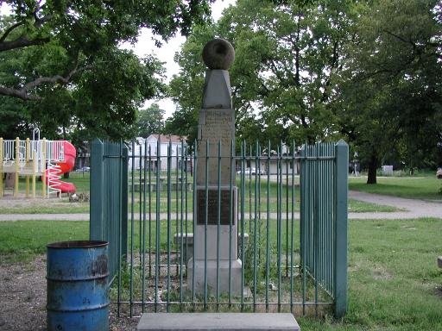
Memorial to John Cleves Symmes located in Hamilton, Ohio. Erected by his son, Americus Symmes, in the 1840s.
Note the hollow globe on the top of the memorial.
Photograph copyright © 2000 by Alex Boese.

The bronze plaques on the four sides of the memorial read:
This monument was erected in the  mid 1840's by Americus Symmes  to mark the grave site of his father,  Captain John Cleves Symmes.  This restoration is a bicentennial Gift  to the City of Hamilton from  Historic Hamilton, Incorporated.  Dedicated March 13, 1991.  In memory of Dorothy Bronson Beeler,  1912-1989, a founder of  Historic Hamilton, Incorporated in 1979,  Restoration by Edgar Tafur, Sculptor.  MAJOR GIFTS  Adeline Zolter in memory of  Mr. and Mrs. Scott Zoller  Mr. and Mrs. William Beckett  in memory of  Mary Millikin Beckett  Nancy Iske Tryloff in memory of  James Louis Iske  Dr. and Mrs. Spencer August  in memory of Calvil William Jung  David and Sally Watson  Mrs. Ellsworth A. Wente, Jr. in  memory of Ellsworth A. Wente, Jr.,  Dr. and Mrs. John A. Stewart  Bill Wilks in memory of  his wife Pat  Dr. Dan Skinner and  Dr. Malcolm Branson Fund | Capt. John Cleves Symmes  as a Philosopher,  and the originator of  Symmes Theory of Concentric  Spheres and Polar voids;  He contended that the Earth  is hollow and habitable  within. | Capt.  JOHN C. SYMMES  a Native of  New Jersey,  died  in May 1829  Aged 49 yrs. &  6 months. | Capt. John Cleves Symmes  entered the Army of the U.S.  as an Ensign  in the year 1802. He afterward  rose to the rank of Captain,  and performed daring feats  of Bravery in the Battles of  Lundy's Lane and sortie from  Fort Erie.

