Hollow Earth
http://en.wikipedia.org/wiki/Hollow_Earth
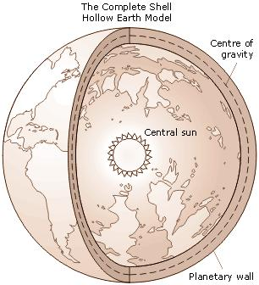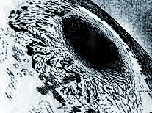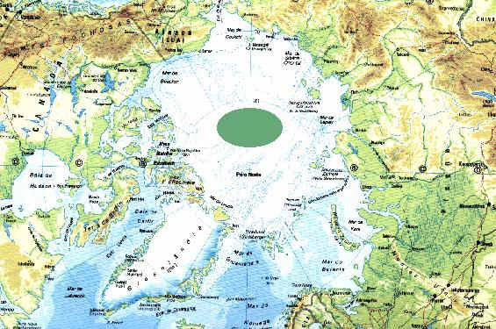

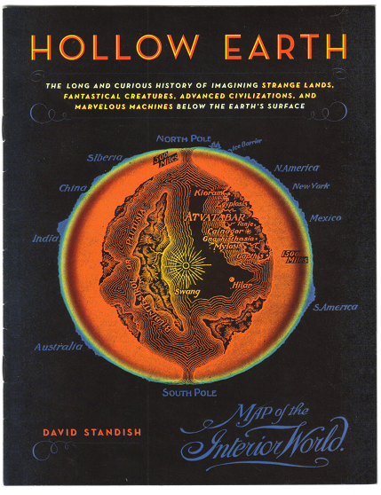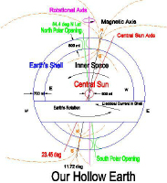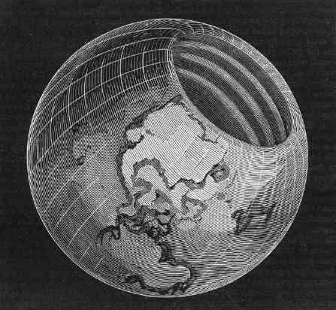

A "Hollow Earth" theory posits that the planet Earth has a hollow interior and, possibly, a habitable inner surface. At one time, adventure literature made this idea popular, and it remains a popular feature of many fantasy and science fiction works as well as in some conspiracy theories. However, the hypothesis of a Hollow Earth has long been contradicted by overwhelming geodetic evidence as well as by the modern understanding of planet formation, and the scientific community now dismisses continued adherence to the notion as pseudoscience.

Contents
- 1 Hollow Earth claims
  - 1.1 Conventional hollow Earths
    - 1.1.1 Early history
    - 1.1.2 19th century
    - 1.1.3 Recent history
  - 1.2 Concave hollow Earths
- 2 Gravity and a Hollow Earth
- 3 Hollow Earths in fiction
  - 3.1 Literature
  - 3.2 Other cultural references
- 4 Hollow Moon
- 5 References
- 6 See also
- 7 Bibliography
- 8 External links

Hollow Earth claims

[] Conventional hollow Earths

[] Early history
In ancient times, the idea of subterranean realms seemed arguable, and became intertwined with the concept of "places" such as the Greek Hades, the Nordic svartalfheim, the Jewish Sheol, and the Christian Hell.

Edmund Halley's theory


Leonhard Euler's purported hollow-Earth thought-experiment, featuring openings at the poles, with an internal star.

Edmund Halley in 1692 (Philosophical Transactions of Royal Society of London) put forth the idea of Earth consisting of a hollow shell about 500 miles (800 km) thick, two inner concentric shells and an innermost core, about the diameters of the planets Venus, Mars, and Mercury. Atmospheres separate these shells, and each shell has its own magnetic poles. The spheres rotate at different speeds. Halley proposed this scheme in order to explain anomalous compass readings. He envisaged the atmosphere inside as luminous (and possibly inhabited) and speculated that escaping gas caused the Aurora Borealis.

Some have claimed Leonhard Euler also proposed a hollow-Earth idea, getting rid of multiple shells and postulating an interior sun 600 miles (1000 km) across to provide light to advanced inner-Earth civilization. This claim may result from a mis-reading of a paper that simply involved a thought experiment.^{[citation needed]}Sir John Leslie expanded on this idea, suggesting two central suns, which he named Pluto and Proserpine (this was unrelated to the dwarf planet Pluto, which was discovered and named some time later).

[] 19th century
In 1818, John Cleves Symmes, Jr. suggested that the Earth consisted of a hollow shell about 800 miles (1,300 km) thick, with openings about 1400 miles (2,300 km) across at both poles with 4 inner shells each open at the poles. Symmes became the most famous of the early Hollow Earth proponents. He actually proposed making an expion to the North Pole hole, thanks to efforts of one of his followers, James McBride, but the new President of the United States, Andrew Jackson (in office 1829 - 1837), halted the attempt. Symmes died in 1829.
However, another follower, Jeremiah Reynolds, also delivered lectures on the "Hollow Earth" and also argued for an expion. Eventually he would drop talk about a hollow Earth after the death of Symmes. Reynolds went on an expion to Antarctica himself but missed joining the Great U.S. Exploring Expion of 1838 - 1842, even though that venture was a result of his agitation. He did not participate because he had offended too many in his call for such a trip.
Symmes himself never wrote a book of his ideas but others did. McBride wrote Symmes' Theory of Concentric Spheres in 1826. It appears that Reynolds has an article that appeared as a separate booklet in 1827: Remarks of Symmes' Theory Which Appeared in the American Quarterly Review. In 1868, a professor W.F. Lyons published The Hollow Globe which put forth a Symmes-like Hollow Earth theory, but didn't mention Symmes. Symmes's son Americus then published The Symmes' Theory of Concentric Spheres to set the record straight.

[] Recent history
An early twentieth-century proponent of a hollow Earth, William Reed, wrote Phantom of the Poles in 1906. He propounded the idea of a hollow Earth, but without interior shells or inner suns.
Later came Marshall Gardner who wrote A Journey to the Earth's Interior in 1913 and then an expanded ion in 1920. He placed an interior sun in the hollow Earth. He even built a working model of the hollow Earth and patented it (#1096102). Gardner made no mention of Reed, but did take Symmes to task for his ideas.
Other writers have proposed that "ascended masters" of esoteric wisdom inhabit subterranean caverns or a hollow Earth. Antarctica, the North Pole, Tibet, Peru, and Mount Shasta in California, USA, have all had their advocates as the locations of entrances to a subterranean realm referred to as Agarttha, with some even advancing the theory that UFOs have their homeland in these places.
A book allegedly by a Dr Raymond Bernard which appeared in 1969, The Hollow Earth, exemplifies this idea. The book rehashes Reed and Gardner's ideas and totally ignores Symmes. Bernard also adds his own ideas: UFOs come from the interior, the Ring Nebula proves the existence of hollow worlds, etc. An article by Martin Gardner revealed that Walter Siegmeister used the pseudonym `Bernard', but only with Walter Kafton-Minkel's Subterranean Worlds: 100,000 years of dragons, dwarfs, the dead, lost races & UFOs from inside the Earth in 1989 did the full story of Bernard/Siegmeister emerge.
The pages of the science fiction pulp magazine Amazing Stories promoted one such idea from 1945 to 1949 as "the Shaver Mystery". The magazine's or, Ray Palmer, ran a series of stories by Richard Sharpe Shaver supposedly claimed as factual, though presented in the context of fiction. Shaver claimed that a superior pre-historic race had built a honeycomb of caves in the Earth, and that their degenerate descendants, known as "Dero", live there still, using the fantastic machines abandoned by the ancient races to torment those of us living on the surface. As one characteristic of this torment, Shaver described "voices" that purportedly came from no explainable source. Thousands of readers wrote to affirm that they, too, had heard the fiendish voices from inside the Earth.
Fantastic stories (supposedly believed as factual within fringe circles) have also circulated that Adolf Hitler and some of his followers escaped to hollow lands within the Earth after World War II via an entrance in Antarctica. (See also Hitler's supposed adherence to concave hollow-Earth ideas, below.)
In 2001 the Australian father-and-son team Kevin and Matthew Taylor self-published the book The Land of No Horizon (direct link National Library of Australia ISBN 0-646-41057-1). Among other things it proposes an expanding and hollow Earth (as well as other planetary bodies) which eventually reached equilibrium. The book also looks at a range of topics including but not limited to evolution, human physiology, impact craters and other geology in light of such a hollow Earth.
Kevin and Matthew Taylor's view of a hollow planet envisages a hollow globe with a small (depending on planet size) central sun ignited by radiation from the inner surface. They use this view both to explain Earth's magnetic field (replacing the dynamo theory) and the origin and ignition of stars.
Some writers have proposed building megastructures that have some similarities to a hollow Earth -- see Dyson sphere, Globus Cassus.

[] Concave hollow Earths
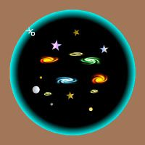
Example of a concave hollow Earth. Humans live on the interior; with the universe in the center.

Instead of saying that humans live on the outside surface of a hollow planet, sometimes called a "convex" hollow-Earth theory, some have claimed that our universe itself lies in the interior of a hollow world, calling this a "concave" hollow-Earth theory. The surface of the Earth, according to such a view, might resemble the interior shell of a Dyson sphere. Generally, scientists have taken neither type of speculation seriously.
Cyrus Teed, an eccentric doctor from upstate New York, proposed such a concave hollow Earth in 1869, calling his scheme "Cellular Cosmogony". Teed founded a cult called the Koreshan Unity based on this notion, which he called Koreshanity. The main colony survives as a preserved Florida state historic site, at Estero, but all of Teed's followers have now died. Teed's followers claimed to have experimentally verified the concavity of the Earth's curvature, through surveys of the Florida coastline making use of "rectilineator" equipment.
Several twentieth-century German writers, including Peter Bender, Johannes Lang, Karl Neupert, and Fritz Braun, published works advocating the hollow Earth theory, or Hohlweltlehre. Stories have even been circulated, although apparently without historical documentation, that Hitler was influenced by concave hollow-Earth ideas and sent an expion in an unsuccessful attempt to spy on the British fleet by aiming cameras up into the sky (Wagner, 1999).
At least one contemporary proponent of a concave hollow Earth theory has developed adjustments to the laws of physics that take into account gravitation, optics, and so forth. The Egyptian mathematician Mostafa Abdelkader authored several scholarly papers working out a detailed mapping of the concave Earth model. See M. Abdelkader, "A Geocosmos: Mapping Outer Space Into a Hollow Earth," 6 Speculations in Science & Technology 81-89 (1983). Abstracts of two of Abdelkader's papers also appeared in Notices of the American Mathematical Society, (Oct. 1981 and Feb. 1982). In one chapter of his book On the Wild Side (1992), Martin Gardner discusses the hollow Earth model articulated by Abdelkader. According to Gardner, this theory posits that light rays travel in circular paths, and slow as they approach the center of the spherical star-filled cavern. No energy can reach the center of the cavern, which corresponds to no point a finite distance away from Earth in the widely accepted scientific cosmology. A drill, Gardner says, would lengthen as it traveled away from the cavern and eventually pass through the "point at infinity" corresponding to the center of the Earth in the widely accepted scientific cosmology. Supposedly no experiment can distinguish between the two cosmologies. Martin Gardner notes that "most mathematicians believe that an inside-out universe, with properly adjusted physical laws, is empirically irrefutable". However, Gardner rejects the concave hollow Earth theory, not as disproven, but instead entirely on the basis of Occam's Razor.
In a trivial sense, of course, one can always define a coordinate transformation such that the interior of the Earth becomes "exterior" and the exterior becomes "interior". (For example, in spherical coordinates, let radius r go to R²/r where R is the Earth's radius.) Such transformations would require corresponding changes to the forms of physical laws; the consensus suggests that such theories tend towards sophistry.

[] Gravity and a Hollow Earth
Someone on the inside of a putative hollow Earth would not experience an outward pull and could not stand on the inner surface; rather, the theory of gravity implies that a person on the inside would be nearly weightless. This was first shown by Newton, whose shell theorem mathematically predicts a gravitational force of zero everywhere inside a spherically symmetric hollow shell of matter, regardless of the shell's thickness. A tiny gravitational force would arise from the fact that the Earth does not have a perfectly symmetrical spherical shape, and also from tidal forces due to masses such as the Moon which do not form part of the spherical shell. The centrifugal force from the Earth's rotation would also pull a person outwards, but even at the equator this is only 1/300 of ordinary Earth gravity.
Also, if the Earth were largely hollow but made of the same materials, it would have much less mass than what is actually observed (from, e.g., the strength of gravity at the outer surface).

[] Hollow Earths in fiction

[] Literature
- In Ludvig Holberg's 1741 novel Nicolai Klimii iter subterraneum, Nicolai Klim falls through a cave whilst spelunking and spends several years living on both a smaller globe within and the inside of the outer shell.
- An early science-fiction work called Symzonia: A Voyage of Discovery by a "Captain Adam Seaborn" appeared in print in 1823. It obviously reflected the ideas of John Cleves Symmes, Jr, and some have claimed Symmes as the real author. One recent reprint of the work gives Symmes as the author. Others disagree. Some researchers say it deliberately satirized Symmes's ideas, and think they have identified the author as an early American author named Nathanial Ames who wrote other works, including one that might have served as the inspiration of Moby Dick (see Lang, Hans-Joachim and Benjamin Lease. "The Authorship of Symzonia: The Case for Nathanial Ames" New England Quarterly, June 1975, page 241-252).
- Edgar Allan Poe used the idea in his 1838 novel The Narrative of Arthur Gordon Pym. He also touches on it in "MS. found in a bottle" and "The Unparalleled Adventure of One Hans Pfaall".
- Jules Verne, who did not often stray far from the bounds of scientific plausibility in his works, used the idea of a hollow Earth in his 1864 novel, A Journey to the Center of the Earth.
- James De Mille's novel A Strange Manuscript Found in a Copper Cylinder (1888) is a Victorian satire of the inverted society within the hollow Earth.
- Willis Emerson's science-fiction novel (1908) recounts the adventures of one Olaf Jansen who traveled into the interior, found an advanced civilization, and then left it. Some people regard The Smoky God as non-fiction.
- Edgar Rice Burroughs wrote adventure stories set in the inner world of Pellucidar (including, at one point, a visit from his character Tarzan). Although the inner surface of the Earth has an absolutely smaller area than the outer, Burroughs's Pellucidar has oceans on the outer surface corresponding to continents on the inner surface and vice-versa, and therefore the inner world actually has a greater total land area than the outer. It is inhabited by primitive humans and creatures extinct on the outer surface, including the Mahars, pterodactyl-like creatures with psychic powers. Pellucidar has a central miniature sun which never sets, so that its human inhabitants have never developed the notion of time.
- The Russian geologist Vladimir Obruchev uses the concept of the hollow Earth in his popular scientific novel Plutonia to take the reader through various geological epochs.
- The Cthulhu Mythos stories of H. P. Lovecraft (et al.) feature as a common theme a subterranean gateway or labyrinth that serves as the home of various Great Old Ones.
- Nehwon, the setting of Fritz Leiber's stories about Fafhrd and the Gray Mouser, is a concave hollow world, a bubble in the universal sea. The story "Trapped in the Sea of Stars" explains this setting.
- A hollow Earth featured in the children's "Choose Your Own Adventure" novel The Underground Kingdom.
- In Richard A. Lupoff's novel Circumpolar (1984), the Earth is donut-shaped, and Amelia Earhart, Charles Lindbergh, and various famous aviation pilots must fly through the middle of the planet in order to win an air race.
- Rudy Rucker's novel The Hollow Earth appeared in 1990, and features Edgar Allan Poe and his ideas.
- The novel Indiana Jones and the Hollow Earth by Max McCoy (1997) expands on the legend of an advanced civilization dwelling in the Earth's interior.
- Eoin Colfer's Artemis Fowl series of novels has a population of fairies living inside the Earth, under the mantle.
- Umberto Eco's thriller Foucault's Pendulum features dubious characters who dream of an absolute power stemming from telluric currents, which they believe to be possibly related to the hollow nature of the Earth, and supposedly known to the Templars.
- The short story "Black as the Pit, From Pole to Pole" by Howard Waldrop and Steven Utley continues the journey of Frankenstein's creature through a hollow earth similar to Edmund Halley's model.
- Weird NJ Issue #27
- The sixth book in the Chronicles of Narnia series, The Silver Chair, features a group of near-humans living under the ground in Narnia.

[] Other cultural references
- In the Tiny Toon Adventures episode "Journey to the Center of Acme Acres", a series of earthquakes shake up the city, causing Plucky and Hamton to fall into a crater in the ground. They fall for hours before finally reaching the center, which is hollow. They are shaken back and forth as a result of the momentum from falling, before stopping and floating in mid-air at the dead center of the world.
- The Dungeons & Dragons role-playing game's Mystara campaign setting included a Hollow World expansion, which served as a nature preserve of sorts, where gods placed extinct creatures and civilizations.
- The comics series Les Terres Creuses by Belgian comics writers Luc and François Schuiten features several hollow-Earth settings.
- The comic book series BPRD by Mike Mignola, creator of Hellboy, did a collection called "Hollow Earth", where the team journeys into great caverns inside the Earth inhabited by Hyperborian people and fantastic machines, some emblazoned with a swastica. At the center is the city of the creatures and their leader.
- The Transformers: Cybertron cartoon series features a character, Professor Lucy Suzuki, who believes in the Hollow Earth Theory.
- The video game Terranigma for the Super Nintendo Entertainment System features both a hollow Earth and a normal Earth.
- The PC Adventure game "Torin's Passage" features a depiction of a hollow Earth (though technically the fictional planet is called "Strata") similar to the one described by Edmund Halley, with the surface world (called "The Lands Above" in the game) being the largest, while the worlds within it (four, known collectively as "The Lands Below") become progressively smaller as the player, "Torin" descends into them from The Lands Above.
- The band Bal-Sagoth has, on their new album The Chthonic Chronicles, a song about the hollow Earth called "Invocations Beyond the Outer-World Night".
- The 2004 Japanese horror movie Marebito (稀人), directed by Takashi Shimizu, also references hollow Earth theory and the netherworld or subterranean realms.
- In the 1970s, comic-book artist Mike Grell produced the comic-book Warlord, about a pilot who finds himself in Skartaris, a sword-and-sorcery world reached through an opening at the North Pole. First believed to be the hollow interior of the Earth, Skartaris was later revealed to be a parallel dimension. In Justice League Unlimited's third season, the episode "Chaos at the Earth's Core" takes place within Skartaris.
- The Marvel Universe features several underground empires ruled by villains like the Mole Man or Tyranus. A race of mutant survivors from ancient Lemuria known as Deviants also live underground.
- In Mage: The Ascension, the Hollow Earth exists as an alternate reality (or "horizon realm") that mages and especially the Sons of Ether faction can visit, but virtually all ways of accessing without magic have ceased to exist in the modern age because people no longer believe the Earth could be hollow.
- The video game Final Fantasy IV for the Super Nintendo Entertainment System (Released as "Final Fantasy II" in the United States) features a subterranean world that is inhabited by dwarves.
- The webcomic, Overcompensating also references hollow earth theories in this August 2006 strip^{[1]}.
- In the console Strategy/RPG series, Super Robot Wars, which mainly features licensed anime properties, the very first original "series" created to buttress the all the disseparate properties was Masou Kishin Cybuster or Elemental Lord Cybuster, which when introduced in 1990 in Super Robot Wars 2 for the Famicom and further expanded in Super Robot Wars Gaiden: Lord of the Elemental for the Super Famicom, told the tale of a Japanese youth named Masaki Andoh who found himself magically trasported into the Hollow Earth world of LaGais which is populated by a human civilization which mixes mysticism with mechanical science. There, he is chosen to be the pilot of the Elemental Lord of Wind, Cybuster, to battle a great evil.
- A Dyson sphere is a hypothetical shell constructed around a star. The Star Trek: The Next Generation episode "Relics" features such a structure.
- In the Marvel comic book series X-Men, within Antarctica there is a "lost universe" called the Savage Land which is full of forests, mountains, rivers, and strange beings just as in the descriptions of many of the voyagers in search of the entrance to the hollow planet.
- The planet Naboo in Star Wars has a "hollow core", but it is filled with water.

[] Hollow Moon
An allied theory regarded The Moon as being hollow, with the interior having a breathable atmosphere - which allowed various SF writers to postulate Lunar life, including intelligent life, despite scientific observation that the Lunar surface is airless.
The most well-known example is H.G. Wells's book The First Men in The Moon and the films made on the basis of it. The idea recurs in various other writings such as Edgar Rice Burroughs' The Moon Maid and The Moon Men (1925), and "The Lomokome Papers", Herman Wouk's less known single venture into Science Fiction (1947)^{[2]}.
"That Hideous Strength" by C.S. Lewis takes place on Earth, but an important part of its background is the hollow Moon, known by its inhabitants as "Sulva", in whose caverns a titanic struggle between the forces of Good and Evil is taking place.
This sub-genre seems to have died out following the actual Moon landing in 1969.

[] References
- ^ wigu.com/overcompensating
- ^ see Wouk - Lomokome Papers at epinions.com

[] See also
- Agartha
- Brinsley Le Poer Trench, 8th Earl of Clancarty
- Cyrus Teed
- Dyson sphere
- Flat Earth
- John Cleves Symmes, Jr.
- Nazi mysticism
- Neal Adams
- New Swabia
- Subterranean fiction
- Travel to the Earth's center
- Unidentified flying object
- Vril

[] Bibliography
- Kafton-Minkel, Walter. Subterranean Worlds. Loompanics Unlimited, 1989.
- Seaborn, Captain Adam. Symzonia; Voyage of Discovery. J. Seymour, 1820

[] External links
- Umberto Eco. "Outlandish theories: Kings of the (hollow) world", The International Herald Tribune, July 21, 2006. Review of Paul Collins' book Banvard's Folly, which includes a chapter on Symmes.
- Hollow and Habitable Within: Symmes's Theory of Earth's Internal Structure and Polar Geography - a scholarly article on Symmes's theory
- At the Earth's Core, by Edgar Rice Burroughs
- The Cellular Cosmogony, by Koresh: full text of Cyrus Teed's book about the inside-out Earth at www.sacred-texts.com
- The Phantom of the Poles, by William Reed: full text at www.sacred-texts.com
- Hollow Earths: page illustrating several hollow-Earth proposals with diagrams
- Stephen Wagner, Nazis and the Hollow Earth, Paranormal.About.com (11 January 1999): (thinly sourced) discussion of rumors about the Nazis and hollow Earth ideas.
- Koreshan State Historic Site, official web page.
- Unofficial Koreshan State Historic Site, unofficial web page.
- American Communal Utopias and The Koreshan Unity: A Bibliography Brief overview and great bibliography of works, if slightly dated.
- Turning the Universe Inside-Out: Ulysses Grant Morrow's Naples Experiment Examination of the Naples Experiment, and why it failed, but also covers the major hollow Earth theories and Koreshan beliefs.
- The Smoky God, by Willis George Emerson. Complete novel
- Voyage to our Hollow Earth, Journey to the North Pole and Beyond - 24 day Trip, June 26, 2006 - July 19, 2006. Expion aboard the nuclear-powered russian icebreaker Yamal
- The Hollow Earth - from The UnMuseum
- Hollow Earth Insider, "a dedicated worldwide group of Insiders researching, not only the Hollow Earth/Subterranean Mysteries, but also reports on the UFO/Alien connection and other mysteries, the New World Order and other conspiracies"
- The Expanding Hollow Earth Theory - a book by proponents of a hollow-Earth theory.
- The Hollow Earth Theory, "A band inspired by the theory"
- List of Some Hollow Earth books in Print at amazon.com
- Phoenix Science Foundation, organization supporting an expion
==================================================================================================================================
END

