

by Joshua Shapiro
Co-author of the Book,
"Mysteries of the Crystal Skulls Revealed,"
with Sandra Bowen & F.R. 'Nick' Nocerino
Updated: January 16th, 1996
www.v-j-enterprises.com/article.html

-------------------------------------------------------------------------------------------------------------------------------------------------------------------------------------------------------

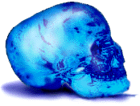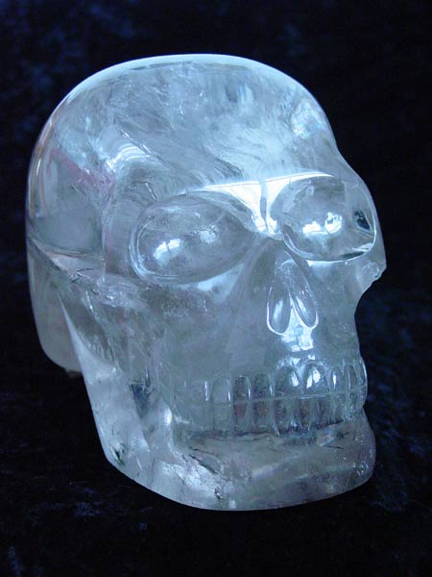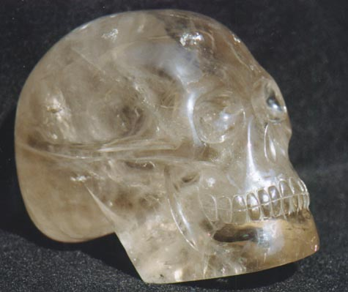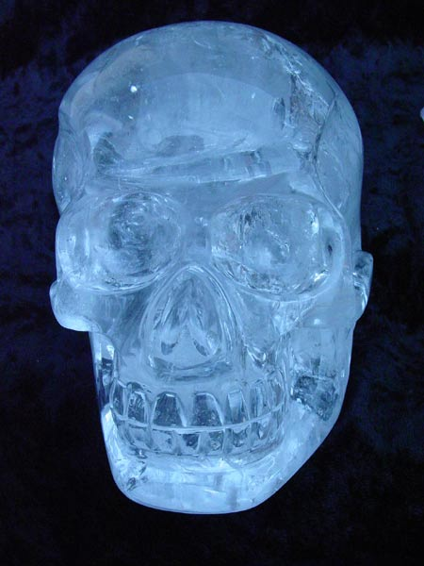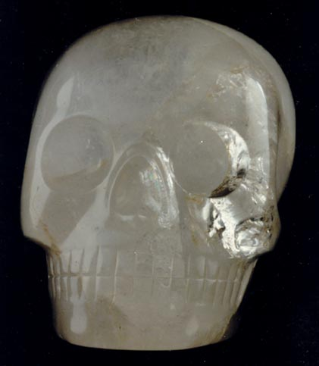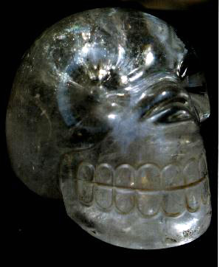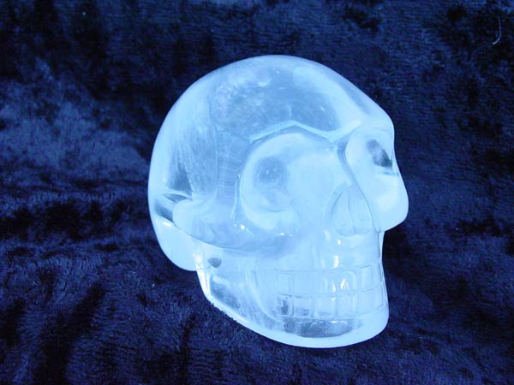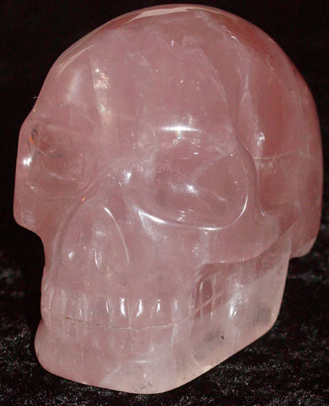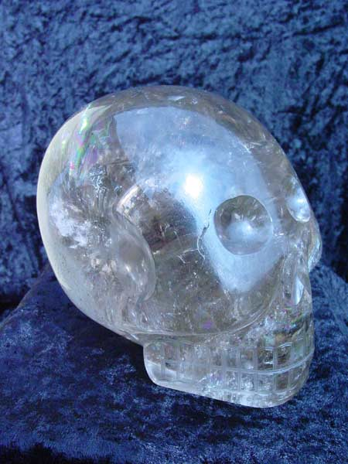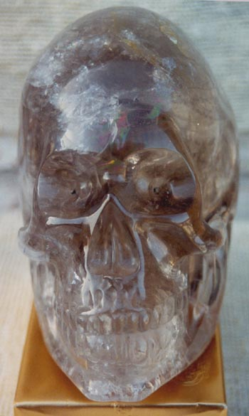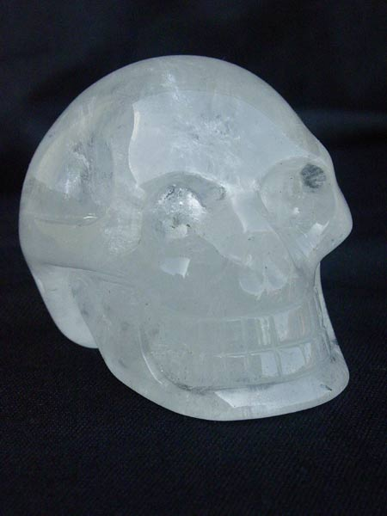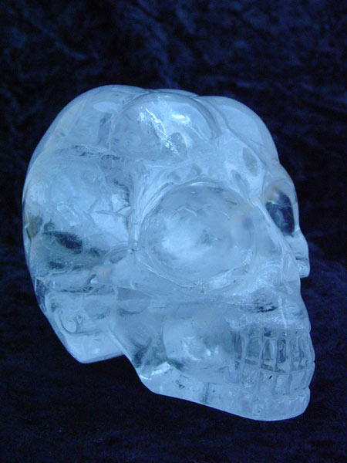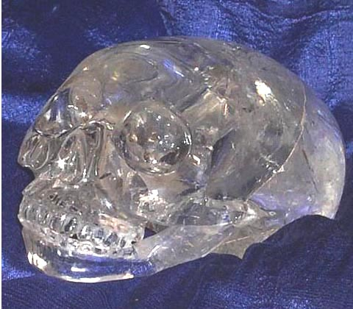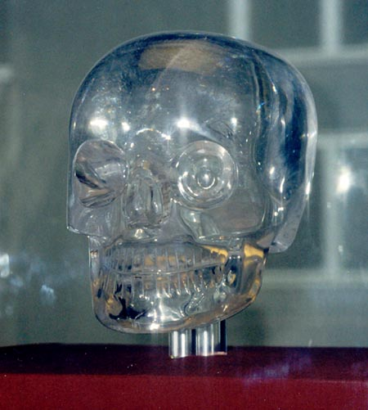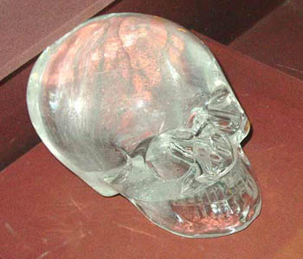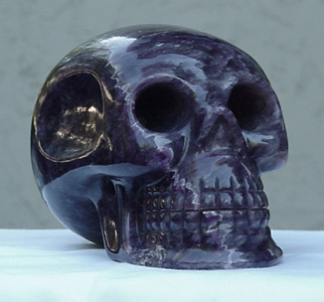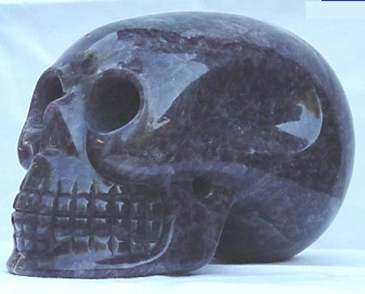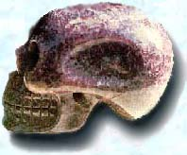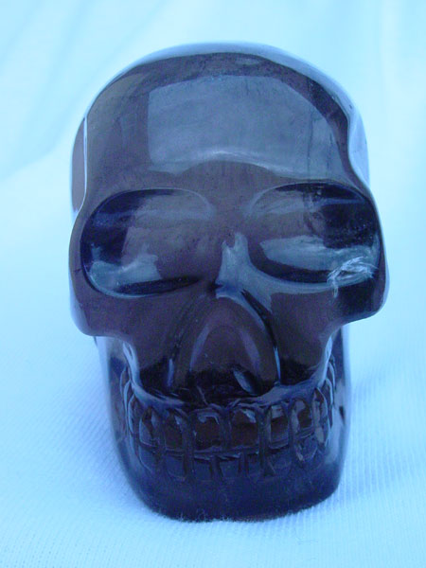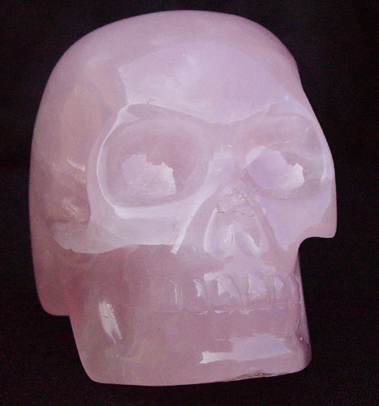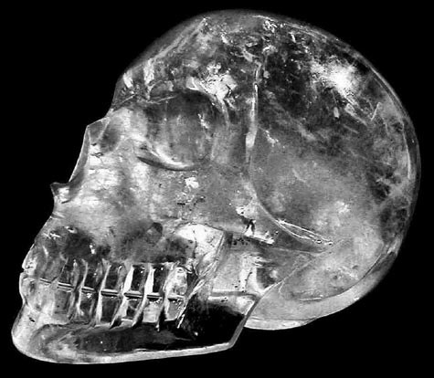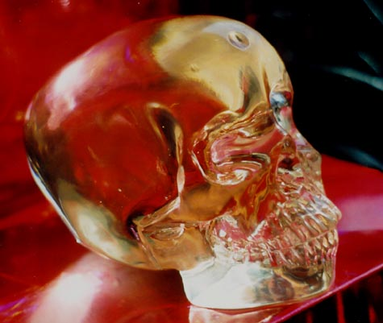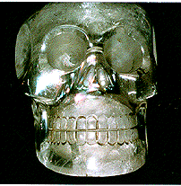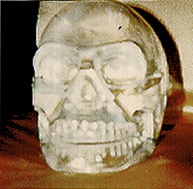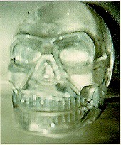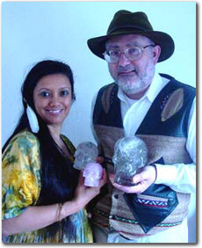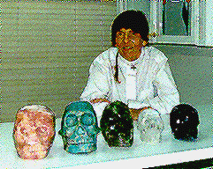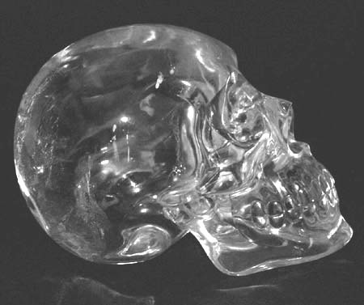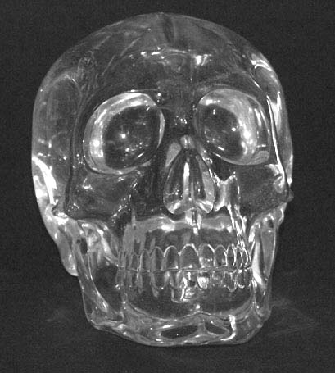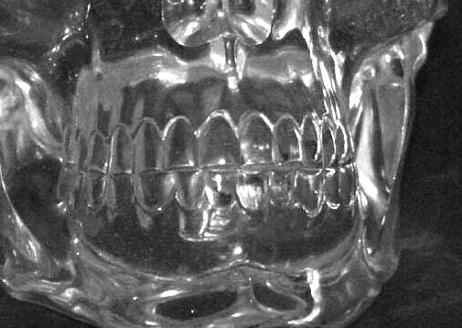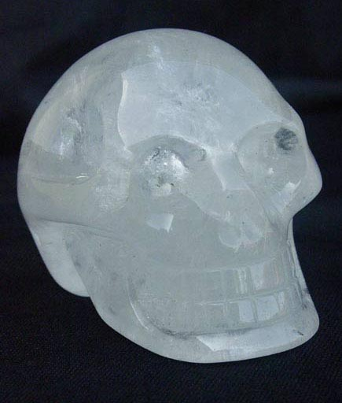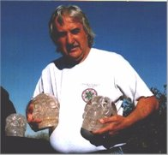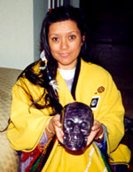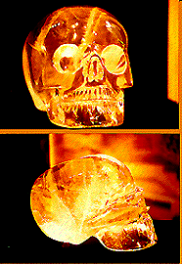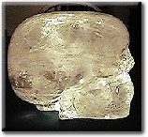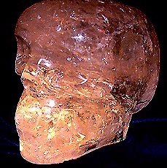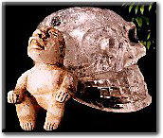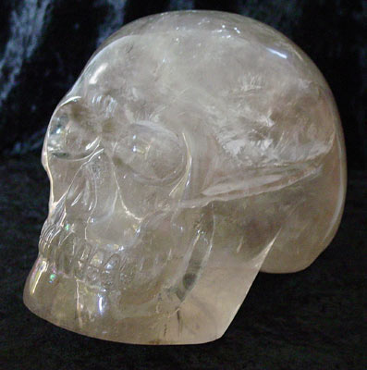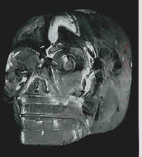

--------------------------------------------------------------------------------------------------------------------------------------------------------------------------------------------

Today the topic of quartz crystals is a hot item! You will find books about crystals in almost every bookstore (even non- metaphysical ones). There is a great battle occurring between holistic doctors/healers and the traditional medical profession about whether crystals can actually be effective in facilitating some form of healing. However, the intention of this article is to go beyond what has been publicly shared on this topic and discuss one of the most amazing uses of quartz by the ancients -- the Crystal Skulls.
What are we referring to when we say a Crystal Skull? A Crystal Skull is a piece of quartz crystal shaped in the form (or approximating that) of a human skull. There are two types of skulls that exist, those which have been carved in a known process by modern-day craftsmen, thus these are called contemporary skulls and others which have been discovered in or near ancient ruins, known as old or ancient crystal skulls. The most interesting of these skulls are the ancients one which are human size or larger. In working with these ancient crystal skulls, we find an incredible energy generally linked to the artifact and many strange physical phenomena. | 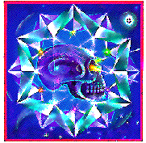  Painting from Cover of Brazilian  Edition of Crystal Skull book done  by Mário Diniz da Silva Filho
The places where the human sized ancient crystal skulls have been found in are prodominately various ruins (Mayan, Aztec, etc ....) in Mexico or Central America with unsupported rumors of some skulls being discovered in South America. However, recently, other crystal skulls are beginning to appear in other parts of the world as well. Thus far, four types of ancient quartz skulls are known including clear quartz, amethyst, rose quartz and smoky quartz. The contemporary carved Crystal Skulls are being manufactured in Mexico, Brazil, Germany & Nepal and there are many local crystal stores which sell some of these skulls as well. The ancient skulls not only have baffled our scientists (when a skull was available for research) regarding how they were made, but have a great deal of psychic phenomena occurring around them.
For example, several of ancient skulls have been brought to Hewlett-Packard, located in the San Francisco area. Hewlett- Packard (HP), long known as a manufacturer of printers and computer systems, has one of the most extensive scientific and crystal research laboratories in the world. The scientist working at HP, who had a chance to work with some of these ancient crystal skulls were hard pressed to explain how a primiitve culture could have carved crystal into such precise shapes and especially against the natural axis of the crystal without the use of sophisticated tools.
Crystal is a substance that has a perfect symmetry of alignment on a molecular level. When a carver cuts crystal, if they attempt to carve against this axis, the crystal begins to shatter. Even with the elaborate laser equipment that is available today, it would be very difficult to manufacture such a Crystal Skull that is so precise and fashioned against the natural symmetry of the crystal. Of course, this does not even begin to address the strange psychic phenomena that has been recorded that occurs in the presence of an ancient Crystal Skull.
What Crystal Skulls are known today? The most famous Crystal Skull is called the Mitchell-Hedges Crystal Skull. It is an almost exact copy of a human skull, totally clear as glass and is composed of two pieces including a movable jaw. It was found in the ruins of a Mayan city called Lubaantun, in Belize in 1924, by Anna Mitchell-Hedges, on her seventeenth birthday. Her father, famed explorer F. A. Mitchell-Hedges, was leading this expedition (funded by the British Government) as he was looking for evidence of lost Atlantis. At first they found the top part or cranium of the skull in what appeared to be an altar room. Three months later they found the lower jaw nearby. The natives went into a frenzy when the skull was first brought out. Mr. Mitchell-Hedges did not have the heart to keep this sacred object from the Maya so he gave it back to the natives. In 1927, when the expedition was ready to leave, the Head Mayan Priest presented the Crystal Skull back to Mitchell-Hedges in gratitude for the food, medical supplies and clothing that the expedition had provided for his people. Thus this mysterious artifact is named after Mitchell- Hedges who uncovered the skull. It has been in their family ever since except for a brief period in England in the 30's when Mitchell-Hedges received a loan using the crystal skull as collatoral. In the past, Anna Mitchell-Hedges has had the Crystal Skull on display at several New Age conferences around the United States. Also, she has allowed private appointments to be made to experience the Crystal Skull in her home (now in Canada).
Two other Crystal Skulls that can be seen on public display at times are the British Crystal Skull, in the Museum of Mankind in London, England and the Paris Crystal Skull, in the Trocadero Museum in Paris, France. Both of these single piece skulls were uncovered by soldiers of fortune in Mexico in the late 1890's. It is speculated that these individuals obtained these skulls by buying them from the local peasants, who make their living robbing artifacts from ancient ruins. Both skulls are made from cloudy clear quartz and neither is as intricately carved nor as precise as the Mitchell-Hedges Crystal Skull. In 1936, a report was published by the Royal Anthropological Institute of Great Britian in their journal called "Man" that compared the British Skull to the Mitchell-Hedges Skull, since they were both in England at the time. They were quite curious about these artifacts as they are somewhat similar in size and shape. The Society was trying to decide which Crystal Skull was created first and which was a copy. Arguments were presented in the article for both possibilities and no conclusive decision was reached.

BRITISH CRYSTAL SKULL
This crystal skull was discovered by a
Soldier of Fortune in the late 1890's in
Mexico. It is currently residing in the
British Museum of Man in London,
England and has been there since
1898. It is a one piece clear quartz
full size quartz crystal skull.

(c)Photothèque Musée De L'Homme

PARIS CRYSTAL SKULL
This clear quartz skull was also
discovered by a Soldier of Fortune
in Mexico in the late 1890's. It is
currently in the Trocadero Museum
in Paris, France. You may notice a
slight indentation on the top, which
is a hole that was cut into the
skull purported to hold a cross.
In our book "Mysteries of the Crystal Skulls Revealed" we discuss several other skulls which are unknown to the public. I would like to just briefly mention them here in order to bring the reader up to date on what is known so far.
In 1979, co-author Mr. Nocerino was contacted by a Mayan Priest in Mexico and was able to work with another clear frosty skull for four months with over 30 researchers. They called it the Mayan Crystal Skull because many of the psychic impressions received depicted scenes from the Mayan culture. This crystal skull is not as human-looking as the Mitchell-Hedges Skull. It does have circular indentations in the temple areas and is one piece. At present, its whereabouts are unknown. In 1982, the same Mayan Priest brought another skull to the United States, the Amethyst Crystal Skull (a purple colored quartz). At present we believe the Amethyst Skull is held by private owners in San Jose, California. This skull is similar in style to the Mayan Crystal Skull but slightly smaller. Both of these skulls were brought to Hewlett Packard for research and also found to be cut against the axis of the crystal.
(c)Steven Mehler

MAYAN CRYSTAL SKULL
Yet another single clear quartz skull
discovered in Guatemala in 1912 and
brought to the U.S. in 1979 for a
short period of research by a
Mayan Shaman in Mexico. Its current
whereabouts are unknown.
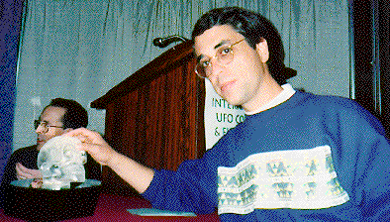
(c)Ari José Mallmann Homem

THE PRESENCE
This picture was taken of Ari José
Mallmann Homem of Ribeirão Preto in Brazil.
He is shown here with the "Presence" which
was on display at the UFO Congress, held in
Las Vegas in December of 1993. Purportedly
this skull was discovered in Peru and at the
moments, its whereabouts are unknown.

During the Second World War in France, Mr. Nocerino saw another clear Crystal Skull known as the "Light of Christ". This skull was clear and one piece, and held by a secret society. In the late 1940's near the Guatemala-Honduras border, Mr. Nocerino saw the Rose Quartz Crystal Skull that was two pieces with a movable jaw that was an almost exact copy of the style of the Mitchell-Hedges Crystal Skull except this skull was slightly bigger and was very well guarded by local natives. He has also seen two other Amethyst Crystal Skulls, one in Marin County of California and another in San Jose, Mexico ( the San Jose Crystal Skull ) which was buried in a tomb dated ninth or tenth century a bit larger than most other crystal skulls weighing about thirteen or fourteen pounds.
Since the publication of our books, other crystal skulls have beguh to service. For example, there is a report of another clear skull with a movable jaw existing in Peru kept in secret by the Peruvian Government.
Also related to a crystal skull in Peru, hrough Michael Lightweaver, who is an extraordinary New Age Networker in North Carolina (USA), we heard of a special Inca Teacher, who guides groups in Peru that Michael has worked with ( note, I just met with this individual in Cusco in October, 1995 and he requested that his name be kept anonymous). We asked for Michael to send us some articles done by this special individual ( who shares information about the "Inca Prophecy" ) and my wife Vera, contacted him to be a guide for her own metaphysical journey to Peru in 1993. Vera discovered from this teacher that he had seen a crystal skull in the northern part of Peru that was held by the Campa people, living quietly in the jungle. When my friend Gloria, showed him some photos of various ancient crystal skulls (as see went with Vera to Peru in 1994), he said that the skull he saw was similar to "ET" (see description of Joke Van Dieten in a few paragraphs below) as it had a pointed jaw. He described this skull (speaking in Spanish to Vera over the phone and Vera translating for me into English) as a single piece of clear quartz with blue in the eyes and on the top of the head. The Campa brought the skull out to him, to see if he knew what it was. He only felt it had great healing energies and sacred knowledge. This is the first confirmation we have had of a crystal skull in Peru although I keep seeing a clear blue skull in my mind's eye somewhere in the vicinity of where this teacher saw this skull.
In 1988, the Parks of Houston, Texas, begin to share with others a large frosty clear quartz skull that weights 18 lbs. The name of this skull is the Texas Crystal Skull or the skull telepathically communicate to caretaker JoAnn Parks to call it "MAX". The Parks inherited this skull from a Tibetan Monk who used the crystal skull in his healing center to help heal people who came in. Mrs. Parks eventually became the secretary of this center. In appreciation for the support the Tibetan Healer received from the Parks, he left them "MAX" when he died in 1980. The Parks are open to have people come to visit them and see the crystal skull. "Max" has been on display at a number of New Age and UFO conferences in the U.S. and recently, she told us that she is traveling three weekends, every month now. Max is also participating at the Wolf Song Gatherings, held yearly by Mary Thunder, to bring elders from various indigenous cultures together to discuss peace and share their knowledge. Lastly, JoAnn Parks has been working with a spiritual channel and healer, Star Johnson who has been receiving telepathic communications from Max and began speaking in a strange language (possibly a Space Language) after working with this crystal skull. Star leads a special ceremony with "MAX" to help activate the energy grid of our planet in special locations.
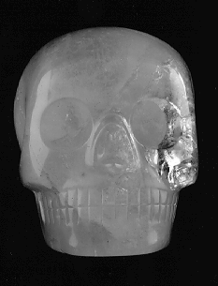
This Negative is on File
All Rights Reserved
Copyright (c) Date 3-23-88

MAX

The Texas
Crystal Skull
THE TEXAS CRYSTAL SKULL
Attn: JoAnn Parks
P.O. Box 751261
Houston, TX 77275-1261
(713)991-4545
(This image was scanned from
an original photograph sold by
JoAnn and Carl Parks)

When I was in Las Vegas in 1989, doing some lectures to help promote my crystal book, I met an elderly gentlemen named Jose Iniquez, who was born in Mexico. Upon the completion of this lecture, Jose told the group there that he had in his possession a small clear quartz skull with Mayan Symbols carved into it. He said that he had this skull since 1942 and found it in a Mayan ruin during a field trip conducted by his class from school. He claimed that after the skull came into his possession every dream and desire he ever had in his life was fullfilled. I had a chance to work with this skull in the summer of 1989 and found that it indeed had a powerful energy. Jose died in 1993 and the whereabouts of this skull are not known at this time. Jose told me that a small amethyst skull was also found next to his and that a friend of his in Mexico has this other skull.
In April of 1991, I was in Los Angeles participating at a local holistic conference. I had been invited to speak about the Crystal Skulls. I have a friend Eric, who is the owner of a beautiful crystal store in this area. He had a booth at the conference for his store and told me that he had received a new crystal skull from a family in Central America. When he first told me this for some reason I had the impression it was just a contemporarily carved skull. I soon discovered this was not the case and the person who was going to buy the skull was also in town at this time. Eric permitted me an opportunity to meet with this new owner and see the skull. This skull is a one piece smoky quartz skull that has a pointed head and the teeth come to an overbite. Thus, when the new guardian, Joke (pronounced Yo-ka) Van Dietan saw this skull for the first time, was my first time. Joke decided to call the skull "ET" because the skull looks a bit extraterrestrial. I did have an opportunity to meditate with this skull and definitely felt it was an ancient one but that it was not fully activated.
During Christmas time of 1992 (in the Chicago area), Joke and her friend Hans from Germany decided to visit us (Joke was living in Switzerland at the time, recoving from a brain surgery to remove a tumor in her brain, the size of an orange). Now she is perfectly fine and contributes her incredible healing process to "ET", which she purchased a few months before she was diagnosed. She use to have very bad headache which is why she had an x-ray performed.). Thus for the first time in our lives, my wife and I had an opportunity to actually live and sleep with this skull for four days. We brought the crystal skull to the Bahai Temple in Wilmette and meditated with it in the main chapel where the Bahai services are held. This indeed was a very powerful experience. The last incredible incident that occurred during this visit was bringing "ET" together with the famous "Mitchell-Hedges" Crystal Skull, that was in Valparaiso, Indiana at this time (about 90 miles from Chicago). It was a powerfully moving experience to be in the presence of two ancient crystal skulls. I felt strongly that these two artifacts were not strangers to each other, and perhaps this is true since both of these skulls were discovered in close proximity to each other, around the Belize area.
Joke has a vision of obtaining twelve different skulls. Since her acquistion of "ET" she also purchased: Shui Ting Er - an amazonite skull discovered in Mongolia; The Luv Skull - a Rose Quartz Skull discovered near Luv Russia in a mound containing artifacts from the Scylanthians and lastly, the Jesuit Skull, which is purported connected to the Jesuits and possibly St. Francis of Assisi, this last one is a third of size human skull that is made from clear quartz. It has been very interesting working with Joke, she is a dynamic individual who loves living on the edge.
In November/December of 1995, we traveled with Joke to Australia to share two of the four skulls ("ET" and the "Jesuit") she has purchased. To the best of our knowledge this will be the first time, Australians will experience a Crystal Skull. It was a fast pace two week period including spending five days at the Body-Mind-Spirit Festival in Sydney where we had a booth sharing information about our 1996 Peruvian Tours on one side and the crystal skulls on the other. Joke permitted people to sit and have a five minute session with the crystal skulls (also shared a small booklet that discussed how she came to be the caretaker of four skulls). I would say that 90-95% of the people experienced some energy at least with one of the crystal skulls (mostly, "ET", the smoky quartz skull). One woman, a well known Reiki healer and teacher in Australia, I felt made a connection with "ET" and spoke about the skull as being the physical condensation of an energetic being who had come from another dimension far removed from our own and was drawn to the Earth and we experience this being in the physical as a crystal skull. Joke also had my co-author Mr. Nocerino work with these two crystal skulls for three months and archaeologist who Mr. Nocerino knows told her that there is no known bone skull that has ever been found in the ground that matches the appearance of "ET". It was a great experience and Joke received many invitations to come back to Australia to continue to share her crystal skulls there. Joke had a special connection with Australia as this was the place she was when her tumor was discovered, in the Sydney area, so in graditude for helping her, she felt it was important to share the crystal skulls with the people there. She was quite surprised at people's response to her two treasures.
Another area I started to explore in 1994 was Internet. When I first searched for any information related to Crystal Skulls, I came up with nothing. In March of 1995, we tried an experiment, we worked with an Internet provider in Colorado (Bob Garth, Protree computers) who offered us the opportunity to create our own Internet World Wide Web Site relatively inexpensively. Little did we know what was in store for us. This gave us an opportunity to share information with the over 30 million subscribers around the world.
The first interesting lead we received on Internet came from a man Carlos, who lived in Wisconsin. He sent to us an email indicating that he had attended a 1993 UFO Congress in Las Vegas, Nevada, where a clear quartz crystal skull was shown. A video was made of the presentation with the crystal skull, so based on his information I contact the UFO Congress in Oakland, Calfornia and was able to obtain a copy. I was surprised to find that my old board member, Arsenia Pitts, who assisted in helping to create a non-profit foundation we formed in 1989 in Las Vegas called Fund (1989-1991) was sitting up front as the caretaker of the skull. We tried via Fund to share information about the crystal skulls and also we did have some meetings with Jose Iniques (who I mentioned before), discussing having the foundation share his crystal skull with the world. We even had a discussion of the foundation becoming the owners of this skull but this never did work out. Arsenia called her crystal skull "The Presence". I had heard from another of our board members that Arsenia had bought a crystal skull but this was the first time I had really seen the skull. Purportedly Arsenia was contacted by a friend in Sedona, AZ and met a couple who collect and sell different crystals. They claimed that they obtained this skull in Peru and wanted to sell it. In April of 1995, an old girlfriend who is a psychic, called me and ask if I knew of a crystal skull that was stolen and I said no. She had been contacted to see if she could track where the crystal skull was psychicly. I finally got confirmation that this skull in Las Vegas was the one that had been stolen when two people living in Lake Geneva, Wisconsin attended a lecture in May (1995) that my wife Vera and I gave about Peru. They used to live in Las Vegas and had worked with Arsenia and "The Presence" so they knew about it and that appearantly a professional took it from Ms. Pitts car.
More interesting things happened after we started a crystal skull mailing list on the Internet in May of 1995. First, one of the members of the list, Marc Whitford, wrote about an experience he had with a half size contemporary clear quartz crystal skull that was made in Brazil. This skull was sitting in the Crystal Gallery, located in Washington, D.C. When Marc entered the store, he was drawn to examine and touch the skull. He received permission from one of the owners of the store to meditate with this crystal skull and as he focused upon it, he became aware that he could manipulate its energy which produced changes in the skull. When he had finished, a crack had appeared inside of the skull. After this experience, Marc has been able to work with all forms of crystals and able to mentally make the quartz change. Then we received a fax from a person on the east coast saying that she had a human size clear quartz skull that possibly came from Brazil. We have not been able to meet with this person yet to verify this statement.
Another interesting lead came through some postings on the News Groups on Internet by Robert Rouse, a self pro-claimed lightworker and UFO researcher. Robert began to share the bi- weekly newsletter of the Center of Attention from northern California, close to San Jose. In one of the April issues, the newsletter mentions Wayne Nicholas and his journey to the sacred Mayan Sunrise Ceremony in Uxmal, Mexico, held on March 21st, 1995, in celebration of a sacred Mayan Prophecy. While particpating in this gathering, Wayne mentioned meeting Jane Doherty who had with her a crystal skull (actually Wayne had a vision he would see a crystal skull at the gathering. He thought it might be "MAX", the Texas Crystal Skull which was invited but Ms. Parks does not want to take the crystal skull out of the US). So after a few phone conversations with Wayne, he finally gave Jane my phone number and she called me at my job in June (1995).

Below is a brief article I have written about Jane and her two small ancient crystal skulls:

"Maya" - A Crystal Skull from Mexico
Jane Doherty, Caretaker, S. Plainfield, NJ
August, 1995
Eight years ago, Jane Doherty, was walking in a store in Mexico and just as she was ready to leave, thinking to herself, there was nothing there, she spotted a glass case that called to her. Inside this case, she was surprised to see were two small skulls made from quartz crystals plus some additional Mayan artifacts. She felt such an affinity to the skulls that she had to purchase them. One of the skulls, the larger one was made from clear quartz and the other skull was made from rutilated quartz and had more of a brown color. She had no idea of what she was doing at the time, all she remembers is that the case said "Artifacts" and when she asked the storekeeper where they were from, since she didn't speak Spanish, all she heard was from some local ruins.
About the time she acquired these crystal skulls, Jane began to look at other ways of making a living, as she was a school teacher at the time and found that she had an interest in more metaphysical or paranormal subjects. She started to find that she could do spiritual consultations and especially was interested in working with other people using hypnotic regressions to receive information about their past lives. However, a strange thing happened, people became more interested in having Jane do psychic readings for them and began to receive some very clear information for them and about their lives. Also she noticed that the clear quart crystal skull was always near her while doing these sessions ( she had given the smaller one to a nephew as a gift ). So somehow, this crystal skull was acting as a catalyst to activate Jane's natural spiritual gifts.
At the present time, Jane is the President of the Jersey Society for Parapsychology, and does Ghost Investigations and clears haunted houses. She offers Haunted House Toursin the New Jersey - New York area (the last one in October, 1995). She has also been featured on "Sightings" and other special shows on NBC and was a honorable mention in two books dealing with ghosts. She is consulted by the media as an expert on parapsychology and for her psychic insights. One strange that occurs to Jane when she is in the presence of a ghost is that her stomach will bloat out, like she is pregnant.
How I became familiar with Jane is indirectly through Internet. A person by the name of Robert Rouse, had been posting copies of the Center of Attention's newsletters (A New Age Center in Santa Clara, California) to one of the mailing lists I am subscribed to. One of this center's members, Wayne Nicholas, went to attend the sacred Mayan Sunrise Ceremony, on March 21st, in Uxmal, Mexico. This ceremony was held as part of a prophecy that new energies would start to be infused into the earth. The gathering drew people together from all over the world. Wayne reported that he met Jane at this gathering and she brought a crystal skull with her. Wayne described in the center's newsletter some of the powerful ceremonies conducted with the skull, while they were there.
So I called Wayne, begged, asked, pleaded, to receive Jane's phone number, so I could obtain more insight into who she was and what type of crystal skull she had. Then one day at my job, I picked up the phone and there was Jane Doherty. Amazing, I thought, the universe is working doubletime!! In any case, we began a friendship which at the writing of this article, has only been over the phone but in less then one month, we have setup between us, nine crystal skull lectures in New York City - New Jersey, Wisconsin, Chicago and Indiana for September (1995).
Some additional information I learned from Jane: She had read our crystal skull book ("Mysteries of the Crystal Skulls Revealed") and was thinking of contacting me for over a year. After Jane read our book, she decided to work with the clear quartz skull and began to focus upon her mind upon her. She was startled when this crystal skull began to move by itself in a wave-like motion, on its own, strutting forward three times. Jane told me more about the physical appearance of the two skulls. 'Maya', the larger of the two skulls is clear quartz crystal and has some indentations in the temples, similar to the Amethyst and Mayan Crystal Skulls discussed in our book. "Maya" was the crystal skull that Jane brought to Mexico and she calls it "Maya" because she felt that in Uxmal, this crystal skull became re-activated and also because this skull has the feel of being feminine. The smaller, second crystal skull is a rutilated skull that she calls "Alden", the middle name of her close friend Ron in California, who felt it was extremely important that she go to Mexico, so she honors Ron by naming this second skull after him. So "Maya" and "Alden" really have not been shared with the public too much, but this coming September, Jane and myself will begin to work together to offer a series of lectures to discuss many of the known ancient crystal skulls today and to also provide people an opportunity to work directly with the crystal skulls in Jane's possession. We will also begin to do some research with "Maya" by working with sensitives and scientifically minded individuals, in order to gain a better understanding of how these skulls were made and for what purpose.
-------------------------------------------
As a post note to the above article, I would like to briefly share the results of the eight lectures and three research sessions that we did during the timeframe mentioned in the article above, September, 1995. During this month we setup lectures in New York City (Sept. 9th), Clark, NJ (Sept. 10th), three lectures in Wisconsin (Sept.15-17th), two lectures in the Chicago area (Sept. 22nd and 25th) and one in Indiana (Sept. 27th). We also conducted three research sessions with over fourty people, one in Brooklyn, NY, Janesville, WI (close to the home of the white buffalo now brown) and one in our home in Des Plaines, IL.
A brief summary of our results: The research sessions we conducted with Jane's crystal skull consisted of have each participant sit with the two skulls and share whatever they were feeling or any visions they had. Generally Jane and I would be with this person, Jane would take photographs and I handled the video camera. We also audio taped each session. Sometimes during the sessions, depending upon what the participant said or was experiencing we would ask questions. Almost every person who helped us with this research felt some type of energy with "Maya" and "Alden". Three men were able to hold "Maya" and by moving their hands around the skull, changed the energy and cleared the crystal. One of these gentlemen, who is a master of working with energy (trained in the Far East), actually had smoke coming from the skull in one of his sessions. About half of the people who worked with the skulls felt that they were very old and the other half felt they might have been made more recently. But everyone felt a very calming and uplifting energy from either one or both of the skulls.
When I had an opportunity to work with "Maya", a strange thing occurred. I have an Indiana Jones hat I wear for my lectures. I use the nickname of "Illinois" Shapiro to describe myself, being that I was born in Chicago and I feel a kind of adventours spirit like "Indy". While I was working with the crystal skull, holding it, experiencing its energy, Ms. Doherty decided to put my hat on her own head. She said when I touched "Maya" my hat would vibrate. Another thing we tried was to see the effect of the crystal skull upon ourselves by taking some kirlian photographs before working with "Maya" and while holding and focusing on "Maya". For both Ms. Doherty and myself, the color of our aura went from an orange color to brilliant purple, blue and white. I have copies of these pictures which I am posting onto the Internet, on our Web Site, to share with others. A woman who worked with "Max", the Texas Crystal Skull and used some similar equipment also had a similar result.
The conclusion of this research was: Although I can not say definitively that the crystal skulls which Ms. Doherty possess are ancient (but this is her belief), they certainly have the ability to conduct some powerful energy. In addition, Ms. Doherty is the only caretaker we are aware of, who uses her crystal skulls to assist her with her spiritual consultations. It is my theory and was my experience, that there may be some type of spiritual entity who is connected to Ms. Doherty and the crystal skulls and is helping to activate these crystals. Although we did not know what to expect from the people participating in this research, I can safely say that we were pleasantly surprised by the connection that people felt with the two crystal skulls. All of these sessions were audio and video taped and we are in the process at this time of transcribing them.

In 1995, there is one other skull I heard about and even obtained some pictures of, which is known as the Crestone Skull or San Luis Valley Skull. I am not sure the exact year when this skull was discovered, but a woman who has a ranch in the San Luis Valley near Crestone, Colorado, one day was walking on her property and found this strange looking object. It was in the shape of a skull but it appeared to be as if it had been melted or molded. I first heard about the Crestone Skull when Chris La Fontaine of Lightspeed in Minneapolis, Minnesota gave me a call. He knew about my interest in Crystal Skull from our web site. At the time of the call, I was in New York City, participating at the Whole Life Expo, where I had given a lecture with Jane Doherty and her two crystal skulls. Upon returning home, I gave Chris a call and he told me about the Crestone Skull and he and his ladyfriend's experiences with it. He also told me that the women who found it, had entrusted it to a local New Age bookstore, near Crestone, Light Reflections and that the people at the bookstore allowed other people to come and meditate with the skull. Chris gave me the phone number for the bookstore so I could contact them directly. The very same night, a friend I had met at the Whole Life Expo, called me and told me a friend of hers told her about the Crestone Skull as well. Very strange but I guess not for working with the skulls.
I called Light Reflections and spoke to the daughter of the owners, Alta. Alta told me that a good number of people had come to their store and many had experience some energy with the skull. Also they were not sure what material this crystal skull was made from, some sensitive felt that it was a projection of an entity, fairly recently into our reality. She also mentioned that had done a meditation around the skull with over a hundred people. Also that Tom Dongo, a UFO researcher from Sedona (AZ) had taken a set of pictures of the skull, so I quickly sent a check and received a set of six pictures (if you go to our web site listed below, I have been given permission to scan one picture). She also informed me that my friend Steve Mehler, who lived in Colorado Springs and we interviewed in our book, "Mysteries of the Crystal Skulls Revealed", had seen the skull and worked with it. So I looked into my computer database and pulled Steve name out and he basically confirmed what everone had told me, that he also experienced an energy with the crystal skull, that he was not sure of what material it was made from and that it appeared as if it had been melted or molded somehow.
In my last conversation with Alta, she told me that the finder of the Crestone Skull was having some financial difficulties and might lose her ranch. So Alta was going to start to travel and share the skull with others. She had attended the UFO Congress in Mesquite, Nevada in November (1995) and brought the skull with her. She said people there also experienced an energy connected with the skull and that she had received a few invitations from people there to go to other locations to share it. Also I spoke to my friend Carlos in Wisconsin, who told me about "The Presence" and he said he did not feel any energy himself from the skull. So we have another mystery.

As one can see, more and more crystal skulls seem to be popping up. In the year of 1995, I have become acquainted with the existence of another five or six. At this time, I continually see around me, in my mind's eye, what appears to be a clear blue quartz skull. Where it is and if I will ever meet this skull, I do not know but if it does exist and one day I am drawn to find it, it will certainly be an interesting adventure. One of my goals or visions is to eventually create a crystal skull conclave where all the caretakers of ancient crystal skulls are invited as well as the most well known researchers. Now lets move on to an analysis of the type of activities that happen around the crystal skulls and some theories.
What type of unusual phenomena has occurred around the Crystal Skulls? First, I would like to share a few personal experiences with the ancient Crystal Skulls I have seen. I was in the presence of the Amethyst Crystal Skull in April of 1983 and the Mitchell-Hedges Skull in May & June of 1986.
One of the psychic or inner gifts which I have discovered and seems to come naturally, without effort, is the ability to feel or sense energy/vibration. When I first came in contact with each of these skulls, I felt as if they were quiet or as if there was absolutely no energy within them. After seeing the Mitchell- Hedges skull, I discussed this experience with one of the other co-author of my book, Sandra Bowen. Sandra had worked with Mr. Nocerino for three weeks of intensive research with this Crystal Skull in November of 1985. At this time, she had a totally different reaction from mine as she instantly connected with the skull and felt tremendous energy around it. Thus I concluded that this skull could conduct totally different sessions with individuals around it at the same time. Apparently, when one first begins to work with a Crystal Skull, there is a period of getting acquainted. Now, if I am in the presence or even see a picture (or a mold, in 1993, we came in contact with a person in Chicago who had a cement type mold of the Mitchell-Hedges Skull and I still felt an energy with this) of either of these Crystal Skulls, I immediately feel a connection and a great deal of energy around and inside of me. I begin to receive mental images of places and people of which I am not always certain what it means. Also I receive tremendous insights into myself, universal knowledge or an intuitive understanding of spirit and a feeling of being charged. I know within my being that I have worked with the Crystal Skulls in prior lifetimes as I will inwardly hear suggestions of how to activate and work with the skulls.
Some people who have been in the presence of the Mitchell-Hedges Crystal Skull have told the owner that they received a healing of some form or found that their psychic abilities became expanded. Other people have fallen into a trance while being with this skull. But the most dramatic phenomena which occurs around the Crystal Skulls, which is a very special part of my co-author, Mr. Nocerino's research, are the holographic images which appear inside of the crystal skulls when they are activated through a combination of color, light, sound or human energy. Some of the scenes that have appeared within the skulls are UFOs, Big Foot, Unicorns, flying people, mermaids, dolphins, whales, mountains, other Crystal Skulls, alien beings, forest, caves, etc ... To this date, no one is quite sure of the exact process which manufactures these pictures. Even when any of the co-authors have done public lectures sharing the crystal skulls through slides and video, there are always people who see images inside of the skulls!
Just exactly how many Crystal Skulls are there? In this article we have discussed more than ten ancient human sized and shaped skulls. However, it is the general consensus among the researchers that many more skulls exist and will be coming out in the near future. That possibly there could be multiple sets of thirteen skulls that work together. As we view each of the different Crystal Skulls that are known, we see that there are some which are very similar in shape and size and perhaps belong to one specific group of thirteen whereas others are of a different shape could be in a another group of skulls. Some of the skulls appear to be an attempt to duplicate the more ancient ones. If one studies most of the world's major religions, the concept of thirteen comes up repeatedly. For example in Christianity there is Jesus and the twelve apostles or what about the twelve tribes of Israel and their priests, the Kohans. It has even been speculated that our solar system once had thirteen planets, one of which was destroyed (Maldek, a planet between Mars and Jupiter which is now the asteroid belt between the two planets) and two others which we have yet to discover, one possibly beyond Pluto.
What are the Crystal Skulls? The most productive research we have done on the Crystal Skulls to obtain such answers involves using psychic procedures. This is because Carbon 14 dating does not work on inorganic objects such as quartz crystal and our scientists are still unclear how the skulls were made. In other words, we have interviewed and received reports from people who have either been in the presence of one or more Crystal Skulls and given us their psychic impressions or from various spiritual channels. These channels have received information from a variety of sources including dolphins, extraterrestrials or multi- dimensional beings who talk through them. From the synthesis of their information, I would like to share with the reader the following conclusions. However, as was discussed in the first book published about the Crystal Skulls, done by Richard Garvin (1973), there are numerous theories which have been given through these sources and very few which completely agree.
We believe the Crystal Skulls are a form of computer which are able to record energy and vibration that occur around the them. The skull will pictorially replay all events or people who have come into contact with them (i.e. - they contain the history of our world). Just as our modern computers can receive or send energy/information from similar types of machines, so too can the Crystal Skulls send information amongst themselves. We believe, as the ancient legends describe, that the Crystal Skulls can and have been used for healing. They played a key role in many cultures who saw the skull as the Godhead. We have also found a very strong link with extraterrestrials and feel that Space Beings either brought these skulls to our world or gave us the techniques to fashion them. We believe that the holographic images of UFOs and Aliens that are displayed in the skulls and have been observed by various researchers and sensitives adds support to such a theory.
If the Crystal Skulls were not brought by extraterrestrials then certainly we must conclude their have been civilizations much more technologically or spiritually advanced than our own today. We have had several channels suggest the skulls were created in Atlantis or Lemuria. That the Crystal Skulls could have originally been a human bone skulls that were changed to crystal through the power of the mind. Also, that the skulls are connected to the people who live in the Inner Earth. This idea presents the theory that our earth is Hollow with a small central sun at its core and openings at the poles. Gravity, which is located at the center of the Earth's crust, 800 miles thick, hold objects and people to the inner or outer surface. Supposedly, 13 master Crystal Skulls hold the genetic coding of Twelve Inner Earth Tribes and the thirteenth or central skull represents the family of these tribes.
I personally feel that the Crystal Skulls are not only here to share ancient knowledge and wisdom, but to assist in awakening our race to higher spiritual laws and understanding of itself. They are announcing that many of the ancients tools are coming back now because the planet is ready to use them again in a harmonious way. The Crystal Skulls are a tangible sign that indeed a Golden Age is fast approaching our world. They are inwardly calling those who have worked with them in past lifetimes and will help to activate the inner divinity and higher knowledge within these individuals.
There is a great deal more we could say about the Crystal Skulls but for now, this must come in some future article. If any of the readers have additional information about the Crystal Skulls or an experience they would like to share, please feel free to contact us at the address listed below. Also, we would be happy to answer any questions as well.
Thank you and Blessings in the Light of the New Age,

Joshua "Illinois" Shapiro

1997 will be the continuation of connections as humanity moves forward into a partnership of brotherhood and living harmoniously together. Also, we are about to see physical manifestations of Spirit as the world as we know it is about to be changed forever. Now more than ever we must learn how to work and play together. Listen to the inner voice for direction and how to participate
in this magical process ... to the days ahead!!!
For more information about the crystal skulls or to obtain a copy of
our book ("Mysteries of the Crystal Skulls Revealed", 1989),
please see our contact information below:

===================================================================================================================================

The Amethyst
Crystal Skull
by Joshua Shapiro
(from the book:
"Mysteries
of the
Crystal Skulls
Revealed")

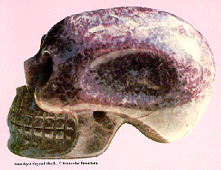

This picture was taken by Francois Beaudoin,
when the Amethyst Crystal Skull was given to
her {owner of the Ram Metaphysical Bookstore,
San Jose, California} and her friend Steve
Mehler, for four days of research in 1980.

I Distinctly remember my reaction to the pictures of the Amethyst Skull,
during my important visit to Francoise's Ram Metaphysical Bookstore. It was as if a shock hit my entire system. It was not that the skull was uncomfortable to look at-- it touched me inwardly, very deeply. I thought perhaps this was a remembrance of working with this skull before, or having contact with it. I also remember hearing myself say, "This skull shouldn't be out yet!" I cannot say why I thought that. All I can relate is that something happened to me, something changed inside me after seeing the pictures. It was as if this had been set-up long ago with the idea that when I was ready, the part familiar with the Crystal Skulls would awaken. But inwardly I kept asking, "Why me?"
The thought occurred to me, as I looked at the Amethyst Skull, that it somehow represented one of the many outer signs that the transformation into the Aquarian Age (or the Golden Age) is really happening now! Even though I was just looking at a picture of the Crystal Skull, I felt that it was as powerful as the real skull itself. Francoise told us that they had another batch of pictures they took, but somehow these mysteriously disappeared and the photo developing company could not find their negatives. This is just one of many strange stories that surrounded the Amethyst Skull, as if there is some sort of protective energy field around it, and only those who are supposed to see or experience it do so.

This particular skull is made out of pure amethyst crystal
, of a very deep dark purple. Steve Mehler told me that this skull had been taken to the Hewlett-Packard research laboratories, and they were not sure how the skull could have been created, even if the skull's creator(s) had possessed an advanced technology similar to our own. The crystal itself has a marbled effect with patches of different shades of purple here and there. There are a number of thin light-purple wavy lines (called sutures) which go across the top part of the skull and down the front of the face.
Steve also had the Crystal Skull in his home for five days; he invited many well-known crystal researchers, as well as psychics and healers, to see the skull and ex-perience it. Steve still has tape recordings of all of these sessions.
I gathered some of the impressions received about the Amethyst Crystal Skull from local residents [San Jose] who were psychically sensitive and had been in the presence of it. Many spoke of great wisdom stored within it, as well as memories of events in history which have occurred in the presence of the Amethyst Skull. Many intuitively felt or received visions that such Crystal Skulls were used during the time of Atlantis, the Mayans or perhaps even earlier. My friend Ruth psychically saw that in Atlantis they would place jewels in the eye sockets (probably other crystals) to activate the skull. It then would light up and either communicate telepathically or actually speak in words with the head priest. The priest (or whoever was permitted to work with the skull in this way) could obtain universal knowledge and wisdom directly from the skull. She also saw that the Crystal Skull had some kind of a metal helmet that it wore.

I saw the Amethyst Skull during a special showing
of the skull for a potential buyer at an art gallery in San Jose. The Amethyst Skull was kept in a vault at the gallery and the owner brought out the skull wrapped in a cloth. About ten people sat around a table with the skull. Most of the time I was very quiet, just sitting there and trying to experience the energy or vibration of it.
As I tapped into the energy of the skull, I felt a living being, a vibrant consciousness that was sleeping, yet awake enough to know we were there. Many of us felt a loving vibration and great power. I did have a chance to actually touch the skull and I felt a stream of energy move from the skull to my right hand, up through my arm and stop at the top of my shoulder. Somehow I feel that a permanent bond was made at this time. Today, whenever I think of the Amethyst Skull, I immediately inwardly see it sitting over my right shoulder, suspended in space. A few times, I have felt as if this skull has been placed over my head as if my brain is being programmed with the knowledge from this skull. So one does not always have to be in the physical presence of a Crystal Skull to work with one. To this day, I sense it is one of the main forces that guides and protects me on my spiritual/networking journeys.
One result of seeing the Amethyst Skull was that I began drawing many people into my life who were involved with crystals. I feel that the Amethyst Skull was my trigger to get in touch with my past lifetimes when I worked with crystals. Numerous people have told me that they remember me from Atlantis, which was one of the civilizations most active in the use of crystals. Also, if someone had told me back in 1983 that I would be involved with a book about the Crystal Skulls, I would have laughed. As I look back over the years, the signs were clear that this was part of the work I came here to do.

As time goes on we will understand more about these Crystal Skulls.
But for now, I see them as physical, natural tools which can connect us to the spiritual realms and the spiritual beings who are assisting our movement into the fast-approaching Golden Age. They can be activated at any moment by the appropriate vibration, giving us wisdom and knowledge of the ancients.

-----------------------------------------------------------------------------------------------------------------------------------------------------------------------------------------------------

The Mitchell-Hedges
Crystal Skull

by Joshua Shapiro
(from "Mysteries of the
Crystal Skulls Revealed")

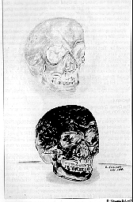
Illustration from Crystal Skull book
drawn by Alexandra Kokorich

The Crystal Congress
( San Francisco, California -- June, 1986 )
In the opening ceremonies for this conference, the Mitchell-Hedges Skull was displayed right near the podium during the opening speech. Sandra (Bowen) and I were sitting about forty feet away and we could feel its power. It was so strong I could not focus on the speakers. I kept feeling myself being pulled into the Crystal Skull. And as I sat there, I had a vision of Mayan natives kneeling in prayer in front of it.
We were working at a booth at this conference where we sold books and Nick's picture packets of the Mitchell-Hedges Skull. On Saturday afternoon during one of our breaks, Sandra and I went over to see the Crystal Skull. We did a short prayer with the skull and then she left, but I couldn't leave. I felt a loving energy surrounding me and I knew I wasn't supposed to go. So I stayed a few minutes, asking the skull, "How do you create the images within yourself, when you are so clear to begin with?" Then I inwardly heard, "Watch," and I saw an etheric copy of the skull move out and float above it. Then I heard, "Now look at the skull and see what you feel." I looked at it and felt that it was empty, as if it had been transformed to ordinary rock quartz crystal and was no longer special. As a substance, crystal is the best conduit for the high level energies passing through it, and the skull shape draws immediate attention. But it is an external consciousness which is in control of the skull and works through it.
The other message which I received was also in-line with my question. I saw little bubbles forming inside the skull and shifting ever so slightly. It was so subtle that if you weren't watching this precise spot in the skull, you would never have seen it. I was seeing the crystal change its form right in front of my eyes. Then I heard, "You see, we can instantaneously re-model this crystal at will. To describe it to you in a way you would understand, think of it as if we could change the crystal to a liquid and mold it." So, the Mitchell-Hedges Skull had indeed answered my questions and given me an experience I shall never forget.
When I left the table that the skull was on, I felt a tremendous feeling of joy. I loved everybody and felt very elated. Imagine what would happen if we could get several Crystal Skulls together, generating a vibration like this. Maybe they could immediately eliminate all negativity in our world. Also, as I reflect upon this experience, I recall that while I was gazing at the skull and having this short conversation or communication, I was oblivious to the entire world.

======================================================================================================================================

This Negative is on File
All Rights Reserved
Copyright (c) Date 3-23-88

MAX

The Texas
Crystal Skull
THE TEXAS CRYSTAL SKULL
Attn: JoAnn Parks
P.O. Box 751261
Houston, TX 77275-1261
(713)991-4545
(This image was scanned from
an original photograph sold by
JoAnn and Carl Parks)

"MAX", The Texas Crystal Skull
( Keeper: JoAnn Parks, Houston, TX, July, 1995 )
Si puslapi skaitykite lietuviskai
(To read this Page in Lithuanian)
The largest ancient crystal skull at the present time is known as "Max", the Texas Crystal Skull. I had my first opportunity to see "Max" in February, 1988, when it was on display at the Whole Life Expo in Los Angeles. Since that time, "Max" and his keeper, JoAnn Parks, have traveled all over the United States, providing others an opportunity to experience this ancient artifact. Recently, Mrs. Parks and "Max" came to visit our home town of Chicago, and was very well received. Mrs. Parks told me during our phone conversation that she is receiving many invitations to bring "Max" to various cities throughout the country. In addition, while she was recently in Miami, doing a presentation at a local museum, some professional technicians took a holographic image of "Max", which should be available to the public at some future time. Mrs. Parks is also working on a new book that will share more information about the history of "Max", what type of experiences people have had in the presence of "Max" and research that has been performed upon this crystal skull. We strongly recommend to our readers, if you have an opportunity to experience "Max", you don't want to miss out.
If a person wishes to contact Mrs. Parks, to find out the schedule of events related to "MAX" and in which cities he will be available to be seen and experienced, she can be contacted at:
The Texas Crystal Skull, Attn: JoAnn Parks, P.O. Box 751261, Houston, TX 77275-1261; (713)991-4545

One of the people who had an opportunity to spend time with "Max" while he was in Chicago is Debbie Smoker. Debbie is a contributing writer for New Avenues, a local New Age journal published bi-monthly for the Southern Wisconsin area. Debbie had an opportunity to interview Mrs. Parks to discuss how she came in contact with "Max" and what has happened to Mrs. Parks since that time. We have been granted permission to re-print Debbie's article to share with our readers.
Enjoy and discover the mysteries surrounding "Max" ............... Joshua

MAX, the Crystal Skull
By Debbie Smoker, R.Ht.
(June/July 95 issue, New Avenues)
Believed to be between 5,000 and 36,000 years old, Max is known to be one of the 13 ancient crystal skulls of the world. Interestingly, they were all found in Central America and Mexico. Much research is currently being done on the skulls. However, their origin is still a baffling mystery. They seem to defy logic. Everything that is known about lapidary work indicates that the skulls should have been shattered fractured, or fallen apart when carved.
Many People have profound visions and psychic experiences when viewing the skulls. Some believe that the skulls are intricate computers, possibly brought before from other planets, and hold knowledge about the origin of our race and the planet Earth.
Max was given to JoAnn and Carl Parks by a Tibetan red hat lama named Norbu Chen. I recently spoke with JoAnn about Max and I was impressed with her integrity. It struck me immediately that she is not out for personal attention or sensationalism. She is a kind woman with a great sense of humor, who had the courage to do what the Universe has asked of her. This is what she told me:
Debbie: How do you know Norbu Chen?
JoAnn: We met Norbu through our family medical doctor in 1973. At the time, we really didn't know who he was or what be did Norbu needed some work done on his home, so our doctor recommended my husband who is in the custom furniture manufacturing business. After working on his house for about two months, my husband picked up a magazine and saw Norbus' picture in it with an article titled Norbu Chen, Tibetan Healer. We were amazed! I then asked my husband to introduce me to Norbu because our daughter was dying of bone cancer and the doctors had only given her three months to live. When I met Norbu and touched his hand, I knew instinctively that there was something extraordinary about this man. I learned that he had been back in the United States for some time practicing his ancient Tibetan healing methods. I asked all about his work. He told me that be needed someone to answer phones and to tell his patients how to prepare their bodies to the healing energies that would go to the acupuncture points and meridian points of the body. Without really realizing what the next seven years had in store for me, I offered to help him. Norbu did work with my daughter and she lived three more years, far longer than the three months we had been told to expect. All I knew was that he was helping people and that's what mattered.
Debbie: I think it was obvious that you were destined to meet.
JoAnn: Well I hadn't even been into metaphysics, didn't work with crystals, and never heard of crystal skulls. It was like walking out of a closet into a whole new world. Norbu had an office in the same building as our family doctor. He had to use a lot of strong mind power and breath probe. He completely immerses into our being in the healing proms. But be had to make a lot of loud noises. This disturbed people in other offices, so Norbu built a room onto his home and moved his office there.
I was totally unprepared for what I saw the first time I walked in. From floor to ceiling, the room was entirely red. Norbu now wore red and black robes rather than conventional clothing, and I wondered what I had gotten myself into He then showed my hus- band and I his altar which held several ancient artifacts on it, including a 400 year old trumpet and the crystal skull which were gifted to him by the Guatemalan shamans in Central America. He never did tell me much about the skull.
Norbu founded the Chakpori Ling Healing Foundation in Texas. I witnessed many miracles there and was eventually allowed to go down and watch some of the healing ceremonies. I didn't realize at the time that this was a very, great honor. I remember that one of the Tibetan lamas was always fixing me Tibetan hamburgers, and those were some spicy meatballs!
I never read anything about the crystal skull, but the monks talked to it and chanted to it in Tibetan and claimed they communicated with it. They would tap into the energy of the skull and run it through the meridian of the patients' body to assist their healings. So they used it as their spiritual and healing tool.
My husband and I were very close to Norbu and before he died, Norbu told us nothing about the skull except that it was a rare and special crystal and that only a few of them exist in the world today. He said, "Take this, and one of these days you will know what it is for and about."
Well we didn't know, but we brought it home and put it in a box in the closet for seven years, from 1980 to 1987. During this time it would come to me in dreams. It told me it was looking for a man and I should find him. I couldn't believe it, but suddenly found myself standing in the closet and talking to a rock. I fondly said, "Wait a minute! I don't want anything to do with you ." We argued for seven years. He said, "You will be talking to hundreds of people about me. I'm very important to mankind. You've got to find this man for me. By the way, my name isn't The Skull. My name is Max."
So here I am, standing in the closet talking to a rock and telling him that I'd help find this man. (She laughs) So in June of 1987, I was watching a local TV show about UFOs. And there was a picture of the famous Mitchell-Hedges skull. Until then I hadn't realized there were more skulls. So I called the TV station and told them I had a skull. They were very skeptical but eventually came out to see it. They were flabbergasted. From there I went to the Houston Museum where I learned of several other skulls, one in a museum in France, one in London England, and some are in private collections. I learned that Max is the only skull currently allowed to be researched and to go to sacred ceremonies or be looked at and touched. He goes to many, many ceremonies, including the Activation Ceremony, (Editor's Note: Special Ceremony that was conducted with healer - Star Johnsen in the past, view this page for more information) which is the aligment of his energy field with various vortexes and grids around the U.S. He's in healing ceremonies.
He is also involved in Native Indian ceremonies. At Mary Thunder's Ranch, Max goes to the Sweat Lodge, Medicine Wheel, and Sacred Pipe Ceremonies. Mary is Cherokee and Souix.
Debbie: I didn't realize that Native American culture would relate to something like that.
JoAnn: Absolutely. They know about the skulls. Grandma Tywiah Nitsch, a well-known Seneca Indian, loves Max and has six Wolfsong Gatherings going (gatherings of peace). Max was in Wolfsong Two. I have a video that was filmed down there, called Max, the Crystal Skull It shows Max in ceremony, and shows many of the Mayan, Aztec and Peruvian elders and Celtic and Aborigines from all over the world talking about Max and what he means. They believe they will all come back together again some day. They don't pray to it. They just honor it, pay tribute to it. They revere it as a communication device.
Debbie: So what do they think the skulls are, energies or connections with Beings of other places?
JoAnn: Well, yes. There are many theories. Although used in Mayan ceremonies, they are not believed to have been created by the Mayans. Max has met with psychics and gurus, metaphyscians, shamans, lawyers, Indian Chiefs, parapsychology researchers, and UFO investigators. People come ftom all over the world. They come here thinking that either he is extraterrestrial, brought here by visitors of a distant star system and he's programmed like a computer. He carries ancient knowledge from his past. Perhaps the rock has picked up some sound and vibration and images occuring around it and it has programmed it and it's in there. Various people sit there and get visions and images off of it. Others believe it's an Atlantian crystal - that it came from both places.
Debbie: Did anyone ever ask MAX directly, 'Where did you come from?"
JoAnn: He says he comes from both places. He comes from Pleiades and from Atlantis. He is a gift to mankind. He's here as a teacher, and as a tool, to bring people together as a Oneness. He's also here for mankind's spiritual growth. He seems to open up an energy in the mind that is there, but just needs a little push. People pick up visions of the past, of other planets, and some are creatively inspired. They feel healing. Max is a personal experiece.
Debbie: What kind of experiences do you have with Max?
JoAnn: Mainly through dreams. I'll even have UFO dreams where they'll talk to me and tell me things. It doesn't dominate my life. I keep my feet on the ground. I keep an open mind and an open heart and that's how we want people to view Max. It's only been in the last few hundred years that the skull has been used as a symbd of evil. In ancient history the skull was used as a symbol of knowledge.
Debbie: How did you finally meet F.R. 'Nick Nocerino?
JoAnn: I called museums, TV stations, etc. searching for information on anyone who knew anything about the skulls until finally someone gave me his name. He told me he had known about the skull and been searching for it since 1949. Max said 'This is the man!' Nick brought some documentation, and from there it has been a learning process. Nick was able to identify Max in two ways, the first by his documented skill in psychometry, and the second by information that he was given in 1947 by a shaman in Central America when he was working for the Government. I keep in touch with Nick regularly.
I've written a book on the history of Max which is, as of yet, untitled. It's just now going to the publishers, so it will be a while yet before it is out. Max is the largest of all the skulls, weighing 18 pounds.
Debbie: What did you do for a living before all this started?
JoAnn: Absolutely nothing. I was just a regular little housewife, cleaned my home. I did the books for our family business and raised my two children. I was raised in the typical southern Lutheran Church but I keep an open mind. Your truths are your truths and mine are mine. Each carries his own truth. You don't have to believe and like everything you see, but if you don't examine other peoples' truths then you have nothing to compare your own to.
Debbie: Thank you so much. I'm looking forward to meeting you in June. Anything else you would like to add?
JoAnn: Right now our plans are just to continue to allow Max to continue to be a joy and inspiration to many thousands of people to come. Maxwill be waiting to meet you.
In 1990, Mrs. Parks wrote a booklet that introduced and told a brief history about "Max". This booklet was entitled, The Story of Max, The Texas Crystal Skull . In this section, I would like to paraphase a few more details about "Max" that were not covered in the interview above.
Some interesting information which has been discovered about Max, during its research: Max is at least 10,000 years old or older (generally 36,000 years is attributed to its age). Max was probably carved from a piece of quartz that was at least 40 or 50 pounds. If the skull had been hand rubbed down to 18 lbs., it is estimated that it took 200 or 250 years (etc) to do. This is because it is not believed that the Mayans really created the skulls nor was it hand rubbed down in Mrs Parks' opinion. Max was found in a tomb in Guatemala between 1924 and 1926.
From the scooped out indentation underneath Max, it is speculated that this was an altar skull, where it may have been worshipped as a God. The major inclusions found within "Max" travel all the way down the inside part of the skull. The creators of "Max" carved right into these inclusions. Due to the depth of the inclusions most experts (crystal carvers, geologist, gemologists) all believe that no diamond-tipped tools could have been use to shape "Max" (if such tools even existed at the time of "Max's" creation).
Just as with other crystal skulls, Mrs. Parks believe that "MAX" is like a computer and has the ability to record and replay events that occur in its presence.
"Max" and JoAnn Parks are now traveling all over the United States. Generally, when JoAnn works alone, she will offer a lecture and a hands-on workshop as well as private sessions with "MAX". If you would be interested to setup a private appointment with "Max" or to sponsor a weekend event including "Max" and Joann, please feel free to write or call:
The Texas Crystal Skull, Attn: JoAnn Parks, P.O. Box 751261, Houston, TX 77275-1261; (713)991-4545
Through Mrs. Parks, you can also obtain her booklet, The Story of Max, The Texas Crystal Skull or she has available a video tape entitled MAX, The 36,000 Year Old Crystal Skull: The Oldest Peace Elder at Wolf Song II produced by Blue Star Productions. This is a wonderful tape where "Max" is part of this sacred gathering of International Indigenous Elders for World Peace, held in 1992. Mrs. Parks also offers some black and white photographs of "MAX", various small contemporary carved crystal skulls from Brazil who stay with "MAX" and carry his energies and various other related informational videos.

PERSONAL MESSAGE FROM JOANN PARKS

We feel "MAX" will continue to be a Joy and Inspiration to many thousands of people to come, that he has been exposed to us at this time to Mankind for a particular purpose, and that purpose is only just beginning to be realized.
I am so thankful to God to be a part, in whatever small way that may be, to help us understand who we are and where we are going. God has given us many gifts and tools in many forms to help us along our own path of Truth. Is "MAX" simply a tool for us, given to help us along?
WE know "MAX" is special, and Carl and I think you for this opportunity to share "MAX" with you. We hope he leaves you with that special little something which he does so well.
Always,
JoAnn & MAX
======================================================================================================================================
END

