Col. James Churchward 1852-1936
http://en.wikipedia.org/wiki/James_Churchward
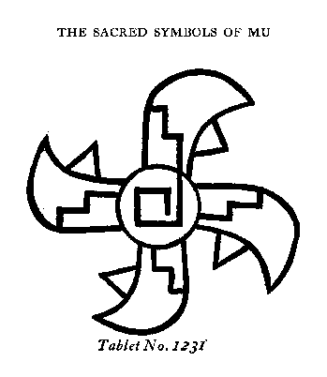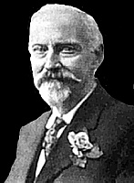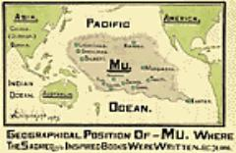
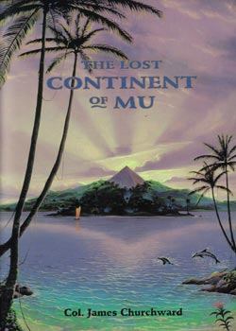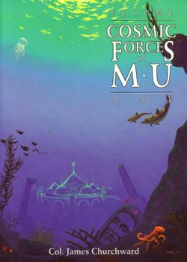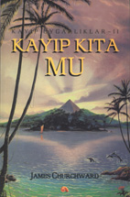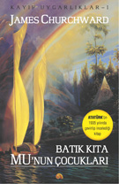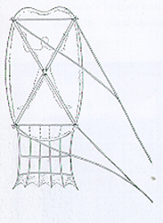
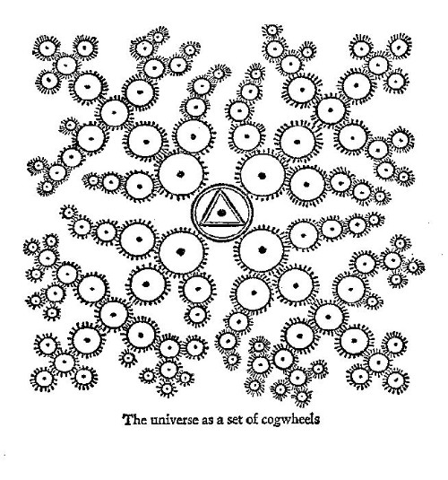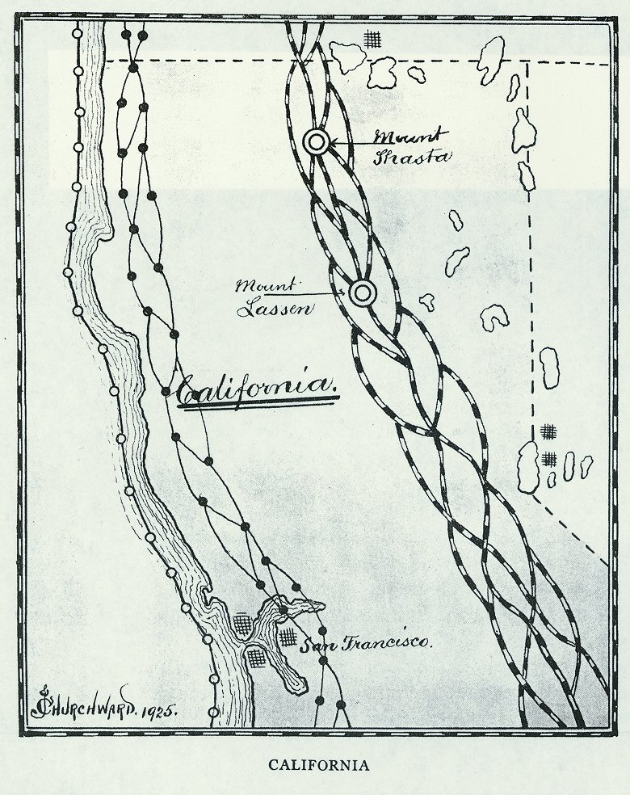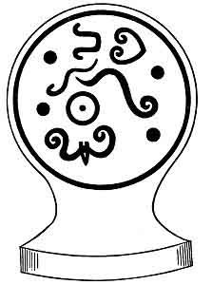
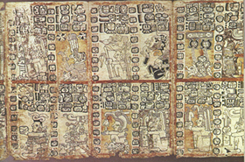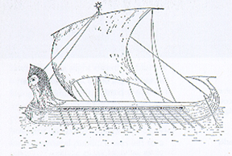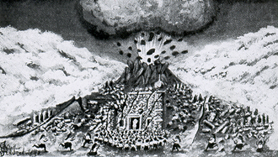

Col. James Churchward (1852-1936) was a British occult writer. In 1926 he published The Lost Continent of Mu, which claimed to prove the existence of a lost continent, called Mu, in the Pacific Ocean.
According to Churchward, Mu "extended from somewhere north of Hawaii to the south as far as the Fijis and Easter Island." He claimed Mu was the site of the Garden of Eden and the home of 64,000,000 inhabitants - known as the Naacals. Its civilization, which flourished 50,000 years before Churchward's day, was technologically more advanced than his contemporaries', and the ancient civilizations of India, Babylon, Persia, Egypt and the Mayas were merely the decayed remnants of its colonies.
Geologically, the existence of Mu, as described by Churchward, is extremly unlikely, since the Andesite Line would run through the western parts of the continent.
Churchward claimed to have gained his knowledge of this lost land after befriending an Indian priest, who taught him to read an ancient dead language (spoken by only three people in all of India). The priest disclosed the existence of several ancient tablets, written by the Naacals, and Churchward gained access to these records after overcoming the priest's initial reluctance. His knowledge remained incomplete, as the available tablets were mere fragments of a larger text, but Churchward claimed to have found verification and further information in the records of other ancient peoples.
His writings attempt to describe the civilization of Mu, its history, its inhabitants, and its influence on subsequent history and civilization.
Churchward claimed that the ancient Egyptian sun-god Ra originated with the Mu; he claimed that Rah was the word which the Naacals used for "sun" as well as for their god and rulers.
Churchward is mentioned in fiction in the short story Through the Gates of the Silver Key by H. P. Lovecraft.
Churchward's writings are a key influence for the plot of the anime series RahXephon.
He is also a source of information for Acharya S, in her two books, "The Christ Conspiracy: The Greatest story ever Sold" and "Suns of God: Krishna, Buddha, and Christ Unveiled."
The name Mu, as applied to a lost continent, was made popular by the French physician Augustus Le Plongeon, as an alternative name for Atlantis, a lost land supposedly located in the Atlantic Ocean. It goes back to Charles Étienne Brasseur de Bourbourg, though.

Works
- The Lost Continent of Mu (1926)
- The Children of Mu (1931)
- The Sacred Symbols of Mu
- Cosmic Forces of Mu
- Second Book of Cosmic Forces of Mu
- Books of the Golden Age

External Links
- The Sacred Symbols of Mu, at sacred-texts.com
========================================================================================================================
END

