**Martin and Osa Johnson**

From Wikipedia, the free encyclopedia

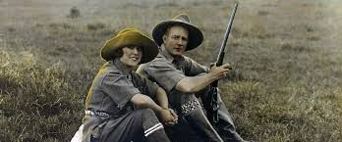 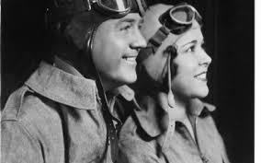

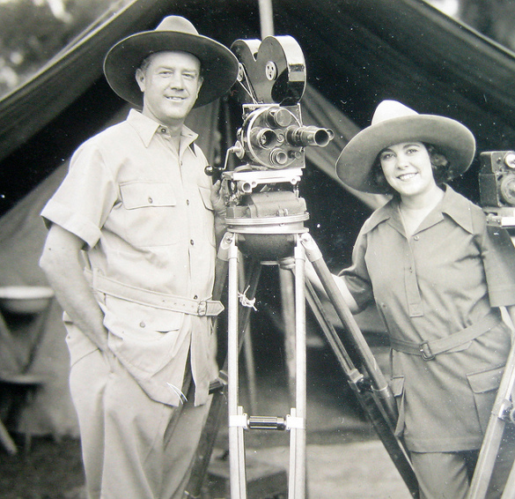 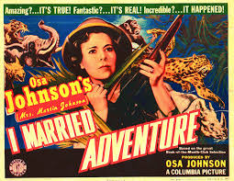 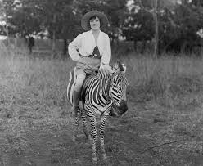

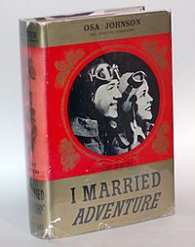 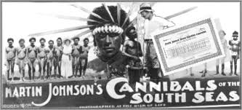 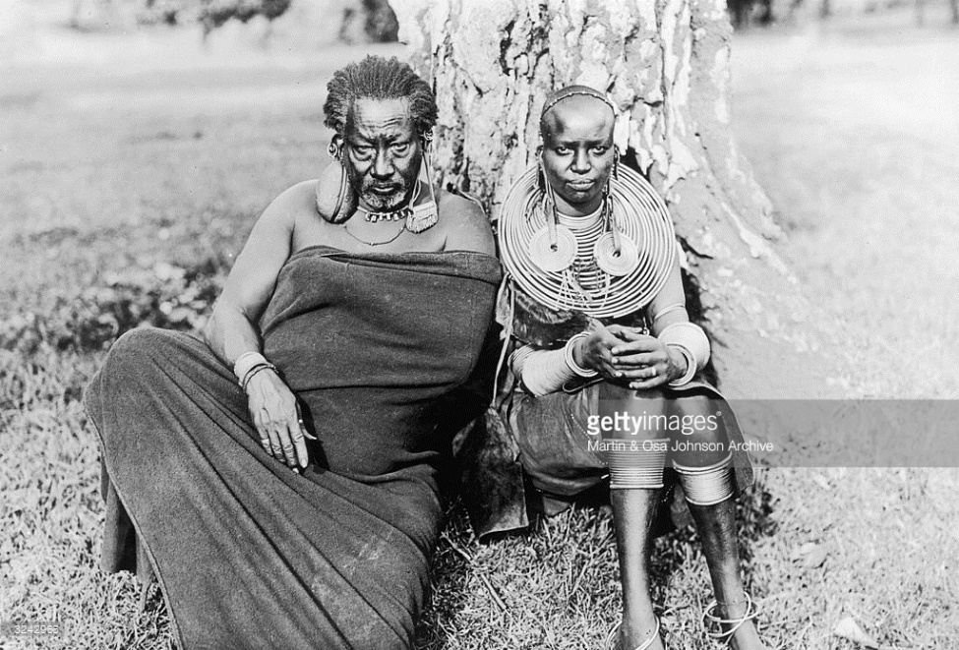

I Married Adventure by Osa Johnson

**Martin Elmer Johnson** (October 9, 1884 – January 13, 1937) and his wife **Osa Helen Johnson** ([née](https://en.wikipedia.org/wiki/N%C3%A9e) Leighty, March 14, 1894 – January 7, 1953) were [American](https://en.wikipedia.org/wiki/United_States) [adventurers](https://en.wikipedia.org/wiki/Adventurers) and [documentary](https://en.wikipedia.org/wiki/Documentary) filmmakers.

**Contents**

* [1 Biography](https://en.wikipedia.org/wiki/Martin_and_Osa_Johnson#Biography)
* [2 Safaris](https://en.wikipedia.org/wiki/Martin_and_Osa_Johnson#Safaris)
* [3 I Married Adventure](https://en.wikipedia.org/wiki/Martin_and_Osa_Johnson#I_Married_Adventure)
* [4 Osa Johnson's The Big Game Hunt](https://en.wikipedia.org/wiki/Martin_and_Osa_Johnson#Osa_Johnson.27s_The_Big_Game_Hunt)
* [5 Martin and Osa Johnson Safari Museum](https://en.wikipedia.org/wiki/Martin_and_Osa_Johnson#Martin_and_Osa_Johnson_Safari_Museum)
* [6 Sister museums – Musée de Manega and Sabah Museum](https://en.wikipedia.org/wiki/Martin_and_Osa_Johnson#Sister_museums_.E2.80.93_Mus.C3.A9e_de_Manega_and_Sabah_Museum)
* [7 Disney's Animal Kingdom Lodge](https://en.wikipedia.org/wiki/Martin_and_Osa_Johnson#Disney.27s_Animal_Kingdom_Lodge)
* [8 Martin + Osa](https://en.wikipedia.org/wiki/Martin_and_Osa_Johnson#Martin_.2B_Osa)
* [9 Other references](https://en.wikipedia.org/wiki/Martin_and_Osa_Johnson#Other_references)
* [10 Selected filmography](https://en.wikipedia.org/wiki/Martin_and_Osa_Johnson#Selected_filmography)
* [11 Bibliography](https://en.wikipedia.org/wiki/Martin_and_Osa_Johnson#Bibliography)
* [12 References](https://en.wikipedia.org/wiki/Martin_and_Osa_Johnson#References)
* [13 External links](https://en.wikipedia.org/wiki/Martin_and_Osa_Johnson#External_links)

**Biography**

In the first half of the 20th century an American couple, Martin and Osa Johnson, captured the public's imagination through their films and books of adventure in exotic, faraway lands. Photographers, explorers, marketers, naturalists and authors, Martin and Osa studied the wildlife and peoples of East and Central Africa, the South [Pacific Islands](https://en.wikipedia.org/wiki/Pacific_Islands) and British [North Borneo](https://en.wikipedia.org/wiki/North_Borneo). They explored then-unknown lands and brought back film footage and photographs, offering many Americans their first understanding of these distant lands.

Osa Leighty was born and raised in [Chanute, Kansas](https://en.wikipedia.org/wiki/Chanute,_Kansas). Although born in [Rockford, Illinois](https://en.wikipedia.org/wiki/Rockford,_Illinois), Martin Johnson grew up in [Lincoln, Kansas](https://en.wikipedia.org/wiki/Lincoln,_Kansas), and [Independence, Kansas](https://en.wikipedia.org/wiki/Independence,_Kansas).

Martin Johnson took part as a crew member and cook in [Jack London](https://en.wikipedia.org/wiki/Jack_London)'s 1907–1909 voyage across the Pacific aboard the [*Snark*](https://en.wikipedia.org/wiki/The_Cruise_of_the_Snark). After that, he started a traveling road show that toured the United States displaying photographs and artifacts collected on the voyage. He met Osa Leighty while passing through her hometown of [Chanute, Kansas](https://en.wikipedia.org/wiki/Chanute,_Kansas), and they married in May 1910.[[1]](https://en.wikipedia.org/wiki/Martin_and_Osa_Johnson#cite_note-1)

**Safaris**

[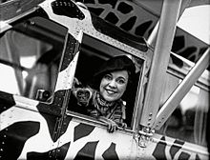](https://en.wikipedia.org/wiki/File:Osa_Johnson_and_airplane.jpg)

Osa with a gibbon in an airplane

In 1917, Martin and Osa departed on a nine-month trip through the [New Hebrides](https://en.wikipedia.org/wiki/New_Hebrides) ([Vanuatu](https://en.wikipedia.org/wiki/Vanuatu)) and [Solomon Islands](https://en.wikipedia.org/wiki/Solomon_Islands). The highlight of the trip was a brief, but harrowing, encounter with a tribe called the [Big Nambas](https://en.wikipedia.org/wiki/Big_Nambas) of northern [Malekula](https://en.wikipedia.org/wiki/Malekula). Once there, the chief was not going to let them leave. The intervention of a British gunboat helped them escape. The footage they got there inspired the feature film [*Among the Cannibal Isles of the South Seas*](https://en.wikipedia.org/w/index.php?title=Among_the_Cannibal_Isles_of_the_South_Seas&action=edit&redlink=1) (1918).

The Johnsons returned to Malekula in 1919 to film the Big Nambas once again, this time with an armed escort. The escort proved unnecessary as the Big Nambas were disarmed by watching themselves in *Among the Cannibal Isles of the South Seas*. Martin and Osa finished their trip in 1920 with visits to [British North Borneo](https://en.wikipedia.org/wiki/British_North_Borneo) (now [Sabah](https://en.wikipedia.org/wiki/Sabah)) and a sailing expedition up the coast of East Africa. After returning home, they released the features [*Jungle Adventures*](https://en.wikipedia.org/w/index.php?title=Jungle_Adventures&action=edit&redlink=1) (1921) and [*Headhunters of the South Seas*](https://en.wikipedia.org/w/index.php?title=Headhunters_of_the_South_Seas&action=edit&redlink=1) (1922).

The Johnsons' first African expedition, from 1921 to 1922, resulted in their feature film [*Trailing Wild African Animals*](https://en.wikipedia.org/w/index.php?title=Trailing_Wild_African_Animals&action=edit&redlink=1) (1923).

During the second and longest trip, from 1924 to 1927, the Johnsons spent much of their time in northern [Kenya](https://en.wikipedia.org/wiki/Kenya) by a lake they dubbed Paradise, at [Mount Marsabit](https://en.wikipedia.org/wiki/Mount_Marsabit). The movies [*Martin's Safari*](https://en.wikipedia.org/w/index.php?title=Martin%27s_Safari&action=edit&redlink=1) (1928), [*Osa's Four Years in Paradise*](https://en.wikipedia.org/w/index.php?title=Osa%27s_Four_Years_in_Paradise&action=edit&redlink=1) (1941), and the film [*Simba: King of the Beasts*](https://en.wikipedia.org/wiki/Simba:_King_of_the_Beasts) (1928) were made with footage of these trips.

In 1925, Osa and Martin met the Duke and Duchess of York, later [King George VI](https://en.wikipedia.org/wiki/King_George_VI) and [Queen Elizabeth](https://en.wikipedia.org/wiki/Elizabeth_Bowes-Lyon), while on safari in Kenya.[[2]](https://en.wikipedia.org/wiki/Martin_and_Osa_Johnson#cite_note-2)

The third African safari from 1927 to 1928 was a tour of the [Nile](https://en.wikipedia.org/wiki/Nile) with friend and supporter [George Eastman](https://en.wikipedia.org/wiki/George_Eastman), founder of [Eastman Kodak](https://en.wikipedia.org/wiki/Eastman_Kodak). This trip, along with previous footage was one of the first talkies for the Johnsons, [*Across the World with Mr. and Mrs. Johnson*](https://en.wikipedia.org/w/index.php?title=Across_the_World_with_Mr._and_Mrs._Johnson&action=edit&redlink=1) (1930), which included Martin's narrative.

In 1928 three Eagle Scouts were selected in national competition to go on safari with the Johnsons in East Africa: Robert Dick Douglas, Jr., of North Carolina, David R. Martin, Jr., of Minnesota, and Douglas L. Oliver of Georgia. The three scouts co-authored the 1928 book *Three Boy Scouts in Africa*. Douglas (1912-) is a retired attorney, Martin (1913-2004) became an executive in the [Boy Scouts of America](https://en.wikipedia.org/wiki/Boy_Scouts_of_America), and Oliver (1913-2009) was an Emeritus Professor of Anthropology at both Harvard University and the University of Hawaii.

From 1929 to 1931, the Johnsons spent a fourth tour in Africa in the [Belgian Congo](https://en.wikipedia.org/wiki/Belgian_Congo). There they filmed the [Mbuti](https://en.wikipedia.org/wiki/Mbuti) people of the [Ituri Forest](https://en.wikipedia.org/wiki/Ituri_Forest) and the [gorillas](https://en.wikipedia.org/wiki/Gorilla) in the Alumbongo Hills. The 1932 feature movie [*Congorilla*](https://en.wikipedia.org/w/index.php?title=Congorilla_%28film%29&action=edit&redlink=1) was in part a product of this trip, and was the first movie with sound authentically recorded in Africa.

[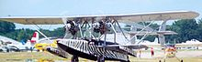](https://en.wikipedia.org/wiki/File:OSAS_ARK.jpg)

Osa's Ark S-38

In 1932 the Johnsons learned to fly at the Chanute Municipal Airport (now named the [Chanute Martin Johnson Airport](https://en.wikipedia.org/wiki/Chanute_Martin_Johnson_Airport)) in Osa's hometown of [Chanute](https://en.wikipedia.org/wiki/Chanute,_Kansas). Once they had their pilot's licenses, they purchased two [Sikorsky](https://en.wikipedia.org/wiki/Sikorsky_Aircraft) amphibious planes, a [S-39-CS](https://en.wikipedia.org/wiki/Sikorsky_S-39) "Spirit of Africa" and [S-38-BS](https://en.wikipedia.org/wiki/Sikorsky_S-38) "Osa's Ark". On their fifth African trip, from 1933 to 1934, the Johnsons flew the length of Africa getting now classic aerial scenes of large herds of elephants, giraffes, and other animals moving across the plains of Africa. They were the first pilots to fly over [Mt. Kilimanjaro](https://en.wikipedia.org/wiki/Mt._Kilimanjaro) and [Mt. Kenya](https://en.wikipedia.org/wiki/Mt._Kenya) in Africa and film them from the air. The 1935 feature film [*Baboona*](https://en.wikipedia.org/w/index.php?title=Baboona&action=edit&redlink=1) was made from this footage.

On January 3, 1935 *Baboona* was shown on an Eastern Air Lines plane becoming the first sound movie shown during flight.[[3]](https://en.wikipedia.org/wiki/Martin_and_Osa_Johnson#cite_note-3) The movie premiered January 22, 1935 at the Rialto Theatre in New York City.[[4]](https://en.wikipedia.org/wiki/Martin_and_Osa_Johnson#cite_note-4) In 1935, the Johnsons were featured on [Wheaties](https://en.wikipedia.org/wiki/Wheaties) cereal boxes as "Champions of Sports." Osa Johnson was the second female to appear on the box and she and Martin were the first married couple selected for this honor.

The Johnsons' final trip together took them to [British North Borneo](https://en.wikipedia.org/wiki/British_North_Borneo) again, from 1935 to 1936. They used their smaller amphibious plane, now renamed "The Spirit of Africa and Borneo", and produced footage for the feature [*Borneo*](https://en.wikipedia.org/w/index.php?title=Borneo_%28film%29&action=edit&redlink=1) (1937).

Martin Johnson was a member of the [Adventurers' Club of New York](https://en.wikipedia.org/wiki/Adventurers%27_Club_of_New_York).[[5]](https://en.wikipedia.org/wiki/Martin_and_Osa_Johnson#cite_note-5) He described the Borneo expedition before the club on November 19, 1936, the event being called "Martin Johnson Night."[[6]](https://en.wikipedia.org/wiki/Martin_and_Osa_Johnson#cite_note-6) He previewed his "Borneo Pictures" before the group on December 17, 1936.[[7]](https://en.wikipedia.org/wiki/Martin_and_Osa_Johnson#cite_note-7)

Martin Johnson died in the [crash of a Western Air Express](https://en.wikipedia.org/wiki/Western_Air_Express_Flight_7) flight near [Newhall, California](https://en.wikipedia.org/wiki/Newhall,_California), on January 12, 1937. Osa was severely injured but recovered. By October 1937, the [*New York Times*](https://en.wikipedia.org/wiki/New_York_Times) was publishing dispatches of Osa's latest trip to Africa, in which she described lifestyles and practices of the Maasai and other tribes.[[*citation needed*](https://en.wikipedia.org/wiki/Wikipedia:Citation_needed)] She died in New York City of a heart attack in 1953.

**I Married Adventure**

Osa Johnson’s autobiography *I Married Adventure* (IMA) was the best-selling non-fiction book of 1940. The continued popularity of IMA with its zebra-striped cover has generated interest in collecting first editions. It had been thought book covers with the title “I MARRIED *Adventure*” were first editions and those with “I MARRIED ADVENTURE” (all block letters) were later editions. The edition variations are now known due to years of collecting and studying all IMA editions by J.E. Paul Lewison of New York. A title with “*Adventure*” in italics can be a first edition or a Book of the Month Club (BMC) edition or a seventh edition. The difference is determined by examining the copyright page. First editions will include “MANUFACTURED IN THE UNITED STATES OF AMERICA BY THE HADDON CRAFTSMEN, INC., CAMDEN, N.J.” BMC editions state “PRINTED IN THE UNITED STATES OF AMERICA” plus the BMC logo is on the dust jacket (if it has survived). Seventh editions specifically state “SEVENTH IMPRESSION”. Confusingly the seventh edition had both “*Adventure*” and “ADVENTURE” versions.

**Osa Johnson's The Big Game Hunt**

Television's first wildlife series, *Osa Johnson's The Big Game Hunt* a.k.a. *The Big Game Hunt*, premiered in 1952. The 26 half-hour episodes were released by Explorers Pictures and primarily used Johnson film. Episodes introduced by Osa Johnson were African Army, Boy Scouts in Africa, Climbing Fish, The Floating Terror, Giant Elephants, Goring Brutes, Headhunters of Borneo, Jungle Panic, Jungle Power, Jungle Warriors, Rhinoceros, Simba's Trail, Slinking Fury and Weird Tribes. Episodes introduced by [Ivan T. Sanderson](https://en.wikipedia.org/wiki/Ivan_T._Sanderson) were Armed Menace, Cameras in the Wilderness, Herds of Destruction, Jaws of Death, Kill to Live, Man-Eaters of the Masai, Monkey Safari, Orang-utan, Pygmy Hunters, Return to Adventure, Terror of the Plains and Trek through the Wild Lands.

**Martin and Osa Johnson Safari Museum**

The [Martin and Osa Johnson Safari Museum](http://www.safarimuseum.com/) is located in Osa's hometown of [Chanute, Kansas](https://en.wikipedia.org/wiki/Chanute,_Kansas). Formed in 1961 to preserve the Johnsons' achievements and to encourage further research into their fields of study, the Safari Museum (as it was originally named) has grown and flourished. The museum started with a core collection of the Johnsons' films, photographs, manuscripts, articles, books, and personal belongings donated by Osa's mother. The museum shares the beautiful old railroad depot with the Chanute Public Library.

In 1998 the Martin and Osa Johnson Safari Museum was named by the History Channel Traveler website as one of the "Top-Ten Historic Sites for Valentine's Day" that "capture romance, American-style." In 2001 [The Pitch (newspaper)](https://en.wikipedia.org/wiki/The_Pitch_%28newspaper%29) named Chanute, Kansas, and the museum as "Best Romantic Day Trip."

The museum is governed by a twelve-member volunteer Board of Trustees. Additionally, there are honorary trustees who help support and represent the museum. Honorary trustees include: Jack Badal, [Robert Ballard](https://en.wikipedia.org/wiki/Robert_Ballard), [Kevin Brownlow](https://en.wikipedia.org/wiki/Kevin_Brownlow), Gary K. Clarke (director emeritus of the [Topeka Zoo](https://en.wikipedia.org/wiki/Topeka_Zoo) and president of [Cowabunga Safaris](http://cowabungasafaris.com/)), [Clive Cussler](https://en.wikipedia.org/wiki/Clive_Cussler), Nancy Durbin, [Jack Hanna](https://en.wikipedia.org/wiki/Jack_Hanna), Joyce Harrell, Dick Houston (president of [Elefence International](http://www.elefence.org/)), Yvonne Houston (Osa's niece), Eleanor & Pascal Imperato, Schuyler Jones, [Nancy Landon Kassebaum Baker](https://en.wikipedia.org/wiki/Nancy_Landon_Kassebaum_Baker), Kenneth Love, Margaret Moore, [Mike Resnick](https://en.wikipedia.org/wiki/Mike_Resnick), Kay & [George Schaller](https://en.wikipedia.org/wiki/George_Schaller), Igor Sikorsky, Jr. (son of [Igor Sikorsky](https://en.wikipedia.org/wiki/Igor_Sikorsky)), [Roy Thomas](https://en.wikipedia.org/wiki/Roy_Thomas), Mahlon Wallace III, Stan Walsh ([Travel Adventure Cinema Society](http://www.travelfilms.org/speakers/artistdetail.php?membership_id=0088/)), Keith Wauchope ([United States Ambassador to Gabon](https://en.wikipedia.org/wiki/United_States_Ambassador_to_Gabon), retired) and Holly Wofford ([Lake Paradise Entertainment](http://www.lakeparadiseentertainment.com/) producer).

Honorary trustees in memoriam include: Marianna Beach, Vern Carstens (Johnsons’ pilot), Dick Douglas, Clarke Getts (Osa’s second husband), Byron Harrell, Belle Leighty (Osa’s mother), David Martin, Douglas Oliver, C. Jackson Selsor, Kenhelm Stott, Jr. (general curator emeritus of the [San Diego Zoo](https://en.wikipedia.org/wiki/San_Diego_Zoo) and trustee of the [National Underwater and Marine Agency](https://en.wikipedia.org/wiki/National_Underwater_and_Marine_Agency)), [Lowell Thomas](https://en.wikipedia.org/wiki/Lowell_Thomas), Joseph Tilton (Johnsons’ cameraman) and Helen (Joyce) & George Wauchope (Helen was the Johnsons’ secretary who previously worked for Lowell Thomas).

**Sister museums – Musée de Manega and Sabah Museum**

The Martin and Osa Johnson Safari Museum has two international sister museums: [Musée de Manega](https://en.wikipedia.org/wiki/Mus%C3%A9e_de_Manega) in Burkina Faso and [Sabah Museum](https://en.wikipedia.org/wiki/Sabah_Museum) in [Sabah](https://en.wikipedia.org/wiki/Sabah), Malaysia. These partnerships resulted from curatorial exchanges in 2000 and 2004 through the International Partnerships Among Museums program.

On February 22, 2011 the Sabah Museum opened its "Safari in Sandakan" exhibit at the Sandakan Heritage Museum in [Sabah](https://en.wikipedia.org/wiki/Sabah), Malaysia. This exhibit covers the Johnsons' 1920 and 1935-1936 Borneo expeditions and was designed by Sabah Museum Curator Stella Moo.

The SUARA Community Filmmaking, in partnership with the Sabah Museum and the Sabah Society, has agreed on premiering the last film of Osa and Martin Johnson's last adventure in North Borneo. It was premiered on 30 September 2012 at the Borneo Eco Film Festival as it was the first time shown in Borneo.[[8]](https://en.wikipedia.org/wiki/Martin_and_Osa_Johnson#cite_note-8)

**Disney's Animal Kingdom Lodge**

[The Walt Disney Company](https://en.wikipedia.org/wiki/The_Walt_Disney_Company) was the first organization to license Johnson film from the Martin and Osa Johnson Safari Museum for the 1976 program "Filming Nature's Mysteries." Disney again licensed Johnson film as part of the "Rafiki's Planet Watch" at [Disney's Animal Kingdom](https://en.wikipedia.org/wiki/Disney%27s_Animal_Kingdom) when it opened April 22, 1998.

The architects and Disney team developing a new "[safari lodge](https://en.wikipedia.org/wiki/Safari_lodge)" borrowed Johnson films from the museum in 1997 and 1998 for research and inspiration. [Disney's Animal Kingdom Lodge](https://en.wikipedia.org/wiki/Disney%27s_Animal_Kingdom_Lodge) opened April 16, 2001. Included is an ongoing exhibit of 36 Johnson photographs along with an original copy of Osa Johnson's 1940 autobiography *I Married Adventure* in the lodge's Sunset Lounge.

**Martin + Osa**

Martin and Osa Johnson were the namesake, inspiration and background story for the 2006-2010 [Martin + Osa](https://en.wikipedia.org/wiki/Martin_%2B_Osa) clothing line and national chain of 28 Martin + Osa stores launched by [American Eagle Outfitters](https://en.wikipedia.org/wiki/American_Eagle_Outfitters). Martin + Osa used references to the Johnsons on their clothing and accessories. Examples included "1910" (the year Martin and Osa married), "S-38" (refers to the Sikorsky S-38 amphibian airplane flown by the Johnsons) and "NC-52V" (the aircraft registration number of their Sikorsky S-39). Similarly since 2010 the Johnsons and Osa Johnson’s autobiography "I Married Adventure" have provided inspiration for other companies and their products including Aje, Byredo, [Charlotte Olympia](https://en.wikipedia.org/wiki/Charlotte_Olympia), Colenimo, Cotton Babies, DwellStudio, Illumé, [Kate Spade New York](https://en.wikipedia.org/wiki/Kate_Spade_New_York), Maiyet, and Okapi.

**Other references**

* Osa Johnson (also known as The Woman in the Safari Outfit) is a main character in the play [*Chamber Music*](https://en.wikipedia.org/wiki/Chamber_Music_%28play%29) by [Arthur Kopit](https://en.wikipedia.org/wiki/Arthur_Kopit) (1962).
* It has been noted the animated film [*Up*](https://en.wikipedia.org/wiki/Up_%282009_film%29) (2009) contains story elements similar to the Johnsons’ real-life story. This ranges from a childless couple to a “scout” on the trip. Muntz’s airship, named “Spirit of Adventure”, sounds like a cross between the Johnsons’ “Spirit of Africa” plane and Osa’s popular *I Married Adventure* autobiography. A fictional poster promotes the launch of the “Spirit of Adventure” on April 25, 1934, from New York City. Coincidentally this was the starting point and the time frame of the Johnsons’ 1933-1934 “Flying Safari”. Also, the Fredricksens’ dream of a home overlooking “Paradise Falls” is reminiscent of the home the Johnsons built overlooking “Lake Paradise” or “Paradise Lake”.
* In 2005 the [Cairo Club Orchestra](http://cairocluborchestra.com/) of [Melbourne](https://en.wikipedia.org/wiki/Melbourne), Australia, revived the 1932 Congorilla Fox-Trot (inspired by the Johnsons' 1932 movie *Congorilla*).
* Martin and Osa Johnson photographs appear in the movies [*Lemony Snicket's A Series of Unfortunate Events*](https://en.wikipedia.org/wiki/Lemony_Snicket%27s_A_Series_of_Unfortunate_Events) (2004) and [*Night at the Museum*](https://en.wikipedia.org/wiki/Night_at_the_Museum) (2006) as well as the short film *The Lost Explorer* (2010) by [Tim Walker](https://en.wikipedia.org/wiki/Tim_Walker). Johnson film segments were used in [Su Friedrich](https://en.wikipedia.org/wiki/Su_Friedrich)'s film *Hide and Seek* (1996).
* In 2010 Martin and Osa Johnson were voted one of the 8 Wonders of Kansas! People ([Kansas Sampler](https://en.wikipedia.org/wiki/Kansas_Sampler) Foundation).
* Poet Elizabeth Bishop's poem "In the Waiting Room" references a picture of Martin and Osa Johnson in a February, 1918 National Geographic she read as a child.
* Martin Johnson is sarcastically referenced in "The Baby in the Icebox," a short story by James M. Cain that was first published in the American Mercury magazine in 1932.

**Selected filmography**

* *Cannibals of the South Seas* (1912)
* *Jack London's Adventures of the South Seas* (1913)
* *Among the Cannibal Isles of the South Seas* (1918)
* *Jungle Adventures* (1921) (filmed in [British North Borneo](https://en.wikipedia.org/wiki/British_North_Borneo))
* *Headhunters of the South Seas* (1922)
* *Trailing Wild African Animals* (1923)
* *Martin's Safari* (1928)
* *Simba: King of the Beasts* (1928)
* *Across the World with Mr. and Mrs. Johnson* (1930)
* *Wonders of the Congo* (1931)
* [*Congorilla*](https://en.wikipedia.org/w/index.php?title=Congorilla_%28film%29&action=edit&redlink=1) (1932)
* *Wings Over Africa* (1934)
* [*Baboona*](https://en.wikipedia.org/w/index.php?title=Baboona&action=edit&redlink=1) (1935)
* *Children of Africa* (1937)
* *Jungle Depths of Borneo* (1937)
* *Borneo* (1937) (filmed in [British North Borneo](https://en.wikipedia.org/wiki/British_North_Borneo))
* *Jungles Calling* (1937)
* *I Married Adventure* (1940)
* *African Paradise* (1941)
* *Tulagi and the Solomons* (1943)
* *Big Game Hunt* (1950s), on TV

**Bibliography**

* *Johnson, Martin (1929). LION. New York - London: G.P. Putnam's Sons.*

**References**

• *Pratt, George C. (June 1979).* [*"Osa and Martin Johnson: World Travellers In Africa"*](http://image.eastmanhouse.org/files/GEH_1979_22_02.pdf) *(PDF). Image (International Museum of Photography at George Eastman House, Inc.)* ***22*** *(2): 21–30. Retrieved June 9, 2014.*

• • Johnson, Osa. *I Married Adventure*. (1940). J.B. Lippincott Company. U.S.A. 6th Edition chap. 23 page. 289-293

• • Daly, Phil M.. "Along the Rialto". *The Film Daily*. January 4, 1935. page. 7

• • Imperato, Pascal James; Imperato, Eleanor M. *They Married Adventure*. (1992). Rutgers University Press. U.S.A. page. 185

• • "Martin Johnson" (obituary). *The Adventurer*, January 1937.

• • "The November Dinner." *The Adventurer*, December 1936.

• • "The December Meeting." *The Adventurer*, January 1937.

* 1. • <http://www.beff.org.my/films-borneo.php#on>

**External links**

|  |  |
| --- | --- |
| https://upload.wikimedia.org/wikipedia/en/thumb/4/4a/Commons-logo.svg/30px-Commons-logo.svg.png | Wikimedia Commons has media related to [***Martin and Osa Johnson***](https://commons.wikimedia.org/wiki/Category:Martin_and_Osa_Johnson). |

* [Works by Martin Johnson](http://www.gutenberg.org/author/Johnson,+Martin) at [Project Gutenberg](https://en.wikipedia.org/wiki/Project_Gutenberg)
* [Works by or about Martin Elmer Johnson](https://archive.org/search.php?query=%28%28subject%3A%22Johnson%2C%20Martin%20Elmer%22%20OR%20subject%3A%22Johnson%2C%20Martin%20E%2E%22%20OR%20subject%3A%22Johnson%2C%20M%2E%20E%2E%22%20OR%20subject%3A%22Martin%20Elmer%20Johnson%22%20OR%20subject%3A%22Martin%20E%2E%20Johnson%22%20OR%20subject%3A%22M%2E%20E%2E%20Johnson%22%20OR%20creator%3A%22Martin%20Elmer%20Johnson%22%20OR%20creator%3A%22Martin%20E%2E%20Johnson%22%20OR%20creator%3A%22M%2E%20E%2E%20Johnson%22%20OR%20creator%3A%22M%2E%20Elmer%20Johnson%22%20OR%20creator%3A%22Johnson%2C%20Martin%20Elmer%22%20OR%20creator%3A%22Johnson%2C%20Martin%20E%2E%22%20OR%20creator%3A%22Johnson%2C%20M%2E%20E%2E%22%20OR%20creator%3A%22Johnson%2C%20M%2E%20Elmer%22%20OR%20title%3A%22Martin%20Elmer%20Johnson%22%20OR%20title%3A%22Martin%20E%2E%20Johnson%22%20OR%20title%3A%22M%2E%20E%2E%20Johnson%22%20OR%20description%3A%22Martin%20Elmer%20Johnson%22%20OR%20description%3A%22Martin%20E%2E%20Johnson%22%20OR%20description%3A%22M%2E%20E%2E%20Johnson%22%20OR%20description%3A%22Johnson%2C%20Martin%20Elmer%22%20OR%20description%3A%22Johnson%2C%20Martin%20E%2E%22%29%20OR%20%28%221884-1937%22%20AND%20Johnson%29%29%20AND%20%28-mediatype:software%29) at [Internet Archive](https://en.wikipedia.org/wiki/Internet_Archive)
* [Works by or about Osa Helen Johnson](https://archive.org/search.php?query=%28%28subject%3A%22Johnson%2C%20Osa%20Helen%22%20OR%20subject%3A%22Johnson%2C%20Osa%20H%2E%22%20OR%20subject%3A%22Johnson%2C%20O%2E%20H%2E%22%20OR%20subject%3A%22Osa%20Helen%20Johnson%22%20OR%20subject%3A%22Osa%20H%2E%20Johnson%22%20OR%20subject%3A%22O%2E%20H%2E%20Johnson%22%20OR%20subject%3A%22Johnson%2C%20Osa%22%20OR%20subject%3A%22Osa%20Johnson%22%20OR%20creator%3A%22Osa%20Helen%20Johnson%22%20OR%20creator%3A%22Osa%20H%2E%20Johnson%22%20OR%20creator%3A%22O%2E%20H%2E%20Johnson%22%20OR%20creator%3A%22O%2E%20Helen%20Johnson%22%20OR%20creator%3A%22Johnson%2C%20Osa%20Helen%22%20OR%20creator%3A%22Johnson%2C%20Osa%20H%2E%22%20OR%20creator%3A%22Johnson%2C%20O%2E%20H%2E%22%20OR%20creator%3A%22Johnson%2C%20O%2E%20Helen%22%20OR%20creator%3A%22Osa%20Johnson%22%20OR%20creator%3A%22Johnson%2C%20Osa%22%20OR%20title%3A%22Osa%20Helen%20Johnson%22%20OR%20title%3A%22Osa%20H%2E%20Johnson%22%20OR%20title%3A%22O%2E%20H%2E%20Johnson%22%20OR%20title%3A%22Osa%20Johnson%22%20OR%20description%3A%22Osa%20Helen%20Johnson%22%20OR%20description%3A%22Osa%20H%2E%20Johnson%22%20OR%20description%3A%22O%2E%20H%2E%20Johnson%22%20OR%20description%3A%22Johnson%2C%20Osa%20Helen%22%20OR%20description%3A%22Johnson%2C%20Osa%20H%2E%22%20OR%20description%3A%22Osa%20Johnson%22%20OR%20description%3A%22Johnson%2C%20Osa%22%29%20OR%20%28%221894-1953%22%20AND%20Johnson%29%29%20AND%20%28-mediatype:software%29) at [Internet Archive](https://en.wikipedia.org/wiki/Internet_Archive)
* [*Cannibal-land: Adventures with a Camera in the New Hebrides*](https://archive.org/details/canniballandadv00johngoog) (1922)
* [Martin Johnson African Expedition Corporation stock certificate](http://scripophily.stores.yahoo.net/marjohafexco.html) (1924)
* [Google Books](https://en.wikipedia.org/wiki/Google_Books) previews:
  + *Enright, Kelly (August 16, 2011).* [*Osa and Martin: For the Love of Adventure*](http://books.google.com/books?id=YUhm8uoT7QcC&printsec=frontcover&dq=osa+and+martin#v=onepage&q&f=false)*. Guilford, CT: Lyons Press.* [*ISBN*](https://en.wikipedia.org/wiki/International_Standard_Book_Number)[*978-0-7627-6360-3*](https://en.wikipedia.org/wiki/Special:BookSources/978-0-7627-6360-3)*.*
  + *Imperato, Pascal James; Imperato, Eleanor (March 1, 1999).* [*They Married Adventure: The Wandering Lives of Martin and Osa Johnson*](http://books.google.com/books?id=nmiIkPd5G8YC&printsec=frontcover&cad=1#v=onepage&q=&f=false)*. Piscataway, NJ U.S.A.:* [*Rutgers University Press*](https://en.wikipedia.org/wiki/Rutgers_University_Press)*.* [*ISBN*](https://en.wikipedia.org/wiki/International_Standard_Book_Number)[*978-0-8135-2695-9*](https://en.wikipedia.org/wiki/Special:BookSources/978-0-8135-2695-9)*.*
  + *Johnson, Osa (August 14, 1997) [1st. pub.* [*J. B. Lippincott & Co.*](https://en.wikipedia.org/wiki/J._B._Lippincott_%26_Co.)*:1940].* [*I Married Adventure: The Lives of Martin and Osa Johnson*](http://books.google.com/books?id=zLyrsEvkaZUC&printsec=frontcover&cad=1#v=onepage&q=&f=false)*. New York - Tokyo: Kodansha Globe.* [*ISBN*](https://en.wikipedia.org/wiki/International_Standard_Book_Number)[*978-1-56836-128-4*](https://en.wikipedia.org/wiki/Special:BookSources/978-1-56836-128-4)*.*
  + *Johnson, Martin (January 11, 2005) [1st. pub.* [*Knickerbocker Press*](https://en.wikipedia.org/wiki/Knickerbocker_Press)*:1928].* [*Safari a Saga of the African Blue*](http://books.google.com/books?id=Os9lHvlLHRcC&printsec=frontcover&cad=1#v=onepage&q=&f=false)*. Whitefish, MT U.S.A.:* [*Kessinger Publishing*](https://en.wikipedia.org/wiki/Kessinger_Publishing)*.* [*ISBN*](https://en.wikipedia.org/wiki/International_Standard_Book_Number)[*978-1-4179-2576-6*](https://en.wikipedia.org/wiki/Special:BookSources/978-1-4179-2576-6)*.*
* [Martin E. Johnson](http://www.imdb.com/name/nm0425766/) at the [Internet Movie Database](https://en.wikipedia.org/wiki/IMDb)
* [Osa Johnson](http://www.imdb.com/name/nm0425922/) at the [Internet Movie Database](https://en.wikipedia.org/wiki/IMDb)
* [Osa Johnson](https://wfpp.cdrs.columbia.edu/pioneer/ccp-osa-johnson/) at Women Film Pioneers Project
* [Martin and Osa Johnson Safari Museum website](http://www.safarimuseum.com/) - *safarimuseum.com*
* [Martin and Osa Johnson Safari Museum website](http://kansastravel.org/safarimuseum.htm) - *kansastravel.org*
* Agnes Newton Keith (1939, Reprint 2004) [*The Land Below the Wind*](http://www.nhpborneo.com/book/l001)

===========================================================================================================================