**The Karanovo Zodiac -** **Richard D. Flavin 2006**

http://www.flavinscorner.com/karanovo.htm

A previous version of this article appeared as "The Karanovo Zodiac," by Richard D. Flavin, ***Epigraphic Society Occasional Papers***, Vol. 20, 1991 (released 1992), pp. 37-42.  I'd like to thank Prof. Steve Williams for commenting on an early draft that though the "topic is fantastic," I didn't "...claim anything fantastic!"  Also, I'd like to acknowledge the late Dr. Barry Fell for accepting the article and using an image of the 'stamp seal' as the cover for ***ESOP*** #20, as well as Bill Rudersdorf for his advice, editing, and original layout.

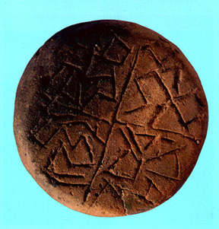  
**The Karanovo Stamp Seal**, © 1991 by Vladimir Vitanov.

     The Karanovo 'stamp seal' is variously regarded as a series of Chalcolithic Bulgarian decorations **[1]**, "proto-writing" which is not part of any "recognizable codified system" **[2],** and "signs consisting of straight lines ... incised between the cross arms of a quartered disk." **[3]**  I here propose that the incised characters from Karanovo bear a remarkable resemblance to the constellations which make up the western zodiac, in a somewhat sequential order, and may very well be the earliest attempt to map the   
heavens yet discovered.

     Epigraphers remain perplexed concerning such ancient European inscriptions as the Azillian signary c.8000 B.C.E. from southern France **[4]**, the Tartaria tablets from Romania and the 'proto-writing' from Gradeshnitsa, Bulgaria dated before 4000 B.C.E., examples of the so-called 'Linear Old European Script' **[5]**, and such Cretan curiosities as the Phaistos Disk and Minoan Linear A. **[6]**  Academics from various disciplines have attempted obscure and occult interpretations of the above mentioned examples, and while some interpretations will perhaps be borne out as further research and discoveries continue, at this time all interpretations must remain unverifiable because of the sheer burden of linguistic requirements should anyone claim to be able to 'read' these ancient incised characters.

     In this paper I will seek to demonstrate the astronomical mapping values of the Karanovo incised characters, free from any temptation at claiming to be able to 'read' the characters as constituting elements of a language.  In my opinion the Karanovo characters are not a mysterious script awaiting decipherment, but rather the earliest map of sequential constellations yet discovered.

     The Karanovo characters are incised on a clay disk 6 cm in diameter and 2 cm thick, with a handle 2 cm long.  The disk was discovered in the remains of a house leveled by fire; an occurrence which slightly scorched the disk, but ultimately may have contributed to its fine state of preservation. **[7]**

     Karanovo is the name of a large tell in the Maritsa Valley, near the modern city of Nova Zagora in central Bulgaria.  The site contains evidence of several stratigraphic layers of habitation.  The incised disk was uncovered at 'level VI', a level scholars disagree as to its relative dating and cultural categorization. Makkay associated 'level VI' with the 'Vinca-Plocnik C' phase and dated the level to 2600-2300 B.C.E.**[8]**,  and Gimbutas made the correspondence between Karanovo VI and the 'Gumelnita' phase, advancing an earlier date of c. 4800 BC. **[9]**  Today, with the use of dendrochronology, most scholars support Gimbutas' dating.

     Rather than choose between various nominal headings, in this paper I'll refer to those who produced the Karanovo 'stamp seal' as Ancient East Balkans (henceforth simply East Balkans), and leave further classification to others. **[10]**

     The East Balkan culture is fast emerging as a metallurgical and fairly complex agricultural society; nonmilitant, as no fortifications are found until a much later period, and near the categorization of a 'true' civilization, were not the culture inhibited by the apparent lack of a script or writing, a conventional mark in the scholarly definition of what is and what is not a 'true' civilization. **[11]**  Even without the ability to produce a recognizable script or writing, the East Balkan culture appears to have attained an advanced state, with only academic semantics preventing the designation of civilization being conferred on this most ancient and advanced culture.

     That the East Balkan culture could have produced a nearly accurate map of the ecliptical constellations in their sequential order is not near as surprising as the fact that this suggestion has not been offered before.  What is of importance here is the ability of an ancient culture to produce such a map of the constellations and the ability of a 'modern' culture (our own) to consider it.

     Recent developments in the field of archaeoastronomy have inspired a fresh appreciation for the near scientific reasoning abilities of the ancients.  Examples of naked-eye astronomy and its application can now be discerned in several of the megalithic tombs along the Atlantic and Mediterranean; the sun rising over the famous heel stone at Stonehenge at the summer solstice being perhaps part of a related   
technology. **[12]**

     Both Old and New World astronomers watched the skies and recorded celestial phenomena in prehistoric times.  It is rapidly becoming clear that such near scientific procedures as simple tabulation, realistic mapping and notation, as well as complex calculations and prediction were not beyond the scope of the preliterates. **[13]**

     It is in this context I will argue for the Karanovo constellation map: that an advanced agricultural society such as the East Balkan should have produced a near accurate star-map comes as an act of verification and should not be subjected to vilification from the school of thought that would teach us that all preliterates in north and central Europe were savage barbarians.

     We know very little about prehistoric and early historic times; the when-where-why-how of such cerebral constructs as numbering, the calendar, the musical scale, and the various astronomical traditions which combined to give rise to the zodiac are still elusive.  That these enlightened breakthroughs occurred is not disputed; the previously mentioned when-where-why-how are still matters seemingly lost to time.

     The Sumero-Babylonians and the ancient Egyptians both possessed constellation traditions at early dates, and it is not unimaginable that the East Balkan culture (should dendrochronology dates prove erroneous) could have absorbed this envisioning of the heavens through either common trade or some process of stimulus diffusion.  However, the advanced state of the East Balkan culture should allow for an independent invention of a sequential constellation tradition as befitting the near scientific accomplishments of a near civilization.  At this time, the introduction of a tradition of star-mapping into   
European prehistory (whatever millennium BC it ultimately belongs to), should serve to further interest.

     In 1969, the Bulgarian archaeologist, V. I. Georgiev, established the sectional vocabulary for the discussion of the Karanovo clay disk. **[14]** The component distinctions consist of: **1) upper right zone, 2) lower right quadrant, 3) lower left zone, and 4) upper left quadrant**.  Georgiev discerned the head of an animal (possibly of a horse, dog, or roe) at the top of the upper right zone.  I believe he correctly identified the figure as a horse, though he was incorrect in all further identifications.

**Upper Right Zone**   
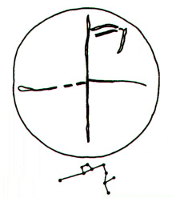**1)Sagittarius   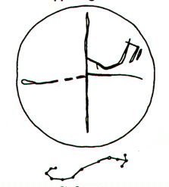2)Scorpius**

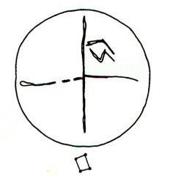**3)Libra**

**Lower Right Quadrant**   
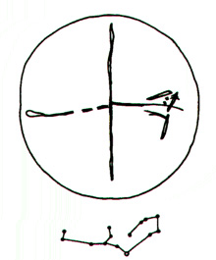**4)Virgo 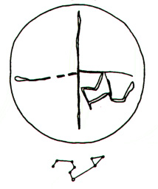  5)Leo**

**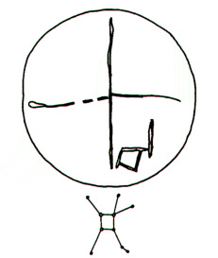  6)Cancer**

**Lower Left Zone**   
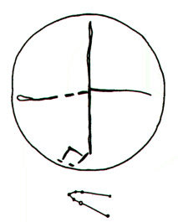**8)Taurus   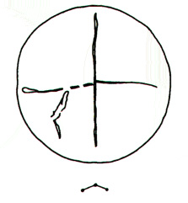9)Aries**

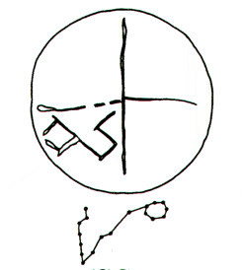**10)Pisces**

**Upper Left Quadrant**   
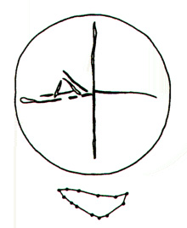**12)Capricornus  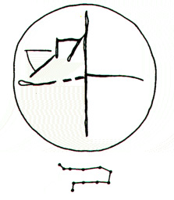7)Gemini**

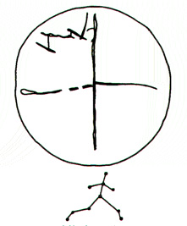**11)Aquarius**

     As can be noticed by the disorder of the upper left quadrant, not every discernment may be correct.  Still, the basic pattern of a realistic, sequential map of the ecliptical constellations appears.  I can only hope further study will ensue and the Karanovo "zodiac" may be better understood against its preliterate background.

**Notes**

**[1]**   Makkay, J., "A chalcolithic stamp seal from Karanovo, Bulgaria," ***Kadmos*** 10 (1971), 1-9.    
**[2]**   Renfrew, C., ***Before Civilization***, Cambridge, 1979, p. 181.    
**[3]**   Gimbutas, M., ***The Goddesses and Gods of Old Europe***, 2nd ed., U. of C. Press, 1982, p. 87.    
**[4]**   Diringer, D., ***The Alphabet***, Philosophical Library, 1948 (as well as subsequent editions), p. 22.  See also Diringer, D., ***Writing***, Praeger, 1962, p. 26.    
**[5]**   Gimbutas, M., see above, p. 85.    
**[6]**   Chadwick, J., "Linear B," in ***Reading The Past***, with an introduction by J. T. Hooker, U. of C. Press/British Museum, 1990.  Separate chapters on Linear A and the Phaistos Disk.  The recent claim of Fisher, Steven Roger, ***Glyphbreaker***, Copernicus/Springer-Verlag, 1997, concerning the Phaistos Disk and a relationship with Linear A and early Greek (with Semitic elements) is an intriguing model-in-progress.    
**[7]**   Mikov, V., Georgiev, G. I., and Georgiev, V. I., in "L' inscription du sceau circulaire de Karanovo - la plus ancienne ecriture d' Europe," ***Arheologia*** 11, Sofia, 1969, 4-13 (in Bulgarian).    
**[8]**   Makkay, J., see above, p. 2 (though Makkay, before the widespread usage of dendrochronology, does admit radiocarbon dating to the end of the fourth or the very beginning of the third millennium B.C.).    
**[9]**   Gimbutas, M., see above, p. 32 (here Gimbutas states emphatically the "Gumeinita" are a "civilization" encompassing sites from Romania, Bulgaria, and the North Aegean).    
**[10]** For a somewhat recent overview of the complexities involved with assigning cultural nomina for certain prehistoric European sites, see Whittle, A., ***Neolithic Europe: A Survey***, Cambridge, 1985, Chapter 5; updated as ***Europe in the Neolithic: The creation of new worlds***, Cambridge, 1996.    
**[11]** Gimbutas, M., see above, Chapter 1.    
**[12]** For an informative collection of essays, see: Brecher, K. and Feirtag, M., eds., ***Astronomy of The*** ***Ancients***, MIT Press, 1979 and 1981.    
**[13]** Marshack, A., "Upper Paleolithic notation and symbol," ***Science*** 178, 817-828 (1972) and Marshack, A., "Cognitive aspects of upper Paleolithic engravings," ***Current Anthropology*** 13 (34), 445-461 (1972).    
**[14]** Georgiev, V. I., see Mikov, V. et al., above p. 10-12.

**Addendum: Possible Functions of A Chalcolithic Sequential Constellation Map**

     With the model of the Karanovo Zodiac arises the necessary conjecture as to the possible uses of a sequential constellation map.  It must be emphatically stated at the outset that the following, as in any workup, consists of proposals concerning the motivations for the design of the Karanovo Zodiac in terms of 'alternative models' only, and should not be interpreted as the advancement of a definitive solution.

**Time**   
The use of a sequential constellation map to mark the passage of time would seem improbable.  A sequential constellation map, in its progression, could have been used to approximate 'monthly' or 'seasonal' divisions of the year, but this seems unlikely.  Examples of solar and lunar notations in preliterate times are widespread and are much more applicable to any time-keeping attempt, more so than a sequential constellation map, which would be very inefficient.

**Agriculture**   
Application of a sequential constellation map to the technology of agriculture is tempting, in so far as the seasonal, quadriserial divisions could be appreciated by the farmer.  However, farming in preliterate Europe continues to amaze investigators as such procedures as grain domestication, crop-rotation, and the willingness to allow land to lie fallow, thereby extending its eventual cultivability, makes it clear that the   
Neolithic farmer in Europe was quite competent.  That a sequential constellation map could have aided an able farmer, while not untenable, seems to detract and gainsay the achievements of the Neolithic farmer.

**Tabulation**   
While the various theories as to the origin of numbers are too involved to discuss here, a commonplace tabulation system needs inclusion in any model encompassing the area of agriculture.  The Neolithic farmer needed a way to keep track of harvests for trade, tithe, and tribute.  yet again, as in Time and Agriculture, a sequential constellation map does not compliment the abilities of the Neolithic farmer to competently manage affairs; a sequential constellation map as a tabulation device goes against untold   
millennia of notation development.

**Religious Rite**   
That the Karanovo Zodiac is in some fashion connected with a religious rite or ritual seems a promising model.  The work of Hans Duerr in the area of geographical multiplicity of totemistic cults in Europe is a fresh amplification of the Frazer/Graves approach to demythification.  Unfortunately, because the Karanovo Zodiac appears devoid of any 'stylization' (excluding Georgiev's identification of the head of a horse, an analeptic discernment of the constellation Sagittarius), in other words, 'realistic' in design, there seems little room for speculation; a bridge between a Chalcolithic sequential constellation map and religion is simply not strong enough to support any debate at this time.

However, mention must be made of Makkay's bold suggestion that the 'stamp-seal', which I refer to as the Karanovo Zodiac, may have been used as a transient stamp on skin rather than on clay objects as with later Mesopotamian stamp seals.  In consideration of this advancement (as well as applications of a 'stamp-seal' being used with baked-items), a religious significance is not beyond conjecture.  Much work needs to be done with this approach.

**Stylized Narrative**   
It is under the model of 'stylized narrative' or 'graphic mnemonics' the Karanovo Zodiac seems most understandable.  Connections between the East Balkans and other pre-Europeans are increasing rapidly as archaeology unveils complex commerce in prehistoric times.  That the Karanovo Zodiac, as a bardic device, could have assisted in the recitation of some tradition seems most attractive.  The model of a Chalcolithic sequential constellation map, which I've suggested here, allows a remarkable correspondence with similar constellations which were later used as idealized indicators when the Babylonians invented the twelve-signed 'zodiac', c. 700-500 BC.  Scholars have long pointed to the duodecimal labors of Hercules, and the related tales of Gilgamesh and Tammuz, as being either inspired or subsequently edited and rewritten to reflect a knowledge of the technology of the zodiac.  A 'tale' of 'twelve', with my advancement of the Karanovo Zodiac, may have originated in prehistorical times, and was then later reinvented with the mathematical zodiac.

**Writing**   
With the apparent correspondence between the Karanovo 'stamp-seal' and the constellations which were later utilized with the zodiac, and the challenging hypothesis that zodiac and calendrical signs evolved into 'letters' (first put forward by Moran, elaborated upon by Kelley, and later brought in line with the Ugaritic alphabet by Gordon), mention should be made of any possible relationship between Chalcolithic designs and later similar designs.  While the arguments of Moran, Kelley, and Gordon are engaging, they unfortunately cannot facilitate an understanding of the Karanovo Zodiac, and its Chalcolithic usage.  What uses of the zodiac evolved, and their application, are areas which must be addressed separately.

     The Karanovo Zodiac may be regarded as a prestige item: the rarity of incised material indicates this conclusion.  As a prestige item, the clay disk upon which the Karanovo Zodiac is incised, recorded some tradition deemed by its owner to be of importance and deserving of its continued preservation and, perhaps, occupying a position of prominence in the house where it was discovered.

     As an item devoted to 1) keeping of time, 2) management of agricultural cycles, and 3) a tabulation process, the Karanovo Zodiac seems to become something akin to static art., in that it would be far removed from the day to day processes of running a farm, telling time, or figuring out how to get from the Bosporus to Majorca.  The Karanovo Zodiac as clay art is a model empty of any respect for the (then) growing areas of science and religion.

     The development of 'religion' in Europe begins, possibly, with the Trois-Freres cave in france and its "great sorcerer."  Art-Science-Religion seems indistinguishable from one another at such an early date.  It is in this misty dawning of early higher thought, the Upper Paleolithic, the inevitable origins of this Chalcolithic sequential constellation map may rest, well beyond our reach.

     Despite the advances of Bronze Age Bactrians, Sumero-Babylonians, and the Egyptians, the Karanovo Zodiac, because of its earlier date, begs the recognition of a 'native' codification and implementation of a sequential constellation map by the East Balkans.

     At this time, the Karanovo Zodiac requires an understanding as a realistic, sequential constellation map, which predates anything yet identified.  I hope this model will inspire fruitful investigations of the origin of constellation traditions and cultural exchanges at the dawn of written records.

**Selected Bibliography:**

**Astronomy and Myth:**   
de Santillana, G. and von Dechend, ***Hamlet's Mill,*** Gambit, 1969.

**Prehistoric Astronomy:**   
Schoemfeld, M., "Prehistoric Astronomy - A Zodiac from Bohusian Province, Norway," ***Scientific American Monthly*** 3:301-303 (1921).    
Vertes, Laszio, "Lunar Calendar from the Hungarian Paleolithic," ***Science*** 149, 855-856 (1965).

**Prehistoric European Religion:**   
Maringer, J., The Gods of Prehistoric Man, Knopf, 1960.    
Duerr, H. P., Dreamtime, Blackwell, 1985.

**The Zodiac and The Alphabet:**   
Moran, H. and Kelley, D., ***The Alphabet and the Ancient Calendar Signs***, 2nd ed., Daily Press, 1969.    
Gordon, C. H., ***Ugaritc Textbook***, Pontifical Biblical Institute, 1967.    
Gordon, C. H., ***Before Columbus***, Crown, 1971.

**c. 1992, 2006  R. D. Flavin.**

========================================================================================================