Petrie, William Matthew Flinders

http://members.optushome.com.au/fmetrol/petrie/notes.html

AND

http://members.optushome.com.au/fmetrol/petrie/links3.html

http://www.uleth.ca/geo/main.htm

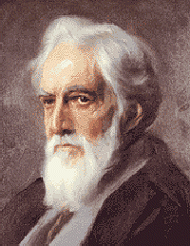

b. June 3, 1853, Charlton, near Greenwich, London
d. July 28, 1942, Jerusalem

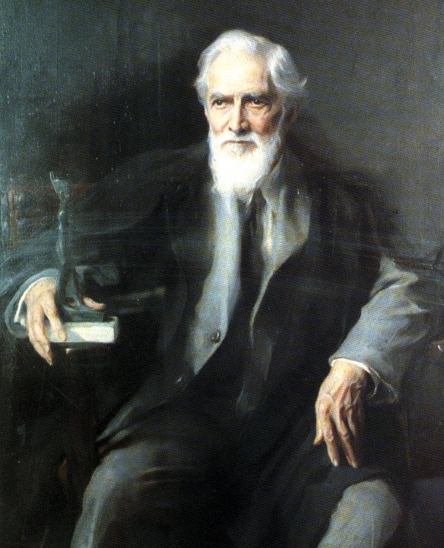

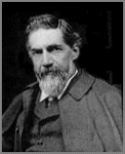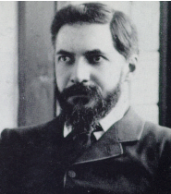

1853-1942

http://emuseum.mnsu.edu/information/biography/pqrst/petrie_flinders.html

"And then came the last, and longed-for scene, for which our months of toil had whetted our appetites- the unwrapping of Horuta. Bit by bit the layers of pitch and cloth were loosened, and row after row of magnificent amulets were disclosed, just as they were laid on in the distant past. The gold ring on the finger which bore his name and titles, the exquisitely inlaid gold birds, the chased gold figures, the lazuli statuettes delicately wrought, the polished lazuli and beryl and carnelian amulets finely engraved, all the wealth of talismatic armory, rewarded our eyes with a sight which has never been surpassed to archaeological gaze. No such complete and rich a series of amulets has been seen intact before; and as one by one they were removed all their positions were recorded, and they may now be seen lying in their original order in the Gizah Museum." -Sir Flinders Petrie
Flinders Petrie is a British Archaeologist and Egyptologist who was born on June 3rd, 1853 in Charlton, Kent. His full name is William Matthew Flinders Petrie. He was named after his father, William, who was a civil engineer and professional surveyor, and his maternal grandfather Matthew Flinders, who was a famous navigator and explorer. Petrie's mother, Anne had a love for science, namely fossils and natural minerals. Both Anne and her husband William taught and encouraged their son to play around with rocks, minerals, and anything else that interested him. At a young age, Flinders developed an interest in archaeology, particularly in the area of ancient weights and measures.
Petrie became excited with mathematics and taught himself trigonometry and geometry at a young age. He got interested in varied standards of measurements. He studied all the valuable information on the subject and tracked about England measuring churches, buildings and ancient megalithic ruins, such as Stonehenge. At the age of thirteen, he read Piazzi Smyth’s Our Inheritance in the Great Pyramids and convinced himself that he must go to Egypt to see the pyramids himself.
Flinders started out working as a practical surveyor in southern England. During this time he became interested in and started studying Stonehenge. He was able to determine the unit of measurement used for the construction of Stonehenge, and in 1880, at the age of 24, Flinders published his first book. It was called Stonehenge: Plans, Description, and Theories, and it became the basis for future discoveries at that site. That same year he started his more than forty years of exploration and examination of Egypt and the Middle East.
From 1880 to 1883, Flinders studied and excavated The Great Pyramid of Giza. He was very meticulous and took his time during this excavation. He studied every layer and every shovelful of soil. This started Flinders on his way to becoming known as one of the great innovators of scientific methods in excavation. In 1883 the book Pyramids and Temples of Gizeh was published to document his time at Giza. In 1884, Flinders discovered fragments of a colossal statue of Ramses II during his excavation of the Temple of Tanis.
After Tanis he spent the next two years performing excavations at the two Nile Delta sites of Naukratis and Daphnae. From the pottery that he uncovered, Flinders was able to prove that both of these sites were ancient Greek trading posts. From the excavations at these two sites, he developed a sequential dating method that would enable him to determine the chronology of Egypt or any civilization by comparing pottery fragments found at various levels.
Flinders tested out his theory at the site of Tel-Hasi located south of Jerusalem in Palestine. He spent six weeks there in 1890. This was only the second stratigraphic study in archaeological history. The first was the excavation of Troy by Hienrich Schliemann. This marked the beginning of careful examination of the levels at a site, rather then just digging and finding random artifacts that are hard to tie together.
It was the precisely recorded data and tender efforts of preserving even the most seemingly insignificant artifact that awarded Flinders Petrie the title of "the father of modern archaeology" by posterity. Sir Flinders Petrie set the standards for methodology and ethics that were then adopted by later excavators. Previously, the carelessness and ignorance from excavators cost Egyptology volumes of valuable information. Petrie’s efforts paved the way to a more sensitive and enlightened era of archaeology.
During the next thirty or forty years Flinders explored and excavated over thirty sites in the Middle East. One of his most famous finds was a stele of Mernepath at Thebes. This stele has the earliest known Egyptian reference to Israel inscribed on it. (1236-1223B.C.)
Although Flinders was self-taught and had no formal schooling, he received many honorary degrees and was made the Edwards Professor of Egyptology at University College, London in 1892 and held that position until 1933. He was also the founder of The Egyptian Research account, which he established in 1894. It eventually became the British School of Archaeology in 1905.
Through the years Flinders wrote over one hundred books, and nearly nine hundred articles and reviews. One of his most significant works was published in 1904. It is entitled Methods and Aims Of Archaeology, and it defined both methodology of archaeology and the goals and direction of where it was heading.
In 1927 Flinders returned to Palestine and Tel-Hasi. He spent the next ten years uncovering the ruins of ten cities there. The scientific methods that he used during this time provided the guidelines for all future excavations in Palestine. Flinders remained in Palestine until his death at the age of eighty-nine. He died in Jerusalem on July 28, 1942.

Resources:
Britannica.com. Petrie, Flinders,
http://www.britannica.com/bcom/eb/article/1/0,5716,60991+1,00.html
1999 Grolier Interactive Multimedia Encyclopedia
Tribuneindia…The fact file, Illa Vij
http:tribuneindia.com/99sep18/Saturday/fact/htm
Written By Jeffrey Hertaus

"The Great Pyramid has lent its name as a sort of by-word for paradoxes; and, as moths to a candle, so are theorisers attracted to it. The very fact that the subject was so generally familiar, and yet so little was accurately known about it, made it the more enticing; there were plenty of descriptions from which to choose, and yet most of them were so hazy that their support could be claimed for many varying theories."
SIR FLINDERS PETRIE ... 'The Pyramids and Temples of Gizeh', 1883.
Oil painting of Petrie Links for Petrie Books written by Petrie.

Sir Flinders Petrie's 1880/82 survey of the Giza plateau which included the GREAT PYRAMID of KHUFU and the relatively unknown TRIAL SITE is probably the most detailed Egyptian study ever undertaken by a surveyor.
This is the original edition of 1883 which was sold out during the first few months. The second edition which summarized many of the tables into a few lines and omitted much of the technical work appeared in early 1885.
Petrie's approach to the 1880/82 survey is seen as something quite extraordinary and it warrants the remarks he sometimes made about the "rough and ready" character of those preceding him. For example when measuring the Great Pyramid's descending passageway Petrie refers to his encounter with screw-driver marks.
For those who have taken time to study some of the surveys conducted on the Giza plateau, Petrie's contribution stands head and shoulders above the rest. Whether he is right or wrong in all his readings is not the issue ... he just did things better.
After his extensive triangulation on the Giza plateau Petrie was somewhat taken back by what he uncovered and said of the Great pyramid "a triumph of skill. Its errors, both in length and in angles, could be covered by placing one's thumb on them."
Petrie measured everything in inches, a 10th of an inch, a 100th of an inch and occasionally a 1000th of an inch. It was acceptable then ... and it should still be acceptable now.
He went to Egypt as a professional surveyor but he also had experience as a mechanical engineer and his interest in metrology was written into a number of previous books.

Book to webpage
Some of the book's type is sprinkled with dramatic dashes, for example ; —the Sphinx—and —Mr Gill. They are not overdone and so have been retained more or less as they appear in the text. For appearance sake however, the book's italics has been converted to the alternate underline , although in some instances (where a reference has been made) this has not been necessary. Additionally, some words of the book have come up poorly in the scan and might occasionally appear with ~ in place of a letter or letters, in particular (and with much annoyance) the decimal place or the "period" (for English speaking countries). Every effort has been made to correct them.
Font used = Arial, Geneva, MS Sans Serif.
Main text and Tables, font & size = Arial, Geneva –1 or small.
Greek symbols = HM Phonetic, substitute Symbol.
Language = xhtml. The incompatible browser problem still lingers on with xhtml but should gradually subside. Pigs might fly too. In the meantime I have been forced to write for Internet Explorer only. If this offends a small minority using Netscape and Opera ... tough !
Also note that Petrie's comments which originally appeared in the margins or at the bottom of the page have been edited to appear closer to the text in question, that is to say immediately following it.
In webpage format you also have the advantage of being able to click on a reference link, namely the illustration plates that Petrie included at the back of his book.
I cannot vouch that the text and tables of the original book have been faithfully reproduced in these pages. Errors will always occur and go unnoticed for a time. The pages have however been proof read, the latest attempt in August 2002.
Petrie's 1880-1883 measurements for the Great pyramid are not the only ones available but they are the most reliable. Almost all serious investigations now quote Petrie. Sometimes the Egyptian government survey of 1925 is also quoted. In the notes, where necessary, I have included the 1925 government measures for comparison.
And thankyou to all who have already queried parts of the text, suggested solutions or just commented. It makes it worthwhile.

THE BOOKS OF FLINDERS PETRIE
(~denotes joint authorship; * excavation reports)

1874 Researches on the Great Pyramid: or, French Connections: Being a preliminary notice of some Facts, etc.
1877 Diagram of the Great Pyramid: to show that the Great Pyramid's Passages are not Chronological, as taught in the So-Called Time Passage Theory.
1877 Inductive Metrology: or the Recovery of Ancient Measures from the Monuments.
1880 Stonehenge: Plans, Descriptions and Theories.
1883 The Pyramids and Temples of Gizeh.
1885 *Tanis. Part I, 1884 - 1885 (E.E.F. Memoir 2).
1885 The Pyramids and Temples of Gizeh (second, abridged edition).
1886 *~Naukratis. Part I, 1884 - 1885 (E.E.F. Memoir 3).
1887 Racial Photographs from the Egyptian Monuments (on spine, Racial Types from Egypt).
1887 *~Tanis. Part II. Nebesheh (Am) and Defenneh (Tahpanhes) (E.E.F. Memoir 4).
1888 A season in Egypt, 1887.
1889 Two Hieroglyphic Papyri from Tanis, Part 2: the Geographical Papyrus (E.E.F. Memoir 4).
1889 *~Hawara, Biahmu, and Arsinoe.
1889 Historical Scarabs. A Series of Drawings from the Principal Collections, arranged Chronologically.
1890 *~Kahun, Gurob, and Hawara.
1891 *~Illahun, Kahun, and Gurob.
1891 *Tell el Hesy (Lachish).
1892 *~Medum.
1892 Ten Years' Digging in Egypt, 1881 - 1891.
1894 *~Tell el-'Amarna.
1894 A History of Egypt. Vol I. From the Earliest Times to the XVth Dynasty.
1895 Egyptian Decorative Art: a Course of Lectures at the Royal Institution.
1895 Egyptian Tales, translated from the Papyri. First Series IVth to XIIth Dynasty. Illustrated by Tristram Ellis.
1895 Egyptian Tales, translated from the Papyri. Second Series, XVIIIth to XIXth Dynasty.
1896 A History of Egypt. Vol. II. During the XVIIth and XVIIIth Dynasties.
1896 *~Koptos.
1897 *Six Temples at Thebes. 1896.
1898 *~Deshasheh, 1897 (E.E.F. Memoir 15).
1898 Religion and Conscience in Ancient Egypt: Lectures delivered at University Collage, London.
1898 Syria and Egypt, from the Tell el-'Amarna Letters.
1900 *~Dendereh, 1898 (E.E.F. Memoir 17).
1900 *The Royal Tombs of the First Dynasty, 1900. Part I (E.E.F. Memoir 18).
1900 *~Hierakonpolis I (E.R.A. 4), by J.E. Quibell.
1901 *Diospolis Parva: The Cemeteries of Abadiyeh and Hu, 1898 - 1899 (E.E.F. Memoir 20).
1901 *The Royal Tombs of the Earliest Dynasties, 1901 (E.E.F. Memoir 21).
1902 *Abydos. Part I (E.E.F. Memoir 22).
1903 *Abydos. Part II (E.E.F. Memoir 24).
1904 *~Ehnasya, 1904 (E.E.F. Memoir 26).
1904 Methods and Aims in Archaeology.
1905 A History of Egypt. Vol. III. From the XIXth to the XXXth Dynasties.
1905 *Roman Ehnasya (Herakleiopolis Magna), 1904 (E.E.F. Memoir 26). Supplementary Plates and Text.
1906 *Hykos and Israelite Cities (B.S.A.E. 12)
1906 The Religion of Ancient Egypt.
1906 *~Researches in Sinai.
1906 Migrations.
1907 *Gizeh and Rifeh (B.S.A.E. 13).
1907 Janus in Modern Life.
1908 *~Athribis (B.S.A.E. 14).
1908 *~Memphis I (B.S.A.E. 15).
1909 *~The Palace of Apries (Memphis II) (B.S.A.E. 17).
1909 Personal Religion in Egypt before Christianity.
1909 *~Qurneh (B.S.A.E. 16).
1909 The Arts and Crafts of Ancient Egypt.
1910 *~Meydum and Memphis (III) (B.S.A.E. 18).
1910 The Growth of the Gospels as Shown by Structural Criticism.
1911 ~Historical Studies (B.S.A.E. 11).
1911 *Roman Portraits and Memphis (IV) (B.S.A.E. 20).
1911 The Revolutions of Civilization.
1911 Egypt and Israel.
1912 The Formation of the Alphabet (B.S.A.E. Studies 3).
1912 *The Labyrinth, Gerzeh, and Mazghuneh (B.S.A.E. 21).
1913 The Hawara Portfolio: Paintings of the Roman Age, found by W. M. Flinders Petrie in 1888 and 1911 (B.S.A.E. 22).
1913 *~Tarkhan I and Memphis V (B.S.A.E. 23).
1914 *Tarkhan II (B.S.A.E. 25).
1914 Amulets, illustrated by the Egyptian Collection in University College, London.
1915 *~Heliopolis, Kafr Ammar, and Shurafa (B.S.A.E. 24).
1917 Scarabs and Cylinders with Names, illustrated by the Collection in University College, London (B.S.A.E. 29).
1917 Tools and Weapons, illustrated by the Egyptian Collection at University College, London, and 2000 Outlines from Other Sources (B.S.A.E. 30).
1917 Corpus of Prehistoric Pottery and Palettes (E.R.A.).
1918 Eastern Exploration, Past and Future. Lectures at the Royal Institution.
1919 Some Sources of Human History.
1921 Corpus of Prehistoric Pottery and Palettes (E.R.A.).
1922 A History of Egypt. Vol. I. (Tenth edition, revised).
1922 The Status of the Jews in Egypt.
1923 Social Life in Ancient Egypt.
1923 *~Lahun II. The Pyramid (B.S.A.E. 33).
1924 *Sedment I (B.S.A.E. 34).
1924 *Sedment II (B.S.A.E. 35).
1924 Religious Life in Ancient Egypt.
1924 "Ancient Egyptians", in Herbert Spencer, Descriptive Sociology, division I, no. I.
1925 *~Tombs of the Courtiers and Oxyrhynkhos (B.S.A.E. 37).
1925 Buttons and Design Scarabs, illustrated from the Egyptian Collection in University College, London (B.S.A.E. 38).
1926 Ancient Weights and Measures, illustrated from the Egyptian Collection in University College, London (B.S.A.E. 39).
1926 Glass Stamps and Weights, illustrated from the Egyptian Collection in University College, London (B.S.A.E. 40).
1927 Objects of Daily Use, with over 1800 Figures from University College, London (B.S.A.E. 42).
1928 Gerar (B.S.A.E. 43).
1929 ~How to Observe in Archaeology.
1929 *~Bahrein and Hemamiyeh.
1930 *~Beth-Pelet (Tell Fara) I (B.S.A.E. 48).
1930 *Antaeopolis: the Tombs of Qau (B.S.A.E. 51).
1930 Decorative Patterns of the Ancient World (B.S.A.E. 49).
1931 *Ancient Gaza I. Tell el Ajjul (B.S.A.E. 53).
1931 Seventy Years in Archaeology
1932 *Ancient Gaza II. Tell el Ajjul (B.S.A.E. 54).
1932 *Ancient Gaza III. Tell el Ajjul (B.S.A.E. 55).
1934 *Ancient Gaza IV. Tell el Ajjul (B.S.A.E. 56).
1934 Measures and Weights.
1934 Palestine and Israel: Historical Notes.
1935 Shabtis, illustrated by the Egyptian Collection in University College, London. With a Catalogue of Figures from many other Sources (B.S.A.E. 57).
1937 *~Anthedon, Sinai (B.S.A.E. 58).
1937 The Funeral Furniture of Egypt. Stone and Metal Vases (B.S.A.E. 59).
1938 Egyptian Architecture (B.S.A.E. 60).
1939 The Making of Egypt.
1940 Wisdom of the Egyptians (B.S.A.E. 63).
1952 *~City of Shepherd Kings, and Ancient Gaza V (B.S.A.E. 64).
1953 Ceremonial Slate Palettes (B.S.A.E. 66).
1953 Corpus of Proto-Dynastic Pottery: Thirty Places of drawings by W. M. Flinders Petrie. Centenary Double Volume (B.S.A.E. 66B).

His pamphlets, articles and reviews are too numerous to list here: he contributed to the Encyclopaedia Britannica, Hastings' Dictionary of the Bible, and Dictionary of Religion and Ethics, to Records of the Past, and to J. A. Hammerton's Wonders of the Past and Universal History of the World. A bibliography of his writings, compiled by Eric P. Uphill, can be found in The Journal of Near Eastern Studies (published by the University of Chicago), volume 31, no. 4 (October 1942), pp. 356 - 379. It contains over 1000 items.

OBITUARIES AND APPRECIATIONS

- ALBRIGHT, W. F., in Bulletin of the American Schools of Oriental Research , 87, 1942.

- EMERY, W. B., "The Founder of Egyptian Archaeology: Genius of Flinders Petrie," in The Times, 6.8. 1953.

- GARDINER, A. H., in Nature, vol. 50. 15.8. 1942, p.204.

- GLUEK, Nelson, in Bulletin of the American Schools of Oriental Research, 87. 1942, p.6f.

- GLANVILLE, S. R. K., "Flinders Petrie: the Scientific Classification of Archaeological Material," in Proceedings of the Royal Insitution, 32, 1942, p.344ff.

- HARDEN, D. B., "The Centenary of Sir Flinders Petrie," in Museums Journal 53, no.4, July 1953, p.107ff.

- JAMATI, Habib, in Chronique d'Egypt, 35, 1943, p.120;39, 1945, p.120.

- MYRES, J. N. L., in Man, 43 (1943), no.9, p.20f.

- NEWBERRY, P. E., in Journal of Egyptian Archaeology, 29, 1943, p.67ff.

- O'CONNOR, David, in Expedition, Winter 1979, p.17f.

- SMITH, Sidney, in Obituary Notices of Fellows of the Royal Society, vol. 5, Nov. 1945, p.3ff, reprinted from Proceedings of the British Academy, vol.28, 1942, p.307ff.

- TUFNELL, Olga, in Palestine Exploration Quarterly, 75, 1942, p.4f.

- The Archaeology of Palestine Centenary Exhibition, Institute of Archaeology Occasional Papers, 10, London, 1953.

- Museum of Egyptology, University College, London. Flinders Petrie Centenary Exhibition, 1953.

This page is courtesy of Margaret Drower's book, Flinders Petrie, A Life in Archaeology(London: Victor Gollanez LTD 1985)

Petrie's key measurements for the Great Pyramid

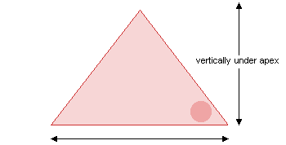
OUTSIDE THE GREAT PYRAMID
Base —  Height —  Slope — | 9068.8 ± .5 inches = 755.69 - 755.78 ft.  (Egyptian Govt survey, 1925. 755.44 - 756.08 ft) ¹  5776.0 ± 7.0 inches = 480.75 - 481.92 ft. ²  (Egyptian Govt survey, 1925. 481.4 ft)  51º 52' ± 2'  Observations with goniometer 51º 48' - 51º 57',  Casing stones "in situ", approx 51º 45' - 51º 49' ³  (Egyptian Govt survey. 1925. 51º 52')
¹ Square base seen as uneven. (Egyptian Govt survey, 1925). It might have been measured that way in 1925 but if we listen to Petrie who praises Khufu's "quality of workmanship", it is most unlikely that the square base on the pavement would have originally been finished as anything but true. The greatest difference between the 4 sides recorded by Petrie is the equivalent of about 46mm (East 9067.7, South 9069.5 inches).
² The fact that Petrie could not get a better reading than ± 7.0 inches for height emphasizes the importance he attached to the missing outer casing, ie; the thicknesses for the individual missing blocks giving the true slope can only be guessed at. Over-riding the guess work can only be done if we settle for a slope as a continuation of the casing blocks in situ on the North side. (see below)
³ If Petrie slightly misread the true baseline or the true baseline level, as has often been suggested, then it is quite possible that the lesser angles offer the better estimate for the original slope :
ie : Casing stones in situ : North side. 51 º 45' - 51º 49' (by theodolite).
Note :
The Great Pyramid has been in ruins for a very long time. When its outer casing either fell to the ground or was stripped by the Arabs all hope of recording its true dimensions ceased there and then. We really do not know its true baseline, hence its height and slope. At some time or other the pyramid was also hit by natural disasters (Petrie). A series of earthquakes would not seem an unreasonable assumption so our best estimates will now probably rely on the ability of future researchers to declare it a true geometric structure, one that responds to known proportions. This certainly poses a problem because a number of known proportions giving "more or less" similar results conveniently fall within the limits of the best recorded data : see "Theories compared with facts"

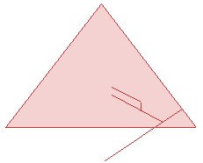
INSIDE THE GREAT PYRAMID
Descending passage  Ascending passage | 26º 31' 23" ± 5" ?  Lower part (up to Gallery) 26º 02' 30"  Upper part (Gallery) 26º 16' 40"  Mean of whole 26º 12' 50"
With the ascending passage, we may well ask why the masons worked their way up to the beginning of the Gallery at approximately 26º 02' but then changed it noticeably for the Gallery itself. Did the masons stop at the Gallery to re-calculate after some concern was raised about the angle of the newly laid floor ?. Would it have missed its mark at King's chamber height ?. Perhaps the angle of the Gallery floor was then readjusted to bring it back in line with the planned angle. Petrie's data "Mean of whole" 26º 12' 50" may in fact reflect the planned angle closer than we think. This being the case we still have two different angles to contend with, the ascending angle about a 1/3 of a degree less than the descending. The question is ... why were the two angle planned this way and what was behind their geometry ? Of course if the descending passageway wasn't honed with incredible accuracy (a consistent altitude) we might not be asking these questions.
At the Trial Site East of the Great pyramid where the masons experimented with design the passageway angles reflect the same 1/3 of a degree difference.
Comments welcome
True scale : If drawing the Great pyramid to scale Section 64 is to be consulted for it has all the necessary measurement to correctly place the passageways and chambers.

Metrology
Royal cubit ... Base of King's chamber ... 20.632 ± .004 inches (523.95 - 524.15mm)
Royal cubit ... Summarized Pyramid ...... 20.620 ± .005 inches (523.62 - 523.87mm)
Digit (unit named by Petrie) ... .727 ± .002 inches (18.41 - 18.52mm)
Note : The royal cubit standard agreed upon for the 4th dynasty is generally quoted as the second measure, ie; 20.620 ± .005 inches although as you can see there is but 1/3rd of a millimetre difference between them. The digit, so named by Petrie, is mainly from the 4th dynasty tombs he examined and it is consistently accurate to within 1/10th of a millimetre. Although some might disagree on the way he presented this data it is by far the best indication we have for metrological proficiency during this period.

http://www.uleth.ca/geo/main.htm

 |  | 
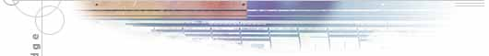
 | MAJOR CONTRIBUTIONS TO ARCHAEOLOGY  - "He is generally recognized as having single handedly established Near Eastern archaeology as a scientific discipline." (Valerie M. Fargo, Biblical Archaeologist, volume 47:4, December 1984, C.1 Publication of the American Schools of Oriental Research p.220-223, 240-243)  - He would systematically excavate and then record everything, rather than discarding ordinary objects and sherds that other archaeologists would normally discard. These objects he saved could then be used for future study.  - His best known find is the Merneptah Stele which contains the oldest known reference to Israel. This was found at Thebes in 1896. It is now in the Egyptian museum in Cario.  - In Tell el-Hesi, Petrie determined that the evolution of pottery corresponds to the sequence of soil layers by comparing Tell el-Hesi pottery with Abydos pottery. Therefore, he established the foundation of Pottery Chronology and Stratigraphic Excavation.  - Petrie developed a system of Sequence Dating. This system groups pottery and other artifacts into families. These families are then based on form, decoration, and ware. This shows the typological evolution of pottery, and permits the Near Eastern archaeologists to control the excavation.  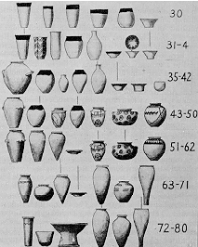  - Petrie also had the habit of publishing his data immediately after the completion of his fieldwork.  - Petrie developed a new field of investigation in the cemeteries at Naqada. This field was the art of tomb-excavating, which set a standard for later archaeologists.  - Petrie trained workman at Qufti ( named Quifti workmen). Thereby establishing the pattern of trained labour at all subsequent Near East excavations.  - Petrie also developed the wax method of preserving beads. He would drip wax along the path of the beads. This cements them together so he can remove them without displacing their order.

EXCAVATIONS

1881 - 1883 Giza, Abu Rawash (1882)
In Petrie's first season at Giza, he conducted surface surveys of the pyramids. Measurements inside the pyramids were taken as soon as tourists left and continued through the night. Because it was so hot, Petrie would work naked inside the pyramids and just wear a vest and pants outside of the pyramids.
Petrie observed the methods of pyramid construction and systematically measured every detail.
In his second season, he cleared pits through the chips which flanked the sides of the Great Pyramid and traced the trenches and pavement around it. Petrie made 85 of these holes at Khufu's Pyramid, 108 holes at Khafra Pyramid, and 91 at Menkaura's Pyramid.

1884 Tanis
Petrie had 170 workmen employed without renumeration! Petrie excavated the low mounds of the cities of the dead. A Greek and Roman city. Petrie found local pottery, imported marbles, statuettes, glass mosaics, and metal work but his main job was to draw plans of temple ruins.
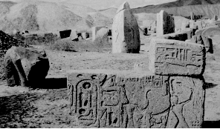
1883 - 1886 Nile Delta (Tanis, Naucratis, Nabesha, Defenna)
In 1885, Petrie uncovered and explored the ancient Greek city of Naucratis.
In 1886, he uncovered the towns of Am and Daphnae. In these towns, the remains of Pharaonic habitation was discovered. Petrie also excavated Nabesha in 1886.

1886 - 1887 Nile River Area (Aswan, Western Thebes, Dahsler)
In Thebes, Petrie discovered over 700 inscriptions and a huge series of cones and weights. Petrie also found the Racial Portrait Series and inscriptions of the Israelites at war against the Egyptians. Petrie also found an undisturbed tomb of the 17th dynasty, a mummy with jewellery, gold necklaces, bracelets, earings, girdle, and tomb furniture.
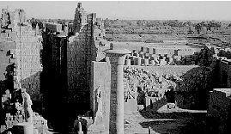
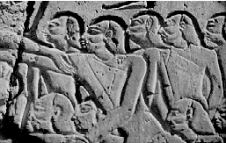
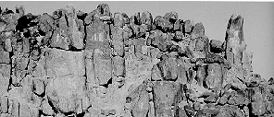
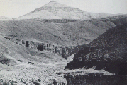
1887 - 1890 Fayum
Petrie excavated Medinet el Fayum and found four or five levels of occupation.

1888: Biahmu, Arsinoe

1888 - 1889: Hawara
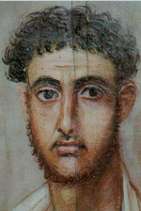
1889: Kahun, Ghurob
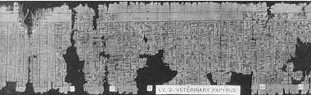
1890: El Lahun
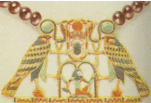
1890 Tell el Hesei
The Wadi Hesi cut through this tell, exposing the occupational layers. Petrie excavated here for six weeks. It is here that Petrie created pottery chronology and determined the importance of stratigraphic excavation.
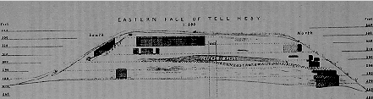
1890 - 1891 Meydum
At this pyramid, Petrie drew pictures of the of the earliest known tombs. He also surveyed the pyramid's corners and they showed that this pyramid was imitated by Khufu in the Great Pyramid. He also found polished red ware pottery called Meydum Ware.
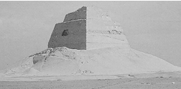
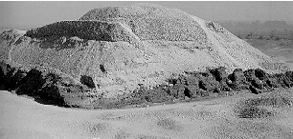
1891 - 1892 Tell el Amarna (ancient Akhetaten)
Petrie found blue painted pottery, figures of the Pharoah Akhenaten, green glaze mouldings, and ponds in deep hollows like those shown in the reliefs on the walls of the tombs. These scenes show Akhenaten and his wife Nefertiti worshipping the god Aton.
Petrie found what he states as the, "most important discovery artistically since the Old Kingdom statues of Mariette." A large hall with beautifully painted pavement (the floor) that covered an area 25 square feet.
Petrie also discovered workshops of manufacture from crushing quartz pebbles to the final decoration of glass vessels and tiles that were on columns and walls.
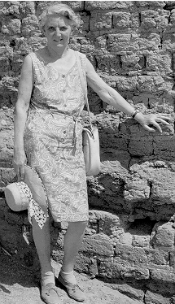
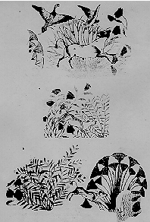
1893 - 1894 Quft, Coptos
Quft is ancient Coptos, where Petrie noticed among the ruins of a Roman temple, a column with the cartouche of Tutmosis III. He also found prehistoric Egyptian remains and stone lions. It was here that he trainedhis workmen called Qufits, to systematically excavate sites.

1894 - 1895 Ballas, Naqada, Western Thebes, Ramesseum
In the Ballas and Naqada area, Petrie found a cemetery and carved blocks indicating the site of the temple. This temple was dedicated to Seth, Lord of Nubt and the city was known as Ombos. A preliterate society was founded by these predynastic inhabitants of Egypt. This is were Petrie established a system for tomb digging. Petrie excavated 2200 graves in this area but only published 136.
In Western Thebes and Ramesseum, Petrie continued to record tombs and found a portrait of the "White Queen."
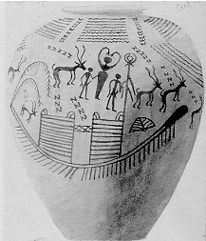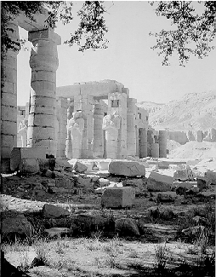
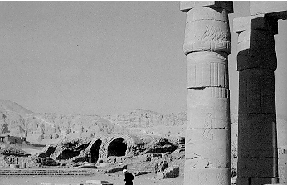
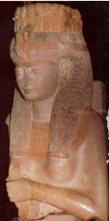
1896 Behnesa
At this site, Petrie found mounds, ruins of a city which once was the capital of a nome, which the Greeks called Oxyrhynchus. Petrie found the most papyri and papyrus rolls here of any site in Egypt.

1897 Deshasha (excavated for the Egypt Exploration Society)
Petrie found tombs dated to the 5th dynasty, linen shirts, and a relief with a battle scene between Egyptians. These discoveries increased knowledge of Old Kingdom burial customs.
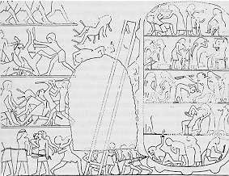
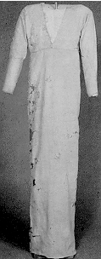
1897 - 1898 Dendara (excavated for the Egypt Exploration Society)
Petrie excavated catacombs of sacred animals: cats, gazelles, birds, and snakes. Petrie also excavated the Mastaba Tombs (6th - 11th dynasty) which are the oldest brick vaults known.

1898 - 1899 Abadiya, Hu (excavated for the Egypt Exploration Society)
In Abadiya, Petrie excavated four cemeteries between Semaina and Sheikh and found pots and stone vases.
In Hu, Petrie excavated tombs of all periods and found a lot of Roman remains, prehistoric material and pottery.

1899 - 1904 Abydos
In Abydos, Petrie found the remains of kings of the earliest dynasties. The pottery Petrie discovered here was used to formulate his pottery chronology by comparing these to Tell el- Hesi's pottery. He found burials of every period of Ancient Egyptian history, from prehistoric until Roman times. Petrie excavated at the burial ground of Thines which was a huge site with two Ramesside Temples. Petrie found a lot of royal seals and many tombs, including the tomb of the Pharoah Den.
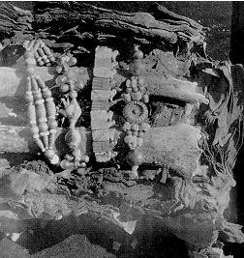
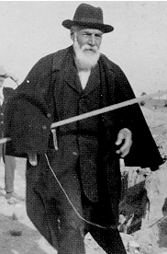
1900 - 1901 Mahasna, Beit Khallaf, El `Amra (PEF)
In Mahasna, which is north of Abydos, Petrie found a prehistoric settlement of wattle and daub huts.
In Beit Khallaf, Petrie found five large mastabas from the 3rd dynasty. At this site, Garstang, a fellow archaeologist, helped Petrie find where Zoser's tomb was to be located.
At El`Amra, Petrie excavated a cemetery and found thousands of little ushabtis (little figurines placed in tombs) that were given to the PEF members as tokens of appreciation.

1903 - 1904 Ahnas (PEF), Sedment (PEF), Ghurob (PEF)
At Ahnas el Medina (Ehnasya, aka Herakleiopolis Magna), Petrie re-dug M. Naville's and Count D'Hulst's site. They had found nothing older than Ramesses II. Petrie tried to prove them wrong. His biggest find was a gold statuette of the god Herishef.
At Ghurob (Tell Medinet Ghurad), Ali es Suefi found tombs with gypsum covering them, 19th dynasty tombs, and wooden statuettes. He also found foreign pottery, possibly from traders (Greek pottery), and found that the cartonnage (wrappings) around the head of the mommies were made of layers of papyri. These papyrus were wills and receipts.
At Sedment, Petrie found the necropolis of Ahnas. Naville had also dug up coffins at this site.
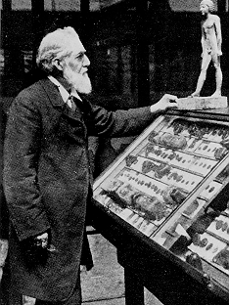
1904 Buto (PEF), Tell el Fara'in
Buto was a sacred city which had been the capital of a predynastic kingdom. Petrie found 1st dynasty potteries here but had to abandon the site because it was sinking into the Delta mud.
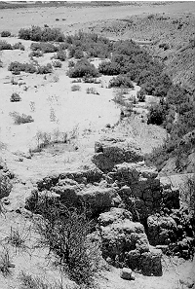
1904 - 1905 Wady el Maghara (PEF), Serabit - Sinai (PEF)
At Wady el Maghara, Petrie excavated the Valley of Caves and an ancient turquoise mine. Here Petrie found a figure from Sa-nakht of the 3rd dynasty. He also found 12 dynasty inscriptions, tools, and pots.
At Serabit el Khadem, Petrie excavated a temple on a hilltop, 250 feet up the Wady, where there were a series of courts where great pillars stood. Petrie found scripts of Egyptian officials who visited the area with the mining expeditions which are known as the 19th dynasty Proto-Sinaitic Scripts. He also found a portrait of a head of Queen Tiy (wife of Amenophis).
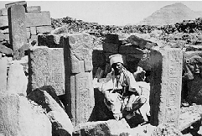
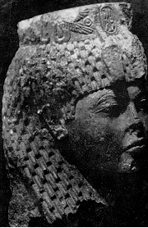
1905 Tell el Maskhuta
Naville (under the supervision of Petrie) found ruins of Pithom, a domain of the god Atum, at this site.

1905 - 1906 Tell el Yehudiya
This site is also known as the Mound of the Jew. Petrie excavated a Hellinistic Jewish cemetery called the City of Onias at Graeco. This became the type-site for this period of Egyptian history.

1906 Tell el Retaba, Saft el Henna, Ghita
Tell el Retaba was a promising mound that Petrie wanted to excavate..
At Saft el Henna, Naville found a shrine covered with religious inscriptions and identified it with the Biblical Goshen.
At Ghita, Naville found ruins of a Roman town and a cemetery. He also found archaic Greek scripts. Petrie said they were Libyan and the burials were of South Arabian mercenaries serving with the Roman garrison.

1906 - 1907 Giza, Rifa, Bala`iza, Shaganba
Giza was excavated by George Reisner who was a rival of Petrie's. The tomb of the mother of Cheops was found here along with the pyramids (see pyramids).
At Bala`iza, coptic monasteries of the 8th century, and manuscript leaves were found.
Large tombs were found in Rifa. Petrie states that these tombs were originally quarries for the stone with which the local governors of monarchs had built their palaces by the Nile but then changed into tombs for the noblemen.
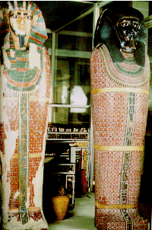
1907 Atrib, Deir el Abyad, Hagarsa

1908 Memphis (1908 - 1913)
In Memphis, Petrie found four palaces. He excavated a series of mounds among palm trees and used pottery chronology to date the mounds. He found Ramesside houses on one mound and found that this was the ancient capital of Egypt.
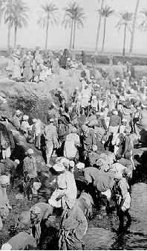
Mit Rahina was a mound of Memphis that was very wet. This increased the cost of excavating this site because pumps were needed to drain the water. Petrie found this mound to be a temple of the Ptolemaic Period which was dedicated to the lion-headed goddess of Athribis. He dated this to the period of Constantine. In Petrie's first season here, he found reused Old Kingdom blocks and some Middle Kingdom inscriptions. Petrie discovered the Temple of Merenptah. Petrie also found that Mit Rahina was four miles wide and eight miles long, including suburbs, villas, and gardens. What Petrie really wanted to find here was the fortress/palace of the first kings of united Egypt.
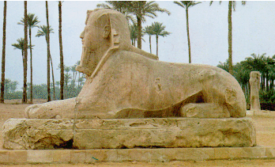
One of the palaces Petrie found at Memphis was the palace of Apries which was 400 feet long with large columns up to 50 feet high. He found bronze scale armour and weapons here which signified there was a military presence at this palace.

In the Ptah Temple, Petrie found a sphinx carved from one piece of alabaster which was 26 feet long and weighed more than 70 tons.
Petrie excavated Memphis every January to March or April, when the rains quit until he completely abandoned the site due to costly measures and feuds between land owners.

1908 - 1909 Qurna
This area was called the Valley of the Tombs of the Kings. Petrie excavated the Ramesseum again (see 1894 -1895 excavations). Here Petrie preserved the mummy by coating it with collodion. He gave the mummy to the Royal Scottish Museum in exchange for funding in 1910.

1909 - 1910 Meydum
Petrie excavated the Pyramid of Meydum which was made of stone. The Arabs called this pyramid the false pyramid because it was built by Snoferu and is a smaller version of his father Khufu's Great Pyramid.
While at Meydum, Petrie copied lots of paintings and even slept in the Nefermaat Tomb. He also found the pyramid temple which was the temple of King Snoferu. It was a limestone building with a courtyard.
Petrie also analysed the Great Mastaba Tomb which was constructed of fancy short brick, white plastered architecture. He found pottery here and dated it to the 4th dynasty and called it "Meydum Ware."
There was also a cemetery at Meydum where Petrie found complete skeletons with no grave goods.
1910 - 1911 Hawara, Mazghuna, Gerza
At Hawara, Petrie excavated the Pyramid of Ammenemes III which was made of mud brick. He tunnelled through the brick of the pyramid to find the burial chamber . Once inside the burial chamber, Petrie discovered a mummy with a picture of a girl by it. He also discovered a picture of a 25 year old woman which according to Petrie, would be an anthropologist's and a historian's dream find. A cemetery was found on the north side of the pyramid and was said to be of Roman date.
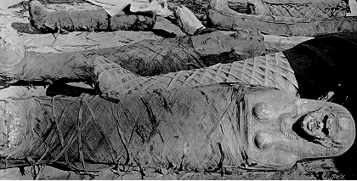
At Mazghuna, Petrie found brick pyramids which he dated to the 12th dynasty.
Gerza was a prehistoric cemetery dug by Wainwright and Mackay under Petrie's supervision.

1911 Shurafa, Atfih
Shurafa was a village on the east bank of the Nile. It was a Roman settlement where skulls were found which were dated to the Ptolemaic and Roman periods. Petrie supervised this excavation.
Atfih was the site of the ancient Aphroditopolis. Petrie found a Ptolemaic tomb and dated it to the 13th dynasty or Persion.

1911 - 1912 Tarkhan, Kafr ‘Ammar
Tarkhan, which is a site west of the village of Kafr ‘Ammar, is where the treasure of Lahun was found. Tarkhan is the richest and largest prehistoric cemetery in Egypt. Petrie uncovered 100 graves in week one of his excavation!
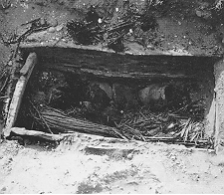
Near the village of Kafr ‘Ammar, Petrie uncovered Old Kingdom tombs. He found predynastic tomb furniture which he used to study the weave of rushmatting because the furniture was preserved remarkably well. Petrie also discovered lots of clothes, an early hierarchical inscription on a coffin lid, and a jar sealed with the name of King Narmer who was the unifier of Egypt.
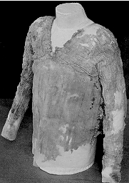
1912 Heliopolis
Heliopolis was located north east of Cairo. Petrie excavated the temples of the sun god, Re, where only a solitary obelisk wall was still upright.

1912 - 1913 Riqqa
At Riqqa, Petrie found a corpus of Middle and New Kingdom pottery.

1913 - 1914 el Lahun, Haraga
At el Lahun, Petrie discovered jewellery. He also excavated the pyramid of Illahun which was made of mud brick. This pyramid is hewn from natural rock to 40 feet. Petrie also found a sarcophagus of Sesostris II.
Petrie also excavated the Cemetery of Illahun at el Lahun. Here, Petrie found extensive beadwork which he secured in wax and therefore developed the wax method.
At Haraga, which is four miles from el Lahun, Petrie found tombs of the 12th and 18thdynasty.

1919 - 1920 Kahun, Ghurob
Kahun was a compact walled, Middle Kingdom town, with regular streets of houses which adjoined eachother back to back. He cleared the town systematically by measuring, planning, and drawing. Petrie discovered many objects here, including pottery, tools, ropes, fishing nets, sickles, hoes, rakes, games, dolls, sandals, furniture, toilet objects, and a papyrus with medical treatise on gynaecology.
At Ghurob, Petrie discovered 19th dynasty tombs (see 1903 - 1904).

1920 - 1921 Ghurob, Sedment, Abydos
See prior excavations.

1922 Behnesa
Petrie excavated the mounds of Behnesa (Oxyrhynchus) which are on the desert edge, 12 miles west of the town Beni Mazar (see 1896 excavations).

1923 - 1924 Qau, Hemamiya (Badari)
Qau el Kebir is located on the east bank of the Nile between Asyut and Sohag. Qau el Kebir is the ancient Antaeoplis. Starkey found a papyrus wrapped in a cloth and buried in a jar, containing the earliest Coptic version of St. John's Gospel. Petrie mounted this at his home. Petrie also recorded and drew the tombs located here. This excavation was supervised by Petrie.
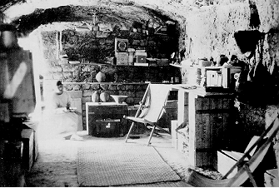
At Hemamiya, Brunton (supervised by Petrie) discovered cemeteries. The first tombs found were predynastic but some found later had polished red black topped pottery. Petrie named this new pottery "Badarian" after the district Badari in which they were working. This "Badarian" pottery dated earlier than Amratian pottery.

1926 - 1927 Tell Jemmeh
Tell Jemmeh, also called Gerar and Yurzaa by modern scholars, is located nine miles south east of Gaza. Petrie planned the compilation of a corpus of dated shapes for Tell Jemmeh, such as he had made for Egypt. Petrie found that Tell Jemmeh was a heavily fortified town for 1000 years. He found granaries which could feed 70,000 men for two months during the Persian period. He also discovered Greek ware in the earliest level during Tutmosis III time. Petrie discovered that during the Solominic Period, smelting furnaces and iron tools were used at Tell Jemmeh.
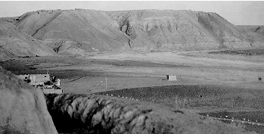
1928 - 1930 Tell Far`a
Tell Far`a is also called Sharuhe and Beth-Pelet. It may have been the first halting place of the Pharaoh Ahmose's army on their march into Palestine, the ancient land of Retenu, ca. 1520 BC. Petrie found tombs here containing a bronze couch of the Persian Period, gold jewellery, and a silver figurine of a swimming girl.
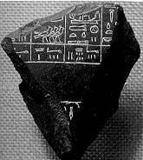
1930 - 1934, 1937 - 1938 Tell el`Ajjul (Gaza)
In the cemetery area, inside the palace, Petrie found a tomb containing gold grave goods bearing the name of Tutankhamun and a scarab of a later Pharaoh, Ramesses II. Petrie named this the Governors tomb. Petrie also found jewellery including female figures that could be the goddess Astarte. Petrie found the most gold here. Another important discovery was a gold ring of Alfre (Irish) origin. This showed that the British Isles and the Near East had traded with each other. Before Petrie was to return here again, bandits had destroyed his camp and therefore, the police refused to let Petrie come back because it was unsafe.
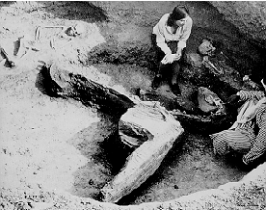
1935 - 1937 Shaikh Zowehd

1938 Trans-Jordan Survey
Petrie toured the area and dated pottery to 3rd century AD in Malfuf. This was Petrie's last fieldwork.

VITAE
Birth 1853
William Matthew Flinders Petrie was born on June 3, 1853 in Charlton, England. During his stay at the hospital, a nurse dropped him on his head which punched in his skull and left a mark on his temple.

Age 3, 1856
Petrie was fascinated with, and knew of many foreign places.

Age 5, 1858
Petrie marvelled over the Great Comet of 1858.

Age 6 - 8,1859-`61
Petrie learned English, French, Latin, and Greek grammar from his mother. Due to this scholarly pressure at such a young age, Petrie had a nervous break down. Therefore, the doctor ordered him to be left alone for two years. During these two years, he read books, became fascinated with scales and weights. Whenever he had access to one, he would weigh everything in sight.
In 1861, Petrie received coins from a marine shop of Woolwich, England and became fascinated by collecting coins. This fascination peaked when he found the coin Allectus. Besides coins, Petrie also collected minerals from the streets. One can say that Petrie began doing archaeology at age 8.
During that same year, he was visited by a little boy of 10 (later, Rev. Longley Hall, Director of C.M.S. schools in Palestine) who told Petrie of the unearthing of a Roman villa in the Isle of Wright. This story of the rough digging horrified Petrie. He protested that the ". . . earth ought to be pared away inch by inch, to see all that was in it and how it lay."

Age 10, 1863
Petrie started to relearn the languages he had been taught, but just couldn't grasp the concepts. He would forget each lesson after it was finished, therefore, he just knew the basics.
He had chronic asthma which kept him indoors, away from other children, which is why he was educated privately.
From age ten and a half until eighteen, Petrie wasn't taught anything from anyone else. He taught himself mathematics from an Oxford extension course.

Age 13,1866
Petrie received Greek copper coins from a man named Riley who became his friend and taught him all the shady practices of life concerning cheating and dealing. Petrie said that Riley taught him more of the world than anyone else.
During that same year (1866), Petrie read "Our Inheritance in the Great Pyramid" by Piazzi Smith. This book, along with the persuasion of his father, encouraged Petrie to go and survey the Great Pyramid.
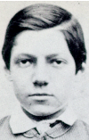
Age 15, 1868
Petrie would read a book a day in his cousin's garden at Puttenham. Petrie would also visit the British Museum once a week until he knew the museum by heart.

Age 19, 1872
Petrie and his father went out to Stonehenge and surveyed the formations.

Age 22, 1875
Petrie surveyed the huge earthworks and stone circles in South England. He received little payment for this job (1872).

Age 24, 1877
Petrie published his first book, ‘Inductive Metrology,' with the help of his father.

Age 27, 1880
Petrie travelled to Egypt to start his fascinating career as an archaeologist (1880).

Age 39, 1892
Petrie was appointed Edwards Professor of Egyptology at the University Collage, London. He kept this position until 1933 when he became Professor Emeritus. Over the years he received numerous honorary recognitions including the F.R.S., F.B.A., D.C.L., Litt.D., LL.D., D,Lit., D.Sc., Ph.D.
Age 43,1896
Petrie met Hilda Mary Isobel Urlin who was to become his wife. He also became a member of the Egyptian Exploration Fund later this year.

Age 44, 1897
Petrie was married to Hilda Mary Isobel Urlin. They were married in their travelling clothes. They started their honeymoon in Paris and then went to Africa. They then went to Egypt and rented a coal barge to travel down the Nile, Which was the romantic part of the honeymoon, according to Petrie.
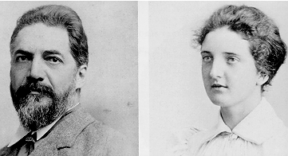
Age 70, 1923
Petrie was Knighted for his, "services to Egypt." Petrie didn't put much emphasis on this knighthood. The ceremony was scheduled for 10:30 a.m. and he was back to work by 12:00.
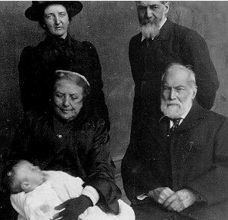
On his 70th birthday, friends and colleagues raised money for a bronze medal, called the Petrie Medal, to be awarded, "for distinguished work in archaeology." It was given to Petrie by the Chancellor of the University Collage, London, at a cermony.
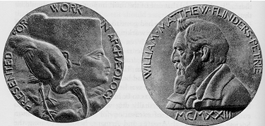
Age 82, 1935
Petrie retired and took up residence at the American School (now The W.F.Albright Institute of Archaeological Research) in Jerusalem where he lived for 7 years.
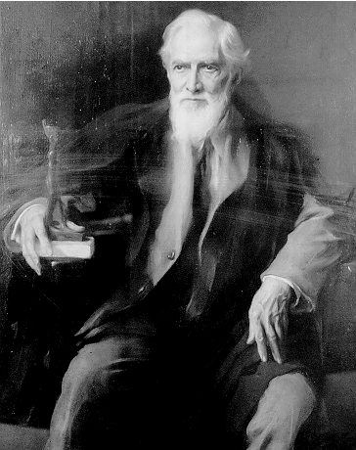
Age 89, 1942
On July 29, at 4:30 a.m., he passed away due to malaria. His grave is in the protestant cemetery on the summit of Mount Zion. He wrote this verse before he died:

"No more running boy in English woods,
No more to roam the ewe-leaze and the tor,
No more to delve in pyramids and towns,
No more to trace the thoughts of man yore,
No more, No more."

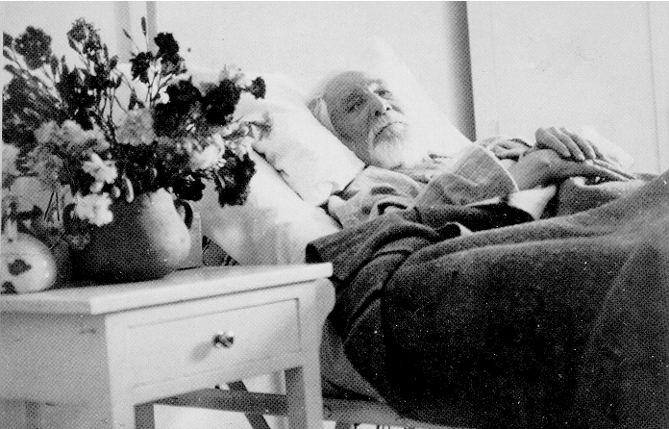

ANECDOTES

- Sir William Matthew Flinders Petrie spent his honeymoon on a coal barge.

- During the Gurob excavation, Petrie had been kept awake by the barking of dogs. Therefore, he was too tired to continue the work the next day so he told the workers that until the dogs disappear, they would be locked out without pay. After that, the workers chased and hunted the dogs until there were no dogs to bother his sleep anymore.

- Once two hammers were missing from an excavation so Petrie had another lock out until these hammers returned. Two hammers were returned but they were probably stolen from another camp.

- Once Petrie was directing workmen in hauling a coffin from the bottom of a tomb shaft. As soon as the coffin was at the top, Petrie yelled "Push!" The workmen all gave it a big push and the coffin fell back down. After that, whenever Petrie said push, the workers would pull.

- One time Petrie was at Wady Maghara without water supplies. He asked the Beduim to show him where a well was. The Beduim wouldn't show Petrie until he paid him money. Petrie wouldn't pay so he took a bucket and walked over the hill to the well. The Beduim thought he had magical powers because he found the well. Actually, Petrie had noticed two canals on his way there so he just followed them.

- At Mit Rahina excavation, the site was infested with rats so Petrie had to get mongoose in order to continue work.

- Petrie wouldn't allow any telephones in his house. He regarded it as an interruption of work. Petrie also said that watching sports and reading novels were a waist of time.

- At the end of his life Petrie said that he wanted to donate his head to the Royal Collage of Surgeons in London. When he died, Dr. Thompson removed Petrie's head and preserved it. The war had broken out ,this prevented shipment and the head was kept under Hilda's bed. After the war it was shipped in a jar to London, but its label was lost, and the jar wasn't identified until the mid 1970's.

- Petrie would strip entirely naked while working inside the pyramids of Giza. He would also wear pink vests outside the pyramid so tourists would think he was strange and leave him alone.

- During the Second World War, at the American School in Jerusalem Mrs. Petrie would steal sugar from other tenentes' rations. Once she got caught and used the excuse, ‘I need the sugar to feed my husband's brain.' and she got away with it!

TRIBUTES

1. Dawson, W. R. and Uphill, Who was Who in Egyptology, 2nd Edition, London, 1972, P.228ff.

2. Drower, Margaret, Flinders Petrie, A Life in Archaeology (London: Victor Gollanez LTD 1985).

3. Fargo, Valerie M., Biblical Archaeologist, Volume 47:4, December 1984, C.1. Publication of the American Schools of Oriental Research, p.220-223, 240-243.

4. Petrie, Ann Flinders, and Ann Lisette Flinders Petrie, in Matthew Flinders: The Ifs of History (ed. R. W. Russel), Flinders University of South Australia, 1979.

5. Smith, Sidney, Proceeding of the British Academy, Volume 28, p.307-324, 1942.

6. Wheeler, R. E. M., Adventure and Flinders Petrie, in Antiquity, XXVII (1953), p.87ff.

Virtual Kahun
“Bringing Collections Together”
Sir William Matthew Flinders Petrie
http://www.kahun.man.ac.uk/petrie.htm

The man responsible for the excavation of the pyramid of Senwosret II and its surrounding area was Sir William Matthew Flinders Petrie. A breed apart from his contemporaries, Petrie was a systematic excavator, indeed a pioneer. His work would set the benchmark for further excavations.
Petrie was born on June 3rd, 1853 in Charlton, Kent. When he was four Petrie became so ill his mother became convinced that he was a weak child. Since she was a scholar herself, she taught him at home and introduced him to Hebrew, Latin and Greek. Later on, a governess taught him, but when he became ill again, his official education effectively ended.
Petrie was an inquisitive child and developed an insatiable appetite for facts, toying with mathematics, discovering geometry and devising chemical experiments at the age of 15. His father, an industrial engineer, taught him the use of a sextant and how to map sites, so by the time he was 18 Petrie spent many days alone making surveys around his home. He wrote his first book at the age of 22 on the recovery of Ancient Measurements from Monuments, based on work he had done at Stonehenge.
Between 1880 and 1882, Petrie went to Egypt having read a book written by a family friend, Charles Piazzi-Smyth on the measurements of Egypt’s pyramids. Since the book was heavily criticized, he travelled to Giza and the Great Pyramids, Saqqara, Dahshur and the Bent Pyramid, and Abu Rawash, exploring the pyramids’ interiors and measured and triangulated to confirm these results. Returning again to Giza, he measured the thickness of sides and base of the royal sarcophagus and of the inside floor. Eventually he concluded that every measurement Piazzi-Smyth had taken was inaccurate. Petrie’s own survey, the Pyramids and Temples of Giza, was published in 1883 and remains a standard in the field.
Having accomplished such impressive work he was recommended to the Egypt Exploration Fund (now Egypt Exploration Society), who needed an archaeologist in Egypt to succeed Edouard Naville. Petrie accepted the position and was given the sum of 250 pounds per month to cover the excavation’s expenses. In November 1884, Petrie arrived in Egypt to begin his excavations. Petrie devised a way to ensure that no artefacts slipped on to the black market by offering payment to his workmen for the smallest find.
Petrie went on to lead excavations at many of the most important archaeological sites in Egypt such as Hawara, Meydum, Abydos and Amarna. He also developed a method for establishing the historical chronology of a site based on identifying different pottery styles. Petrie was known and respected for his belief in the importance of evidence like potsherds for informing the archaeologist about life in the past. He believed that this type of evidence was far more useful and informative to the archaeologist than individual, spectacular objects.
However, he soon became disheartened with the Fund and tendered his resignation in 1886. He set up an independent organization called the Egypt Research Account, later to become the British School of Archaeology in Egypt. He was also appointed the first Edwards Professor of Egyptology at University College in London in 1892 and awarded a knighthood in 1923.

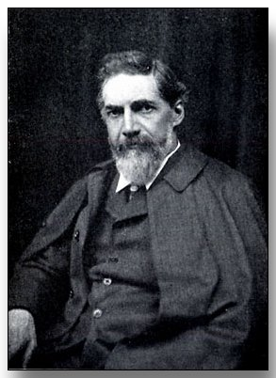
Sir William Matthew Flinders Petrie,
Father of modern Egyptology
Small Coincidences:
Piazzi Smyth, Baden-Powell & Flinders Petrie
http://www.pinetreeweb.com/bp-petrie.htm

Sir William Matthew Flinders Petrie is known as a pioneer in the field of archaeology and Egyptology. In his autobiography, Seventy Years in Archaeology, he wrote of an interesting connection with the Smyth and Baden-Powell families:
CHAPTER I.
PREPARATION
THE first chance in life is ever being born at all, and a mighty uncertain affair it seems to us mortals.
My grandfather, Captain Matthew Flinders, who died at forty, left two young friends who kept in touch with his widow and daughter for half a century. One was his cousin, a midshipman on his ship H.M.S. Investigator, John Franklin, of Arctic fame. From his childhood, John was always the heroic gentleman. One evening my great-grandmother, visiting his mother, rose to leave, saying it was getting too late; Johnnie, then four years old, at once said, "Never mind, Mrs. Tyler, I will see you home."
The other friend was William Henry Smyth, but for whom my father and mother might never have met. He was a man of wide interests, known as a literary sailor, as surveyor, astronomer, and antiquary. His sons were notable for rising to the top of their professions, his daughters for marrying men who, later, were equally successful. Some of their names reflected his tastes; Piazzi, the Astronomer Royal for Scotland, was named from the Sicilian astronomer; Rosetta, the wife of Sir William Flower, had her name from the Rosetta stone. Their house in London in the 'forties was a centre of many interests, and my mother, Anne Flinders, often stayed with them when up in town for meetings.
Piazzi Smyth had begun his career as an assistant to Sir John Herschel at the Cape, and thence naturally knew my grandfather, Petrie, who was head of a department there. He brought my father and uncles into the Smyth circle on their return to England. Amid the many friends who went to and fro there, it did not escape the eye of Mrs. Smyth that her eldest daughter, Henrietta, and young William Petrie were very intimate. Now she was a very careful mother, and knew her duties. She felt that my father had not that amount of worldly wisdom which she desired for her daughter's success, so Henrietta was promptly taken to Cambridge, and soon after married the sexagenarian Professor Baden-Powell.
Meanwhile William Petrie and Anne Flinders had been constantly meeting at the Smyths, and some years later my father and mother were married. So Mrs. Smyth was the agent by whom Scouting and Egyptian archaeology took their present form. B.P. and I both speculate whether either, or neither, of those subjects would have been otherwise so shaped?
He wrote of the role of Piazzi Smyth's work on the Pyramids had in leading to his own interest in Egyptology. As noted below, he was later to disprove scientifically some of Piazzi Smyth's central conclusions about the Pyramids.
…. A new stir arose when one day I brought back from Smith's bookstall, in 1866, a volume by Piazzi Smyth, Our Inheritance in the Great Pyramid. The views, in conjunction with his old friendship for the author, strongly attracted my father, and for some years I was urged on in what seemed so enticing a field of coincidence. I little thought how, fifteen years later, I should reach the "ugly little fact which killed the beautiful theory"; but it was this interest which led my father to encourage me to go out and do the survey of the Great Pyramid; of that, later on.
Sir William Matthew Flinders Petrie, Seventy Years in Archaeology (1932)

In The Genesis of British Archaeology, John David Wortham writes about Piazzi Smyth, his influence on Flinders Petrie and Petrie's ultimate discrediting of Smyth's work on the Great Pyramid. Obviously, with little patience for the religious interpretations of early pyramid researchers, he coins the term "pyramidiot" to describe the development of what he saw as a quasi-religious cult. To some degree, It remains today in the "New Age" term "Pyramidology."
By 1800, Egyptologists were certain that the Egyptians had used the pyramids as tombs, but during the course of the nineteenth century a multitude of cranks and cultists disputed the idea. Eventually professional Egyptologists would be able simply to ignore the various pyramid cults, but during the nineteenth century, they could not always do so. At least one pyramid cultist, Charles Piazzi Smyth, performed useful work in measuring the Great Pyramid at Giza and thereby made for himself an international reputation as an authority on the structure, origins, and function of the Great Pyramid. A multitude of other pyramidiots attracted considerable attention, scholarly and otherwise. The bizarre speculations concerning the pyramids had a long life, and at least one pyramid cult has succeeded in maintaining itself in the twentieth century.”

The next step in pyramidiotic speculation was taken by John Taylor, a friend of Coleridge and Keats and a minor literary critic. In 186o he published a book on the Great Pyramid under the title The Great Pyramid: Why Was It Built? and Who Built It? In 1864 he published another book in which he replied to his critics: The Battle of the Standards.
According to Taylor, Holy Scripture contained references to the Great Pyramid in many passages; the architect of the Great Pyramid had not been an Egyptian but Noah, the designer of the Ark. Furthermore, locked in the measurements of the Great Pyramid were secrets of which the ancient Egyptians themselves had remained unaware. Among these secrets was the length of the "sacred cubit," identical to the cubit that the Israelites had used in biblical times. Taylor supplied "evidence" that the English system of measurement had derived from the "divine" system embodied in the Great Pyramid. Because many Englishmen admired Taylor's evident piety-and his opposition to the adoption of the French metrical system-his book enjoyed modest popularity.
Taylor's chief disciple and the real founder of the Great Pyramid cult was Charles Piazzi Smyth, the astronomer royal of Scotland. Smyth, an inventor known for his improvements in photography, became a convert to pyramidiocy after reading Taylor's books, and in 1864 he published a defense of Taylor's ideas: Our Inheritance in the Great Pyramid.
In 1865, Smyth, convinced that more precise measurements of the Great Pyramid than those available in published works were necessary, took his own scientific expedition to Giza.
Smyth was interested only in the Great Pyramid. The other monuments of the plateau he considered evil, pagan, and idolatrous. He spent his days making measurements of the exterior of the pyramid, its inner chambers and passages, and the sarcophagus. Smyth hated the tourists who came to Giza. He found them noisy and bothersome, and they forced him to suspend work for several hours each day. Above all, he felt that they did not show enough respect for the Great Pyramid.
Despite his strange ideas and misconceptions, Smyth performed much valuable work at Giza. He made the most accurate measurements of the Great Pyramid that any explorer had made up to that time, and he photographed the interior passages, using a magnesium light, for the first time. In 1867 he published the results of his efforts and his own speculations about the Great Pyramid in his magnum opus, Life and Work at the Great Pyramid.
Smyth's theories about the Great Pyramid exceeded those of John Taylor in grotesquerie. The Great Pyramid, Smyth maintained, was not an Egyptian monument. Rather, it was the oldest man-made structure; the other Egyptian pyramids were only filthy, pagan imitations. Although the Egyptians might have furnished the physical labor necessary to erect the Great Pyramid, the architectural genius who designed it must have been some personage of the Old Testament. The pyramid was a perfect structure, a product of divine inspiration, which embodied in its measurements a perfect system of weights and measures, among them the sacred cubit of the Israelites, the pyramid inch, and a system of prophecy. By use of the correct mathematical formulas, Smyth intended to unlock the secrets of the pyramid, secrets that included information about the past history of man, his future, and the Christian dispensation. He claimed that he had derived a number of astronomical facts, some dates of important events of the past, and a prediction about when the millennium would begin.
Many scholars published what should have been devastating criticisms of these theories. They showed, for example, that when deriving his formulas Smyth simply juggled facts and figures until he came up with a seeming correspondence and that many of the data upon which he based his theorizing, such as the average size of the casing stones that had once covered the Great Pyramid, were wrong. Contemporary Egyptologists knew that the Great Pyramid was not the earliest of the monuments, but one of the latest. However, pyramidiots were unswayed by facts.
Theories as bizarre as Smyth's inevitably produced a storm of criticism. What is surprising is the amount of support they received from reputable journals. Smyth responded quickly to all criticism. Shortly after the publication of his Life and Work at the Great Pyramid he produced an answer to its critics: The Antiquity of Intellectual Man. When the Royal Society of Edinburgh refused him permission to read a paper on the Great Pyramid in 1874, he resigned his fellowship in protest and published his reasons for doing so in a pamphlet entitled The Great Pyramid and the Royal Society.
During this controversy Smyth enlisted support mainly from two groups: the opponents of the introduction of the metric system into England and the antievolutionists. Smyth had stated in his books that the English inch was a close copy of the "pyramid inch," a perfect unit of measurement inspired by God. Hence, according to Smyth's reasoning, Parliament would be committing an irreligious act if it adopted the atheistic French metric system. Furthermore, Smyth continued to insist that the Great Pyramid was the oldest man-made monument in the world and hence that man had always displayed, with the Deity's aid, a high degree of intellectuality. These views were directly contradictory to theories of the evolutionary nature of man's development, a fact that the antievolutionists and Smyth clearly realized.”

While Petrie's new methodology was revolutionizing archaeology, his discoveries in the field were forcing Egyptologists to rewrite much of their reconstruction of ancient history. Among Petrie's discoveries were the city of Tanis, the Greek trading outpost at Naucratis, the location of ancient Daphnae, the pyramid of Amenemhet III, the prehistoric cultures at Qift, and the prehistoric and early dynastic remains at Abydos.
Petrie was born at Charlton, England, on June 8, 1853. From a very early age he demonstrated an interest in ancient remains. When he was thirteen, he bought a copy of Charles Piazzi Smyth's Our Inheritance in the Great Pyramid and showed it to his father,' who was an engineer. William Petrie saw in Smyth's theories an admirable reconciliation of science and religion, and he wanted to do what he could in support of this reconciliation. He decided that he and his son should go to Giza and use their skills to secure even more precise measurements of the Great Pyramid.
To train for their work, William and Flinders Petrie practiced surveying Stonehenge, assembled a collection of surveying instruments, and read everything they could find on the antiquities of Egypt. In 1875 they published a book they had written on the measurement of ancient earthworks.
William Petrie was something of a procrastinator and kept delaying the trip to Egypt. Eventually his son had to go without him. That was probably just as well, for by this time Flinders Petrie had rejected the ideas of Piazzi Smyth.
Had his father been present at Giza, the probable clash of opinions might have hampered the work.
Petrie arrived in Egypt in December, 188o, and remained until the end of May, 1881.⁴ While he was there, he restricted his activity to surveying, relying primarily on triangulation. In October, 1881, Petrie went back to Egypt, and except for a two-month trip up the Nile, remained at Giza until the end of April, 1882. During this second visit to Egypt he did some excavating.
Petrie's findings at Giza enabled him to disprove two prominent theories about the Pyramids, the accretion theory of Richard Lepsius and the belief of Charles Piazzi Smyth that the Great Pyramid was a product of divine revelation and, therefore, flawless. Petrie destroyed Lepsius' theory by showing exactly how the ancient Egyptians had constructed the Pyramids, and he also found much evidence that indicated the Great Pyramid contained imperfections resulting from poor construction and earthquake damage.
In examining the King's Chamber in the Great Pyramid, Petrie found that one or more earthquake shocks had broken every roof beam on the south side. Only the inward thrust of the massive walls held the four-hundred-ton granite roof in place. This damage had very likely occurred before the Egyptians had finished the construction, for mortar covered the cracks. Petrie believed that two architects had worked on the Great Pyramid and that the second had possessed much less skill than the first. The second architect had used rough stone and had often forgotten to dress the stone. The plaster applied to such areas failed to hide these imperfections. Petrie also found cracks that the workers had made in cutting the block for the sarcophagus. Charles Piazzi Smyth had noticed none of these defects.
From: John David Wortham, Genesis of British Archaeology, 1549-1906, Norman: University of Oklahoma, 1971.

From: Encylcopaedia Britannica Online (2002).
Sir William Matthew Flinders Petrie
born June 3, 1853 , Charlton, near Greenwich, London
died July 28, 1942 , Jerusalem
British archaeologist and Egyptologist who made valuable contributions to the techniques and methods of field excavation and invented a sequence dating method that made possible the reconstruction of history from the remains of ancient cultures. He was knighted in 1923.
Petrie was named for his maternal grandfather, Matthew Flinders, British navigator, pioneer hydrographer, and explorer of Australia and Tasmania. A frail child, Petrie was privately educated, early developing archaeological and ethnological interests, particularly in the area of ancient weights and measures, and in Egyptology.
At the age of 24, Petrie wrote Inductive Metrology, or the Recovery of Ancient Measures from the Monuments, a work that represented a new approach to archaeological study. Fieldwork done at various locations in Britain, including Stonehenge , enabled him to determine by mathematical computations the unit of measurement for the construction of the monument. His Stonehenge: Plans, Description, and Theories was published in 1880, and in that same year he began the surveys and excavation of the Great Pyramid at Giza, which initiated his four decades of exploration in the Middle East.
During the 1884 excavation of the Temple of Tanis , Petrie discovered fragments of a colossal statue of Ramses II. In 1885 and 1886, at Naukratis and Daphnae in the Nile River delta, he uncovered painted pottery by which he proved that those sites had been trading colonies for the ancient Greeks. It was this discovery that caused him to believe that history could be reconstructed by a comparison of potsherds ( pottery fragments) at various levels of an excavation.
Petrie first applied his principle of sequence dating in Palestine, at the site of Tel Hasi, south of Jerusalem. In 1890, in a period of only six weeks, the indefatigable excavator found a series of occupations for which he was able to supply tentative dates of habitation. Petrie's work at the hill site marked the second stratigraphic study in archaeological history; the first was carried out at Troy by Heinrich Schliemann. The excavations of these two men marked the beginning of the examination of successive levels of a site, rather than the previously practiced method of haphazard digging, which had produced only a jumble of unrelated artifacts. Most of Petrie's contemporaries in archaeology questioned his hypothesis that chronology could be established by potsherds, whether painted or undecorated. But, with the progressive sophistication of archaeology, the examination and classification of broken pottery became routine procedure.
Petrie made other important discoveries in the Al-Fayyum region of Egypt . At Gurob he found numerous papyri and Aegean pottery that substantiated dates of ancient Greek civilizations, including the Mycenaean. At the Pyramid of Hawara he searched through the tomb of Pharaoh Amenemhet III to discover how grave robbers could have found the tomb's opening and made their way through the labyrinth surrounding the two sarcophagi that they emptied. He concluded that they must have been given the master plan by an informer. At Al-Fayyum also he made a rich find of 12th-dynasty jewelry (housed at the Metropolitan Museum in New York City since 1919). He was delighted by his discovery of the earliest-known Egyptian reference to Israel on the stela (a stone slab monument) of Merneptah, king of ancient Egypt from 1213 to 1204 BC.
In 1892 Petrie was made Edwards professor of Egyptology at University College, London, and he served in the position until 1933, when he became professor emeritus. In 1894 he founded the Egyptian Research Account, which in 1905 became the British School of Archaeology.
Petrie added to the knowledge of the pyramid builders during his exploration of the necropolis of Abydos, holy city of the cult of Osiris, god of the dead. At Tell El- Amarna he excavated the city of Akhenaton, or Amenhotep IV, ruler of Egypt from 1353 to 1336 BC, revealing the now-famous painted pavement and other artistic wonders of the Amarna age (14th century BC). Three thousand graves found by Petrie at Naqadah, northeast of Thebes, were identified as those of primitive ancient Egyptians.
In 1904 Petrie published Methods and Aims in Archaeology, the definitive work of his time, in which he lucidly defined the goals and methodology of his profession along with the more practical aspects of archaeology—such as details of excavation, including the use of cameras in the field. With uncommon insight, he noted that research results were dependent on the personality of the archaeologist, who, in addition to possessing broad knowledge, had to have insatiable curiosity. His own abundance of that characteristic was never questioned.
Inscriptions that Petrie found on the Sinai Peninsula represented an intermediate stage (not later than 1500 BC) of written communication between Egyptian hieroglyphics and the Semitic alphabet. Although he wrote The Formation of the Alphabet (1912), language was not Petrie's forte, and he depended on a sixth sense for free translation of inscriptions and for establishing dates through the study of the forms of hieroglyphs.
Under the auspices of the American School of Research, he excavated in Palestine from 1927 until 1938, when he was 85. In those years, again at Tel Hasi, he uncovered the ruins of 10 cities. His scientific methods provided the guidelines for all subsequent Palestinian excavations. He died in Jerusalem at the age of 89.
"Petrie, Sir Flinders" Encyclopædia Britannica
<http://www.britannica.com/eb/article?eu=60991>
[Accessed December 25, 2002].

Biblical Archaeology
Deconstructing The Walls Of Jericho
 | http://www.prometheus.demon.co.uk/04/04herzog.htm |  | Ze'ev Herzog
According to the Bible the history of Israel began when Abraham was called by Yahweh to leave his family and his home and settle in Canaan. His son Isaac, and his grandson, Jacob, lived there until Jacob was forced by famine to flee to Egypt with his remaining sons, where one of them, Joseph, already held a position of prominence. The descendants of Jacob were enslaved in Egypt. Yahweh charged Moses with the deliverance of his people from bondage. This he did with the aid of Yahweh, who dried up the 'Sea of Reeds' so that the Israelites could cross in safety, while the pursuing Egyptian army drowned. Moses and his people continued to Mount Sinai, where a convenant was concluded establishing Yahweh as the God of his chosen people, Israel. The conditions of the convenant were laid down in a law including the Ten Commandments. However, because of the people's disobedience their march toward the Promised Land turned into forty years of wanderings in the wilderness. Finally, after the death of Moses, the people of Israel entered Canaan from the east, crossing the River Jordan. Under the leadership of Joshua they sacked Jericho, after the city walls came tumbling down rather miraculously, and then went on to conquer the rest of Canaan. None of the details of this account can be verified by other sources as the distinguished Israeli archaeologist Ze'ev Herzog argues in his article 'Deconstructing the Walls of Jericho: Biblical Myth and Archaeological Reality.'
Herzog argues that 'the formative stages of the People of Israel were utterly different from those the Bible articulates. Nonetheless, such views have not percolated into the awareness of the public at large.' He believes that most 'Israelis (as well as Jews in the Diaspora) would still be shocked to read such conclusions as these: that the People of Israel did not sojourn in Egypt, did not wander in the wilderness, did not conquer the land of Canaan in a military campaign, and did not pass it on as inheritance to the Twelve Tribes of Israel.
The portion of the Levant known as Palestine has had many different names including Canaan and Eretz Israel or Land of Israel. After 132 CE the Romans renamed the region Palestine because the Jews had rebelled against Roman authority not once, but twice. Aware of Jewish history the Romans renamed the land after Israel's most bitter enemy, the Philistines, to humiliate the Jews. The Romans sought to make a point that this region was no longer Eretz Israel, but Roman land. The word comes from the Latin Palestina (Philistine Land).
This introduction to accompany Professor Herzog's article provides the reader with an outline of the beginnings of archaeological research in Palestine and Jericho.
Digging up the Bible
One of the unique topographical features of the Near East landscape is the large number of mounds, or tells, that populate it. They were long believed to be naturally occurring hillocks until archaeologists, at the end of the 19th century, demonstrated that in fact these tells were man-made ('tell' is the transliteration of the Arabic, while 'tel' is from the Hebrew). The first serious, biblically oriented topographical study of the region was carried out in 1838 by the American scholars Edward Robinson and Eli Smith, who identified scores of historic sites in Palestine on the basis of modern Arabic place names. But the mystery of the tells remained until 1890, when Sir William Matthew Flinders Petrie laid the foundations for modern archaeological science.
A distinguished Egyptologist, Petrie proved conclusively, after conducting field work at Tell el-Hesi, that tells were in fact the mounded-up, layered remains of ancient cities, towns and fortifications. These trapezoidal mounds are to be found in the Near East because settled urban populations have existed there for millennia, with generation after generation rebuilding upon earlier rubble; the debris thereby becoming compactified. The height of a tell can be considerable. The depth of debris at Jericho is about 18m (60ft) and at Megiddo about 21m (70ft).
Petrie established two key elements of archaeological study that have endured to the present day - the principle of stratigraphy, or the decipherment of the various layers of ruins; and ceramic typology, the technique of dating layers by means of the pottery or potsherds discovered in the strata. Problems, however, remained because every archaeologist that worked in Palestine followed Petrie in labelling their excavated strata with vague names like 'Amorite' and 'Semitic' leading to much confusion in biblical archaeology.
In 1922, however, archaeologists agreed upon the use of a single system of classification invented by a Danish museum curator in the 19th century: the Stone, the Bronze and the Iron ages (see box on Archaeological Periods and Chronology). In the 1920s the precise dates of the three ages in Palestine were still unclear, but the categories were clearly discernible in all excavations. It was now possible for archaeologists to begin to trace the conquest of the land of Canaan by Joshua and the Israelites.
The Fall of Jericho
Yahweh gave Joshua precise instructions on how to capture Jericho. For six days the people marched silently round the city, preceded by the priests carrying the ark of the covenant and blowing trumpets. On the seventh day they marched around the city seven times. On the seventh circuit, just before the priests were about to blow their trumpets, Joshua told the people to shout. The priests blew their trumpets, the people shouted, and the walls of the city collapsed. The Israelites marched in and killed the inhabitants of Jericho.
Situated in the Jordan Valley, nearly 300m below sea level and approximately 13km to the north-east of the Dead Sea is Jericho, 'city of palms' of the Old Testament. Bounded by Mount Nebo to the east, the Central mountains to the west and the Dead sea to the south, Jericho lies in the centre. It is the world's oldest know inhabited city. The mound that is the remains of that ancient city is now known as Tell es-Sultan and is located besides a spring called Elisha's fountain. New Testament Jericho is a separate site to the south of Tell es-Sultan.
Although the remains of several excavations scar Tell es-Sultan, it was not until the pioneering work of Dame Kathleen Kenyon of the Institute of Archaeology, London in the 1950s that the city's ancient past was revealed. The earliest human habitation at Jericho dates from about 8000 BCE, when there was a permanent settlement of about two thousand. Its irrigation system, large stone tower and massive defensive wall built a thousand years later. Archaeological investigations of the tell provided detailed records of successive settlements on the site, but the level corresponding with the city destroyed by Joshua was not among them.
The first work on the site was done by Captain Charles Warren of the British Royal Engineers who were surveying Palestine in 1867. He sank a shaft into the tell but failed to find to discover anything of archaeological significance and abandoned any further work. It was not until 1930 that the first a major expedition, lasting six years, was undertaken by Liverpool University under the direction of Professor John Garstang, one of the most distinguished archaeologists of the day. Garstang created headlines around the world when he claimed to have unearthed the fabled tumbling walls of Joshua.
It was twenty years later that Kenyon, between 1952 and 1956, disproved Garstang's claim. Under the auspices of the British School of Archaeology in Jerusalem and supported by the Department of Antiquities of the Hashemite Kingdom of Jordan she undertook a major excavation and re-evaluation of the site using new techniques of soil removal and classification. Among her many findings were that the walls that Garstang had identified as Late Bronze Age and dated to 1600-1400 BCE were in fact much earlier and belonged to the Early Bronze Age which she dated as ending in 2100 BCE. Thus the evidence was at least 500 years too early for it to have been destroyed by Joshua.
Biblical scholars and archaeologists believed that the period between the end of the Bronze Age and the beginning of the Iron Age (1550-1000 BCE) was of special importance for both ancient history and biblical archaeology. This period had been an era of destruction and invasion. Though the Old Testament offers no date for the conquest of the Promised Land, later ancient texts and archaeological evidence suggested that this was the only possible period in which Joshua and the Israelites could have arrived in Canaan. Joshua's Jericho lay buried in the tell close to the point where the Late Bronze Age strata ended and the Iron Age strata began. Wedged between these two strata should have been a black band, the ash and the tumbled bricks of the city's fallen walls. Kenyon found evidence that during the Early Iron Age, the period which was the only possible time for the first Israelite settlements in Canaan, Jericho had been largely deserted, having been in a state of ruin ever since the destruction of the last Bronze Age city 300 years earlier.
The Bible
The word 'Bible' is derived from the Greek word 'biblia' meaning 'books'. As the collection of Jewish and Christian texts came to be increasingly regarded as a single entity, 'The Books' became 'The Book'. By the end of the second century BCE the adjective 'holy' had been added.
With the exception of a few passages in Aramaic, the Old Testament was written entirely in Hebrew. As Aramaic became the common language among Jews following the Exile (6th century BCE), however, translations for the use of the faithful were made into that tongue. Greek was the next language to predominate in much of the ancient world as a consequence of the conquests of Alexander the Great.
The earliest translation of the Pentateuch, or the first five books (Genesis, Exodus, Leviticus, Numbers and Deuteronomy, which in Hebrew are called the Torah or Law) was the Septuagint. According to legend this translation was accomplished under the direction of 70 (or 72) Jewish scholars living in Alexandria. These scholars had completed the translation of the Pentateuch into Greek by about 250 BCE, and over the course of the next two centuries the remainder of the Old Testament was also rendered into Greek.
The spread of Christianity inspired additional Greek and Latin translations of the Bible. Augustine complained of the 'infinite variety of Latin translations'. To remedy the problem, in the year 382 CE Pope Damascus commissioned the leading biblical scholar Jerome to prepare a standard Bible in Latin. For some two decades Jerome worked on the project, using in particular Old Testament Hebrew and Aramaic manuscripts rather than the Septuagint. For the New Testament Jerome followed in the footsteps of his predecessors by using existing Latin and Greek manuscripts. His work, completed in 405 CE, gradually gained wide-spread acceptance among Latin speaking Christians - it was thus referred to as the versio vulgata, 'the common version'.

Hypothesis:
Relieving chambers and King's Chamber
http://www.mars.sphere.ne.jp/p-inpaku/Pyramid/sub81.htm

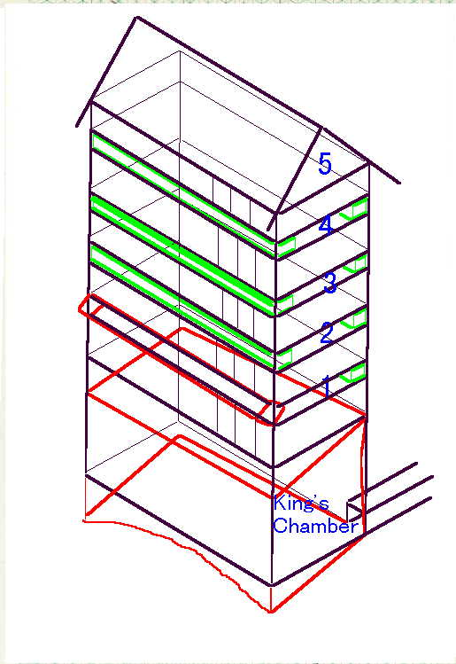
William Matthew Flinders Petrie did extensive investigations on the Great Pyramid in 1880s. On this page, explanation starts with his report which shall be the basis for discussion. Then author's view on the relieving chambers and the King's chamber is explained, followed by the hypothesis on these chambers.
1. Petrie's Report
The description on structures and damages of the relieving chambers and the King's Chamber taken from F. Petrie's "The Pyramids and Temples of Gizeh" (1883) is listed below. The figure of the chambers is also shown on the right. In the figure, the green lines show supporting blocks, and the red lines show deformation of the King's Chamber and a supporting block, which is fallen outside.
a. | All chambers over the King's Chamber
* | Floored with horizontal beams of granite, rough dressed on the under sides, but wholly unwrought above.
* | N. and S. side are blocked by blocks of granite from the first to the third chambers, and by that of limestone in the fourth chamber.
* | E. and W. walls are immense limestone walls wholly outside of; and independent of; all the granite floors and supporting blocks.
* | All the chambers stand, being unbonded, and capable of yielding freely to settlement.

b. | The fifth or top chamber
* | The sloping roof-slabs appear.
* | The roof-slabs have separated at the apex 1.55 inches at E. end and 1.0 inch at W. end.
* | The (E. and W.) end walls are very rough.

c. | The fourth chamber
* | The supporting blocks along the N. and S. sides are all of limestone, and are much cracked and flaked up by top pressure.
* | The (E. and W.) end walls have sunk as much as 3 inches in relation to the floors and sides; as is shown by the ledges of plaster ... ,which have originally fitted into the edge of the ceiling.
* | The roof-beam by the forced entrance has been plastered over.

d. | The third chamber
* | The N. and S. sides granite blocks rest on pieces of limestone, put in to fill up hollows, and bring them up to level.
* | The chamber sides are much slopped over with liquid plaster.
* | On the N.side is a vertical line on the western granite block, over the edge of a limestone block beneath it, apparently to show the builders where to place it.

e. | The second chamber
* | The S.E. corner shows cracks in the roof of .52 inch wide.
* | Some of the lines on the S. wall blocks of granite, are over some of the plastering, but under other parts of the plaster.
* | On the S. wall, there is a very bad joint at 51.5 inches from the W. wall.

f. | The first chamber
* | The S. wall has fallen outwards, dragging past some of the roof-beams, and breaking other beams at the S.E. corner.
* | The E. and W. end walls have sunk, carrying down with them the plaster which had been daubed into the top angle, and which cracked freely off the granite roofing.

g. | The King's Chamber
 | The report contains a figure of the measurements of the King's Chamber. It shows that
* | The N. wall positions the highest among four walls. The E. corner of the wall is higher than the W. corner. So the N.E. corner is the highest point. The passage to the Antechamber located at the N.E. corner is intact, while the edge of the corner is bent (buckling) at the third -fourth course.
* | The S. wall positions the lowest among four walls. The W. corner of the wall is lower than the E. corner. So the S.W. corner is the lowest point. The S.W. corner is slightly bent, but in general, the corner is intact.
* | The E. wall is more inclined in N-S direction than the W. wall.
* | Center of the floor is higher than E. and W. edges, which is projected on the S. wall.
* | When every roof beams were broken across near the South side; and since which the whole of the granite ceiling, is uphold solely by sticking and thrusting...massive roof-beams either cracked across or torn out of the wall, more or less, at the South side: and the great Eastern and Western walls of limestone... have sunk bodily. (From the report)
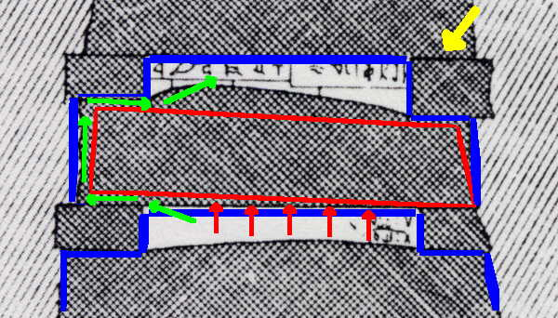
2. Structure of the chambers
These chambers form mysterious configuration. From the structural view point, however, configuration of the chambers is simple.
There is a large cubic space with dimension of roughly 5 meters in North - South direction, 10 meters in East - West direction, and 20 meters in height composed by the walls of limestone. In this empty space, components made of granite, except for the supporting blocks at the fourth chamber which are of limestone, are built up. Firstly the floor of the King's Chamber is placed at the bottom of the space, then the walls are placed. On the walls, the nine ceiling blocks are placed. After that, set of supporting blocks and new ceiling blocks are layered four times. The supporting blocks of each layer are so carefully placed that they are exactly above the North and South walls of the King's Chamber. Further they are leveled by limestone blocks placed underneath. Plaster is applied to the ceiling, the supporting blocks and the side walls of the first, the second, the third and the fourth chambers. All the chambers stand, being unbonded, and capable of yielding freely to settlement. The relieving chambers and the King's Chamber seem to form one continuous structure.
3. Hypothesis on the chambers
The author has two images on the function of the chambers, both of which are relating to the idea of "freely to settlement or movement".
3.1 Air reservoir
Each chamber has the following features.
* | The ceiling stones have flat bottoms. While the supporting blocks, which are leveled, have flat tops, resulting exact touch of the two surfaces. (Yellow arrow)

* | The ceiling stones and the supporting blocks have flat sides, resulting exact touch with other surfaces.

* | Plaster is applied to the ceiling stones, the supporting blocks and the E. and W. side walls filling gaps of two stones.
* | In each chamber, height of the ceiling stones at the point of supporting blocks are different, allowing free vertical movement of the shorter ceiling stones.
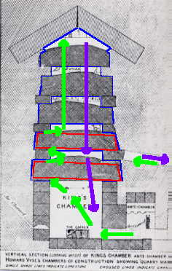
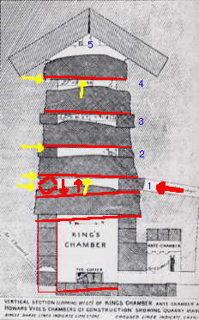
With these reasons, each chamber forms a sealed space. (shown by blue lines, above figure). If pressure is applied to a ceiling from below, then the lightest stone of the ceiling is lifted, allowing air in the lower chamber to move to the upper chamber. (Shown by green arrows, above figure)
Like this, air is supplied from the lower chamber to the upper chamber throughout the chambers. When the pressure in a lower chamber becomes lower than that of the upper, the pressurized air of the upper chamber leaks through possible small gaps between the stones and returns to the lower chambers again. Regarding supply and flow of the air, further consideration is necessary.
There might be relationship with the hypothesis and the damages at the relieving chambers and the King's Chamber. Since the second chamber and above are lifted against side walls, the first chamber is expanded upward and downward, and the King's Chamber is pressed from the top. (See the figure). Such damages can be made only if pressure is applied directly to the first chamber through the passage from the Grand Gallery.
Details from the Petrie's report relating to this issue are
b. | The fifth or top chamber
* | The roof-slabs have separated at the apex 1.55 inches at E. end and 1.0 inch at W. end.
c. | The fourth chamber
* | The supporting blocks along the N. and S. sides are all of limestone, and are much cracked and flaked up by top pressure.
* | The (E. and W.) end walls have sunk as much as 3 inches in relation to the floors and sides; as is shown by the ledge of plaster ... ,which have originally fitted into the edge of the ceiling.
e. | The second chamber

* | The S.E. corner shows cracks in the roof of .52 wide.
* | On the S. wall, there is a very bad joint at 51.5 inches from the W. wall.
f. | The first chamber
* | The S. wall has fallen outwards, dragging past some of the roof-beams, and breaking other beams at the S.E. corner.
* | The E. and W. end walls have sunk, carrying down with the plaster which had been daubed into the top angle, and which cracked freely off the granite roofing.
g. | The King's Chamber
* | The N.E. corner is the highest point. The passage to the Antechamber located at the N.E. corner is intact, while the edge of the corner is bent (buckling) at the third -fourth course.
* | The S.W. corner is the lowest point. The S.W. corner is slightly bent, but in general, the corner is intact.
* | The East wall is more inclined in N-S direction than the west wall.
* | Center of the floor is higher than east and west edges, which is shown on the south wall.
* | When every roof beams was broken across near the South side.
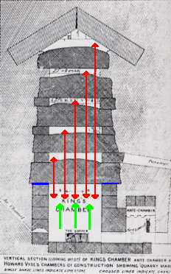
3.2 Variable weight to the ceiling of the King's Chamber
Here is another image.
When pressure inside the King's Chamber is low, then air seal between the ceiling and the walls, shown by blue lines, works to keep the air inside. With rising of the pressure, the ceiling of the King's Chamber starts to lift. With further rising of the pressure, all the ceiling of the King's Chamber and part of the ceiling of the second floor lift. Like this, finally the whole ceiling is lifted. With decreasing of the pressure, the ceiling descends. Regarding supply and flow of the air, further consideration is necessary.

END

