**René Adolphe Schwaller de Lubicz** 1887-1961

http://en.wikipedia.org/wiki/R._A._Schwaller_de_Lubicz

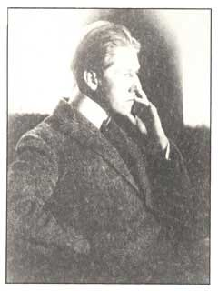 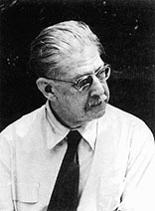 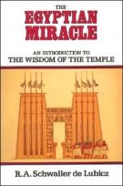

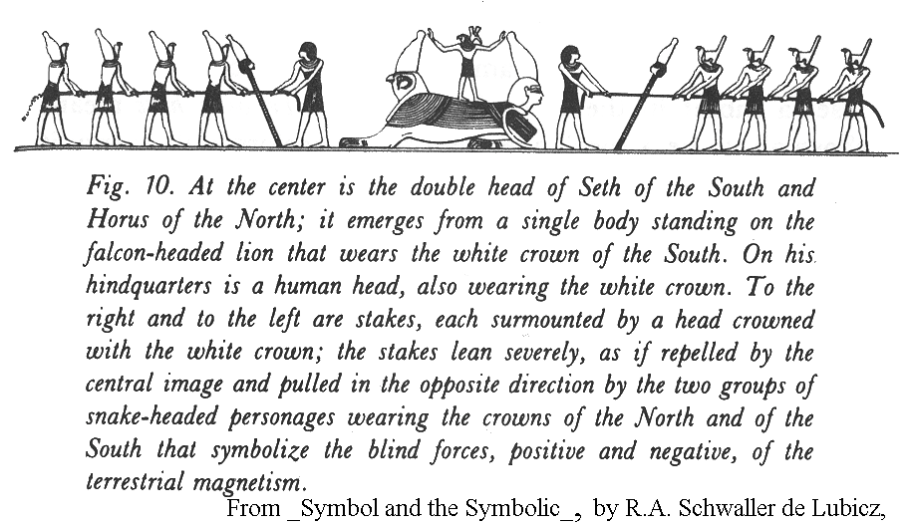

**René Adolphe Schwaller de Lubicz** (1887 – 1961), born in [Alsace-Lorraine](http://en.wikipedia.org/wiki/Alsace-Lorraine), was best known for his 15-year study of the art and architecture of the [Temple of Luxor](http://en.wikipedia.org/wiki/Temple_of_Luxor) in [Egypt](http://en.wikipedia.org/wiki/Egypt) and his subsequent book *The Temple of Man* ([ISBN 0-89281-021-1](http://en.wikipedia.org/wiki/Special:BookSources/0892810211)). In the book, he explored the connectedness of ancient Egyptian philosophy, spirituality, mathematics, and science.

He was given the title "de Lubicz" by the Lithuanian writer and diplomat [Oscar Vladislas de Lubicz Milosz](http://en.wikipedia.org/wiki/Oscar_Milosz)[[1]](http://en.wikipedia.org/wiki/R._A._Schwaller_de_Lubicz#cite_note-0).

His background is that of an [alchemist](http://en.wikipedia.org/wiki/Alchemy), inspired by [Paracelsus](http://en.wikipedia.org/wiki/Paracelsus) and other such "masters of the craft" (as it is declared in the foreword of *The Temple of Man*) and, as such, he taught groups of people inclined to accept that approach to the study of nature.

His elucidation of the [Temple of Luxor](http://en.wikipedia.org/wiki/Temple_of_Luxor) and his presentation of the Egyptian understanding of a special quality of innate [consciousness](http://en.wikipedia.org/wiki/Consciousness) form a bridge that attempts to link the "sacred" science of the Ancients, to its modern rediscovery in our own time.

In his chief work, *The Temple of Man*, he proposes, and argues in great detail, for an interpretation of the Egyptian outlook rooted in [numerology](http://en.wikipedia.org/wiki/Numerology) and [sacred geometry](http://en.wikipedia.org/wiki/Sacred_geometry); in several of his other works, he makes a corresponding case for the metaphysical richness of various mathematical concepts. As with much ancient mathematics, Egyptian research became quite complex. The complexity of various ancient mathematical concepts covered in his book provide an ongoing source of debate.

His arguments are controversial today among [Egyptologists](http://en.wikipedia.org/wiki/Egyptologist) and contradictory to the thrust of anthropological and archaeological understanding. He is considered by some contemporary [mystics](http://en.wikipedia.org/wiki/Mysticism) and students of [hermeticism](http://en.wikipedia.org/wiki/Hermeticism) to be one of the more important [philosophers](http://en.wikipedia.org/wiki/Philosophers), [mathematicians](http://en.wikipedia.org/wiki/Mathematicians), and [Egyptologists](http://en.wikipedia.org/wiki/Egyptologists) of the twentieth century.[[*citation needed*](http://en.wikipedia.org/wiki/Wikipedia:Citation_needed)] His work is not widely accepted by Greek and Roman schools of thought. Many adherents of [Gurdjieff](http://en.wikipedia.org/wiki/Gurdjieff)'s fourth way find parallels in de Lucicz's writings.

**Bibliography**

* **Al-Kemi: A Memoir : Hermetic, Occult, Political, and Private Aspects of R.A. Schwaller de Lubicz**, [Andre Vandenbroeck](http://en.wikipedia.org/w/index.php?title=Andre_Vandenbroeck&action=edit&redlink=1), Lindisfarne Books, 1990, [ISBN 0-940262-31-2](http://en.wikipedia.org/wiki/Special:BookSources/0940262312)
* **"AOR" R. A. Schwaller de Lubicz, Sa Vie. Son Œuvre**, [Isha Schwaller de Lubicz](http://en.wikipedia.org/w/index.php?title=Isha_Schwaller_de_Lubicz&action=edit&redlink=1), La Colombe, Éditions du Vieux Colombier, Paris, 1963.
* **La vie et l'œuvre de René Schwaller de Lubicz**, [Erik Sablé](http://en.wikipedia.org/w/index.php?title=Erik_Sabl%C3%A9&action=edit&redlink=1), Éditions Dervy, Paris, 2003, [ISBN 2-84454-173-9](http://en.wikipedia.org/wiki/Special:BookSources/2844541739)

**References**

1. [**^**](http://en.wikipedia.org/wiki/R._A._Schwaller_de_Lubicz#cite_ref-0) Malkowski, Edward (2007). *Spiritual Technology of Ancient Egypt: Sacred Science and the Mystery of Consciousness*. Deep Books. [ISBN](http://en.wikipedia.org/wiki/International_Standard_Book_Number) [1594771863](http://en.wikipedia.org/wiki/Special:BookSources/1594771863).

**External links**

* [Gary Lachman](http://en.wikipedia.org/wiki/Gary_Lachman): [*René Schwaller de Lubicz and the Intelligence of the Heart*](http://www.unitedearth.com.au/lubicz.html)
* **(Spanish)** [*foro de egiptología* - Lubicz](http://www.geocities.com/duarta/lubicz.html), A very critic article with examples of this author's published opinions and views.
* **(Spanish)** [*Schwaller de Lubicz*](http://my.opera.com/mercurioradiante/blog/biograf-a-de-renschwaller-de-lubiczr), A biography on an alchemist's site.