Sir Ernest Alfred Thompson Wallis Budge 1857-1934
http://en.wikipedia.org/wiki/E._A._Wallis_Budge
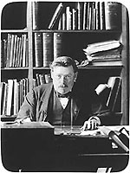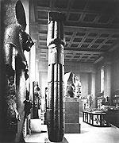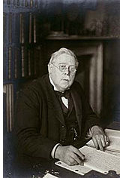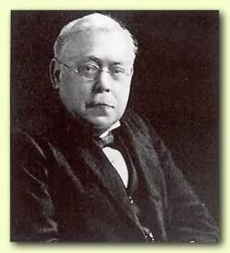
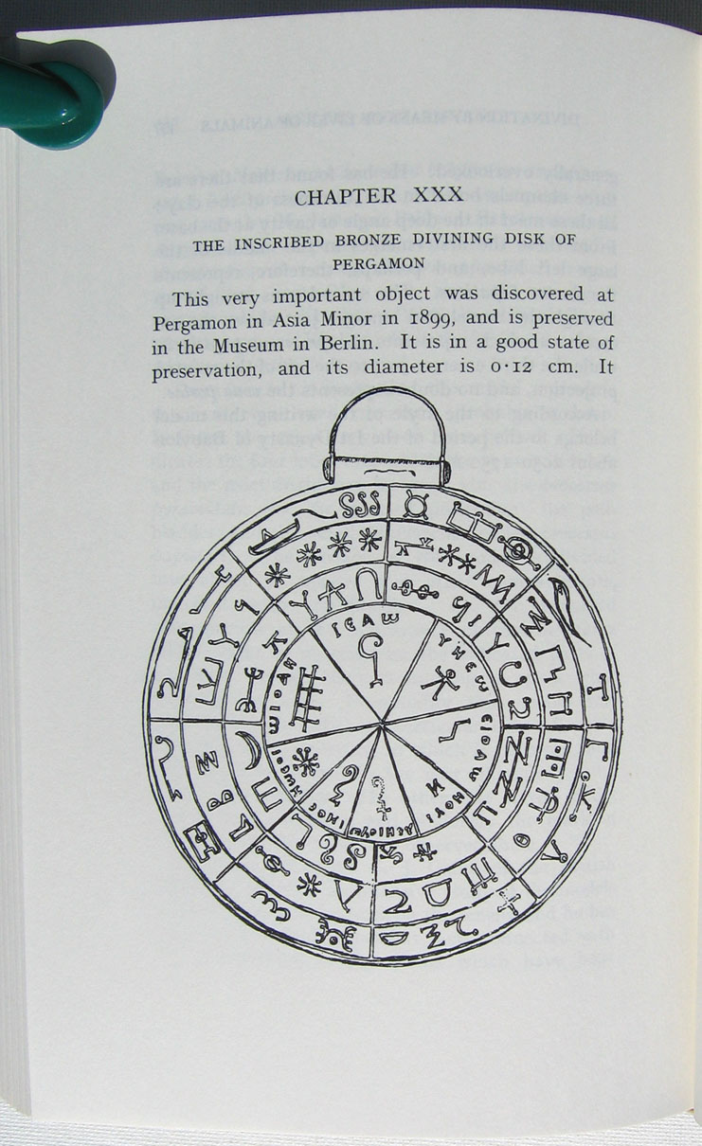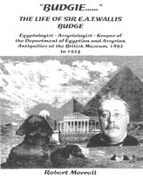

Sir Ernest Alfred Thompson Wallis Budge - (July 27, 1857–November 23, 1934) - was an English Egyptologist, Orientalist, and Philologist who worked for the British Museum and published numerous works on the ancient Near East.

Contents
- 1 Early life
- 2 Career at the British Museum
- 3 Literary and social career
- 4 Selected Works by Wallis Budge
- 5 Further reading
- 6 External links and sources

Early life
E.A. Wallis Budge was born in Bodmin, Cornwall to Mary Ann Budge, a young woman whose father was a waiter in a Bodmin hotel. Budge's father has never been identified. Budge left Cornwall as a young man, and eventually came to live with his grandmother and aunt in London.
Budge became interested in languages before he was ten years old, but given that he left school at the age of twelve in 1869 to work as a clerk at the firm of W.H. Smith, he mostly studied Hebrew and Syriac with a volunteer tutor. Budge became interested in learning Assyrian in 1872, when he also began to spend time in the British Museum. Budge was introduced to the Keeper of Oriental Antiquities, Samuel Birch, and his assistant, the Assyriologist George Smith, and Smith helped Budge occasionally with his Assyrian, whereas Birch allowed the young man to study cuneiform tablets in his office and obtained books for him to read from the British Library.
From 1869 to 1878 Budge spent whatever free time he had from his job at W.H. Smith studying Assyrian, and he often went to St. Paul's Cathedral over his lunch break to study during these years. When the organist of St. Paul's, John Stainer, noticed Budge's hard work, he decided to help the boy to realize his dream of working in a profession that would allow him to study Assyrian, and Stainer contacted Budge's employer, the Conservative Member of Parliament W.H. Smith, as well as the former Liberal Prime Minister W.E. Gladstone, and asked them to help his young friend. Both Smith and Gladstone agreed to help Stainer to raise money for Budge to attend Cambridge University, where Budge studied Semitic languages, including Hebrew, Syriac, Ethiopic and Arabic from 1878 to 1883, continuing to study Assyrian on his own. Budge worked closely during these years with the famous scholar of Semitic languages William Wright, among others.

[] Career at the British Museum
Budge entered the British Museum in the re-named Department of Egyptian and Assyrian Antiquities in 1883, and though he was initially appointed to the Assyrian section, he soon transferred to the Egyptian section, where he began to study the ancient Egyptian language with Samuel Birch until the latter's death in 1885. Budge continued to study ancient Egyptian with the new Keeper, Peter le Page Renouf, until Renouf's retirement in 1891. In the meantime, Budge was deputed by the British Museum to excavate British Museum sites and establish ties with antiquities dealers in Egypt and Iraq, to both of which countries he travelled between 1886 and 1891. Budge returned from these missions to Egypt and Iraq with enormous collections of cuneiform tablets, Syriac, Coptic and Greek manuscripts, as well as significant collections of hieroglyphic papyri. Perhaps his most famous acquisitions from this time were the beautiful Papyrus of Ani, a fragment of a lost work by Aristotle, and the Tell al-Amarna tablets. Budge's prolific and well-planned acquisitions gave the British Museum arguably the best Ancient Near East collections in the world, and the Assyriologist Archibald Sayce remarked to Budge in 1900, ". . . What a revolution you have effected in the Oriental Department of the Museum! It is now a veritable history of civilization in a series of object lessons . . ."
Budge became Assistant Keeper in his department after Renouf retired in 1891, and was confirmed as Keeper in 1894, a position in which he remained until 1924, specializing in Egyptology. Budge and the other collectors for the museums of Europe regarded having the best collection of Egyptian and Assyrian antiquities in the world as a matter of national pride, and there was tremendous competition for Egyptian and Iraqi antiquities. They smuggled antiquities in diplomatic pouches, bribed customs officials, or simply went to friends or countrymen in the Service of Antiquities to ask them to pass their cases unopened. Budge was no more scrupulous than the others, but his exaggarated reputation for wrong-doing is more the result of the attacks by his professional enemies, such as Flinders Petrie and his many followers, than it is anything else.

[] Literary and social career
Budge was also a prolific author, and he is especially remembered today for his works on Egyptian religion and his now-dated hieroglyphic primers. Budge's works on Egyptian religion were unique in that he maintained that the religion of Osiris had emerged from an indigenous African people, a position which Petrie and others regarded as impossible, insisting that the entirety of Egyptian culture had been imported by Aryan invaders. His works were widely read by the educated public and among those seeking comparative ethnological data, including James Frazer, who incorporated some of Budge's ideas on Osiris into his ever-growing work The Golden Bough. Budge was somewhat interested in paranormal matters, and many people who were involved with the occult and spiritualism after losing their faith in Christianity were dedicated to Budge's works, particularly his translation of the Egyptian Book of the Dead, which was very important to such writers as the poet William Butler Yeats and James Joyce. His works on Egyptian religion have remained consistently in print since they entered the public domain, and this is most likely because Budge was, himself, a proponent of the liberalization of Christianity and devoted to comparative religions, and his works often appeal to those who are similarly motivated.
Budge was a member of the literary and open-minded Savile Club in London, proposed by his friend H. Rider Haggard in 1889, and accepted in 1891. He was a much sought-after dinner guest in London, his humorous stories and anecdotes being famous in his circle, and it is hardly surprising that the low-born Budge was fascinated not only by the company of literary men, but also by that of the aristocracy. He sedulously sought the company of the well-born, many of whom he seems to have met when they brought to the British Museum the scarabs and statuettes they had purchased while on holiday in Egypt. Budge never lacked for an invitation to a country house in the summer or to a fashionable townhouse during the London season.
Budge seems to have felt that he had something to prove to his contemporaries, for he published works at an alarming rate, often sacrificing attention to detail to quantity of publications, and though his books are widely available to the public, his work is widely considered today as unreliable, and usually misleading. Budge was knighted for his distinguished contributions to Egyptology and the British Museum in 1920, also the year he published his sprawling autobiography, By Nile and Tigris. He retired from the British Museum in 1924, and lived on until 1934, continuing to publish book after book up until the completion of his last work, From Fetish to God in Ancient Egypt (1934). In his will, Budge established the Lady Budge Research Fellowships at Cambridge and Oxford Universities, which continue to this day to support young Egyptologists.
The British Museum has published an official statement about Budge's works on their website, which can be read by clicking the external link below. The statement indicates that old rivalries die hard in the British Museum, and the presence of a number of old works by Flinders Petrie on the list of recommended readings might well suggest a source for the continuing hostility to Budge.

[] Selected Works by Wallis Budge
- 1885. The Dwellers On The Nile: Chapters on the Life, Literature, History and Customs of the Ancient Egyptians (The Religious Tract Society)
- 1888. The Martyrdom and Miracles of St. George of Cappodocia: The Coptic Texts (London: D. Nutt)
- 1889. Easy Lessons in Egyptian Hieroglyphics with Sign List., London; 2nd ed. c. 1910. Egyptian Language: Easy Lessons in Egyptian Hieroglyphics with Sign List. London: Kegan Paul, Trench, Trübner & Company, Limited. (Reprinted London: Routledge and Kegan Paul Limited, 1966; Reprinted New York: Dover Publications, 1983)
- 1893. The Book of Governors: The Historia Monastica of Thomas, Bishop of Margâ, A. D. 840; ed from Syriac Manuscripts in the British Museum and Other Libraries. 2 vols. London: Kegan Paul, Trench, Trübner & Company, Limited
- 1895. The Book of the Dead: The Papyrus of Ani in the British Museum; the Egyptian Text with Interlinear Transliteration and Translation, a Running Translation, Introduction, etc. [London]: British Museum. (Reprinted New York: Dover Publications, 1967)
- 1899. Egyptian Magic. London, Kegan Paul. (Reprinted New York, Citadel Press, 1997)
- 1900. Egyptian Religion. London. (Reprinted New York, Bell Publishing, 1959)
- 1904. The Gods of the Egyptians, or, Studies in Egyptian Mythology. 2 vols. London: Methuen & Co. ltd. (Reprinted New York: Dover Publications, 1969)
- 1905. The Egyptian Heaven and Hell. 3 vols. Books on Egypt and Chaldaea 20–22. London: Kegan Paul, Trench, Trübner & Company, Limited. (Reprinted New York: Dover Publications., 1996)
- 1907. The Egyptian Sudan, Its History and Monuments. London, Kegan Paul (Reprint New York, AMS Press, 1976).
- 1908. The Book of the Kings of Egypt, or, The Ka, Nebti, Horus, Suten Bȧt, and Rā Names of the Pharaohs with Transliterations, from Menes, the First Dynastic King of Egypt, to the Emperor Decius, with Chapters on the Royal Names, Chronology, etc. 2 vols. Books on Egypt and Chaldaea 23–24. London: Kegan Paul, Trench, Trübner & Company, Limited. (Reprinted New York: AMS Press, 1976)
- 1911. Osiris and the Egyptian Resurrection, Illustrated after Drawings from Egyptian Papyri and Momuments. 2 vols. London: P. L. Warner. (Reprinted New York: Dover Publications, 1973)
- 1920. By Nile and Tigris: A Narrative of Journeys in Egypt and Mesopotamia on Behalf of the British Museum Between the Years 1886 and 1913. 2 vols. London, John Murray. (Reprinted New York: AMS Press, 1975).
- 1920. An Egyptian Hieroglyphic Dictionary, With an Index of English Words, King List and Geographical List with Index, List of Hieroglyphic Characters, Coptic and Semitic Alphabets, etc.. London: John Murry. (Reprinted New York: Dover Publications., 1978)
- 1925. The Mummy: A Handbook of Egyptian Funerary Archaeology. 2nd ed. Cambridge: Cambridge University Press. (Reprinted New York: Dover Publications, 1989)
- 1928. The Divine Origin of the Craft of the Herbalist. London, The Society of Herbalists (Reprinted New York, Dover Books, 1996)
- 1928. A History of Ethiopia: Nubia and Abyssinia. (Reprinted Oosterhout, the Netherlands: Anthropological Publications, 1970)
- 1929. The Rosetta Stone in the British Museum: The Greek, Demotic and Hieroglyphic Texts of the Decree Inscribed on the Rosetta Stone Conferring Additional Honours on Ptolemy V Epiphanes (203–181 B.C.) with English Translations and a Short History of the Decipherment of the Egyptian Hieroglyphs, and an Appendix Containing Translations of the Stelae of Ṣân (Tanis) and Tall al-Maskhûṭah. London: The Religious Tract Society. (Reprinted New York: Dover Publications, 1989)
- 1932a. The Chronicle of Gregory Abû'l Faraj, 1225–1286, the Son of Aaron, the Hebrew Physcian, Commonly Known as Bar Hebraeus; Being the First Part of His Political History of the World, Translated from Syriac. 2 vols. London: Oxford University Press. (Reprinted Amsterdam: Apa-Philo Press, 1976)
- 1932b. The Queen of Sheba and Her Only Son, Menyelek (I); Being the "Book of the Glory of Kings" (Kebra Nagast), a Work Which is Alike the Traditional History of the Establishment of the Religion of the Hebrews in Ethiopia, and the Patent of Sovereignty Which is Now Universally Accepted in Abyssinia as the Symbol of the Divine Authority to Rule Which the Kings of the Solomonic Line Claimed to Have Received Through Their Descent from the House of David; Translated from the Ethiopic. 2nd ed. 2 vols. London: Oxford University Press.
- 1934. From Fetish to God in Ancient Egypt. Oxford University Press (Reprinted New York, Dover Books, 1988)

[] Further reading
- Morrell, Robert. 2002. "Budgie…": The Life of Sir E. A. T. Wallis Budge, Egyptologist, Assyriologist, Keeper of the Department of Egyptian and Assyrian Antiquities at the British Museum, 1892 to 1924. Nottingham: [privately published]
- Budge, E.A. Wallis. 1920. By Nile and Tigris. 2 vols. London, John Murray.

[] External links and sources
- The Book of the Dead translated by E. A. Wallis Budge - online and fully illustrated
- E.A. Wallis Budge at the British Museum
- "E. A. Wallis Budge" at the Anthropology Biography Web
- Works by E. A. Wallis Budge at Project Gutenberg
- Babylonian Life and History at The DCL.
==============================================================================================================================
END

