James Henry Breasted 1865-1935

http://en.wikipedia.org/wiki/James_Henry_Breasted

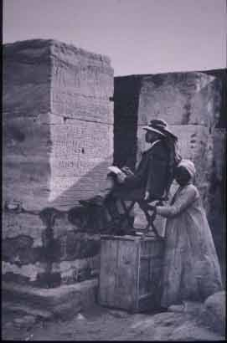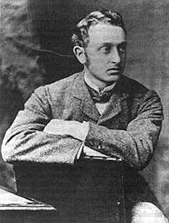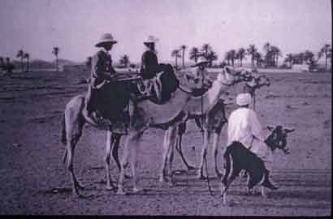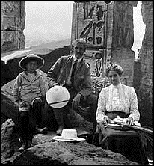

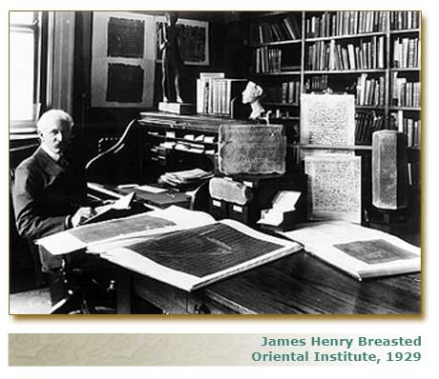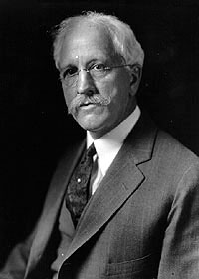

James Henry Breasted (August 27, 1865–December 2, 1935) was born in Rockford, Illinois and was an archaeologist and historian. He was educated at North Central College (then North-Western College) (1888), the Chicago Theological Seminary, Yale University (MA 1891) and the University of Berlin (PhD 1894). He was the first American citizen to obtain a PhD in Egyptology. Breasted was in the forefront of the generation of archeologist-historians who broadened the idea of "Western Civilization" to include the entire "Near East" in Europe's cultural roots.
He became an instructor at the University of Chicago in 1894 and was appointed Professor of Egyptology and Oriental History at in 1905 (the first such chair in the United States). In 1901, he was appointed director of the Haskell Oriental Museum, forerunner of the Oriental Institute, which had opened at the University of Chicago in 1896. Though the Haskell Oriental Museum contained works of art from both the Near East and the Far East, his principal interest was in Egypt; he began to work on a compilation of all the extant hieroglyphic inscriptions, which was published in 1906 as Ancient Records of Egypt, which remains an important collection of translated texts; as Peter A. Piccione wrote in the preface to its 2001 reprint, it "still contains certain texts and inscriptions that have not been retranslated since that time."
In 1919, funding was obtained from John D. Rockefeller for the Oriental Institute of Chicago, under whose auspices Breasted headed the University’s first archaeological survey of Egypt. In 1923 he was elected a member of the National Academy of Sciences. He died in 1935 from pneumonia, while returning from a trip to Egypt. He is buried in Greenwood cemetery, Rockford, Illinois. His grave site is marked with a large marble obelisk, which was a gift from the Egyptian government.
Breasted is now perhaps most widely known for his coinage of the term "the Fertile Crescent" to describe the area from Egypt to Mesopotamia.

[edit] Further reading
- Charles Breasted, Pioneer to the Past: The Story of James H. Breasted (New York: Charles Scribner's Son, 1943.)

