Silver & Gold 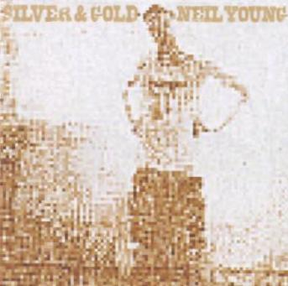

Silver & Gold was released in April 2000. The cover shot for this album was taken by Neil's daughter Amber on a Nintendo Game Boy Camera. Additional vocals were provided by Linda Ronstadt & Emmylou Harris. For a promotional piece on this album, Neil gave these thoughts on each of the songs on "Silver & Gold":
Good To See You – "I wrote this on the back of the bus, early on in the tour. All I had was the line 'Good to see you,' and I thought, 'Well, what good is that?' But it said what needed to be said. It's about coming home after being gone a long time."
Silver & Gold – "This one says to me that relationships are more important than material things. You could take a look at me and say I was really full of it, because I have so many possessions it's ridiculous. But it's dawning on me how useless most of them are."
Daddy Went Walkin' - "It's got my father in it, but I think it's about everybody's father, everybody's parents. It's like taking a look at these old folks who have lost their mates, or who've gotten a divorce years ago, like my parents. And it's about kids hoping that their parents will get back together again. It's a hope all kids in that situation have, I think."
Buffalo Springfield Again – "What's cool about CSN&Y is it gives Stephen and me a chance to play around with what we were doing back then and take it to another level. When he came up to the ranch to work on the box set, part of it was kind of depressing in the end because I think we both felt like it had all been cut short. We realized how much more there was for us to do."
The Great Divide – "This is a good example of a song that you can't just break out when you're sitting around with a bunch of friends having a good time. You have to have exactly the right people and the right situation. Fortunately I did. Ben Keith plays steel on that one and Oscar Butterworth did a great job on drums."
Horseshoe Man – "He's the one we can all count on, the one who makes things interesting. He fixes broken hearts by taking the pieces and throwing them up and down. He shakes things up."
Red Sun – "I wrote this song on a really fresh day. My head was feeling good and I was really open. I remember I was by myself when I did it and, by the end, I was crying. It was very emotional. I kept hearing Emmylou Harris' voice on it and I finally ended up taking it to Tucson to Linda Ronstadt's house, where she and Emmylou were working on an album with Dolly Parton. They ended up singing on a lot of the songs on this album, but this one really got to me. The song's got a little bit of religion in it and Emmylou's voice, especially, is suited to that."
Distant Camera – "There was one thing I let go on this album. It's on this song and it still bothers me. There was a misplaced beat and nobody liked it but me and I wanted to leave it in because that's just the way it had happened originally. But I took it out and to this day, whenever I hear this song I think about that kick drum. And I probably always will. That's just the way my mind works."
Razor Love – "It cuts clean through. It's the kind of love that cuts clean through everything."
Without Rings - "This is one of the first songs I recorded, back when I thought I was doing an acoustic solo album. It's another one I wrote in the back of the bus, somewhere in Florida at some weird amusement park in the middle of the Everglades. I had this big piece of newspaper with felt tip marker writing all over it. It's kind of like 'Mr. Soul,' inasmuch as it was written on a piece of newspaper with a felt tip marker and it all came out in one long line and then it was done."

