Year of the Horse

Neil Young & Crazy Horse
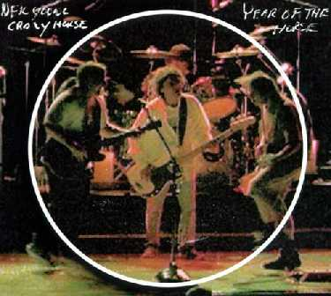
Year Of The Horse was released in June 1997 by Neil Young & Crazy Horse. Musicians on this album were:
- Neil Young: Vocals, electric and acoustic guitars, piano, harmonica
- Crazy Horse:
  - Frank Sampedro: Electric and acoustic guitars, synthesizer, vocals
  - Billy Talbot: Bass, vocals
  - Ralph Molina: Drums, vocals, percussion
"Sedan Delivery" was omitted from vinyl LP copies of this album.
This album, comprised of performances from Neil & Crazy Horse's 1996 "Broken Arrow" tour, was intended to be the soundtrack to the feature film of the same name directed by Jim Jarmusch (a film that was released late in 1997); however, none of the performances in the movie are on the CD.

.

