MirrorBall 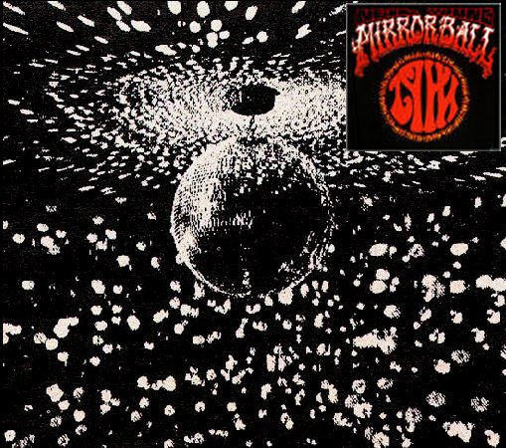
Mirrorball was released in June 1995.This CD was done by Neil Young & Pearl Jam, but, due to the objections of Epic Records (Pearl Jam's record label), the fact that the backing musicians effectively constitute Pearl Jam, there is no mention of them on the album cover or booklet.

