WELD

Neil Young & Crazy Horse
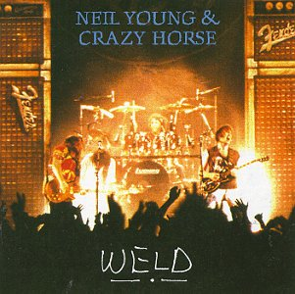
Weld was released in October 1991 by Neil Young & Crazy Horse. Musicians on this album were:
- Neil Young: Vocals, guitars
- Frank Sampedro: Guitars, keyboards, vocals
- Billy Talbot: Bass, vocals
- Ralph Molina: Drums, vocals
"Blowin' In The Wind" was written by Bob Dylan.
"Farmer John" was written by Don Harris and Dewey Terry.
This is a live album of Neil & Crazy Horse's 1991 tour to promote Ragged Glory.
A live video was also released at the same time. This album was issued in a limited edition package along with Arc.

.

