Ragged Glory

Neil Young & Crazy Horse
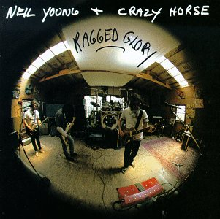
Ragged Glory was released in September 1990 by Neil Young & Crazy Horse. Musicians on this album were:
- Neil Young: Vocals, guitars
- Crazy Horse:
  - Frank Sampedro: Guitars, vocals
  - Billy Talbot: Bass, vocals
  - Ralph Molina: Drums, vocals
.

