Freedom 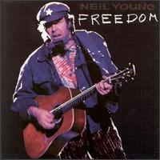
Freedom was released in October 1989. Primary musicians on this album were:
- Neil Young: Vocals, guitar, piano
- Chad Cromwell: Drums
- Rick Rosas: Bass
- Frank Sampedro: Guitars, keyboards, mandolin
- Ben Keith:Pedal steel on "The Ways of Love", pedal steel and vocals on "Too Far Gone", keyboards on "No More" and "Rockin' In The Free World"
Secondary musicians were:
- The Bluenotes on "Crime In The City" and "Someday"
- Steve Lawrence: Lead tenor saxophone
- Ben Keith: Alto saxophone
- Larry Cragg: Baritone saxophone
- Claude Cailliet: Trombone
- John Fumo: Trumpet
- Tom Bray: Trumpet
- Linda Ronstadt: Vocals on "Hangin' On A Limb"
- Poncho Villa: Acoustic guitar on "Eldorado"
- Tony Marsico: Bass on "No More"
"On Broadway" is a Drifters cover. The entire "Sixty to Zero" song actually lasts about 30 minutes and has 11 verses. The full version was played on Neil Young & The Bluenotes 1988 tour. The version on this album is just a shortened version.

