Rust Never Sleeps

Neil Young & Crazy Horse
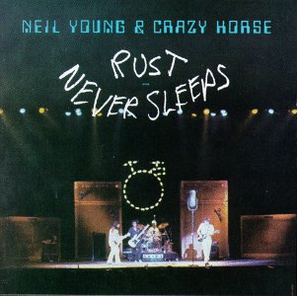
Rust Never Sleeps was released in June 1979 by Neil Young & Crazy Horse. Musicianson this album were:
- Neil Young: vocals, guitars, harmonica, piano
- Crazy Horse on "Powderfinger", "Welfare Mothers", "Sedan Delivery", and "Hey Hey, My My"
- Frank (Poncho) Sampedro: guitars, keyboards, vocals
- Billy Talbot: bass, vocals
- Ralph Molina: drums, vocals
- On "Sail Away", Nicolette Larson provided vocals, Joe Osborne Bass, & Carl Himmel played drums.
Some of the acoustic tracks were recorded during a series of shows that Neil did at the Boarding House in San Francisco early in 1978. All of the electric tracks were recorded live in concert on the 1978 Rust Never Sleeps tour, but the audience track was later removed and other embellishments and overdubs were made in the studio.
Songs:
- My My, Hey Hey (Out Of The Blue) [3:45]
- Thrasher [5:38]
- Ride My Llama [2:29]
- Pocahontas [3:22]
- Sail Away [3:46]
- Powderfinger [5:30]
- Welfare Mothers [3:48]
- Sedan Delivery [4:40]
- Hey Hey, My My (Into The Black) [5:18]

