Journey through the Past
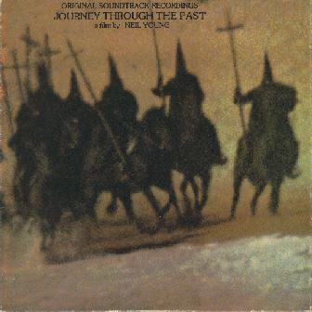
Journey Through The Past was released by Neil Young in December 1972. This is the soundtrack to Neil Young's movie of the same name.
The movie opened to critical scorn and was seen by few people.
"For What It's Worth / Mr. Soul" was stitched together from studio tapes and mimed to on the television show "The Hollywood Palace" on January 20th, 1967.
"Are You Ready For The Country ", "Alabama", and "Words" are alternate takes from the sessions for Harvest, recorded on September 26 and 27, 1971 at Neil's ranch. These versions feature conversations between band members.
"Southern Man", "Find The Cost of Freedom" and "Ohio" were recorded during a CSNY concert at the Fillmore East on June 5, 1970.
The orchestral tracks (Relativity Invitation, Handel's Messiah, King of Kings) were performed by the Tony & Susan Alamo Christian Foundation Orchestra & Chorus and recorded on February 10, 1972.
"Soldier" was the only "new" song by Neil on this double album, and it is available on Decade. It was recorded in a sawmill to the accompaniment of a roaring fire from a sawdust burner. "Let's Go Away For Awhile" is a Beach Boys song from their album Pet Sounds.

Songs:
- For What It's Worth / Mr. Soul
- Rock & Roll Woman
- Find The Cost of Freedom
- Ohio
- Southern Man
- Are You Ready For The Country
- Let Me Call You Sweetheart
- Alabama
- Words
- Relativity Invitation
- Handel's Messiah
- King of Kings
- Soldier
- Let's Go Away For Awhile

