# Mel Gibson: Hollywood Is ‘Den Of Parasites’ Who ‘Feast On Blood Of Kids’

[November 30, 2017](http://yournewswire.com/2017/11/) [Baxter Dmitry](http://yournewswire.com/author/baxter/) [Entertainment](http://yournewswire.com/category/entertainment/) [355](http://yournewswire.com/mel-gibson-parasites-blood-kids/#mh-comments)

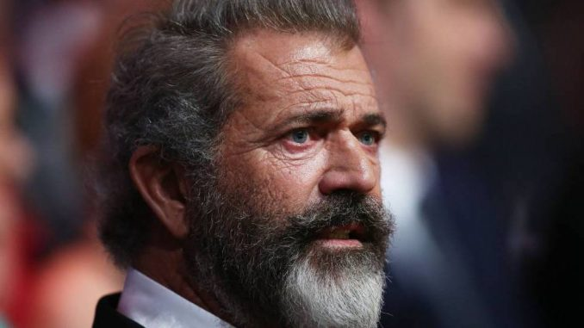

**Hollywood studios are “*drenched in the blood of innocent children*” according to Mel Gibson who claims the consumption of “*baby blood is so popular in Hollywood that it basically operates as a currency of its own.*”**

Hollywood elites are an “*enemy of mankind continually acting contrary to our best interests*” and “*breaking every God given taboo known to man, including the sanctity of children*,” Mel Gibson said in London, where he is promoting his role in [**Daddy’s Home 2**](https://www.vanityfair.com/hollywood/2017/11/mel-gibson-daddys-home-2-comeback), his most prominent on-screen role in years.

*“It’s an open secret in Hollywood. These people have their own religious and spiritual teachings and their own social and moral frameworks. They have their sacred texts – they are sick, believe me – and they couldn’t be more at odds with what America stands for.*”

Mel Gibson appeared on the [**Graham Norton Show**](http://www.independent.co.uk/arts-entertainment/tv/news/mel-gibson-graham-norton-show-controversial-allegations-a8075771.html) on the BBC on Friday, and he schooled shocked guests about the real nature of Hollywood elites in the green room backstage after his appearance.

Explaining that he spent the last ten years “*working on my own ideas, outside of the Hollywood system*” after being blacklisted by Hollywood in 2006 for sharing opinions about the industry and the world that run counter to liberal orthodoxy, Gibson said, “*I don’t know how to break it to you gently… Hollywood is institutionalized pedophilia.*

*“They are using and abusing kids.*“

“*They churn through a huge amount of kids every year. Their spiritual beliefs, if you can call them that, direct them to harvest the energy of the kids. They feast on this stuff and they thrive on it,*” the Hacksaw Ridge director said.

“*What do I mean? This isn’t some kind of artistic abstraction. They harvest the blood of children. They eat their flesh. They believe this gives them life force. If the child was suffering in body and psyche before it died, they believe this gives them extra life force.”*

“*There is a creative and loving force inside most of us that guides us through life. These people don’t have this. For them it’s the opposite.”*

According to Mel Gibson, who has spent 30 years in and out of the Hollywood system, the industry elites*“thrive on pain, trauma, stress, abuse, and suffering.”*

“*Hollywood is drenched in the blood of innocent children. For a long time all the references to pedophilia and cannibalism were symbolic or allusive. But I was personally introduced to the practice in the early 2000s. I can talk about this now because these people, the execs, they’re dead now.”*

*“The blood of a sexually abused infant is considered highly ‘enriched’ and is highly prized. The money changing hands, the favors, the kickbacks – you have no idea. Babies are a high-functioning currency all of their own. Babies are their premium brand of high-grade caviar cocaine diamond steak.”*

But according to Gibson this isn’t a flavor-of-the-month perversion, popular among men and women who have grown bored of standard issue sins.

“*This isn’t anything new. If you do some research you will see it’s a metaphysical, alchemical phenomenon and you can find it behind the scenes in all the dark eras in history.*

*“It’s a dark, multidimensional occult art and practice, used by secret societies in the last few hundred years for social programming and mind control, and raised to a zenith by Hollywood in America in our era.*“