**Madonna, Hanks Tweet From Corona Quarantine, Stirring Pedogate Scrutiny**

by [CD Media Staff](https://creativedestructionmedia.com/author/cdmedia-staff/)March 21, 2020[7](https://creativedestructionmedia.com/analysis/2020/03/21/madonna-hanks-tweet-from-corona-quarantine-stirring-pedogate-scrutiny/#comments)5962

**SHARE**[2](https://creativedestructionmedia.com/analysis/2020/03/21/madonna-hanks-tweet-from-corona-quarantine-stirring-pedogate-scrutiny/?fbclid=IwAR2S7bqnRMMoOWkgY19ttMZzEwqD3gAViV6JvYtvfnRjg4kgS01p2-Bgsq0)

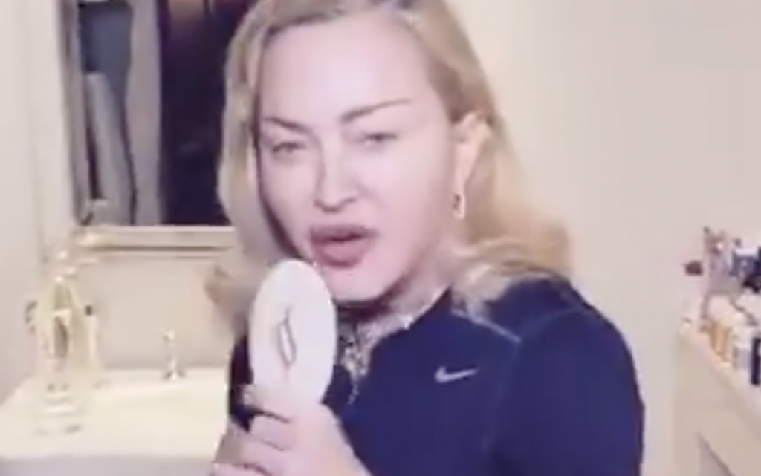*Madonna. Screencap via Twitter*

“Ironically, the brand of the typewriter is Corona”

–*Madonna*

*Editor’s Note: CDMedia prides itself on real reporting and analysis…before you say we are promoting something not real, please consider…Alex Jones was right, Weinstein is in jail, and Epstein didn’t kill himself.*

As a matter of principle, CD Media avoids “celebrity news,” but as Hollywood figures have insisted on inserting themselves into the spotlight during a global crisis, we felt it was worthwhile to point out the jarring oddity of a handful of recent tweets and the creepy parallels they suggest.

Social media is scratching its collective head over recent posts by global megastars Tom Hanks and Madonna.

Let’s begin with Madonna, perhaps more famous lately for Trump-bashing than her music. Yes, it was the Material Girl who, in January of 2017, gave a [rambling protest speech](https://www.bing.com/videos/search?q=madonna+blows+up+white+house&view=detail&mid=CE085E5A3C4B4A5C147CCE085E5A3C4B4A5C147C&FORM=VIRE) about “blowing up the White House.” Decked out in an all-black “pussy hat” instead of standard-issue pink, hers resembled devil horns more than kitty-cat ears. Her words, though–they were an incitement to violence that she later claimed was “a metaphor.”

**A metaphor? Precisely so.** “Symbolism shall be their undoing” is a chestnut, a notion well worn among the folks who take note of and dissect “Hollyweird.” Too many of its denizens strike Satanic poses, sport pendants with irreligious significance, and ink themselves with angry symbols (hello, former Rep. Katie “throuple” Hill with her Iron Cross).

In the cases of [Jim Carrey](https://www.independent.co.uk/arts-entertainment/films/news/jim-carry-face-trial-ex-girlfriend-death-cathriona-white-a7766846.html)and [Kevin Spacey,](https://popculture.com/trending/2019/05/02/kevin-spacey-accuser-found-dead-after-being-struck-by-vehicle/)people who accuse them of wrongdoing turn up dead. Suspicious circumstances. The stars walk free, even as they themselves predicted they would in creepy roleplaying tweets, even after being called out by fellow stars.

[https://pbs.twimg.com/profile_images/877952436526362626/CuCSnu0U_normal.jpg](https://twitter.com/KevinSpacey)

**[Kevin Spacey](https://twitter.com/KevinSpacey)**

[✔@KevinSpacey](https://twitter.com/KevinSpacey)

 · [Dec 24, 2018](https://twitter.com/KevinSpacey/status/1077263549326651392)

Let Me Be Frank [https://youtu.be/JZveA-NAIDI](https://t.co/OzVGsX6Xbz)

[[https://pbs.twimg.com/profile_images/1240095851999113218/Y0WfOzVr_normal.jpg](https://twitter.com/YouTube) **YouTube** ‎@YouTube](https://twitter.com/YouTube)

[[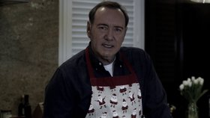](https://twitter.com/KevinSpacey/status/1077263549326651392)](https://twitter.com/KevinSpacey/status/1077263549326651392)

[https://pbs.twimg.com/profile_images/1609859040/EB1_normal.jpg](https://twitter.com/EllenBarkin)

**[Ellen Barkin](https://twitter.com/EllenBarkin)**

[✔@EllenBarkin](https://twitter.com/EllenBarkin)

unfortunately you cannot be frank anymore. you also might find it difficult to be a sexual predator and a pedophlie. what you can be is a prisoner. we’d all tune in to see that.

[1,320](https://twitter.com/intent/like?tweet_id=1077786014968619009" \o "Like)

[5:39 AM - Dec 26, 2018](https://twitter.com/EllenBarkin/status/1077786014968619009)

[Twitter Ads info and privacy](https://support.twitter.com/articles/20175256)

[228 people are talking about this](https://twitter.com/EllenBarkin/status/1077786014968619009" \o "View the conversation on Twitter)

An aging diva, Madonna has endured [a few stumbles lately](https://hollywoodlife.com/2020/02/29/madonna-falls-off-chair-paris-show-madame-x-injury/). Earlier in the year, she fell down during a live performance and injured her knee. In a subsequent show, she fell off a chair while dancing. She blamed the knee injury for the second tumble. At yet another gig, at London’s famed Palladium, she ran so late that the house crew shut the lights during her set, thereby ending the evening while the 61 year-old showered the staff with invective. She falls down a lot. [In 2019](https://www.thesun.co.uk/tvandshowbiz/9105818/madonna-dramatically-falls-backwards-off-stage-to-end-epic-eurovision-performance-but-fans-are-divided/), again[in 2015](https://www.youtube.com/watch?v=D4C58lLNO6Q)(this one is funny).

Like many of the wealthy, Madonna is hiding out during the coronavirus outbreak. In her words, she’s doing so “out of honor and respect for COVID-19.”

Thanks for thinking of the virus first, Madge.

In two consecutive video tweets that she titled “Quarantine Diaries,” the singer sits at a typewriter. She did voiceover for the videos, a recitation of what she’s typing on the analog device. It’s perhaps the most belabored way to send a tweet ever conceived.

She rambles on about the virus making her aware of the importance of words, and that’s a good clue: **the words she chooses are important.**

[https://pbs.twimg.com/profile_images/1118548625397821441/2K2ZFJPw_normal.png](https://twitter.com/Madonna)

**[Madonna](https://twitter.com/Madonna)**

[✔@Madonna](https://twitter.com/Madonna)

Madame Quarantine Diaries ............... [#covid19](https://twitter.com/hashtag/covid19?src=hash) [#staysafe](https://twitter.com/hashtag/staysafe?src=hash) [#becreative](https://twitter.com/hashtag/becreative?src=hash)

[[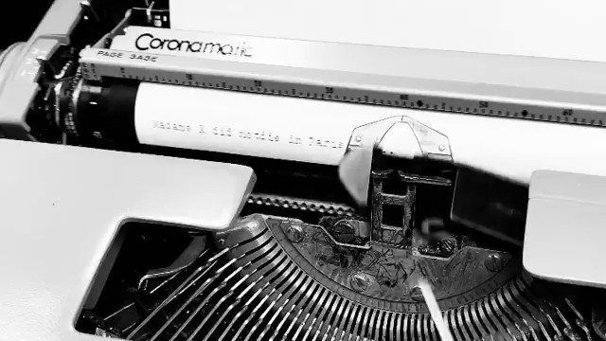](https://twitter.com/Madonna/status/1239971047471869955)](https://twitter.com/Madonna/status/1239971047471869955)

[4,717](https://twitter.com/intent/like?tweet_id=1239971047471869955" \o "Like)

[6:45 PM - Mar 17, 2020](https://twitter.com/Madonna/status/1239971047471869955)

[Twitter Ads info and privacy](https://support.twitter.com/articles/20175256)

[1,581 people are talking about this](https://twitter.com/Madonna/status/1239971047471869955" \o "View the conversation on Twitter)

Madonna randomly waxes hungry at the end of the video, yearning for “a bowl of pasta”. So what, right? Who doesn’t like pasta?

Except that anyone who followed the Pizzagate conspiracy in 2017 raises a sharp eyebrow when *any* celebrity mentions **cheese pizza, pasta, hot dogs, walnut sauce, or handkerchiefs,**just a few of the [words identified by the FBI](https://wikileaks.org/wiki/FBI_pedophile_symbols)as encoded language for pedophiles during the bureau’s investigation of pedophile rings.

“Pasta,” per the FBI, is code for a young boy. More on this in a moment. Handkerchiefs mean different things depending on their color. Red is suicide.

Well, well. What do we have here?

[https://pbs.twimg.com/profile_images/1193951507026075648/Ot3GmqGK_normal.jpg](https://twitter.com/tomhanks)

**[Tom Hanks](https://twitter.com/tomhanks)**

[✔@tomhanks](https://twitter.com/tomhanks)

Wrap Gifts! [@Hankskerchiefs](https://twitter.com/HanksKerchiefs)! Bespoke perfection and gorgeous. Colin Hanks knows his kerchiefs! Hanx. [#Hankskerchiefs](https://twitter.com/hashtag/Hankskerchiefs?src=hash)

[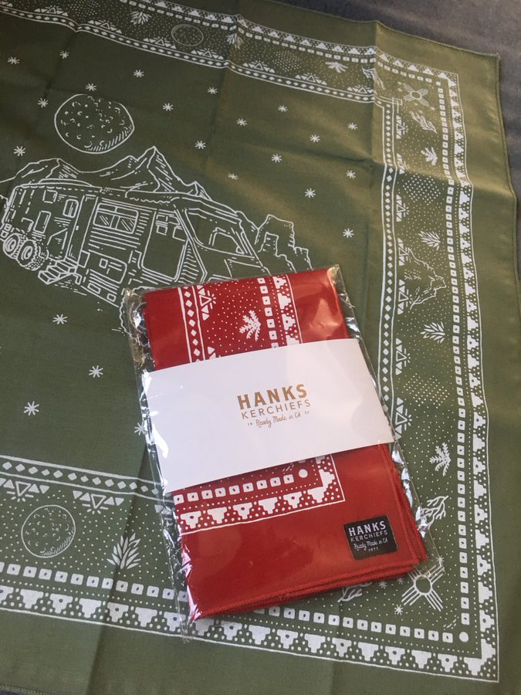](https://twitter.com/tomhanks/status/1128061487929389056/photo/1)

[8,066](https://twitter.com/intent/like?tweet_id=1128061487929389056" \o "Like)

[11:16 PM - May 13, 2019](https://twitter.com/tomhanks/status/1128061487929389056)

[Twitter Ads info and privacy](https://support.twitter.com/articles/20175256)

[958 people are talking about this](https://twitter.com/tomhanks/status/1128061487929389056" \o "View the conversation on Twitter)

Odder still: this was tweeted just 24 hours before the questionable suicide of [pedophile whistleblower Isaac Kappy](https://www.smobserved.com/story/2018/07/29/news/actor-isaac-kappy-accuses-director-steven-spielberg-others-of-pedophilia-in-rambling-video/3565.html). Kappy had famously accused Steven Spielberg of pedophilia. In what is hopefully an unrelated development, Spielberg’s adopted Honduran daughter recently [began a career in pornography](https://www.foxnews.com/entertainment/steven-spielberg-daughter-porn-star).

But I digress. Back to the singer of “Like A Virgin.”

“Ironically, the brand of the typewriter is Corona,” Madonna intones as she taps away at the keys. Indeed, you can see the name stamped on the machine, the mark of a famous old American company (now Smith Corona). That in itself isn’t weird or noteworthy until you realize that **her tweet was posted on March 17th, *the same day* Tom Hanks sent this tweet, also featuring a Corona typewriter.**

[https://pbs.twimg.com/profile_images/1193951507026075648/Ot3GmqGK_normal.jpg](https://twitter.com/tomhanks)

**[Tom Hanks](https://twitter.com/tomhanks)**

[✔@tomhanks](https://twitter.com/tomhanks)

[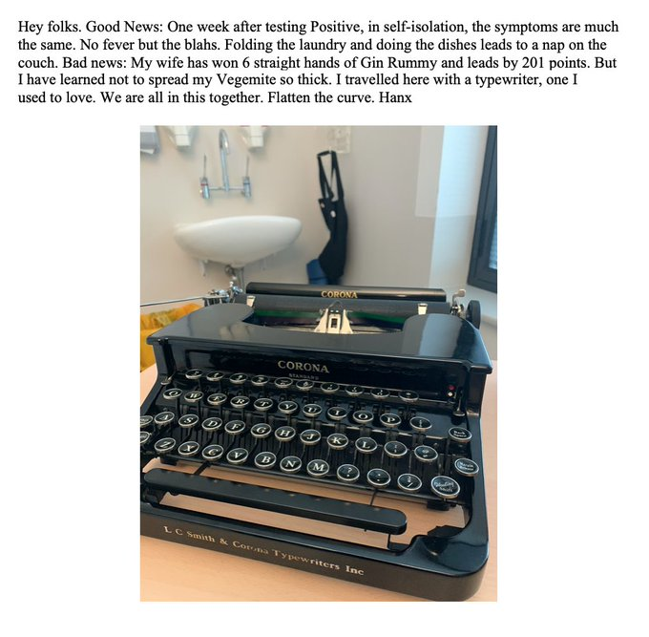](https://twitter.com/tomhanks/status/1240024515498786816/photo/1)

[271K](https://twitter.com/intent/like?tweet_id=1240024515498786816" \o "Like)

[10:17 PM - Mar 17, 2020](https://twitter.com/tomhanks/status/1240024515498786816)

[Twitter Ads info and privacy](https://support.twitter.com/articles/20175256)

[24.1K people are talking about this](https://twitter.com/tomhanks/status/1240024515498786816" \o "View the conversation on Twitter)

It’s not a coincidence.

Remember, Hanks and Madonna worked together closely on “A League of Their Own.” They’re friends. **So why do they choose this time, a global emergency, a pandemic, to trade inside jokes?**Note as well: Hanks chooses to type his tweets and then photograph them, as opposed to simply typing his messages on the Twitter app, much like Madonna taking video of her tweet-writing performance.

In short, yes, they’re making fun of you.

It turns out Hanks is a typewriter aficionado. He collects them. It’s a quirky passion of America’s favorite leading man. The cover photo of his recent book of short stories, “Uncommon Type,” features antique typewriter keys.

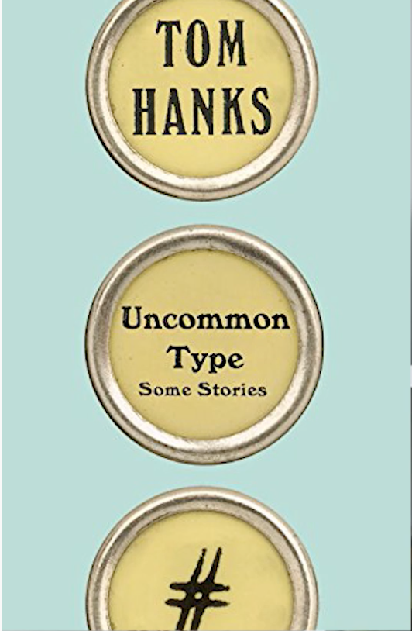

“I traveled here with a typewriter, one I used to love,” Hanks jokes in his tweet. The implication is that he likes the machine less now that its brand name is associated with a dreadful virus. OK…but who travels with a typewriter?

Oh haha, Tom. Aren’t pandemics funny?

But the throwaway joke isn’t the point. Hanks came into the Pizzagate discussion as a result of a photo that made the internet rounds years ago. In it, Hanks holds a note which reads, “I’m not allowed to talk!!”

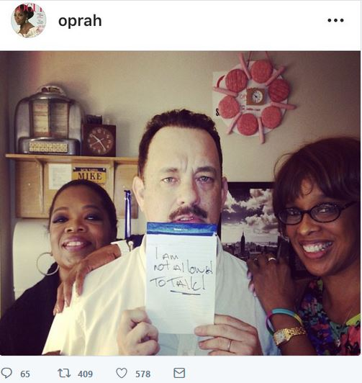*Image: YouTube*

Hanks, flanked by Oprah and her girlfriend Gayle King, sports a mustache and black eye. The fact that Oprah posted it to her Instagram account doesn’t dissuade everyone from claiming there’s something dark at works here. After all, it was posted at the height of Pizzagate outrage. It was interpreted by some as a middle finger, a you-can’t-catch-me taunt directed at the deplorables, the *hoi polloi*.

Are Hanks and Oprah close? Well…in 2017, he went on a multi-day [mega-yacht cruise off Tahiti with her](https://www.bing.com/videos/search?q=hanks+oprah+bruce+obama+yacht&view=detail&mid=5DCA500AC9DE2BEC67EF5DCA500AC9DE2BEC67EF&FORM=VIRE). Along with the Obamas. And Bruce Springsteen. Other than crew, the five-some were the only passengers.

Now that Oprah’s long and close relationship with convicted rapist Harvey Weinstein is out in the open, the photo has gotten more mileage. Moreover, the [two sex scandals](https://www.huffpost.com/entry/oprahs-south-africa-schoo_n_181161) at her now-defunct South African private school loom larger in the rearview mirror. (And speaking of falling on stage, what’s the deal? Why are Madonna, Hillary, and Oprah all falling down lately?)

But I digress again.

Back to Madonna. The [second “Quarantine Diaries” entry](https://twitter.com/Madonna/status/1240346120670281732)isn’t worth embedding here, just an old woman typing about her angst. This time she pines not for pasta, but a dry martini with three olives. She does say something when she twists around 360 degrees in her chair, but I can’t make it out, perhaps you can (please comment below if so). The twist seems significant in the theatrics of the video.

Next, she tweeted an anti-Trump video, and then**this shockingly weird tweet yesterday:**

[https://pbs.twimg.com/profile_images/1118548625397821441/2K2ZFJPw_normal.png](https://twitter.com/Madonna)

**[Madonna](https://twitter.com/Madonna)**

[✔@Madonna](https://twitter.com/Madonna)

Living in Special Times............thank GOD for imagination and fried fish! [#quarantine](https://twitter.com/hashtag/quarantine?src=hash) [#covid_19](https://twitter.com/hashtag/covid_19?src=hash) [#staysafe](https://twitter.com/hashtag/staysafe?src=hash) [#becreative](https://twitter.com/hashtag/becreative?src=hash)

[[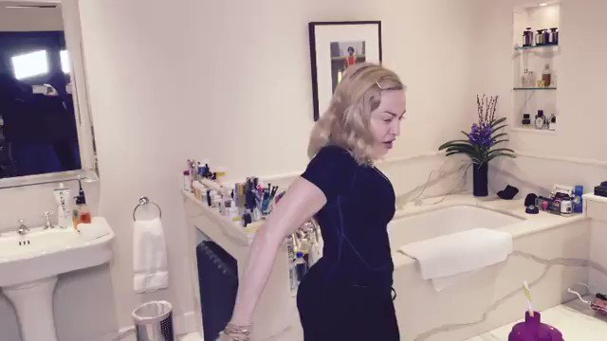](https://twitter.com/Madonna/status/1241035131554615298)](https://twitter.com/Madonna/status/1241035131554615298)

[16.9K](https://twitter.com/intent/like?tweet_id=1241035131554615298" \o "Like)

[5:13 PM - Mar 20, 2020](https://twitter.com/Madonna/status/1241035131554615298)

[Twitter Ads info and privacy](https://support.twitter.com/articles/20175256)

[14K people are talking about this](https://twitter.com/Madonna/status/1241035131554615298" \o "View the conversation on Twitter)

Back to the pasta reference at the end.

Madonna isn’t stupid. She knows the effect of that word, especially at the end of such a weird, awful performance. What does “fried fish” symbolize?

This comes to mind:

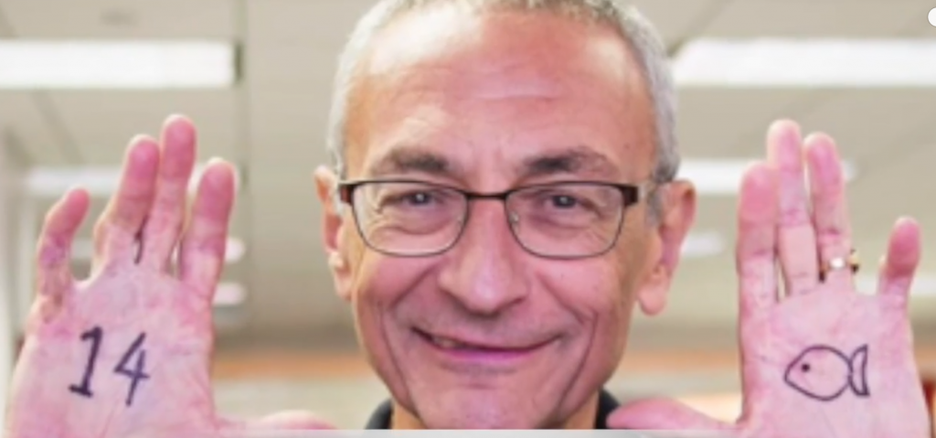*John Podesta. YouTube*

I’m not expert enough in this world of creepy symbology to interpret, but it’s worth mentioning.

Regardless, *what’s going on with this woman?* She stumbles halfway through her routine. Is that her bum knee, or booze, and/or pills? Did she finally have that martini? Why are so many celebrities in quarantine?

**With so many international flights shut down, has a crucial supply chain been shut down?**

Enter half-brother of Barack, Malik Obama. Perhaps you recall Malik’s support of Trump in 2016. Big story, no? Brotherly betrayal and all? Malik accused Barack of dishonesty, going so far as to tweet what he claimed was [Barack’s actual birth certificate](https://freedomoutpost.com/bombshell-interview-malik-obama-says-barack-is-dishonest-a-schemer-frank-marshall-davis-may-be-his-real-father/). Mainstream media blacklisted Malik to the point that Billy Carter, dead for three decades, likely had a higher Q score. Malik is really quite a witty guy. He’s a master tweeter, if that’s a word.

**Malik Obama has a theory** as to what’s going on. Click on the tweet below and follow the comments. Hint: he knows the answer to his question, it’s purely rhetorical.

[https://pbs.twimg.com/profile_images/1081639677915000832/OhOfOcaA_normal.jpg](https://twitter.com/ObamaMalik)

**[Malik Obama](https://twitter.com/ObamaMalik)**

[✔@ObamaMalik](https://twitter.com/ObamaMalik)

What's Adrenochrome folks?

[11.2K](https://twitter.com/intent/like?tweet_id=1240825457903308800" \o "Like)

[3:20 AM - Mar 20, 2020](https://twitter.com/ObamaMalik/status/1240825457903308800)

[Twitter Ads info and privacy](https://support.twitter.com/articles/20175256)

[5,955 people are talking about this](https://twitter.com/ObamaMalik/status/1240825457903308800" \o "View the conversation on Twitter)

The statistic you don’t hear about enough, if at all: 800,000 children disappear annually worldwide. From places like Haiti, where the Clinton Foundation was involved in “rescue operations,” and Monica Petersen, who was investigating the Clinton connection, [died mysteriously](https://www.snopes.com/fact-check/monica-petersen-killed/). Draw what conclusions you will. It’s either the sickest joke perpetrated on the internet, or the world’s best-kept, darkest secret.

I’m going to leave it at that. Buy ammo, and may God bless us all.