SUPERMAN VERSUS BATMAN

**‘Batman v Superman’ hidden occult and Illuminati symbolism**

[**Home**](http://illuminatiwatcher.com/)»[**Film**](http://illuminatiwatcher.com/category/film/)»‘Batman v Superman’ hidden occult and Illuminati symbolism

Posted By [IlluminatiWatcher](http://illuminatiwatcher.com/author/gunslinger/" \o "Posts by IlluminatiWatcher) on Jul 14, 2015 | [46 comments](http://illuminatiwatcher.com/batman-v-superman-hidden-occult-and-illuminati-symbolism/#respond)

In 2016 we’ll see a film called *Batman v Superman: Dawn of Justice* that reinforces many concepts of Illuminati symbolism that I’ve covered here on [IlluminatiWatcher.com](http://illuminatiwatcher.com/batman-v-superman-hidden-occult-and-illuminati-symbolism/illuminatiwatcher.com) in the past few years. The hidden occult message screams loud and clear to me, and I hope you can at least understand where I’m coming from as I explain my viewpoint in this article.

First, let me just say that I’m excited to watch this film because I’m a reformed fan-boy and have always been interested in these comic book mashups. However, the more I learn about the occult the easier it is to read through the lines of entertainment and see the real message underneath it all.

For example, I couldn’t help but notice the symbolism of the [All Seeing Eye](http://illuminatiwatcher.com/decoding-illuminati-symbolism-the-all-seeing-eye/)on the trailer with Superman getting choked out:

[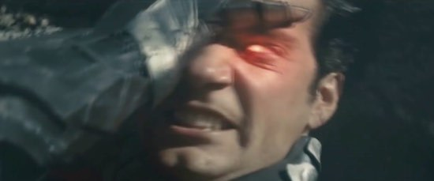](https://i2.wp.com/illuminatiwatcher.com/wp-content/uploads/2015/04/Batman-v-Superman-All-Seeing-Eye.jpg)

For this next point, I’ll need you to take a look at this clip that I pulled from the *Batman v Superman* teaser trailer:

[**?**](http://liveburst.com/ref/1/)

This concept reinforces that which I’ve laid out in my hip hop conspiracy book [*SACRIFICE: MAGIC BEHIND THE MIC*](http://illuminatiwatcher.com/sacrifice-magic-behind-mic-illuminati-hip-hop/)and also my [continuing work on the Google-Occult Apocalypse](http://illuminatiwatcher.com/new-book-the-transhuman-and-occult-agenda-how-google-will-solve-the-problem-of-humanity/) where we’re being culled into a digital Matrix world with no physical death (and consequently no soul). This will successfully ‘override’ God’s creation and intention for life which is the bottom line in occult beliefs.

In the film poster you can see that they show the eyes scrawled out, which I believe could be saying that these superheroes have no soul since the eyes are the window to the soul:

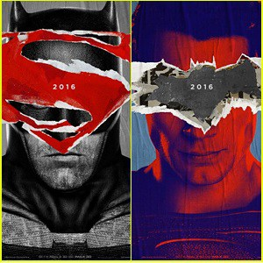

Of course, the occultists think they’re doing us a favor or perhaps becoming new gods themselves, but this is the classic tale of Lucifer reaching for the highest stars to become greater than God, which always ends in disaster for this fallen angel and his followers. This might even be why we see the ancient Egyptian obelisk prominently featured in the trailer, as it was the symbol of the sun worshippers (which you’ll notice in the image as well as the rising sun, or perhaps even the morning star of Lucifer):

[](https://i1.wp.com/illuminatiwatcher.com/wp-content/uploads/2015/04/Batman-v-Superman-obelisk.jpg)

In that clip above you heard the following statement:

*Devils don’t come from the Hell beneath us, they come from the sky.*

This is very crucial to the overarching point of science-fiction, aliens, and UFOs. They are all occultist beliefs and ideas because they originate with the concept of contacting other worldly entities. This is precisely what I predicted would happen at the high profile ritual of [Katy Perry’s 2015 Super Bowl performance](http://illuminatiwatcher.com/katy-perry-illuminati-goddess-2015-super-bowl-halftime-show/):

[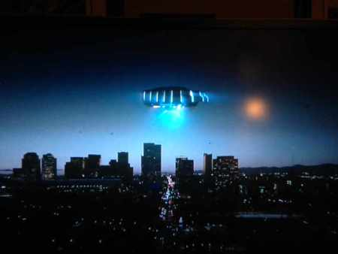](https://i2.wp.com/illuminatiwatcher.com/wp-content/uploads/2015/02/IlluminatiWatcherDotCom-Katy-Perry-Super-Bowl-UFO-city-WO.jpg)

Examples are abound of this type of thing- [Jack Parsons and L. Ron Hubbard’s *Babalon Working* rituals](http://illuminatiwatcher.com/aleister-crowleys-sex-magick-revealed-on-hbos-going-clear-scientology-doc/), the Typhonian OTO, etc. I’ve talked about these concepts many times in the past, but those of you who have been with me for some time will also notice that the [Sign of Typhon: the “V”](http://illuminatiwatcher.com/decoding-illuminati-symbolism-mark-beast-x/) is present in the title of this film. Typically, we would see the term “vs” being used, but the director opted for “v” instead. Why is that? Is he employing the usage of the Sign of Typhon in the title itself?

He was asked why he chose “v” over “vs” and this is what came out of it:

*The director can’t say exactly how the relationship between the two superheroes evolves, “****but suffice it to say there is a ‘v’ in between their names****” in the movie title, Snyder says. He explains that having the “v” instead of “vs.” is a way “to keep it from being a straight ‘versus’ movie, even in the most subtle way.”*

Does this clarify it any? One could draw a comparison to the symbolism of the [beast from the Abyss](http://illuminatiwatcher.com/decoding-illuminati-symbolism-mark-beast-x/), while others could argue it’s simply an abbreviated form of “vs.” Either way, I’ve got to point out one more Mark of the Beast symbolism that will be hard to argue…

You’ll notice that the villain of the film, Lex Luthor, is the ***only human being***with the power to take on Superman. The hidden message of this tale is that the only thing mankind is capable of is becoming greedy, capitalistic pigs; and that’s the best we’ll ever manage to become. This is basically supporting the [Church of Satan idea of man being no better than an animal](http://illuminatiwatcher.com/illuminati-vampire-symbolism-maroon-5s-animals-video/). The ipso-facto argument is that mutants, extraterrestrials, or aliens (such as Superman) are clearly superior beings; even “gods”:

[**?**](http://liveburst.com/ref/1/)

[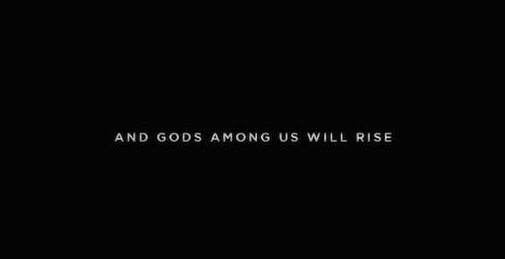](https://i1.wp.com/illuminatiwatcher.com/wp-content/uploads/2015/04/Batman-v-Superman-Gods-will-rise.jpg)

Getting back to that [Mark of the Beast symbolism](http://illuminatiwatcher.com/decoding-illuminati-symbolism-mark-beast-x/) I wanted to cover; If you take a look at the logo for Lex Luthor’s company on the film you’ll also notice it contains the Mark of the Beast with the “X”:

[](https://i1.wp.com/illuminatiwatcher.com/wp-content/uploads/2015/04/Batman-v-Superman-Mark-of-Beast-Lexcorp-X.jpg)

This has been purposefully changed from the LEXCORP logo in the comic series (from what I can tell by looking online-I’ve never read the comics myself):

[](https://i0.wp.com/illuminatiwatcher.com/wp-content/uploads/2015/04/Batman-v-Superman-Lexcorp-logo-original.jpg)

In fact, in the film you’ll learn that the LEXCORP Industries is headquartered in Metropolis (the town where Superman works at the Daily Planet as Clark Kent). This begs me to draw comparison to the 1924 occult film *Metropolis* which was the first high-budgeted sci-fi film ever made; a piece of art that has been emulated by many celebrities with occult-allegations…

[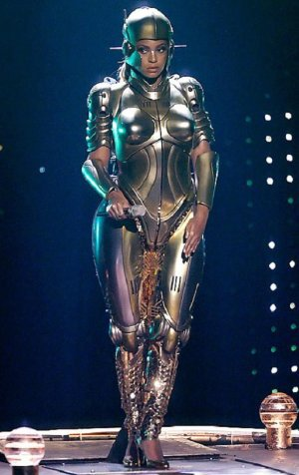](https://i1.wp.com/illuminatiwatcher.com/wp-content/uploads/2015/01/IlluminatiWatcherDotCom-Metropolis-False-Maria-Beyonce.jpg)

…which was a film that I exposed for *also* having the [Mark of the Beast “X”](http://illuminatiwatcher.com/decoding-illuminati-symbolism-mark-beast-x/)over the soul of the robotic entity known as False Maria:

[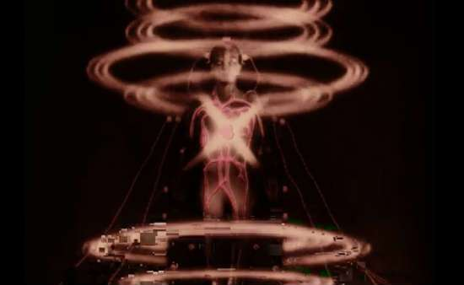](https://i2.wp.com/illuminatiwatcher.com/wp-content/uploads/2015/02/Metropolis-Mark-of-the-Beast-X-and-O-False-Maria-WO.jpg)

At the beginning of the *Superman Man of Steel*film you can see the occult origins of Superman when he pops out of a blackhole by Saturn (did you catch the reference to the [Illuminati symbolism of Interstellar](http://wp.me/p2ijVF-7xV) as well?…):

[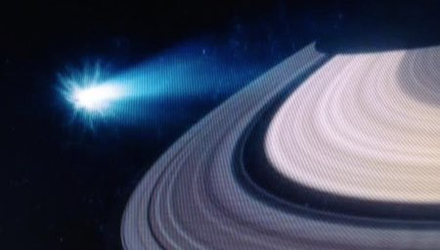](https://i1.wp.com/illuminatiwatcher.com/wp-content/uploads/2015/04/Superman-Man-of-Steel-Black-Hole-Saturn.jpg)

So there you have it; a brief synopsis of why the *Batman v Superman*film will be a message of occult and Illuminati symbolism. Many of you understand where I’m coming from, while others of you may be left wondering if any of this is true. I realize it sounds very sensational and over-analytical, but I assure you that there is a message embedded in these films. There are more films being released about super heroes than ever before. I believe it is a push on the transhuman agenda, or perhaps a way of channeling energy into the agenda of pulling demonic extraterrestrials into our world.

For even more- check out the video of the analysis on the IlluminatiWatcher YouTube channel (*and be sure to subscribe while you’re there for the latest updates):

If you’re left with more questions and want to understand why this is happening; [check out my START HERE page](http://illuminatiwatcher.com/start/) where you can connect on social media and get more free resources.