Nasreddin Hodja Stories (Turkey/Central Asia)

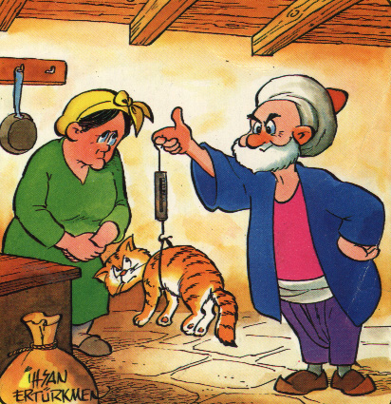
~ Delicious Stew ~
One day Nasreddin Hodja bought 2 kilograms of meat from the neighbourhood butcher. He brought the meat home and asked his wife to cook a real nice stew for dinner. Thus secured the evening meal, he happily headed off to his field to work.
Hodja's wife did cook the stew but about lunch time a few of her friends and relatives came over for a visit. Having nothing else to serve to her guests, she served the stew. They all ate heartily and finished it all.
Hodja came home after a long day's work and asked his wife if the stew was ready.
`Ahh, ahh! You have no idea what befell the stew.' his wife said, `The cat ate it all.'
Nasreddin Hodja, suspicious, looked around and saw the scrawny little cat in one corner, looking as hungry as himself. Hodja grabbed the cat and weighed him on his pair of scales. The poor thing weighed exactly two kilos.
`Woman,' said the Hodja, `if this is the cat, where is the stew? If this is the stew, then where is the cat?'

Cauldron ~
Nasreddin Hodja had borrowed a cauldron from his neighbour. When he didn't return it for a long time, the neighbour came knocking on the door.
`Hodja Effendi, if you are finished with the cauldron could I take it back? The wife needs it today.'
`Ah, of course,' Hodja said, `just wait here a minute and I'll fetch it.'
When Hodja came back to the door with the cauldron, the neighbour noticed that there was a small pot in it.
`What is this?'
`Well, neighbour, congratulations, your cauldron gave birth to a baby pot.' said the Hodja.
The neighbour, incredulous, yet delighted, thanked the Hodja, took his cauldron and the new little pot, and went home.
A few weeks after this incident, one day The Hodja came again, asking to borrow the cauldron. The neighbour didn't even hesitate and lent Hodja the cauldron with pleasure. However, once more it was taking the Hodja forever to return it back. The neighbour had no choice but to go asking for it again.
`Hodja Effendi, are you done with the cauldron?'
`Ahh neighbour, ahh' bemoaned The Hodja, `I am afraid your cauldron is dead.'
`Hodja Effendi, that's not possible, a cauldron cannot die!' exclaimed the disbelieving neighbour. But Nasreddin Hodja had his answer ready.
`My dear fellow, you can believe that it can give birth, why can't you believe that it can also die?'

