table top | bed head
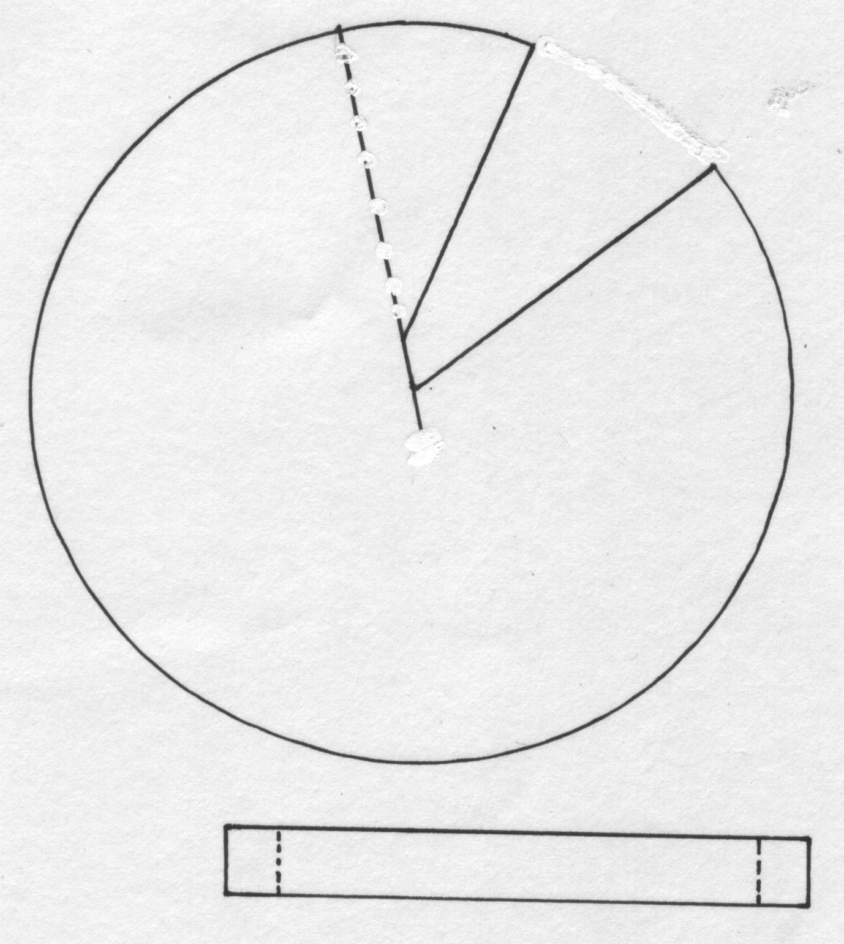
chair back & seat [optional alternative to above]

Suggest printing a page of lamps on yellow coloured cardstock ☺

