US ARMY CIC Documents from the 1940's
Object amazingly similar to White's in
File 202085 "Flying Saucers in Denmark".

http://www.hardevidence.com/

http://www.hardevidence.com/CIC.htm


Feb 25  TUE  2003  Jeff Rense Show | Bob White  Strange Item Ejected From UFO?

A Freedom of Information Act release of all US Army documents related to UFO's
reveals startling information that may support Bob White's claims.
A UFO release packet supposedly containing all documents relating to UFO's that fall under the Freedom of Information Act guidelines was posted on December 1, 1998 at the Fort Belvoir website. These files were also obtained independently by a few UFO researchers who had filed previous requests. One such researcher is John Greenwald at the Black Vault.
Within this recently declassified group of documents is File # 202085 "Flying Saucers in Denmark". The similarities between the object shown and The object recovered following Bob White's UFO Encounter some 40 years later are striking.
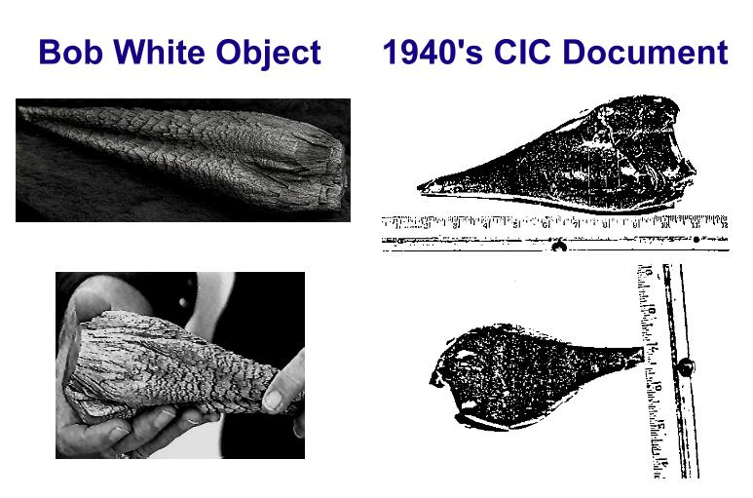
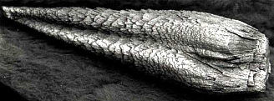

Actual Size white motal object
You can view .gif files of these documents at the Black Vault:
http://www.blackvault.com/ufos/all_ufo_docs_-_army.html

Ongoing Analysis
This page will keep you up to date on our 3 year, in-depth, scientific analysis.
In the early spring of 1999, Hard Evidence was contacted by a major lab in California, interested in testing the Unknown Object beyond the limited scope pursued by Los Alamos, New Mexico Tech, and others.
We are very happy to announce that this analysis is ongoing. Upon it's completion, we will share not only the data, but the name of this world class facility. Updates on additional analysis from Canada will also be posted here.

Analysis Update 12/15/99
- Scanning Electron Microscope Photos added.
- 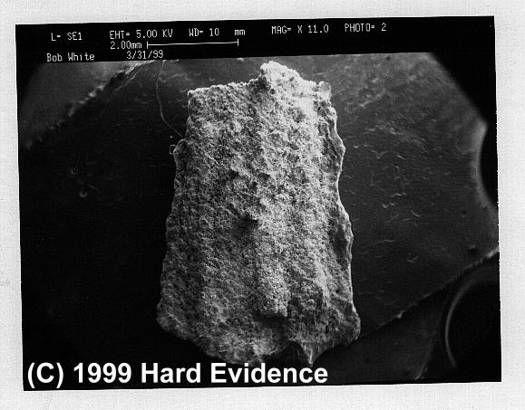Sample at Mag 11.00 x
- 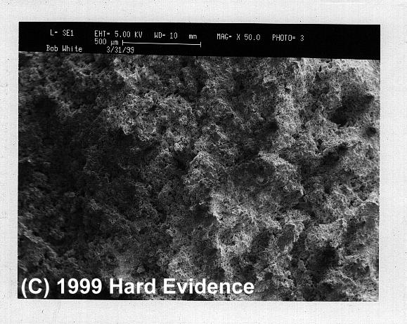Sample at Mag 50.00 x
- 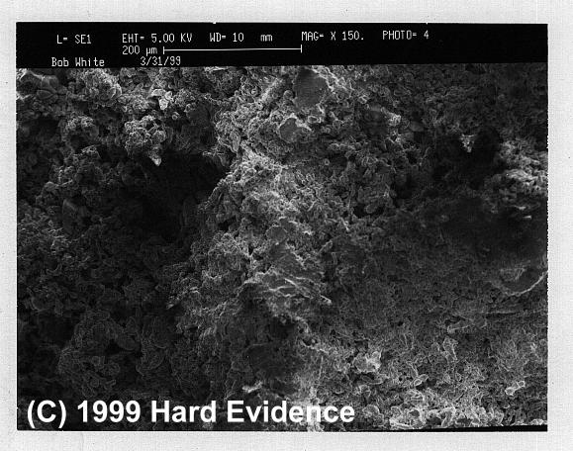Sample at Mag 150.00 x
- 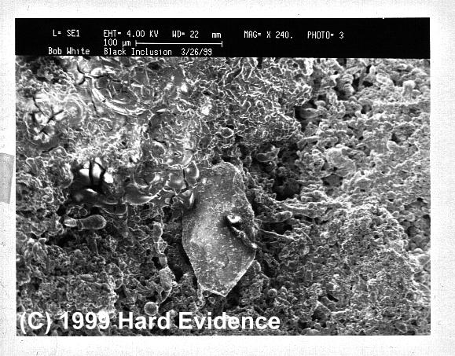Sample at Mag 240.00 x
- 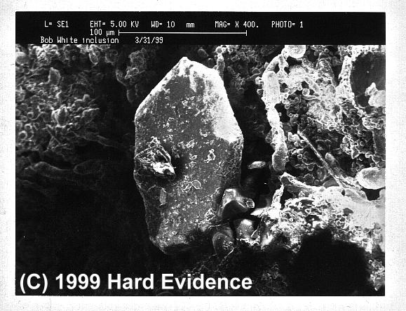Sample at Mag 400.00 x
- 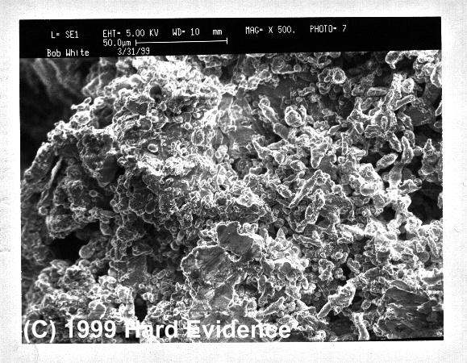Sample at Mag 500.00 x
- 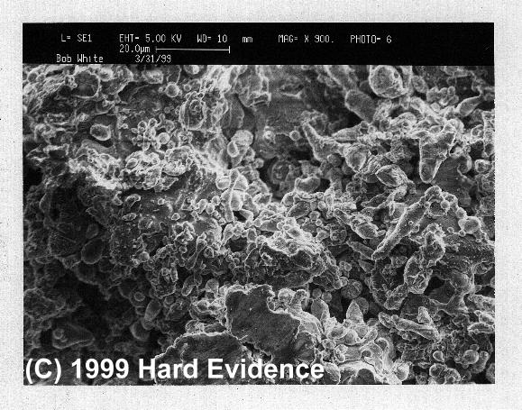Sample at Mag 900.00 x
- 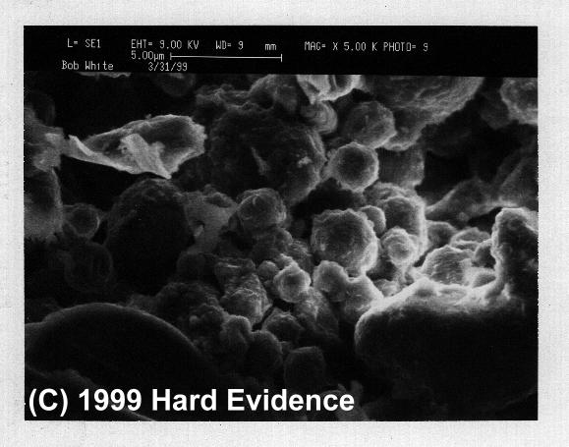Sample at Mag 5000.00 x

Analysis Update 12/02/99
- California analysis ongoing - elemental composition from this analysis so far includes:
Aluminum, Silicon, Chromium, Iron, Magnesium, Manganese, Nickel, Vanadium, Zinc, Barium, Titanium, Cobalt, Calcium, Strontium, Zirconium, Gadolinium

- Stills from Los Alamos Analysis Video Added Below

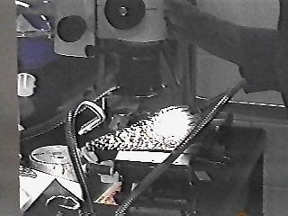
Los Alamos National Labs 9-24-96
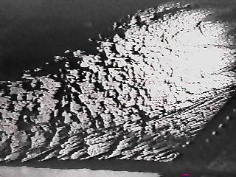
- Release of Canadian Analysis doubtful after $1,000,000 reward was withdrawn by the Flying Saucer Restaurant. We believe after consulting with our sources, that an analysis will not be forthcoming.

Analysis Update 7/20/99
- Waiting on release of Canadian analysis.
- California analysis ongoing.
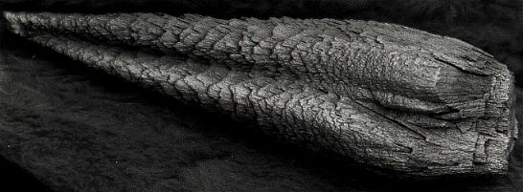
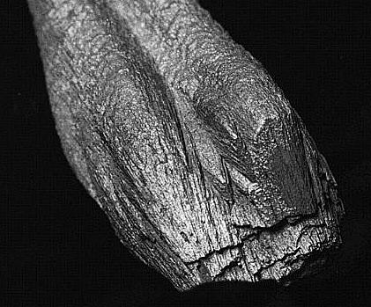

Analysis Update 5/22/99
- Element Strontium, overlooked by Los Alamos and New Mexico Tech, found! Read a description of this strange element from a Los Alamos Periodic Table.
- Scanning Electron Microscope (SEM) photographs of Inclusions
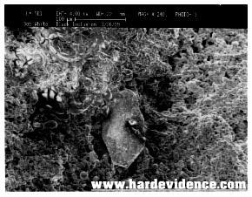
SEM photo of Black Inclusion Taken 3/26/99
Click Here for a larger image
What did Los Alamos have to say about these inclusions?
Below is an excerpt from the Los Alamos Report
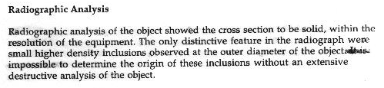
Until this time, SEM photographs were not available to us for exhibition. The National Lab at Los Alamos, and the National Institute for Discovery Science supplied Bob with only photo-copied versions of their reports. SEM images were not discernible in any of the poor quality documents given to Bob. We are appreciative of the proper scientific inquiry, and protocols exhibited by the major lab currently attempting to identify the Unknown Object.
END

