**The Return of Planet X - Luca Scantamburlo**   
  
Italy, February 2008

<http://projectcamelot.org/luca_scantamburlo.html>

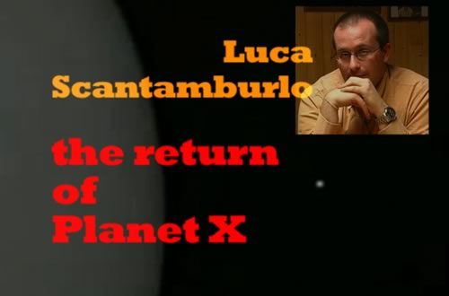

two-part interview with Luca Scantamburlo, an Italian journalist who thoroughly investigated Cristoforo Barbato's meeting with a Vatican source who in 2001 had given Barbato what he stated was a two minute video of Planet X at close range, filmed from a Vatican-controlled space probe called Siloe. This interview tells the detailed story behind the so-called Jesuit Footage, and features extracts from what Luca regards as a close replica of the original video, anonymously posted <http://www.disclose.tv/action/viewvideo/691/NSD42_secret_video___unknown_planet/>

Luca Scantamburlo, an Italian journalist of tremendous heart and intelligence, is a courageous and independent UFO researcher who took it upon himself to publicize the events surrounding a fellow-Italian, Cristoforo Barbato, a few years ago.  
  
We are also in touch with Barbato, but he speaks no English and was not in a position to meet with us. So it fell upon Luca, who had investigated Barbato's story and interviewed him at length, to present to Project Camelot the story of what Barbato had learned about the return of Planet X.  
  
The story, at its simplest, is this: Barbato had written an important article about the Secrets of Fatima, focusing on the mystery of the untold Third Secret. Following this, he was contacted by someone who told him he was a Jesuit priest, working for the Vatican Intelligence Service (SIV), and who had important information to reveal. At first Barbato was skeptical, but the Jesuit was persistent; and eventually Barbato was able to substantiate all his claimed personal details. The Jesuit was exactly who he said he was.  
  
At Barbato's insistence, they finally met in a public place in Rome. At that point the Jesuit gave Barbato a significant amount of information about the return of Planet X, which was being carefully tracked by the Vatican and others; and handed Barbato a two-minute videotape - never publicly released, although [this short clip](http://www.disclose.tv/action/viewvideo/691/NSD42_secret_video___unknown_planet/) (which we incorporated in our video) appears very similar - which the Jesuit said was Planet X filmed at close range from a classified Vatican-controlled space probe called Siloe.  
  
This, and the complex web of detail and controversy that surrounds it, was the subject of our interview. Luca is the foremost English-speaking authority on this subject, which is why we approached him. We were charmed with his friendship, courtesy, intelligence, and the depth of his own research and analysis, and are pleased to present it all here in a comprehensive and important two-part interview.

**Planet X and the "JESUIT FOOTAGE" Classified "SECRETUM OMEGA." First Indirect Confirmation!**

by [**Luca Scantamburlo**](mailto:info@angelismarriti.it)   
Posted November 9, 2006

<http://projectcamelot.org/luca_scantamburlo.html>

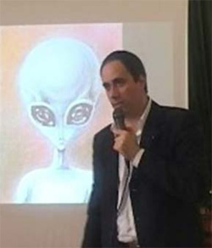

**Cristoforo Barbato speaking about the Secretum Omega. Photo used with his kind permission -** [**www.secretum-omega.com**](http://www.secretum-omega.com/)**.**

After the release of the controversial 'MJ-12' files and of the 'Guardian' files, by an anonymous individual, and perhaps for the first time in history, one member of the ufological community, an Italian freelance writer and investigator, was able to check the credentials of the alleged anonymous insider, an individual that was still working for the intelligence community and had not been fired or retired. This mystery man was responsible for the release of the above classified material. He was an insider of a presumed Vatican intelligence structure and his actions were supported by his colleagues. But first of all, let me tell you something about that freelancer: Cristoforo Barbato.

Born in Naples in 1972, is an Italian independent UFO researcher; in the last 7 years he worked and written for several UFO magazines and frontier studies published in Italy: Notiziario UFO and Dossier Alieni for example. For many years Barbato was also a member of the C.U.N. (Centro Ufologico Nazionale), the main Italian ufological association. Moreover he has collaborated to the realization of two Italian encyclopedias on the UFOs subject, entitled UFO Dossier X, published by the Fabbri Edizioni and Stargate - Enigmi dal Cosmo, by Curcio Editore. Barbato has also participated as speaker at some national conventions on the UFOs, where he has had the possibility to meet different important UFOs researchers, both Italians and international: among them Col. Philip Corso, U.S. Army retired officer.

For some years Barbato was editor in charge in Rome for some Italian magazines, as Stargate, Extra Terrestrial and Stargate Magazine. During that period he wrote on the magazine "Stargate" many reports about Fatima Apparitions and the famous "Third Secret". After the publication of those reports, precisely in the year 2000, he received several e-mails from a person who qualified himself as a Vatican insider. From those e-mails rose up the story of a presumed Vatican Intelligence Agency, whose code would be S.I.V.: "Servizio Informazioni del Vaticano", which in Italian means "Vatican Information Services". In short the Vatican Secret Services. Barbato, at the beginning, was very skeptical and did not rely on him. After one year of such an epistolary contacts (in the meantime the insider revealed himself as a S.I.V. membership, belonging to the Jesuit Order and working by the Holy See), the Italian freelance demanded a meeting with him, as a necessary condition to carry on the contacts. In spite of the risks the Vatican insider accepted, and I suppose he was aware it was necessary considering his baffling revelations. Two meetings took place in a public space in Rome in 2001. After that at least his identity was clear: he was not a mythomaniac; he was really a Jesuit working by the Holy See. Of course the Italian freelance has been protecting his source, avoiding to spread his name; and very soon Barbato realized that he knew much more than what he had told him by e-mail.

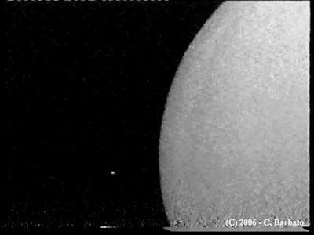

**Photo used with the kind permission of Cristoforo Barbato -** [**www.secretum-omega.com**](http://www.secretum-omega.com/)**.**

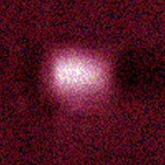

**Closeup of object to the right of Planet X. Object has been enlarged with noise added. Photo used with the kind permission of Cristoforo Barbato -** [**www.secretum-omega.com**](http://www.secretum-omega.com/)**.**

Moreover in 2001 the Vatican insider sent to Cristoforo Barbato by post a videotape (shown for the first time during a meeting that took place in Pescara, in Italy, on 30 April 2005), containing a footage of 2 minutes regarding observations of a planetoid in the deep space (the presumed Tenth Planet, "the Planet X"), while it was approaching to the Solar System. The video, which shows an introduction of writings of classification on it, had been carried out by a secret space probe named "Siloe". The Vatican deep throat told Barbato the space probe was equipped with a sophisticated infrared camera and an electromagnetic impulses propulsion, and was assembled in Area 51(Nevada), and then orbited by an aircraft of the type "Aurora", a secret hypersonic aircraft; the space probe Siloe, always according the Barbato's contact, sent the images of the planetoid in October 1995 (after it came back to the border of Solar System to have more power of signal), to a secret radio telescope hidden in an unused oil-refining plant in Alaska, totally managed by some Jesuits belonging to the S.I.V. The radio telescope, he added, was built in 1990 to observe anomalous celestial bodies on approaching the Solar System.

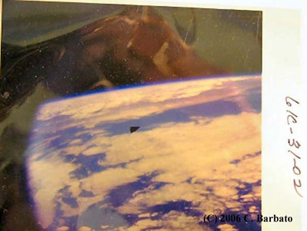

**An unknown spacecraft possibly the Aurora escaping earth's atmosphere. Photo taken during a STS mission. Photo used with the kind permission of Cristoforo Barbato -** [**www.secretum-omega.com**](http://www.secretum-omega.com/)**.**

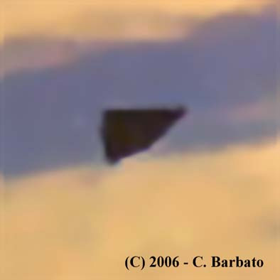

**Closeup of triangle object traveling over earth. Photo used with the kind permission of Cristoforo Barbato -** [**www.secretum-omega.com**](http://www.secretum-omega.com/)**.**

After his conference in Pescara (Italy), Barbato spread a press release which, according to the Jesuit's information, would confirm also the story of a secret meeting of First Contact happened during the strange absence of President Eisenhower in a February evening of 1954, while the President was on holiday in Palm Springs, in California, absence officially motivated with a sudden visit by a dentist for an emergency dental treatment. As a matter of fact on Saturday night of February 20, 1954, Eisenhower's Press Secretary announced that Eisenhower had lost a tooth cap while eating fried chicken and had to be rushed to a local dentist (source: Michael Salla, PhD, http://www.exopolitics.org/Study-Paper-8.htm). Here is a passage from Barbato's press release: "[…] the meeting with an Alien delegation at Muroc Air Field Base in February 1954 in the presence of president Dwight Eisenhower and James Francis McIntyre, bishop of Los Angeles. After that incredible event McIntyre flew to Rome to refer everything to Pope Pius XII who decided to found the S.I.V with the aim to gather every possible bit of information about Aliens and how they interacted with the American Government. From then bishop McIntyre and Detroit Archbishop Edward Mooney became the main information co-coordinators between the USA and the Vatican State. Incredibly, later on there should have been some direct personal meetings between S.I.V. members and a Nordic-looking race of Aliens coming from the Pleiades. These Aliens presumably warned humans against another alien race met by the Americans in the California Desert . These meetings between S.I.V and Aliens took place mainly in the USA territory but also - twice - in the Vatican State , precisely in Vatican Gardens at the Papal Academy of Sciences in presence of Pope Pius XII. My Jesuit contact also confirmed to me the reality of the George Adamsky-John XXIII meeting and talked about some very interesting details about it. He also called "Secretum Omega" the highest secrecy level in S.I.V, equivalent to the NATO Cosmic Top Secret."

I interviewed Barbato for the Italian bimonthly magazine UFO Notiziario (UFO news), nr.62, April-May 2006, in which the magazine published some frames of the video and a very interesting presumed image (provided almost for sure by the Jesuit to Barbato), regarding the phantom "Aurora" (so far denied by U.S. officials) an American large secret hypersonic aircraft capable of a Mach 6 performance. In the presumed picture, taken by a classified STS mission in 2002, you can see a full-body shape aircraft (a black triangle) coming out from the earthly atmosphere to go into the Space. Other detailed information have been revealed on Barbato's website (www.secretum-omega.com), where last September the Italian freelance published on-line the interview to his contact, the Jesuit, taken place in 2001 in Rome. The Jesuit member of the S.I.V. told Barbato that on occasion of the secret meeting at Muroc Air Field Base, in 1954, military cameramen filmed the outstanding event "with three movie cameras (16 millimeters), detached in different places, loaded with colour film and working by spring engines; this last rather unconformable resolution, because it compelled every cameraman to change reel every 3 minutes, it was necessary since in the presence of the Aliens and of their spacecrafts, the electrical engines of the biggest movie cameras did not work. They filmed 7 rollers of 30 meters, a total of 20 minutes shot." Among the Jesuit's revelations, two of them are astonishing: about the planetoid visible in the videotape, the Vatican insider told the Italian freelance that it is the Planet X (the Sumerian Nibiru); about the "Guardian Files", he confessed him are a "dramatic truth", apart from the frames of the presumed E.B.E.

The Barbato' s researches shocked me and roused me to investigate as journalist the "Secretum Omega" enigma. Since 2005 up to now, on some magazines, websites and essays, I found out several circumstantial evidences that seem to prove the existence of the S.I.V. and the "Secretum Omega", their highest clearance. Barbato, before than me, found the most important and explicit of them on an historical essay, a book written by Mark Aarons and John Loftus, entitled "Ratlines" (see chapter 1). Anyway, above all because of the mass-media silence, I decided to baptize the Barbato's video with the name of "Jesuit Footage", to draw upon it the public attention. And finally I found an indirect remarkable confirmation of Barbato's testimony: Dr. Steven M. Greer (M.D.), in his recent book "Hidden Truth - Forbidden Knowledge", revealed in the chapter nr. 16 (passages of it have been published by Nexus New Times magazine, on the survey "Twilight Zone", nr 64, October-November 2006) that, during a meeting with some rebel insiders taken place in December 1994 in Phoenix by Wrigley Mansion, one of them confessed him that determinate Jesuits control technology on UFOs information and contacts with Aliens. So I am convinced that the disturbing inquiries carried out by Barbato deserve our maxim attention, especially to understand how much truth there is about the next Planet X's arrival.

© Luca Scantamburlo, B.A., 9 November 2006

**"The Omega Secret"  
"Secretum Omega"  
by** [**Cristoforo Barbato**](mailto:omegasecret@libero.it)

**(Copyright 2006, Cristoforo Barbato)  
  
Translated from Italian by Robert Morningstar and Matteo Sarti**

<http://www.ufodigest.com/news/1206/omegasecret.html>

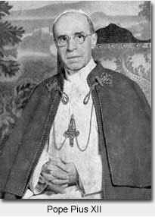

**On the April 30, 2006 the "UFO? The Truth is Top Secret: From Area 51 to Planet X Conference ", organized by the "UFO Observer Cultural Association" was held in the Palazzo della Provincia of Pescara, Italy. Photo used with the kind permission of Cristoforo Barbato -** [**www.secretum-omega.com**](http://www.secretum-omega.com)**.**

**Part I**

During the conference I spoke about underground bases in the USA and dedicated the last fifteen minutes of my speech to a very short summary of my work during last five years that had gone in a new direction and is the leading topic of my future lectures. In the year 2000, I was working in Rome as an editor in the "Stargate" magazine and I wrote many articles about the Fatima Apparitions that took place in Portugal in 1917 and their famous Third Secret, as well as, other Vatican State-related mysteries. After the initial publication of these articles, I started to receive many e-mails from a person who identified himself as a Vatican insider. The mysterious man attempted to contact me anonymously and intermittently because he was interested in me and my research into Fatima.

From those e-mails, a story emerged regarding an enigmatic Vatican Intelligence Agency named "S.I.V.", a code from "Servizio Informazioni del Vaticano". In those letters, there was interesting information and in one of these he advised me that I would receive a video tape about observations of a presumed "10th Planet" coming closer to our Solar System. The video was taken by a space craft, part of a deep space program, started in the early 1990s, called "Siloe."

Through these details, I understood that the writer knew much more information than he was relating to me. For about one year, there were informal contacts via email and postal letters during which he revealed to me that he was a Jesuit member of "S.I.V." and worked in Rome for a certain department of the Holy See, which I verified without his knowledge. Subsequently, I was able (with great difficulty) to arrange the first personal meeting in a public location in the capital (Rome) during which he continued to reveal more information to me.

I greatly desired the first personal meeting, which occurred in 2001, as a condition "sine qua non" because until then I was obviously skeptical (dubious) and untrusting of him even though the information and the video tape were interesting. It was during that meeting that all my doubts completely disappeared when he showed me his credentials, some of which corresponded with what I had previously checked out by myself. In addition, he revealed to me that he was authorized to supervise the so-called "Secretum Omega" ("The Omega Secret"), the highest secrecy category in the Roman Catholic Church, equivalent to (the military's) "Cosmic Top Secret" in NATO.

As prearranged, the dialogue between us was structured in a question and answer form with a stated agreement that I would pose precise questions. Although the format of the meeting was respected (despite my desire to ask various different questions) in the short time available, some of his answers reversed the original setup regarding some subjects. However, the following conversation still represents the main part of the dialogue but not all of it because I decided not to reveal some of the details for the moment.

**The Interview with "The Jesuit"**

**Barbato [B]** : How did you become a member of S.I.V. (Servizio Informazioni del Vaticano)?

**Gesuita [G]** : The S.IV. is composed of different elements, all of which are connected to the Church and mainly composed, at least the Directorate, of priests, the majority of whom are taken from the Jesuit Order, Benedictine Monks and Nuns; in total, a few more than 100 members. There could be fewer members but if one considers all parts of the world where there is a priest or a nun, each is also a potential source of precise information. Some elements of S.I.V. were and are taken from lay areas and institutions, internally connected to the Church, for example, humanitarian associations, political groups close to the Holy See, "young Catholics" movements and others. My background was similar to these.

Briefly, the members were secretly overseen, directed and formed according to determined criteria in certain fields. Nowadays, all of us realize subsequently that we had a personal "guardian angel" or mentor.

**[B]** : Could you give us more details about S.I.V.? Why was it created and how long has it been active…?

**[G]** : The structure is "Top Secret" but for the moment I can tell you that it is organized in a manner analogous to other intelligence organizations like CIA, MI-6, the KGB, etc. It doesn't have an official seat but new a location for reunion is chosen from time to time, always under the oversight of Vatican City. From a chronological point of view, the spark, which ignited the start of said organization, was caused by an event during the first half-decade of the 1950s in the United States, precisely in February of 1954.

This event was the meeting that occurred in California at Muroc Airfield (which later became Edwards Air Force Base) of an alien delegation with the President, Dwight D. Eisenhower, attended by the Bishop of Los Angeles, James Francis McIntyre.

The meeting was filmed by the military with 3 16mm cameras, placed at different points, loaded with color film and spring drive motors; that is because each camera operator had to change the film every 3 minutes and because in the presence of the aliens, electric motor did not work. In total they shot 20 minutes of film in 7 rolls, each of them 30 meters in length.

At the end of the meeting, each member of the Earth delegation swore never to reveal to anyone what he had seen and what he had heard about the aliens. Don't ask me where the film is because I think that you must know the answer. Anyway, some days later, McIntyre, probably disappointed to have sworn himself to secrecy, departed in a hurry with the goal of meeting with Pope Pius XII to inform him of the incredible event.

But in order to reach Italy, Bishop McIntyre had to fly first to New York and then proceed to Rome, always in private aircraft. About half an after take-off from Los Angeles, the airplane suddenly experience technical difficulties and was forced to make an emergency landing at Skyhaven Airport, Las Vegas, NV during the night. During the time that the airplane was being repaired, a certain person boarded the airplane to confer with the Bishop. The man presented military credentials of the US Armed Forces, a colonel in the USAF, and was received by McIntyre. The conversation lasted 20 minutes during which time this man dissuaded the Bishop from revealing all the details of the meeting in which he had assisted because all the alien matters had already been studied for many years exclusively by the USAF. The military emphasized that the President had just requested a spiritual opinion and above all an understanding in a situation so anomalous and that his oath of secrecy also included the Holy Father. Not the least of which concerns was the internal infiltration of the Vatican by Soviet spies. The Bishop replied that it was precisely his intention to inform the Pope of the incredible event.

We now believe that the engine problem was previously and intentionally created in order to bring about that meeting, probably organized by certain military officers without President Eisenhower's knowledge. Before departing the military told the Bishop that notifying Rome would create great problems for him and for his safety, which could cost him much. Furthermore, they couldn't know yet if some divine message had predicted the meeting with the aliens.

Two days later, Pope Pius XII received Bishop McIntyre. After having meditated deeply on the possible implications of an exclusive military relationship with the aliens, the Pope decided to create a secret information department with a structure similar to the fascist military intelligence departments, to be called S.I.V. that would gather all possible information regarding the activities of the alien entity and information acquired by the Americans. It was very important to keep open channels of communication with President Eisenhower.

The S.I.V. was basically constituted to acquire and to manage all secret information above all regarding alien activities and matters, coordinating with other intelligence organization in other countries. The main goal of the newly formed department was to manage all aspect of the moral, philosophical and religious points of view.

**[B]** What made the Pope believe that the American military would have shared such sensitive information with the Vatican? What about the military man who appeared at the airport in Las Vegas?

**[G]** Understand, that meeting convened in the middle of the night by the President of the United States, seeking aid and spiritual support in a situation, unique in the entire story of humanity, I believe was a sign of esteem and trust. In confirmation of this, I tell you that upon returning to the United States, McIntyre and Archbishop Edward Mooney of Detroit were later the principle coordinators of the operation passing the information to the Vatican. But these event took an unexpected turn because McIntyre and other S.I.V. members began to have direct contact, in essence without the knowledge of the military, with an alien race of the Nordic Type, apparently benevolent, coming from the Pleiades. These aliens advised to be careful with the other creatures encountered by the Americans in the California desert. These meetings with the members of S.I.V. happened many times in the United States and twice also inside the Vatican Gardens near the Pontifical Academy of Science, in the presence of Pope Pius XII.

**[B]** Now, Padre Pio of Pietralcina spoke about the existence of other living creatures in other worlds that had attained a higher evolutionary state because they were without sin…Is that true?

**[G}** Without a doubt, but these beings , which you refer to, live in a different dimensional plane, different from in not being the angels in the true sense of the word, while on the other hand the Nordic Aliens that I spoke about previously have flesh and bone, even though they are very evolved to a technological and spiritual point , they still have bodies. These creatures announced to have discovered in the Catholic Church, more precisely in the message of Christ, the pure presence of God and they offered to cooperate, themselves, for the good of humanity.

That firm affirmation on the part of these beings convinced Pius XII to collaborate with them and to consider them as authentic converts to the Christian faith.

The Pontiff probably realized that the Universal Church should communicate its message even to beings coming from other worlds. Besides, these aliens through the years were determined to assist the Church of Rome in all its missions, particularly, in determining the character of social and political situations internationally.

(Author's Note: I suggest that you read what Alberto Perego wrote during his time as Vatican Consul in some of his books.)

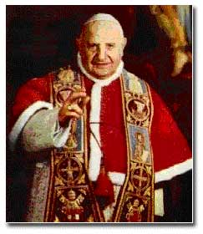

**Pope John XXIII**

Thereafter, even Pope John XXIII benefited from the support of these beings who had espoused the Christian cause but he always preferred to keep it secret speaking solely of "angelic intervention." Pope John XXIII had inherited, in a manner of speaking, an agreement for collaboration between the Holy See and these beneficent aliens of the Nordic Race as stipulated by his predecessor. This situation (the secret agreement) endured throughout the Pontificate of Angelo Giussepe Roncalli, who many times expressed to the leaders of S.I.V. his fears regarding investing too much trust in these beings. That's why today we believe that one of the main reasons for convening The Second Vatican Ecumenical Council was the need to take a first concrete step toward the renewal of the Church, in view of the possibility of immanent contact.

[www.stjames-cathedral.org/Prayer/vatican2-1.htm](http://www.stjames-cathedral.org/Prayer/vatican2-1.htm)

**[B]** Can we include in this intervention or "celestial mediation," the presumed contact that happened in 1963 between American contactee, George Adamski, and the Pope?

**[G}** I was just getting there. Adamski really met the Pope. He went to St. Peter's just once to meet the Pope who at that time had already decided that the Church ought not entertain any further direct contact with these aliens, even if they were positive. Furthermore, John XIII found it unacceptable to reveal this relationship to the Christian populace. The assignment that the aliens commissioned to Adamski was to try to attain a final agreement with the Pope, who was dying. Adamski was a messenger for those aliens who met with the Pope through him. These beings ordered Adamski to deliver a gift to the Pope. The gift contained a liquid substance, which would have saved the Pope from gastric enteritis, which afflicted him at that time and, worse, in his last hours became acute peritonitis.

The Pope did not drink the substance and said before dying as he beheld the Crucifix::

"Quelle braccia allargate del Cristo sono state il programma del mio pontificato. Un pontificato umile e modesto quanto volete, ma di cui mi sono assunto tutte le responsabilità. Sono contento di quello che ho fatto e di come l'ho fatto...."

"The open arms of Christ were the purpose of my pontificate. A humble and modest pontificate as you see, for which I assume all responsibility. I am satisfied in what I have done and how I have done it."

<http://www.medaloffreedom.com/PopeJohnXXIII.htm>

Moreover, this gesture on the part of the aliens convinced the dying Pope, with little lucidity and energy remaining, that the "Space Brothers" might surely conduct positive and benevolent activities toward humanity but that they should operate autonomously and distinctly from the Church and, in general, from human activities, with prayer, actions according to the Law of God and, in particular, under the direction of the Holy Spirit. Adamski's attempted mission ended direct contact between these beings and that Pope and his successors, trusting in the insight of John XXIII who established that it was not allowed to have direct contacts. Later in a secret manuscript from Pope John XIII (Angelo Giussepe Roncalli to his successor, which contained one special dossier about "Servizio Informazioni del Vaticano," the Pope mentioned a passage from the Gospel (of Mark) that clearly explained the position of the Church regarding these benevolent beings coming from other worlds.

Dal Vangelo secondo Marco ( 9, 38 e seg)

In quel tempo, Giovanni rispose a Gesù dicendo: "Maestro, abbiamo visto uno che scacciava i démoni nel tuo nome e glielo abbiamo vietato, perché non era dei nostri". Ma Gesù disse: "Non glielo proibite, perché non c'è nessuno che faccia un miracolo nel mio nome e subito dopo possa parlare male di me. Chi non è contro di noi è per noi. Chiunque vi darà da bere un bicchiere d'acqua nel mio nome perché siete di Cristo, vi dico in verità che non perderà la sua ricompensa".

***From the Gospel of Mark 9: 38 ff.:***

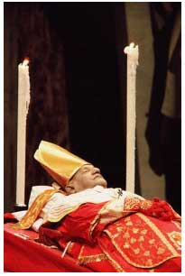

<http://archives.cnn.com/2001/WORLD/europe/03/24/pope.exhumed/index.html>

From the Gospel of Mark 9: 38 ff.:

"At which time, John responded to Jesus saying: "Master, we saw a man who was casting out demons in your name and we forbad him because he was not one of us."

But Jesus said: "Forbid him not, for there is no man who shall do a miracle in my name that can then lightly speak evil of me. For he who is not against us is for us. For whosoever shall give you a cup of water to drink in my name, because you belong to Christ, verily I say unto you, he shall not lose his reward."

**The High Altar at Vatican II Ecumenical Council**

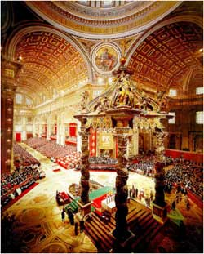

The meaning, in essence, was that the presumed positive activities of these aliens, who accepted the Christic message, should be "blessed" and not opposed (or obstructed) but always kept distinct and parallel to that of the Church. These aliens should be considered as the stranger who rescues in the name of Christ and who should not be impeded from doing so.

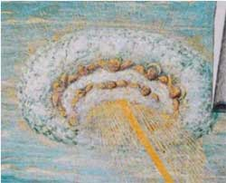

Close up Study of Sky Object in

Carlo Crivelli's

"The Annunciation"

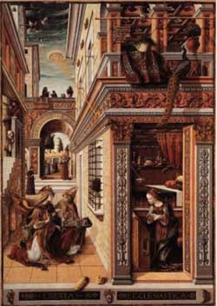

In this course, we could interject the speech, which the new Pontiff gave, in succeeding the late Pius XII, as he proclaimed publicly on the 5th of April, 1961 in St. Peter Plaza before a general audience, saying:

**"Secretum Omega Part II"  
"Secretum Omega"  
by** [**Cristoforo Barbato**](mailto:omegasecret@libero.it)

**(Copyright 2006, Cristoforo Barbato)**

**[B]** Let's talk about your tasks on the S.I.V scene.

**[J]** My tasks were purely technical, the most important of which were , for example, to take extremely secret information coming from a Vatican radio telescope located in Alaska and forward it to respective destinations.

**[B]** Just a second, but to which radio telescope are you referring? I did not know that the Vatican owned such a structure in that area.

**[J]** The Vatican owns and utilizes an extremely advanced radio telescope that is in the vanguard of systems and technology and is only used by Jesuits. It is located inside an industrial park used to store petroleum, apparently abandoned, situated in the state of Alaska. This complex is camouflage because officially the activities that go on inside are not those of the VATT in Arizona and are kept "Top Secret."

** **Translator's note:** I have found a HAARP test application that could possibly be used in a search for Nibiru. HAARP is located in Gakona, Alaska. See "Lunar Radar Experiment": <http://www.nrl.navy.mil/content.php?P=04REVIEW106>

**[B]** When was that apparatus built and, above all, what end in sight did the Vatican have in owning so many other astronomical sites around the world?

**[J]** What I can say is that it was built in the 1990s with the object of studying all anomalous celestial bodies approaching Earth, similar to what the CIA did with one of its "secret eyes," the twin to Hubble, called "SkyHole 12" (a.k.a. Keyhole 12… For details see: <http://en.wikipedia.org/wiki/KH-12> ).

Moreover, the S.I.V. was informed during the meetings (of the aliens) with Pope Pius XII of the approach of a celestial body to the solar system in which resides an advanced very warlike alien race. Very shortly, I knew that the material that I should have been receiving in Rome and then analyzing on a computer was very interesting and extremely secret. It was during the analysis of certain data and information from the Alaska radio telescope that we discovered that one remote deep space probe, part of a deep space exploration program called "SILOE", which was started in 1990 had taken a photograph of a huge planet getting closer to the Solar System. The information was received in Alaska during October 1995, which is when my problems started. I discovered that I was not chosen to decode that particular transmission and a dangerous situation evolved. At that time, my contact revealed to me that, inside the Vatican, there were two factions struggle over possession and control of this information, which was classified far beyond "Top Secret."

**[B]** Can you give me some other details on the space program called SILOE? Who proposed and launched it?

|  |
| --- |
|  |

**[J]** The probe called "SILOE" takes its name from an identically named program of space exploration begun in the early 1990s. Furthermore, regarding this, I can add that this program was part of another one, much wider in scope, named "Kerigma." (Author's note: Regarding the latter ("Kerigma"), nothing was revealed to me.) For now, I can just tell you that this probe was created in Area 51, has an electromagnetic impulse motor, and it was put in orbit by a space plane, like type "Aurora." The probe did not have any calculations or pre-indications of the trajectory or the precise location of "Nibiru," because its purpose was to approach that planet, correcting its direction to avoid impact and to return to this Solar System to a position close enough to transmit the data and images to the secret radio telescope located in Alaska. The probe was launched as soon as the radio telescope was and the probe was capable of transmitting images in 1995.

"Some voices were previously were unknown. But this concerns voices, descending from the sky to the Earth, voices which possess and reflect the omnipotence of the Heavenly Father."