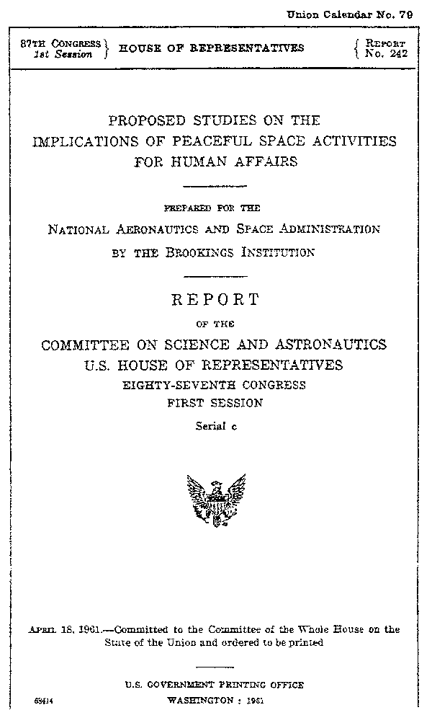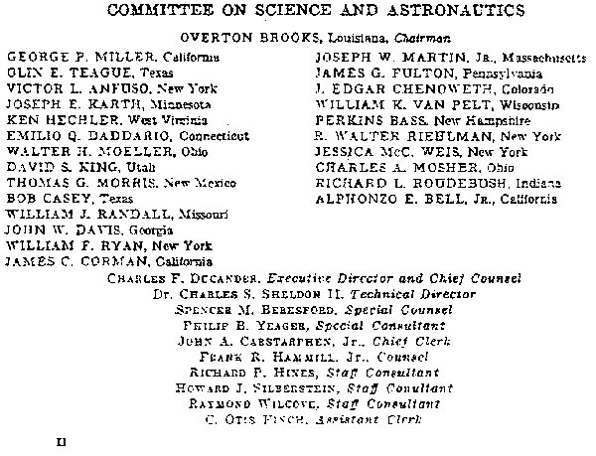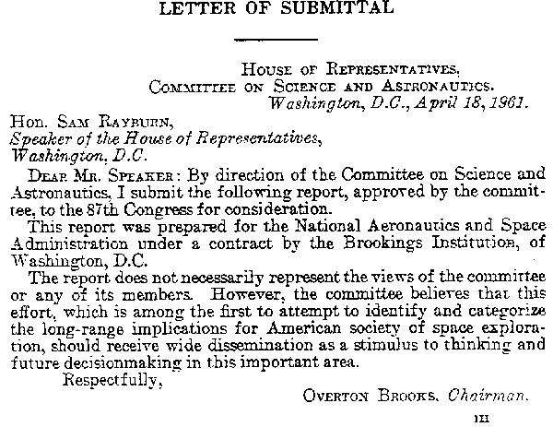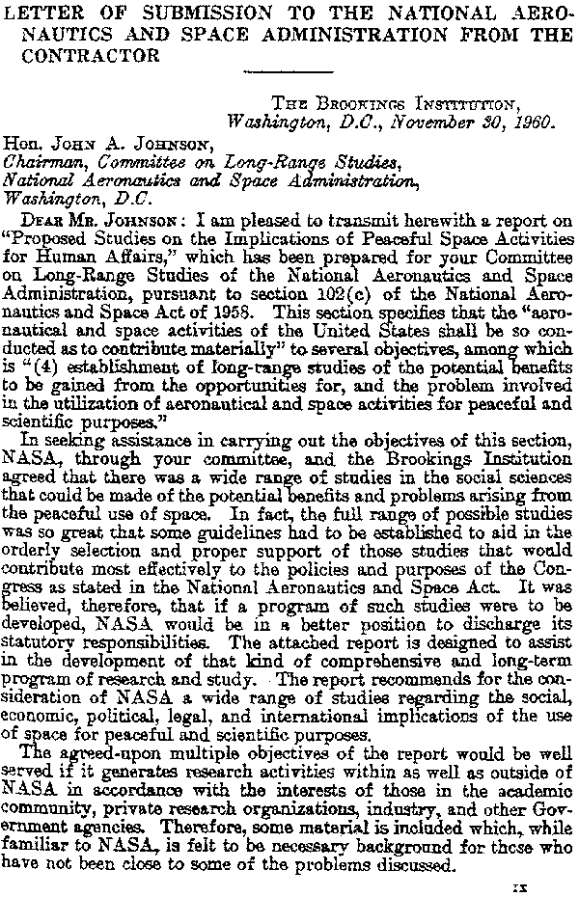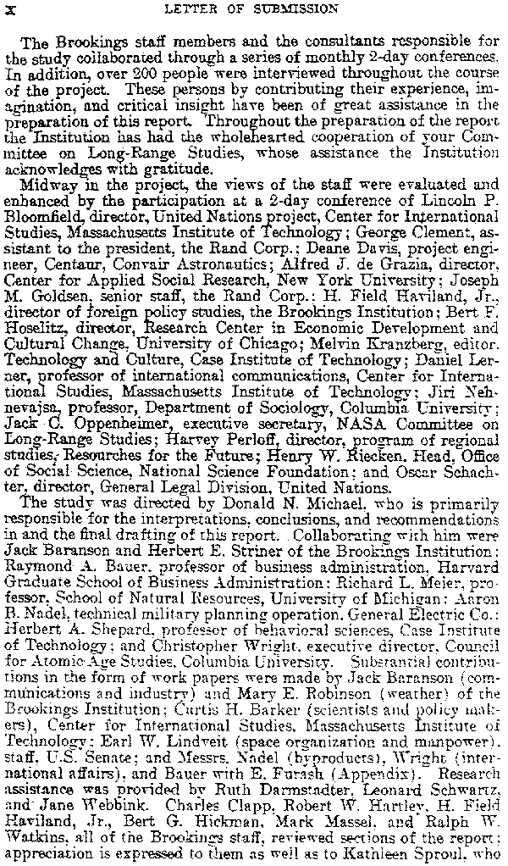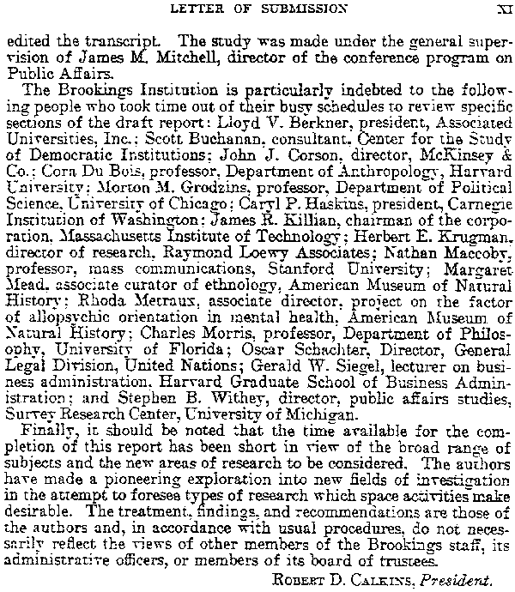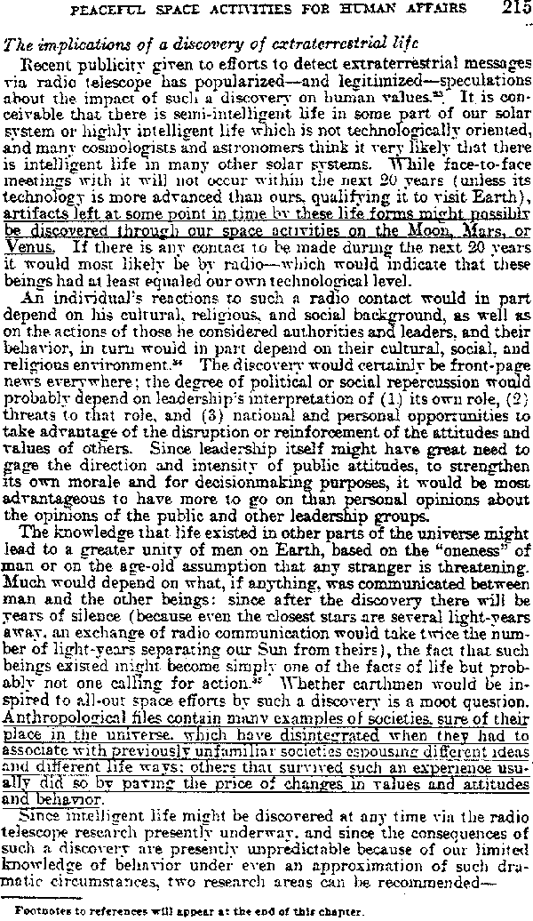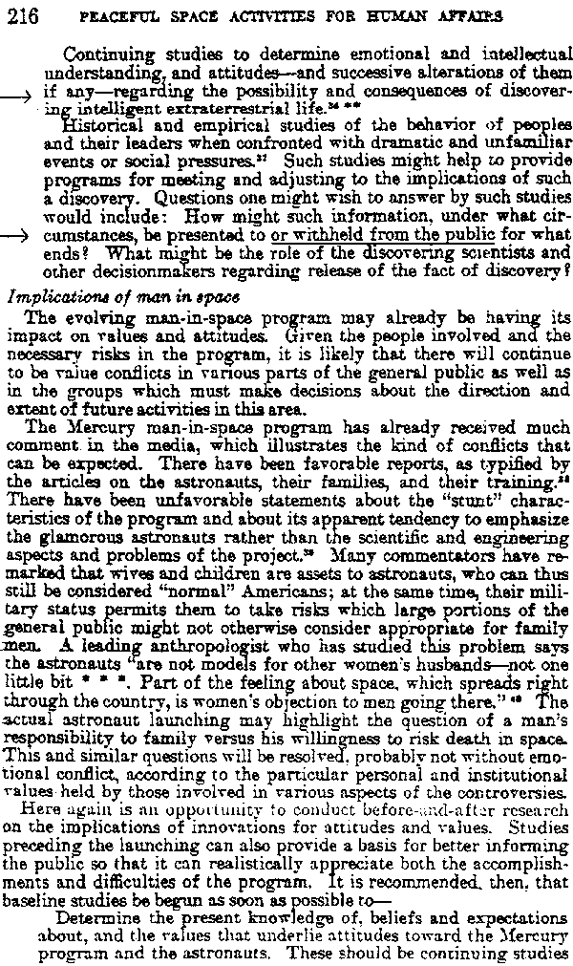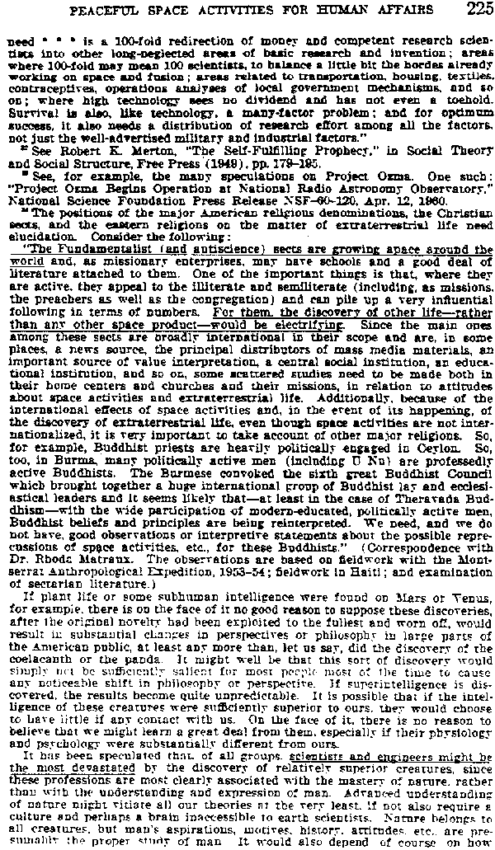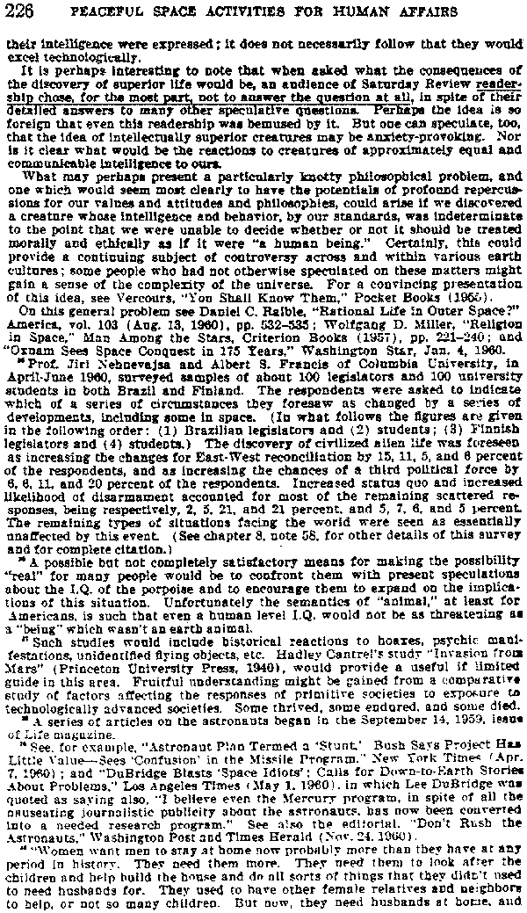

http://allsouthwest.com/library/nasa/Brookings%20Report/

Brookings Report

http://www.zetatalk.com/theword/tword11a.htm

Dateline: The New York Times, Thursday, December 15, 1960
Mankind is Warned to Prepare For Discovery of Life in Space
Brookings Institution Report Says Earth's Civilization Might Topple if Faced by a Race of Superior Beings
Washington. Dec 14 (UPI) -- Discovery of life on other worlds could cause the earth's civilization to collapse, a Federal report said today.
This warning was contained in a research report given to the National Aeronautical and Space Administration with the recommendation that the world prepare itself mentally for the eventuality. The report, prepared by the Brookings Institution, said "while the discovery of intelligent life in other parts of the universe is not likely in the immediate future, it could nevertheless, happen at any time." Discovery of Intelligent beings on other planets could lead to an all-out effort by earth to contact them, or it could lead to sweeping changes or even the downfall of civilization, the report said. Even on earth, it added, " societies sure of their own place have disintegrated when confronted by a superior society, and others have survived even though changed."
Responding to Crisis
"Clearly, the better we can come to understanding the factors involved in responding to such crisis the better prepared we may be." The agency's 100-page report, prepared at a cost of $86,000 was for the space agency's committee on beings-in-space studies. The members, headed by Donald M. Michael also recommended further study of other space activities, including the symptomatic and propaganda effects and the implications of communications and weather satellites. On the question of life in outer space, the report said that if intelligent or super-intelligent beings were discovered in the next twenty years they would probably be found by radio communications with other solar systems.
Evidence of such existence "might also be found in artifacts left on the moon or other planets," it said. An attempt already has been made to contact outer space. Government scientist at Greenbank, West Virginia used radio astronomy in an effort to pick up signals that might have been beamed by intelligent beings. They concentrated on a star about fifteen light years away. Signals were sent from Greenbank were of a kind that would show to anyone receiving on other planets that they were man-made and not natural phenomena.

The "Brookings Report"
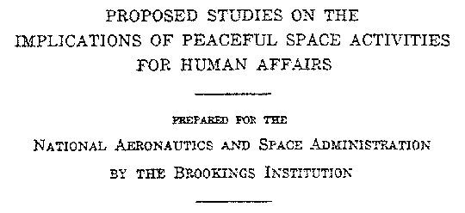
http://www.enterprisemission.com/brooking.html
In mid-1993, Professor Stanley V. McDaniel was seeking additional documentation for his then on-going study -- "The McDaniel Report" -- into NASA's "new imaging and data policy" surrounding its upcoming return to Mars, called "Mars Observer."

Professor McDaniel, former Chairman of the Philosophy Department of Sonoma State University, was in the process of concluding a year-long, outside academic investigation into reasons for "a less-than-enthusiastic" NASA reaction to its scientific and ethical responsibilities relating to the discovery in 1976 of a series of "anomalous objects" on Mars -- located in the Cydonia region of the planet. McDaniel found NASA's abrupt break with over 30 years of prior history of space photography -- refusing on this mission to guarantee, even as the unmanned Mars Observer approached Mars, any new high-resolution images or "live" television of the Cydonia region itself -- increasingly "suspicious."
New Cydonia imagery from Mars Observer -- the first NASA opportunity following the original Viking mission in 1976, on which the "Face on Mars" was found -- could have definitively confirmed or eliminated the 17-year claim of "artifacts on Mars" as a viable scientific hypothesis.
In the final stages of his study, McDaniel asked Richard C. Hoagland for some assistance in locating difficult-to-find historical NASA documents and research papers, relating to its "SETI" project -- the Search for Extraterrestrial Intelligence; Hoagland advised McDaniel of the long-rumored existence of an official NASA "report" -- supposedly commissioned by the space agency in its early years -- relating to prospective NASA censorship of SETI evidence ... if it ever was discovered.
Hoagland then consulted with a former police detective, Don Ecker who, after calling in a couple of "favors," not only confirmed the existence of this highly controversial study -- but came up with the actual title:
"Proposed Studies on the Implications of Peaceful Space Activities for Human Affairs."
Hoagland then called upon another friend, Lee Clinton who, after considerable effort, tracked down an actual copy of the several-hundred-page NASA Study in a Federal Archive -- in Little Rock, Arkansas. Clinton made several copies of the full Study, and duly forwarded sets of the complete document to Hoagland and McDaniel -- who featured it in his final Report, as strongly indicating a long-standing potential NASA policy of "cover-up" on this specific issue.
What is presented here is an abridged copy of this crucial NASA study -- dealing only with the section specifically referencing "implications of the discovery of extraterrestrial life." The full study -- almost 300 pages, covering the full range of NASA's projected space program for the early 1960's, complete with over 400 citations of additional documents, further studies, research reports and background data on a wide variety of projected NASA interests -- is available from The Enterprise Mission (see address, below)
Welcome, then, to "the Brookings Report" -- which increasingly seems to have played a crucial role in determining official NASA policy (if not that of other branches of the Federal government) on the controversial subject of "solar system artifacts" ... for more than thirty years.

In order to offer genuine authenticity of this document, these are scanned GIF images of the actual report.
- Title Page of Brookings Report
- Commitee Members
- Letter of Submittal from Chairman, Overton Brooks
- Letter of Submission to NASA
- Letter of Submission Pg 1 from Robert Calkins, President
- Letter of Submission Pg 2 from Robert Calkins, President
- Brookings Report (Page 215)
  - Mentions Possibility of Artifacts
  - Suggests Society "Disintegration" Potential
- Brookings Report (Page 216)
  - Suggests More Social Studies Needed
  - Suggests the Consideration of Withholding
- Footnotes (Page 225)
  - Electrifying to Fundamentalists
  - Devastation of Scientists and Engineers
- Footnotes (Page 226)
  - Avoidance of Questions

The Enterprise Mission
P. O. Box 1180
Tijeras NM 87059
FAX (505) 286-6130

FORMER NASA SCIENTISTS AND ENGINEERS TO ANNOUNCE IN WASHINGTON
ANALYSIS OF 30-YEAR-OLD 'SUPPRESSED EVIDENCE' REVEALING
ANCIENT ARTIFICIAL STRUCTURES ON MOON

http://www.enterprisemission.com/tmm0014.html
PHOTOS SHOW ASTRONAUTS WALKING AMID APPARENT LUNAR RUINS,
ON "LEAKED" NASA AND SOVIET SPACE PHOTOGRAPHS
RESEARCHERS TO CHALLENGE WHITE HOUSE TO "OPEN NASA FILES"
SUGGEST DELIBERATE 30-YEAR-OLD SUPERPOWER COVERUP BASED ON
OFFICIAL GOVERNMENT REPORT WHICH WARNED
"CIVILIZATION COULD COLLAPSE"
EVIDENCE THROWS NEW LIGHT ON NAGGING QUESTION:
"WHAT REALLY HAPPENED TO APOLLO 13?"

Former NASA scientists, engineers and other researchers, under the aegis of The Mars Mission -- a grassroots space research and policy group of specialists and citizens -- will hold a major press briefing, Thursday, March 21, 1996 at the National Press Club in Washington D.C. In the planned two-hour event, beginning at 9:00 AM, detailed scientific analysis of possible ancient artificial structures -- found on hundreds of archived NASA and Soviet lunar photographs, and thousands of feet of original motion picture film -- will be presented, using state-of-the-art computer and video graphic systems. This material -- some of it held in a university archive outside NASA for almost a quarter of a century -- is part of acontinuing Mars Mission investigation into possible "suppressed" NASA solar system findings, based on a highly controversial warning contained in a 36-year-old government report:
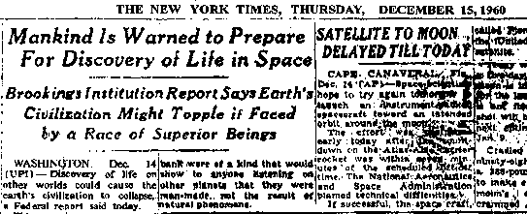
(Click to see article in TEXT FORM or
to see the entire GIF IMAGE of article.)
The Mars Mission's major scientific and political conclusions, to be illustrated with extensive NASA and Soviet lunar photography at the press briefing:
These official mission films -- analyzed over a period of four years, via scientific techniques and computer technologies literally unavailable even to NASA 30 years ago (when the original photographs were taken) -- now provide compelling scientific evidence for the presence of ancient artificial structures on the Moon. Further, it is now apparent that the entire purpose of President John F. Kennedy's sudden, all-out Apollo Program to land Americans on the Moon within ten years was to send American astronauts directly to these ruins, to record them on film, and to bring back physical evidence (including manufactured artifacts) for analysis on Earth.
According to Richard C. Hoagland, head of the Mars Mission and 1993 winner of the International Angstrom Medal for Excellence in Science, who began this intensive examination of NASA and Soviet lunar photography four years ago as part of the research organization's on-going "Mars" investigation, the answer to the question, "Why a NASA cover-up of such extraordinary information?" is simple, if not tragic:
"Look at that New York Times headline; would you reveal the very thing that the best and the brightest' NASA could assemble at the dawn of the Space Age warned could literally collapse civilization': namely, hard physical ruins left by a race of obviously superior beings' -- and in our proverbial back yard,' to boot?! We are 30 years behind where we would have been -- if NASA had been allowed to tell us what they found, at the time these photographs were taken. Imagine the future we would be living now, the discoveries, the scientific and environmental advances the world would be sharing, if fear, coupled with blind and misplaced adherence to authority hadn't intervened . . ."
Hoagland hints that, in addition to the remarkable imaging data on the artifacts, at the press briefing there could be some major political surprises:
"We have evidence that some of the astronauts themselves have attempted to change this 30-year-old policy. But, because they are 'good soldiers', their efforts have been behind the scenes. We are considering presenting this evidence as well.
"It's time for this President to bite the bullet,' to open NASA's files on all of this, and come clean."
For reasons of security, participants in the press briefing -- some of whom currently work on "black projects" for major aerospace companies under direct contract to the U.S. government -- will not be revealed, until shortly before the briefing on the 21st; however, the list of participants does currently include geologists, former NASA engineers, photographic experts, lunar construction engineers, architects, and investigative reporters. Extensive documentation, including hardcopy imaging of specific NASA astronauts "amid the ruins," will be handed out on Thursday.

The Brookings Report
BROOKINGS INSTITUTION PROPOSED STUDIES ON THE IMPLICATIONS OF PEACEFUL SPACE ACTIVITIES FOR HUMAN AFFAIRS
http://www.anomalies.net/brookings/
Washington. Dec 14 (UPI) -- Discovery of life on other worlds could cause the earth's civilization to collapse, a Federal report said today.
This warning was contained in a research report given to the National Aeronautical and Space Administration with the recommendation that the world prepare itself mentally for the eventuality.
The report, prepared by the Brookings Institution, said "while the discovery of intelligent life in other parts of the universe is not likely in the immediate future, it could nevertheless, happen at any time." Discovery of Intelligent beings on other planets could lead to an all-out effort by earth to contact them, or it could lead to sweeping changes or even the downfall of civilization, the report said.
Even on earth, it added, " societies sure of their own place have disintegrated when confronted by a superior society, and others have survived even though changed."
Responding to Crisis
"Clearly, the better we can come to understanding the factors involved in responding to such crisis the better prepared we may be."
The agency's 100-page report, prepared at a cost of $86,000 was for the space agency's committee on beings-in-space studies. The members, headed by Donald M. Michael also recommended further study of other space activities, including the symptomatic and propaganda effects and the implications of communications and weather satellites.
On the question of life in outer space, the report said that if intelligent or super-intelligent beings were discovered in the next twenty years they would probably be found by radio communications with other solar systems.
Evidence of such existence "might also be found in artifacts left on the moon or other planets," it said.
An attempt already has been made to contact outer space. Government scientist at Greenbank, West Virginia used radio astronomy in an effort to pick up signals that might have been beamed by intelligent beings. They concentrated on a star about fifteen light years away.
Signals were sent from Greenbank were of a kind that would show to anyone receiving on other planets that they were man-made and not natural phenomena.
Status on Obtaining Report
I have filed a Freedom of Information Act request to obtain this document from the National Aeronautics and Space Administration (NASA) on Saturday, June 08, 1996. Once I have obtained the full report it will be posted here as a PDF file for your review and use. If you happen to have a copy of the report please let me know or, even better, send a copy of it to me. This would speed up the process considerably. Thank you
Richard C. Hoagland, founder of the Enterprise Mission, recipient of the Angstrom Medal, former science advisor to CBS News and Walter Cronkite, has provided further information on the Brookings Institution Report. Don't misss it!

The Original Scans
- Title Page of Brookings Report
- Commitee Members
- Letter of Submittal from Chairman, Overton Brooks
- Letter of Submission to NASA
- Letter of Submission Pg 1 from Robert Calkins, President
- Letter of Submission Pg 2 from Robert Calkins, President
- Brookings Report (Page 215)
  - Mentions Possibility of Artifacts
  - Suggests Society "Disintegration" Potential
- Brookings Report (Page 216)
  - Suggests More Social Studies Needed
  - Suggests the Consideration of Withholding
- Footnotes (Page 225)
  - Electrifying to Fundamentalists
  - Devastation of Scientists and Engineers
- Footnotes (Page 226)
  - Avoidance of Questions
The Full Brooking Report
These files were encoded into PDF format by http://www.in-search-of.com. A very good resource for paranormal information. We have mirrored these files for ease of use but we suggest you visit In Search Of for lots more good information
- Full Brookings Report
- Table of Contents
- Summary
- Chapters 1-3
- Chapters 4-5
- Chapters 6-7
- Chapters 8-9
- Full Footnotes
- Footnotes 1-4
- Footnotes 5-7
- Footnotes 8-9
- Brooking Summary Report

Extract from
The Brookings Report

http://www.perceptions.couk.com/uef/aliens.txt

Report No 242 87th Congress 1st Session

"Proposed studies on the implications of peaceful space
activities for human affairs"

For NASA by the Brookings Institution

Committee on Science and Astronautics
(34 men 1 woman)

"It has been speculated that, of all groups, scientists and
engineers might be the most devastated by the discovery of
relatively superior creatures, since these professions are
most clearly associated with the mastery of nature rather
than with the understanding and expression of man*"

[* humankind? - ed@perc]

"Advanced understanding of nature might vitiate all our
theories at the very least, if not also require a culture
and perhaps a brain inaccessible to earth scientists"

---------------------------------------------------------
Brookings Institution Report - Confessions

1 revealing summary of elite science - more concerned with
`mastery' than with `understanding'

2 admission that present `theories' probably untrue

3 read that last `brain' bit as you will!
---------------------------------------------------------

"Perceptions" note: we can see even at that early stage
`authorities' were getting anxious about holding on to
"power"

"Brookings Report" - kept under wraps for many years -
went on to propose keeping secret any contact with alien
cultures - under the guise of preventing a "collapse of
civilization"

Question:-

"Is a `civilization' of elites that can't abide truth really
_worth_ propping up?"

-----------------------

From John Stuart Mill, here's a philosopher's quote

"The worth of a State, in the long run, is the worth of the individuals
composing it"

That's us!

---------------------------------------------------------
For small overview of early official reports - check
http://www.perceptions.couk.com/reports.txt

---------------------------------------------------------

---------------------------------------------------------
WebSite copies of Brookings Report

Intro
http://www.humanunderground.com/Brookings.html

.pdf copy
http://www.humanunderground.com/archive/pdf/brookings.pdf

---------------------------------------------------------

http://www.netowne.com/ufos/important/extraordinary.htm

"Philosophy professor Michael Zimmerman...showed how science
has, throughout its history, vigorously resisted evidence
of anomalous events"

http://www.zetatalk.com/theword/tword11j.htm
http://www.humanunderground.com/Brookings.html

---------------------------------------------------------
---------------------------------------------------------

Evidence file for "UEF Index"
http://www.perceptions.couk.com/UEFindex.html

for "Greatest (real) Discoverers"
http://www.perceptions.couk.com/greatest.html

for "Real Genius - Wallace"
http://www.perceptions.couk.com/uef/wallace.html

for "Self Examination"
http://www.perceptions.couk.com/self.html

for "Altruist Survivor"
http://www.perceptions.couk.com/genes8a.html

---------------------------------------------------------

ID
http://www.perceptions.couk.com/uef/aliens.txt

---------------------------------------------------------

From: Brian Zeiler <bdzeiler@students.wisc.edu>
Newsgroups: alt.alien.visitors
Date: 20 Nov 1995 23:47:59 GMT
Organization: University of Wisconsin
http://www.in.tu-clausthal.de/~sdauss/Ufo/Textsammlung/b10_BrookingsReport.htm
In response to a recent query from someone in the Netherlands, I decided to buckle down and trancribe the portion of the Brookings Report which deals with the issue of ETs. Given the role the report plays in the UFO folklore of the '90s, it seems like it would be useful to have this on-line. The full name of the Brookings Report is

"Proposed Studies on the Implications of Peaceful Space Activities for Human Affairs",
and the U[niversity ?] of M catalog lists the author as
Donald N. Michael.
Out of a 272 page report, the question of the impact of discovering ETs occupies a paragraph in the summary on p 30 (1961 edition), page 215 and the top third of page 216, and three long footnotes on pages 225 and 226. (As far as I could tell -- the report doesn't have an index...) Apologies for any typos.

(page 30)
"4. Though intelligent or semi-intelligent life conceivably exists elsewhere in the solar system, if intelligent extraterrestrial life is discovered (sic) in the next 20 years, it will very probably be by radio telescope from other solar systems. Evidences of its existance might also be found in artifacts left on the moon or other planets. The consequences for attitudes and values are unpredictable, but would vary profoundly in different cultures and between groups within complex societies; a crucial factor would be the nature of the communication between us and the other beings. Whether or not earth would be inspired to an all-out space effort by such a discovery is moot: socities sure of their own place in the universe have disintegrated when confronted by a superior society, and others have survived even though changed. Clearly, the better we can come to understand the factors involved in responding to such crises the better prepared we may be."
(pages 215-216)

The implications of a discovery of extraterrestrial life
Recent publicity given to efforts to detect extraterrestrial messages via radio telescope has popularized -- and legitimized -- speculations about the impact of such a discovery on human values.^33 It is conceivable that there is semi-intelligent life in some part of our solar system or highly intelligent life which is not technologically oriented, and many cosmologists and astronomers think it very likely that there is intelligent life in many other solar systems. While face-to-face meetings with it may not occur within the next 20 years (unless its technology is more advanced than ours, qualifying it to visit Earth), artifacts left at some point in time by these lifeforms might possibly be discovered through our space activities on the Moon, Mars, or Venus. If there is any contact to be made during the next 20 years it would most likely be by radio -- which would indicate that these beings had at least equaled our own technological level.
An individual's reactions to such a radio contact would in part depend on his cultural, religious, and social background, as well as the actions of those he considered authorities and leaders, and their behavior, in turn would in part depend on their cultural, social, and religious environment.^34 The discovery would certainly be front-page news everywhere; the degree of political or social repercussion would probably depend on leadership's interpretation of (1) its own role, (2) threats to that role, and (3) national and personal opportunities to take advantage of the disruption or reinforcement of the attitudes and values of others. Since leadership itself might have great need to gage the direction and intensity of public attitudes, to strengthen its own morale and for decision making purposes, it would be most advantageous to have more to go on than personal opinions about the opinions of the public and other leadership groups.
The knowledge that life existed in other parts of the universe might lead to a greater unity of men on Earth, based on the `oneness' of man or the age-old assumption that any stranger is threatening. Much would depend on what, if anything, was communicated between man and the other beings: since after discovery there will be several years of silence (because even the closest stars are several light-years away, an exchange of radio communication would take twice the number of light-years separating our Sun from theirs), the fact that such beings existed might become simply one of the facts of life, but probably not one calling for action.^35 Whether earthmen would be inspired to all-out space efforts by such a discovery is a moot question. Anthropological files contain many examples of societies, sure of their place in the universe, which have disintegrated when they had to associate with previously unfamiliar societies espousing different ideas and different life ways; others that survived such an experience usually did so by paying the price of change in values and attitudes and behaviors.
Since intelligent life might be discovered at any time via the radio telescope research presently underway, and since the consequences of such a discovery are presently unpredictable because of our limited knowledge of behavior under even an approximation of such dramatic circumstances, two research areas can be recommended --
Continuing studies to determine emotional and intellectual understanding and attitudes -- and successive alterations of them if any -- regarding the possibility and consequences of discovering intelligent extraterrestrial life.^36
Historical and empirical studies of the behavior of peoples and their leaders when confronted with dramatic and unfamiliar events or social pressures.^37 Such studies might help to provide programs for meeting and adjusting to the implications of such a discovery. Questions one might wish to answer by such studies would include: How might such information, under what circumstances, be presented to or withheld from the public for what ends? What might be the role of the discovering scientists and other decision makers regarding release of the fact of discovery?
(pages 225-226)
^33 See, for example, the many speculations on Project Ozma. One such: 'Project Ozma Begins Operation at National Radio Observatory,' National Science Foundation Press Release NSF-60-120, Apr. 12, 1960.
^34 The positions of the major American religious denominations, the Christian sects, and the eastern religions on the matter of extraterrestrial life need elucidation. Consider the following:
'The Fundamentalist (and antiscience) sects are growing apace around the world, and as missionary enterprises, may have schools and a good deal of literature attached to them. One of the important things is that, where they are active, they appeal to the illiterate and semiliterate (including, as missions, the preachers as well as the congregation) and can pile up a very influential following in terms of numbers. For them, the discovery of other life -- rather than any other space product -- would be electrifying. Since the main ones among these sects are broadly international in their scope and are, in some places, a news source, the principle distributors of mass media materials, an important source of value interpretation, a central social institution, an educational institution, and so on, some scattered studies need to be made both in their home centers and churches and missions, in relation to attitudes about space activities and extraterrestrial life. Additionally, because of the international effects of space activities and, in the event of its happening, of the discovery of extraterrestrial life, even though space activities are not internationalized, it is very important to take account of other major religions. So, for example, Buddhist priests are heavily politically engaged in Ceylon. So, too, in Burma, many politically active men (including U Nu) are professedly active Buddhists. The Burmese convoked the sixth great Buddhist Council which brought together a huge international group of Buddhist lay and ecclesiastical leaders and it seems likely that -- at least in the case of Theravanda Buddhism -- with the wide participation of modern- educated, politically active men, Buddhist beliefs and principles are being reinterpreted. We need, and we do not have, good observations or interpretive statements about the possible repercussions of space activities, etc., for these Buddhists.' (Correspondence with Dr. Rhoda Matraux. The observations are based on fieldwork with the Montserrat Anthropological Expedition, 1953-54; fieldwork in Haiti; and examination of sectarian literature.)
If plant life or some subhuman intelligence were found on Mars or Venus, for example, there is on the face of it no good reason to suppose these discoveries, after the original novelty had been exploited to the fullest and worn off, would result in substantial changes in perspectives or philosophy in large parts of the American public, at least any more than, let us say, did the discovery of the coelacanth or the panda. It might well be that this sort of discovery would simply not be sufficiently salient for most people most of the time to cause any noticeable shift in philosophy or perspective. If superintelligence is discovered, then the results become quite unpredictable. It is possible that if the intelligence of these creatures were sufficiently superior to ours, they would chose to have little or no contact with us. On the face of it, there is no reason to believe that we might learn a great deal from them, especially of their physiology and psychology were substantially different from ours.
It has been speculated that, of all groups, scientists and engineers might be the most devastated by the discovery of relatively superior creatures, since these professions are most clearly associated with the mastery of nature, rather than with the understanding and expression of man. Advanced understanding of nature might vitiate all our theories at the very least, if not also require a culture and perhaps a brain inaccessible to earth scientists. Nature belongs to all creatures, but man's aspirations, motives, history, attitudes, etc., are presumably the proper study of man. It would also depend, of course, on how their intelligence were expressed; it does not necessarily follow that they would excell technologically.
It is perhaps interesting to note that when asked what the consequences of the discovery of superior life would be, an audience of Saturday Review readers chose, for the most part, not to answer the question at all, in spite of their detailed answers to many other speculative questions. Perhaps the idea is so foreign that even this readership was bemused by it. But one can speculate, too, that the idea of intellectually superior creatures may be anxiety-provoking. Nor is it clear what would be the reactions to creatures of approximately equal and communicable intelligence to ours.
What may perhaps present a particularly knotty philosophical problem, and one which would seem most clearly to have the potentials of profound repercussions for our values and attitudes and philosophies, could arise if we discovered a creature whose intelligence and behavior, by our standards, was indeterminate to the point that we were unable to decide whether or not it should be treated morally and ethically as if it were `a human being.' Certainly, this could provide a continuing subject of controversy across and within various earth cultures; some people who have not otherwise speculated on these matters might gain a sense of the complexity of the universe. For a convincing presentation of this idea, see Vercours, 'You Shall Know Them,' Pocket Books (1955).
On this general problem, see Daniel C. Raible, 'Rational Life in Outer Space?' America, vol. 103 (Aug. 13, 1960), pp. 532-535; Wolfgang D. Miller, 'Religion in Space,' Man Among the Stars, Criterion Books (1957), pp. 221-240; and 'Oxnam Sees Space Conquest on 175 Years,' Washington Star, Jan. 4, 1960.
^35 Prof. Juri Nehnevajsa and Albert S. Francis of Columbia University, in April-June 1960, surveyed samples of about 100 legislators and 100 university students in both Brazil and Finland. The respondents were asked to indicate which of a series of circumstances they foresaw as changed by a series of developments, including some in space. (In what follows the figures are given in the following order: (1) Brazilian legislators and (2) students; (3) Finnish legislators and (4) students.) The discovery of civilized alien life was foreseen as increasing the chances for East-West reconciliation by 15, 11, 5, and 6 percent of the respondents, and as increasing the chances of a third political force by 6, 6, 11, and 20 percent of the respondents. Increased status quo and increased likelihood for disarmament accounted for most of the remaining scattered responses, being respectively, 2, 5, 21, and 21 percent, and 5, 7, 6, and 5 percent. The remaining types of situations facing the world were seen as essentially unaffected by this event. (See chapter 8, note 58, for other details of this survey and for complete citation.)
^36 A possible but not completely satisfactory means for making the possibility 'real' for many people would be to confront them with present speculations about the I.Q. of the porpoise and to encourage them to expand on the implications of this situation. Unfortunately, the semantics of 'animal,' at least for Americans, is such that even a human level I.Q. would not be as threatening as a 'being' which wasn't an earth animal.
^37 Such studies would include historical reactions to hoaxes, psychic manifestations, unidentified flying objects, etc. Hadley Cantrel's study 'Invasion From Mars' (Princeton University Press, 1940), would provide a useful if limited guide in this area. Fruitful understanding might be gained from a comparative study of factors affecting the responses of primitive societies to exposure to technologically advanced societies. Some thrived, some endured, and some died.

From: lbgn@easynet.co.uk (Graeme Nicholson)
Newsgroups: alt.alien.visitors
Subject: Re: Government Studie
Date: Sat, 11 Nov 1995 17:15:47 +0000
In article <47ue82$1l24@news.doit.wisc.edu>, Brian Zeiler <bdzeiler@students.wisc.edu> wrote:
In response to a recent query from someone in the Netherlands, I decided to buckle down and trancribe the portion of the Brookings Report which deals with the issue of ETs. Given the role the report plays in the UFO folklore of the '90s, it seems like it would be useful to have this on-line.
Just a small ammendment: UFO Magazine said this month that the Brookings Institute were commisioned to do this study by NASA direcly , not the government. They also just said the basic reply was "Dont tell the public".
Graeme Nicholson lbgn@easynet.co.uk

zugesandt von Jan-H. Raabe

